**QUE 1What are the new tags added in HTML5?**

**ANS 1**

* Audio
* Video
* Footer
* Header
* Main
* Table
* Nav
* section

**QUE 2 How to embed audio and video in a webpage?**

**ANS 2**

* To embed audio in HTML, we use the <audio> tag.

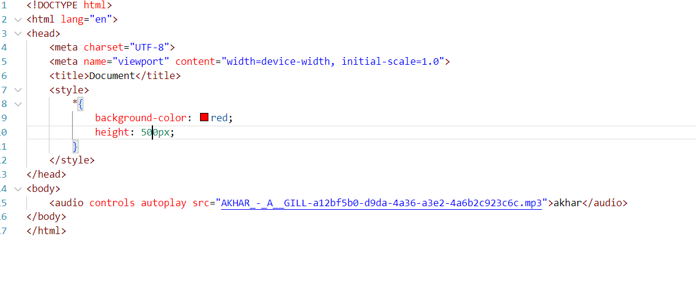

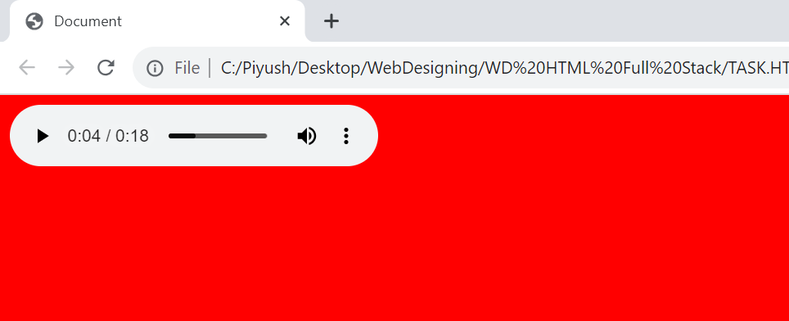

**Video tag**

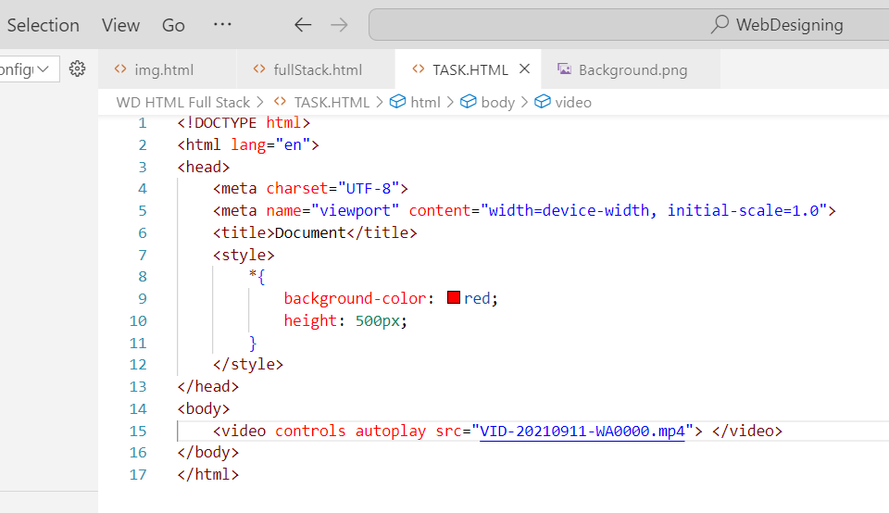



**QUE 3 Semantic element in HTML5?**

**ANS 3**

* In HTML there are some semantic elements that can be used to define different parts of a web page:
* <article>
* <aside>
* span
* form
* table

**QUE 4 Canvas and SVG tags?**

**ANS 4**

|  |  |
| --- | --- |
| **SVG** | **HTML Canvas** |
| SVG has better scalability. So it can be printed with high quality at any resolution | Canvas has poor scalability. Hence it is not suitable for printing on higher resolution |
| SVG gives better performance with smaller number of objects or larger surface. | Canvas gives better performance with smaller surface or larger number of objects. |
| SVG can be modified through script and CSS | Canvas can be modified through script only |
| SVG is vector based and composed of shapes. | Canvas is raster based and composed of pixel. |