**Que.1 What is jQuery?**

**Ans.1-** jQuery is a free, open-source JavaScript library that simplifies HTML DOM tree traversal and manipulation, as well as event handling, CSS animations, and Ajax.

**Que.2** How to Apply CSS Using jQuery, How to Add Class and Remove Class in jQuery , jQuery Animation?

**Ans.2-Applying CSS using jQuery:**

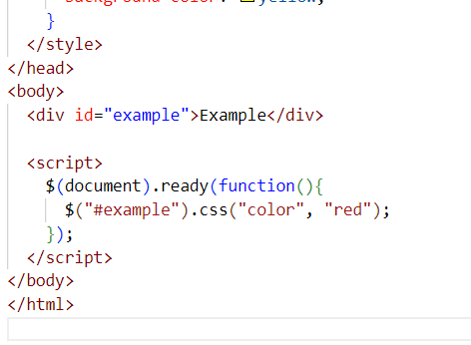

**. Adding and Removing Classes using jQuery:**

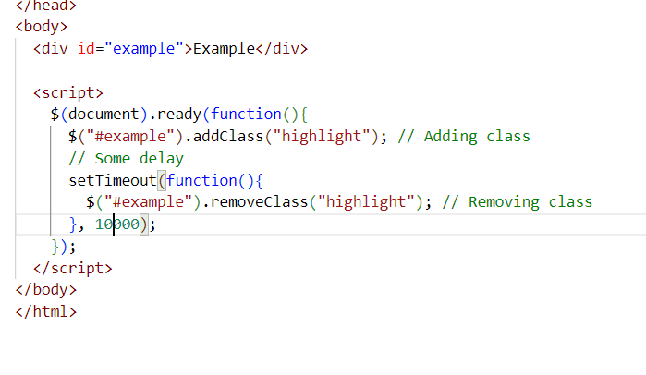

**jQuery Animation:**

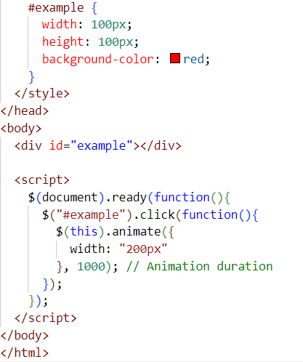

**Que-3How to create slider with animation?**

**Ans-3-** 