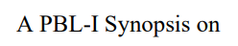
Personal Finance Tracker

Submitted to Manipal University Jaipur

Towards the partial fulfilment for the Award of the Degree of

BACHELOR OF TECHNOLOGY

In Computers Science and Engineering

2025-2026

By

Piyush Prakash Sharma
2427030222


Under the Guidance of
Ms.Harshika Mathur

_________________________________________________________

Sign of Supervisor

Department of Computer Science and Engineering
School of Computer Science and Engineering
Manipal University Jaipur
Jaipur, Rajasthan

I. Introduction to Problem (What, Why, How)

The "What”

When a person tries to manage their finances with modern digital payment apps, they are often met with platforms that actively encourage them to spend more rather than save. FinTracker is a personal finance and budgeting application designed to actively disincentivize overspending. It functions as a mix of a finance app and Duolingo—instead of rewarding users with cashbacks, it rewards them with psychological momentum (savings streaks). It uses feedback loops and the fear of losing that momentum to force accountability, helping users set goals and build genuine financial responsibility.

The "Why”

A significant gap exists in the current personal finance and payments market.

Commercial Payment Apps (e.g., GPay, PhonePe): These platforms often scrape data and rely on toxic positive reinforcement, such as coupons and cashbacks, to encourage continuous spending.

Generic Budgeting Tools: Traditional trackers rely on passive pie charts and lack the visceral emotional feedback necessary to create true financial awareness. They do not hold users accountable on a daily basis when they exceed their limits.

The "How”
The core idea of the application is :
Whenever you spend your money through online methods the app reads your transaction through messages and then notifies you how close you are to reaching your monthly/daily budget limit sort of like breaking the "Savings streak “If by the end of the day you exceeded your daily budget limit then the app can reset your streak or give you an option to keep your streak by spending less the next day.It will also provide user with downloadable detailed reports of their transactions with charts and budget analysis

II. Literature Review

1. Premium Cloud SaaS (e.g., YNAB, Copilot Money)
- Pros: Excellent interfaces; uses Machine Learning for auto-categorization.
- Cons: High paywalls (avg. $100/yr) and requires giving live bank credentials to the cloud, creating privacy risks.
2. Open-Source & Local Tools (e.g., GnuCash, Excel)
- Pros: 100% free and offers complete offline privacy.
- Cons: Extremely high friction. Requires tedious manual data entry with zero automation.
3. Modern UPI Apps (e.g., GPay, PhonePe)
- Pros: Frictionless and highly convenient.
- Cons: Employs "toxic positive reinforcement" (scratch cards, cashbacks) to actively encourage continuous spending.

III. Comparative Study
Application Type / Competitor | Cost | Privacy / Data Security | Categorization Method | Behavioral Focus
Cloud SaaS (YNAB, Monarch) | ❌ High Subscription | ❌ Cloud (Requires Bank Sync) | ⚠️ Rule-based / Manual | ⚠️ Passive Tracking
Copilot Money | ❌ High Subscription | ❌ Cloud (Requires Bank Sync) | ✅ AI / Machine Learning | ⚠️ Passive Tracking
UPI Apps (GPay, PhonePe) | ✅ Free | ❌ Cloud (Monetizes Data) | ⚠️ Basic / Vendor level | ❌ Toxic Positivity (Encourages Spending)
Open Source (GnuCash) | ✅ Free | ✅ 100% Local / Offline | ❌ Strictly Manual Entry | ❌ None
FinTracker (Proposed Solution) | ✅ Free | ✅ 100% Local (CSV Upload) | ✅ ML-Powered (Naive Bayes) | ✅ Aggressive Accountability (Streaks)

IV. Problem Statement

We are living in the era of frictionless spending. With the dawn of UPI apps reducing transactions to a mere tap, the average Indian now spends nearly [15-20%] more than they did in the cash era an increase that holds true even when you account for inflation and rising purchasing power. We've optimized for convenience, but we've completely erased financial accountability.

V. Objective

This application will be designed to actively disincentivize overspending .Unlike commercial products (Gpay ,PhonePe etc)that scrape data and use toxic positive reinforcement like cashbacks and cupons etc. to encourage spending, FinTracker focuses solely on helping you set goals and build financial responsibility. It is sort of a mix of a finance app and duolingo .The same way Duolingo doesn't reward you with money; it rewards you with psychological momentum (the Streak), and more importantly, it uses the fear of losing that momentum (passive-aggressive notifications) to force you to behave, it also relies on feedback loops and daily/monthly saving streaks to hold you accountable.

VI. Planning of Work / Proposed Solution

PBL 1 Implementation :
The current system is a functional Python script executing a linear data pipeline:
- Input : The script accepts a raw CSV bank statement.
- Cleaning: The clean_amount_column function sanitizes currency strings (removing '₹', commas) and standardizes data types.
- Categorization: A keyword-matching algorithm maps transaction descriptions to categories (e.g., "Swiggy" → "Food") using a predefined dictionary.
- Reporting: The openpyxl library generates a structured .xlsx file containing a transaction log, a category summary table, and an embedded Pie Chart.

PBL 2 Implementation

Step 1: Local Data Ingestion (Input)

User defines a monthly budget limit via the UI.

User uploads raw, unstructured bank transaction data (CSV format).

Key Tech: Flask API (/api/upload) handles the local, offline transfer.

Step 2: The Machine Learning Pipeline (Processing)

Data is cleaned (stripping symbols like ₹, handling negative values).

Text descriptions are vectorized using TF-IDF.

The Naive Bayes NLP Classifier predicts the exact expense category (e.g., Food, Utilities) without requiring manual rules.

Step 3: Behavioral Analysis (Logic)

The system calculates the total spend vs. the user's predefined budget threshold.

The emotional feedback engine determines the state of the user's "Savings Streak" and generates the appropriate pushback notification.

Step 4: Multi-Channel Output (Visualization)

Frontend: Real-time JSON data updates the isometric React dashboard (animating SVG rings and panels).

Backend: openpyxl generates a formatted, downloadable Excel report complete with color-coded summaries and embedded charts.

LIBRARIES USED :
1. Machine Learning & AI
- scikit-learn: The core brain of the project. It is used to build the TF-IDF Vectorizer (which turns transaction text into numbers) and the Multinomial Naive Bayes Classifier (which predicts the expense category).
- joblib: Used for model serialization. After train_model.py finishes training the AI, joblib saves the trained models into the .pkl files (expense_model.pkl and expense_vectorizer.pkl) so the Flask app can load them instantly without retraining.
2. Data Processing & Output
- pandas: The industry standard for data manipulation. It handles reading the raw, unstructured CSV uploads, cleaning the data (like removing currency symbols), and preparing the dataframes for the ML model.
- openpyxl: The engine behind your Excel generation. It takes the categorized data and writes it into a fully formatted .xlsx file, complete with color-coding and embedded pie charts for the final user report.
3. Backend Web Framework
- Flask: A lightweight Python web framework. It acts as the bridge between your machine learning Python code and your frontend user interface. It serves the dashboard and handles the /api/upload route that receives the user's CSV.
4. Synthetic Data Generation (Testing)
- Faker: Used specifically in generate_large_csv.py. It generates highly realistic, randomized synthetic data (fake names, transaction amounts, and descriptions) to create the test_transactions.csv file. This proves your app can handle large datasets (500+ rows) without needing real, sensitive bank data.

Future Enhancements

1. WhatsApp Bot Integration for Frictionless Manual Entry

The Concept: Deploying a conversational AI bot via the WhatsApp Business API to handle offline, cash-based, or unrecorded transactions. Users can simply text "Spent ₹300 on auto" to the bot, which passes the data to the Naive Bayes model.

The "Why": Behavioral friction is the enemy of financial tracking. Since users already spend hours daily on social messaging apps, moving the input mechanism to WhatsApp eliminates the hurdle of opening a separate app. It meets the user where they already are.

2. Real-Time Device Notification & SMS Parsing

The Concept: Transitioning from static CSV uploads to a local, on-device listener that intercepts and parses bank transaction SMS and UPI push notifications in real time.

The "Why": Immediate feedback drives behavioral change. By capturing transactions the second they occur, the app can instantly trigger "savings streak" alerts and pushback notifications, closing the psychological gap between the act of spending and the awareness of the budget limit—all without compromising privacy by connecting to cloud banking APIs.

VII. Screenshots

PBL 1:
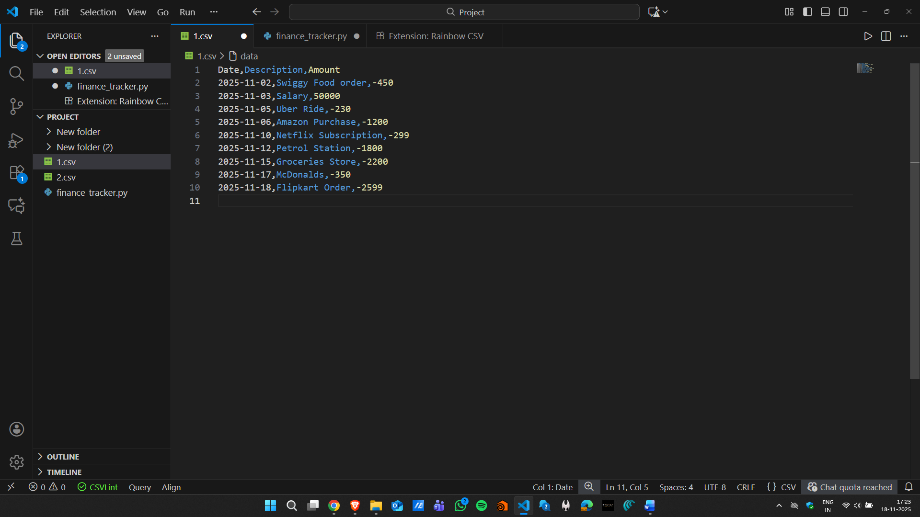
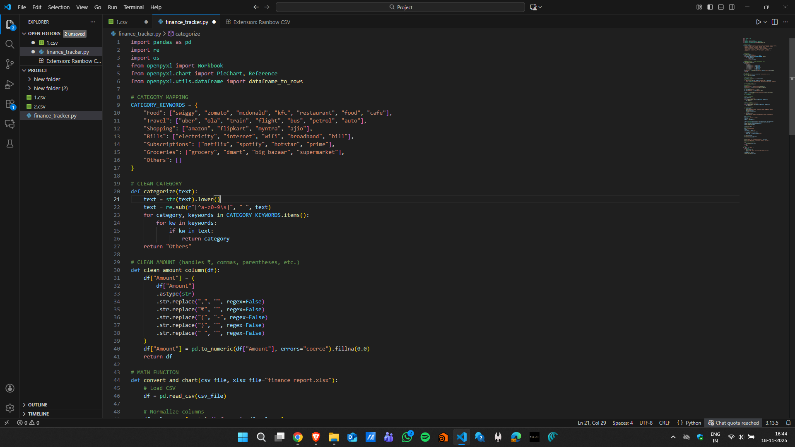
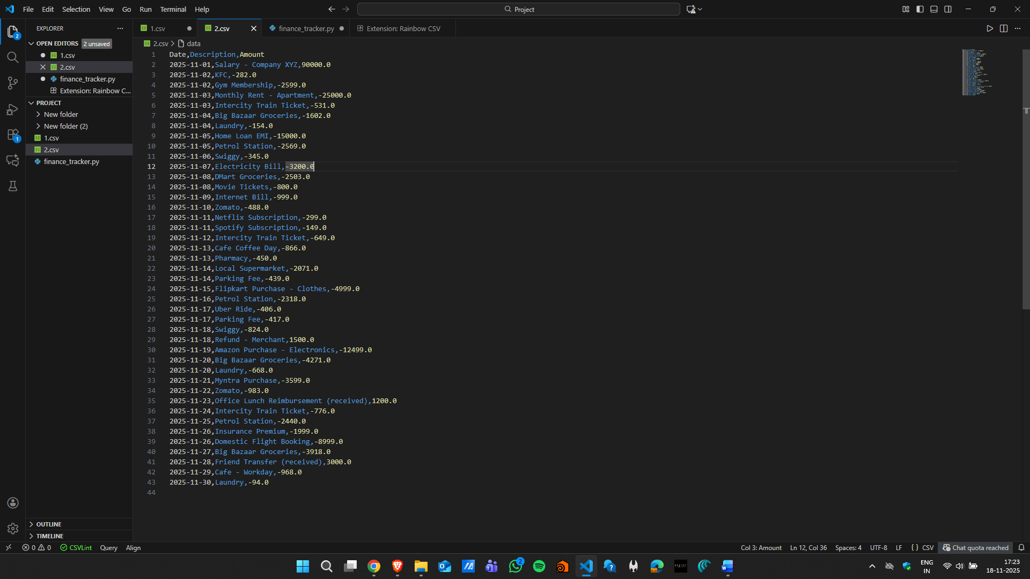
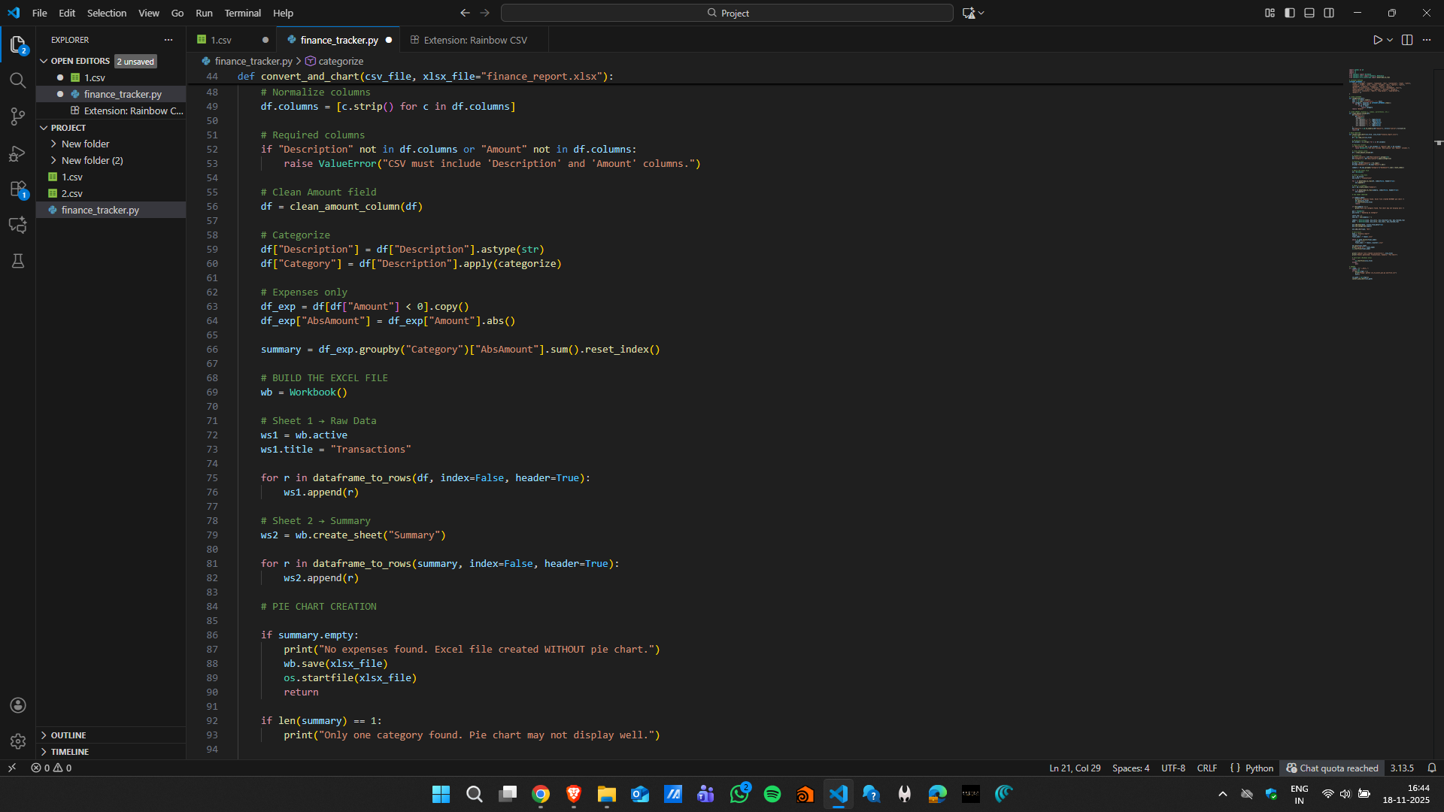

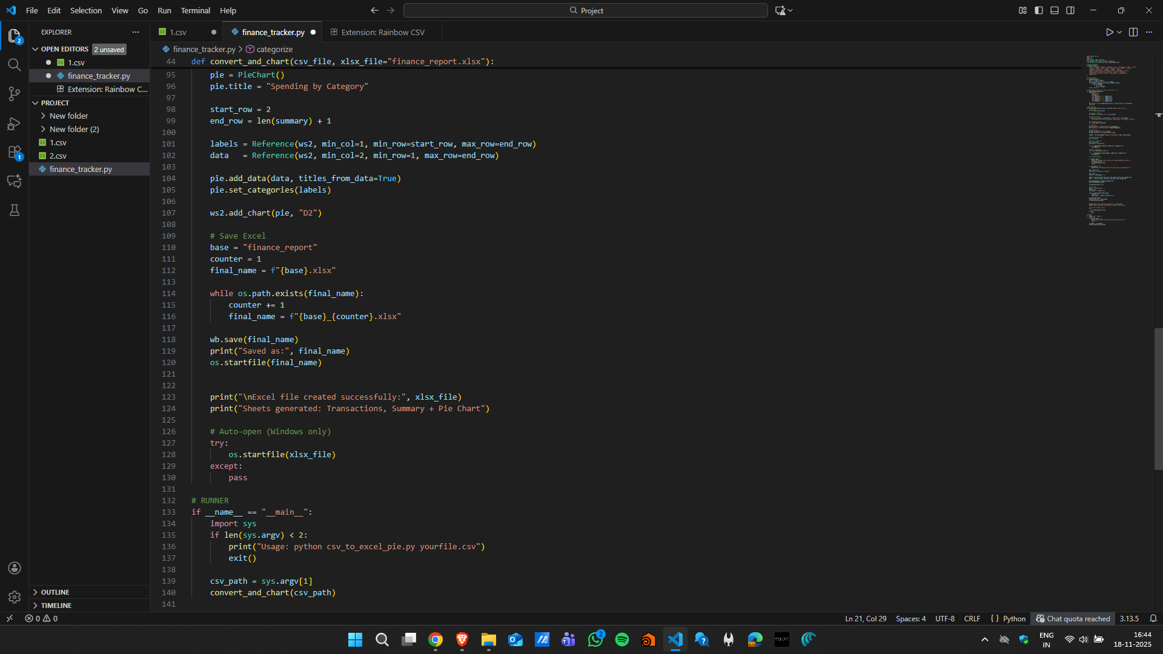

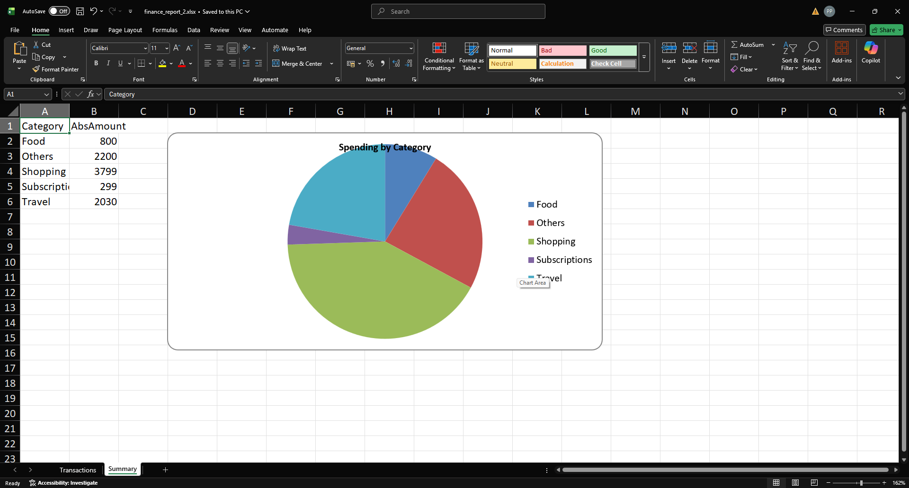
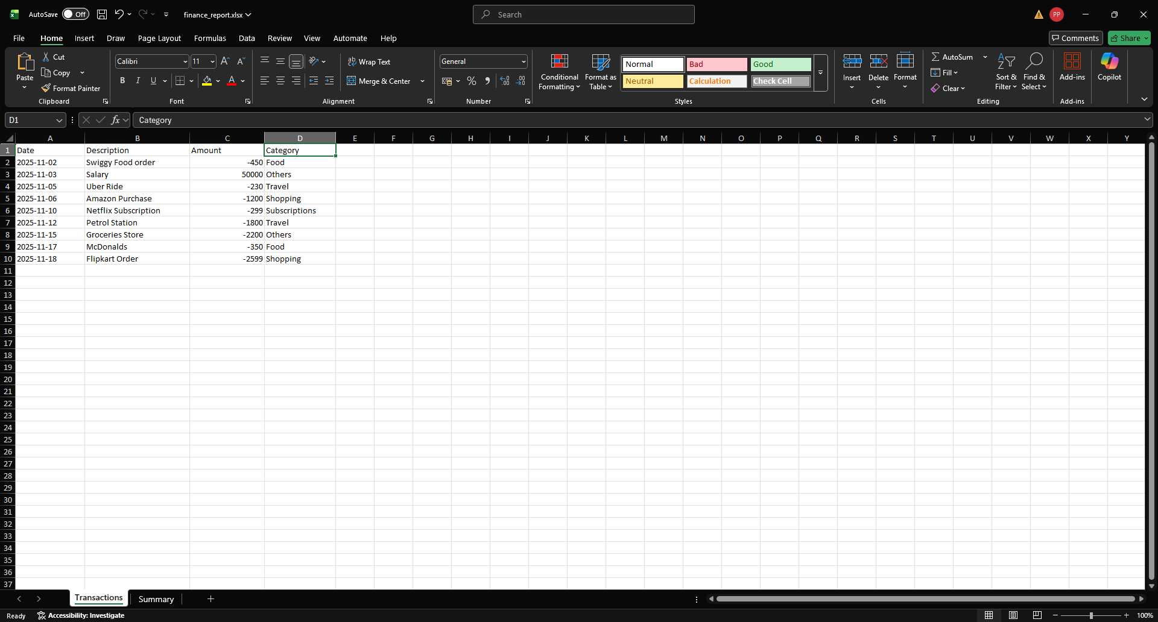

PBL 2:
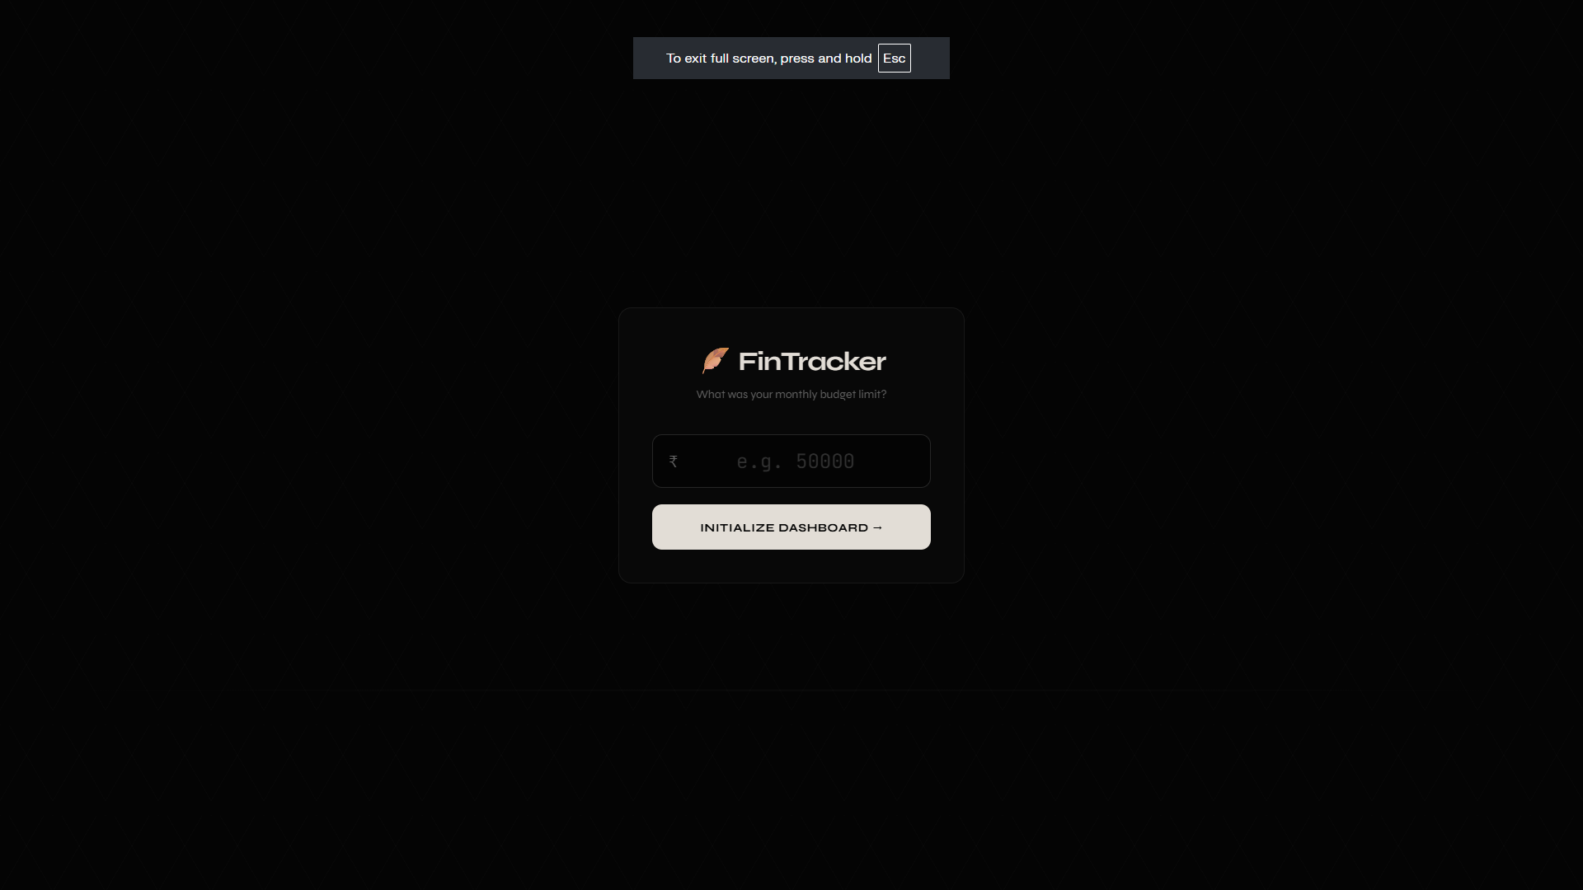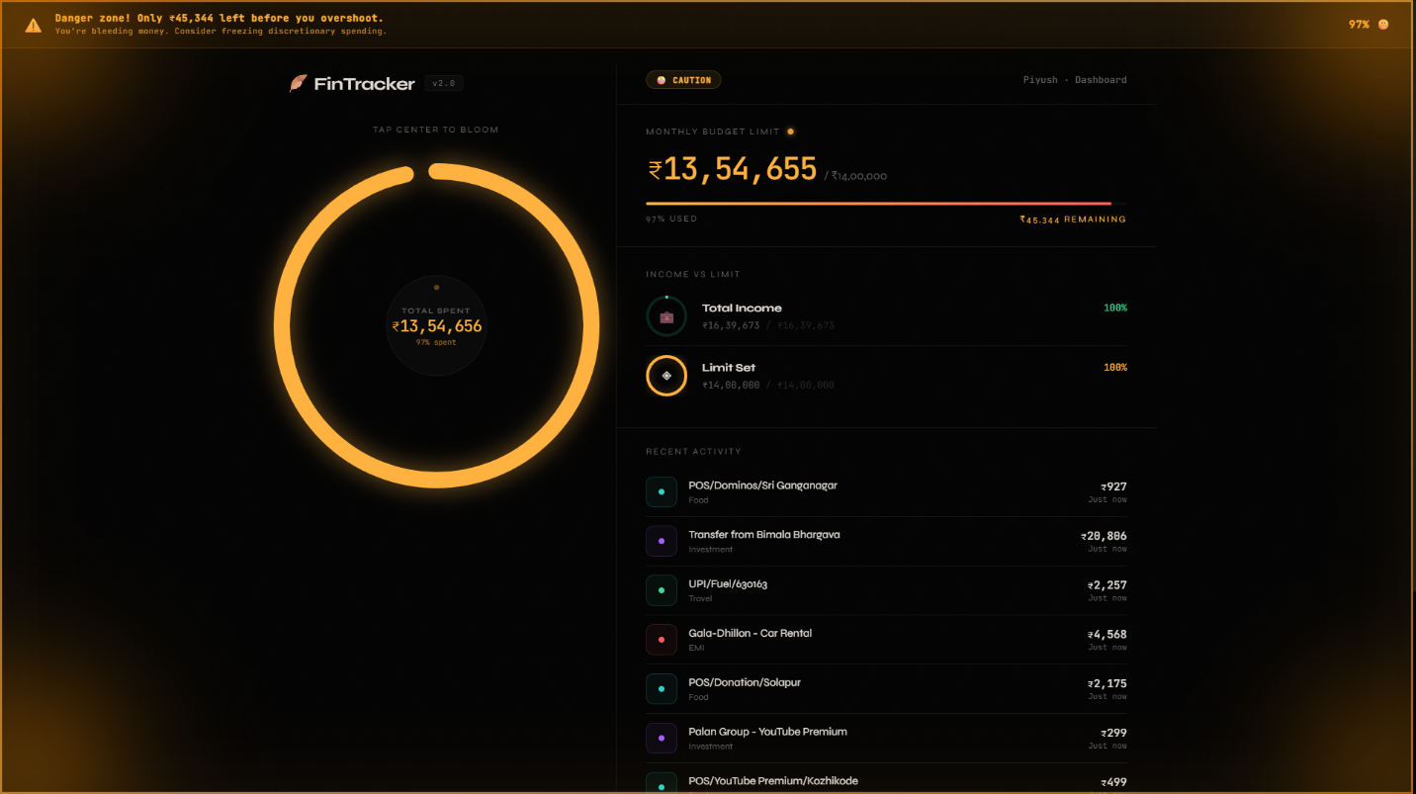
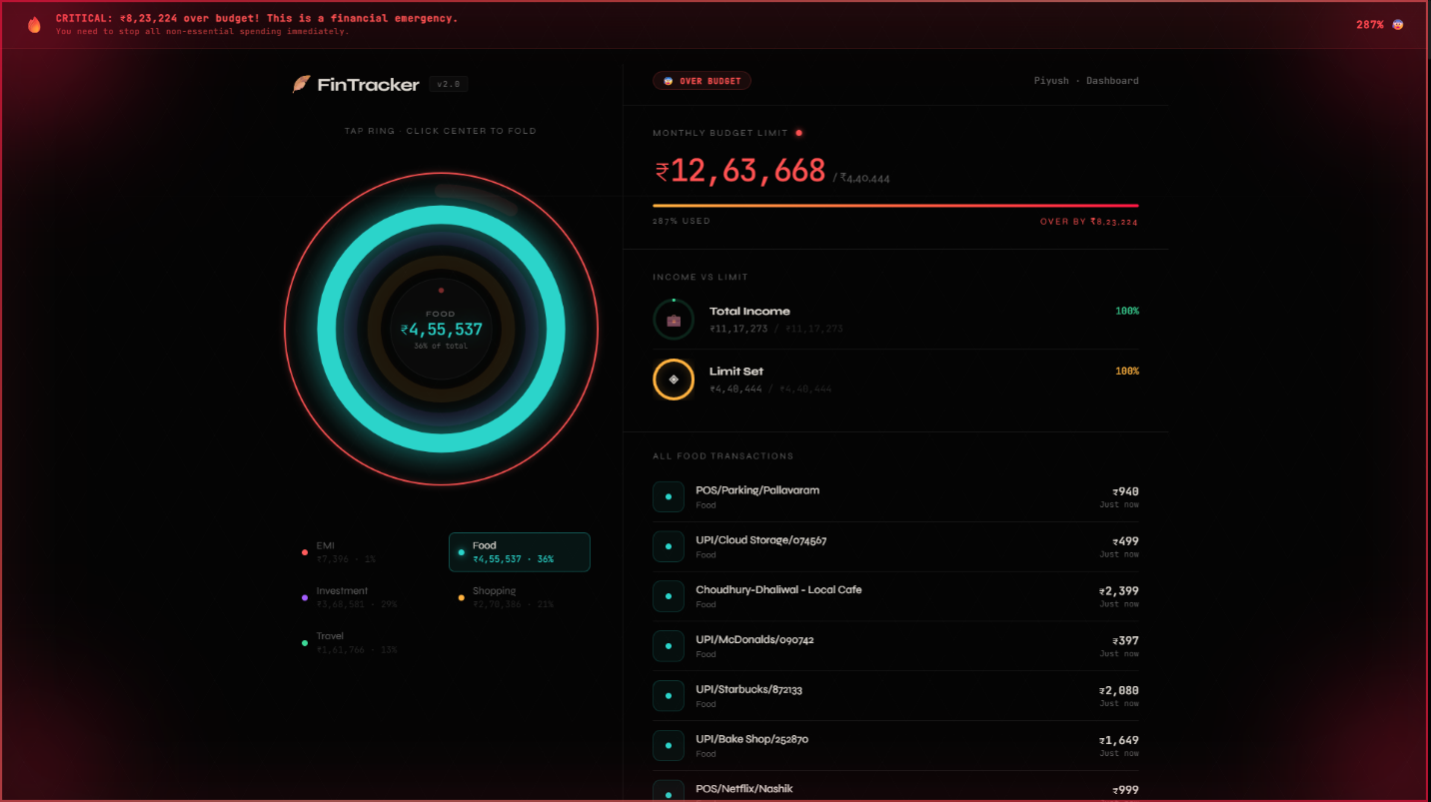

VIII. Bibliography
- Pandas Development Team. (2024). pandas: powerful Python data analysis toolkit. Available: https://pandas.pydata.org
- Gazoni, E. & Clark, C. (2024). openpyxl: A Python library to read/write Excel 2010 xlsx/xlsm files. Available: https://openpyxl.readthedocs.io
- Pedregosa, F. et al. (2011). Scikit-learn: Machine Learning in Python. Journal of Machine Learning Research, 12, 2825-2830.
- Plaid Inc. (2024). Plaid API Documentation. Available: https://plaid.com/docs/
- You Need A Budget (YNAB). (2024). The Four Rules of Budgeting. Available: https://www.ynab.com/the-four-rules

