//
1].create table S (`S#` char(5) not null,Sname char(20),Status SMALLINT,City char(15));
desc S;
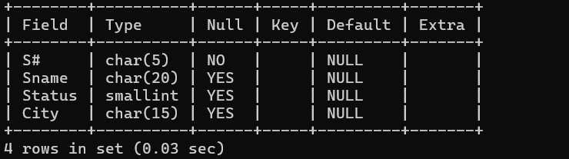
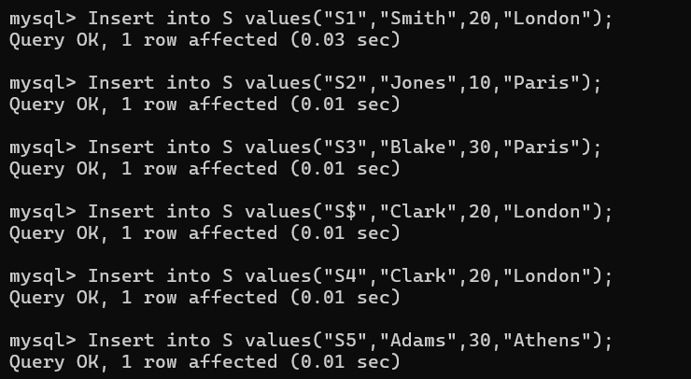
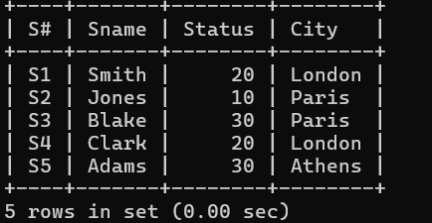

2.]
create table P (`P#` char(6) not null ,Pname char(20), Color char(6),Weight smallint,CITY char(15));
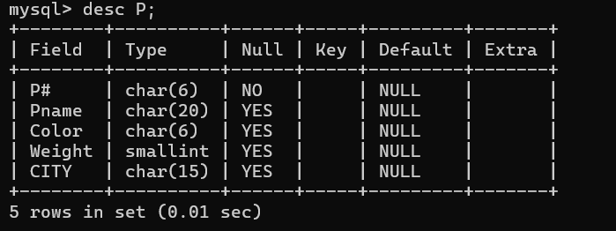
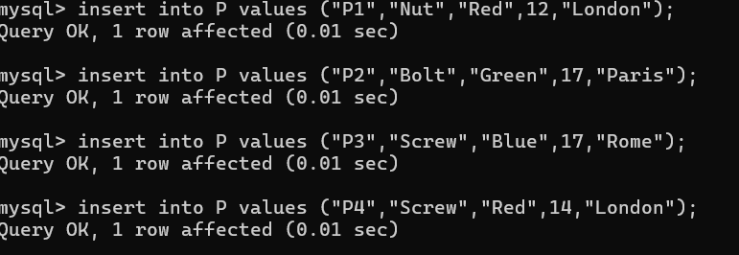
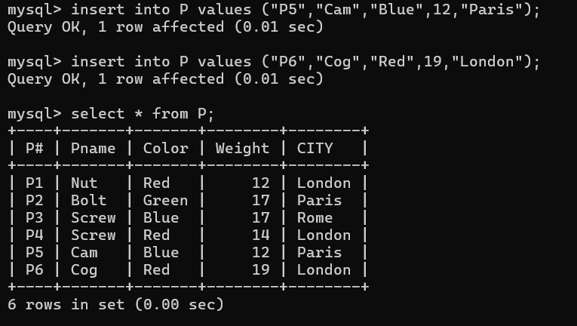
3.]
create table J (`J#` char(4) not null ,Jname char(10),CITY char(15));
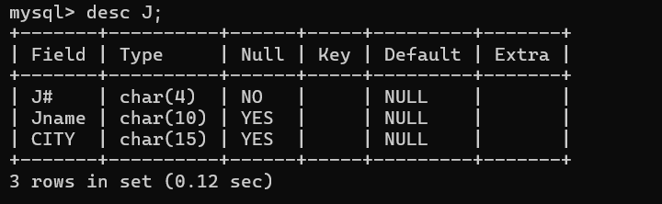
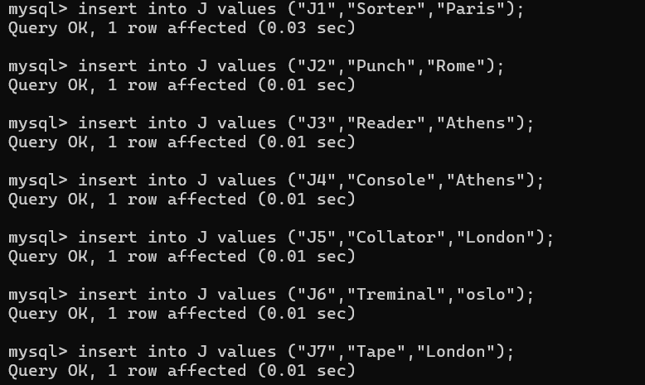
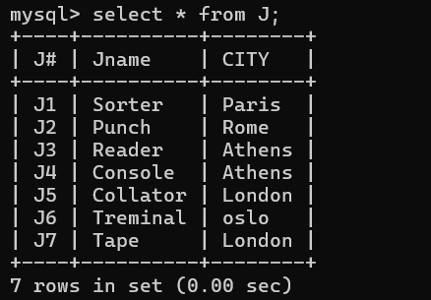
4.]create table sp (`S#` char(4) not null ,`P#` char(4) not null,`J#` char(4) not null,QTY int);