Department of Computer Engineering
Faculty of Technology
Dharmsinh Desai University, Nadiad
[ENTER DEGREE & SEMESTER]
Subject: [ENTER SUBJECT CODE & NAME]
Project Report
Project Title:
CollabSphere – Student Project Collaboration Platform
By:
[ENTER STUDENT NAME 1]
Roll No.: [ENTER ROLL NO 1]
Student ID: [ENTER STUDENT ID 1]
[ENTER STUDENT NAME 2]
Roll No.: [ENTER ROLL NO 2]
Student ID: [ENTER STUDENT ID 2]
Guided by:
[ENTER GUIDE NAME]

CERTIFICATE
Department of Computer Engineering
Faculty of Technology
Dharmsinh Desai University, Nadiad
This is to certify that the project report entitled “CollabSphere – Student Project Collaboration Platform” is a bonafide record of the work carried out by [ENTER STUDENT NAME 1] (Roll No.: [ENTER ROLL NO 1], Student ID: [ENTER STUDENT ID 1]) and [ENTER STUDENT NAME 2] (Roll No.: [ENTER ROLL NO 2], Student ID: [ENTER STUDENT ID 2]) in partial fulfilment of the requirements of the subject [ENTER SUBJECT CODE & NAME] of [ENTER DEGREE & SEMESTER], Department of Computer Engineering, Faculty of Technology, Dharmsinh Desai University, Nadiad.
The work was carried out under the guidance of [ENTER GUIDE NAME] during the academic term [ENTER ACADEMIC YEAR].
______________________
Guide
[ENTER GUIDE NAME]

TABLE OF CONTENTS
1. Abstract . . . . . . . . . . . . . . . . . . . . . . . . . . . . . . . 1
2. Introduction . . . . . . . . . . . . . . . . . . . . . . . . . . . . . 2
2.1 Project Overview . . . . . . . . . . . . . . . . . . . . . . . . . 2
2.2 Problem Statement . . . . . . . . . . . . . . . . . . . . . . . . 2
2.3 Objectives . . . . . . . . . . . . . . . . . . . . . . . . . . . . 2
2.4 Technology / Platform / Tools . . . . . . . . . . . . . . . . . . 3
3. Functional and Non-functional Requirements . . . . . . . . . . . . . . 4
3.1 Functional Requirements . . . . . . . . . . . . . . . . . . . . . 4
R.1: User Management . . . . . . . . . . . . . . . . . . . . . . . 4
R.2: Project Discovery and Management . . . . . . . . . . . . . . 5
R.3: Collaboration Requests and Team Membership . . . . . . . . . 6
R.4: Task Management . . . . . . . . . . . . . . . . . . . . . . . 7
R.5: Real-Time Messaging . . . . . . . . . . . . . . . . . . . . . 8
R.6: Showcase & Social Interactions . . . . . . . . . . . . . . . 8
R.7: Administration & Content Moderation . . . . . . . . . . . . . 9
3.2 Non-functional Requirements . . . . . . . . . . . . . . . . . . . 10
3.2.1 Security . . . . . . . . . . . . . . . . . . . . . . . . . 10
3.2.2 Performance . . . . . . . . . . . . . . . . . . . . . . . . 10
3.2.3 Usability . . . . . . . . . . . . . . . . . . . . . . . . . 11
3.2.4 Reliability . . . . . . . . . . . . . . . . . . . . . . . . 11
3.2.5 Maintainability . . . . . . . . . . . . . . . . . . . . . . 11
3.2.6 Scalability . . . . . . . . . . . . . . . . . . . . . . . . 12
4. UML Diagrams and Database Design . . . . . . . . . . . . . . . . . . . 13
4.1 Use Case Diagram . . . . . . . . . . . . . . . . . . . . . . . . 13
4.2 Class Diagram . . . . . . . . . . . . . . . . . . . . . . . . . . 14
4.3 Activity Diagram – Project Collaboration Workflow . . . . . . . . 17
4.4 Activity Diagram – Task Management & Showcase Workflow . . . . . 18
4.5 Sequence Diagram – Collaboration Request Workflow . . . . . . . . 19
4.6 Sequence Diagram – Real-Time Messaging Workflow . . . . . . . . . 20
4.7 Database Design . . . . . . . . . . . . . . . . . . . . . . . . . 21
5. Implementation Detail . . . . . . . . . . . . . . . . . . . . . . . . 25
5.1 Authentication and User Management . . . . . . . . . . . . . . . 25
5.2 Project Discovery and Management . . . . . . . . . . . . . . . . 25
5.3 Collaboration Requests and Team Workspace . . . . . . . . . . . . 26
5.4 Task Management . . . . . . . . . . . . . . . . . . . . . . . . . 26
5.5 Real-Time Messaging . . . . . . . . . . . . . . . . . . . . . . . 27
5.6 Showcase and Social Features . . . . . . . . . . . . . . . . . . 27
5.7 Administration and Content Moderation . . . . . . . . . . . . . . 28
5.8 Frontend Architecture . . . . . . . . . . . . . . . . . . . . . . 28
5.9 Backend Architecture . . . . . . . . . . . . . . . . . . . . . . 29
5.10 Backend Organisation . . . . . . . . . . . . . . . . . . . . . . 30
5.11 Database Implementation . . . . . . . . . . . . . . . . . . . . 31
5.12 Algorithms and Flowcharts . . . . . . . . . . . . . . . . . . . 31
A. Collaboration Request Processing . . . . . . . . . . . . . . . 31
B. Task Status Transition . . . . . . . . . . . . . . . . . . . . 32
C. Real-Time Message Processing . . . . . . . . . . . . . . . . . 33
D. Role-Based Access Control . . . . . . . . . . . . . . . . . . 34
6. Testing . . . . . . . . . . . . . . . . . . . . . . . . . . . . . . . 35
6.1 Testing Approach . . . . . . . . . . . . . . . . . . . . . . . . 35
6.2 Test Cases . . . . . . . . . . . . . . . . . . . . . . . . . . . 35
7. Screen-shots . . . . . . . . . . . . . . . . . . . . . . . . . . . . . 38
8. Conclusion . . . . . . . . . . . . . . . . . . . . . . . . . . . . . . 43
9. Limitation and Future Extension . . . . . . . . . . . . . . . . . . . 44
9.1 Current Limitations . . . . . . . . . . . . . . . . . . . . . . . 44
9.2 Future Extensions . . . . . . . . . . . . . . . . . . . . . . . . 44
10. Bibliography . . . . . . . . . . . . . . . . . . . . . . . . . . . . 45

1. Abstract
CollabSphere – Student Project Collaboration Platform is a full-stack web application engineered using the MERN stack (MongoDB, Express.js, React.js, and Node.js) to resolve the fragmentation and inefficiency surrounding student project recruitment, team workspace management, real-time messaging, completed-project showcases, and administrative moderation in academic environments. The platform bridges the gap between students seeking skilled collaborators and project owners searching for motivated team members by providing a centralized, secure web interface.
Registered students can construct comprehensive profiles detailing their technical skillsets and social portfolios, post new project ideas, and discover active projects using multi-attribute search filtering. A structured collaboration request lifecycle governs team formation: interested students submit requests that project owners can review and accept or reject. Upon acceptance, the system automatically synchronizes the student into the project's official member roster while strictly enforcing predefined team capacity constraints.
Inside the private team workspace, members manage project tasks through a controlled task state machine and communicate instantly via a Socket.IO real-time chat service integrated with persistent REST message history storage. Once a project reaches completion, project owners can publish a public Showcase featuring technology tags, live demo URLs, and screenshot galleries. The broader student community can engage with published showcases through idempotent liking and embedded comment threads.
System security and access control are maintained via JSON Web Token (JWT) authentication and role-based authorization for two distinct roles: Student and Administrator. Administrators monitor platform activity through a dedicated metrics dashboard, enforce content safety by reviewing user reports, moderate projects with ordered cascade deletion, and manage account statuses. The backend delivers a RESTful API compliant with a standard JSON response envelope, while the React frontend utilizes Vite and Tailwind CSS for optimal client-side performance.
Keywords: Student collaboration, MERN stack, real-time messaging, Socket.IO, role-based access control, REST API, project showcases.

2. Introduction
2.1 Project Overview
CollabSphere is a university collaboration platform built to streamline academic and independent student project workflows. The system accommodates two primary user roles: Student and Administrator. Students post project ideas, search for open projects by skill, send collaboration requests, manage project tasks, chat in real-time with team members, and publish showcase portfolios. Administrators oversee system integrity by reviewing statistics, managing user accounts, deleting inappropriate projects, and processing user reports.
The software architecture follows a decoupled client-server pattern. A modern React.js frontend built with Vite and styled with Tailwind CSS interacts with a Node.js and Express.js REST API server. Data persistence is managed by MongoDB using Mongoose object modeling, while real-time workspace chat relies on WebSocket connections managed by Socket.IO.
2.2 Problem Statement
In university environments, student collaboration often suffers from decentralized communication channels, informal team formation, and a lack of visibility for completed projects. Without a dedicated collaboration platform, several specific difficulties arise:
● Students face difficulty finding teammates with specific technical skills across different departments.
● Project owners lack a structured mechanism to review applicant profiles and manage team capacity.
● Team task tracking and workspace communication are fragmented across third-party social messaging apps.
● Completed student projects are rarely documented publicly, leading to duplicated efforts and lost portfolio opportunities.
● Platform administrators lack centralized oversight to moderate inappropriate content or resolve user misconduct.
2.3 Objectives
The main objectives of the CollabSphere platform are as follows:
● To provide a centralized discovery portal where students can search and filter open projects by skill, category, and difficulty.
● To establish a structured collaboration request workflow with automated team membership synchronization and capacity limits.
● To equip project teams with a private workspace containing task management boards and real-time Socket.IO chat.
● To enable students to publish completed projects as public Showcases with social interaction capabilities (likes and comments).
● To deliver an administrative control panel for reviewing platform statistics, managing user statuses, and moderating content.
● To enforce robust JWT authentication, bcrypt password hashing, and role-based authorization across all backend routes.
2.4 Technology / Platform / Tools
Table 2.1 lists the technology stack utilized in the implementation of CollabSphere.
Table 2.1: Technologies Used
Layer | Technology | Purpose
Frontend | React.js, Vite, Tailwind CSS | Component-based user interface, rapid bundling, and modern styling.
Backend | Node.js, Express.js | Server runtime and RESTful web API framework.
Database | MongoDB, Mongoose | NoSQL document store and object data modeling.
Real-Time Messaging | Socket.IO | WebSocket-based bidirectional real-time workspace communication.
Security & Auth | JWT, bcryptjs | Token-based stateless authentication and password hashing.

3. Functional and Non-functional Requirements
3.1 Functional Requirements
The functional requirements of CollabSphere are organized into seven core modules (R.1 to R.7). The application enforces role-based permissions for two primary user roles: Student and Administrator. Table 3.1 details the operations permitted for each role.
Table 3.1: Role-wise Permitted Operations
Operation | Student | Administrator
Public Registration & Login | Yes | Yes
Profile & Skill Management | Yes | Yes
Create & Edit Projects | Yes | No
Search & Filter Projects | Yes | Yes
Submit Collaboration Request | Yes | No
Accept/Reject Join Requests | Yes (Owner only) | No
Create & Manage Tasks | Yes (Team member) | No
Real-Time Workspace Chat | Yes (Team member) | No
Publish Project Showcase | Yes (Owner only) | No
Like & Comment on Showcases | Yes | Yes
File Content Report | Yes | Yes
Platform Statistics & Moderation | No | Yes
R.1: User Management
● R.1.1: Register User
Description: Allows new students to create an account by providing name, email, password, and optional profile details. Validates email format and unique constraints.
Input: Name, Email, Password
Output: JWT Token, Formatted User Object
● R.1.2: Login User
Description: Authenticates registered students and administrators using email and password. Generates a signed JWT upon successful validation.
Input: Email, Password
Output: JWT Token, Formatted User Object
● R.1.3: Manage User Profile
Description: Allows authenticated users to update profile details (name, bio, skills, portfolio links, avatar). Protects email, password, and role from unauthorized mutation.
Input: Allowlisted Profile Fields
Output: Updated Profile Data
● R.1.4: Role-Based Access Control
Description: Enforces endpoint authorization based on user role (student vs admin) and resource ownership.
Input: JWT Header, Target Resource
Output: Authorized Execution or 401/403 Error
R.2: Project Discovery and Management
● R.2.1: Create Project
Description: Enables students to post project proposals specifying title, description, category, required skills, team size, deadline, and difficulty.
Input: Project Attributes
Output: Created Project Document
● R.2.2: Search and Filter Projects
Description: Provides multi-attribute search across title and description, combined with category, difficulty, status, and skill filters.
Input: Search Keywords, Filter Parameters
Output: Paginated Project Results
● R.2.3: Project Lifecycle Management
Description: Enforces forward-only status transitions (OPEN -> IN_PROGRESS -> COMPLETED) restricted to the project owner.
Input: Target Status
Output: Updated Project Status
● R.2.4: Project Bookmarking
Description: Allows students to add or remove projects from their personal bookmarks list using idempotent operations.
Input: Project ID
Output: Updated Bookmark State
R.3: Collaboration Requests and Team Workspace
● R.3.1: Submit Collaboration Request
Description: Allows students to apply for open projects. Enforces rules: project must be OPEN, sender cannot be owner or member, no duplicate pending request.
Input: Project ID, Message Note
Output: Pending Request Document
● R.3.2: Review & Decide Requests
Description: Allows project owners to accept or reject pending requests. Accepting checks team capacity and syncs the sender into memberIds.
Input: Request ID, Decision (ACCEPTED/REJECTED)
Output: Updated Request & Team Roster
● R.3.3: View Team Roster
Description: Displays the complete team roster (owner and accepted members) formatted as public user profiles.
Input: Project ID
Output: List of Member Profiles
R.4: Task Management
● R.4.1: Task CRUD Operations
Description: Allows team members to create, view, update, and delete workspace tasks assigned to team members.
Input: Task Fields, Assignee ID
Output: Task Document
● R.4.2: Task Status Machine
Description: Enforces forward-only task transitions (TODO -> IN_PROGRESS -> COMPLETED) restricted to team members.
Input: Task ID, New Status
Output: Updated Task Status
R.5: Real-Time Messaging
● R.5.1: Send & Store Chat Message
Description: Persists workspace chat messages via REST API while validating team membership.
Input: Project ID, Message Text
Output: Saved Message Document
● R.5.2: Real-Time Socket Broadcast
Description: Broadcasts new messages via Socket.IO room (project:<id>) to connected team members.
Input: Socket Event, Room ID
Output: Real-Time UI Update
● R.5.3: Chat History Retrieval
Description: Fetches paginated chat history for a project workspace in newest-first order.
Input: Project ID, Page Parameters
Output: Paginated Message List
R.6: Showcase & Social Interactions
● R.6.1: Publish Showcase
Description: Allows project owners to publish completed projects as public showcases with tech tags and demo links.
Input: Showcase Payload
Output: Published Showcase Document
● R.6.2: Social Interactions (Likes & Comments)
Description: Supports idempotent likes and embedded comments on public showcases.
Input: Showcase ID, Like Toggle / Comment Text
Output: Updated Likes & Comments
R.7: Administration & Content Moderation
● R.7.1: View System Statistics
Description: Provides administrators with platform metrics (users by role/status, projects by status, showcases, reports).
Input: Admin JWT
Output: Platform Statistics Object
● R.7.2: Account Moderation
Description: Allows admins to suspend or reactivate user accounts. Rejects self-suspension attempts.
Input: User ID, Target Status
Output: Updated User Status
● R.7.3: Project Moderation & Cascade Delete
Description: Allows admins to delete inappropriate projects with application-level cascade across tasks, messages, requests, and showcases.
Input: Project ID
Output: Deletion Confirmation
● R.7.4: Content Report Management
Description: Allows admins to review user reports and update their status to RESOLVED or DISMISSED.
Input: Report ID, Target Status
Output: Updated Report Status
3.2 Non-functional Requirements
3.2.1 Security
• All protected backend API endpoints verify identity using JSON Web Tokens (JWT) passed in the Authorization header.
• User passwords are securely hashed before storage using bcryptjs with a cost factor of 10 salt rounds.
• Role-based access control (RBAC) middleware restricts administrative endpoints exclusively to admin accounts.
• Sensitive account attributes (password hashes, role escalation) are protected from user profile update payload injection.
• Suspended user accounts are immediately rejected at authentication and during active session checks.
3.2.2 Performance
• Database queries utilize compound indexing on high-frequency query targets ({projectId, createdAt} and {status, createdAt}).
• API endpoints utilize page-based pagination (?page=1&limit=10) to cap maximum data transfer payloads.
• Vite frontend bundling achieves production asset chunking under 500 kB for minimal initial loading latency.
• Socket.IO real-time event broadcasting operates with minimal latency without redundant database write overhead.
3.2.3 Usability
• The client application implements a clean, consistent design system based on predefined color tokens (#FAF8F5, #FF5A36).
• Role-specific navigation bars automatically adjust visible actions for Student and Administrator users.
• Clear visual badges indicate project lifecycle statuses (OPEN, IN_PROGRESS, COMPLETED) and request states.
• Responsive layout design ensures usability across desktop, tablet, and mobile viewport resolutions.
3.2.4 Reliability
• Inputs across all REST endpoints are validated against strict schema constraints before persistence.
• The backend implements a centralized error handler enforcing a uniform JSON error envelope ({success: false, message}).
• State machine transitions (projects, tasks, requests) follow strict forward-only rules to prevent invalid states.
• Database startup requires successful connection before accepting incoming web traffic.
3.2.5 Maintainability
• The backend follows a clean Model-View-Controller (MVC) architectural separation across models, controllers, and routes.
• Shared utility functions (user formatting, project formatting, pagination parsing) eliminate redundant code.
• The React frontend utilizes reusable UI components, custom hooks (useAuth, useSocket), and context providers.
• Comprehensive Jest unit and integration test suites cover critical business logic and authorization paths.
3.2.6 Scalability
• Decoupled REST API and Socket.IO real-time servers allow independent vertical and horizontal scaling.
• Mongoose schema design separates independent domain entities into collections linked by ObjectIds.
• Embedded subdocuments (Showcase comments) optimize single-document fetch performance for portfolio views.

4. UML Diagrams and Database Design
4.1 Use Case Diagram
The CollabSphere system defines two primary actors: Student User and Administrator. Table 4.1 lists the use cases associated with each actor.
Table 4.1: Actors and Use Cases
Actor | Use Cases
Student User | Register/Login, Manage Profile, Create/Edit Projects, Search & Filter Projects, Bookmark Projects, Submit Collaboration Request, Decide Requests (Owner), Manage Workspace Tasks, Real-Time Chat, Publish Showcase, Like & Comment on Showcases, File Reports.
Administrator | Login, View Platform Statistics, Manage User Statuses (Suspend/Reactivate), Moderate Projects (Cascade Delete), Review & Resolve Reports.
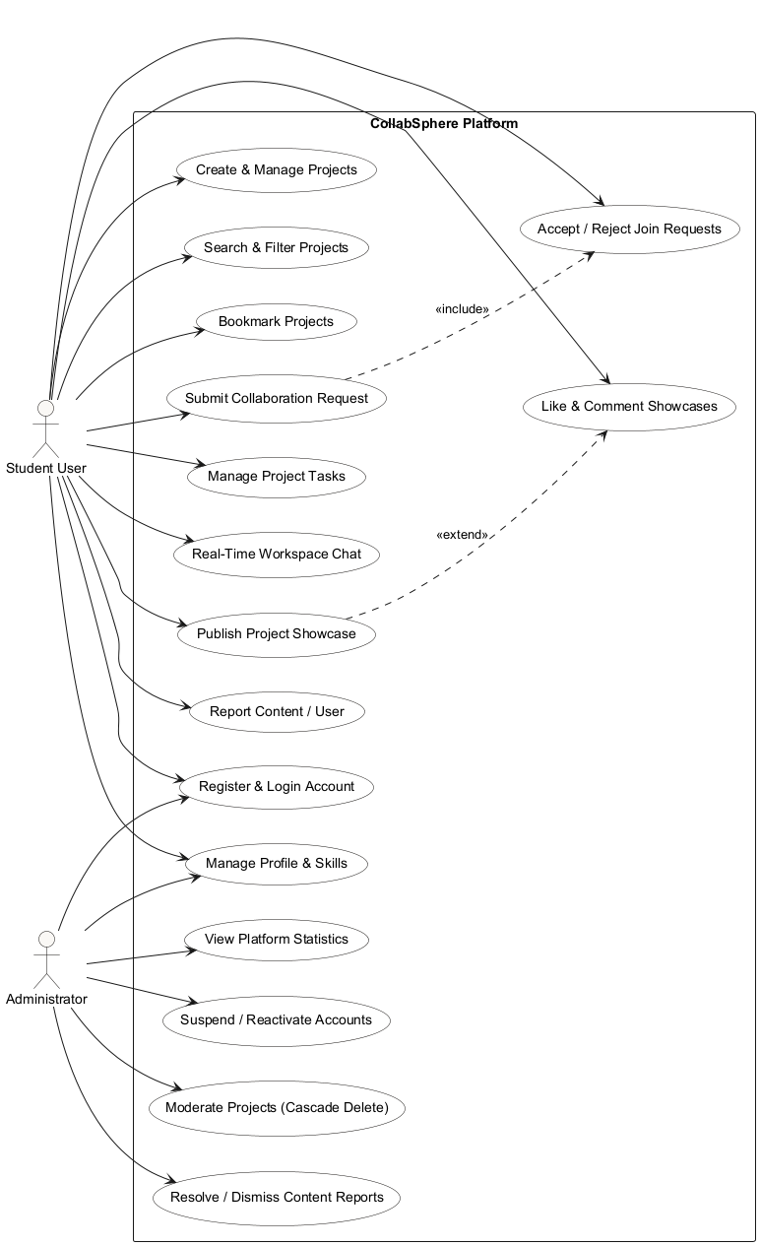
Figure 4.1: Use Case Diagram of CollabSphere
4.2 Class Diagram
The core domain classes of CollabSphere are User, Project, CollaborationRequest, Task, Message, Showcase, Comment, and Report. User roles (student and admin) are represented via the role attribute on the User class. Table 4.2 describes the main classes, and Table 4.3 details entity relationships.
Table 4.2: Main Classes
Class | Description
User | Represents registered user accounts, holding identity credentials, skill tags, profile bio, avatar, role, and account status.
Project | Represents student project proposals, maintaining owner reference, member list, required skills, status, and bookmarks.
CollaborationRequest | Represents join applications submitted by students to open projects, tracking status (PENDING/ACCEPTED/REJECTED).
Task | Represents project workspace tasks assigned to team members, managing status flow (TODO/IN_PROGRESS/COMPLETED).
Message | Stores persistent workspace chat history linked to a project and sender.
Showcase | Represents published portfolio showcases for completed projects, maintaining tech tags, likes count, and embedded comments.
Report | Represents content or misconduct flags submitted by users for administrative review.
Table 4.3: Relationships Between Classes
Class | Relationship | Target Class | Multiplicity
User | owns | Project | 1 to Many
User | memberOf | Project | Many to Many
Project | receives | CollaborationRequest | 1 to Many
Project | contains | Task | 1 to Many
Project | hasHistory | Message | 1 to Many
Project | publishedAs | Showcase | 1 to 1 (Unique)
Showcase | embeds | Comment | 1 to Many
User | files | Report | 1 to Many
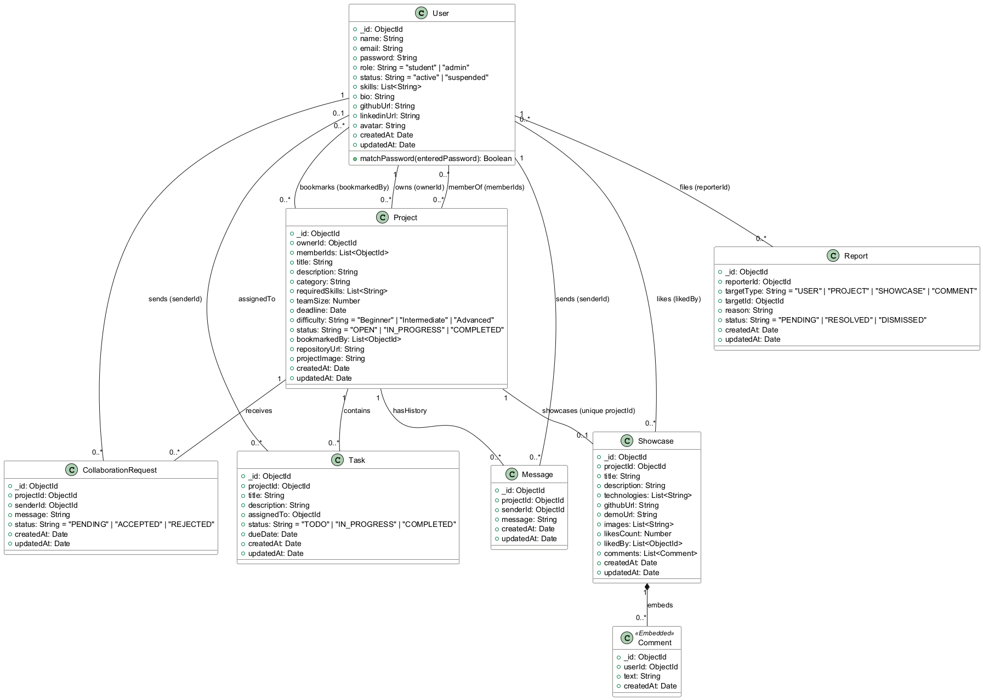
Figure 4.2: Class Diagram of CollabSphere
4.3 Activity Diagram – Project Collaboration Workflow
Figure 4.3 illustrates the end-to-end activity flow of project discovery, collaboration request submission, owner decision, team membership synchronization, and capacity validation.
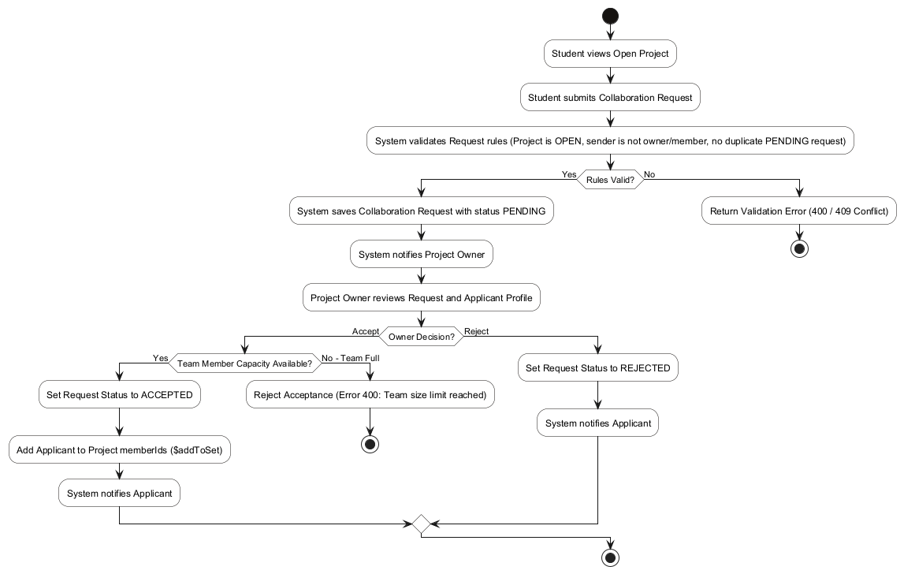
Figure 4.3: Activity Diagram – Project Collaboration Workflow
4.4 Activity Diagram – Task Management & Showcase Workflow
Figure 4.4 details the workspace task lifecycle and the subsequent showcase publication workflow executed when a project finishes.
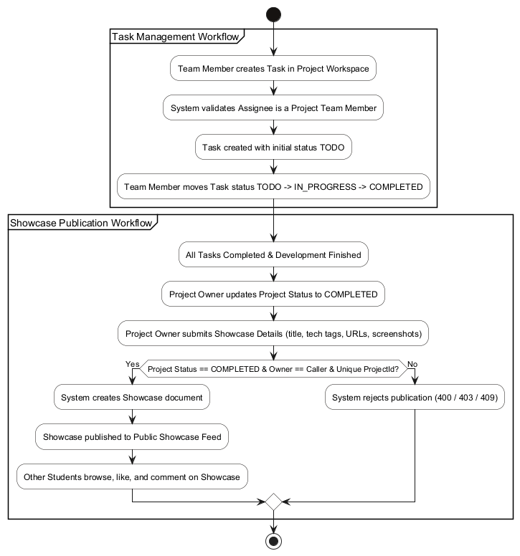
Figure 4.4: Activity Diagram – Task Management & Showcase Workflow
4.5 Sequence Diagram – Collaboration Request Workflow
Figure 4.5 maps the sequence of interactions between the Applicant Student, React Frontend, Express API Controller, MongoDB Database, and Project Owner during join request processing.
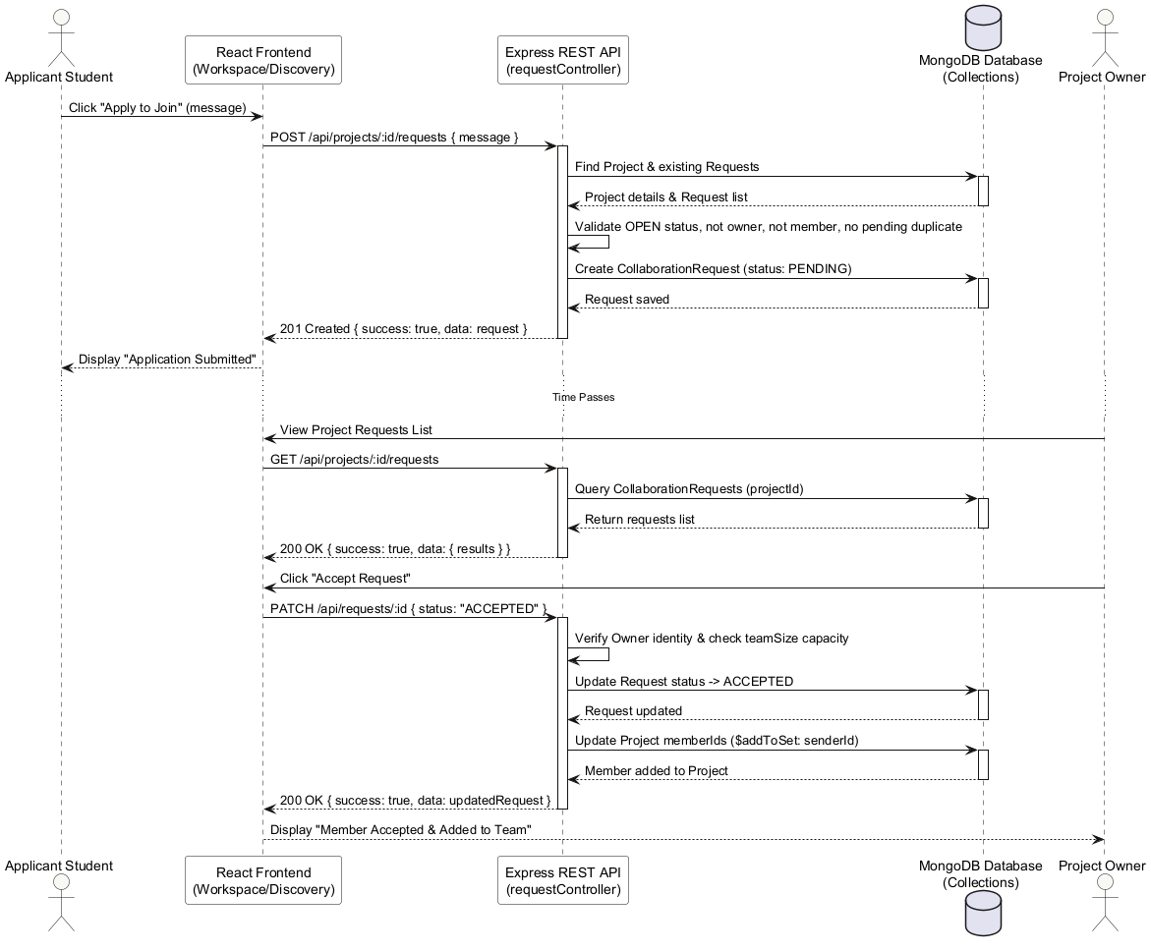
Figure 4.5: Sequence Diagram – Collaboration Request Workflow
4.6 Sequence Diagram – Real-Time Messaging Workflow
Figure 4.6 details the interaction sequence during REST message persistence and instant Socket.IO room event broadcasting to connected team members.
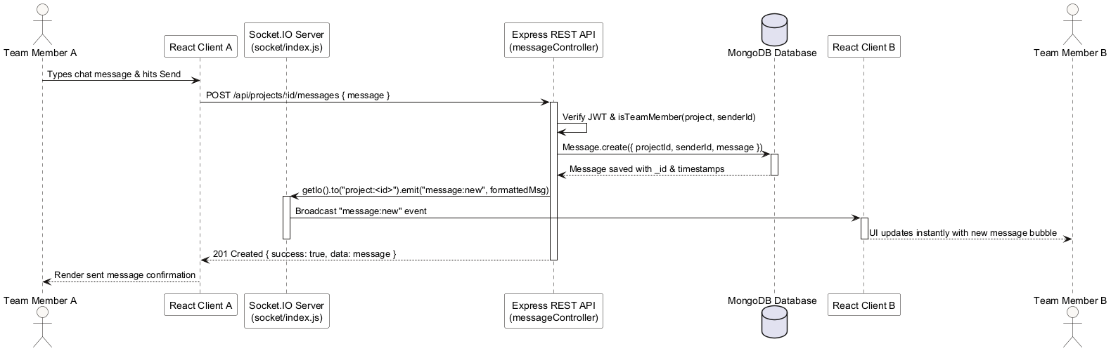
Figure 4.6: Sequence Diagram – Real-Time Messaging Workflow
4.7 Database Design
CollabSphere utilizes MongoDB for document storage. Table 4.4 outlines the seven database collections, while Table 4.5 specifies collection relationships.
Table 4.4: Main Collections
Collection | Purpose & Schema Highlights
Users | Stores student and admin user accounts, hashed passwords, profile skill arrays, role, and account status (active/suspended).
Projects | Stores project proposals, maintaining ownerId reference, memberIds array, status enum, team size limit, and bookmarkedBy array.
CollaborationRequests | Stores join applications linking projectId and senderId, tracking request status (PENDING/ACCEPTED/REJECTED).
Tasks | Stores project workspace tasks assigned to team members, enforcing forward status transitions.
Messages | Stores persistent chat messages linked to projectId and senderId, indexed on {projectId, createdAt}.
Showcases | Stores published project portfolios with tech tags, likes array, and embedded comment subdocuments.
Reports | Stores user-submitted flags targeting users, projects, showcases, or comments for administrative review.
Table 4.5: Database Relationships
Relationship | Description
Users -> Projects | One user owns multiple projects (ownerId); multiple users belong to a project (memberIds).
Projects -> CollaborationRequests | A project receives multiple collaboration requests from interested students.
Projects -> Tasks | A project workspace contains multiple tasks assigned to current team members.
Projects -> Messages | A project workspace stores multiple chat messages.
Projects -> Showcases | A completed project publishes exactly one showcase (1:1 relationship enforced via unique index).
Showcases -> Comments | Comments are stored as an embedded subdocument array inside the Showcase document.
Users -> Reports | A user can file multiple reports targeting platform content or misconduct.
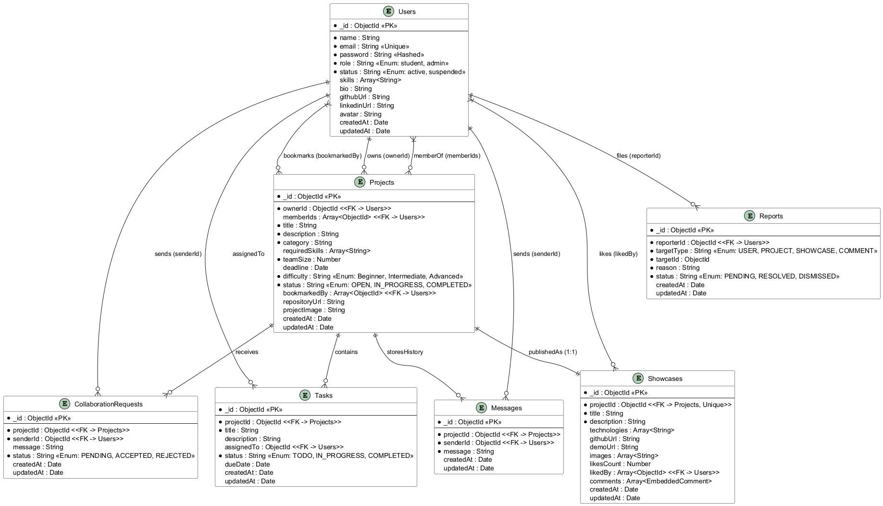
Figure 4.7: ER / Database Design Diagram of CollabSphere

5. Implementation Detail
5.1 Authentication and User Management
Authentication is implemented in authController.js and enforced via authMiddleware.js. User registration validates email format and checks for duplicates before hashing the password using bcryptjs at 10 salt rounds. Upon successful authentication, a signed JWT token containing the user's ID and role is returned. The middleware verifies this token on protected routes and verifies account status.
5.2 Project Discovery and Management
Project CRUD operations are implemented in projectController.js. The listProjects handler supports multi-attribute filtering by search keyword, category, difficulty, status, and required skills, delivering paginated results using parsePagination and buildPagination helpers.
5.3 Collaboration Requests and Team Workspace
Collaboration request logic resides in requestController.js. Submitting a request enforces validation rules: the target project must be OPEN, the sender cannot be the project owner or an existing member, and duplicate pending requests are rejected (Error 409). When an owner accepts a request, the system checks team size capacity before adding the applicant to memberIds via Mongoose $addToSet.
5.4 Task Management
Task management is handled by taskController.js. All task CRUD actions require project team membership verified by the shared isTeamMember helper. Tasks enforce forward-only status transitions (TODO -> IN_PROGRESS -> COMPLETED) and ensure task assignees belong to the project team.
5.5 Real-Time Messaging
Workspace chat is managed by messageController.js and socket/index.js. Messages sent via REST are persisted to MongoDB and immediately broadcast via Socket.IO to the room project:<id>. Socket connections authenticate via JWT handshake, and room joins re-verify team membership.
5.6 Showcase and Social Features
Showcase functionality is implemented in showcaseController.js. Publishing requires project ownership and COMPLETED status, enforced via a unique projectId index. Public showcase feeds support idempotent liking ($addToSet/$pull) and embedded comment creation.
5.7 Administration and Content Moderation
Administrative operations are located in adminController.js and protected by adminMiddleware.js. Admins can view platform statistics, suspend or reactivate user accounts, resolve/dismiss content reports, and delete projects using an ordered application-level cascade (Tasks -> Messages -> Requests -> Showcase -> Project).
5.8 Frontend Architecture
The frontend is built with React.js, Vite, and Tailwind CSS. Client routing is managed by React Router DOM with ProtectedRoute and AdminRoute guards. State management relies on AuthContext for authentication and SocketContext for WebSocket connectivity.
5.9 Backend Architecture
The backend follows a layered REST API architecture implemented with Node.js and Express.js. Data access is handled by Mongoose communicating with MongoDB. Figure 5.1 depicts the system layers.
[FIGURE 5.1: LAYERED ARCHITECTURE OF COLLABSPHERE PLACEHOLDER]
Layers: React Frontend -> REST API -> Express.js / Node.js -> Mongoose -> MongoDB
(Awaiting genuine screenshot / asset insertion)
Figure 5.1: Layered Architecture of CollabSphere
5.10 Backend Organisation
The backend source code follows an MVC organization, detailed in Table 5.1. Listing 5.1 presents the role authorization middleware implementation.
Table 5.1: Backend Organisation
Component | Responsibility & Module Paths
Models | Mongoose schemas defining domain data validation (User.js, Project.js, Task.js, Message.js, Showcase.js, Report.js, CollaborationRequest.js).
Controllers | Business logic handlers enforcing domain rules and status state machines (authController, projectController, taskController, etc.).
Routes | Express route definitions mapping API endpoints to controllers (authRoutes, projectRoutes, adminRoutes, etc.).
Middleware | JWT verification (authMiddleware), admin checking (adminMiddleware), and centralized error handling (errorHandler).
Socket Handlers | Socket.IO server initialization, JWT handshake auth, and room join management (socket/index.js).
// backend/middleware/authMiddleware.js
const adminMiddleware = (req, res, next) => {
if (!req.user || req.user.role !== 'admin') {
return res.status(403).json({
success: false,
message: 'Access denied — administrator privileges required'
});
}
next();
};
Listing 5.1: Simplified Role-based Authorization Middleware
5.11 Database Implementation
Database collections are implemented using Mongoose schemas with strict type validation, default values, and index definitions. Unique indexes are defined on Users.email and Showcases.projectId. Compound indexes accelerate paginated query paths.
5.12 Algorithms and Flowcharts
A. Collaboration Request Processing
Input: Request submission payload (projectId, message).
Process Steps:
1. 1. Retrieve target Project document from MongoDB database.
2. 2. Verify Project status is OPEN; otherwise return Error 400.
3. 3. Verify sender is neither project owner nor current member; otherwise return Error 400.
4. 4. Query existing CollaborationRequest documents for pending request; if found return Error 409.
5. 5. Create and save CollaborationRequest document with status PENDING.
6. 6. When owner decides ACCEPTED, verify teamSize capacity limit.
7. 7. Update request status to ACCEPTED and add sender to Project.memberIds via $addToSet.
8. 8. Return HTTP 200 OK with updated request data.
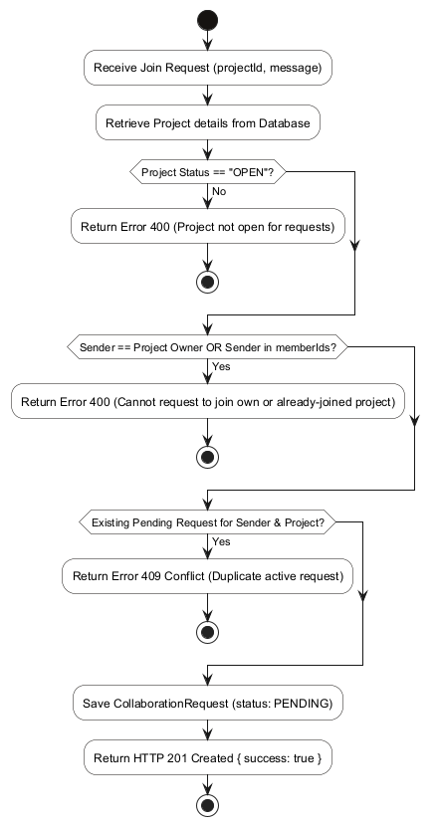
Figure 5.2: Flowchart – Collaboration Request Processing
B. Task Status Transition
Input: Task update request (taskId, newStatus).
Process Steps:
1. 1. Fetch Task document and parent Project document.
2. 2. Verify caller is project owner or member; otherwise return Error 403.
3. 3. Check requested status against forward-only state machine (TODO -> IN_PROGRESS -> COMPLETED).
4. 4. If transition is invalid (backward or skipped), return Error 400.
5. 5. Update Task status in database.
6. 6. Return HTTP 200 OK with updated task data.
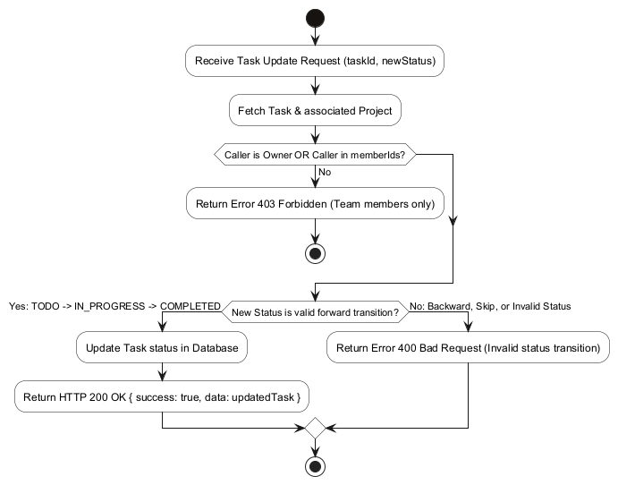
Figure 5.3: Flowchart – Task Status Transition
C. Real-Time Message Processing
Input: Incoming REST message payload (projectId, message text).
Process Steps:
1. 1. Verify caller JWT token and project team membership.
2. 2. Persist Message document to MongoDB Messages collection.
3. 3. Obtain active Socket.IO server instance via getIo().
4. 4. Emit message:new event to room project:<id>.
5. 5. Connected client sockets in room update chat UI immediately.
6. 6. Return HTTP 201 Created to REST caller.
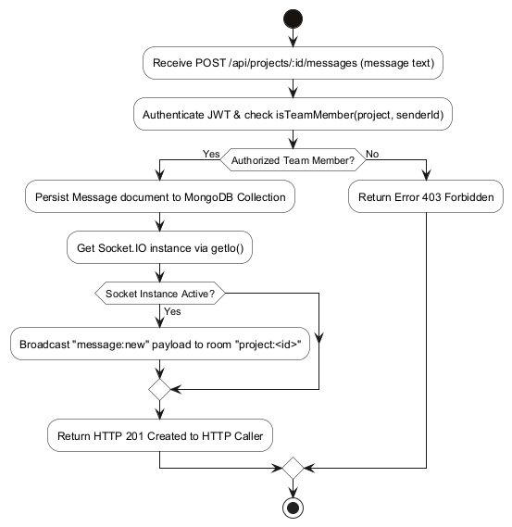
Figure 5.4: Flowchart – Real-Time Message Processing
D. Role-Based Access Control
Input: Incoming HTTP request to protected route.
Process Steps:
1. 1. Extract Bearer JWT token from Authorization header.
2. 2. Verify JWT signature; if invalid or expired return Error 401.
3. 3. Fetch user account status from database; if suspended return Error 401.
4. 4. Attach user payload {userId, role} to request object.
5. 5. If route requires admin role, verify req.user.role === 'admin'.
6. 6. If authorization fails, return Error 403 Forbidden.
7. 7. Proceed to target controller handler.
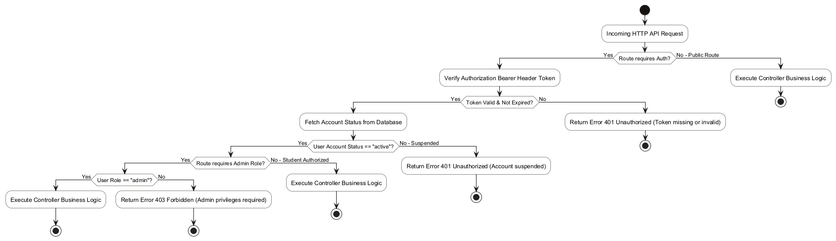
Figure 5.5: Flowchart – Role-Based Access Control

6. Testing
6.1 Testing Approach
Testing was conducted to verify backend API endpoint contracts, business logic constraints, authorization rules, and regression safety. Automated backend testing was executed using Jest and Supertest against an isolated MongoDB test database (collabsphere_test). The automated backend test suite comprises 176 passing tests across 12 test suites. Table 6.1 outlines the testing types.
Table 6.1: Types of Testing
Testing Type | Description & Coverage
Backend API Testing | Verification of REST endpoints using valid/invalid payloads and checking JSON response envelopes.
Authentication Testing | Verification of user registration, password hashing, login token generation, and invalid credential handling.
Authorization Testing | Verification of JWT header requirements and role-based access restrictions (student vs admin).
Workflow State Machine Testing | Verification of forward-only state transitions for projects, tasks, and collaboration requests.
Socket.IO Integration Testing | Verification of WebSocket handshake auth, room join authorization, and message broadcasting.
Regression Testing | Re-execution of all 176 Jest tests across 12 suites to confirm existing functionality remains green.
6.2 Test Cases
Table 6.2 presents representative test scenarios derived directly from the automated Jest test suite execution.
Table 6.2: Representative Test Cases
Test Case ID | Test Scenario | Actual Result | Status
AUTH-01 | Register student user with valid payload | User registered, HTTP 201, JWT & user returned | PASS
AUTH-02 | Register student user with duplicate email | HTTP 409 Conflict returned with error message | PASS
AUTH-03 | Login with valid email and password | HTTP 200 OK, JWT token & user returned | PASS
AUTH-04 | Access protected route without JWT token | HTTP 401 Unauthorized returned | PASS
PROJ-01 | Create project proposal as authenticated student | Project created, HTTP 201, status OPEN | PASS
PROJ-02 | Update project status OPEN -> IN_PROGRESS by owner | Status updated successfully, HTTP 200 OK | PASS
PROJ-03 | Non-owner attempts to update project status | HTTP 403 Forbidden returned | PASS
REQ-01 | Submit join request to OPEN project | CollaborationRequest created with status PENDING | PASS
REQ-02 | Submit join request to non-OPEN project | HTTP 400 Bad Request returned | PASS
REQ-03 | Owner accepts request when capacity available | Request status ACCEPTED, sender added to memberIds | PASS
TASK-01 | Team member creates task in project workspace | Task created with status TODO, HTTP 201 | PASS
MSG-01 | Team member sends chat message via REST API | Message saved to DB and broadcast to room | PASS
SHOW-01 | Publish showcase for COMPLETED project | Showcase document created and published | PASS
ADM-01 | Admin fetches platform statistics | HTTP 200 OK, statistics metrics returned | PASS
ADM-02 | Admin deletes project with cascade | Project, tasks, messages, requests & showcase deleted | PASS

7. Screen-shots
This section presents figure placeholders for the principal user interface screens of CollabSphere. Each placeholder box below corresponds to an actual application view and is accompanied by screenshot capture instructions provided in docs/project-report/SCREENSHOT_GUIDE.md.
[FIGURE 7.1: LANDING PAGE PLACEHOLDER]
Public landing page displaying hero section, core platform features, and navigation controls.
(Awaiting genuine screenshot / asset insertion)
Figure 7.1: Landing Page
[FIGURE 7.2: LOGIN PAGE PLACEHOLDER]
Authentication login page with email/password input fields and error handling feedback.
(Awaiting genuine screenshot / asset insertion)
Figure 7.2: Login Page
[FIGURE 7.3: STUDENT REGISTRATION PAGE PLACEHOLDER]
User registration page collecting full name, email, password, skills, and portfolio links.
(Awaiting genuine screenshot / asset insertion)
Figure 7.3: Student Registration Page
[FIGURE 7.4: STUDENT DASHBOARD PLACEHOLDER]
Authenticated student dashboard displaying active projects overview, team requests, and quick actions.
(Awaiting genuine screenshot / asset insertion)
Figure 7.4: Student Dashboard
[FIGURE 7.5: PROJECT DISCOVERY & SEARCH PAGE PLACEHOLDER]
Project search portal featuring multi-attribute filtering by category, difficulty, status, and required skills.
(Awaiting genuine screenshot / asset insertion)
Figure 7.5: Project Discovery & Search Page
[FIGURE 7.6: PROJECT DETAILS VIEW PLACEHOLDER]
Detailed project view illustrating project description, owner profile, required skills, team capacity, and join action.
(Awaiting genuine screenshot / asset insertion)
Figure 7.6: Project Details View
[FIGURE 7.7: CREATE PROJECT FORM PLACEHOLDER]
Form interface for proposing new projects with required skill selection and team size configuration.
(Awaiting genuine screenshot / asset insertion)
Figure 7.7: Create Project Form
[FIGURE 7.8: COLLABORATION REQUESTS MANAGEMENT PLACEHOLDER]
Project owner interface for reviewing applicant profiles and accepting or rejecting join applications.
(Awaiting genuine screenshot / asset insertion)
Figure 7.8: Collaboration Requests Management
[FIGURE 7.9: TEAM WORKSPACE & ROSTER VIEW PLACEHOLDER]
Private team workspace displaying team member profiles and project status indicators.
(Awaiting genuine screenshot / asset insertion)
Figure 7.9: Team Workspace & Roster View
[FIGURE 7.10: TASK MANAGEMENT BOARD PLACEHOLDER]
Workspace task board displaying task creation modal, assignee selectors, and status update controls.
(Awaiting genuine screenshot / asset insertion)
Figure 7.10: Task Management Board
[FIGURE 7.11: REAL-TIME PROJECT WORKSPACE CHAT PLACEHOLDER]
Workspace chat window demonstrating persistent chat history and real-time Socket.IO message bubbles.
(Awaiting genuine screenshot / asset insertion)
Figure 7.11: Real-Time Project Workspace Chat
[FIGURE 7.12: SHOWCASE GALLERY & SOCIAL FEED PLACEHOLDER]
Public showcase gallery displaying completed projects, technology tags, and screenshot thumbnails.
(Awaiting genuine screenshot / asset insertion)
Figure 7.12: Showcase Gallery & Social Feed
[FIGURE 7.13: SHOWCASE DETAIL, LIKES & EMBEDDED COMMENTS PLACEHOLDER]
Detailed showcase view demonstrating technology breakdown, live links, like counter toggle, and comment thread.
(Awaiting genuine screenshot / asset insertion)
Figure 7.13: Showcase Detail, Likes & Embedded Comments
[FIGURE 7.14: ADMIN DASHBOARD & PLATFORM OVERVIEW PLACEHOLDER]
Administrative control panel presenting platform metrics for users, projects, showcases, and reports.
(Awaiting genuine screenshot / asset insertion)
Figure 7.14: Admin Dashboard & Platform Overview
[FIGURE 7.15: USER MANAGEMENT & SUSPENSION MODAL PLACEHOLDER]
Admin user management interface for filtering accounts and toggling active/suspended statuses.
(Awaiting genuine screenshot / asset insertion)
Figure 7.15: User Management & Suspension Modal
[FIGURE 7.16: PROJECT MODERATION & CONTENT REPORTS MANAGEMENT PLACEHOLDER]
Admin moderation view displaying user content reports and project deletion cascade confirmation.
(Awaiting genuine screenshot / asset insertion)
Figure 7.16: Project Moderation & Content Reports Management

8. Conclusion
The project CollabSphere – Student Project Collaboration Platform was successfully engineered and implemented as a full-stack web application using the MERN stack (MongoDB, Express.js, React.js, Node.js) and Socket.IO. The platform successfully addresses the challenges of student project recruitment, workspace task coordination, real-time communication, completed project showcase publication, and administrative content moderation.
The following key functionalities were fully implemented and empirically verified:
● Stateless authentication and role-based access control (RBAC) using JWT tokens and bcryptjs password hashing.
● Project creation, multi-attribute search filtering, bookmarking, and owner-gated forward status transitions.
● Structured collaboration request workflow with automated team membership synchronization and team size enforcement.
● Private team workspace task management enforcing a forward-only task state machine.
● Real-time workspace chat using Socket.IO project rooms integrated with REST message history storage.
● Public Showcase feed for completed projects featuring technology tags, idempotent likes, and embedded comments.
● Administrative moderation dashboard providing platform statistics, user status management, content report resolution, and project cascade deletion.
● An automated backend test suite comprising 176 passing tests across 12 test suites, ensuring robust application reliability.

9. Limitation and Future Extension
9.1 Current Limitations
The following verified scope boundaries and architectural limitations apply to the current implementation of CollabSphere:
● Native Cloudinary SDK file uploads are deferred; image attributes currently store validated image URL strings.
● Immediate forced termination of active Socket.IO connections upon administrative user suspension is deferred; suspended users are blocked upon room join attempts.
● There is no dedicated native mobile application (iOS/Android); access is provided through the responsive React web client.
● External email and SMS notification gateways are not integrated; notifications are delivered within the web application.
● Automated AI-assisted skill matching and project recommendation engines are not included in the current build.
9.2 Future Extensions
The following features represent planned future enhancements for subsequent platform iterations:
● Development of a cross-platform mobile application using React Native.
● Integration of Cloudinary SDK for direct drag-and-drop client image uploads.
● Implementation of active Socket.IO session revocation upon user status changes.
● Integration of Nodemailer / SendGrid for automated email notifications.
● Addition of AI-powered student skill recommendation algorithms for project owners.

10. Bibliography
The following official technical documentation, specifications, and standards were referenced during the development of CollabSphere:
[1] React Community, “React Documentation,” 2024. [Online]. Available: https://react.dev/
[2] Vite Core Team, “Vite Frontend Tooling Guide,” 2024. [Online]. Available: https://vite.dev/guide/
[3] Node.js Foundation, “Node.js v20.x API Documentation,” 2024. [Online]. Available: https://nodejs.org/en/docs/
[4] Express.js Authors, “Express.js Web Framework Guide,” 2024. [Online]. Available: https://expressjs.com/
[5] MongoDB Inc., “MongoDB Documentation,” 2024. [Online]. Available: https://www.mongodb.com/docs/
[6] Mongoose Team, “Mongoose v8.x Document ODM Reference,” 2024. [Online]. Available: https://mongoosejs.com/docs/
[7] Socket.IO Authors, “Socket.IO Real-Time Engine Documentation,” 2024. [Online]. Available: https://socket.io/docs/v4/
[8] M. Jones, J. Bradley, and N. Sakimura, “JSON Web Token (JWT),” RFC 7519, Internet Engineering Task Force, May 2015.
[9] Tailwind Labs, “Tailwind CSS Utility-First Framework,” 2024. [Online]. Available: https://tailwindcss.com/docs
[10] Jest Framework Authors, “Jest Testing Framework Guide,” 2024. [Online]. Available: https://jestjs.io/docs/getting-started
[11] npm Package Registry, “bcryptjs - Optimized bcrypt in JavaScript,” 2024. [Online]. Available: https://www.npmjs.com/package/bcryptjs

