Table of Contents

Document Version 2

1. Purpose 3

1.1. Intended Audience 3

1.2. Intended Use 3

1.3. Scope 3

1.4. Definitions and Acronyms 3

2. Overall System Description 4

2.1. Use Case Diagrams 4

2.2. System Architecture 5

2.3. Functional Requirements 6

2.3.1. Function xxxx 6

2.3.2. Function yyyy 7

2.3.3. Function zzzz 7

3.1. Non-Functional Requirements 8

3.1.1. Non-Functional Requirement xxxx 8

4. Software Architecture 9

4.1. Static Software Architecture 9

# Document Version

|  |  |  |  |  |
| --- | --- | --- | --- | --- |
| No | Update | Name | Date | Version |
| 1. | Initial version | SRS_project_SmartFireAlertSystem | 5/6/2025 | 1.0 |

# Purpose

## Intended Audience

This SRS document describes the System Requirements and Software Design for a smart fire alert system and the target audience are the SDCF working on the development of an IoT driven system which continuously monitors the homes of elderly residents for early signs of fire.

## Intended Use

The SRS defines the overall System Architecture and Requirements as well as the Software Architecture and Design. This document is also contains the definition of the System Requirements which shall be used as the input for System Test cases and Software Unit Test cases.

## Scope

## Definitions and Acronyms

|  |  |
| --- | --- |
| **Acronym** | **Description** |
| LED | Light Emitting Diode |
| BUZZ | Buzzer |
| SW | Software |
| HW | Hardware |
| THS | Temperature and Humidity Sensor |
| VS | Visual Sensor |
| LS | Light Sensor |
| LCD |  |

# Overall System Description

## Use Case Diagrams

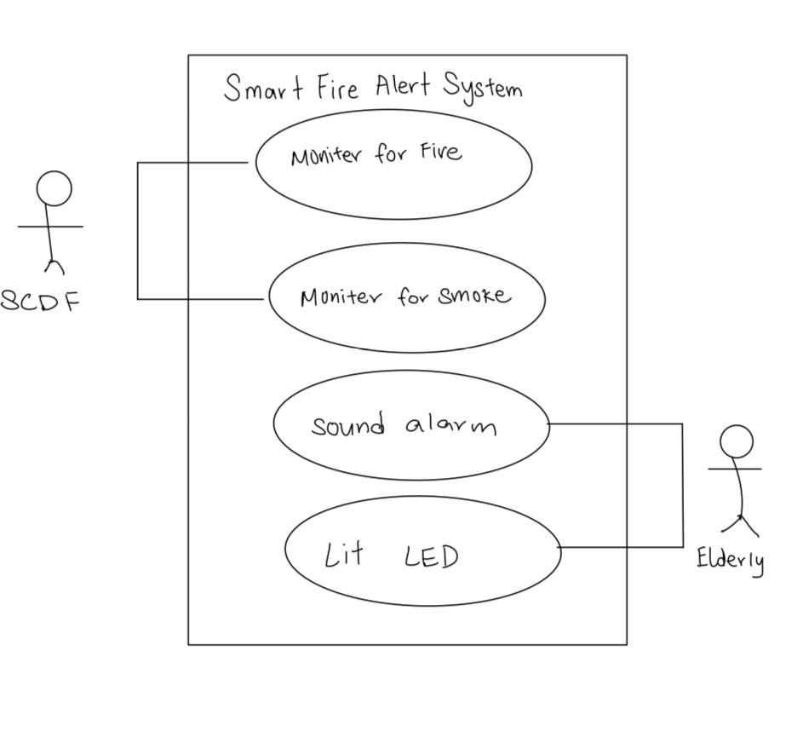

## System Architecture



LCD

Buzzer

Temperature Sensor

SPI_ADC_CH01

LED

I2C

**Raspberry Pi Development Board**

Visual Sensor

Light Sensor

## Functional Requirements

### Status Report

Allows both SCDF and elderly to see instructions on LCD

|  |  |
| --- | --- |
| **REQ_ID** | **Requirement** |
| REQ-01 | When the Smart Fire Alert System is first powered ON, the text below shall be displayed on the LCD screen  print (“System Activated”) |
| REQ-02 | If temperature > 57, the text below shall be displayed on the LCD screen  print (“There is fire, run”) |
| REQ-03 | If temperature <57, the text below shall be displayed on the LCD screen  print (“Have a Nice Day”) |

### Function yyyy

Add short description here …

|  |  |
| --- | --- |
| **REQ_ID** | **Requirement** |
| REQ-xx |  |

### Function zzzz

1. Add short description here …

|  |  |
| --- | --- |
| **REQ_ID** | **Requirement** |
| REQ-xx |  |

## Non-Functional Requirements

### Non-Functional Requirement xxxx

Add short description here …

|  |  |
| --- | --- |
| **REQ_ID** | **Requirement** |
| REQ-xx |  |
| REQ-xx |  |

# Software Architecture

## Static Software Architecture

The Software Architecture defines the various Software Components that are developed to realize the implementation of the system requirements.

**PowerMgt**

**HMI**

**Application Layer**

**Hardware Abstraction Layer (HAL)**

**ADC**

**USonic**

**NFC**

**Servo**

**RainSens**

**BlackCoffee**

**HotWater**