

# Practical-1

**Aim:** Perform Exploratory Data Analysis on the given dataset using Python. Procedure:

1. Import the dataset
2. View the head of the data
3. View the basic information of data and description of data
4. Find the unique value of data and verify the duplication of data
5. Plot a graph for unique value of dataset
6. Verify the presence of null value and replace the null value
7. Visualize the needed data

# Program:

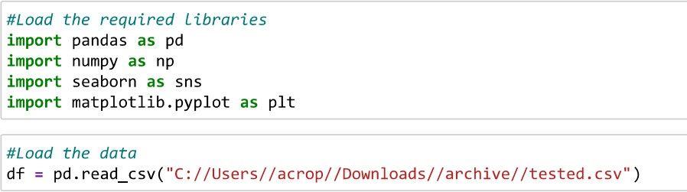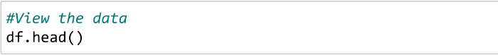

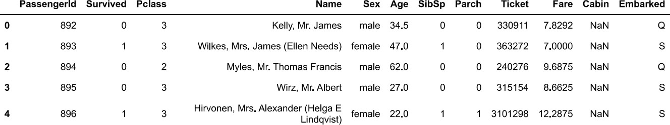



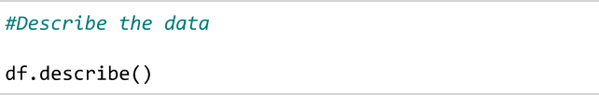

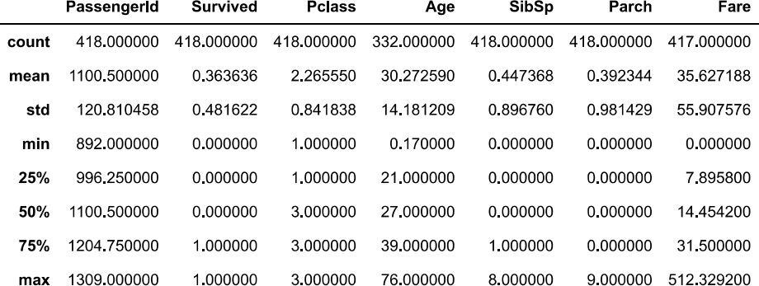

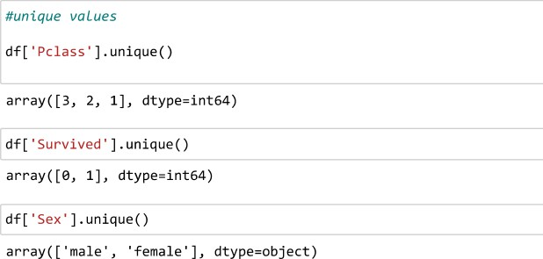



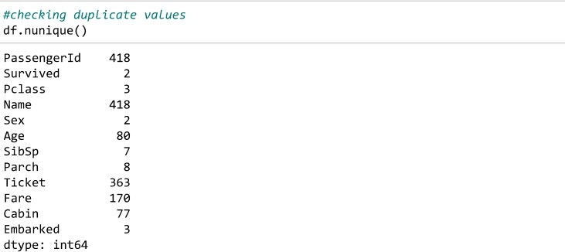

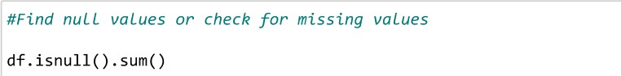

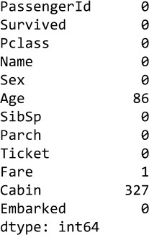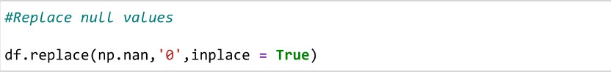

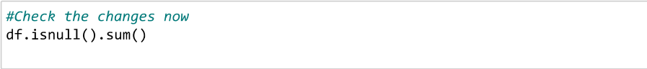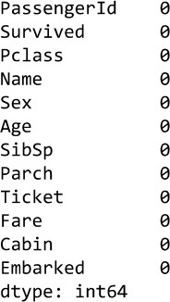



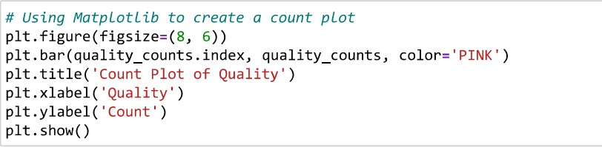

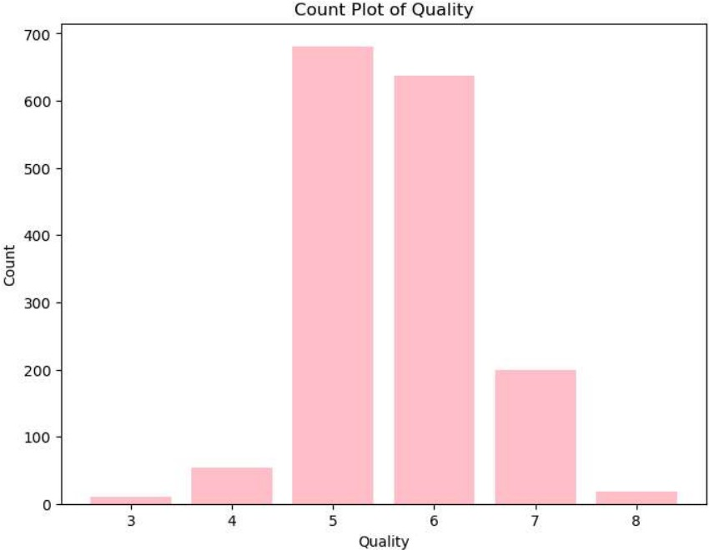

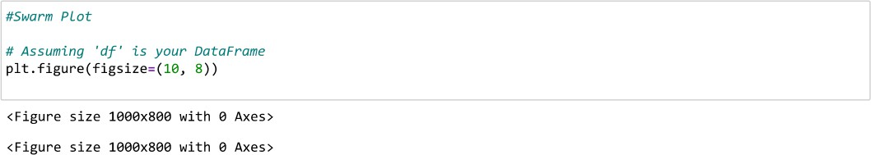



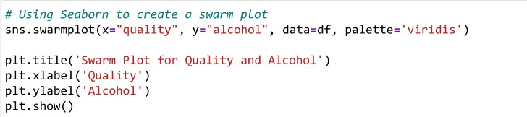

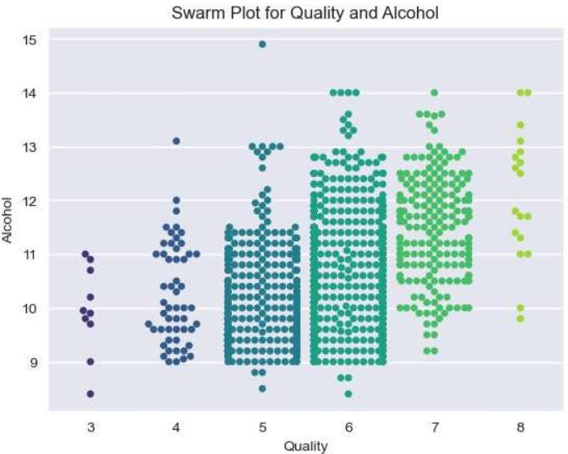

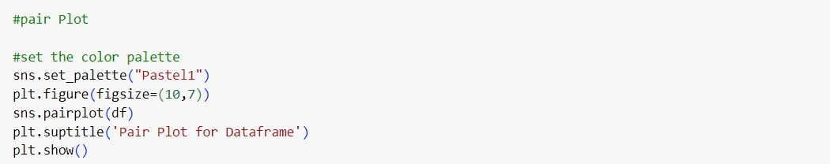



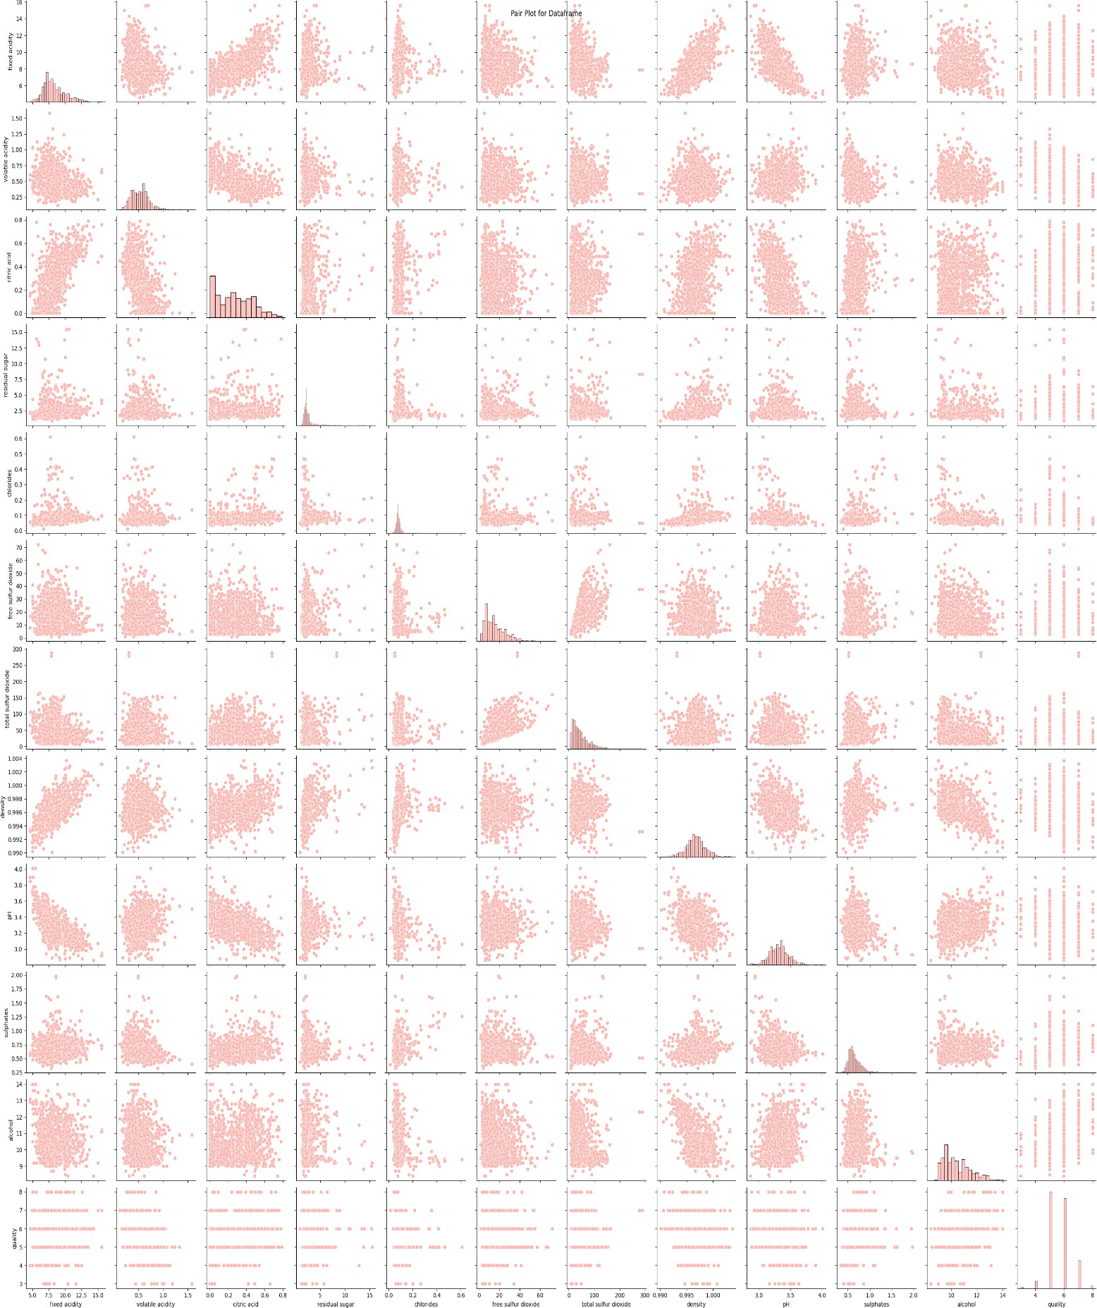





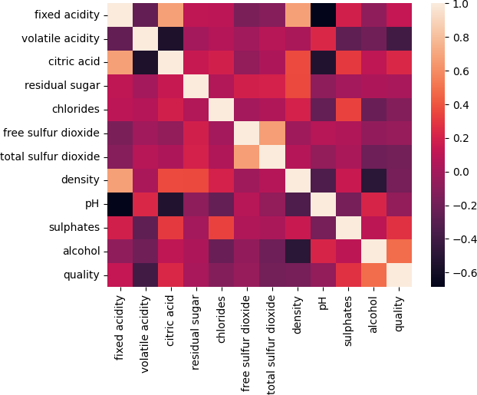

**Practical-2**

**Aim:** Calculate mean, median and mode of the first 50 records in the given dataset using python

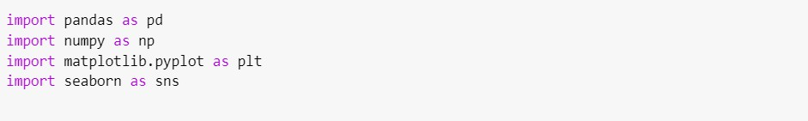





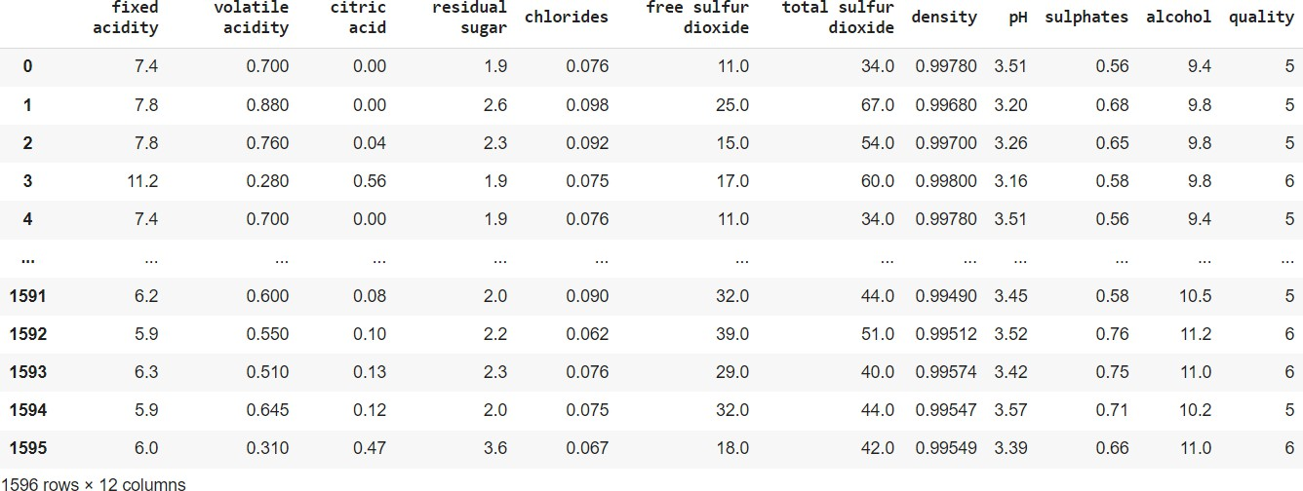

**B.Tech CSE Year: 3RD Semester: 5TH**

