**Class:** Third Year (Computer Science and Engineering)

**Year:** 2021-22 **Semester:** 1

**Course:** Programming Lab-3 (5CS352)

**END SEMESTER EXAMINATION - 2021-22**

**Exam Seat No:**

1. Exam Seat Number – 2019BTECS00089
2. Name : Piyush Pramod Mhaske

**Problem Statement 1:**

Design a website for Student Project Funding with following objectives:\r\n Index/Home Page showing information, purpose, login and registration option for students.\r\n Student Registration – Student name, College name, ID proof, Class, Year, password\r\n After login – form for applying for funding. It includes – Project title, Abstract, Hardware requirement, Software requirement and expected budget.\r\nEvery page should be responsive\r\n Provide all validations\r\n Use styles to make it attractive\r\nLink all pages using navigation bar\r\n Use appropriate HTML elements and CSS properties\r\n Host website on any free web hosting service and upload the source code GitHub public repository

**Details/Comparison/Observations:**

Designed a website with name of student project funding. Added nice style to the webpage. Added login and contact us form. Also added register here page where students can register their project for funding.

**Screenshot 1:**

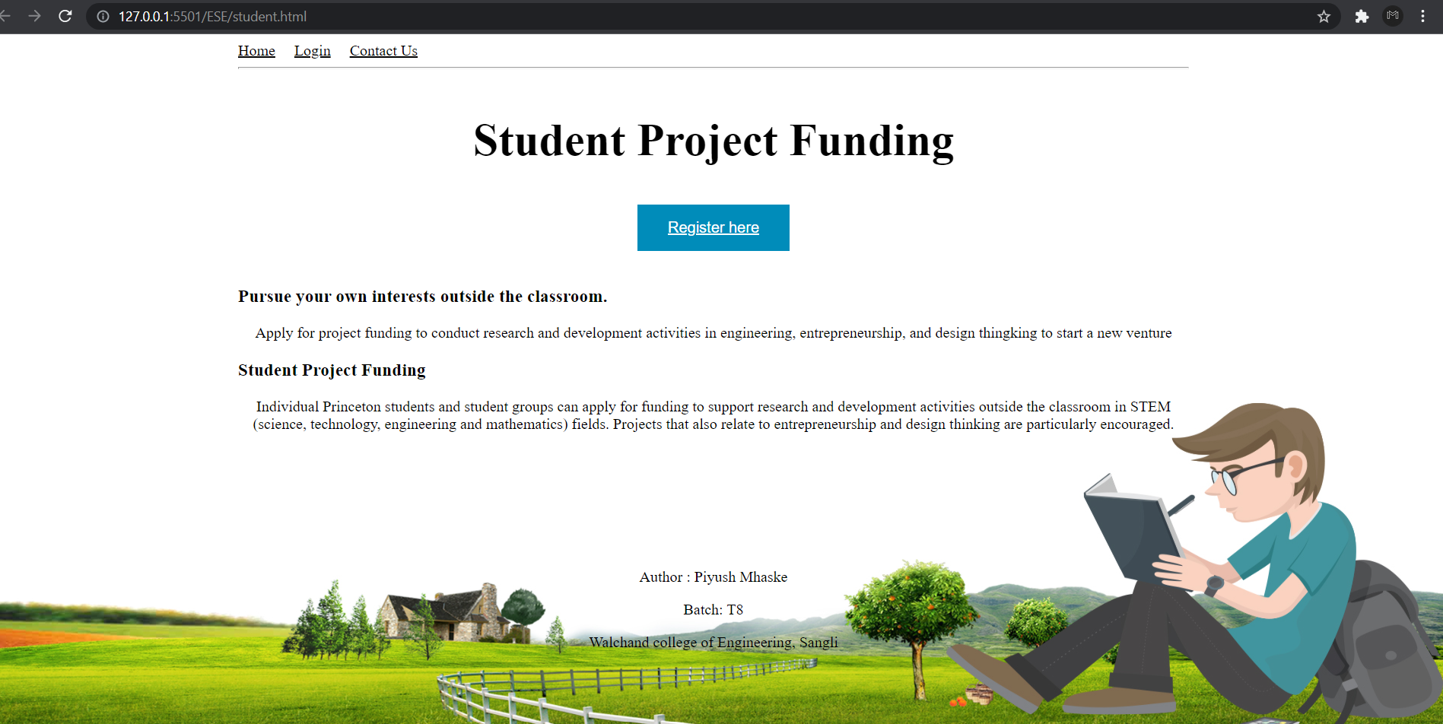

**Information 1:**

This is the front page of the website where student can register by clicking register here page

**Screenshot 2:**

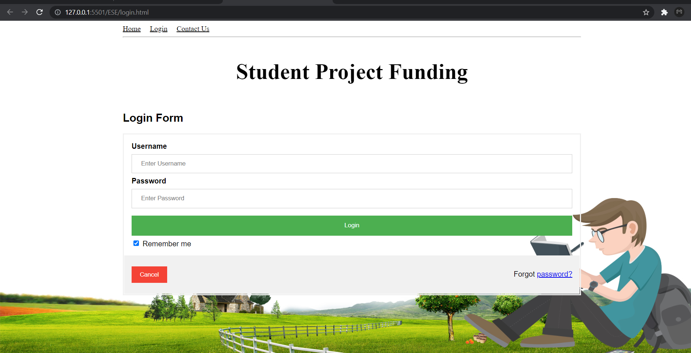

**Information n:**

This is the login page.

**Screenshot 3:**

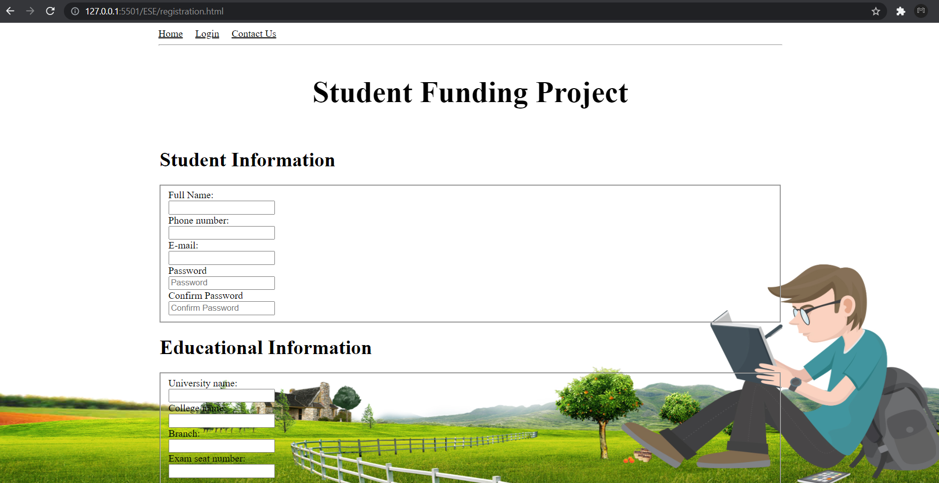

**Information 3:**

This is the registration page where students have to register to login the page

**GitHub Link:**

**Note: (Student should remove this part while preparing the document)**

1. Upload only .pdf file on WCE Moodle.
2. Rename .pdf file with “PL3_2021_22_ExamSeatNumber.pdf”.
3. Upload all source code files on GitHub public repository and add its link in this report.