Thursday 03/08/2022 – Assignment:

Assignment1:

Display the various people of different technical portfolios by using different components:

Input:

Create an component name e-info:

import { Component, OnInit } from '@angular/core';

import { DataService } from '../data.service';

@Component({

  selector: 'app-e-info',

  templateUrl: './e-info.component.html',

  styleUrls: ['./e-info.component.css'],

  providers: [DataService]

})

export class EInfoComponent implements OnInit {

  infoReceived1: string[]=[];

  infoReceived2: string[]=[];

  infoReceived3: string[]=[];

  getInfoFromService1(){this.infoReceived1 = this.dservice.getInfo1()}

  getInfoFromService2(){this.infoReceived2 = this.dservice.getInfo2()}

  getInfoFromService3(){this.infoReceived3 = this.dservice.getInfo3()}

  constructor(private dservice:DataService) { }

  ngOnInit(): void {

  }

}

Step-2: Crete a button listfor employee details:

Input e-info.component.html:

<button type="button" name="button" (click)='getInfoFromService1()'>Employee1</button>

<ul class="list-group">

    <li *ngFor = "let info of infoReceived1" class="list-group-info">{{info}}</li>

</ul>

<button type="button" name="button" (click)='getInfoFromService2()'>Employee2</button>

<ul class="list-group">

    <li *ngFor = "let info of infoReceived2" class="list-group-info">{{info}}</li>

</ul>

<button type="button" name="button" (click)='getInfoFromService3()'>Employee3</button>

<ul class="list-group">

    <li *ngFor = "let info of infoReceived3" class="list-group-info">{{info}}</li>

</ul>

Step -3:create a service

import { Injectable } from '@angular/core';

@Injectable({

  providedIn: 'root'

})

export class DataService {

  info1: string[]=["Piyush Sharma",'Dotnet developer','piyush@abc.net']

info2: string[]=["Abhinav Tyagi",'Senior Developer','abhinav@abc.net']

info3: string[]=["Dashpreet",'Developer','dashpreer@abc.net']

getInfo1():string[]{

  return this.info1

}

getInfo2():string[]{

  return this.info2

}

getInfo3():string[]{

  return this.info3

}

  constructor() { }

}

App component.html

<h1>Angular Services</h1>

<app-e-info></app-e-info>

Then register the service and it shows the record after run success fully

Output1:

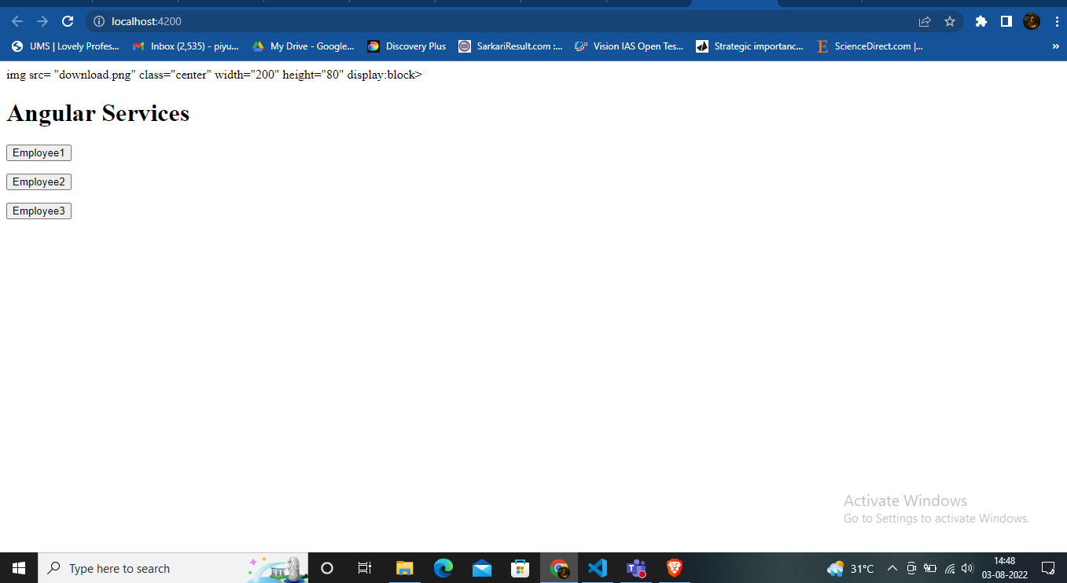

Output 2:

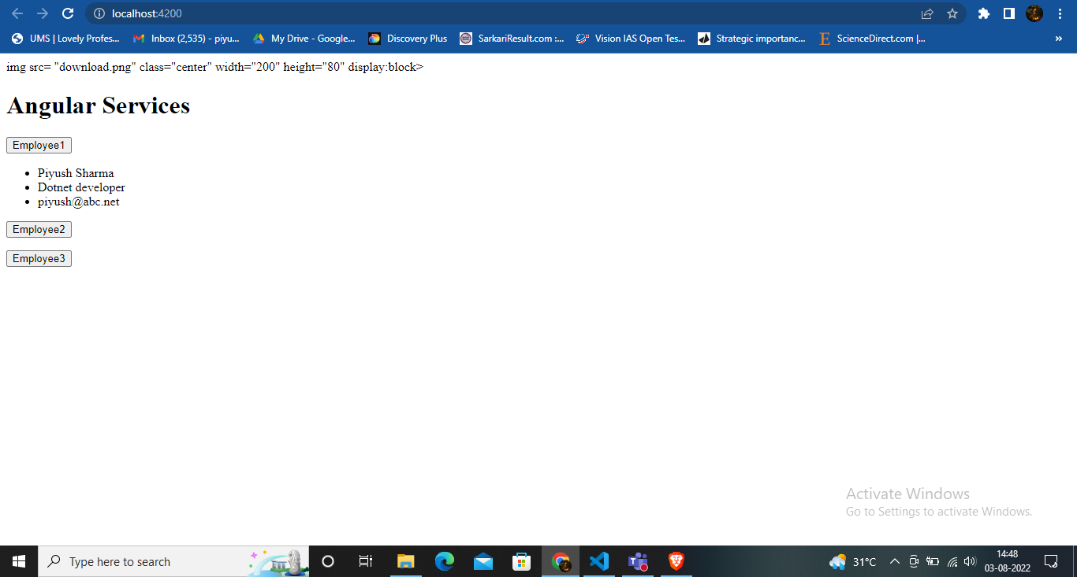

Output 3:

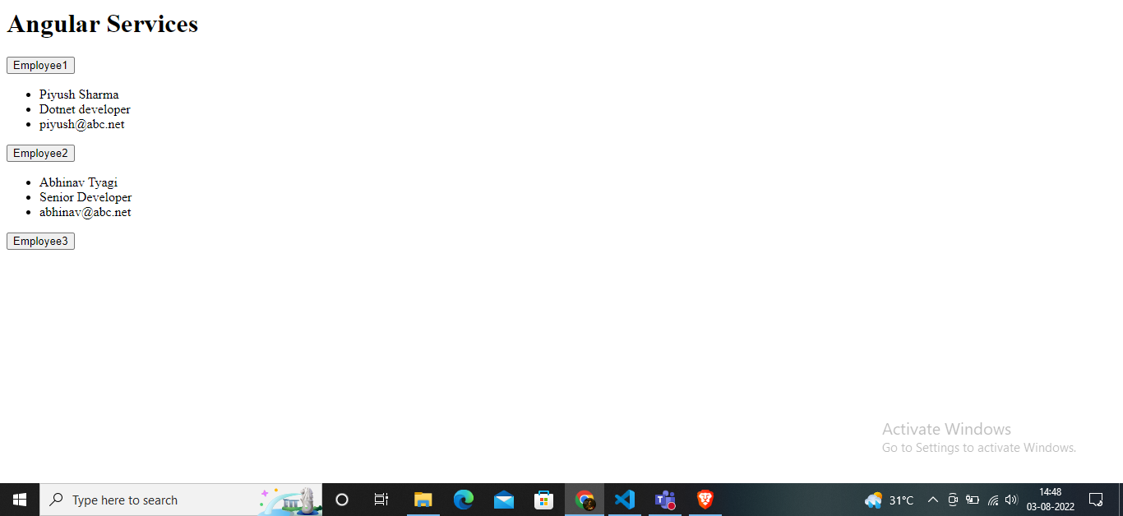

Assignment 2 and 3 are connected to create an online shopping application to display the details of product:

Step 1: I created an new application called ecommerce

Step-2 :created an three component:

a.Product-details

b.Product-List

c. Top-bar

Input:

<h2>Products</h2>

<div *ngFor="let product of products">

    <h3>

        <a [title]="product.name + ' details'">

            {{ product.name }}

          </a>

    </h3>

</div>

Input:

import { Component, OnInit } from '@angular/core';

import { products } from '../products';

@Component({

  selector: 'app-product-list',

  templateUrl: './product-list.component.html',

  styleUrls: ['./product-list.component.css']

})

export class ProductListComponent implements OnInit {

  products:any = products;

  constructor() { }

  ngOnInit(): void {

  }

}

Input3;

Topbarcomponent.html

div>

    <div style="background-color:rgb(37,110,247);">

      <app-top-bar></app-top-bar>

      </div>

      <div class="container">

        <div class="row">

          <div class="col-md-6">

            <a href="">

              <h1>Welcome to Piyush Sharma Store</h1>

            </a>

          </div>

          <div class="col-md-6 d-flex justify-content-end">

            <a style=" padding: 10px;"

              class="button fancy-button">

              <i class="fas fa-shopping-cart">shopping-cart</i>

              checkout

             </a>

           </div>

        </div>

      </div>

Input : app routingmodule;

import { NgModule } from '@angular/core';

import { RouterModule, Routes } from '@angular/router';

import { ProductDetailsComponent } from './product-details/product-details.component';

import { ProductListComponent } from './product-list/product-list.component';

const routes: Routes = [

  {

    path:'' , component:ProductListComponent

  },

  {

    path: 'products/:productID' , component:ProductDetailsComponent

  },

];

@NgModule({

  imports: [RouterModule.forRoot(routes)],

  exports: [RouterModule]

})

export class AppRoutingModule { }

input:

<div>

  <app-top-bar></app-top-bar>

  <div class="container">

    <router-outlet></router-outlet>

  </div>

</div>

Crete an file product.ts

export interface Product{

    id: number;

    name: string;

    price: number;

    description: string;

}

    export const products =[

        {

            id : 1,

            name : 'Phone xl',

            price : 799,

            description : 'A large phone with one of the best screens',

        },

        {

            id : 2,

            name : 'Phone Mini',

            price : 599,

            description : 'A great phone with one of the best cameras',

        },

        {

            id : 3,

            name : 'Phone Standard',

            price : 899,

            description : 'Small Phone with best battery',

        }

    ]

Output:

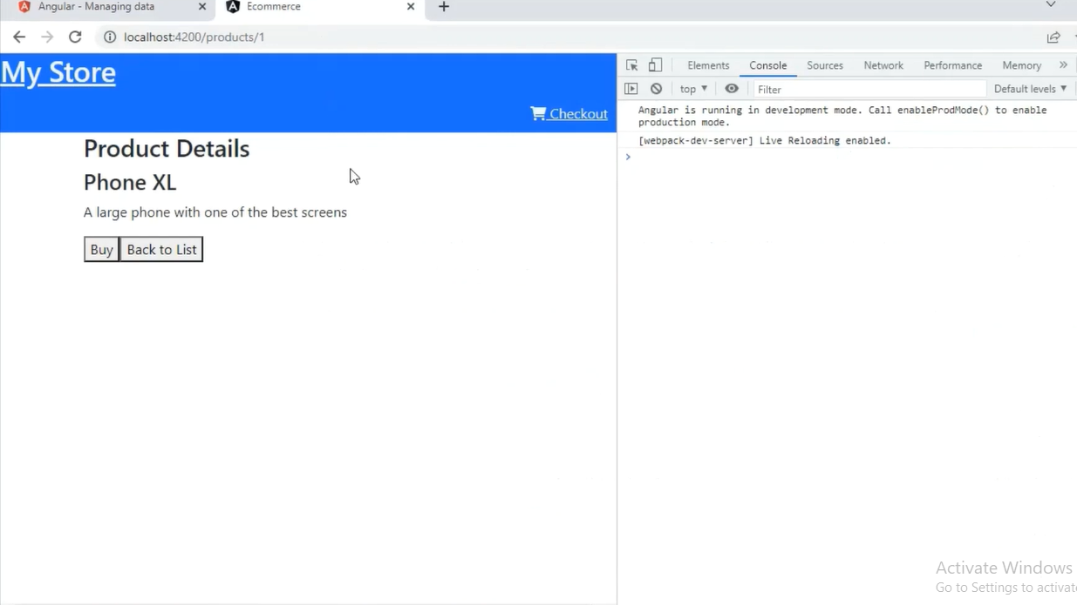

Output2:

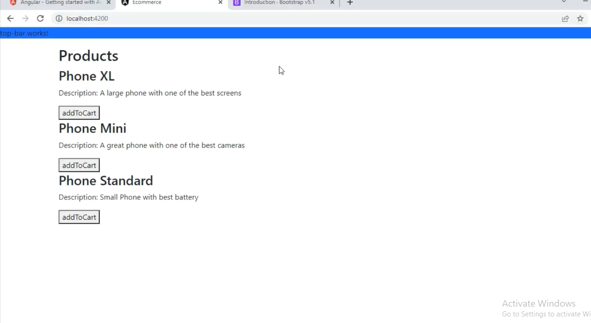

adding a **Buy** button and setting up a cart service to store information about products in the cart.

You need to create an service:

Import product interface from product.ts into the cart service

import { Product } from './products'; /* . . . */ export class CartService { items: Product[] = []; /* . . . */ }

crete getcount item to count item ina cart as we show in below output:

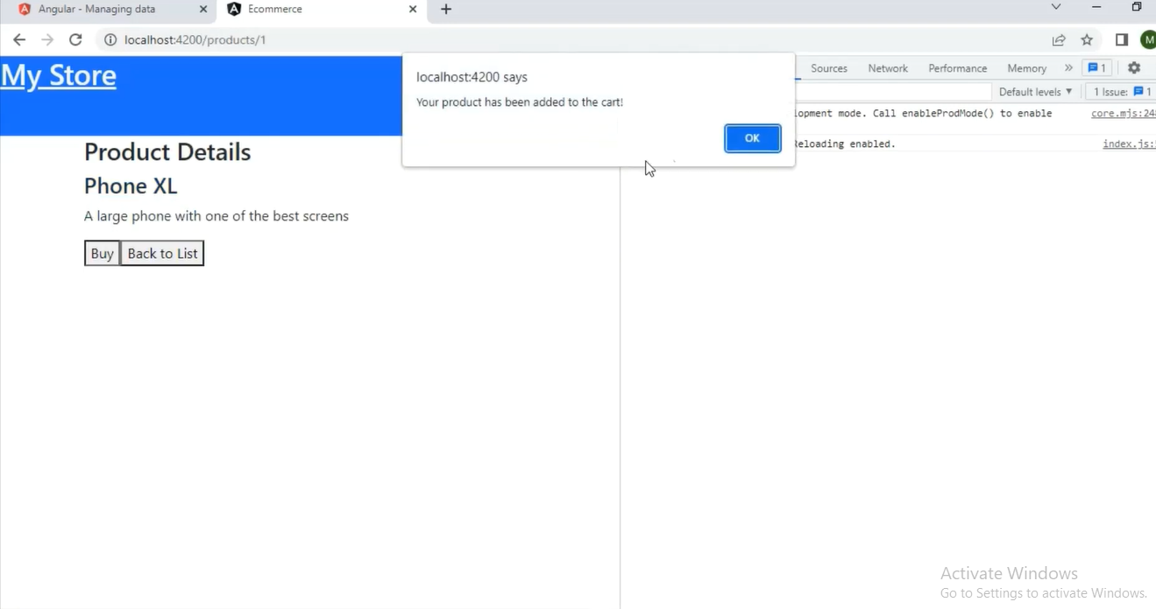

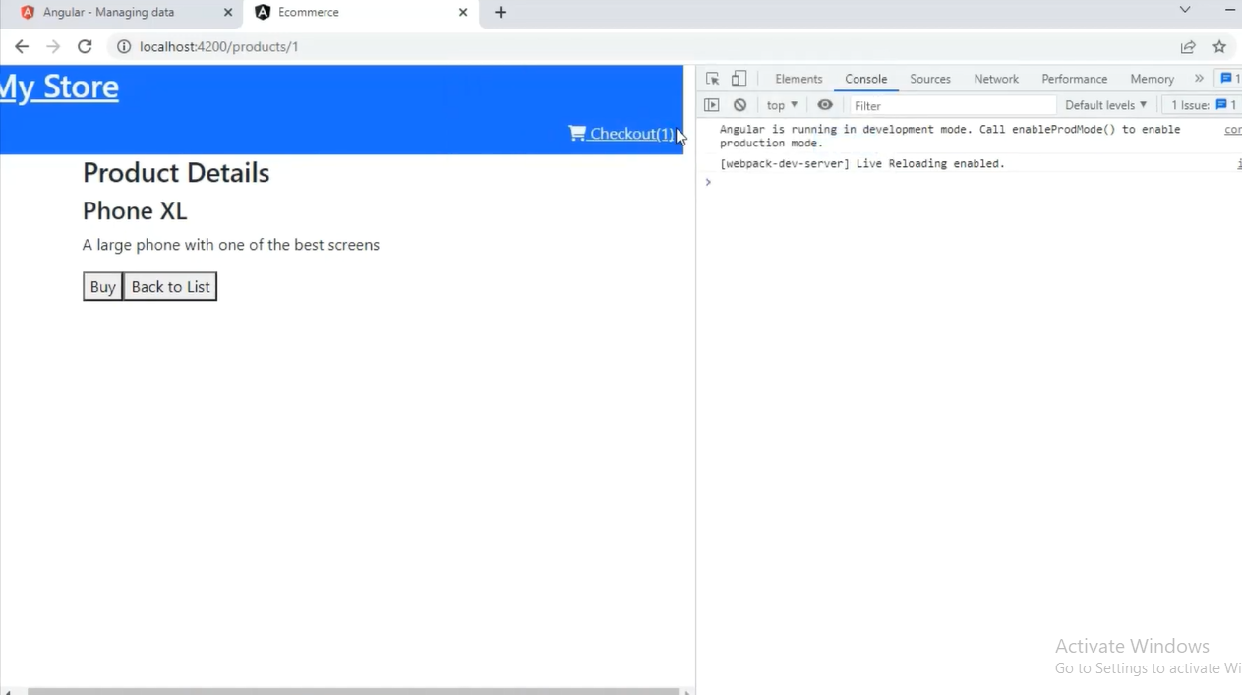

To add the shopping cart symbol in your web site you refer to cdn link libraries in your index.html file.