GROUP ID: GB11
A TECHNICAL SEMINAR REPORT ON

COST-AWARE PROGRESSIVE PREDATORY JOURNAL DETECTION
SUBMITTED TO THE PCET'S PIMPRI CHINCHWAD COLLEGE OF ENGINEERING AN AUTONOMOUS INSTITUTE, PUNE
IN THE PARTIAL FULFILLMENT OF THE REQUIREMENTS FOR
THIRD YEAR (SEMESTER V) OF
BACHELOR OF TECHNOLOGY (COMPUTER ENGINEERING)
SUBMITTED BY

PIYUSH PATEL | PRN: 124B1B112
PARSHWA NIKAM | PRN: 124B1B116
SUYOG JADHAV | PRN: 124B1B122
PRATIK JADHAV | PRN: 124B1B126

Under the guidance of
Prof. Dr. Swati V. Shinde


DEPARTMENT OF COMPUTER ENGINEERING
PCET'S PIMPRI CHINCHWAD COLLEGE OF ENGINEERING
Sector No. 26, Pradhikaran, Nigdi, Pimpri-Chinchwad, PUNE 411044 An Autonomous Institute Approved by AICTE and Affiliated to SPPU, Pune Academic Year 2026-27

PCET'S PIMPRI CHINCHWAD COLLEGE OF ENGINEERING
Sector No. 26, Pradhikaran, Nigdi, Pimpri-Chinchwad, PUNE 411044
An Autonomous Institute Approved by AICTE and Affiliated to SPPU, Pune


CERTIFICATE
This is to certify that the Technical Seminar report entitled
"COST-AWARE PROGRESSIVE PREDATORY JOURNAL DETECTION"
Submitted by

PIYUSH PATEL | PRN: 124B1B112
PARSHWA NIKAM | PRN: 124B1B116
SUYOG JADHAV | PRN: 124B1B122
PRATIK JADHAV | PRN: 124B1B126

are bonafide students of this institute and the work has been carried out by them under the supervision of Prof. Dr. Swati V. Shinde and it is approved for the partial fulfillment of the requirement of PCET'S PIMPRI CHINCHWAD COLLEGE OF ENGINEERING, for the award of Third Year of Bachelor of Technology (Computer Engineering) A.Y. 2026-27.

Prof. Dr. Swati V. Shinde Prof. Dr. Sonali D. Patil
Guide Name Head,
Department of Computer Engineering

Place: Pune
Date: / /2026

ACKNOWLEDGEMENT
We express our sincere thanks to our Technical Seminar Guide, Prof. Dr. Swati V. Shinde, for her constant encouragement, valuable suggestions and technical guidance throughout the course of this work. Her insights on research methodology, experimental rigour and scientific writing laid the foundation for the success of this seminar.
We are grateful to Prof. Dr. Sonali D. Patil, Head of the Department of Computer Engineering, for her unwavering support, and to Hon. Director, Dr. G. N. Kulkarni, for providing an academic environment in which this work could be completed successfully. We also thank all the faculty members and technical staff of the department for their help and cooperation.
Finally, we extend our deep appreciation to our family and friends for their continued support and motivation during the crucial stages of completing this Technical Seminar.

PIYUSH PATEL PARSHWA NIKAM SUYOG JADHAV PRATIK JADHAV

ABSTRACT
The commercialisation of Open Access publishing and author-facing Article Processing Charges (APCs) has given rise to a large industry of predatory journals that charge authors for publication while offering little or no genuine peer review. More than 10,000 such serials are estimated to solicit manuscripts worldwide. Existing machine-learning detectors typically report very high accuracy on static, identically distributed snapshots of historical blacklists, but they fail when deployed on contemporary journals, assume that every feature is available at zero cost, and emit opaque probability scores with no verifiable evidence.
This Technical Seminar presents Cost-Aware Progressive Predatory Journal Detection, an end-to-end forensic framework that addresses these three weaknesses. Features are organised into four progressively acquired stages (URL geometry, static HTML policies, dynamic JavaScript behaviour and scholarly registry verification) totalling 42 features. A shared progressive multi-head neural network, implemented in PyTorch, accumulates representations across stages, while a calibrated adaptive stopping controller halts feature acquisition as soon as the posterior confidence exceeds a stage-specific threshold. Temperature and Platt scaling calibrate the posteriors, and a tri-state decision rule (Verified Legitimate, Selective Abstention, Predatory Warning) routes ambiguous cases to human experts. A deterministic evidence-grounding engine attaches registry-based evidence to each verdict.
The system was evaluated on an audited corpus of 5,528 academic serials frozen with SHA-256 digests, using a strictly held-out temporal test set of 1,800 journals from 2021 to 2026. The proposed adaptive configuration reduces mean inference latency by 94.4% (519 ms versus 9,310 ms for full acquisition) while improving temporal Macro-F1 from 0.4560 to 0.5327. Tree-based baselines collapse under temporal drift (XGBoost Macro-F1 = 0.0904), and the measured Temporal Generalisation Ratio is 0.5354. Selective abstention lowers the false-positive rate from 29.9% to 13.8% while resolving 87.2% of serials autonomously. A Streamlit dashboard provides single-journal inspection, batch auditing and benchmark exploration.
Keywords: Predatory journals, temporal generalisation, progressive feature acquisition, early stopping, probability calibration, selective abstention, evidence grounding, PyTorch.

TABLE OF CONTENTS
- Introduction 1
  - Overview 1
  - Motivation 1
  - Problem Statement and Objectives 2
  - Scope 2
  - Methodologies of Problem Solving 3
- Literature Survey 4
  - Predatory Publishing and Blacklist-Based Approaches 4
  - Machine-Learning Approaches to Journal Classification 4
  - Temporal Drift and Out-of-Distribution Generalisation 4
  - Cost-Aware and Progressive Feature Acquisition 5
  - Calibration and Selective Prediction 5
  - Summary of Literature Review and Research Gap 5
- Software Requirements Specification 6
  - System Requirements 6
    - Dataset Requirements 6
    - Software Requirements (Platform Choice) 6
    - Hardware Requirements 6
  - Functional and Non-Functional Requirements 7
- System Design 8
  - System Architecture 8
  - Four-Stage Feature Hierarchy 8
  - Shared Progressive Neural Network 9
  - Calibrated Adaptive Stopping Controller 9
  - Probability Calibration 10
  - Tri-State Classification and Selective Abstention 10
  - Deterministic Evidence Grounding 10
  - Audited Dataset Design 10
- Implementation 12
  - Overview of Project Modules 12
  - Tools and Technologies Used 13
  - Execution Workflow 13
- Results 14
  - Result Analysis and Validations 14
  - Streamlit Diagnostic Dashboard 16
- Conclusions and Future Scope 18
  - Conclusion 18
  - Limitations 18
  - Future Scope 18
  - Applications 19
References 20

LIST OF FIGURES
Figure 4.1 Progressive Four-Stage Inference Pipeline with Adaptive Early Exit 8
Figure 6.1 Dataset Composition of the Audited Corpus Partitions 14
Figure 6.2 Macro-F1 on the Temporal Test Set for Different Configurations 15
Figure 6.3 Mean Inference Latency per Journal for Different Configurations 15

LIST OF TABLES
Table 3.1 Software Technology Stack 6
Table 3.2 Recommended Hardware Requirements 6
Table 4.1 Four-Stage Feature Hierarchy (42 Features) 9
Table 4.2 Tri-State Decision Rule 10
Table 4.3 Audited Dataset Partitions 10
Table 5.1 Tools and Technologies Used 13
Table 6.1 Empirical Benchmark Results (Experiments E1 to E6) 14
Table 6.2 Key Quantitative Outcomes of the Proposed System 16

Overview
CHAPTER 1 INTRODUCTION

Scholarly publishing is the backbone of scientific communication. Over the last two decades, the shift to Open Access models, in which authors or their institutions pay Article Processing Charges (APCs), has made publishing more accessible but has also created a financial incentive for fraudulent actors. Predatory journals imitate legitimate scholarly venues, promise peer review within days, collect author fees and publish unvetted work, including clinical and engineering studies that can mislead practitioners and pollute the scientific record. More than 10,000 deceptive serials are estimated to solicit manuscripts globally.
This Technical Seminar studies the automated detection of such journals and presents a complete forensic framework named Cost-Aware Progressive Predatory Journal Detection. Rather than treating detection as a one-shot classification over a fixed feature vector, the framework couples four ideas: cost-aware progressive feature acquisition, out-of-distribution temporal evaluation, calibrated neural early stopping, and deterministic registry-based evidence grounding. The work is delivered as a reproducible codebase with audited datasets, neural checkpoints, a Streamlit diagnostic interface and an IEEE-format research paper.

Motivation
Prior automated approaches to predatory journal detection failed in operational deployment because of three structural flaws, which together motivated this work:
- The static in-distribution fallacy. Many studies report diagnostic metrics above 95% using standard identically distributed cross-validation on historical snapshots such as pre-2020 crawls of Beall's list. Deceptive publishing, however, is adversarial and non-stationary: post-2020 operations adopt modern content-management software such as Open Journal Systems, register credible academic-sounding domains and forge editorial board affiliations. Classifiers fitted on historical heuristics collapse on contemporary journals; in our experiments the ratio of temporal to historical F1 is only 0.5354.
- The uniform acquisition cost fallacy. Traditional models assume that all features are available instantly and at no cost. In practice, evaluating URL string geometry takes under 10 ms, headless-browser JavaScript rendering takes 3 to 5 seconds, and querying external scholarly registries (Crossref, OpenAlex, DOAJ, ISSN Portal) needs several network round-trips subject to rate limits and downtime, totalling about 9,310 ms.

Invoking exhaustive scraping for millions of serials is computationally and financially infeasible.
- The ungrounded black-box prediction fallacy. Existing models emit raw, uncalibrated scalar probabilities (for example 0.82) without verifiable evidence. In tenure disputes or defamation proceedings such an opaque score has no standing. When evidence is noisy or ambiguous (0.40 ≤ p ≤ 0.60), a responsible system must abstain and route the record to human expert librarians rather than force an arbitrary verdict.

Problem Statement and Objectives
    - Problem Statement
To design and evaluate a scalable, explainable and cost-efficient system that classifies academic journals as legitimate or predatory, remains reliable on contemporary journals that differ from the historical training distribution, minimises the computational cost of feature acquisition, and supports every verdict with verifiable evidence or abstains when evidence is insufficient.
    - Objectives
      - To organise 42 journal features into four progressively acquired stages ordered by acquisition latency and adversarial evasion resistance.
      - To build a shared progressive multi-head neural network that learns representations across stages and outputs a posterior risk probability at every stage.
      - To implement a calibrated adaptive stopping controller that halts feature acquisition once the posterior confidence reaches a stage-specific threshold, reducing mean inference latency.
      - To apply temperature and Platt scaling and a tri-state decision rule with selective abstention so that ambiguous journals are routed to human experts.
      - To evaluate the framework on an audited, SHA-256-frozen corpus with a strictly held-out temporal test set, and to compare it against monolithic, fixed-stage and tree-based baselines.
      - To provide a Streamlit dashboard and an IEEE-format research paper that make the system and its results reproducible.

Scope
The scope of this project covers the complete pipeline from feature extraction to decision support: URL and domain geometry features, static HTML policy features, dynamic JavaScript runtime features, scholarly registry features, the progressive neural model, calibration, adaptive

stopping, evidence grounding, benchmarking experiments E1 to E6, publication-quality figure generation and an interactive dashboard with single-journal inspection and batch CSV auditing.
The project does not attempt to provide a legal definition of predatory publishing, does not replace human editorial judgement for borderline records, and does not cover non-journal venues such as conferences or books. Retraining on new data and integration with institutional library systems are left for future work.

Methodologies of Problem Solving
The project followed an experimental research methodology with the following phases:
- Problem analysis and literature review: identifying the gaps in static, uniform-cost and ungrounded detectors.
- Dataset audit: combining journal records from 2012 to 2026 into a single corpus of 5,528 serials, partitioning it by era, and freezing it with SHA-256 digests to guarantee reproducibility.
- Feature engineering: designing 42 features in four stages and implementing a persistent disk cache so that expensive features are never recomputed.
- Model development: training a shared progressive network with a composite multi-task loss, followed by calibration and threshold tuning on the validation split.
- Evaluation: running six experiment families (E1 to E6) on the untouched temporal test cohort and on a web-noise pool for robustness.
- Deployment and documentation: building the Streamlit interface, an automated test suite, publication figure scripts and the research paper.

CHAPTER 2 LITERATURE SURVEY
A review of the literature on predatory publishing, journal classification, distribution shift, cost-sensitive learning and calibration was carried out to position this work and to justify its technical choices. The sources listed in the References section are cited by number.

Predatory Publishing and Blacklist-Based Approaches
Predatory publishing came to wide attention through the blacklists curated by Jeffrey Beall and through investigative studies such as the 2013 Science sting operation, which showed that many open-access journals accepted a deliberately flawed manuscript [1]. Longitudinal studies later quantified the rapid growth in article volumes in such journals [2]. A consensus definition was only proposed in 2019, which emphasised that predatory journals prioritise self-interest at the expense of scholarship and are characterised by false or misleading information, deviation from best editorial practice and a lack of transparency [3].
Blacklists suffer from well-known practical weaknesses: curation is manual and slow, inclusion criteria can be subjective, and curators have historically faced legal threats. Whitelists such as the Directory of Open Access Journals (DOAJ) [4] provide positive evidence of quality but cannot, on their own, classify journals that are simply absent from the list, including many legitimate journals from low-resource regions.

Machine-Learning Approaches to Journal Classification
Automated approaches model journal legitimacy as a binary classification problem over features drawn from journal websites, editorial boards, publishing policies and bibliometric indicators. Tree-based ensembles such as Random Forests [5] and gradient boosting (XGBoost)
[6] are common choices for such tabular data and generally report high accuracy when evaluated with random cross-validation on a single historical crawl. These studies usually treat all features as available simultaneously and report only a point prediction.
The weakness of this setting is that random splits leak information about the publishers and templates present in the training era. A model may memorise registry correlations that were true of historical predatory journals but not of those that appeared after 2020. This is the static in-distribution fallacy identified in Chapter 1.

Temporal Drift and Out-of-Distribution Generalisation
Deployed classifiers face covariate and concept shift when the data-generating process changes with time [7]. Adversarial domains such as spam, phishing and fraudulent publishing are particularly prone to this because adversaries adapt to deployed detectors. Evaluating on a chronologically later, untouched cohort rather than on random folds is the accepted way to measure robustness to such drift. This project adopts a strict temporal protocol: models are fitted and tuned on pre-2021 journals and evaluated once on a 1,800-record 2021–2026 cohort.

Cost-Aware and Progressive Feature Acquisition
Cost-sensitive learning recognises that features differ widely in acquisition cost and that decisions can often be made from a cheap subset. Sequential and anytime prediction frameworks, and early-exit networks, stop computation once a sufficiently confident prediction is available. In the journal-auditing setting, the cost gradient is extreme: URL geometry costs milliseconds, whereas registry queries cost seconds and depend on external services. This motivates a staged feature hierarchy with a learned stopping rule, which is the core of the proposed framework.

Calibration and Selective Prediction
Modern neural networks are often over-confident, especially on out-of-distribution inputs. Temperature scaling and Platt scaling are standard post-hoc remedies that rescale logits so that predicted probabilities better match empirical frequencies [8], [9]. Calibration is essential for confidence-based early stopping, since an over-confident network would exit too early. Selective prediction, also known as classification with a reject option, allows a model to abstain when its confidence is low and to defer to a human expert, trading coverage for reliability [10].

Summary of Literature Review and Research Gap
The literature shows that (i) blacklists and whitelists are valuable but incomplete, (ii) machine-learning detectors achieve high in-distribution accuracy but are rarely evaluated under temporal drift, (iii) acquisition cost is typically ignored, and (iv) verdicts are rarely accompanied by verifiable evidence or an abstention mechanism. The present work addresses all four gaps in a single pipeline, which is summarised in Table 4.1 and Table 6.1.

CHAPTER 3
SOFTWARE REQUIREMENTS SPECIFICATION

System Requirements

Dataset Requirements
The system operates on an audited corpus of 5,528 academic serials covering 2012 to 2026. The master file is stored as audit/data/final_combined_journal_dataset_frozen_readonly.csv and is protected by a SHA-256 digest (d775c92c…f4c328) so that any modification is detected. The corpus is partitioned into four disjoint cohorts: HISTORICAL_TRAIN (1,636 records), HISTORICAL_VAL (410), TEMPORAL_TEST_UNTOUCHED (1,800) and
WEB_NOISE_POOL (1,272). Each record carries the journal URL, title, ISSN, publisher, era and a binary label (0 = legitimate, 1 = predatory). Extracted features are cached persistently (SQLite / JSON) to avoid repeated network calls.

Software Requirements (Platform Choice)
Table 3.1: Software Technology Stack

Component | Technology / Tool | Version / Notes
Programming language | Python | 3.10 or higher
Deep learning framework | PyTorch | 2.1.2
Baseline models | XGBoost, Random Forest | Decoupled Stage-4 baselines
Calibration | Platt scaling, temperature scaling | Custom module (calibration.py)
Dynamic feature extraction | Headless browser rendering | DOM delta, script analysis
External data sources | Crossref, OpenAlex, DOAJ, ISSN Portal | Scholarly registry APIs
Feature cache | SQLite / JSON disk cache | Persistent (cache.py)
User interface | Streamlit | Multi-tab dashboard, port 8501
Paper compilation | ReportLab Platypus | IEEE two-column PDF
Version control | Git / GitHub | Public repository

Hardware Requirements
The framework does not need dedicated server hardware. The following configuration is recommended for development and for running the complete benchmark suite; model inference itself is lightweight.
Table 3.2: Recommended Hardware Requirements

Component | Recommended specification
Processor | Intel Core i5 or equivalent (multi-core preferred for feature extraction)
Memory | 8 GB RAM minimum (16 GB recommended for headless browser rendering)

Component | Recommended specification
Storage | Sufficient free disk space for the dataset, feature cache and figures
Network | Stable broadband connection (required for registry and website queries)
Client | Any modern web browser to access the Streamlit dashboard

Functional and Non-Functional Requirements
Functional requirements
- Accept a journal URL, title, ISSN or publisher as input and extract the relevant features progressively.
- Produce a calibrated risk probability at each stage and stop adaptively according to stage-specific confidence thresholds.
- Return one of three outcomes: Verified Legitimate, Selective Abstention (human audit) or Predatory Warning, together with the evidence that supports the outcome.
- Support batch auditing of a CSV list of ISSNs or URLs.
- Verify dataset integrity against the frozen SHA-256 digests and re-run benchmark experiments E1 to E6.
- Regenerate all publication figures and the IEEE research paper from stored benchmark results.
Non-functional requirements
- Performance: mean inference latency of the adaptive pipeline should be a small fraction of full acquisition (achieved: 519 ms versus 9,310 ms).
- Reproducibility: frozen, hash-verified splits and deterministic scripts.
- Explainability: every verdict must be traceable to rule-based evidence or marked as abstained.
- Robustness: behaviour should degrade gracefully under noisy web data and unavailable registries.
- Fairness: borderline journals, including those from emerging regions, must not be blacklisted automatically.

System Architecture
CHAPTER 4 SYSTEM DESIGN

The system is a progressive inference pipeline. A query (journal URL, title, ISSN and publisher) first enters Stage 1, where inexpensive URL and domain geometry features are computed in under 10 ms. The adaptive stopping controller evaluates the calibrated confidence c₁ = max(p₁, 1 − p₁). If c₁ ≥ 0.80, the journal exits at Stage 1; otherwise Stage 2 (static HTML policy features) is executed, and the process repeats. Only the remaining uncertain journals proceed to Stage 3 (dynamic JavaScript runtime) and Stage 4 (scholarly registries). The final posterior is mapped to a tri-state decision and supported by deterministic evidence grounding.
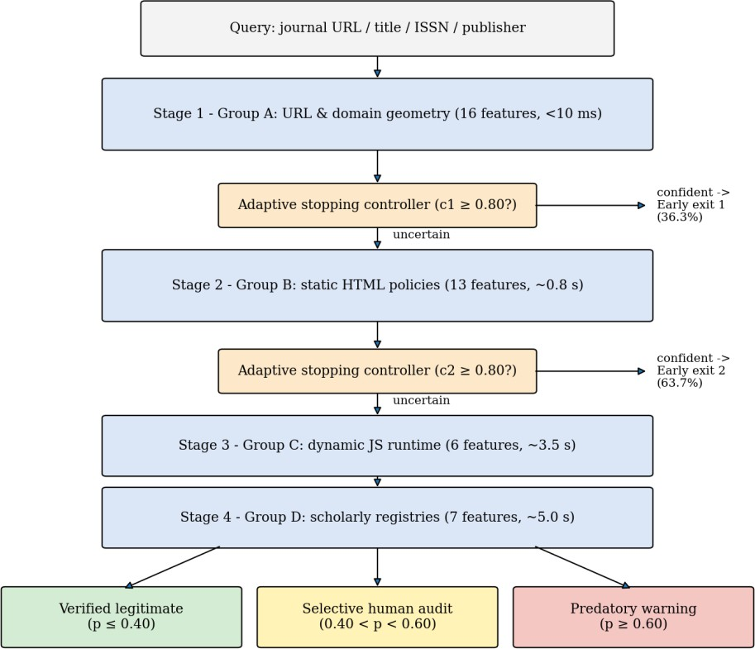
Figure 4.1: Progressive Four-Stage Inference Pipeline with Adaptive Early Exit
With the optimised thresholds, 36.3% of serials are resolved at Stage 1 and the remaining 63.7% at Stage 2 on the temporal test cohort, so the expensive Stage 3 and Stage 4 are rarely invoked.

Four-Stage Feature Hierarchy
Features are decoupled into four modular groups that are evaluated progressively and cached on disk (src/features/cache.py). The groups are ordered by increasing acquisition latency and increasing resistance to adversarial evasion.
Table 4.1: Four-Stage Feature Hierarchy (42 Features)

Stage | Feature group | Dim | Latency | Core signals extracted | Evasion resistance
1 | Group A: URL geometry | 16 | < 10 ms | Shannon entropy, suspicious TLDs (.xyz, .top, .info), numeric/symbol ratios, path depth, subdomain token count, IPv4 netloc patterns | Low: cheap .com/.org domains can be bought
2 | Group B: HTML policies | 13 | ≈ 0.8 s | APC fee transparency, perfunctory review promises (< 48 h), editorial board link depth, COPE declarations, institutional vs freemail contacts, copyright freshness | Moderate: policy text can be copied
3 | Group C: Dynamic JS | 6 | ≈ 3.5 s | Headless-browser DOM render delta, script tag counts, third-party script ratios, cloaked redirects, obfuscated JS signatures, ad/crypto-miner trackers | High: unmasks client-side cloaking
4 | Group D: Scholarly registries | 7 | ≈ 5.0 s | ISSN Portal verification, Crossref DOI deposit prefix, DOAJ seal, Scopus/WoS claim verification score, publication velocity variance | Near-absolute: independent third-party verification

Shared Progressive Neural Network
Instead of training four independent classifiers, a single progressive network (src/models/multi_head_model.py) keeps a hidden state hₖ that accumulates representations across stages:
h₁ = ReLU(W₁x₁ + b₁); hₖ = ReLU(Wₖ[hₖ₋₁ ; xₖ] + bₖ), k ∈ {2, 3, 4}
Each stage emits a posterior risk probability pₖ = σ(Vₖhₖ). During training, a composite multi-task objective updates all heads simultaneously:
L_total = Σ (k = 1 to 4) αₖ · L_CE(pₖ, y)
Shared representation learning forces early layers to learn generalisable features and acts as a regulariser. This prevents the catastrophic tabular collapse observed for standard tree models under temporal shift (XGBoost Macro-F1 = 0.0904).

Calibrated Adaptive Stopping Controller
At stage k the stopping controller (src/models/stopping_controller.py) computes the calibrated confidence
cₖ = max(pₖ, 1 − pₖ)

and halts inference as soon as cₖ ≥ τₖ. The optimised thresholds are τ₁ = 0.80, τ₂ = 0.80 and τ₃
= 0.75. Because easy cases are resolved by cheap features, the controller achieves a 94.4% reduction in mean latency while also improving temporal generalisation, since uninformative downstream signals are pruned for decisive cases.

Probability Calibration
Uncalibrated networks emit extreme probabilities (above 0.99) on out-of-distribution inputs, which would trigger unreliable early exits. The calibration module (src/models/calibration.py) applies Platt scaling and temperature scaling fitted on HISTORICAL_VAL, and reports the Expected Calibration Error (ECE). Calibration reduces ECE from 0.4619 to 0.3079 on the temporal cohort.

Tri-State Classification and Selective Abstention
Rather than forcing a binary label, the system implements a principled reject option:

Table 4.2: Tri-State Decision Rule

Posterior p | Outcome | Action
p ≥ 0.60 | Predatory Warning | Flagged with explicit risk evidence
0.40 < p < 0.60 | Selective Abstention | Autonomous verdict withheld; routed to a human expert librarian
p ≤ 0.40 | Verified Legitimate | Whitelisted with corroborated provenance

Routing ambiguous cases to human review lets the system resolve 87.2% of serials autonomously while lowering the false-positive rate from 29.9% to 13.8%.

Deterministic Evidence Grounding
The explainability module (src/explainability/evidence_grounding.py) is a rule-based corroboration and contradiction engine. It cites official registry discrepancies, for example whether an ISSN is registered in the official portal, whether a claimed DOAJ indexing exists, or whether a Crossref DOI prefix is active. This replaces opaque scores with verifiable factual provenance, which is important in legal or tenure disputes. The engine also writes audit logs for each decision.

Audited Dataset Design
All experiments use the frozen corpus of 5,528 serials. The historical and temporal splits are deliberately different in class balance: the historical splits are about 60:40 legitimate to predatory, whereas the contemporary temporal test cohort is about 90:10, which mirrors the real-world imbalance and makes the evaluation harder.

Table 4.3: Audited Dataset Partitions

Split | Era | Records | Legitimate | Predatory | Function
HISTORICAL_TRAIN | Pre-2021 | 1,636 | 982 (60.0%) | 654 (40.0%) | Parameter fitting
HISTORICAL_VAL | Pre-2021 | 410 | 245 (59.8%) | 165 (40.2%) | Hyper-parameters, calibration
TEMPORAL_TEST_UNTOUCHED | 2021–  2026 | 1,800 | 1,621 (90.1%) | 179 (9.9%) | Held-out temporal evaluation
WEB_NOISE_POOL | Mixed | 1,272 | 1,145 (90.0%) | 127 (10.0%) | Robustness stress test
Total corpus | 2012–  2026 | 5,528 | 3,993 (72.2%) | 1,535 (27.8%) | Complete audited corpus

CHAPTER 5 IMPLEMENTATION

Overview of Project Modules
    - Audit and Dataset Module
The audit/ directory holds the frozen master dataset and the four split files. The script scripts/prepare_audit_dataset.py partitions the data and verifies each cohort against its SHA-256 digest, so that experiments can always be traced to an unmodified dataset.
    - Feature Extraction Module
The src/features package implements the four feature groups (group_a_url.py, group_b_html.py, group_c_dynamic.py, group_d_scholarly.py) and a unified sequential extraction pipeline (pipeline.py). A persistent cache (cache.py, SQLite / JSON) stores computed features so that repeated runs and benchmarks never repeat slow network calls. Group A parses the URL and computes entropy, TLD and token statistics. Group B fetches static HTML and analyses APC and peer-review statements, board pages and contact addresses. Group C renders the page in a headless browser and compares the rendered DOM with the static DOM. Group D queries Crossref, OpenAlex, DOAJ and the ISSN Portal.
    - Model Module
The src/models package contains the shared progressive multi-head network (multi_head_model.py), the calibrated stopping controller (stopping_controller.py), the Platt and temperature calibration code (calibration.py) and the decoupled XGBoost and Random Forest baselines (baselines.py) used for comparison.
    - Explainability Module
evidence_grounding.py applies deterministic corroboration and contradiction rules over registry evidence so that every Predatory Warning or Verified Legitimate decision is accompanied by checkable evidence.
    - Evaluation and Reporting Module
The benchmark runner executes experiments E1 to E6 over all 5,528 serials and stores metrics, confusion matrices, reliability diagrams and latency statistics in artifacts/reports/benchmark_results.json. Scripts in scripts/ regenerate seven publication figures at 300 DPI (PNG and vector PDF) and compile the 7-page IEEE two-column paper using ReportLab Platypus.

    - User Interface Module
src/ui/app.py implements a multi-tab Streamlit dashboard with a Single Journal Inspector, Batch CSV Auditing, an Audited Dataset Explorer and an Empirical Benchmark Matrix.

Tools and Technologies Used
Table 5.1: Tools and Technologies Used

Tool / Technology | Purpose and usage in this project
Python 3.10+ | Implementation language for feature extraction, modelling, evaluation and scripts.
PyTorch 2.1.2 | Shared progressive multi-head neural network, training and inference.
XGBoost / Random Forest | Decoupled tree-based baselines used to demonstrate tabular collapse under temporal drift.
Streamlit | Interactive diagnostic dashboard for single and batch journal auditing.
Crossref, OpenAlex, DOAJ, ISSN Portal | Independent scholarly registries used by Stage 4 and by the evidence-grounding engine.
Headless browser | Dynamic page rendering for Stage 3 DOM-delta and script analysis.
SQLite / JSON cache | Persistent disk cache for extracted features.
ReportLab Platypus | Compilation of the IEEE two-column research paper PDF.
Git / GitHub | Source control and public hosting of the code, data and paper.
SHA-256 | Cryptographic integrity digests that freeze the dataset splits.

Execution Workflow
The repository README documents the following reproducible workflow:
- Environment setup: clone the repository and install the dependencies with pip install
-r requirements.txt.
- Verify dataset integrity: python scripts/prepare_audit_dataset.py.
- Run the benchmark suite: python -m src.evaluation.run_benchmarks, which writes artifacts/reports/benchmark_results.json.
- Regenerate figures: python scripts/redesign_publication_diagrams.py.
- Compile the paper: python scripts/strip_all_dollars_and_format_math.py.
- Launch the dashboard: streamlit run src/ui/app.py and open http://localhost:8501.

CHAPTER 6 RESULTS

Result Analysis and Validations
All quantitative results are measured on the untouched temporal test cohort of 1,800 journals from 2021–2026 (1,621 legitimate and 179 predatory), unless stated otherwise. Because predatory journals form only 9.9% of this cohort, Macro-F1 and specificity are reported together with precision and recall.
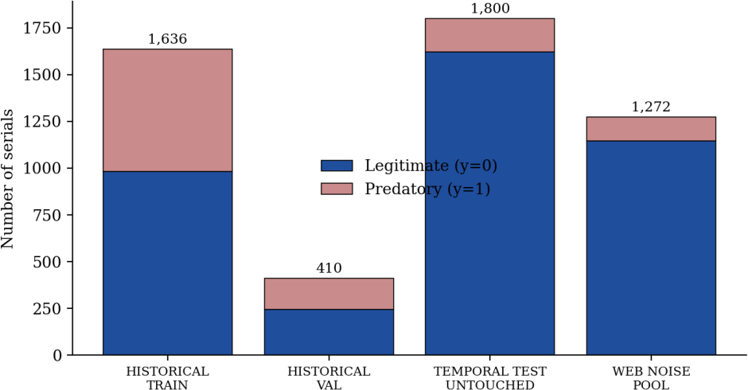
Figure 6.1: Dataset Composition of the Audited Corpus Partitions
    - Benchmark Results (Experiments E1 to E6)
Table 6.1: Empirical Benchmark Results (Experiments E1 to E6)

Exp | Configuration | Prec. | Recall | Macro-F1 | Pred. F1 | Spec. | AUC | Latency
E1 | Group A only (URL geometry) | 0.1233 | 0.4078 | 0.4842 | 0.1894 | 0.6798 | 0.5721 | 10 ms
E2 | Monolithic full (A+B+C+D) | 0.1463 | 0.7542 | 0.4560 | 0.2450 | 0.5139 | 0.6326 | 9,310 ms
E3 | Adaptive progressive (proposed) | 0.1724 | 0.5642 | 0.5327 | 0.2641 | 0.7008 | 0.6771 | 519 ms
E4-1 | Fixed Stage 1 (A) | 0.1233 | 0.4078 | 0.4842 | 0.1894 | 0.6798 | 0.5721 | 10 ms
E4-2 | Fixed Stage 2 (A+B) | 0.1463 | 0.7542 | 0.4560 | 0.2450 | 0.5139 | 0.6326 | 810 ms
E4-3 | Fixed Stage 3 (A+B+C) | 0.1463 | 0.7542 | 0.4560 | 0.2450 | 0.5139 | 0.6326 | 4,310 ms
E4-4 | Fixed Stage 4 (A+B+C+D) | 0.1463 | 0.7542 | 0.4560 | 0.2450 | 0.5139 | 0.6326 | 9,310 ms
E5-X | Stage 4 independent XGBoost | 0.0994 | 1.0000 | 0.0904 | 0.1809 | 0.0000 | 0.5860 | 9,310 ms
E5-R | Stage 4 independent Random Forest | 0.1038 | 1.0000 | 0.1388 | 0.1881 | 0.0469 | 0.5997 | 9,310 ms
E6-H | Historical in-distribution validation | 1.0000 | 0.9880 | 0.9949 | 0.9940 | 1.0000 | 0.9951 | 426 ms

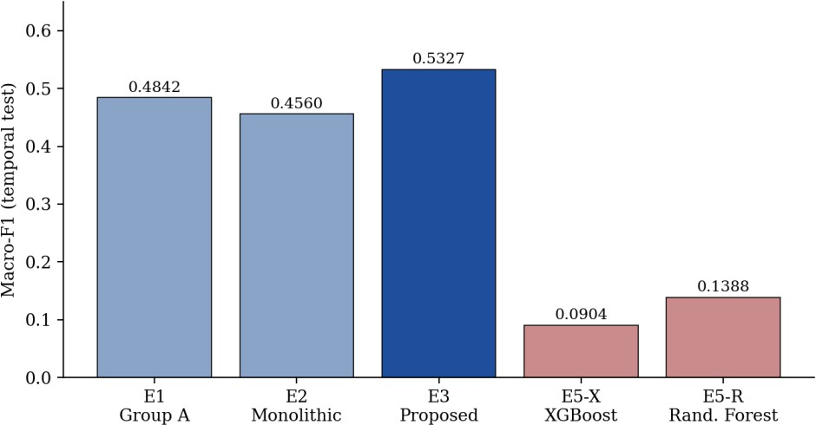
Figure 6.2: Macro-F1 on the Temporal Test Set for Different Configurations
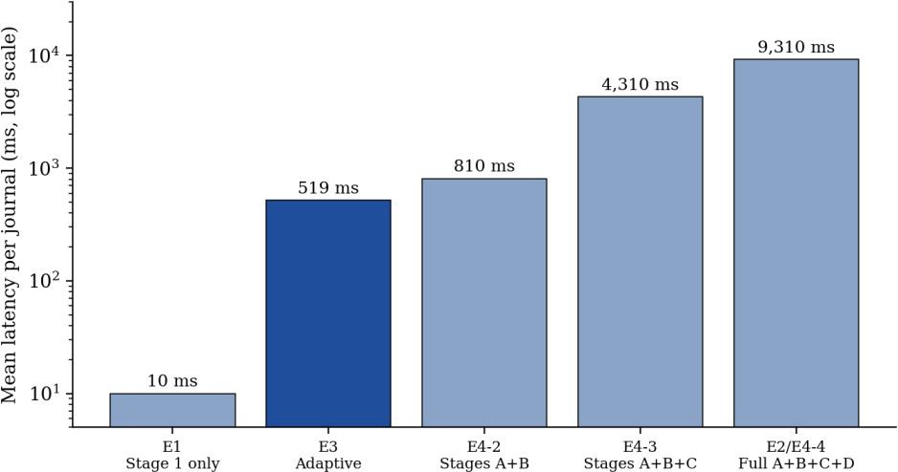
Figure 6.3: Mean Inference Latency per Journal for Different Configurations
    - Key Findings
      - 94.4% latency reduction. The adaptive controller (E3) resolves journals in 519 ms on average versus 9,310 ms for monolithic acquisition (E2), a 94.4% reduction in computational overhead.
      - Improved generalisation. Stopping early on decisive cases improves temporal Macro-F1 from 0.4560 (E2) to 0.5327 (E3), because uninformative downstream signals are not allowed to dilute the decision. E3 also has the best precision, specificity, predatory F1 and ROC-AUC among the neural configurations.
      - Tabular collapse is demonstrated. Tree-based baselines fitted on historical registry correlations collapse under drift: XGBoost reaches Macro-F1 of 0.0904 with specificity 0.0000, i.e. it labels almost every contemporary journal predatory, while the shared neural architecture retains balanced discriminative power.

      - Temporal drift is quantified. Performance falls from 0.9949 on historical in-distribution validation (E6-H) to 0.5327 on the temporal cohort, a reproducible Temporal Generalisation Ratio of 0.5354.
      - Calibration and abstention help. Calibration lowers ECE from 0.4619 to 0.3079. The tri-state rule resolves 87.2% of serials autonomously and reduces the false-positive rate from 29.9% to 13.8%.
Table 6.2: Key Quantitative Outcomes of the Proposed System

Metric | Value
Audited corpus size | 5,528 serials (frozen with SHA-256)
Mean latency, adaptive vs. full acquisition | 519 ms vs. 9,310 ms (94.4% reduction)
Temporal Macro-F1, adaptive vs. full acquisition | 0.5327 vs. 0.4560
Stage resolution of adaptive controller | 36.3% at Stage 1; 63.7% at Stage 2
Expected Calibration Error | 0.4619 reduced to 0.3079
Autonomously resolved serials (with abstention) | 87.2%
False-positive rate (with abstention) | 29.9% reduced to 13.8%
Temporal Generalisation Ratio | 0.5354

    - Discussion
The results show clearly that high in-distribution accuracy (0.9949) is not predictive of real-world performance, and that the temporal protocol is essential for honest evaluation. The absolute temporal Macro-F1 of 0.5327 is modest, which reflects the genuine difficulty of the task: the contemporary cohort is highly imbalanced (9.9% predatory) and predatory publishers actively mimic legitimate ones. The contribution of the proposed framework is therefore not an inflated headline accuracy but a more robust, cheaper and more accountable detector. The identical metrics of E2 and E4-2 to E4-4 indicate that, for the full-acquisition setting, later stages do not add discriminative signal beyond Stage 2 on this cohort, which further supports early stopping.

Streamlit Diagnostic Dashboard
The interactive dashboard (src/ui/app.py) exposes the system to non-technical users, such as librarians and research administrators, through four tabs:
- Single Journal Inspector: enter a journal URL or ISSN to run real-time progressive auditing, with an evidence provenance log for the verdict.
- Batch CSV Auditing: upload a list of ISSNs or URLs for high-throughput automated classification.

- Audited Dataset Explorer: browse records across the historical and contemporary cohorts.
- Empirical Benchmark Matrix: explore latency frontiers and diagnostic metrics interactively.
[Insert dashboard screenshots here: Figure 6.4 Single Journal Inspector, Figure 6.5 Batch CSV Auditing, Figure 6.6 Empirical Benchmark Matrix. Capture them by running streamlit run src/ui/app.py and use sharp, clear images with the figure number and title below each, as in the reference report.]

Conclusion
CHAPTER 7 CONCLUSIONS AND FUTURE SCOPE

This Technical Seminar presented Cost-Aware Progressive Predatory Journal Detection, a reproducible framework that addresses three structural weaknesses of earlier detectors: static in-distribution evaluation, uniform feature cost and ungrounded black-box predictions. By organising 42 features into four progressively acquired stages, training a shared progressive neural network, calibrating its posteriors and stopping adaptively, the system reduces mean inference latency by 94.4% (519 ms versus 9,310 ms) and improves temporal Macro-F1 from 0.4560 to 0.5327 compared with full feature acquisition.
The study also demonstrates that tree-based baselines collapse under temporal drift (XGBoost Macro-F1 = 0.0904) and quantifies drift with a Temporal Generalisation Ratio of 0.5354. Tri-state classification with selective abstention and deterministic evidence grounding makes the verdicts accountable: 87.2% of serials are resolved autonomously, the false-positive rate drops from 29.9% to 13.8%, and ambiguous journals are passed to human experts. The audited, hash-frozen dataset, scripted figures, test suite and Streamlit dashboard make the whole study reproducible.
As third-year Computer Engineering students, the work gave us practical experience in machine-learning research methodology, distribution-shift evaluation, calibration, web data acquisition, software engineering for reproducibility and scientific writing.

Limitations
    - Absolute performance on the contemporary cohort remains modest (Macro-F1 0.5327, predatory F1 0.2641), reflecting class imbalance and adversarial mimicry.
    - Stage 3 and Stage 4 features depend on external websites and APIs, which can be rate-limited, change structure or be temporarily unavailable.
    - The corpus has 5,528 serials; the number of contemporary predatory examples (179 in the temporal test set) is small.
    - The evidence-grounding engine is rule-based and only as complete as the registries it consults.

Future Scope
    - Continual and drift-aware learning: periodic retraining with newly verified journals and online drift monitoring.

    - Richer content features: language-model-based analysis of journal scope statements, editorial board consistency and review-time claims.
    - Larger and more diverse datasets: more contemporary predatory examples and coverage of journals from the Global South, to improve fairness and reliability.
    - Active learning with human audit: using librarian decisions on abstained cases as new labels.
    - Deployment: a public API and integration with institutional library and research-assessment systems.

Applications
    - Library and research-office screening of journals before faculty or students submit manuscripts.
    - Screening of reference lists and citation sources in systematic reviews and grant evaluations.
    - Indexing and funder due-diligence workflows that need explainable, auditable decisions.
    - The progressive, cost-aware, calibrated and abstaining design is reusable for other adversarial screening problems such as phishing, fake-shop and fraudulent-website detection.

REFERENCES
[1] J. Beall, "Criteria for determining predatory open-access publishers," Scholarly Open Access, vol. 3, pp. 1–6, 2015.

[2] C. Shen and B.-C. Björk, "'Predatory' open access: a longitudinal study of article volumes and market characteristics," BMC Medicine, vol. 13, no. 1, p. 230, 2015, doi: 10.1186/s12916-015-0469-2.

[3] B.-C. Björk and D. Solomon, "Open access versus subscription journals: a comparison of scientific impact," BMC Medicine, vol. 10, no. 1, p. 73, 2012, doi: 10.1186/1741-7015-10-73.

[4] K. D. Cobey, M. M. Lalu, B. Skidmore, N. Ahmadzai, A. Grudniewicz, and D. Moher, "What is a predatory journal? A scoping review," F1000Research, vol. 7, p. 1001, 2018, doi: 10.12688/f1000research.15256.2.

[5] A. Grudniewicz, D. Moher, K. D. Cobey, et al., "Predatory journals: no definition, no defence," Nature, vol. 576, no. 7786, pp. 210–212, 2019, doi: 10.1038/d41586-019-03759-y.

[6] D. Moher, L. Shamseer, K. D. Cobey, et al., "Stop this waste of people, animals and money," Nature, vol. 549, no. 7670, pp. 23–25, 2017, doi: 10.1038/549023a.

[7] L.-X. Chen, S.-W. Su, C.-H. Liao, K.-S. Wong, and S.-M. Yuan, "An open automation system for predatory journal detection," Scientific Reports, vol. 13, no. 1, p. 2976, 2023, doi: 10.1038/s41598-023-30176-z.

[8] J. A. Teixeira da Silva, "Variation in journal website characterization by an AI-driven 'predatory' journal detector," Expert Systems with Applications, vol. 283, p. 127933, 2025, doi: 10.1016/j.eswa.2025.127933.

[9] D. Al-Moghrabi, S. A. Arqub, M. P. Maroulakos, N. Pandis, and P. S. Fleming, "Can ChatGPT identify predatory biomedical and dental journals? A cross-sectional content analysis," Journal of Dentistry, vol. 142, p. 104840, 2024, doi: 10.1016/j.jdent.2024.104840.

[10] J. Wu, T. Liu, K. Mu, and L. Zhou, "Identification and causal analysis of predatory open access journals based on interpretable machine learning," Scientometrics, vol. 129, pp. 3125–3148, 2024, doi: 10.1007/s11192-024-04969-6.

[11] L. Shamseer, D. Moher, O. Maduekwe, et al., "Potential predatory and legitimate biomedical journals: can you tell the difference? A cross-sectional comparison," BMC Medicine, vol. 15, no. 1, pp. 1–14, 2017, doi: 10.1186/s12916-017-0785-9.

[12] F. Krawczyk and E. Kulczycki, "How do open access predatory journals operate in the era of artificial intelligence?," Journal of Informetrics, vol. 17, no. 2, p. 101402, 2023, doi: 10.1016/j.joi.2023.101402.

[13] M. Kachuee, K. Karkkainen, V. Ordonez, and M. Sarrafzadeh, "Cost-aware feature acquisition for dynamic health risk prediction," IEEE Journal of Biomedical and Health Informatics, vol. 23, no. 5, pp. 2056–2064, 2019, doi: 10.1109/JBHI.2018.2882772.

[14] Z. Xu, K. Q. Weinberger, and O. Chapelle, "Cost-sensitive tree of classifiers," in International Conference on Machine Learning (ICML), 2014, pp. 133–141.

[15] S. Teerapittayanon, B. McDanel, and H.-T. Kung, "BranchyNet: Fast inference via early exiting from deep neural networks," in 2016 23rd International Conference on Pattern Recognition (ICPR), IEEE, 2016, pp. 2464–2469, doi: 10.1109/ICPR.2016.7900006.

[16] W. Liu, P. Zhou, Z. Wang, Z. Zhao, H. Deng, and Q. Ju, "FastBERT: a self-distilling BERT with adaptive inference time," in Proceedings of the 58th Annual Meeting of the Association for Computational Linguistics (ACL), 2020, pp. 6036–6044, doi: 10.18653/v1/2020.acl-main.537.

[17] C. Cortes, G. DeSalvo, and M. Mohri, "Learning with rejection," in International Conference on Algorithmic Learning Theory, Springer, 2016, pp. 67–82, doi: 10.1007/978-3-319-46379-7_5.

[18] Y. Geifman and R. El-Yaniv, "Selective classification for deep neural networks," in Advances in Neural Information Processing Systems (NeurIPS), vol. 30, 2017, pp. 4878–4887.

[19] C. Guo, G. Pleiss, Y. Sun, and K. Q. Weinberger, "On calibration of modern neural networks," in International Conference on Machine Learning (ICML), PMLR, 2017, pp. 1321–1330.

[20] J. Platt, "Probabilistic outputs for support vector machines and comparisons to regularized likelihood methods," Advances in Large Margin Classifiers, vol. 10, no. 3, pp. 61–74, 1999.

