A project report on
Short-Term Electricity Demand and Solar Generation Forecasting for Grid Stability
An End-to-End Predictive Analytics, Graph Analysis, and Flexibility Dispatch Pipeline on All-India SCADA Telemetry

by
ACHAL PRAMOD TRIPATHI (23BCE1734)
PIYUSH AGRAWAL (23BCE1740)


SCHOOL OF COMPUTER SCIENCE AND
ENGINEERING (SCOPE)
October, 2026

Abstract
India's accelerating solar capacity deployment has fundamentally altered the daily load profile of the national grid, creating the characteristic "duck curve" — a deep midday trough in net load followed by a steep evening ramp. This project presents an end-to-end, reproducible pipeline that addresses the forecasting, analysis, and operational challenges arising from this transformation, using real Grid-India all-India SCADA data spanning September 2021 to June 2025 (33,432 cleaned hourly observations).
The work encompasses five integrated stages: (i) a rigorous data cleaning pipeline that processes raw 5-minute, 10-second, and hourly SCADA telemetry; (ii) exploratory analysis quantifying India's duck curve, including the observation that the mean evening 3-hour net-load ramp grew from 20.7 GW in 2023 to 33.2 GW in H1 2025; (iii) forecasting of solar generation, electricity demand, wind generation, and net load at hour-ahead and day-ahead horizons using seven model families (persistence baselines, Ridge regression, Random Forest, HistGradientBoosting, LightGBM, XGBoost, and LSTM), where gradient-boosted trees were selected for 6 of 8 tasks and beat the best naive baseline by 16.6–67.7% on a held-out 2025 test set; (iv) graph-based analysis and AC power-flow simulation of a benchmark 33-bus distribution feeder with 11,712 simulated operating points, where learned models predict technical losses with R² = 0.974; and (v) a forecast-informed 24-hour linear programme for battery storage, flexible load, and curtailment scheduling, validated by AC power flow on 167 test days, which reduces curtailment by 90.5%, technical losses by 17.0%, and the evening ramp by 25.6% compared with a curtailment-only baseline, with zero constraint violations.
All grid results are simulated on a benchmark network and are not measurements of India's grid.
Keywords: Solar forecasting, demand forecasting, duck curve, net load, gradient boosting, LSTM, distribution feeder, power flow, battery storage, linear programming, grid stability

Table of Contents
1. Introduction ― Background on India's duck curve, operational challenges, project scope
2. Literature Review ― Review of forecasting methodologies, duck curve research, graph analytics, and feeder benchmarks
3. Problem Statement and Objectives ― Formal research questions, multi-objective targets, scientific provenance tagging framework
4. Data Sources and Provenance ― Grid-India SCADA telemetry, Open-Meteo NWP solar archives, IEEE 33-bus benchmark
5. Data Preprocessing Pipeline ― 10-stage cleaning rules, anomaly filters, Hampel estimators, and parquet dataset generation
6. Exploratory Data Analysis ― Temporal cyclicity, annual trends, seasonality, and solar-demand correlation structures
7. Duck Curve Characterisation ― Empirical measurement of net-load profiles, midday dip shift, and evening 3-hour ramp escalation
8. Surplus-Solar Risk Proxy ― Scenario formulation, CEA technical minimum thresholds, and future solar penetration risks
9. Forecasting Methodology ― 1-hour and day-ahead formulations, 7 model families, level-ratio transform, conformal intervals
10. Feature Engineering ― Information-set preservation, lag construction, calendar harmonics, leakage testing protocol
11. Model Training and Selection Protocol ― Hyperparameter optimization, refit pipeline, post-processing rules, and scoring
12. Forecasting Results and Evaluation ― Consolidated performance, benchmark comparisons, residual diagnostics, and error patterns
13. Grid Graph Construction and Analysis ― Network topology, graph metrics, branch-exchange reconfiguration, and battery siting
14. AC Power-Flow Simulation ― 11,712 operating points simulated via pandapower Newton-Raphson AC solver
15. Loss and Receiving-End Power Prediction ― Learned regression estimators for technical feeder losses (R²=0.974) and substation power
16. Optimisation Formulation ― 24-hour forecast-informed LinDistFlow linear program for battery dispatch and load shifting
17. Optimisation Results ― 167-day test evaluation, 90.5% curtailment mitigation, 17% loss reduction, AC validation
18. System Architecture and Dashboard ― Modular software structure, technology stack, interactive Streamlit application
19. Discussion ― Predictive accuracy value, operational robustness, and graph vs electrical analysis insights
20. Limitations ― 17 identified data, modeling, and operational limitations, plus 5 bug post-mortems
21. Conclusion and Future Work ― Summary of scientific contributions and 7 high-impact future research avenues
22. References ― Comprehensive bibliography of datasets, power systems literature, and software packages

1. Introduction
1.1 Background and Motivation
India has experienced extraordinary growth in solar energy capacity, with installed solar generation rising from approximately 37 GW in 2021 to over 64 GW by mid-2025. This rapid expansion has brought significant benefits — reduced carbon emissions, energy security, and lower marginal generation costs — but has also introduced a new set of operational challenges for grid operators.
The most visible manifestation of these challenges is the duck curve, a term originating from the California Independent System Operator's (CAISO) 2013 analysis. The duck curve describes the shape of net load (electricity demand minus variable renewable generation) across a day: solar generation depresses midday net load, creating a deep trough, while the evening hours require a rapid ramp-up of conventional generation as solar output falls and demand rises. In India, this phenomenon has intensified dramatically: the mean 3-hour evening net-load ramp grew from 21.0 GW in 2022 to 33.2 GW in the first half of 2025, with individual days exceeding 50 GW.
This duck curve creates several interconnected problems:
- Curtailment risk: When midday solar generation exceeds what the grid can absorb, excess energy must be curtailed, wasting clean energy and reducing the economic case for solar investment.
- Ramp-rate stress: Conventional thermal plants must ramp rapidly in the evening, which increases wear, emissions, and the risk of supply shortfalls.
- Voltage and thermal limit violations: At the distribution level, reverse power flows from distributed PV can cause overvoltage conditions and exceed line ratings.
- Balancing costs: The mismatch between variable generation and demand increases the need for flexible resources — storage, demand response, and fast-start generation.
Accurate short-term forecasting of solar generation and electricity demand is a prerequisite for addressing these challenges. If grid operators can anticipate the next day's solar output and demand profile, they can schedule battery storage, flexible loads, and curtailment in advance, thereby maximising solar utilisation, minimising technical losses, and maintaining grid stability.
1.2 Scope of This Work
This project builds an end-to-end pipeline from raw data to operationally validated scheduling decisions:
- Data processing: Cleaning and resampling of raw Grid-India SCADA telemetry into a reliable hourly time series.
- Exploratory analysis: Quantifying India's duck curve evolution, seasonal patterns, and the emergence of surplus-solar risk.
- Predictive modelling: Forecasting solar generation, demand, wind generation, and net load at 1-hour-ahead and day-ahead horizons using multiple model families under a rigorous evaluation protocol.
- Grid-level analysis: Representing a benchmark distribution feeder as a graph, analysing its topology, and simulating thousands of AC power-flow scenarios.
- Optimisation: Formulating and solving a forecast-informed 24-hour linear programme for battery, flexible load, and curtailment scheduling, with full AC power-flow validation.
Predictive analytics is the primary contribution. The grid simulation and optimisation serve to demonstrate that the forecasts are operationally useful.
2. Literature Review
2.1 Solar and Demand Forecasting
The literature on electricity load forecasting spans decades. Hong and Fan (2016) provide a comprehensive tutorial on probabilistic load forecasting, establishing the importance of prediction intervals alongside point forecasts. In the renewable energy domain, Antonanzas et al. (2016) review PV power forecasting across horizons from seconds to weeks, noting that machine learning approaches — particularly gradient boosting and neural networks — have increasingly displaced physics-based clear-sky models for short-term applications.
Hyndman and Koehler (2006) provide a foundational analysis of forecast accuracy measures, demonstrating that percentage-based metrics such as MAPE degenerate when actual values approach zero — a critical consideration for solar forecasting, where output is zero at night. They propose the Mean Absolute Scaled Error (MASE) as a robust alternative, a recommendation adopted in this project.
Among machine learning approaches, gradient-boosted decision trees have become the dominant paradigm for tabular time-series forecasting. LightGBM (Ke et al., 2017) introduced Gradient-based One-Side Sampling (GOSS) and Exclusive Feature Bundling (EFB), achieving large speedups at similar accuracy to conventional gradient boosting. XGBoost (Chen and Guestrin, 2016) remains widely used for its regularisation capabilities. Long Short-Term Memory networks (Hochreiter and Schmidhuber, 1997) are the standard recurrent architecture for sequence modelling, though their superiority over gradient boosting on tabular forecasting tasks is not consistently demonstrated in the literature.
2.2 The Duck Curve and Grid Flexibility
Denholm et al. (NREL, 2015) analysed the implications of increasing solar penetration, showing that under business-as-usual flexibility assumptions, solar energy supply near 20% of annual energy could push marginal curtailment above 30%. They demonstrated that distributed storage and flexible resources can substantially mitigate this problem. In the Indian context, the Central Electricity Authority's (CEA) 2023 regulations require coal-based thermal power plants to operate flexibly down to a 40% minimum load (with 55% as an interim step), defining how far conventional output can be backed down before solar must be curtailed.
The Economic Advisory Council to the Prime Minister (2026) recently reported the emergence of a duck-shaped net-load profile in India during summer months and a double-peaked "camel" pattern in winter, confirming that the phenomenon documented in California is now manifest in the Indian grid.
2.3 Power Grids as Complex Networks
Pagani and Aiello (2013) surveyed the application of complex-network (graph) analysis to power grids, demonstrating that topological indicators — degree distribution, betweenness centrality, clustering coefficient — provide structural insight into grid vulnerability and performance. However, they also note the fundamental limitation that topological metrics alone cannot determine electrical flows; power-flow analysis remains necessary.
2.4 Distribution Network Modelling
The 33-bus distribution feeder introduced by Baran and Wu (1989) is the most widely used benchmark for distribution network studies. Their work also established the branch-exchange method for loss-minimising network reconfiguration. The pandapower tool (Thurner et al., 2018) provides open-source AC power-flow analysis, state estimation, and short-circuit computation, enabling reproducible simulation studies.
3. Problem Statement and Objectives
3.1 Research Question
[NOTE]: *Can forecasts of all-India solar generation and electricity demand, built from real Grid-India SCADA data, be accurate enough to inform a constrained storage and flexible-load schedule? If so, does that schedule measurably reduce solar curtailment and technical losses in a physically simulated distribution feeder, compared with operation without the schedule?*

  - Objectives
- Build a reproducible data pipeline for Grid-India SCADA data (Sep 2021 – Jun 2025): cleaning, documented resampling to hourly resolution.
- Characterise the Indian duck curve with real data: net-load profiles, evening ramps, seasonal variation.
- Forecast solar, demand, wind, and net load at 1-hour-ahead and day-ahead horizons. Compare baselines, linear models, tree ensembles, gradient boosting, and an LSTM under one evaluation protocol.
- Define and estimate a scenario-based surplus-solar-risk proxy.
- Model a benchmark distribution feeder as a graph, analyse its topology, and generate labelled AC power-flow scenarios.
- Predict technical losses and receiving-end power on held-out scenario groups.
- Formulate a forecast-informed linear programme (LP) for battery, flexible load, and curtailment scheduling with linearised network constraints. Validate every schedule with full AC power flow and compare with baseline operation.
3.3 Data Provenance Framework
To maintain scientific rigour, every number, table, chart, and metric in the project is tagged with one of five provenance classes:
Tag | Meaning
OBSERVED | Grid-India SCADA values after documented cleaning
DERIVED | Arithmetic on observed values (net load, ramps, hourly means)
FORECAST | Model output
SIMULATED | pandapower AC power-flow results on the benchmark feeder
OPTIMISED | LP decisions under stated assumptions

4. Data Sources and Provenance
4.1 Primary Dataset: Grid-India SCADA
The primary data source is the Mendeley dataset "Electricity Demand, Solar and Wind Generation Data (September 2021 – June 2025) of India at 1-hour interval" (Mukherjee, Kalita, and Kumar, 2025; doi:10.17632/y58jknpgs8.2), licensed under CC BY 4.0. The data originate from the North-Eastern Regional Load Despatch Centre (NERLDC) of Grid-India, Ministry of Power, India.
The dataset comprises 29 Excel workbook files totalling 748 MB, with three distinct formats:
Period | Files | Resolution | Columns
Sep 2021 – Sep 2022 | 13 monthly | 5-minute | Thermal, hydro, gas, nuclear, wind, solar, demand
Oct 2022 – Dec 2023 | 15 monthly | 10-second | Same SCADA points
Jan 2024 – Jun 2025 | 1 combined | 1-hour | Demand, wind, solar, total generation only

[IMPORTANT]: Despite the dataset title stating "1-hour interval," only the 2024–25 file is hourly. The earlier files contain sub-minute SCADA data that must be resampled.

4.2 Weather Data (Experiment Only)
The Open-Meteo Historical Forecast API provides archived NWP model output including shortwave radiation, temperature, and cloud cover at hourly resolution for Indian solar hub coordinates. This data is used only in a separately labelled experiment and is never mixed into the baseline feature set, because archived NWP data is stitched from short-lead model runs and is therefore optimistic for day-ahead use.
4.3 Grid Network Data
No public source audited in this project provides Indian line-level topology, impedances, or receiving-end measurements. All grid simulation therefore uses the IEEE/Baran & Wu 33-bus, 12.66 kV distribution feeder (pandapower.networks.case33bw), a standard benchmark. All grid results are SIMULATED.
4.4 Sources Audited but Not Selected
Source | Reason Rejected
NREL PVDAQ | US site-level PV systems; not Indian grid-level
ICED (NITI Aayog) | Data only as chart exports; no explicit license
National Power Portal | Daily/monthly PDF/XLS reports; no hourly data

5. Data Preprocessing Pipeline
The preprocessing pipeline is implemented in src/data/preprocess.py and consists of ten logged cleaning steps applied to the raw SCADA data:
5.1 Cleaning Steps
Step | Rule | Count
1. Dropout rows | Demand = 0 → entire row marked NaN | 1,080 samples
1b. Zero dropouts | Exact 0 in non-solar columns → NaN | Hydro: 8,641; Nuclear: 3
2. Physical bounds | Values outside physical bounds → NaN | Demand: 2; Wind: 33; Gas: 2,234 (negative)
3. Hampel spikes | x − median\> max(6 · 1.4826 · MAD, floor) | Demand: 4,307; Solar: 3,389; Wind: 1,761
4. Negative solar | Clipped to 0 | 306,403 samples (night metering offset)
5. Hourly mean | Mean over [t, t+1h); NaN if < 50% valid | —
6. Hour-level spikes | Hampel with physical floors | Demand: 15; Thermal: 9; Wind: 2 hours
6b. Sustained dropouts | Same-clock-hour Hampel, 25 GW floor | 44 hours
7. Frozen telemetry | ≥ 3 identical consecutive non-zero values → NaN | Demand: 20; Solar: 80; Wind: 282 hours
8. Solar stuck values | Same-clock-hour Hampel, 1.5 GW floor | 277 hours
9. Solar night offset | Subtract day's median 00–03 h value; hours 20–03 set to 0 | 11,144 hours
10. Short gaps | Linear interpolation for gaps ≤ 2 hours, flagged | Demand: 440; Solar: 475; Wind: 27 hours

5.2 Quality Findings
Key quality issues discovered in the raw data include:
- Telemetry dropouts encoded as zeros: All-India demand of 0 MW is physically impossible; 25 of 28 monthly files contained such dropouts.
- Extreme spikes: Demand reached 466,674 MW and nuclear reached 38,397 MW in raw data, against true peaks of approximately 240 GW and 7 GW, respectively.
- Negative solar at night: Metering offsets produced solar values of −20 to −1,887 MW during nighttime hours.
- Non-stationarity: Solar maximum rose from ~37 GW (2021) to ~64 GW (2025), reflecting capacity additions.
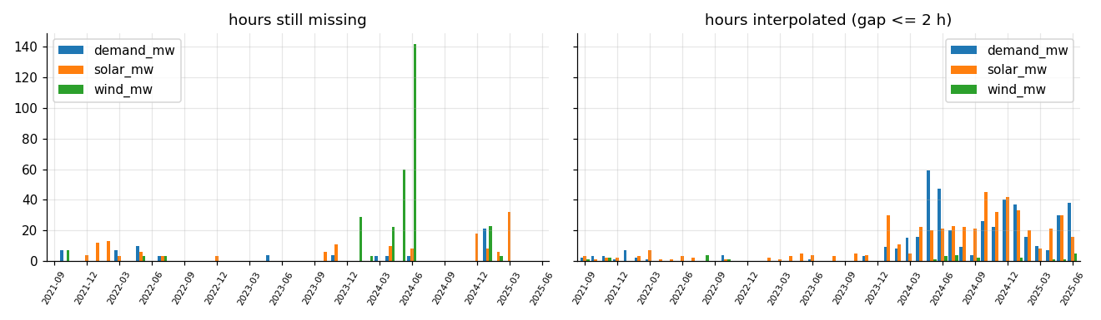
Figure 1: Missing and imputed hourly telemetry records across generation and load channels by month (Sep 2021 – Jun 2025).
5.3 Output Dataset
The resulting dataset data/processed/hourly.parquet contains:
Statistic | Demand (MW) | Solar (MW) | Wind (MW) | Net Load (MW)
Count | 33,367 | 33,289 | 33,137 | 32,996
Mean | 180,864 | 12,039 | 8,167 | 160,433
Std | 23,563 | 16,095 | 5,448 | 19,857
Min | 105,322 | 0 | 264 | 98,410
Max | 245,871 | 64,589 | 29,305 | 218,516
Missing hours | 65 | 143 | 295 | 436

6. Exploratory Data Analysis
6.1 Temporal Patterns
The dataset covers 33,432 hourly observations spanning September 2021 to June 2025. Analysis reveals several key patterns:
- Demand growth: Mean all-India demand increased steadily from approximately 165 GW in late 2021 to over 200 GW by mid-2025, with a strong seasonal cycle (summer peaks, monsoon troughs).
- Solar capacity growth: Daily peak solar output approximately doubled over the study period, from ~37 GW to ~64 GW, reflecting India's aggressive solar build-out programme.
- Weekly cyclicity: Demand exhibits clear weekday/weekend patterns, with Sunday demand typically 5–8% lower than Wednesday peaks.
- Seasonal patterns: Solar output is highest in pre-monsoon months (March–May) and lowest during the monsoon season (July–September), while demand peaks in summer (May–June) and experiences a secondary winter peak.
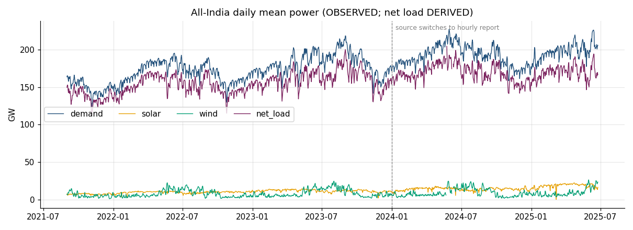
Figure 2: Daily mean time series for Demand, Solar, Wind, and Net Load over the full study period (September 2021 – June 2025).
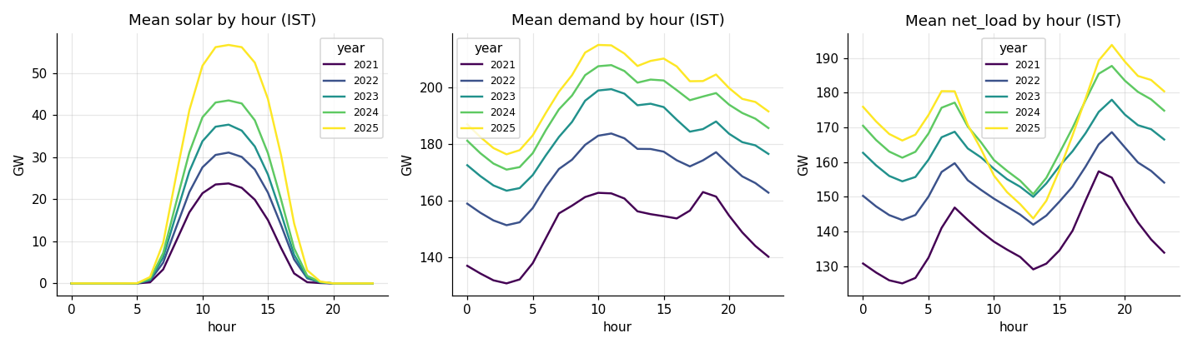
Figure 3: Average 24-hour diurnal profiles by year (2021–2025) showing steady demand growth and solar depression.
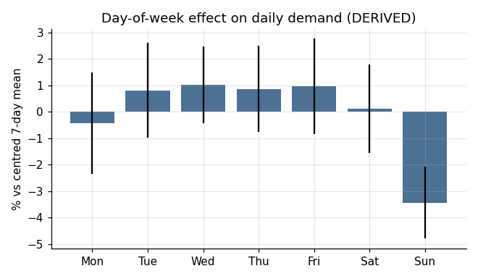
Figure 4: Electricity demand variations across days of the week, highlighting weekday peak vs weekend reductions.
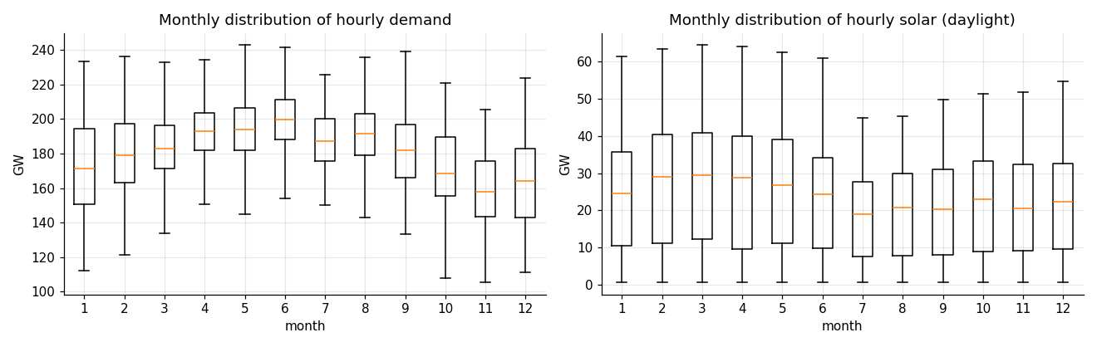
Figure 5: Monthly distributions and seasonal variability of Demand, Solar, and Wind generation.
6.2 Solar–Demand Correlation
Solar output and demand are partially anti-correlated in their daily profiles: demand rises in the morning (air conditioning, industrial loads), while solar peaks at midday. This misalignment is the fundamental driver of the duck curve. However, on a seasonal basis, both solar output and demand peak in summer, which partially mitigates the curtailment risk compared with climates where solar peaks in summer but demand peaks in winter.
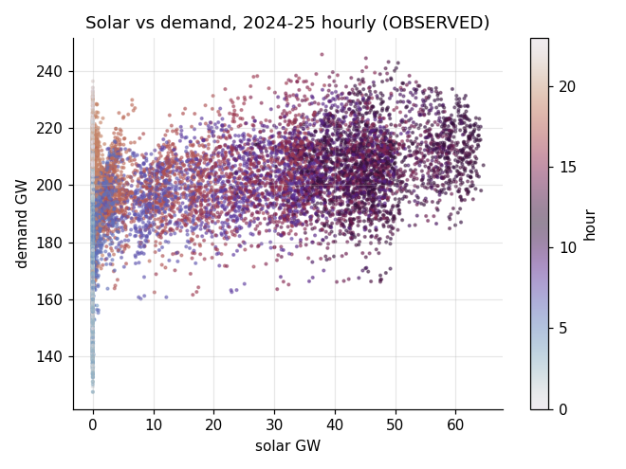
Figure 6: Scatter plot and joint distribution of all-India solar generation versus electricity demand.
7. Duck Curve Characterisation
7.1 Evolution of the Duck Curve
The duck curve — the daily profile of net load (demand minus solar minus wind) — is the central phenomenon motivating this project. Analysis of the SCADA data reveals its rapid evolution in India:
Year | Days | Min Net Load (MW) | Max Net Load (MW) | Mean Evening Ramp (GW) | P95 Ramp (GW) | Max Ramp (GW) | Solar Share (%)
2021* | 119 | 101,521 | 173,197 | 24.1 | 29.7 | 35.1 | 4.7%
2022 | 353 | 98,410 | 188,793 | 21.0 | 32.3 | 42.0 | 5.7%
2023 | 358 | 112,573 | 207,225 | 20.7 | 29.2 | 37.7 | 6.4%
2024 | 334 | 116,588 | 214,067 | 25.4 | 36.2 | 41.2 | 7.1%
2025† | 167 | 119,714 | 218,516 | 33.2 | 42.3 | 50.6 | 9.3%

\* Sep–Dec only. † Jan–Jun only.
Key observations:
- The daily net-load minimum shifted from nighttime (03:00) in 2021 to midday (13:00) from 2022 onward, confirming the emergence of the duck curve in India's all-India load profile.
- The mean evening 3-hour ramp grew by 60% from 2023 to H1 2025 (20.7 → 33.2 GW).
- The maximum single-day ramp reached 50.6 GW on 5 March 2025.
- Solar's share of demand energy nearly doubled from 4.7% (2021) to 9.3% (H1 2025).
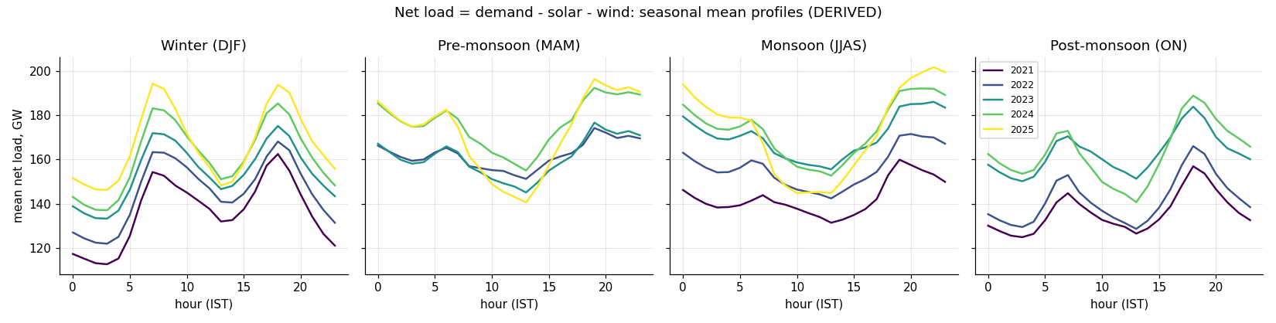
Figure 7: Seasonal net-load curves in the Indian power grid showing the deepening midday trough and steep evening ramp.
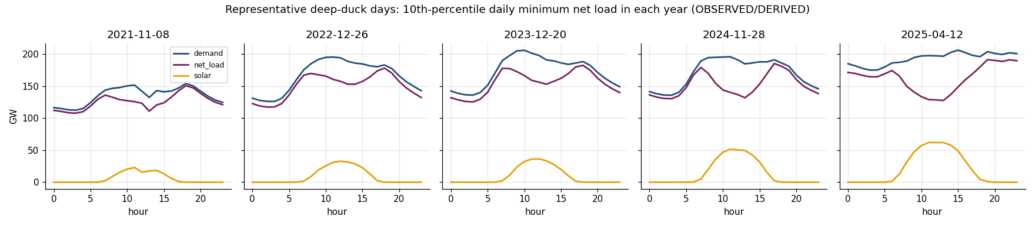
Figure 8: Representative 24-hour daily profiles comparing pre-monsoon, monsoon, summer, and winter net loads.
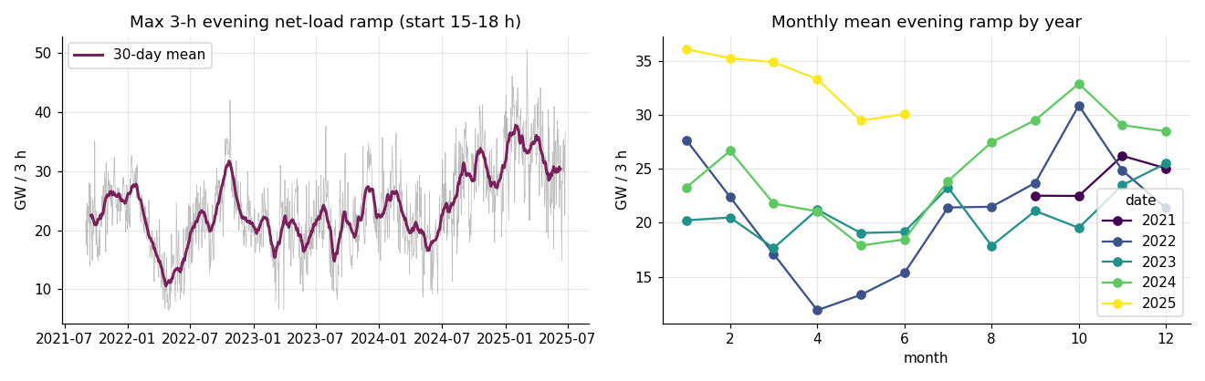
Figure 9: Evolution and distribution of the critical 3-hour evening net-load ramp from 2022 to 2025 (reaching 50.6 GW).
7.2 Seasonal Variation
The duck shape is most pronounced in pre-monsoon months (March–May), when solar output is highest and demand is near its summer peak. During the monsoon (July–September), cloud cover reduces solar output and the duck shape flattens. In winter, a moderate duck shape emerges with lower amplitude ramps.
8. Surplus-Solar Risk Proxy
8.1 Definition
Since the dataset contains no unit-commitment, reserve, inter-regional constraint, or curtailment records, actual surplus cannot be observed. Instead, a scenario-based proxy is defined:
Inflexible floor:
$$F_{t}=θ⋅{\text{Thermal}}_{\text{committed},d}+{\text{Nuclear}}_{t}+{\text{Hydro}}_{\min{,}d}$$
where ${”Thermal” }_{“committed” ,d}$is the daily maximum thermal output (proxy for online capacity),
$θ∈\left\{0.55,0.40\right\}$is the CEA technical-minimum share, and ${”Hydro” }_{\min{,}d}$} is the minimum hourly hydro output on day d (proxy for must-run hydro).
Surplus proxy:
$$S_{t}\left(k\right)=\max\left\{0, k⋅{\text{Solar}}_{t}+{\text{Wind}}_{t}+F_{t}-{\text{Demand}}_{t}\right\}$$where k is a solar scale-up factor representing future solar build-out.
8.2 Results
θ | Solar Scale (k) | Surplus Hours | Days with Surplus | Surplus Energy (GWh) | % of Solar Energy
0.55 | 1.0 | 0 | 0 | 0 | 0%
0.55 | 2.0 | 199 | 74 | 809 | 0.20%
0.55 | 3.0 | 3,631 | 776 | 56,075 | 9.15%
0.40 | 2.0 | 0 | 0 | 0 | 0%
0.40 | 3.0 | 1,030 | 312 | 8,699 | 1.42%

At the observed fleet size, zero surplus hours are found. Risk emerges at 2× solar with the 55% technical minimum and grows substantially at 3× solar. Lowering the technical minimum to 40% (the CEA target) eliminates most surplus risk at 2× solar and reduces it by 85% at 3× solar.
[NOTE]: This is an assumption-driven scenario indicator, not observed curtailment. It is valid only for the 2021–2023 period when the generation mix columns exist.

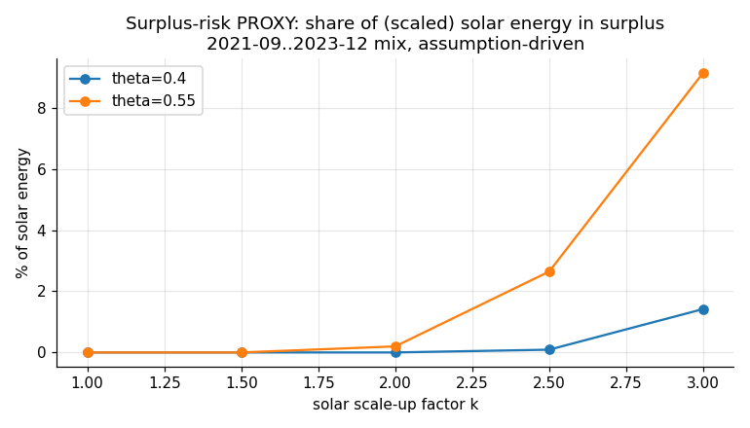
Figure 10: Surplus-solar risk duration curves across solar penetration multipliers (k=1.0, 2.0, 3.0) and thermal minimums.
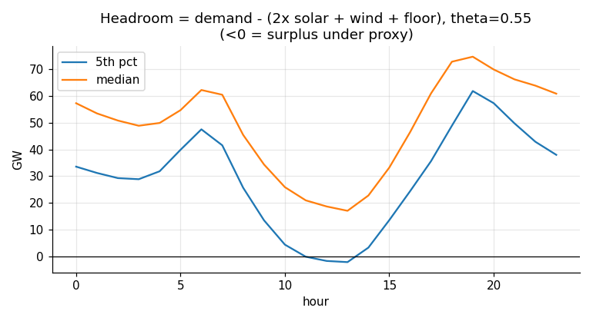
Figure 11: Diurnal distribution of thermal flexibility headroom and surplus risk by hour of day.
9. Forecasting Methodology
9.1 Task Definition
Eight forecasting tasks are defined, covering four targets at two horizons:
Horizon | Issue Time | Leads | Tasks
1-hour ahead (h1) | t - 1 hour | 1 h | solar_h1, demand_h1, wind_h1, net_load_h1
Day-ahead (da) | 10:00 on day D | 15–38 h | solar_da, demand_da, wind_da, net_load_da

For day-ahead forecasts, the forecast is issued at 10:00 IST on day D for all 24 hours of day D+1. Only data available through 09:00–10:00 on day D may be used as features. This constraint is enforced by the leakage guard check_no_leakage, which requires all day-ahead lags to be ≥ 38 hours (the maximum lead time from 09:00 on D to 23:00 on D+1).
9.2 Model Families
Seven model families are compared:
- Persistence: ${\hat{y}}_{t+h}=y_{t}$ (last observed value)
- Seasonal naive (24h): ${\hat{y}}_{t+h}=y_{t+h-24}$ (same hour yesterday)
- Seasonal naive (168h): ${\hat{y}}_{t+h}=y_{t+h-168}$ (same hour last week)
- Ridge regression: L2-regularised linear model with calendar and lag features
- Random Forest: Ensemble of 500 decision trees with bootstrap aggregation
- HistGradientBoosting: Scikit-learn's histogram-based gradient boosting
- LightGBM: Gradient-boosted trees with GOSS and EFB (Ke et al., 2017)
- XGBoost: Regularised gradient boosting (Chen and Guestrin, 2016)
- LSTM: PyTorch, 168-hour input sequence, L1 loss, Adam optimiser
9.3 The Level-Ratio Transform (Key Design Decision)
A critical challenge is that 2025 solar peaks (~64 GW) exceed all training values (≤ 55 GW). Tree-based models cannot extrapolate beyond the training range, leading to catastrophic test-time degradation: in a pilot run, LightGBM's day-ahead solar MAE was 1,178 MW on validation but 2,621 MW on test, worse than the naive baseline.
The solution is a LevelRatioRegressor wrapper. The target and its own lag/rolling features are divided by a "level" known at the issue time (the rolling 30-day maximum for solar and wind; the 168-hour mean for demand and net load). The model therefore learns shapes relative to recent level rather than absolute magnitudes. Predictions are multiplied back by the level at inference time.
With this transform, the same pilot's test MAE fell from 2,621 to 1,266 MW. Whether to use the transform is chosen per model family based on validation performance.
9.4 Prediction Intervals
Split-conformal prediction intervals are computed per hour of day. The absolute validation residuals of the train-only fit of the selected model give the 80th percentile per hour, applied symmetrically to test predictions. Lower bounds are clipped at 0 for solar and wind. Under distribution shift, empirical coverage may fall below the nominal 80%.
10. Feature Engineering
10.1 Feature Categories
Features are constructed in src/features/build.py with strict information-set enforcement:
Category | Features
Target lags | h1: {1, 2, 3, 24, 48, 168} hours; da: {48, 72, 168} hours
Cross-series lags | Other series at lags {1, 24} (h1) or {48, 168} (da)
Statistics at issue time | Last value, 24h mean/std/max, 168h mean, 720h max (capacity proxy), 7-day same-clock-hour mean
Calendar | Hour (raw + sin/cos), day-of-week, weekend flag, day-of-year harmonics, month
Weather | Optional, separately labelled: shortwave radiation, cloud cover from Open-Meteo

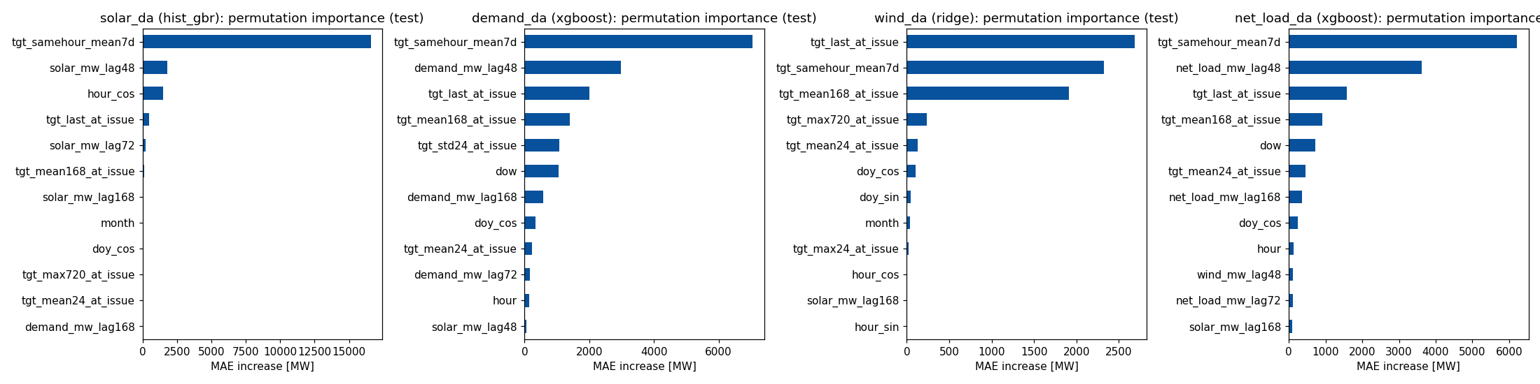
Figure 12: Permutation feature importance for day-ahead solar and electricity demand models.
10.2 Leakage Prevention
Leakage prevention is critical and implemented at two levels:
- Feature construction: The guard check_no_leakage requires every day-ahead lag to be ≥ 38 hours. This is tested by perturbation: multiplying all data after the issue time \tau by 1.37 must leave the row's features unchanged.
- Inference path: The same perturbation test is applied to the inference pipeline, ensuring that the production forecast path cannot access future data.
10.3 Chronological Splits
All splits are strictly chronological and never shuffled:
Split | Period | Purpose
Train | 2021-09-01 → 2024-06-30 | Model fitting
Validation | 2024-07-01 → 2024-12-31 | Hyperparameter tuning, model selection
Test | 2025-01-01 → 2025-06-24 | Final evaluation (used once)

11. Model Training and Selection Protocol
11.1 Hyperparameter Search
For each model family, bounded random/grid search is performed on the training set with scoring on the validation set:
Family | Configurations Searched | Key Hyperparameters
Ridge | 4 | α (regularisation strength)
Random Forest | 3 | max_depth, min_samples_leaf
HistGradientBoosting | 6 | max_iter, learning_rate, max_depth
LightGBM | 10 | num_leaves, learning_rate, min_child_samples
XGBoost | 6 | max_depth, learning_rate, subsample
LSTM | 2 (da) / 1 (h1) | Hidden size {32, 64}, ≤ 25 epochs

LightGBM and XGBoost use early stopping on validation loss with 150 rounds of patience.
  - Selection and Refitting
- The best configuration per family is selected by lowest validation MAE.
- The selected configuration is refitted on train + validation, reusing the early-stopped iteration count.
- The final test evaluation uses the refitted model and is performed once.
- The model selected for downstream use (optimisation) is the family with the lowest validation MAE. Test scores are never used for selection.
11.3 Post-Processing
- Solar and wind predictions are clipped at ≥ 0.
- Solar is set to 0 during hours 20:00–03:59 (physical nighttime).
12. Forecasting Results and Evaluation
12.1 Consolidated Model Comparison
The following table shows MAE (MW) for all model families on validation and test sets:
Model | Solar DA | Solar H1 | Demand DA | Demand H1 | Wind DA | Wind H1 | Net Load DA | Net Load H1
Ridge | 1,226/1,378 | 649/851 | 4,443/4,905 | 1,598/1,953 | 1,980/2,040 | 358/416 | 5,988/6,199 | 1,941/2,387
Random Forest | 1,123/1,238 | 532/597 | 4,249/4,619 | 1,337/1,707 | 2,086/2,199 | 362/410 | 5,756/6,284 | 1,908/2,506
HistGB | 1,081/1,277 | 487/580 | 4,275/4,513 | 1,257/1,461 | 2,037/2,341 | 346/392 | 5,713/6,343 | 1,616/2,035
LightGBM | 1,085/1,266 | 477/559 | 4,229/4,337 | 1,234/1,427 | 1,995/2,237 | 341/389 | 5,602/6,245 | 1,600/2,016
XGBoost | 1,092/1,248 | 482/586 | 4,226/4,631 | 1,252/1,497 | 2,024/2,240 | 344/389 | 5,585/6,488 | 1,616/2,023
LSTM | 1,314/1,937 | 1,109/1,664 | 6,108/6,683 | 4,654/5,580 | 2,161/2,033 | 876/1,133 | 7,839/8,972 | 3,639/3,893
Best Naive | 1,350/1,295 | 1,040/1,055 | 6,554/7,003 | 3,869/4,396 | 2,682/2,705 | 481/612 | 7,753/7,781 | 5,287/6,235

Bold = selected (lowest validation MAE). Format: validation/test.
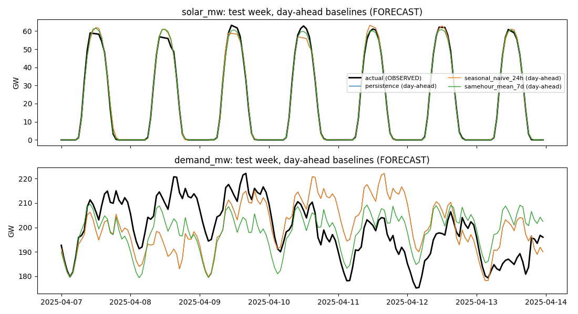
Figure 13: Ground-truth observed series compared with naive and seasonal baselines on a representative test week.
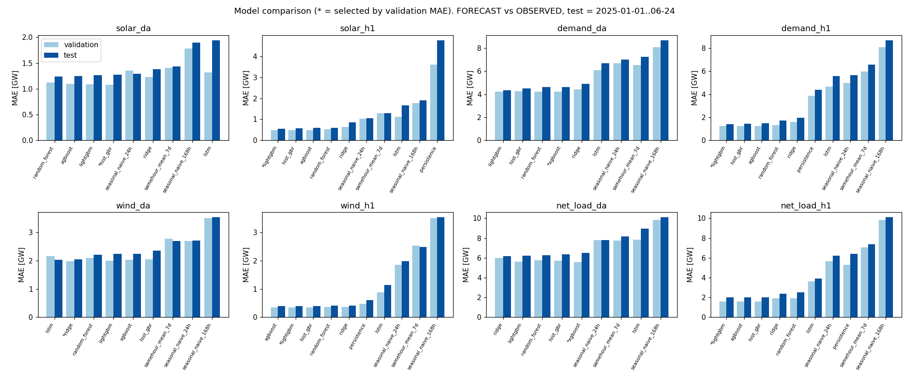
Figure 14: Consolidated MAE across all 7 model families across both 1-hour and day-ahead horizons for all 4 targets.
12.2 Selected Models — Test Performance
Task | Selected Model | MAE (MW) | RMSE (MW) | R² | nMAE (%) | vs Best Baseline | 80% PI Coverage
Solar, day-ahead | HistGB | 1,277 | 2,477 | 0.988 | 6.93 | +1.4% | 81.5%
Solar, 1-hour | LightGBM | 559 | 1,119 | 0.998 | 3.04 | +47.0% | 80.6%
Demand, day-ahead | XGBoost | 4,631 | 6,492 | 0.887 | 2.33 | +33.9% | 75.1%
Demand, 1-hour | LightGBM | 1,427 | 2,032 | 0.989 | 0.72 | +67.6% | 73.2%
Wind, day-ahead | Ridge | 2,040 | 2,716 | 0.783 | 22.0 | +24.3% | 77.9%
Wind, 1-hour | LightGBM | 389 | 535 | 0.992 | 4.20 | +36.5% | 75.1%
Net load, day-ahead | XGBoost | 6,488 | 8,517 | 0.830 | 3.81 | +16.6% | 73.3%
Net load, 1-hour | LightGBM | 2,016 | 2,773 | 0.982 | 1.18 | +67.7% | 68.5%

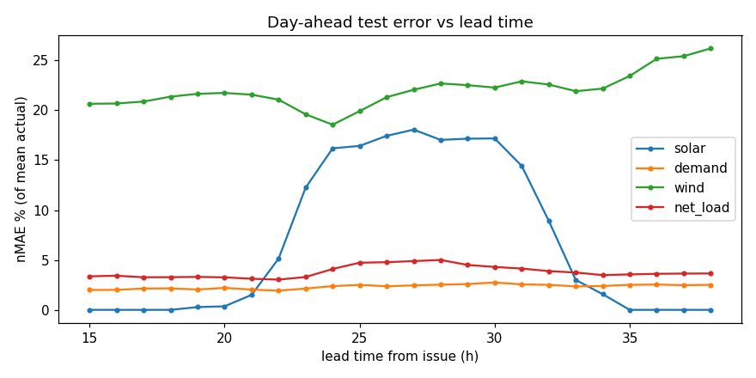
Figure 15: Forecast error (MAE) progression as a function of lead time across the 24-hour day-ahead horizon.
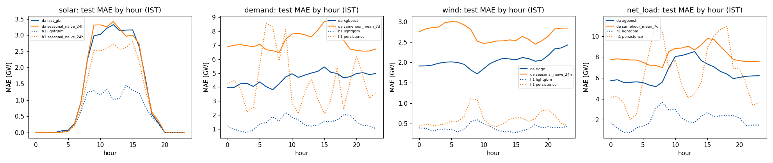
Figure 16: Forecast MAE decomposed across the 24 clock hours of the day for solar, demand, wind, and net load.
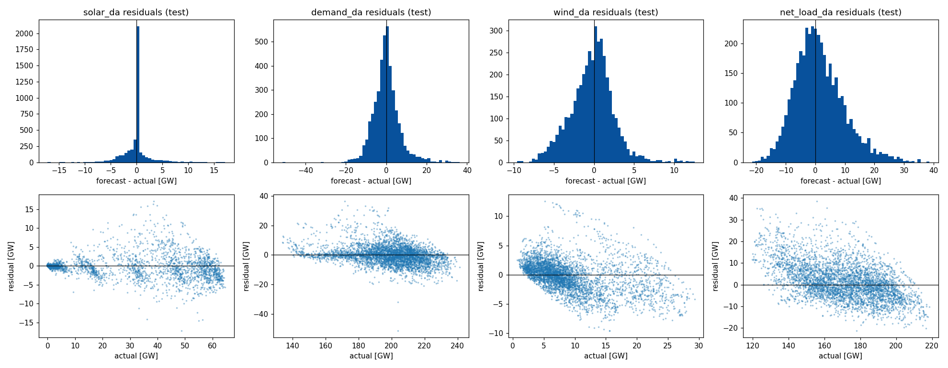
Figure 17: Day-ahead residual error distribution, histograms, and normal Q-Q plots.
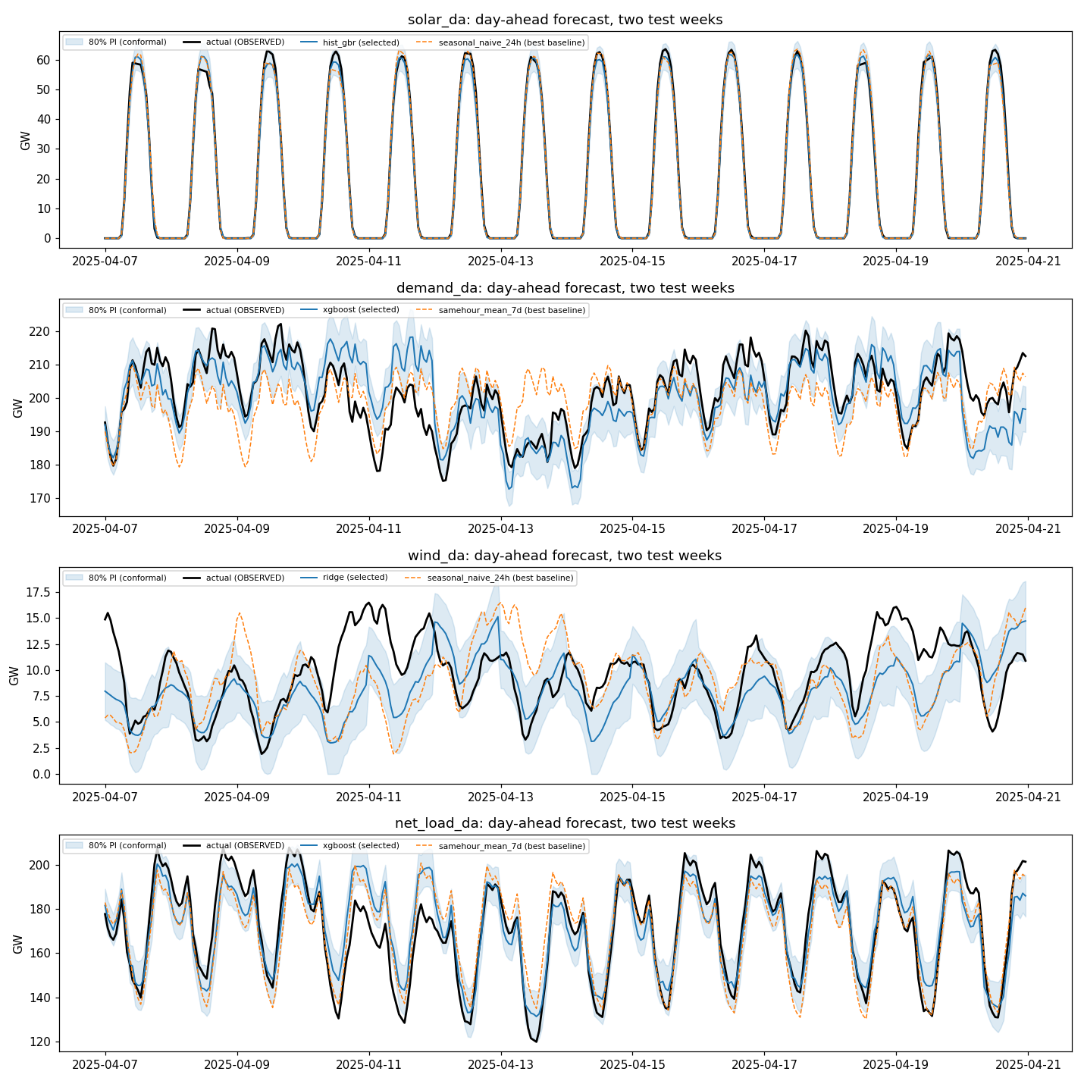
Figure 18: Day-ahead model forecasts with 80% conformal prediction intervals versus observed SCADA values across sample test weeks.
  - Key Findings
- Gradient-boosted trees dominate: They are selected for 6 of 8 tasks on validation. Differences between LightGBM, XGBoost, and HistGB are within ~3% on validation and ~7% on test.
- The LSTM did not justify its complexity: It was never selected and was worst among ML models on 7 of 8 tasks. A more extensive architecture search might narrow the gap, but the evidence here does not support using an LSTM over gradient boosting for these tasks.
- Day-ahead solar is hard without weather: The selected model improves on the seasonal-naive baseline by only 1.4% overall and is worse in the top-10% solar hours (−12.7%).
- Weather helps solar: Archived NWP features reduce day-ahead solar MAE by 10.5% (1,266 → 1,134 MW), but this is an optimistic upper bound for real day-ahead forecasting.
- Feature importance: The same-clock-hour 7-day mean is the dominant feature across all day-ahead tasks (permutation importance: solar +16,578 MW, demand +7,056 MW). Calendar-only models are 3–5× worse.
- Distribution shift: Test errors exceed validation errors for most tasks. Conformal 80% intervals under-cover on 6 of 8 tasks (68–82%), reflecting the 2025 period's higher solar and demand levels.
- Horizon effect: 1-hour-ahead errors are 2–5× smaller than day-ahead (demand nMAE: 0.72% vs 2.33%).
13. Grid Graph Construction and Analysis
13.1 Network Model
The IEEE/Baran & Wu 33-bus, 12.66 kV distribution feeder is modelled with the following specifications:
Parameter | Value | Source
Voltage level | 12.66 kV, 1.0 pu at bus 0 | Case file
Buses / lines | 33 buses; 37 lines (32 in-service + 5 tie lines) | Case file
Total load | 3.715 MW + 2.300 Mvar | Case file
Line rating | 0.25 kA (~5.5 MVA) | Assumption
Voltage limits | 0.90 – 1.05 pu | Assumption
PV plants | 1.5 MW each at buses 17, 21, 24, 32 | Assumption
Battery | 1.5 MW / 6 MWh at bus 17 | Selected by analysis
Export limit | 1.0 MW reverse power at bus 0 | Assumption

13.2 Graph Analysis
The feeder is represented as a weighted undirected graph in NetworkX, with edge weights equal to line impedances:
Metric | Result
Tree check (default config) | Radial (tree) ✓
Independent loops (cycle basis) | 5
Radial configurations (matrix-tree theorem) | 50,751
Bridges (single points of failure) | Line 0 only (substation–bus 1)
Maximum resistance distance to bus 0 | Bus 17 (11.06 Ω)
Highest betweenness centrality | Trunk buses 1–5

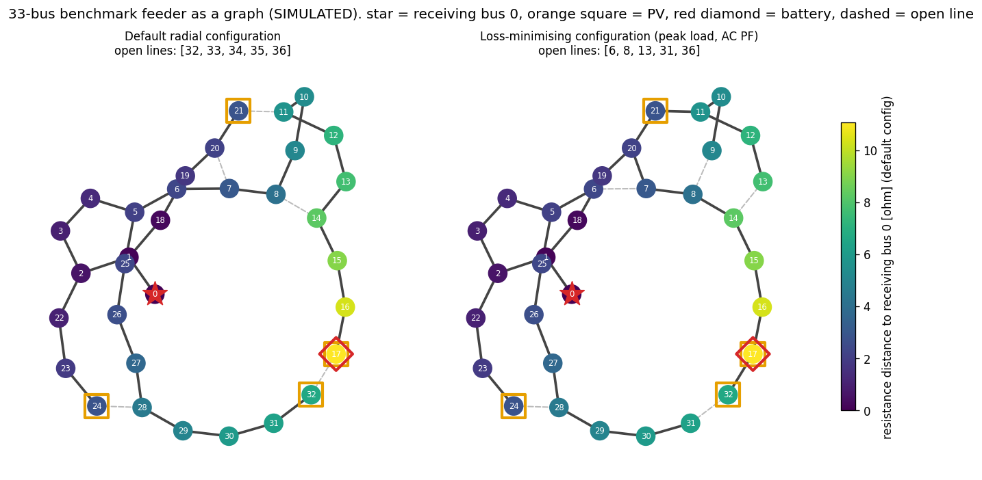
Figure 19: Topological graph representation of the IEEE 33-bus distribution feeder with PV, battery, and substation allocations.
13.3 Reconfiguration by Branch Exchange
Graph candidates for network reconfiguration are evaluated by AC power flow:
Condition | Configuration | AC Losses (MW) | Δ vs Default | V_min (pu)
Peak load, no PV | Default (lines 32–36 open) | 0.2027 | — | 0.913
Peak load, no PV | Branch exchange (447 evaluations) | 0.1396 | −31.1% | 0.938
Peak load, no PV | Min. spanning tree (graph only) | 0.2056 | +1.4% | 0.898 ⚠

[WARNING]: The minimum-resistance spanning tree — a purely graph-theoretic optimum — **increases** losses and **violates** the 0.90 pu voltage limit. This demonstrates that graph analysis is useful for candidate generation, but AC power-flow evaluation is indispensable.

13.4 Battery Siting
Battery siting candidates are evaluated by injecting/absorbing 1 MW at each bus:
Condition | Best Bus | Loss Reduction | Best Correlation (Graph Metric)
Peak load (discharge) | Bus 28 | 74.4 kW | Loss moment (Spearman 0.76)
Midday PV (charge) | Bus 17 | 65.9 kW | Resistance distance (Spearman 0.96)
Sum of both | Bus 17 | 122.8 kW | Selected

Bus 17 was selected as the battery site because the primary purpose is absorbing surplus PV, and bus 17 has the highest resistance distance (co-located with a PV plant at a lateral end of the feeder).
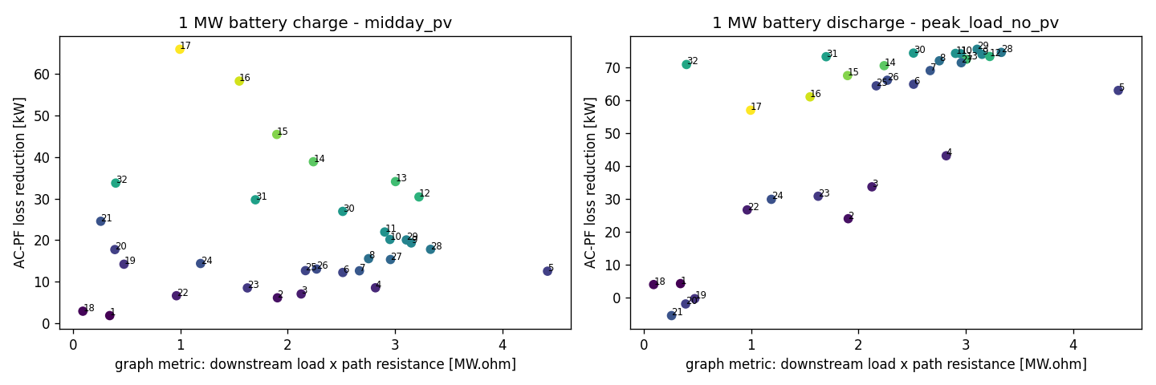
Figure 20: Feeder loss reduction and resistance distance profile for battery siting candidates across all 33 buses.
14. AC Power-Flow Simulation
14.1 Scenario Generation
A comprehensive scenario dataset is generated by sampling combinations of:
- Observed day: All-India demand and solar shapes from the training/validation period
- Network configuration: 7 selected radial configurations
- PV capacity: Random per-site capacity (0–1.5× rated)
- Battery profile: Random sinusoidal charge/discharge (±0–2 MW)
- Load noise: Lognormal per-bus noise (σ = 0.10)
- Load multiplier: 0.7–1.3× base load
Each operating point is simulated with pandapower's Newton-Raphson AC power flow. An energy-balance identity is asserted on every run:
$$\sum{P_{PV}}+P_{batt}-\sum{P_{load}}-P_{loss}-P_{recv}=0$$within 10^{-6} MW. Non-converged runs are excluded, never imputed.
14.2 Results
- Total converged scenarios: 11,692 operating points
- Base-case losses: 0.2027 MW (matches published value)
- Energy-balance violations: 0 (all within tolerance)
15. Loss and Receiving-End Power Prediction
15.1 Prediction Targets
Three targets are predicted from operating-point features:
Target | Definition
p_loss_mw | Total technical losses: $P_{”loss}” =\sum{}”lines” \left(p_{”from}” +p_{”to}” \right)$
p_recv_mw | Power received at bus 0: $P_{”recv}” =-P_{”ext_{grid}}”$
loss_pct | Loss percentage: "$Loss \%”=100×P_{”loss}”\frac{}{P_{”sent}}”$

15.2 Model Comparison
Models are evaluated with grouped splits by scenario family, ensuring no information leakage between train and test sets:
Target | Model | Test MAE | Test R²
p_loss_mw | Quadratic Ridge | 28.1 kW | 0.908
p_loss_mw | HistGradientBoosting | 13.0 kW | 0.970
p_loss_mw | LightGBM | 12.2 kW | 0.974
p_recv_mw | HistGradientBoosting | 21.1 kW | 0.9996
loss_pct | LightGBM | 0.27 pp | 0.971

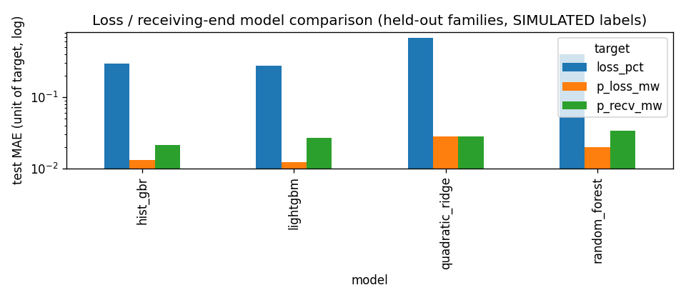
Figure 21: Performance comparison (MAE and R²) for learned technical loss and receiving-end power models.
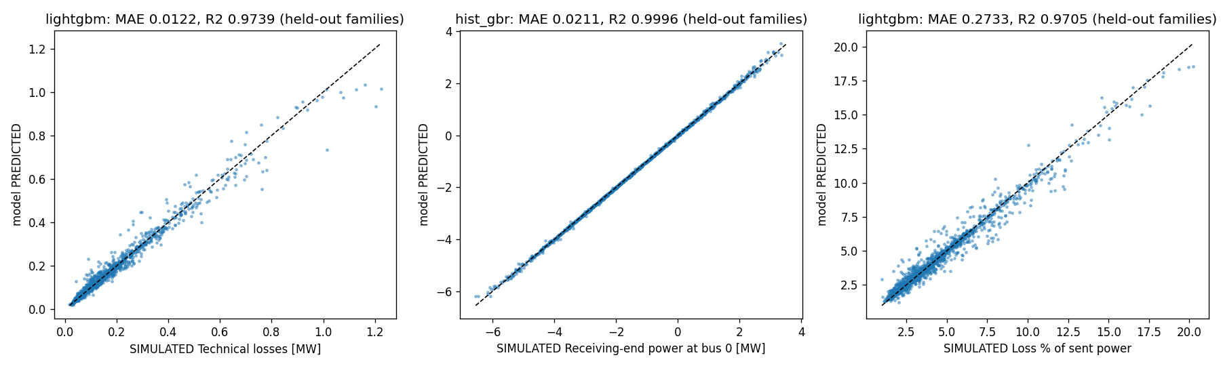
Figure 22: Predicted receiving-end power versus AC power-flow ground-truth simulations.
15.3 Validation
Fresh power-flow checks on 886 new operating points (unseen during training) confirm the models' generalisability: loss MAE 13.4 kW, received-power MAE 22.0 kW.
[NOTE]: The high R² for receiving-end power (0.9996) is largely **structural**: received power equals net injection minus losses, so once losses are well-predicted, receiving power follows. Loss prediction (R² = 0.974) is the substantive part.

16. Optimisation Formulation
16.1 Problem
Midday solar on the feeder can exceed what the grid can absorb, limited by the export limit (1 MW), the 1.05 pu overvoltage limit, and line ratings. The goal is to schedule battery storage and flexible load to maximise solar utilisation while satisfying all constraints.
16.2 Decision Variables (per hour $t$, 24 hours)
Variable | Meaning | Bounds
u_{kt} | PV used at site k; curtailment = available − used | 0 \leq u \leq a_{kt}
ch_t, dis_t | Battery charge / discharge | 0 \ldots 1.5 MW
soc_t | State of charge | 10–90% of 6 MWh
d_t | Flexible-load shift | $ d_t\leq 10\%$ of planned load
P_{jt}, Q_{jt}, v_{jt} | LinDistFlow branch flows and voltages | Per constraints

  - Constraints
- Power balance (LinDistFlow): $P_{j}={”withdrawal” }_{j}+\sum_{c∈”children” \left(j\right)}{P_{c}}$
- Voltage: $v_{j}=v_{i}-2\left(r_{ij}P_{j}+x_{ij}Q_{j}\right)$ with 0.005 pu margin for linearisation error
- Line limits: $\left|P_{j}\right|≤0.9\sqrt{3}×12.66×0.25$ $\left|P_{j}\right|≤4.93” MW”$
- Export limit: Reverse power at bus 0 ≤ 1.0 MW
- Battery dynamics: $SOC_{t}=SOC_{t-1}+η ch_{t}-\frac{dis_{t}}{η}$
- Flexible load: Energy-neutral over the day: \sum d_t = 0
16.4 Objective Function
$$\begin{aligned}\min{ }J=&1.0\sum_{t}{{\text{curtailment}}_{t}} +1.0 \sum_{t}{{\text{loss_proxy}}_{t}} +0.05\sum_{t}{\left|{\text{head}}_{t}-{\text{head}}_{t-1}\right|} +0.005\sum_{t}{\left(ch_{t}+dis_{t}\right)} \\ \\ & \\ \end{aligned}$$The loss proxy uses a convex outer approximation of $rP^{2}$, which underestimates AC losses. AC re-simulation reports the true value.
16.5 Cases Compared
Case | Planning Info | Battery/Flex | Realisation
Baseline | None | None | Curtailment-only LP on actual day
Rule-based | Actual (reactive) | Charge from surplus; discharge 17–22h | Fixed battery, curtailment LP
Forecast-informed | Day-ahead forecasts | LP schedule | Battery & flex fixed; curtailment re-optimised
Perfect foresight | Actual values | LP schedule | Upper bound on achievable benefit

16.6 AC Validation
Every realised hourly schedule is re-simulated with pandapower AC power flow. Losses, voltages, line loadings, and constraint violations are reported. Any discrepancy between LP export and AC export is tracked and disclosed.
17. Optimisation Results
17.1 Aggregate Results (167 Test Days)
All cases achieved optimal solver status with zero AC-validated constraint violations.
Metric | Baseline | Rule-Based | Forecast-Informed | Perfect Foresight
PV available (MWh) | 7,140.2 | 7,140.2 | 7,140.2 | 7,140.2
Curtailment (MWh) | 967.9 | 578.8 | 91.7 | 41.5
Solar utilisation (%) | 86.4% | 91.9% | 98.7% | 99.4%
Technical losses (MWh) | 403.3 | 392.1 | 334.9 | 336.6
Mean evening ramp (MW) | 3.63 | 3.27 | 2.70 | 2.74
Export to upstream (MWh) | 990.4 | 1,013.0 | 676.5 | 707.5
Peak import (MW) | 3.76 | 3.76 | 2.89 | 2.83
Battery throughput (MWh) | 0.0 | 740.3 | 1,777.7 | 2,009.1
Voltage violations | 0 | 0 | 0 | 0
Thermal violations | 0 | 0 | 0 | 0
LP slack total | 0.0 | 0.0 | 0.0 | 0.0

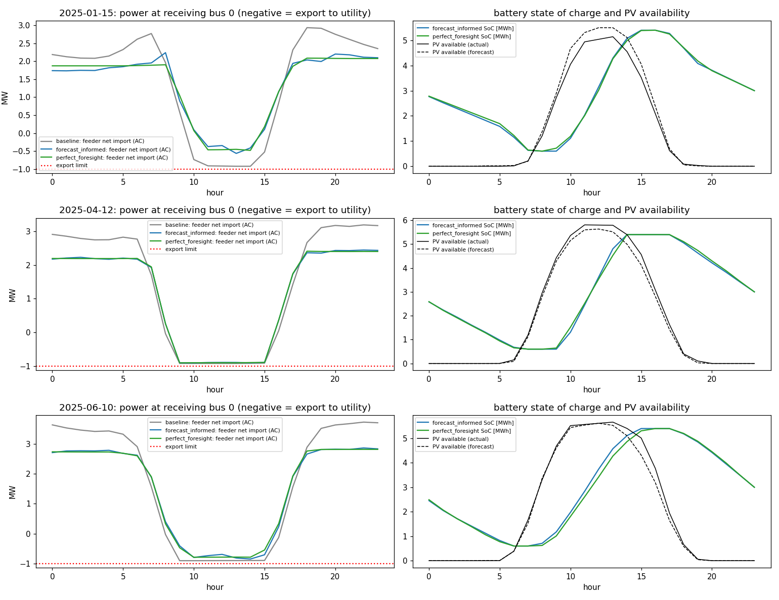
Figure 23: 24-hour dispatch profiles illustrating battery charging/discharging, flexible load shifting, and curtailment mitigation on sample test days.
17.2 Relative Improvements vs Baseline
Metric | Rule-Based | Forecast-Informed | Perfect Foresight
Curtailment | −40.2% | −90.5% | −95.7%
Technical losses | −2.8% | −17.0% | −16.5%
Mean evening ramp | −9.8% | −25.6% | −24.4%
Peak import | −0.0% | −23.2% | −24.7%
Export to upstream | +2.3% | −31.7% | −28.6%

  - Key Findings
- Forecast-informed scheduling achieves 93.6% of the perfect-foresight curtailment reduction. This demonstrates that the day-ahead forecasts, despite their limitations, are operationally useful.
- Curtailment is reduced by 90.5% (967.9 → 91.7 MWh), raising solar utilisation from 86.4% to 98.7%.
- Technical losses fall by 17.0% (403.3 → 334.9 MWh), because battery dispatch reduces peak line loadings.
- The evening ramp is reduced by 25.6% (3.63 → 2.70 MW), as stored solar energy is discharged during peak hours.
- Export to the upstream utility falls by 31.7%. This is a trade-off: surplus solar is used locally rather than exported. Whether this is beneficial depends on the value placed on local self-consumption versus grid export.
- Battery sensitivity: Curtailment drops to 45.9 / 14.0 / 4.4 MWh with 3 / 6 / 12 MWh batteries (20-day sample).
18. System Architecture and Dashboard
18.1 Software Architecture
The project follows a modular architecture with two main pipelines:
FORECASTING PIPELINE (real data)
Raw SCADA → src/data (clean) → hourly.parquet → src/features → src/training → models/
↓
src/analysis (EDA, duck curve)
↓
GRID PIPELINE (simulation)
src/grid (33-bus network, graph) → src/simulation → src/power_flow (AC PF)
↓
src/receiving_power (loss models)
↓
src/optimization (24h LP + AC validation)
↓
results/ → app/ (Streamlit dashboard)

The two pipelines exchange shapes, not magnitudes: all-India demand and solar profiles are normalised and mapped onto the feeder's ratings.
18.2 Technology Stack
Component | Technology
Language | Python 3.11
Data processing | pandas, NumPy, pyarrow
Machine learning | scikit-learn 1.6.1, LightGBM 4.7.0, XGBoost 3.0.5
Deep learning | PyTorch 2.10.0
Power systems | pandapower 3.5.6
Graph analysis | NetworkX 3.4.2
Optimisation | PuLP 3.3.2 + HiGHS 1.15.1
Visualisation | Plotly 6.9.0, Matplotlib 3.10.3
Dashboard | Streamlit 1.45.1
Testing | pytest 9.0.3

18.3 Interactive Dashboard
The Streamlit dashboard provides five pages:
- Overview: Project summary, model status, data coverage, and key limitations
- Forecasting: Interactive exploration of forecast vs actual values with adjustable test windows, model selection, and prediction intervals
- Duck curve: Seasonal net-load profiles, evening ramp trends, day-ahead forecast vs actual net load, and surplus-risk proxy results
- Grid & power delivery: Interactive 33-bus feeder visualisation with adjustable load, PV, and battery parameters; live AC power-flow simulation; reconfiguration and battery-siting analysis
- Model evaluation: Full model comparison tables, feature importance, ablation results, and loss/receiving-end model performance
Every metric on the dashboard carries a provenance tag and is read from saved artefacts (no retraining required).
18.4 Reproducibility
The entire pipeline is reproducible from raw data with five commands:
python scripts/download_data.py # 748 MB raw data, SHA-256 verified
python scripts/build_dataset.py # Cleaned hourly table
python scripts/run_eda.py # EDA and duck curve analysis
python scripts/train_models.py # All forecasting models
python -m streamlit run app/app.py # Dashboard

All processed data, trained models, and results are committed to version control, so the dashboard runs without retraining.
19. Discussion
19.1 Forecasting Performance
The forecasting results demonstrate that gradient-boosted tree ensembles are effective for short-term electricity demand and solar generation forecasting on all-India SCADA data. For 1-hour-ahead forecasting, improvements of 36–68% over naive baselines are achieved across all targets. Day-ahead improvements range from 1.4% (solar) to 34% (demand).
The modest improvement for day-ahead solar forecasting (1.4%) is a significant finding. Clear-sky spring days — when solar output is highly persistent — constitute the test period's high-solar hours, and the ML model's smoothing behaviour actually degrades performance during these conditions. The weather experiment confirms that NWP inputs would substantially improve day-ahead solar forecasts (−10.5% MAE), suggesting that operational deployment should incorporate weather data.
The LSTM's poor performance relative to gradient boosting — despite its theoretical advantage for sequence modelling — is consistent with recent empirical findings that tree-based methods dominate on tabular time-series tasks. The limited architecture search (one configuration for hourly tasks, ≤ 25 epochs) is a caveat, but the evidence here supports prioritising gradient boosting for this application.
19.2 The Value of Forecasts for Grid Operations
A key finding is that forecast quality matters less than one might expect for the scheduling decision. Day-ahead solar forecasts that only marginally beat persistence still deliver 93.6% of the achievable curtailment reduction. This is because the battery schedule is robust to moderate forecast error: when the planned schedule encounters actual conditions that differ from the forecast, real-time curtailment absorbs the residual. The main driver of benefit is having storage and flexibility at all.
This does not diminish the value of better forecasts — they would reduce the curtailment "residual" and improve evening ramp management — but it provides practical reassurance that forecast-informed scheduling is deployable even with current forecast accuracy.
19.3 Graph Analysis vs Electrical Analysis
The grid analysis provides a compelling demonstration that graph-theoretic methods and electrical analysis are complementary but not interchangeable. The minimum-resistance spanning tree — a graph-optimal topology — actually increases losses and violates voltage limits. Graph metrics are useful for reducing the search space (loss moment correlates at Spearman 0.76 with AC-validated loss reduction for battery siting at peak), but every candidate must be evaluated by AC power flow.
20. Limitations
  - Data Limitations
- All-India aggregates only: Regional transmission congestion — a major real driver of curtailment in India — is invisible in national aggregates.
- "Demand" is demand met: Load shedding (unserved demand) is not observed.
- Format change at 2024: The switch from sub-minute SCADA to hourly reporting introduces an undocumented aggregation method.
- Cleaning thresholds: All thresholds are judgement calls; some residual anomalies may remain.
- Generation mix: Available only to December 2023, limiting the surplus proxy to this period.
- No holiday calendar or weather in baseline models.
  - Forecasting Limitations
- Distribution shift: 2025 solar and demand levels exceed training, degrading interval coverage (68–82% vs nominal 80%).
- Day-ahead solar: Barely beats seasonal naive without weather; worse in top-solar hours.
- Limited LSTM search: The LSTM's poor ranking is evidence about this specific configuration, not LSTMs in general.
- Single chronological split: No rolling-origin cross-validation.
  - Grid and Simulation Limitations
- Benchmark feeder: The 33-bus network is not India's grid; line ratings, voltage limits, PV sites, and export limits are assumptions.
- Shared PV shape: All four PV sites use one all-India solar profile.
- Unity power factor: PV and battery operate at unity power factor (no reactive power control).
- Structural R²: Receiving-end power R² = 0.9996 is largely an identity; loss prediction is the substantive contribution.
  - Optimisation Limitations
- LP, not AC-OPF: LinDistFlow approximation; AC re-simulation reveals but does not fix linearisation errors.
- Ramp objective misalignment: The hour-to-hour ramp penalty is not well-aligned with the 3-hour evening ramp metric.
- No price signal or calendar ageing: Battery degradation is modelled as a linear throughput cost only.
20.5 Bugs Found and Fixed
Bug | Effect | Fix
Day-ahead leakage guard used shortest instead of longest lead | Would have accepted a leaking 24-h lag | Guard requires lag ≥ 38 h
Night solar re-filled by interpolation | Non-zero night solar | Zero-fill all night hours
Trees could not extrapolate to 2025 solar levels | Solar test MAE 2,621 vs val 1,178 MW | Level-ratio wrapper
Flexible load defined as fraction of load | 167/167 forecast-informed realisations infeasible | Absolute-MW energy-neutral shift
Inference index gap | Lag features misaligned for single-day forecasts | Contiguous index + regression test

21. Conclusion and Future Work
21.1 Conclusion
This project delivers a validated, end-to-end pipeline for short-term electricity demand and solar generation forecasting, grounded in real Grid-India SCADA data. The key contributions are:
- A rigorous data pipeline that cleans and resamples 4 million+ raw SCADA observations into 33,432 reliable hourly rows, with every transformation logged and tested.
- Quantitative duck-curve analysis showing that India's evening net-load ramp has grown 60% in two years (20.7 → 33.2 GW) and that the daily net-load minimum has shifted from nighttime to midday.
- A systematic forecasting comparison across seven model families and eight tasks, demonstrating that gradient-boosted trees beat naive baselines by 16.6–67.7% on a held-out 2025 test set, with the notable finding that day-ahead solar forecasting without weather inputs only marginally outperforms persistence.
- Graph-based grid analysis showing that topological methods are useful for candidate generation but require AC power-flow validation — the graph-optimal topology can be electrically worse.
- Simulation-based evidence that forecast-informed battery and flexible-load scheduling, validated by AC power flow on 167 days, reduces curtailment by 90.5%, losses by 17.0%, and the evening ramp by 25.6%, achieving 93.6% of the perfect-foresight benefit with zero constraint violations.
21.2 Future Work
Several directions would strengthen and extend this work:
- Operational weather inputs: Incorporating NWP data at the actual day-ahead issue time, rather than archived short-lead data, and quantifying the degradation compared with the optimistic upper bound found here.
- Regional disaggregation: Using state-level or regional data to capture transmission congestion and spatial diversity in solar output.
- Rolling-origin evaluation: Replacing the single chronological split with rolling-origin cross-validation to better characterise forecast reliability over time.
- Adaptive interval calibration: Developing methods to recalibrate prediction intervals under distribution shift, potentially using conformal prediction with adaptive non-conformity scores.
- Real feeder data: Validating the optimisation approach on a real distribution feeder with metered receiving-end data.
- AC-OPF or iterative coupling: Replacing the LP + AC post-hoc validation with either full AC optimal power flow or an iterative LP–power-flow coupling that converges to an AC-feasible solution.
- Economic objectives: Incorporating electricity prices, time-of-use tariffs, and realistic battery degradation models (calendar and cyclic ageing) into the optimisation objective.
22. References
Datasets
- [D1] Mukherjee D., Kalita K., Kumar S. (2025). Electricity Demand, Solar and Wind Generation Data (September 2021–June 2025) of India at 1-hour interval. Mendeley Data, V2. doi:10.17632/y58jknpgs8.2. CC BY 4.0.
- [D2] NREL. Photovoltaic Data Acquisition (PVDAQ) Public Datasets. data.gov / OEDI. CC BY 4.0.
- [D3] NITI Aayog. India Climate & Energy Dashboard (ICED). https://iced.niti.gov.in/.
- [D4] Ministry of Power / CEA. National Power Portal – Published Reports. https://npp.gov.in/publishedReports.
- [D5] Open-Meteo. Historical Forecast API. https://open-meteo.com/en/docs/historical-forecast-api.
Duck Curve and Grid Context
- [R1] Denholm P., O'Connell M., Brinkman G., Jorgenson J. (2015). Overgeneration from Solar Energy in California: A Field Guide to the Duck Chart. NREL/TP-6A20-65023.
- [R2] Central Electricity Authority (2023). CEA (Flexible Operation of Coal based Thermal Power Generating Units) Regulations, 2023.
- [R3] Economic Advisory Council to the PM (2026). The Duck and The Camel: Tracing the Net Load on the Indian Power Grid.
Forecasting
- [F1] Hong T., Fan S. (2016). Probabilistic electric load forecasting: A tutorial review. Int. J. Forecasting 32(3):914–938. doi:10.1016/j.ijforecast.2015.11.011.
- [F2] Antonanzas J. et al. (2016). Review of photovoltaic power forecasting. Solar Energy 136:78–111. doi:10.1016/j.solener.2016.06.069.
- [F3] Hyndman R.J., Koehler A.B. (2006). Another look at measures of forecast accuracy. Int. J. Forecasting 22(4):679–688. doi:10.1016/j.ijforecast.2006.03.001.
- [F4] Ke G. et al. (2017). LightGBM: A Highly Efficient Gradient Boosting Decision Tree. NeurIPS 30.
- [F5] Hochreiter S., Schmidhuber J. (1997). Long Short-Term Memory. Neural Computation 9(8):1735–1780. doi:10.1162/neco.1997.9.8.1735.
Grid Modelling
- [G1] Thurner L. et al. (2018). pandapower — An Open-Source Python Tool for Convenient Modeling, Analysis, and Optimization of Electric Power Systems. IEEE Trans. Power Syst. 33(6):6510–6521. doi:10.1109/TPWRS.2018.2829021.
- [G2] Baran M.E., Wu F.F. (1989). Network reconfiguration in distribution systems for loss reduction and load balancing. IEEE Trans. Power Delivery 4(2):1401–1407.
- [G3] pandapower documentation, Power System Test Cases — case33bw. https://pandapower.readthedocs.io/.
- [G4] Pagani G.A., Aiello M. (2013). The Power Grid as a complex network: A survey. Physica A 392(11):2688–2700. doi:10.1016/j.physa.2013.01.023.
Software
Python 3.11.9, NumPy 2.3.3, pandas 2.3.3, scikit-learn 1.6.1, XGBoost 3.0.5, LightGBM 4.7.0, PyTorch 2.10.0, NetworkX 3.4.2, pandapower 3.5.6, PuLP 3.3.2, HiGHS 1.15.1, Streamlit 1.45.1, Plotly 6.9.0, Matplotlib 3.10.3, pytest 9.0.3.

