**SMART WASTE MANAGEMENT SYSTEM**

by

|  |  |
| --- | --- |
| PIYUSH ARORA | 23BLC1005 |
| ANANYA KARMAKAR | 23BLC1017 |
| PRAGYAN PRIYA PRADHAN | 23BLC1032 |

A project report submitted to

**Dr. M. JAGANNATH**

**SCHOOL OF ELECTRONICS ENGINEERING**

in partial fulfilment of the requirements for the course of

**BECE204L – Microprocessors and Microcontrollers**

in

**B.Tech. ELECTRONICS AND COMPUTER ENGINEERING**



**Vellore Institute of Technology (VIT) CHENNAI**

**Vandalur – Kelambakkam Road**

**Chennai – 600127**

**APRIL 2025**

**BONAFIDE CERTIFICATE**

Certified that this project report entitled “**SMART WASTE MANAGEMENT SYSTEM”** is a bonafide work of **PIYUSH ARORA (23BLC1005), PRAGYAN PRIYA PRADHAN (23BLC1032)** and **ANANYA KARMAKAR (23BLC1017)** who carried out the Project work under my supervision and guidance.

**Dr. M. JAGANNATH**

Professor

School of Electronics Engineering (SENSE),

VIT University, Chennai

Chennai – 600 127.

**ABSTRACT**

Smart Waste Management is an advanced approach to handling waste using technology such as sensors, microcontrollers, and Internet of Things (IoT) systems. It enables real-time monitoring of waste levels, automates collection processes, and ensures better sanitation by reducing overflows, optimizing collection routes, and controlling odours. The goal is to make waste disposal more efficient, hygienic, environmentally friendly, and responsive to urban challenges.

In modern urban infrastructure, waste management remains a critical concern due to rising population density and increasing waste output. Traditional collection methods often result in resource wastage, delayed pickups, and health hazards. The integration of smart systems introduces automation and intelligence into the process, enabling bins to detect fill levels, emit alerts, and manage sanitation independently.

The use of microcontroller-based development boards such as the Silicon Technolabs 8051, in conjunction with ultrasonic sensors and IoT modules like the ESP8266 NodeMCU, allows for real-time waste level tracking and cloud-based monitoring via the Blynk platform. Contactless disposal using ultrasonic sensors enhances hygiene and promotes a cleaner, more efficient waste management process.

With the ability to raise alerts when bins are full, the system enables optimized scheduling of municipal collection trucks, saving fuel and operational costs. This leads to cleaner cities, improved public health, and more efficient use of resources.

In its advanced form, the system can be expanded to include intelligent routing, predictive analysis, and integration with smart city networks, contributing to a more sustainable and cleaner urban environment.

**ACKNOWLEDGEMENT**

We wish to express our sincere thanks and deep sense of gratitude to our project guide, **Dr. M. JAGANNATH,** Professor, School of Electronics Engineering, for his consistent encouragement and valuable guidance offered to us in a pleasant manner throughout the course of the project work.

We are extremely grateful to **Dr. A. Ravi Sankar,** Dean of the School of Electronics Engineering, VIT Chennai, for extending the facilities of the School towards our project and for her unstinting support.

We express our thanks to our Head of the Department **Dr. A. Annis Fathima** and Associate Dean (Academics) – SENSE, **Dr. Reena Monica P** for their support throughout the course of this project.

We also take this opportunity to thank all the faculty of the School for their support and their wisdom imparted to us throughout the course.

We thank our parents, family, and friends for bearing with us throughout the course of our project and for the opportunity they provided us in undergoing this course in such a prestigious institution.

**PIYUSH ARORA PRAGYAN PRIYA PRADHAN ANANYA KARMAKAR**

**TABLE OF CONTENTS**

|  |  |  |  |
| --- | --- | --- | --- |
| **SERIAL NO.** |  | **NAME** | **PAGE NO.** |
| 1. |  | ABSTRACT | 3 |
| 2. |  | ACKNOWLEDGEMENT | 4 |
| 3. |  | INTRODUCTION | 6 |
| 4. |  | OBJECTIVES | 6 |
| 5. |  | COMPONENTS REQUIRED | 7- 10 |
|  | 5.1 | HARDWARE | 7-9 |
|  | 5.2 | SOFTWARE | 10 |
| 6. |  | BLOCK DIAGRAM | 10-11 |
| 7. |  | METHODS OF IMPLEMENTATION | 12-19 |
|  | 7.1 | WORK FLOW | 12 |
|  | 7.2 | HARDWARE PROGRAMMING | 12-16 |
|  | 7.3 | SOFTWARE PROGRAMMING | 16-18 |
| 8. |  | WORKING PROTOTYPE | 18-19 |
| 9. |  | RESULTS | 20 |
| 10. |  | CONCLUSION | 20 |
| 11. |  | FUTURE WORK | 21 |
| 12. |  | REFERENCES | 21 |

**INTRODUCTION**

Smart Waste Management is a technology-driven approach aimed at improving the efficiency, hygiene, and sustainability of urban waste disposal systems. With the rise in population and urbanization, traditional waste management methods have become inadequate, often resulting in overflowing bins, delayed collection, and environmental pollution. This project integrates microcontrollers, IoT technology, and sensors to develop an intelligent waste monitoring system that automates bin tracking, improves hygiene through contactless disposal, and optimizes collection routes to save fuel and operational costs.

**OBJECTIVES**

1. **Contactless Waste Disposal:**
   * Uses an ultrasonic sensor to detect waste brought near the bin, automatically opening the lid for a touch-free disposal, promoting hygiene and reduces the risk of contamination.
2. **Real-Time Fill Level Monitoring:**
   * The system uses ultrasonic sensors to monitor bin fill levels and transmit data wirelessly through the ESP8266 NodeMCU to the Blynk IoT platform.
   * Municipalities can track waste levels in real-time, eliminating the need for manual bin inspections and preventing overflow of waste.
3. **Optimizing Waste Collection and Saving Fuel of Waste Collection Vehicles:**
   * By sending alerts only when bins are near capacity, the system optimizes the schedules for waste collection vehicles. This reduces unnecessary trips, saving fuel, lowering emissions, and cutting operational costs, making the process more sustainable and economical.
4. **Overflow Prevention Mechanism**:
   * The system proactively prevents overflow by monitoring bin levels and notifies the municipalities.
5. **Data Analytics for Smarter Waste Management**:
   * The integration of **Blynk IoT** provides real-time dashboards and analytical insights into waste generation trends.
   * Municipalities can use this data to plan more efficient waste management strategies and predict future needs for the area.

**COMPONENTS REQUIRED**

**HARDWARE**

1. **Silicon TechnoLabs 8051 Development Board**

* Purpose: Main hardware for controlling all components.
* Specifications:
  + Supports ATmega, 89S51/XX, 89S8252 microcontroller chips.
  + Onboard MAX232 and AT89S52 ATMEL 40 pin microcontroller.
  + Includes AVR USB ASP ISP programmer for code uploading.
* Functionality: Central processing unit for the project, coordinating all sensors and modules.

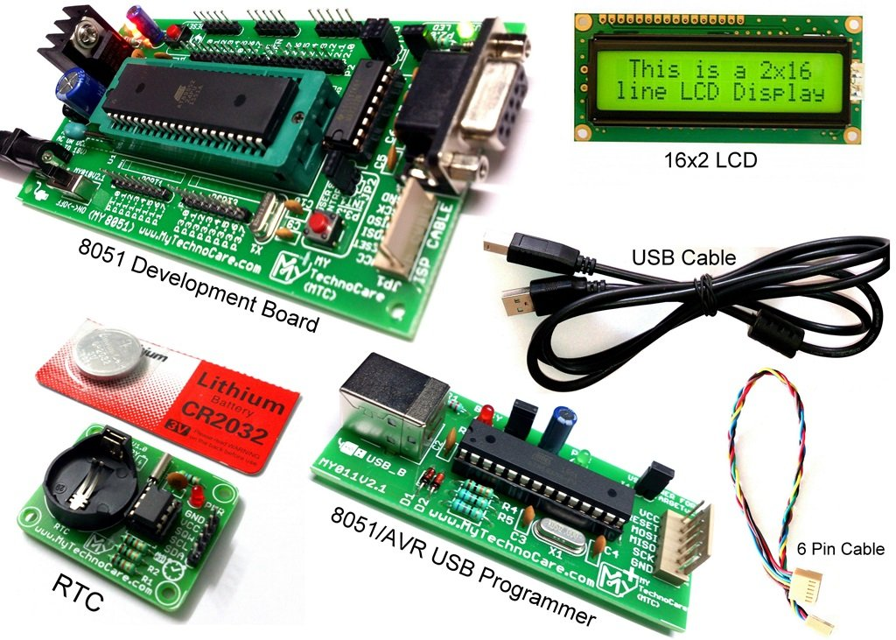

**Figure 1. Silicon TechnoLabs 8051 Development Board**

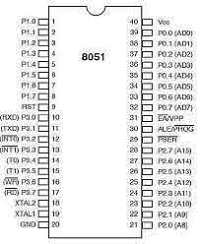

**Figure 2. 8051 Microcontroller Pin Diagram**

2. **Super Debug HC-SR04 Ultrasonic Sensor**

* Purpose: Detects the presence of a person and measures the trash level.
* Specifications:
  + Range: 2 cm to 400 cm with high accuracy.
  + Power Supply: 5V DC.
* Functionality: Two sensors are used— one to detect a person and the other to monitor trash levels.

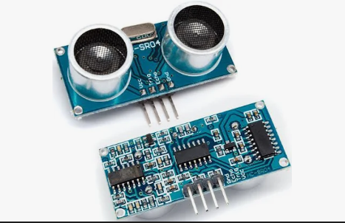

**Figure 3. Super Debug HC-SR04 Ultrasonic Sensor**

3. **Robocraze ESP8266 NodeMCU Development Board**

* Purpose: Collects input from the 8051 board and transmits data to the cloud.
* Specifications: Integrated Wi-Fi (ESP8266 module) with CP2102 chip.
* Functionality: Acts as a bridge between the development board and the Blynk IoT platform for wireless communication.

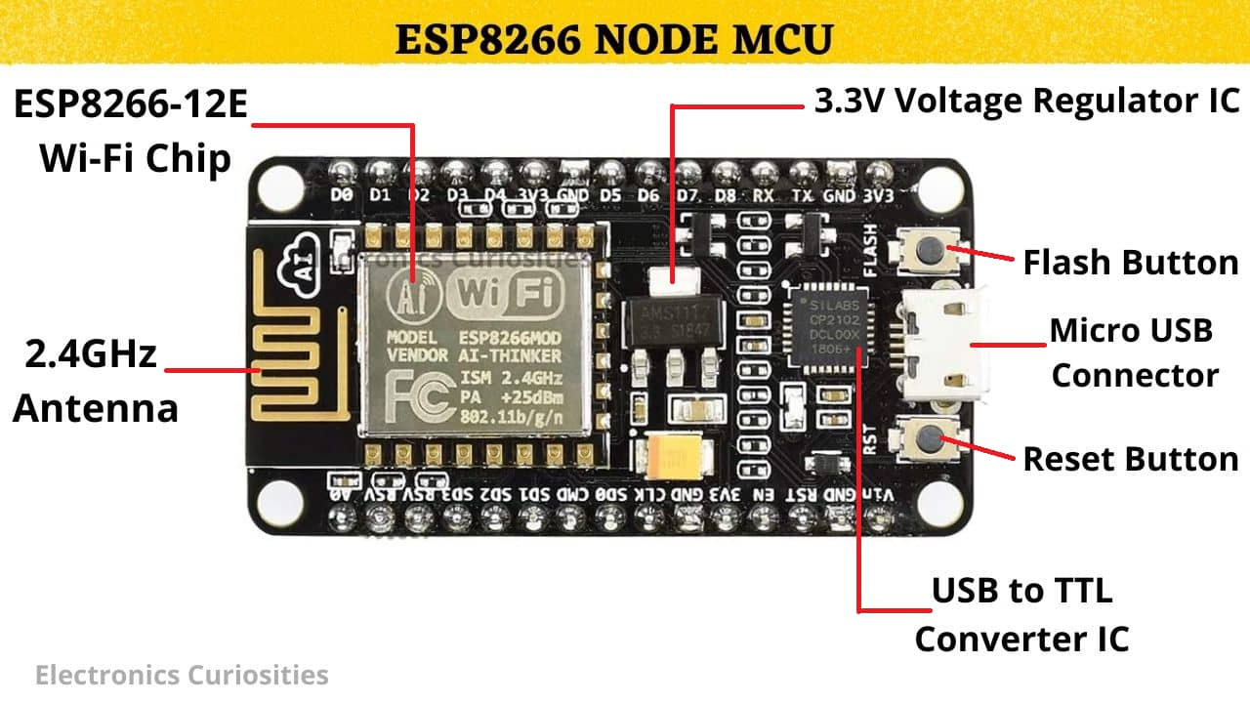

**Figure 4. Robocraze ESP8266 NodeMCU Development Board**

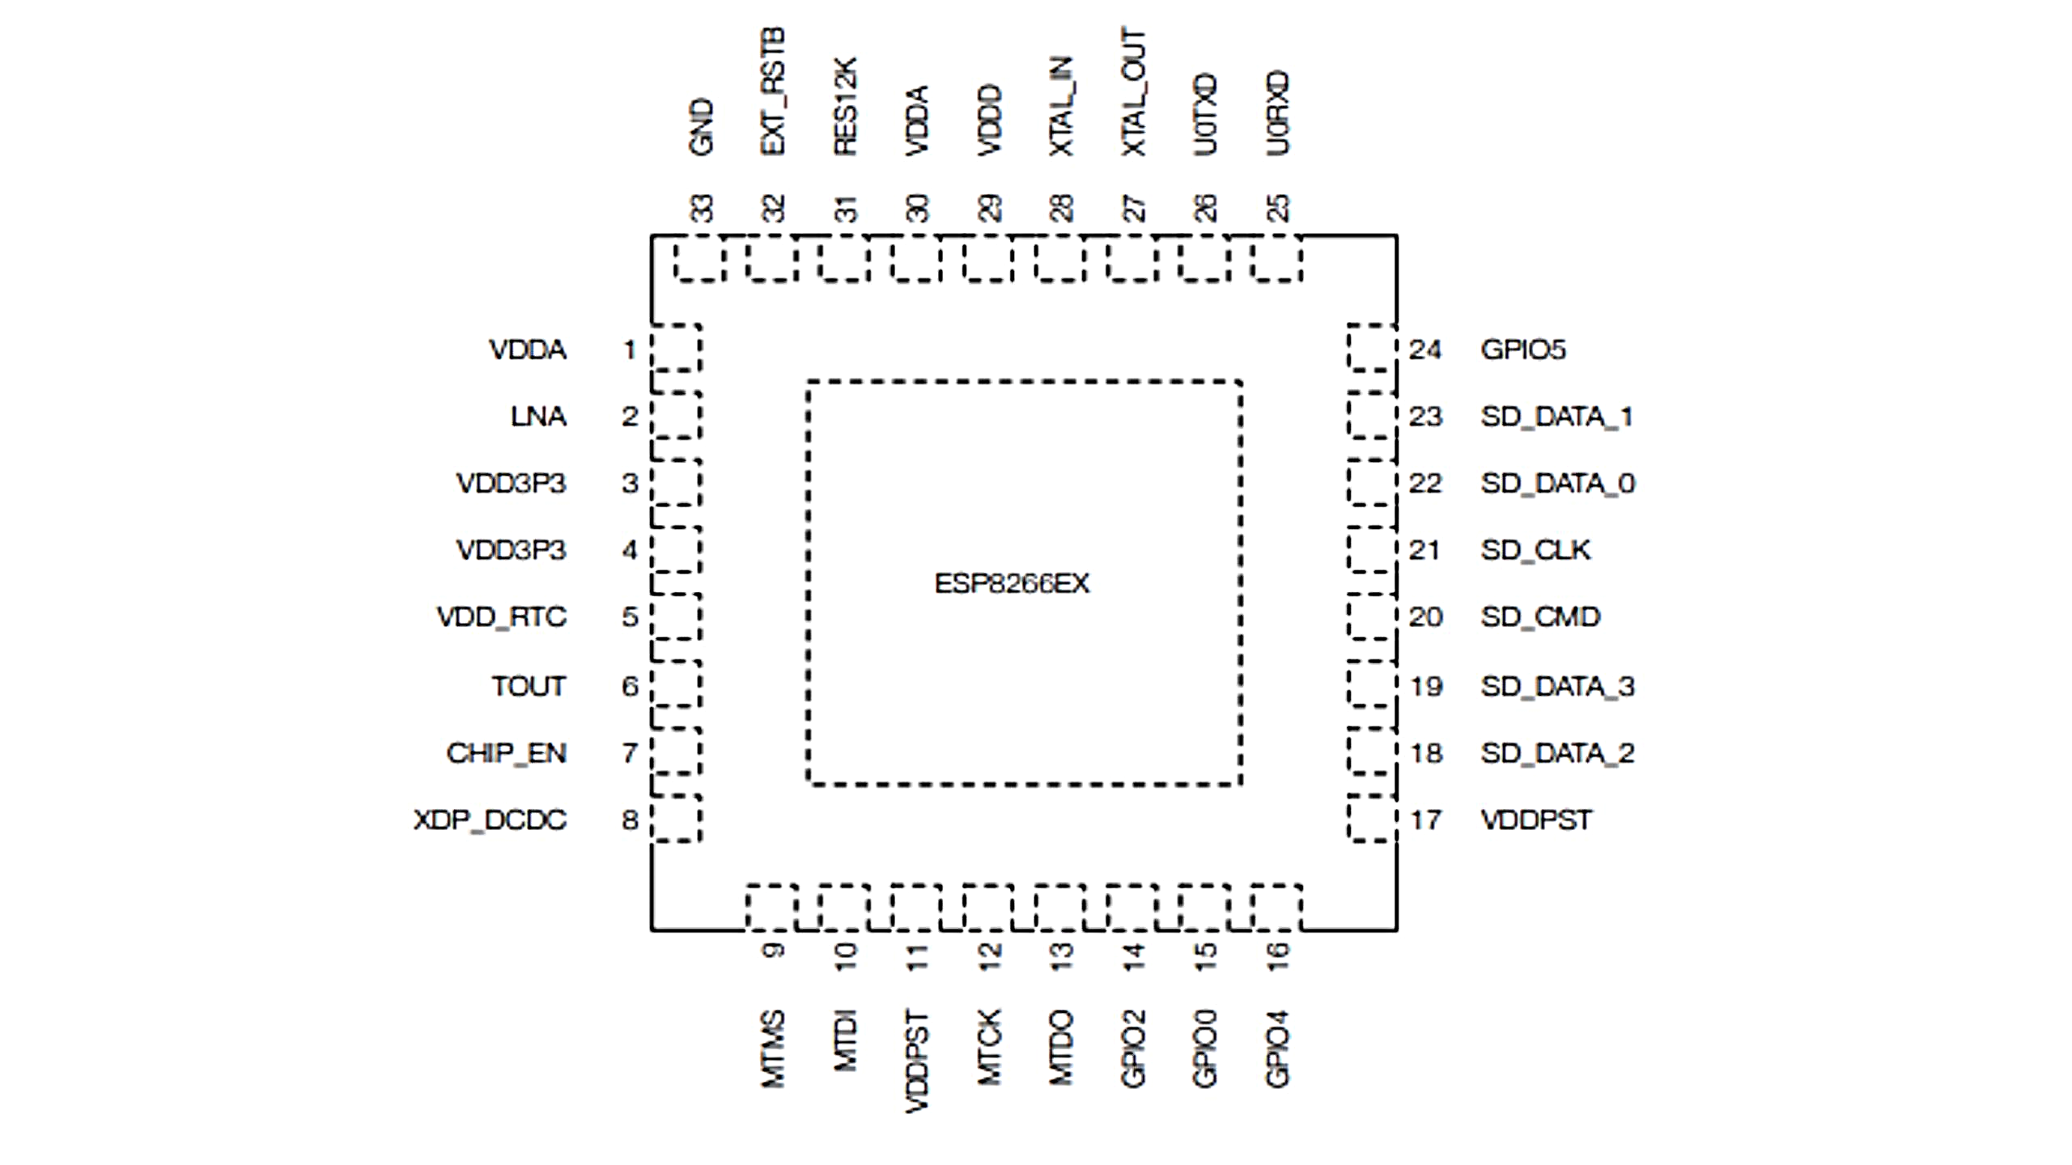

**Figure 5. ESP8266 NodeMCU Pin Diagram**

**SOFTWARE**

4. **Blynk IoT App**

* Purpose: Real-time data analysis and visualization for the corporation.
* Specifications:
  + Cloud-based IoT analytics platform with location tracking.
  + Provides customizable dashboards for monitoring sensor data.
* Functionality: Displays real-time trash levels and alerts based on sensor data for efficient management



**Figure 6. Blynk IOT platform**

**BLOCK DIAGRAM**

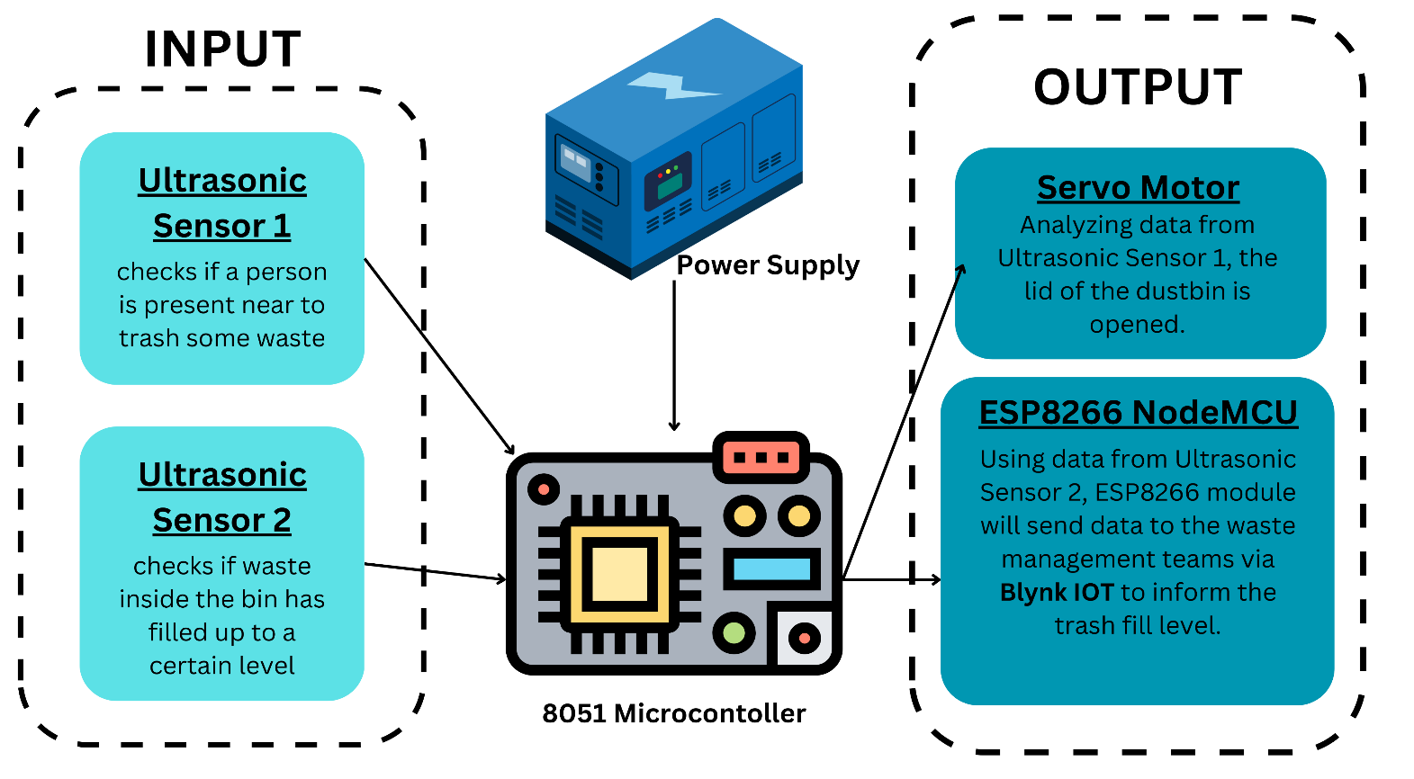

**Figure 7. Block diagram with all components used**

The above block diagram illustrates the functioning of the Smart Dustbin by showing how input components interact with the microcontroller and how outputs are generated-

**Input Section**

* **Ultrasonic Sensor 1**: This sensor is placed at the side of the dustbin and is responsible for detecting the presence of a person intending to dispose of waste. When a person approaches, it sends a signal to the 8051 microcontroller.
* **Ultrasonic Sensor 2**: This sensor is mounted inside the bin to measure the level of accumulated waste. It continuously monitors how full the bin is and transmits this data to the microcontroller.
* **Power Supply**: The entire system, including sensors, controller, and communication modules, is powered through a stable DC power source, ensuring uninterrupted operation.

**Processing Unit**

* **8051 Microcontroller**: Acts as the central control unit for the system. It processes input data from both ultrasonic sensors. Based on Sensor 1’s data, it triggers the servo motor to open the lid. Based on Sensor 2’s data, it relays the waste level information to the ESP8266 module for cloud communication.

**Output Section**

* **Servo Motor**: On detecting a person near the bin (via Sensor 1), the microcontroller activates the servo motor, which opens the lid of the dustbin automatically for contactless waste disposal.
* **ESP8266 NodeMCU (Wi-Fi Module)**: It communicates the trash fill level (from Sensor 2) to the cloud using the **Blynk IoT platform**. This data is accessible to waste management authorities in real-time, allowing them to make informed decisions about waste collection.

**METHODS OF IMPLEMENTATION**

**1. WORKFLOW**

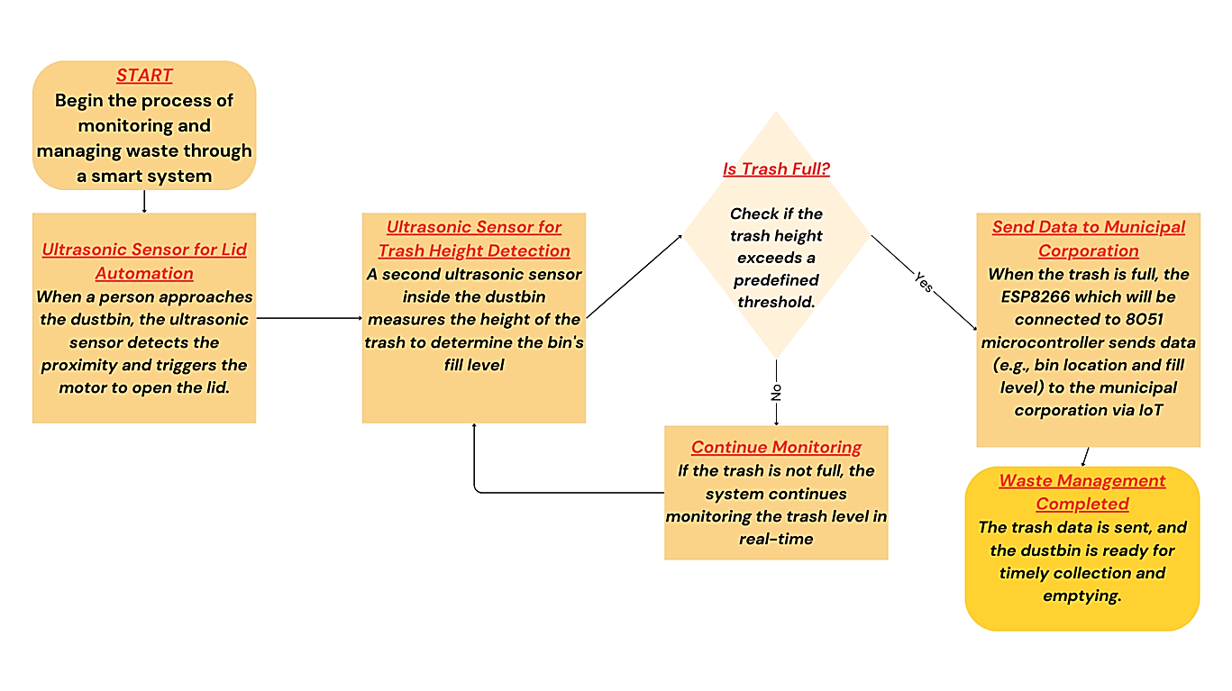

**2. MICROCONTROLLER PROGRAMMING**

The following code was implemented in Keil µVision software and compiled using an ISP programmer-

ORG 0000H

MAIN:

MOV TMOD, #10H

CLR P1.0

CLR P1.7

ACALL DELAY20US

SETB P1.7

ACALL DELAY10US

CLR P1.7

WAIT_ECHO_HIGH:

JB P1.6, MEASURE_ECHO

SJMP WAIT_ECHO_HIGH

MEASURE_ECHO:

CLR TF1

MOV TH1, #0

MOV TL1, #0

SETB TR1

WAIT_ECHO_LOW:

JNB P1.6, STOP_TIMER

JNB TF1, WAIT_ECHO_LOW

STOP_TIMER:

CLR TR1

MOV A, TH1

CJNE A, #0CH, CHECK_DISTANCE

ACALL SERVO_105

ACALL DELAY_3S

ACALL SERVO_0

SJMP MAIN

CHECK_DISTANCE:

SJMP MAIN

DELAY10US:

MOV R2, #2

D10_LOOP:

DJNZ R2, D10_LOOP

RET

DELAY20US:

MOV R2, #5

D20_LOOP:

DJNZ R2, D20_LOOP

RET

SERVO_90:

MOV R3, #50

S90_LOOP:

SETB P1.0

ACALL DELAY_1_5MS

CLR P1.0

ACALL DELAY_18_5MS

DJNZ R3, S90_LOOP

RET

SERVO_105:

MOV R3, #50

S105_LOOP:

SETB P1.0

ACALL DELAY_1_8MS

CLR P1.0

ACALL DELAY_18_2MS

DJNZ R3, S105_LOOP

RET

SERVO_0:

MOV R3, #50

S0_LOOP:

SETB P1.0

ACALL DELAY_1MS

CLR P1.0

ACALL DELAY_19MS

DJNZ R3, S0_LOOP

RET

DELAY_1MS:

MOV TMOD, #10H

MOV TH1, #0xFC

MOV TL1, #0x66

CLR TF1

SETB TR1

WAIT1:

JNB TF1, WAIT1

CLR TR1

RET

DELAY_1_5MS:

MOV TMOD, #10H

MOV TH1, #0xFA

MOV TL1, #0x24

CLR TF1

SETB TR1

WAIT15:

JNB TF1, WAIT15

CLR TR1

RET

DELAY_1_8MS:

MOV TMOD, #10H

MOV TH1, #0xF9

MOV TL1, #0x5E

CLR TF1

SETB TR1

WAIT18:

JNB TF1, WAIT18

CLR TR1

RET

DELAY_0_2MS:

MOV TMOD, #10H

MOV TH1, #0xFF

MOV TL1, #0x1A

CLR TF1

SETB TR1

WAIT02:

JNB TF1, WAIT02

CLR TR1

RET

DELAY_18_2MS:

MOV R2, #18

ACALL DELAY_1MS

ACALL DELAY_0_2MS

RET

DELAY_18_5MS:

MOV R2, #18

ACALL DELAY_1MS

ACALL DELAY_1MS

ACALL DELAY_0_5MS

RET

DELAY_19MS:

MOV R2, #19

D19_LOOP:

ACALL DELAY_1MS

DJNZ R2, D19_LOOP

RET

DELAY_0_5MS:

MOV TMOD, #10H

MOV TH1, #0xFE

MOV TL1, #0x33

CLR TF1

SETB TR1

WAIT05:

JNB TF1, WAIT05

CLR TR1

RET

DELAY_3S:

MOV R4, #30

D3S_LOOP1:

MOV R5, #100

D3S_LOOP2:

ACALL DELAY_1MS

DJNZ R5, D3S_LOOP2

DJNZ R4, D3S_LOOP1

RET

END

**3. SOFTWARE PROGRAMMING**

The following code has been implemented on the Arduino IDE while integrating the Blynk IOT application-

#define BLYNK_TEMPLATE_ID "TMPL369LMIRHz"

#define BLYNK_TEMPLATE_NAME "Quickstart Device"

#define BLYNK_AUTH_TOKEN "OCvkKoZK2dKXWEyjxsOjUeOLLeybuQB8"

#include <ESP8266WiFi.h>

#include <BlynkSimpleEsp8266.h>

char auth[] = "OCvkKoZK2dKXWEyjxsOjUeOLLeybuQB8"; // Paste your Blynk Auth Token here

char ssid[] = "A52s"; // Your WiFi Name

char pass[] = "piyush@13"; // Your WiFi Password

#define TRIG_PIN D1

#define ECHO_PIN D0

#define MAX_DISTANCE 200

BlynkTimer timer;

void sendData() {

digitalWrite(TRIG_PIN, LOW);

delayMicroseconds(2);

digitalWrite(TRIG_PIN, HIGH);

delayMicroseconds(10);

digitalWrite(TRIG_PIN, LOW);

long duration = pulseIn(ECHO_PIN, HIGH);

int distance = duration * 0.034 / 2;

if (distance == 0 || distance > MAX_DISTANCE) distance = MAX_DISTANCE;

Blynk.virtualWrite(V4, distance);

// Send notification through DataStream

if (distance < 11) {

Blynk.virtualWrite(V5, "Overflow");

} else {

Blynk.virtualWrite(V5, "Safe");

}

}

void setup() {

Serial.begin(115200);

Blynk.begin(auth, ssid, pass);

pinMode(TRIG_PIN, OUTPUT);

pinMode(ECHO_PIN, INPUT);

timer.setInterval(1000L, sendData);

}

void loop() {

Blynk.run();

timer.run();

}

**WORKING PROTOTYPE**

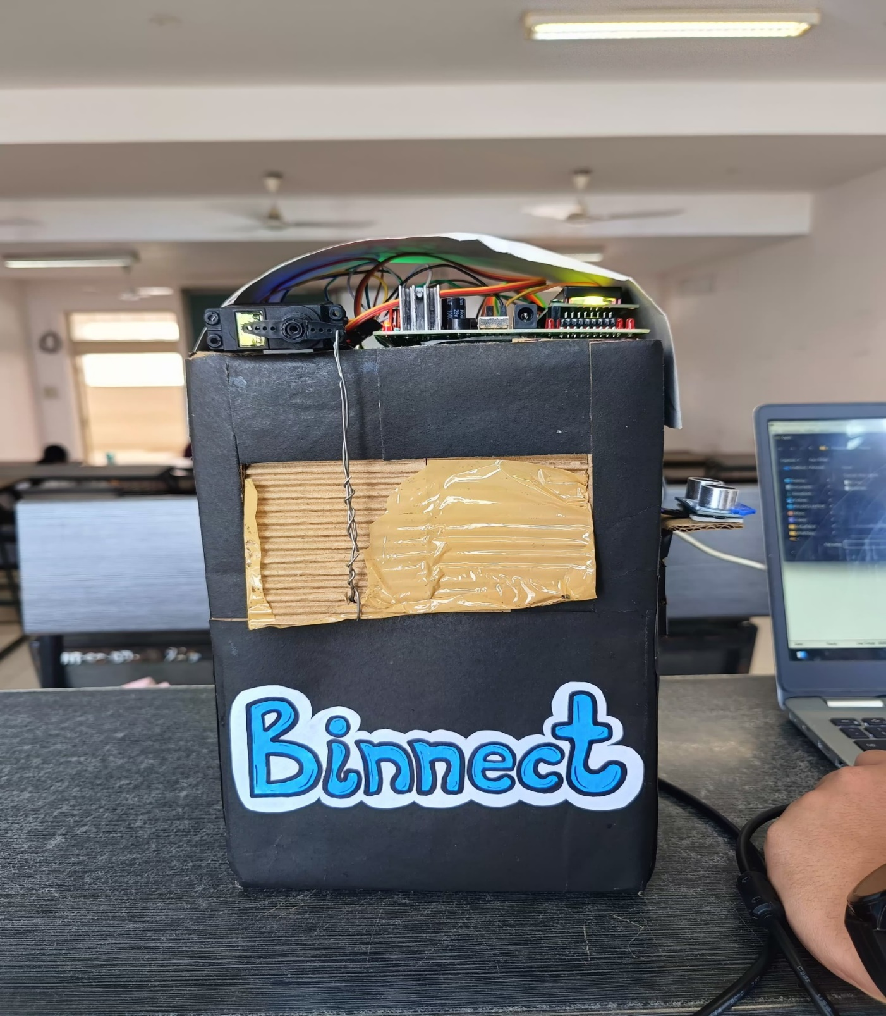

**Figure 8. BINNECT- Smart Waste Management System**

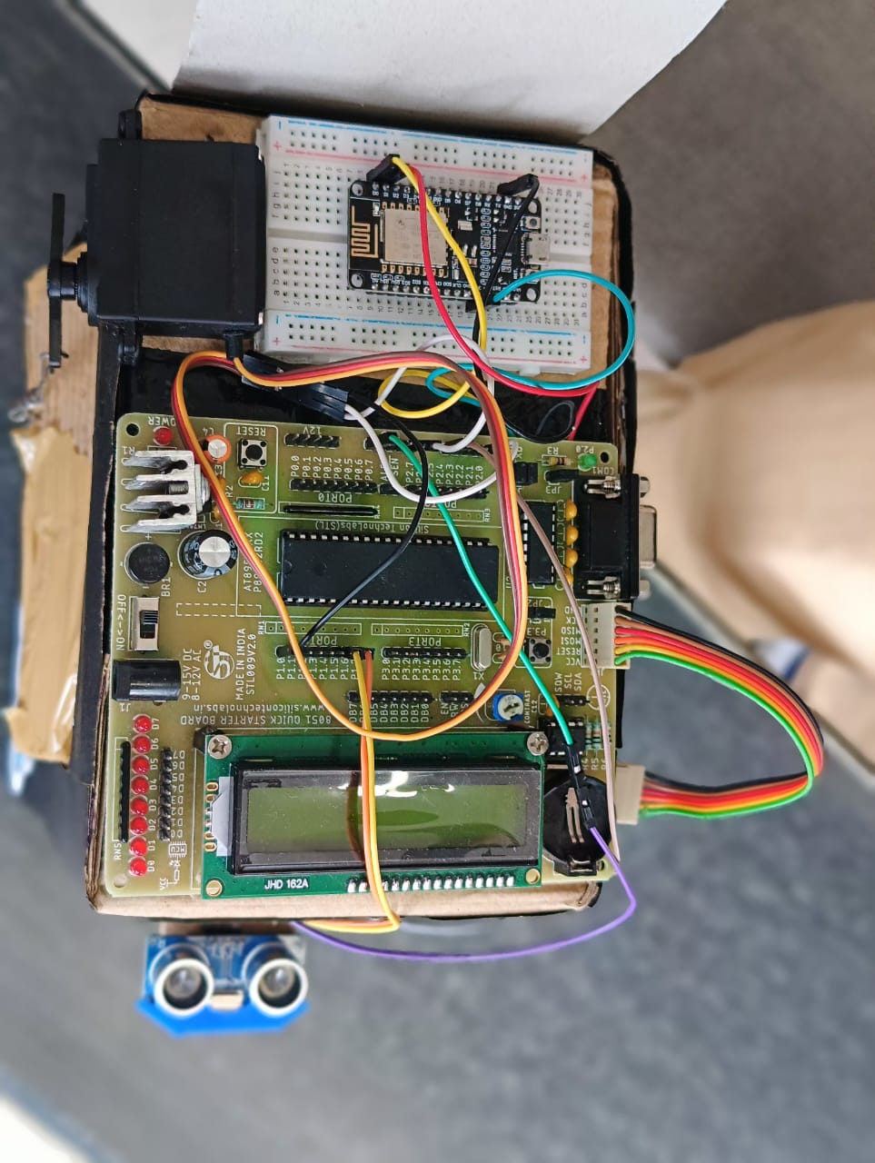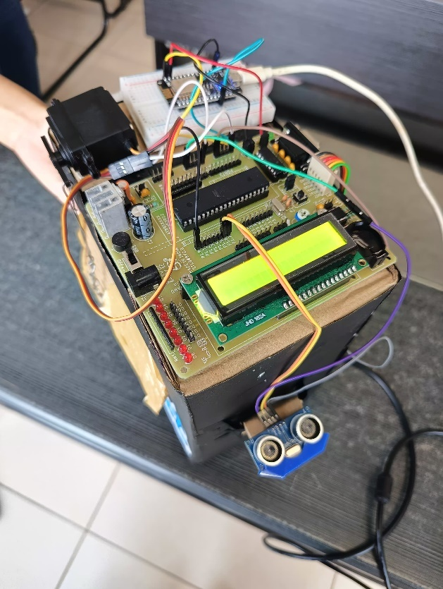

**Figure 9. Connection of the Hardware Components on the Bin**

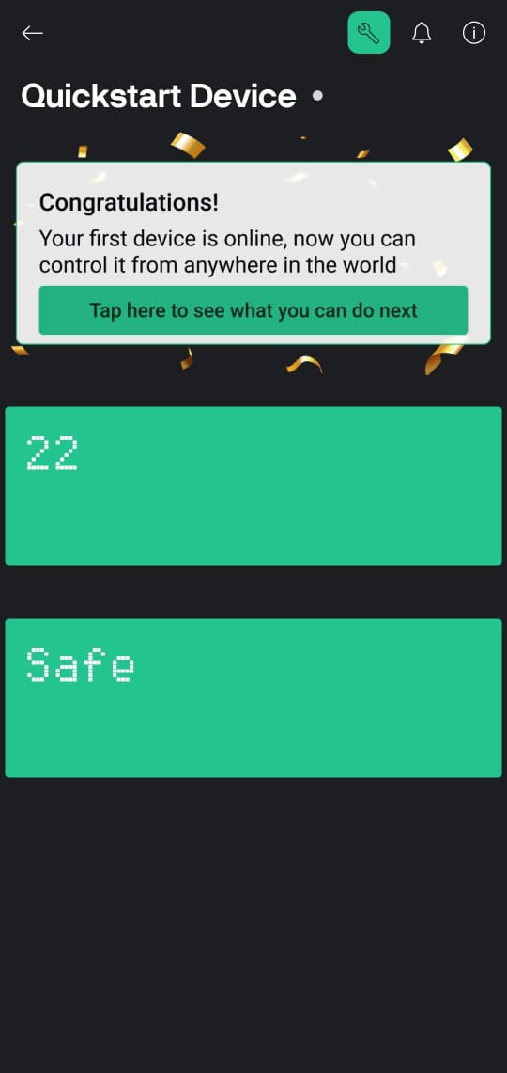

**Figure 10. Data received by the Blynk IOT App from the WiFi Module ESP8266**

**RESULTS**

The Smart Waste Management System was successfully developed and tested using an 8051 microcontroller, ultrasonic sensors, a servo motor, and the ESP8266 NodeMCU for IoT connectivity. The system accurately detected the presence of a person near the dustbin and triggered the servo motor to open the lid, enabling hygienic, contactless waste disposal. The internal ultrasonic sensor efficiently monitored the fill level of the dustbin and successfully transmitted real-time data to the Blynk IoT platform once the threshold was reached. Notifications were displayed on the user’s mobile dashboard, simulating alerts to the municipal waste management team. The system performed consistently under various test conditions, validating its ability to reduce manual monitoring, prevent overflow, and enable smart waste tracking and timely collection.

**CONCLUSION**

The designed Smart Waste Management System effectively modernizes traditional waste collection by introducing automation, real-time monitoring, and cloud-based alerts. It ensures hygienic, hands-free operation through sensor-triggered lid mechanisms and intelligent waste level detection. With timely notifications being sent to relevant authorities via IoT integration, the system not only curbs overflow but also improves operational efficiency. This prototype demonstrates a practical, scalable solution that supports cleaner environments and streamlined municipal waste handling processes.

**FUTURE WORK**

To further enhance the functionality and social impact of the system, several advancements can be integrated:

* **RFID-Based Access Control**: Implementing RFID recognition can help restrict unauthorized access and discourage ragpickers from scattering waste around the bin, thus maintaining public hygiene.
* **Smart Route Tracking**: GPS-based route tracking can be added to make the system portable and suitable for mobile garbage bins, optimizing collection routes based on real-time fill data.
* **Location Tagging**: Associating each bin with its GPS coordinates will assist in easy identification and pickup scheduling, particularly useful in dense urban areas.
* **AI-Powered Waste Segregation**: Integrating image processing and machine learning models can automate waste classification at the source (e.g., biodegradable vs. non-biodegradable), paving the way for better recycling and disposal practices.
* **Battery and Solar Support**: Making the setup energy-efficient and sustainable by incorporating solar panels or rechargeable battery modules for power supply in remote or outdoor areas.

**REFERENCES**

* 1. <https://www.pantechsolutions.net/iot-based-smart-waste-management-system-for-smart-city>
  2. <https://justdoelectronics.com/smart-dustbin-with-new-blynk-app-using-esp8266/>
  3. <https://justdoelectronics.com/smart-dustbin-with-esp8266-and-gps/>
  4. <https://www.irjmets.com/uploadedfiles/paper/issue_6_june_2022/25327/final/fin_irjmets1654350998.pdf>
  5. <https://sist.sathyabama.ac.in/sist_naac/documents/1.3.4/1822-b.e-cse-batchno-30.pdf>