POLYMORPHISM
- Compile-Time Polymorphism
- Function overloading

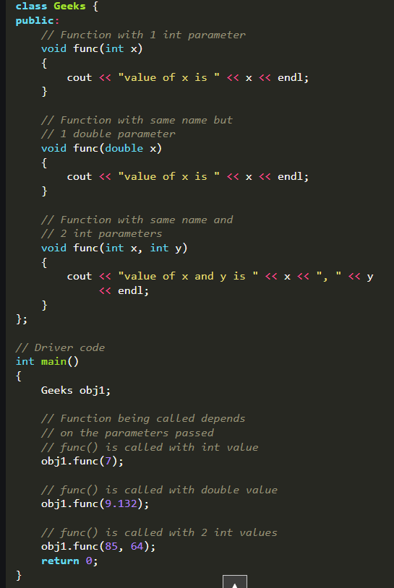
- Operator overloading
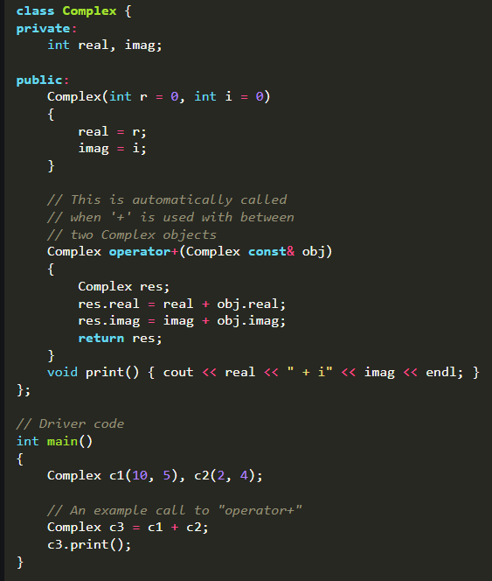

Following is the list of operators that cannot be overloaded.
- Sizeof
- typeid
- Scope resolution (::)
- Class member access operators (.(dot), .* (pointer to member
operator))
- Ternary or conditional (?:)

- Run-Time Polymorphism
  - Function Overriding
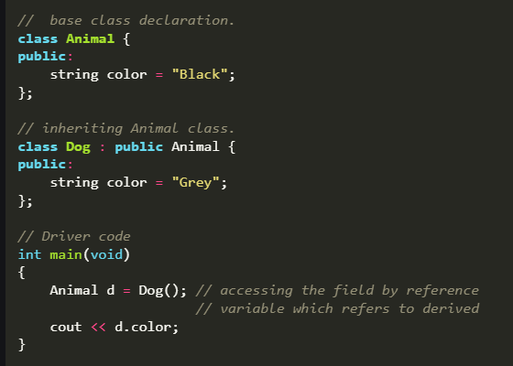
We can see that the parent class reference will always refer to the data member of the parent class.
  - Virtual Function
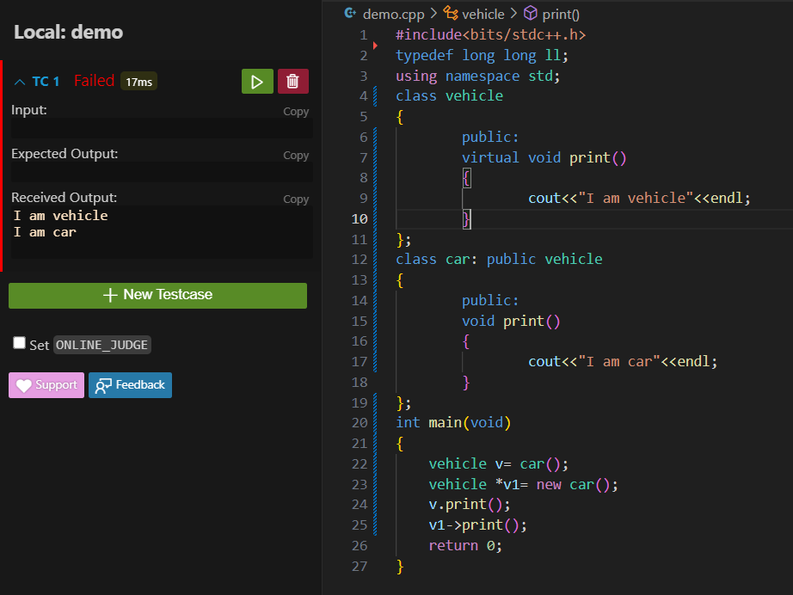
    - Some Key Points About Virtual Functions:
      - Virtual functions are Dynamic in nature.
      - They are defined by inserting the keyword “virtual” inside a base class and are always declared with a base class and overridden in a child class
      - A virtual function is called during Runtime
    - In C++, when you write Vehicle v = Car();, slicing occurs. This is because you're creating an object of type Vehicle, and the object of type Car gets "sliced" down to the Vehicle part of it, losing its Car-specific information, including virtual function behavior.
    - Virtual functions only work when you use pointers or references, which allow the correct method to be called at runtime based on the actual object type (e.g., Car), not the declared type (Vehicle). To enable virtual function behavior, you should declare the object using a pointer or reference like this:
Pure Virtual Class
A pure virtual class in C++ is a class that has only pure virtual functions and no concrete (non-virtual) methods or members. Such a class cannot be instantiated directly and is designed to serve as a base class for other classes to implement its pure virtual functions. Essentially, it acts like an interface, where it defines a set of functions that must be implemented by derived classes.

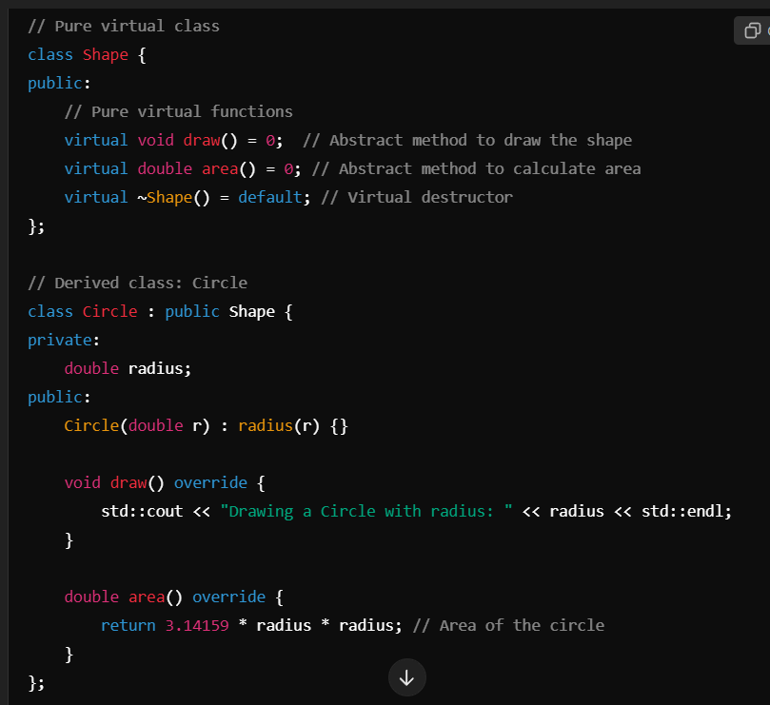

It is also called Abstract Class. An abstract class in C++ is a class that cannot be instantiated and is designed to be a base class for other classes. It typically contains one or more pure virtual functions, which are declared by assigning = 0 in their declarations. These pure virtual functions must be overridden by derived classes.

