CODE LINK - [PayPal-assignments/week1/rg-assignment/src at feature-java · PiyushBhatnagar09/PayPal-assignments](https://github.com/PiyushBhatnagar09/PayPal-assignments/tree/feature-java/week1/rg-assignment/src)

1. **Not a Pure Function**

Because it uses an **instance variable (rate)**, it depends on external state, so the result can change if rate changes.

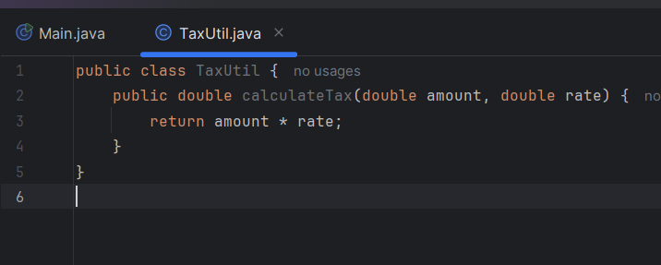

This version only uses input arguments, so it’s a **pure function**.

1. Output

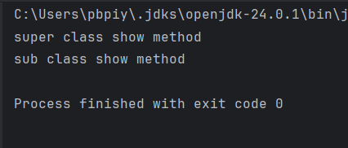

Reason -

Super.show() calls the static method.

new StaticMethods().show() calls the inner class's instance method.

1. Output

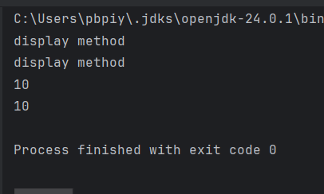

Reason –

* this.display() and display() both call the overridden method in ThisUse.
* this.num and num both refer to the local num of subclass (10).

1. A **Singleton** ensures that only **one instance** of a class is created and provides a global access point to it.
2. Encapsulation means:

* Keeping fields **private**
* Providing **public getters/setters**

1. Output –

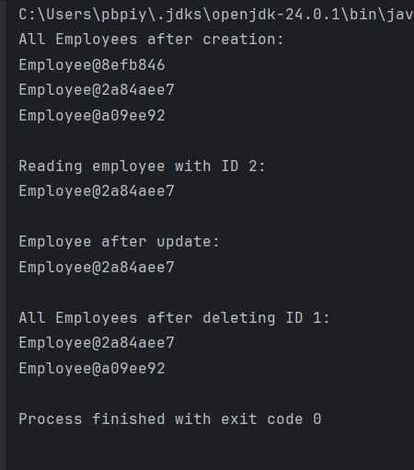

1. Check code in folder