**SCTR’s Pune Institute of Computer Technology Dhankawadi, Pune**

**A.Y. 2023-24**

**WADL MINI PROJECT REPORT ON**

**“BLOG WEBSITE”**

**Submitted By**

Ahmed Sajid - 33105

Aiman Sajid - 33106

Bhavnesh Bhat - 33117

Piyush Bhokre – 33118

Sanika Bhosale – 33119

**Under the guidance of**

Ms. Amruta Patil 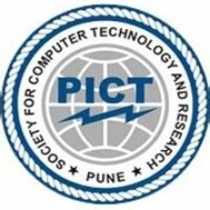

**DEPARTMENT OF INFORMATION TECHNOLOGY**

**ACADEMIC YEAR 2023-24**

**ABSTRACT**

Over the years, web development has undergone significant changes in both frontend and backend development. With the emergence of various web technologies and stacks, developers have had to adapt and choose the best tools and platforms to build web applications. One of the most popular stacks for full stack web application development is the MERN stack.

This report aims to provide an in-depth analysis of the MERN stack, its components, its importance in modern days, and a practical demonstration by building a simple blog application. The MERN stack consists of four main technologies: MongoDB for the database, Express.js for server-side framework, React.js for front-end development, and Node.js for backend development. Additionally, we utilized HTML and CSS to complement the front-end development, enhancing the overall user experience and visual appeal.

**Keywords:** Express.js, Full Stack, HTML, CSS, MERN, MongoDB, Node.js, React.js, Web Development.

**INTRODUCTION**

In the landscape of modern web development, the MERN stack stands out as a powerful framework for building full stack web applications. Comprising MongoDB, Express.js, React.js, and Node.js, this stack offers developers a comprehensive toolkit to create dynamic and robust web experiences.

MongoDB, a NoSQL database, provides flexibility in data storage, while Express.js serves as a minimalist web application framework for handling server-side logic. React.js, a JavaScript library developed by Facebook, facilitates the creation of reusable UI components, enhancing the user interface of applications. Node.js, a server-side JavaScript runtime environment, ties everything together, enabling seamless communication between frontend and backend components.

To illustrate the versatility of the MERN stack, consider its application in various scenarios. For instance, in e-commerce platforms, MongoDB can store product information and user data, while Express.js manages server-side operations like user authentication. React.js powers the front-end, offering an interactive shopping experience, while Node.js ensures smooth data retrieval and processing.

MERN stack applications have become commonplace in everyday digital interactions. Social media giants like Facebook and Instagram, streaming services such as Netflix and Spotify, and e-commerce platforms like Amazon and eBay all utilize the MERN stack to deliver seamless experiences to millions of users worldwide.

In this report, we delve into the intricacies of the MERN stack, its relevance in modern web development, and showcase its practical implementation through a demonstration of building a simple blog application.

**LITERATURE SURVEY**

|  |  |  |  |
| --- | --- | --- | --- |
| **Title** | **Year** | **Author** | **Aim/Objective** |
| How to use MERN stack: A complete guide | 2023 | MongoDB | Provide a comprehensive overview and practical guidance on using the MERN stack. |
| Stack Overflow Developer Survey 2022 | 2022 | Stack Overflow | Offer insights into current trends and technologies used by developers, including MERN stack components. |
| Full stack React projects: Learn MERN stack development by building modern web apps using MongoDB, Express, React, and Node.js | 2020 | Hoque, S. | Provide practical guidance on building full-stack web applications using the MERN stack. |
| Pro MERN Stack: Full Stack Web App Development with Mongo, Express, React, and Node | 2019 | Subramanian, V. | Offer a comprehensive guide to MERN stack development, covering setup, advanced topics, and best practices. |
| Web programming with HTML5, CSS, and JavaScript | 2019 | Dean, J. | Cover essential frontend technologies crucial for MERN stack development. |

Table. Literature Review

**IMPLEMENTATION DETAILS**

**Frontend Development:**

For the front-end development of our blog website, we opted for React.js as our primary framework. React.js was chosen due to its component-based architecture, which allows for the creation of modular and reusable UI components. This approach not only enhances code maintainability but also promotes scalability as the application grows. Additionally, we utilized HTML5 and CSS3 for structuring web pages and styling the application interface, ensuring a visually appealing and user-friendly design.

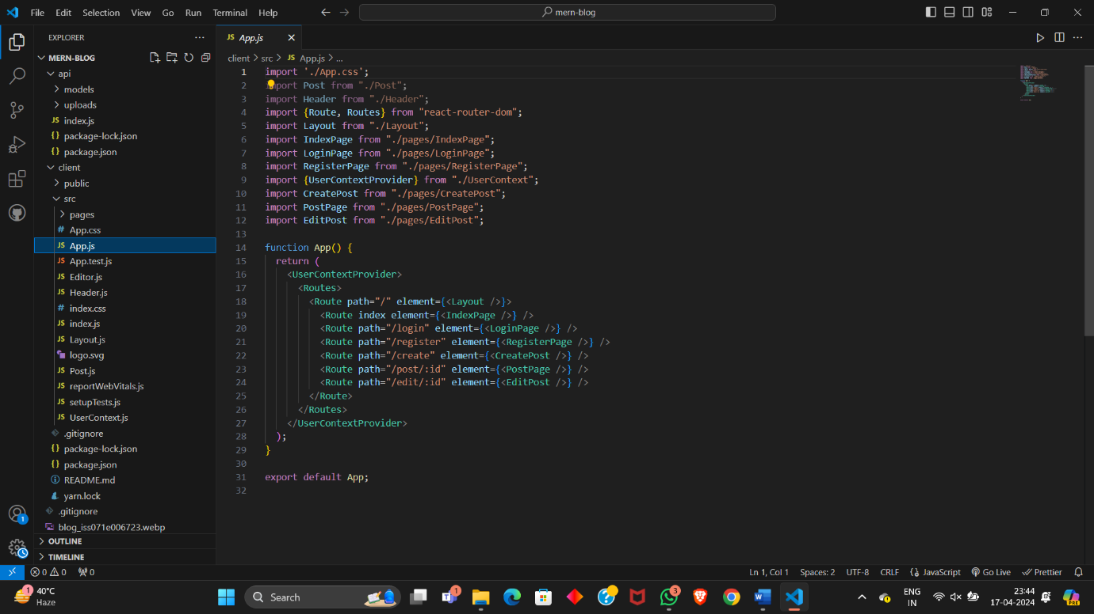

**Backend Development:**

On the backend side, we employed Node.js in conjunction with Express.js as our backend framework. Node.js provides a lightweight and efficient runtime environment for server-side JavaScript execution, while Express.js simplifies the process of routing and handling HTTP requests. Together, they form a robust backend infrastructure capable of managing the business logic and data processing requirements of our blog application. For data storage and management, we integrated MongoDB, a NoSQL database, which offers flexibility and scalability for handling diverse data types and volumes.

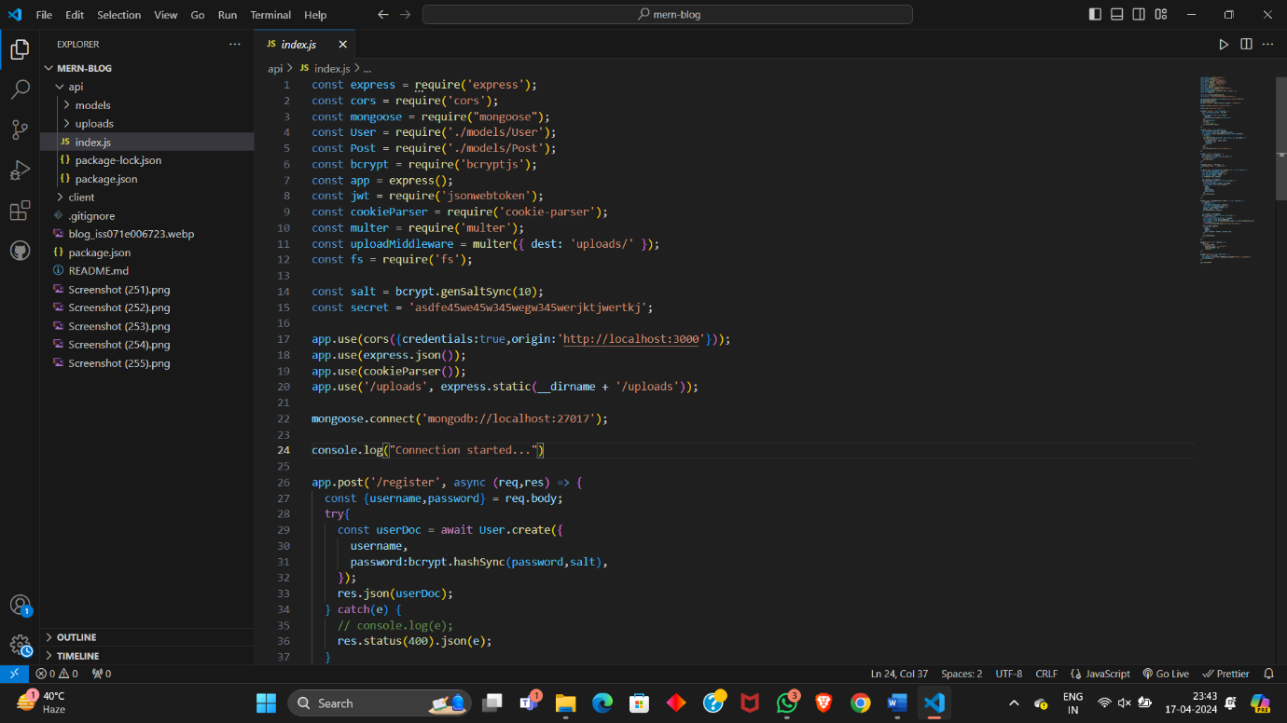

**Integration:**

In terms of integration, our frontend communicates with the backend through RESTful APIs, enabling seamless data exchange between the client and server. We implemented Redux as our state management solution, allowing us to centralize and manage application state efficiently. This facilitates data flow between components and ensures consistency across the application. Additionally, we incorporated JSON Web Tokens (JWT) for user authentication and authorization, enhancing the security of our application by controlling access to protected resources based on user credentials.

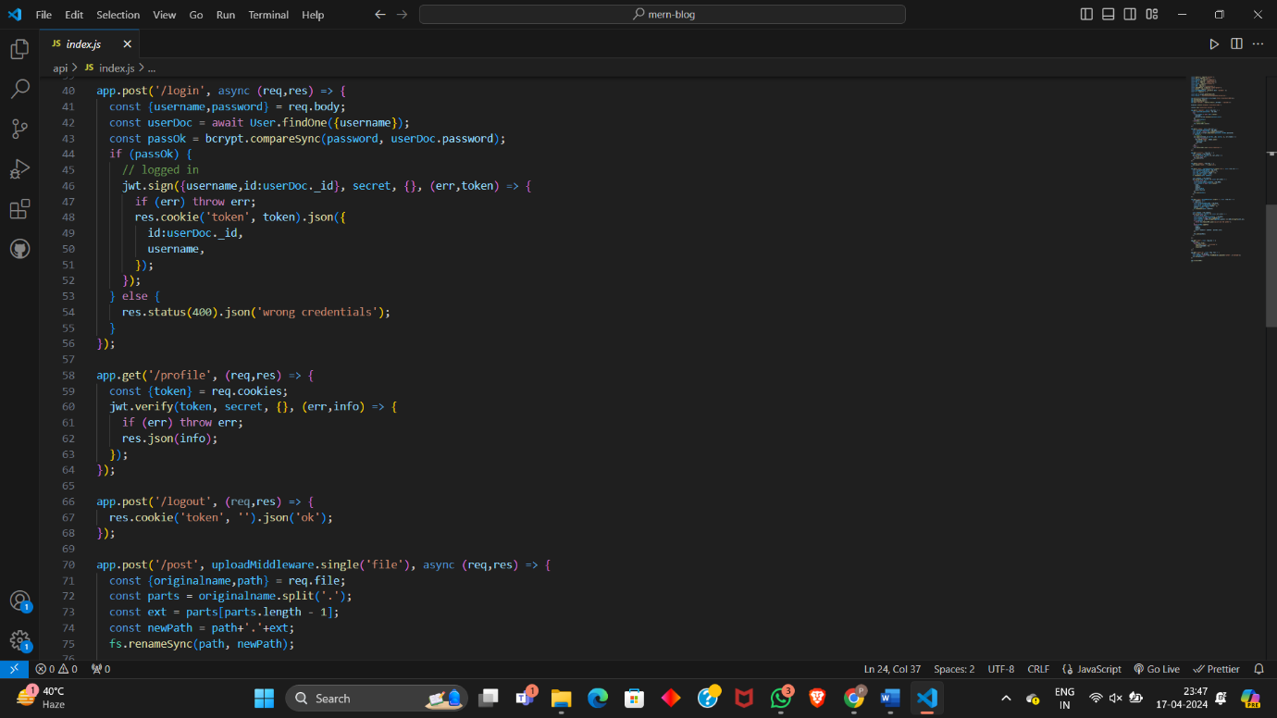

**OUTPUT**

1. **Home Page of the Blog:**

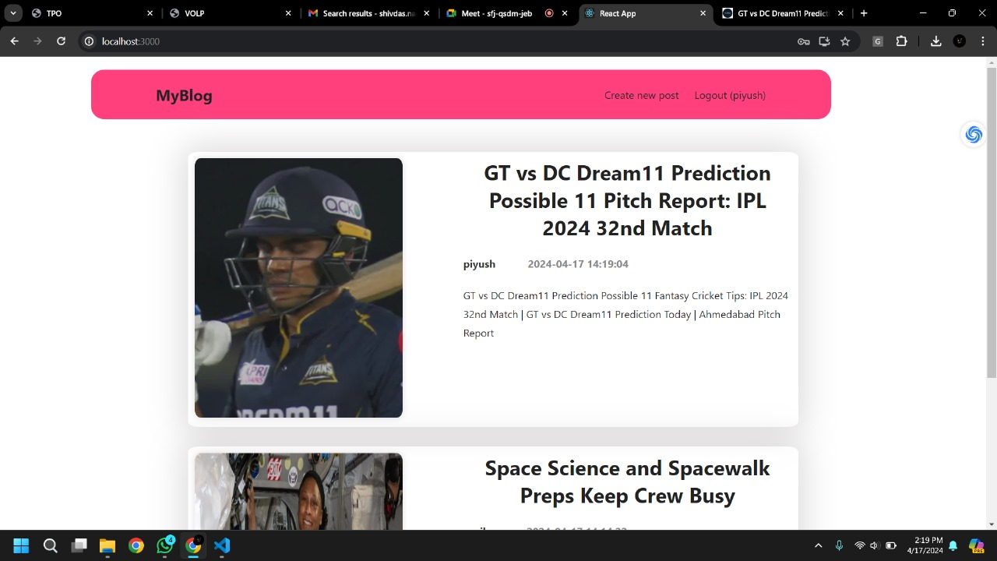

1. **Login Page:**

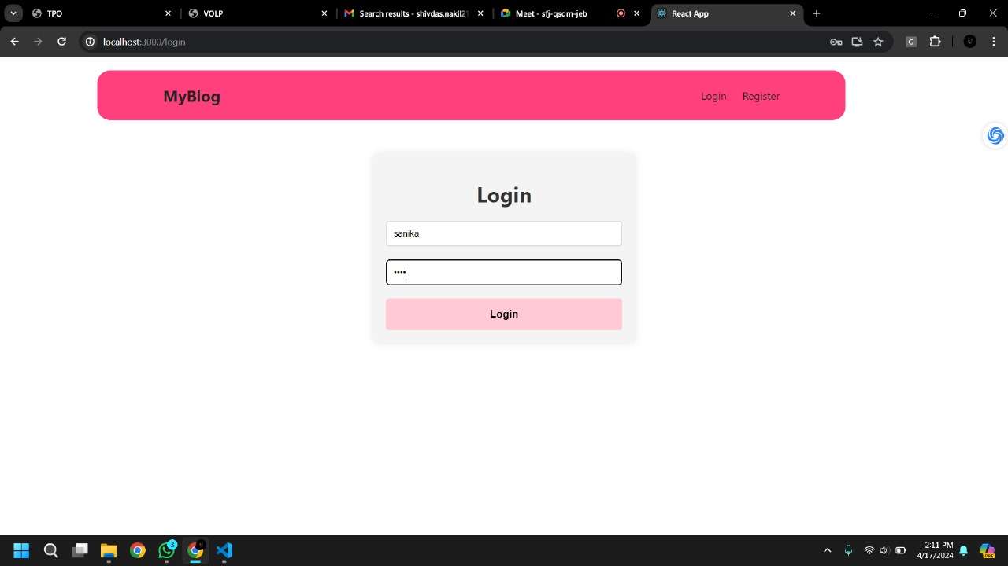

1. **Register Page:**

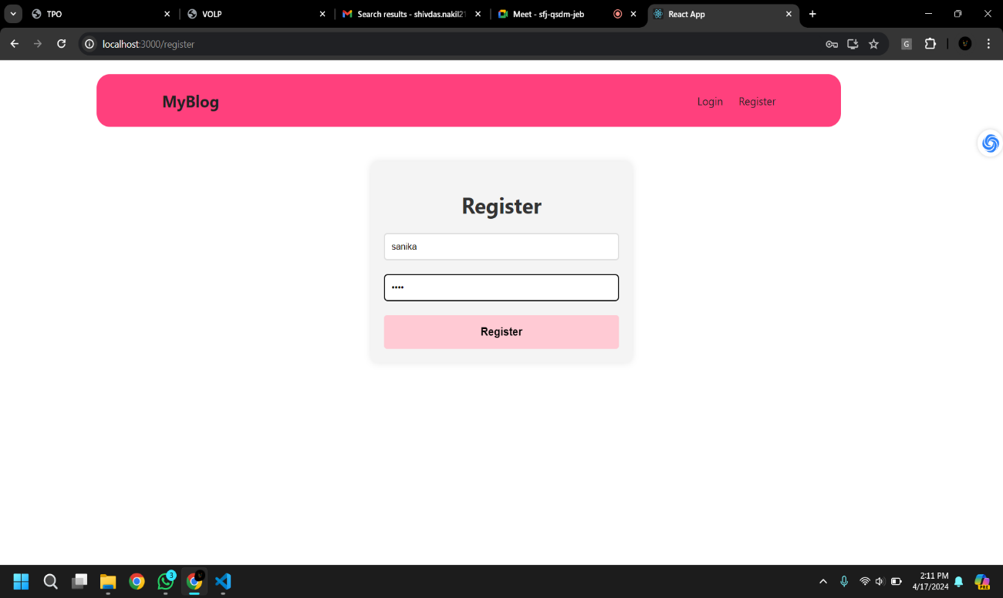

1. **View Post Page:**

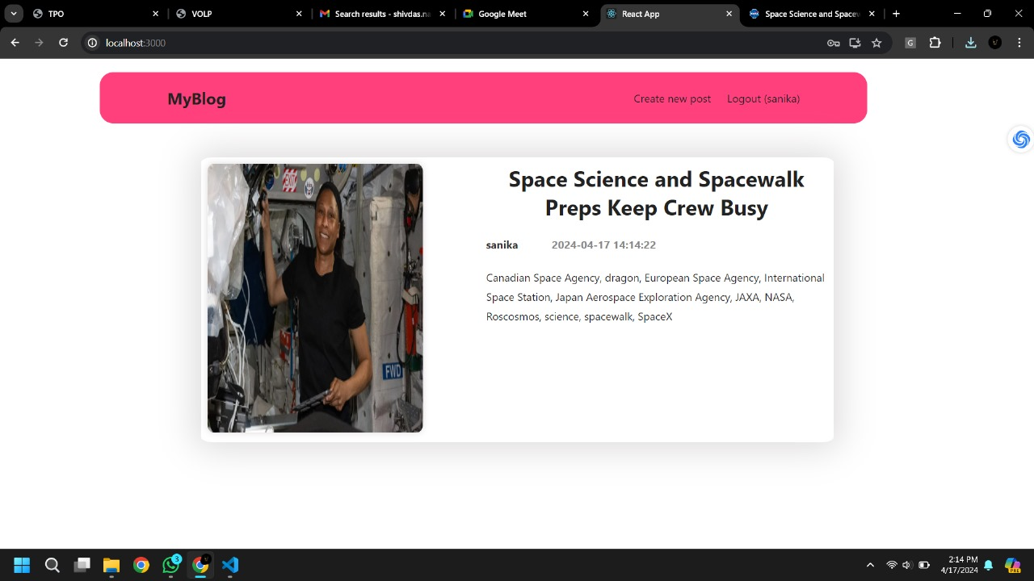

1. **Create Post Page:**

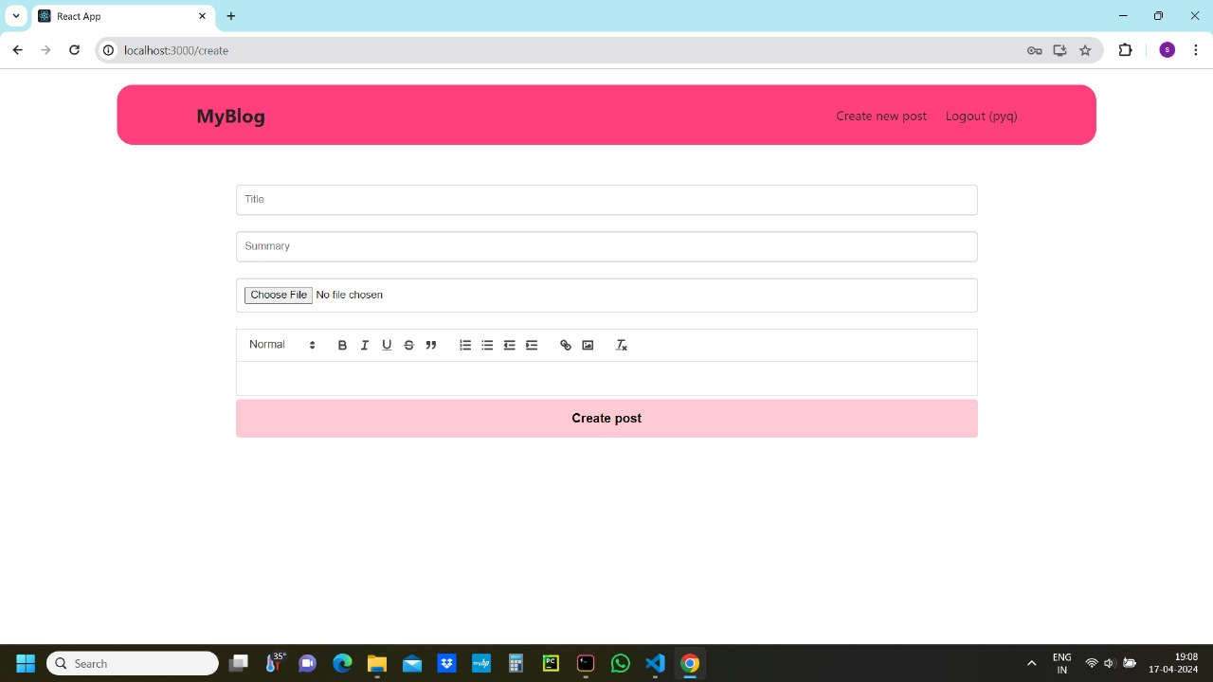

**CONCLUSION**

The primary aim of this thesis was to conduct an in-depth exploration into the foundational principles of the MERN stack and leverage this knowledge to construct a fully functional blog application from scratch. Through meticulous study and analysis of each component comprising the MERN stack – MongoDB, Express.js, React.js, and Node.js – we gained a profound understanding of their individual roles and interactions within the full stack development paradigm. Armed with this comprehensive understanding, we embarked on the development journey with the goal of creating a robust and user-friendly blog platform.

Key functionalities implemented in our blog application include user registration and authentication, allowing users to securely access their accounts and personalize their experience. Additionally, users can browse existing posts, create new posts, and interact with content through comments and likes. The inclusion of these features not only enhances user engagement but also contributes to the overall richness and interactivity of the blog platform.

In conclusion, this thesis project has not only deepened our understanding of the MERN stack but has also equipped us with valuable skills and insights into full stack web development. The successful construction of the blog application serves as a testament to our proficiency in leveraging modern web technologies to create innovative and user-centric solutions. Moving forward, we are excited to continue exploring and pushing the boundaries of web development, fueled by the knowledge and experiences gained from this project.

**REFERENCES**

1. Java T Point. 2011-2021. MERN Stack.

Available at: https://www.javatpoint.com/mern-stack. Accessed on January 28, 2023.

1. MDN Web Docs. 2019. JavaScript basics.

Available at: https://developer.mozilla.org/enUS/docs/Learn/Getting_started_with_the_web/JavaScript_basics#what_is_javascript. Accessed 12 May 2023.

1. Coremans, C. 2015. HTML: a beginner’s tutorial. Brainy Software, Inc.
2. Northwood, C. 2018. The Full Stack Developer: Your essential guide to the everyday skills expected of a modern full stack web developer. Apress.
3. Dean, J. 2019. Web programming with HTML5, CSS, and JavaScript. Burlington, Massachusetts: Jones & Barlett Learning.
4. Nirgudkar, N. & Singh, P .2017. The MEAN Stack. Available at: https://www.irjet.net/archives/V4/i5/IRJET-V4I5795.pdf. Accessed 10 May 2023.
5. Vassallo, K. & Garg, L. 2016. Cross-platform development frameworks: overview of contemporary technologies and methods for cross-platform application development. Available at: https://www.um.edu.mt/library/oar/handle/123456789/25282. Accessed 1 May 2023.
6. Haviv, A.Q. 2016. MEAN Web Development. Packt Publishing.
7. Subramanian, V. 2019. Pro MERN Stack: Full Stack Web App Development with Mongo, Express, React, and Node. Berkeley, Ca: Apress.
8. Sharma, M. 2022. Full Stack Development with MongoDB. BPB Publications.