[For Use by Moderator only]
Accepted Rejected Name : …………………………..…….. Signature : ………………..
End Term SEMESTER END TERM EXAMINATION: 2016

PROGRAMME NAME B.Tech (IT)

COURSE CODE CSE401 COURSE TITLE Artificial Intelligence

Regular Repeaters Both

Time: 3 Hrs Max Marks:70-

Note: Attempt questions from all sections as directed.

Section - A : Attempt any five questions out of six. Each question carries 06 marks. [30 Marks]

Q1. Represent the following sentence using symbolic logic
- God helps those who help themselves
\-/x: helps( god, helps(x , x))
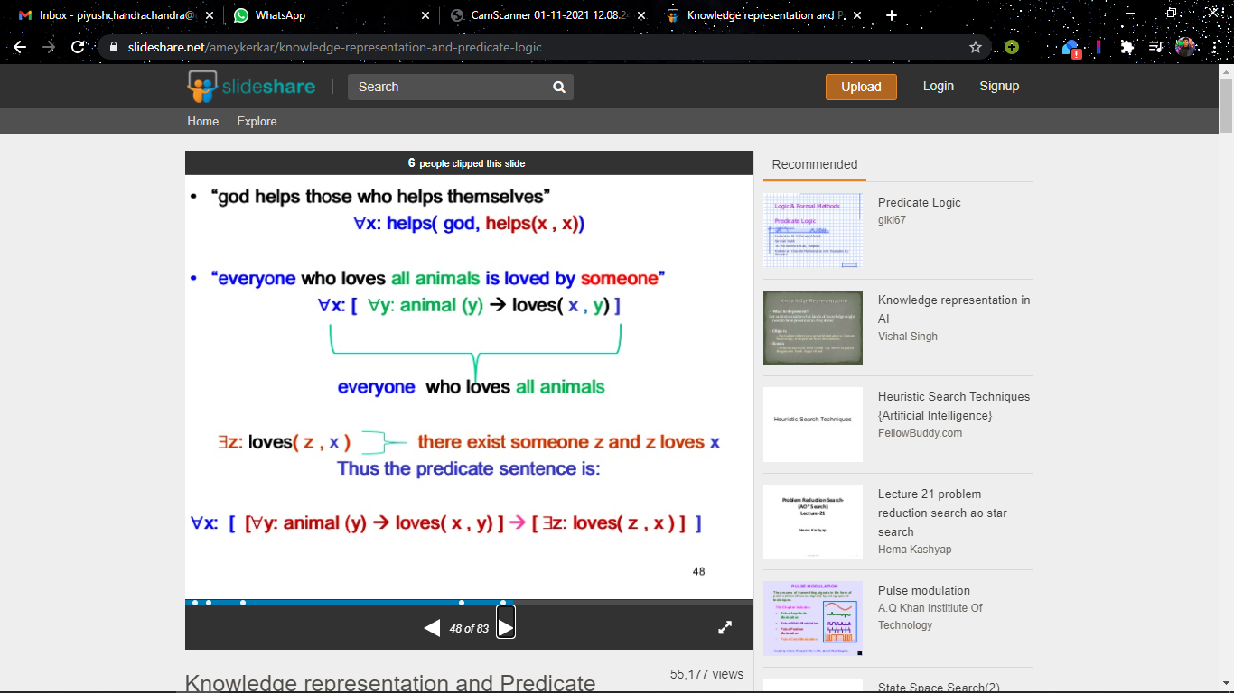
- All student likes good teachers
- No one hate himself 4) There exists a no which is prime, 5 is a prime no.
1.5*4=6
Q2. Given the following two propositional statements, find the interpretation(s), which satisfy these statements. (p → q) → p and (q → p) →q? 6

Q3. Write short notes on Robotics. Compare manipulator kinematics and dynamics? 3+3
Q4. Suppose h1(x, y) and h2 (x, y) are two heuristic functions constructed for use in the water jug problem. x and y denote the contents of the 4L and 3L jugs respectively. Given h1(x, y)> h2(x, y) for all x, y. Which of the two heuristic functions should we use and why? 3+3

Q5. Give an example of a problem for which breath first search would work better than depth first search? 6

Q6. Discuss the following:
(i) Horn Clause
(ii) NLP
3+3

Section – B : Attempt any two questions out of three. Each question carries 10 marks. [20 Marks]

Q7. Identify four application areas where reasoning under conditions of uncertainty is necessary, and explain briefly why. Pick one of these areas and design four inference rules that might be used for reasoning in that domain? 5+5

Q8. i) Consider 8-puzzle problem: a) State the rules you need to use to solve the above problem.
b) Suggest 2 heuristic functions to handle the problem using A* algorithm.
c) Consider a starting state and a goal state. Expand the starting state using A* algorithm. Use any one heuristic function you considered in part b) above?

ii) Draw CD representation of the following sentence: “Smoking is harmful to health.” 5+5

Q9. i) Explain in short the working of MYCIN? CF=2.5 signifies what?
ii )Define soundness and completeness of propositional logic using Axiomatic System. 5+5

Section - C : Compulsory question [20 Marks]

Q10. A fanner with his wolf, goat and cabbage arrives at the bank A of the river they wish to cross. There is a boat at the bank A of river, which the fanner only can row. The boat can carry only two things including rower at a time. If the wolf is ever left with the goat the wolf will eat the goat. Also if the goat is left alone with cabbage the goat will eat the cabbage. Represent the solution using state space representation.
(Crossing river from bank A to bank B).
20
*******

……………………………………
Signature of Paper Setter

Name of Paper Setter……………………………
Employee Code…………………………………
Note: The paper should be typed in double space and should be deleted from the computer immediately after taking the print.

