**Unit 3 System of linear algebraic equations**

**Strucure**

* 1. **Introduction**
  2. **Gaussian elimination method**
  3. **Gauss-Jordan method**
  4. **Gauss-Jacobi method**
  5. **Gauss-Siedel mthod**
  6. **Successive over Relaxation (SOR) method**
  7. **Summary**
  8. **Exercises**

**3.1 Introduction**

A **linear equation** in variables is an equation of the form

where and are constant real or complex numbers. The constant is called the c**oefficient** of ; and is called the **constant term** of the equation.

A **system of linear equations** (or **linear system**) is a finite collection of linear equations in same variables. For instance, a linear system of *n* equations in *n* variables can be written as

(3.1.1)

The above system can be written in the form

where is a non-singular matrix and

Two types of methods are availavle.

1. Exact methods or Direct method
2. Iterative methods

When is of moderate order with co-efficients most non-zero, then usually exact or direct methods are used. Order of is usually < 200 and the linear system is called ***dense***.

When is of large order and most co-efficients zero, then iterative methods are used. is sparseand order of is sometimes as large as

Exact ot direct methods: Cramer’s rules, Gaussian elimination method,

Gauss Jordan Method etc

Iterative methods : Method of simple iteration, Gauss-Seidal iteration method

**Theorem 3.1.** *Any system of linear equations has one of the following exclusive conclusions.*

* 1. *No solution.*
  2. *Unique solution.*
  3. *Infinitely many solutions.*

A linear system is said to be **consistent** if it has at least one solution; and is said to be **inconsistent** if it has no solution.

# Geometric interpretation

The following three linear systems

have no solution, a unique solution, and infinitely many solutions, respectively. See Figure1.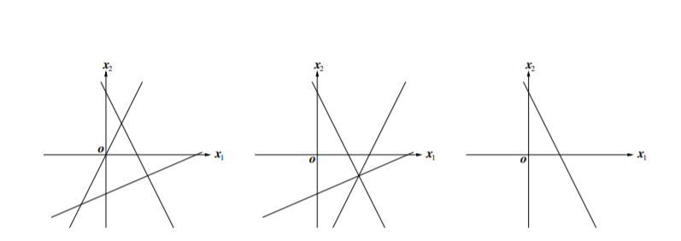

1. No solution (b) a unique solution (c)infinitely many solutions

**Figure 1**

**Note**: A linear equation of two variables represents a straight line in R2. A linear equation of three vari- ables represents a plane in R3.In general, a linear equation of *n* variables represents a hyperplane in the *n*-dimensional Euclidean space R*n*.

# Matrices of a linear system

**Deftnition 3.1.** The **augmented matrix** of the general linear system (3*.*1) is the table

(3.1.2)

and the **coefficient matrix** of (3*.*1) is (3.1.3)

Systems of linear equations can be represented by matrices. Operations on equations (for eliminating variables) can be represented by appropriate row operations on the corresponding matrices. For example,

The corresponding **augmented matrix is**

Now we will do the needful row operations.

Operating  and  on the above, we get

Operating  and  on the above, we get

Operating  on the above, we get

Operating  on the above, we get

Operating  and  on the above, we get

Operating  on the above, we get

.

That is, we get the solution as and

# Elementary row operations

**Deftnition 1.3.** There are three kinds of elementary row operations on matrices:

1. Adding a multiple of one row to another row;
2. Multiplying all entries of one row by a nonzero constant;
3. Interchanging two rows.

Another method for solving system of linear algebraic equations is **Cramer’s Rule. Cramer’s Rule:**

To solve a system of linear equations, a simple method (but, not efficient) was discovered

by Gabriel Cramer in 1750.

Let the system of linear algebraic equations are

, (3.2.1)

Let the determinant of the coefficients of the system (1.4) be i.e., . In this method, it is assumed that . The Cramer’s rule is described in the following. From the properties of determinant

Therefore, .

Similarly, ,……… .

Ingeneral, where

**Inverse of a Matrix**

From the theory of matrices, it is well known that every square non-singular matrix has

unique inverse. The inverse of a matrix **A** is defined by

The matrix is called adjoint of and defined as

, where being the cofactor of in .

The main difficulty of this method is to compute the inverse of the matrix. From the definition of it is easy to observe that to compute the matrix , we have to determine determinants each of order. So, it is very much time consuming. Many efficient methods are available to find the inverse of a matrix, among them **Gauss-Jordan** is most popular.

**3.2 Gaussian elimination method**

We assume that the set of linear equations given by

(3.2.1)

has a unique solution and we proceed as follows.

Let Multiply the 1st equation of (1) by and add to the ith equation when giving the following equivalent equations

(3.2.2)

where and

(3.2.3)

Assuming again . We note that the set of equations (2) except the 1st is a system of linear equations in the unknowns and applying the above eliminations procedure to this system is eliminated from the last equations of the set giving the equivalent system

(3.2.4)

where and

(3.2.5)

Continuing this process, we finally obtain equivalent system of equations at the

(3.2.6)

where and

(3.2.7)

The upper triangular system (6) may easily be solved as follows. From the last equation ; then substituting this value of in the last but one equation we get the value of , and then again substituting the values of in the last but two equation we compute and so on.Finally we get . This process of solving an upper triangular system of linear system of equations is often called ***back substitution***.

When the diagonal coefficient there is unity, the last term of the constant vector contains the value of . This can be used in the th equation represented by the second to the last line to obtain and so on right up to the first line which will yield the value of. The name of this method simply derives from the elimination of each unknown from the equations below it producing a triangular system of equations represented by

(3.2.8)

which can then be easily solved by back substitution where

One of the disadvantages of this approach is that errors (principally round off errors) from the successive subtractions build up through the process and accumulate in the last equation for . The errors thus incurred are further magnified by the process of back substitution forcing the maximum effects of the round-off error into . A simple modification to this process allows us to more evenly distribute the effects of round off error yielding a solution of more uniform accuracy. In addition, it will provide us with an efficient mechanism for calculation of the inverse of the matrix .

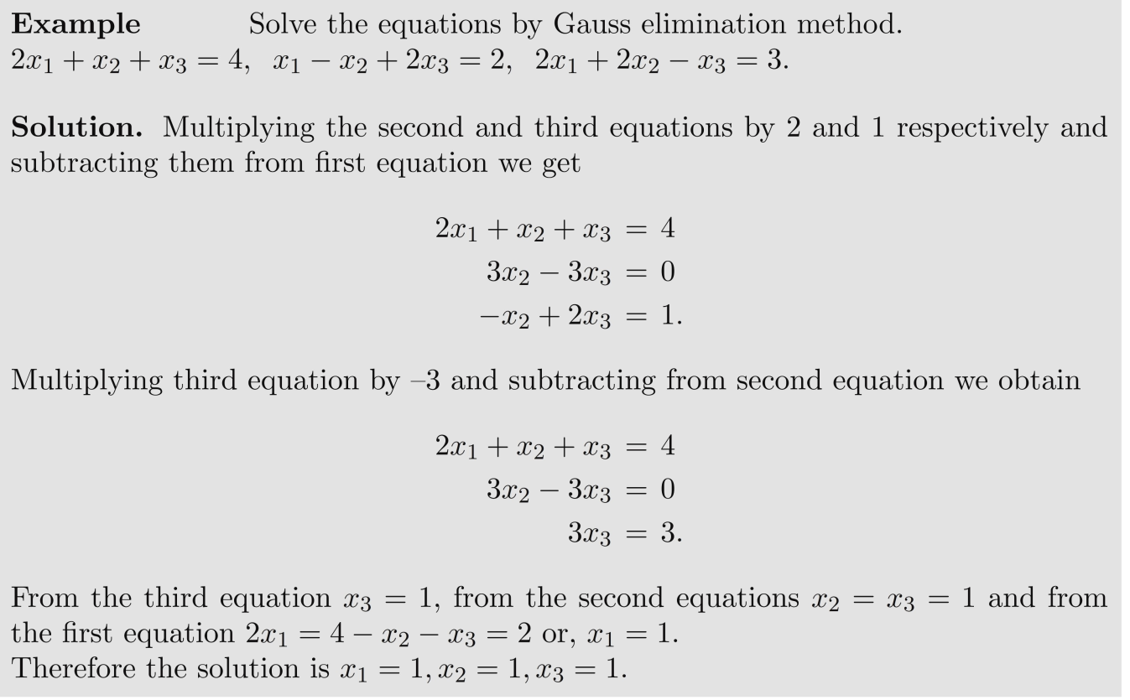

**3.3 Gauss Jordan method**

Let us begin by writing the system of linear equations as we did in Gauss elimination method but now include a unit matrix on the right hand side of the expression. Thus,

……………………………………………(3.3.1)

We will treat the elements of this matrix as we do the elements of the constant vector. Now proceed as we did with the Gauss elimination method producing zeros in the columns below and to the left of the diagonal element. However, in addition to subtracting the line whose diagonal element has been made unity from all those below it, also subtract from the equations above it as well. This will require that these equations be normalized so that the corresponding elements are made equal to one and the diagonal element will no longer be unity. In addition to operating on the rows of the matrix **A** and the elements of , we will operate on the elements of the additional matrix which is initially a unit matrix. Carrying out these operations row by row until the last row is completed will leave us with a system of equations that resemble

(3.3.2)

If one examines the, it is clear that so far we have done nothing to change the determinant of the original matrix **A** so that expansion by minors of the modified matrix represent by the elements  is simply accomplished by multiplying the diagonal elements  together. A final step of dividing each row by will yield the unit matrix on the left hand side and elements of the solution vector will be found . The final elements of **B** will be the elements of the inverse matrix of **A**. Thus we have both solved the system of equations and found the inverse of the original matrix by performing the same steps on the constant vector as well as an additional unit matrix. Perhaps the simplest way to see why this works is to consider the system of linear equations and what the operations mean to them. Since all the operations are performed on entire rows including the constant vector, it is clear that they constitute legal algebraic operations that won't change the nature of the solution in any way. Indeed these are nothing more than the operations that one would perform by hand if he/she were solving the system by eliminating the appropriate variables. We have simply formalized that procedure so that it may be carried out in a systematic fashion. Such a procedure lends itself to computation by machine and may be relatively easily programmed. The reason for the algorithm yielding the matrix inverse is somewhat less easy to see. However, the product of **A** and **B** will be the unit matrix **I**, and the operations that go into that matrix-multiply are the inverse of those used to generate **B**.

**Example**: To see specifically how the Gauss-Jordan method works, consider the following system of equations:

(3.3.3)

If we put this in the form required by expression (3.3.1) we have

(3.3.4)

Now normalize the all rows by factoring out the lead elements of the first column so that

(3.3.5)

The first row can then be subtracted from the remaining rows (i.e. rows 2 and 3) to yield

(3.3.6)

Now repeat the cycle normalizing by factoring out the elements of the second column getting

(3.3.7)

Subtracting the second row from the remaining rows (i.e. rows 1 and 3) gives

(3.3.8)

Again repeat the cycle normalizing by the elements of the third column so

(3.3.9)

and subtract from the remaining rows to yield

(3.3.10)

Finally normalize by the remaining elements so as to produce the unit matrix on the left hand side so that

(3.3.11)

The solution to the equations is now contained in the center vector while the right hand matrix contains the inverse of the original matrix that was on the left hand side of expression (3.3.4). The scalar quantity accumulating at the front of the matrix is the determinant as it represents factors of individual rows of the

original matrix. The row subtraction shown in expressions (3.3.6), (3.3.8), and (3.3.10) will not change the value of the determinant. Since the determinant of the unit matrix on left side of expression (3.3.11) is one, the determinant of the original matrix is just the product of the factored elements. Thus our complete solution is , where and

(3.3.12)

**Pivoting** : We have assumed in each step fo the Gaussian elimination that .

To remove this restriction, begin each step of elimination process by switching rows to put a non-zero elemnt in the pivot posion. Since is non-singular, this is always possible. Sometimes it may happen that the pivot element is small (actually zero, but due to roundoff it becomes vary small). To guard against this, pivoting is used.

Let at stage

Let be smallest row index for which the maximum is attain. If , then switch rows and in and ; and proceed with step of the elimination process.

All multipliesrs will now satisfy

(remember

And this ensures the groth in the elements of and thus eliminating the possibility of loss of significant errors. The pivoting is used in the solving in the linear system of equation is shown in the example given below.

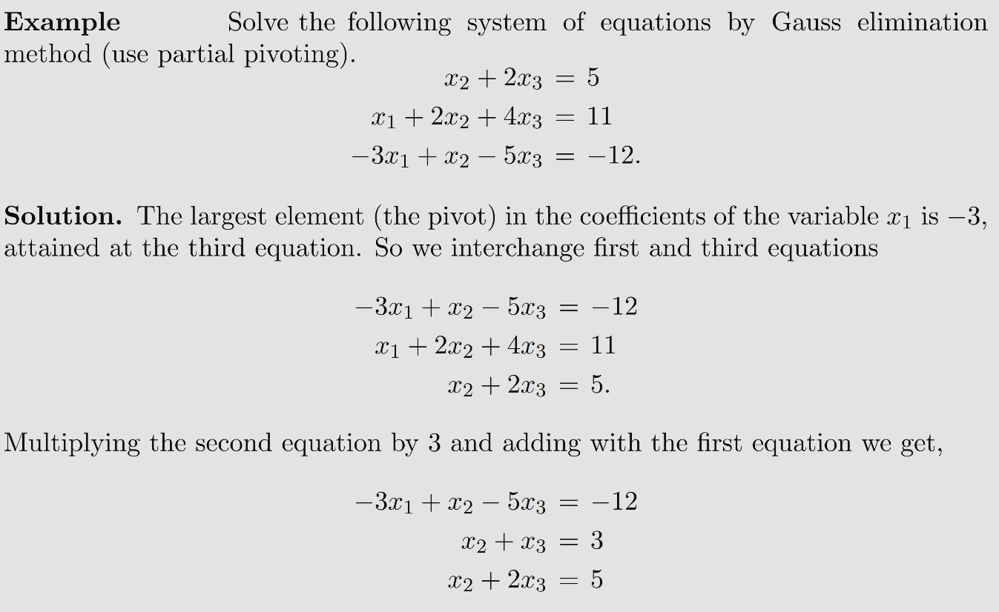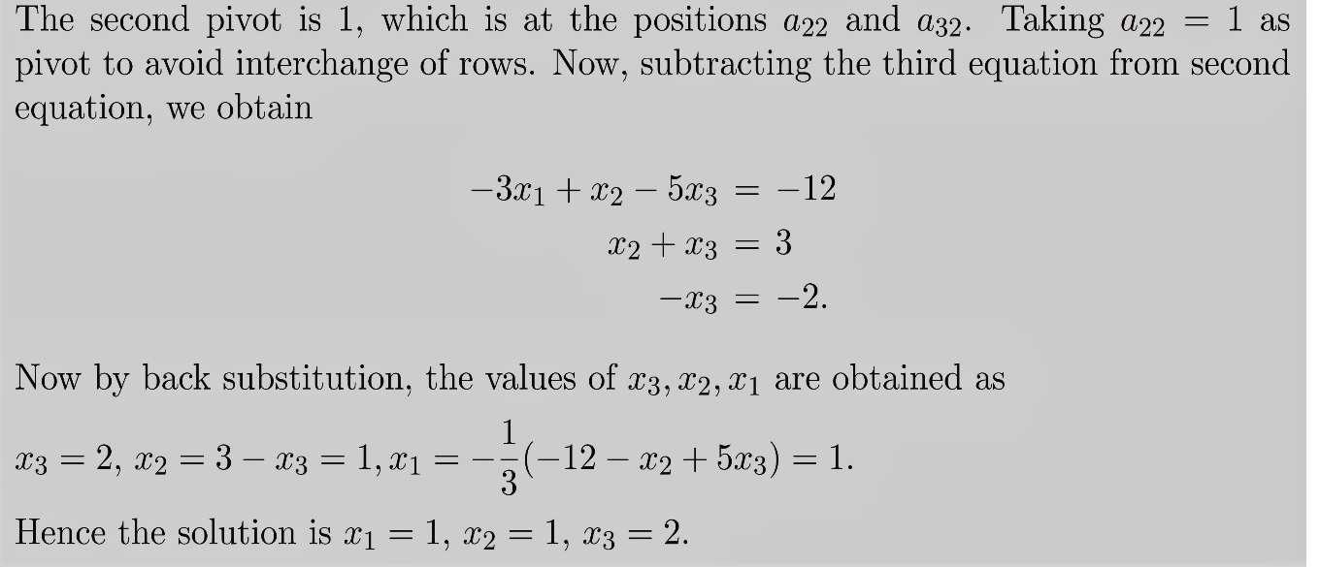

***Some prelimary concepts***

Let be the vector space.

**Norm of a Vector** is defined as a real valued function satisfying the conditions

1. where

**E xample** :

Then , **, = 2**

**Norm of a Matrix:** By a norm of a matrixis defined as a real number which satisfies the following conditions



**E xample** :

Then

= 16.88

**3.4 Gauss-Jacobi iteration method**

Consider the system of linear equations

(3.4.1)

Intially the given equations of the systems are so arranged the , and suppose that this rearrangement is (1). Now (i) is re-set in the form

….. …… …..

Or in brief

(3.4.2)

In the GauSs-Jacobi method the iteration is generated by the formula

(3.4.3)

The initial guess being chosen arbitrarily.

To examine the convergence of the process, set

From (3.4.3) for every *i*, and so

And so

(3.4.5)

Hence for every

(3.4.6)

This shows that if the iteration converges.

The system of linear equations (1) is said to be srtictly diagonally dominant if

i.e. if

Thus the Gauss-Jacobi iteration converges if the given system of linear equations is strictly diagonally dominant.

Let By (3.4.5)

where

Or which gives the estimation of error.

Smaller the value of , more rapid will be the convergence. Also note that the above consition of convergence is sufficient but not necessary.

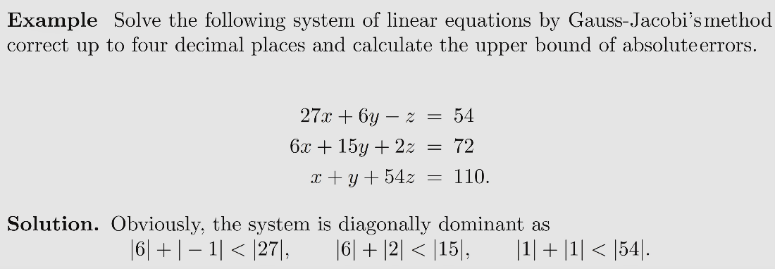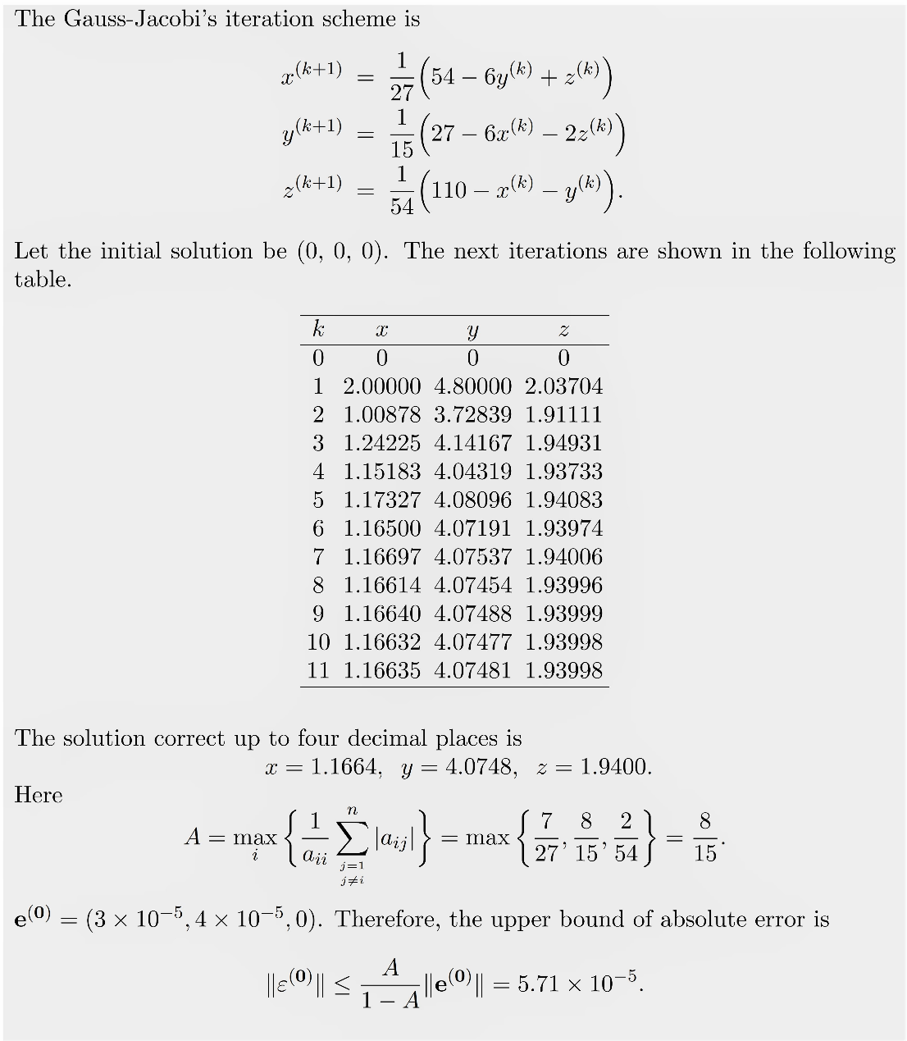

**3.5 Gauss-Seidel iteration method**

A slight variant of the Gauss-Jacobi iteration is the Gauss-siedel method in which the system is also written in the form (2) with but the iteration is carried out successively by the formulae

….. …… …..

)

(3.5.1)

The initial guess being chosen arbitrarily.

We Assert that Gauss-Seidel iteration also converges if where . Assume the . For every

(3.5.2)

Define temporarily

(3.5.3)

and

+

So that for some I,

And so

Or

(3.5.4)

Since

Which leads to

(3.5.5)

Hence for every

(3.5.6)

So that

IF

where .

It may appear the Gauss-Seidael method is more rapidly convergent than the Gauss-Jacobu method.

Here also the condition that the given system is strictly diagonally dominant is sufficient for the convergence of the method but not necessary.

**3.6 Successive Overrelaxation (S.O.R) Method**

We have to sove the linear system

where is a non-singular matrix and .

Assume that the diagonal elements of matrix are non-zero. If some then by interchanging some rows , we can make all . This is possible as is non-singular.

The matrix can always be written as

Where

So , (3.6.1)

becomes (3.6.2)

Now multiplying by some non-zero scalar on bothside of equation (3.6.2) we have

(3.6.3)

(3.6.4)

Adding (3.6.3) and (3.6.4) we get,

(3.6.5)

The iteration scheme is

(3.6.6)

(3..6.6) – (3.6.5) gives,)

Where where iis the error in the stage of approximation.

Or,

where

Suppose are eigen values of the matrix and are corresponding eigen-vectors such that they are linearly independent.

Let

Now,

Now,

i.e.

or,

therefore, equation (3.6.6) will converge if where . This method is called **overrelaxation method** when , and is called the underrelaxation method when When

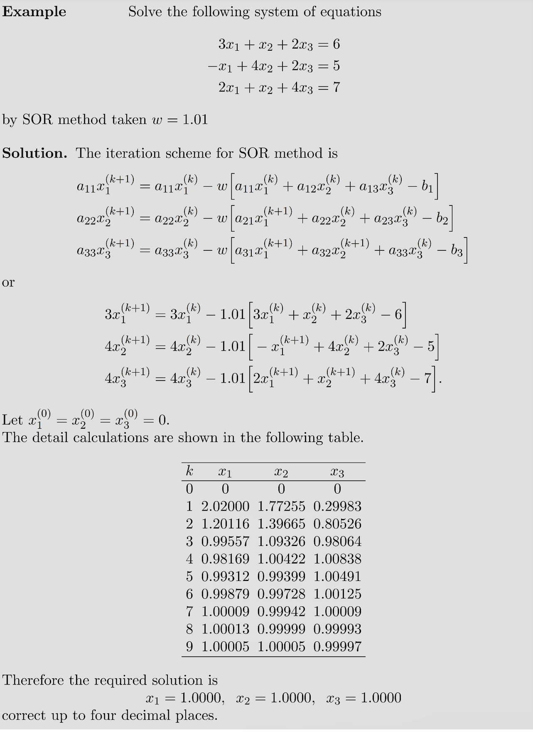

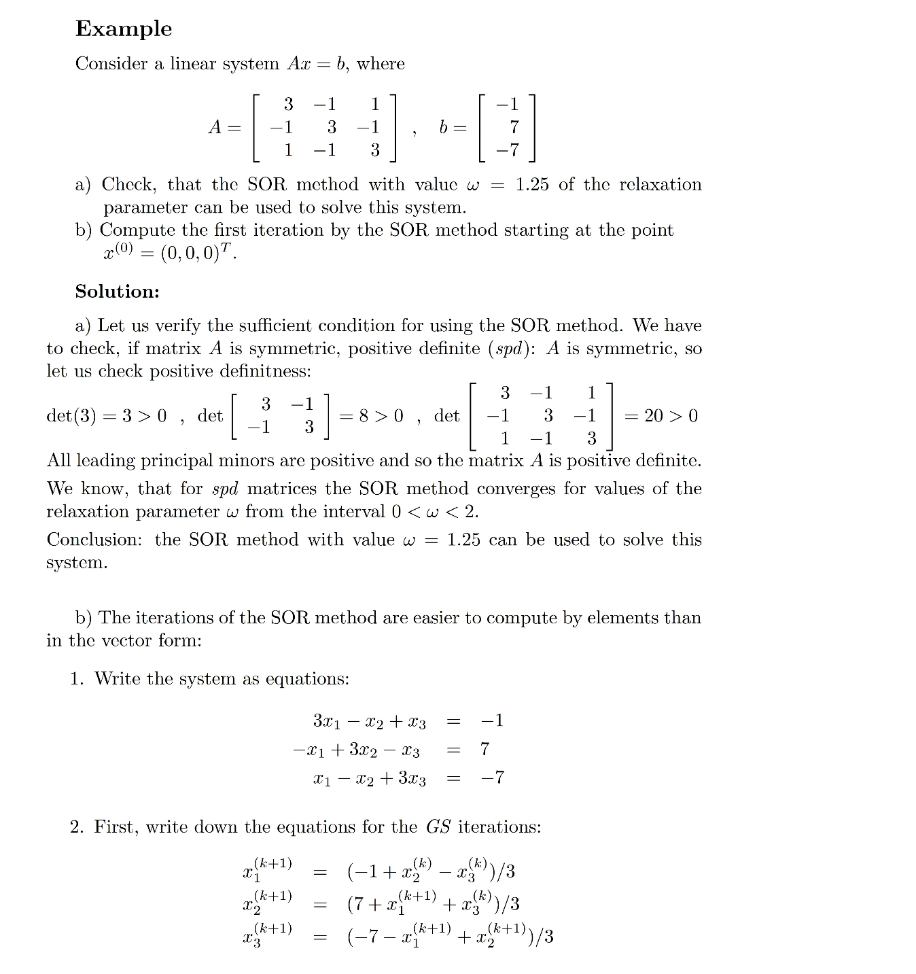

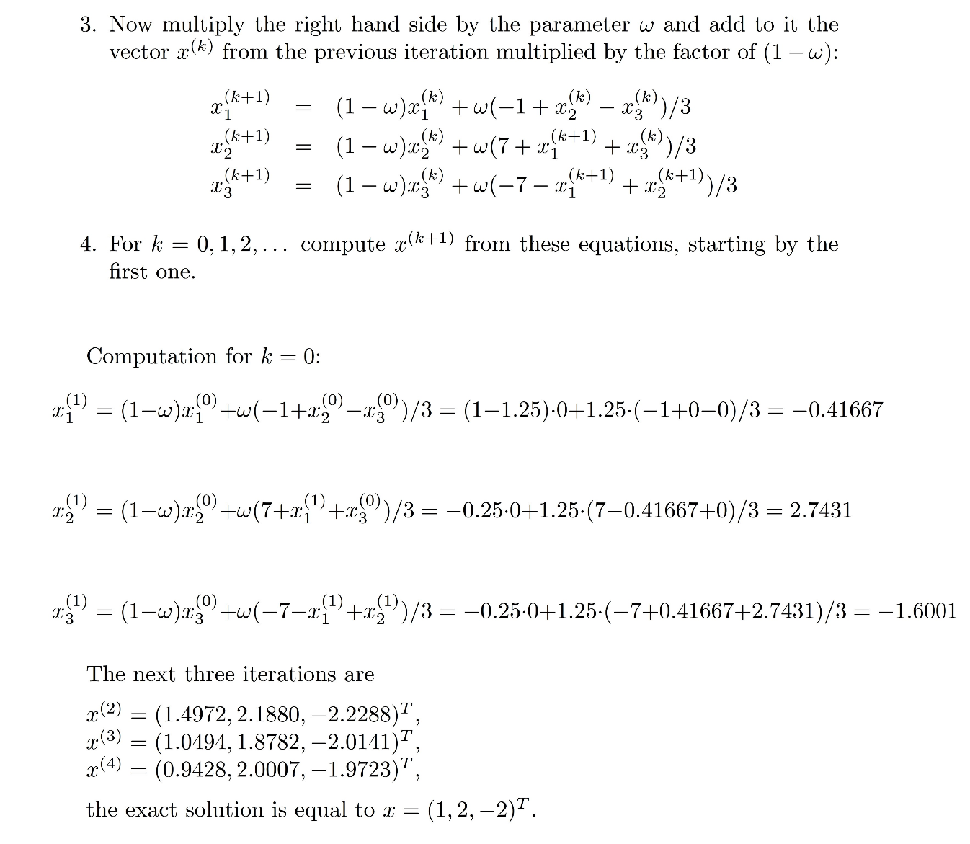

**6.7 Summary**

The system of linear equations has been solved by using direct approach and iterative approach. In the direct approach Gauss elimination method and Gauss-Jordan method have been studied in detail where as the iterative approach Gauss Jacobi, Gauss Seidal methods are studied and their convergence are also studied. In SOR method also the convergence analysis has been studied.

**6.8 Exercises**

1. Using Gauss elimination method with pivoting, solve the system of linear equations

(Ans: )

1. Solve the following system of equations with and without pivoting and compare the result with exact solution (1, 1, 1).
2. Solve the following system of equations by Gauss-Jacobi methos:

(Ans: )

ii.

(Ans: )

1. Solve the following system of equations by Gauss-Seidal method correct upto four decimal places:
2. (Ans : x = 1, y = 1, z = 1)
3. (Ans : x = 2, y = 0.9998, z = 2.9999)
4. Solve the following system of equations by S.O.R method correct upto four decimal places:

x+y+z=6, x - y - z = -4, x +2y - 2z = -1. (Ans: x=1, y= 2, z = 3)