**Unit 4 Interpolation**

**Structure**

* 1. **Introduction**
  2. **Polynomial Interpolation**
  3. **Newton’s Forward Interpolation**
  4. **Newton’s Forward Interpolation**
  5. **Central difference Interpolation**

**4.6 Lagrange’s Interpolation**

**4.7 Finite difference operator**

* 1. **Exercises**
  2. **Summary**

**4.1 Introduction**

The method of obtaining the value of the function for any intermediate value of the argument when the values of a functions are known for a set of values of the arguments is known as interpolation. Mathematically, if the values of the function at be known then finding the value of the function at where is known as interpolation. If lies outside the above said range, then the corresponding process is called extrapolation.

**4.2 Polynomial Interpolation:**

Let . The principle of interpolating polynomial is “the selection of a function from a given class of functions such that the graph passes through a finite set of given points”. When the function is a polynomial, the process of representing by is called The polynomial interpolation is based on the following theorem known as Weierstrass theorem:

**Theorem 1:** Let a function and let be any preassigned small number. Then, a polynomial for which i.e. any continuous function can be uniformly approximated by a polynomial of sufficiently high degree within any prescribed tolerance on the finite interval.

**Theorem 2:** Given any real valued function and distinct points there exist unique polynomial of maximum degree which interpolates at the points .

Exersise: Prove the above theorem.

In a polynomial interpolation the approximation function is taken to be a polynomial of degree given by

(4.1)

and it is given (4.2)

i.e.

Now (4.2) is a system of linear equation with unknowns. Since the

co-efficients determinant

by Vandermonde’s determinant

as the points are distinct the values of can be uniquely determined so that exists and is called interpolating polynomial. The given points are called interpolating points or nodes such that and also we shall write

**4.3 Newton’s Forward Interpolation Formula**

Let y be a continuously differentiable function. Given set of values of and , it is required to find a polynomial of degree, so that and coincide at tabulated points. Let the values of be equidistant so that , ( is the step length, . Since is a polynomial of degree , this can be written in the form

(4.3.1)

We now determine the coefficient using the notation

We have

By continuing this method of calculating the coefficients we shall find that

Substituting these values of in equation(4.3.1), we get

(4.3.2)

Setting , we have from equation (4.3.2)

(4.3.3)

Equation (4.3.3) is **Newton’s forward interpolation formula**.

The **error term** is given by

Note: Newton’s forward interpolation formula is used to interpolate the values of near the beginning of a set of tabulator values.

The difference table used in Newton’s forward formula is as follows:

|  |  |  |  |  |  |  |
| --- | --- | --- | --- | --- | --- | --- |
|  |  |  |  |  |  |  |
|  |  |  |  |  |  |  |
|  |  |  |  |  |  |  |
|  |  |  |  |  |  |  |
|  |  |  |  |  |  |  |
|  |  |  |  |  |  |  |
| …. | …. |  |  |  |  |  |
|  |  |  | ….. |  |  |  |
|  |  |  |  |  |  |  |
|  |  | …… |  |  |  |  |
|  |  |  |  |  |  |  |
|  |  |  |  |  |  |  |

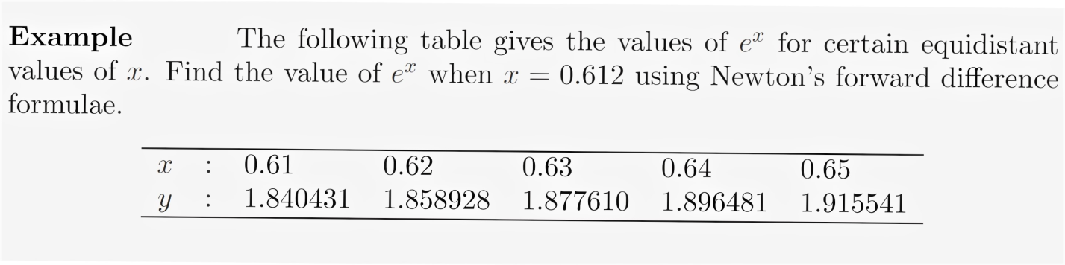

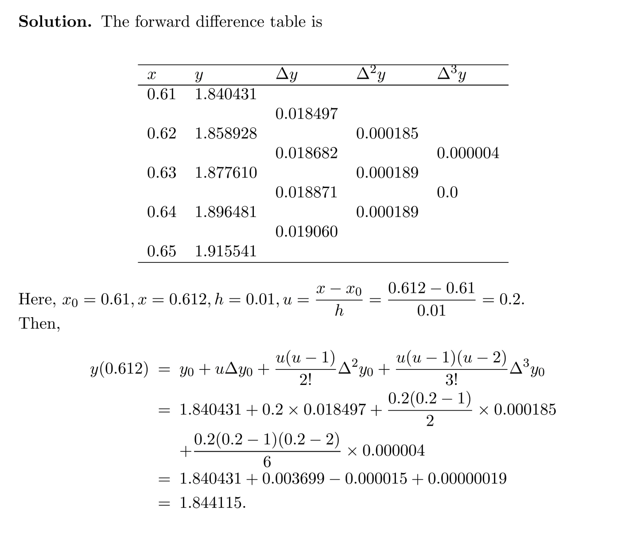

**4.4 Newton’s Backward Interpolation Formula**

Let be a continuously differentiable function. Given set of values of and , it is required to find a polynomial of degree, so that and coincide at tabulated points. Let the values of be equidistant so that , ( is the step length,. Since is a polynomial of degree , this can be written in the form

(4.4.1)

We now determine the coefficient using the notation

We have

By continuing this method of calculating the coefficients we shall find that

Substituting these values of in equation(4.4.1), we get

-1 (4.3.2)

Setting , we have from equation (4.3.2)

(4.3.3)

Equation (4.3.3) is **Newton’s backward interpolation formula**.

The **error term** is given by

Note: Newton’s backward interpolation formula is used to interpolate the values of near the end of a set of tabulator values.

The difference table used in Newton’s backward formula is as follows:

|  |  |  |  |  |  |  |
| --- | --- | --- | --- | --- | --- | --- |
|  |  |  |  |  |  |  |
|  |  |  |  |  |  |  |
|  |  |  |  |  |  |  |
|  |  |  |  |  |  |  |
|  |  |  |  |  |  |  |
|  |  |  |  |  |  |  |
| …. | …. |  |  |  |  |  |
|  |  |  | ….. |  |  |  |
|  |  |  |  |  |  |  |
|  |  | …… |  |  |  |  |
|  |  |  |  |  |  |  |
|  |  |  |  |  |  |  |

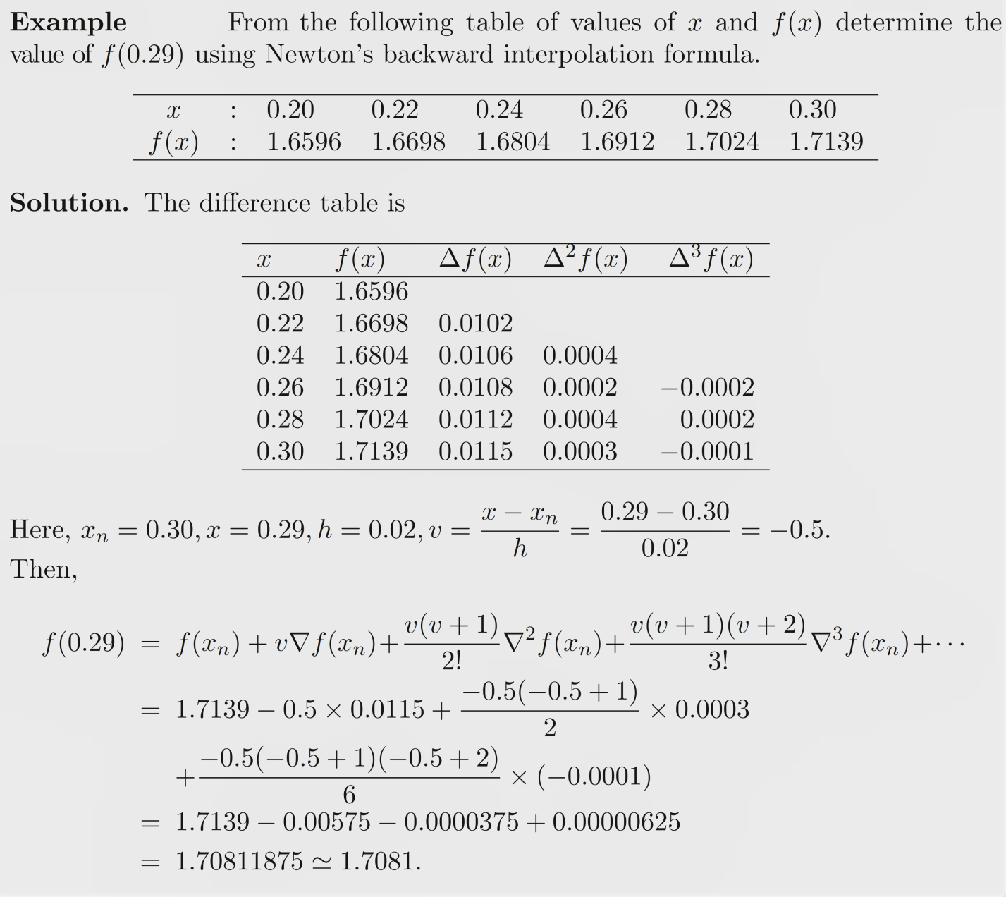

**4.5 Central Interpolation formula**

**4.5.1 Stirling’s Interpolation formula**:

For this formula the number of nodes will be taken to be odd, i.e. The nodes being .

The Gauss forward interpolation formula is given by

where u lies 0 and 1

And Gauss Backward formula is given by

where u lies between -1 and 0

Taking mean of the above two Gauss’s formulas, we get

The above equation is called **Stirling’s interpolation** formula.

Bessel’s formula

**4.5.2 Bessel’s formula** is for is odd and is given by

The above relation is **Bessel’s formula**.

Exercise: Obtain the difference table for Stirling’s and Bessel’s formula.

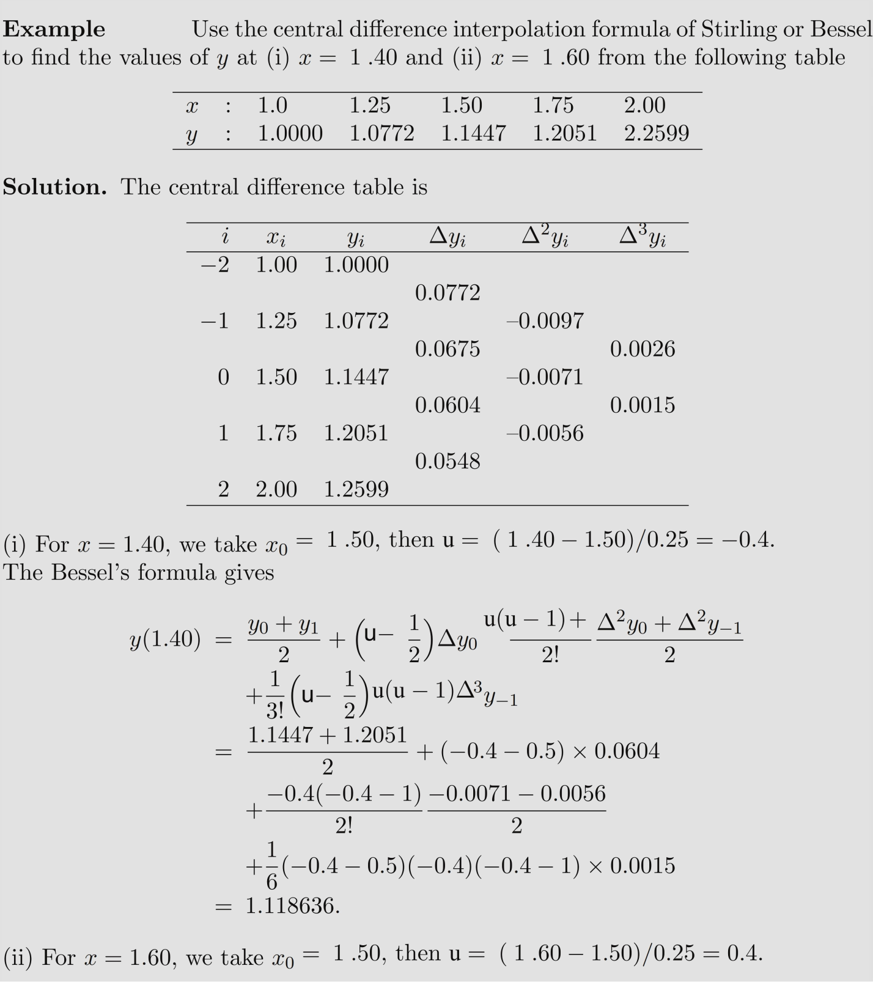

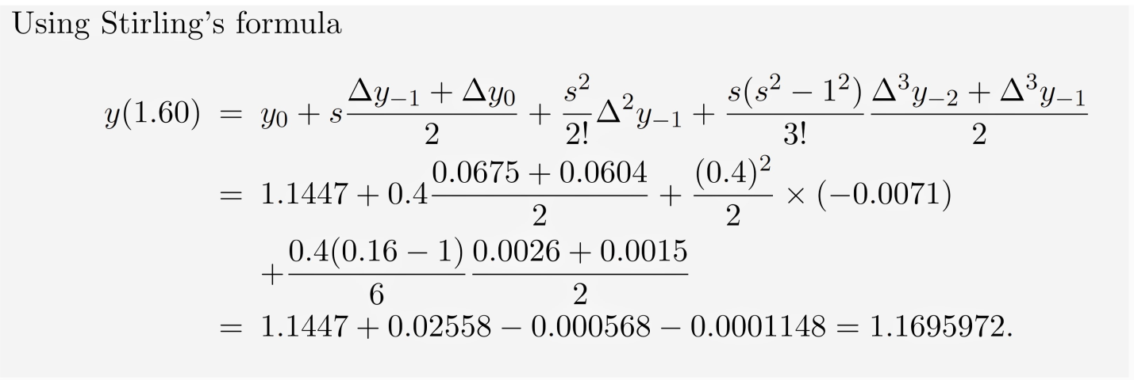

**4.5 Lagrange’s Interpolation**

Let be a continuously differentiable function. Given set of values of and , it is required to find a polynomial of degree, so that and coincide at tabulated points. Here the values of are not equispaced. Since is a polynomial of degree , this can be written in the form

(4.5.1)

where are coefficient to be determined from the relation .

Putting in equation (4.5.1), we get

Putting in equation (4.5.1), we get

Similarly putting in equation (4.5.1), we get

……………………………………………………………….

……………………………………………………………….

Substituting the values of in (4.5.1) we get

which is Lagrange’s interpolation formula. The above formula may be written in the following way as

where

Where

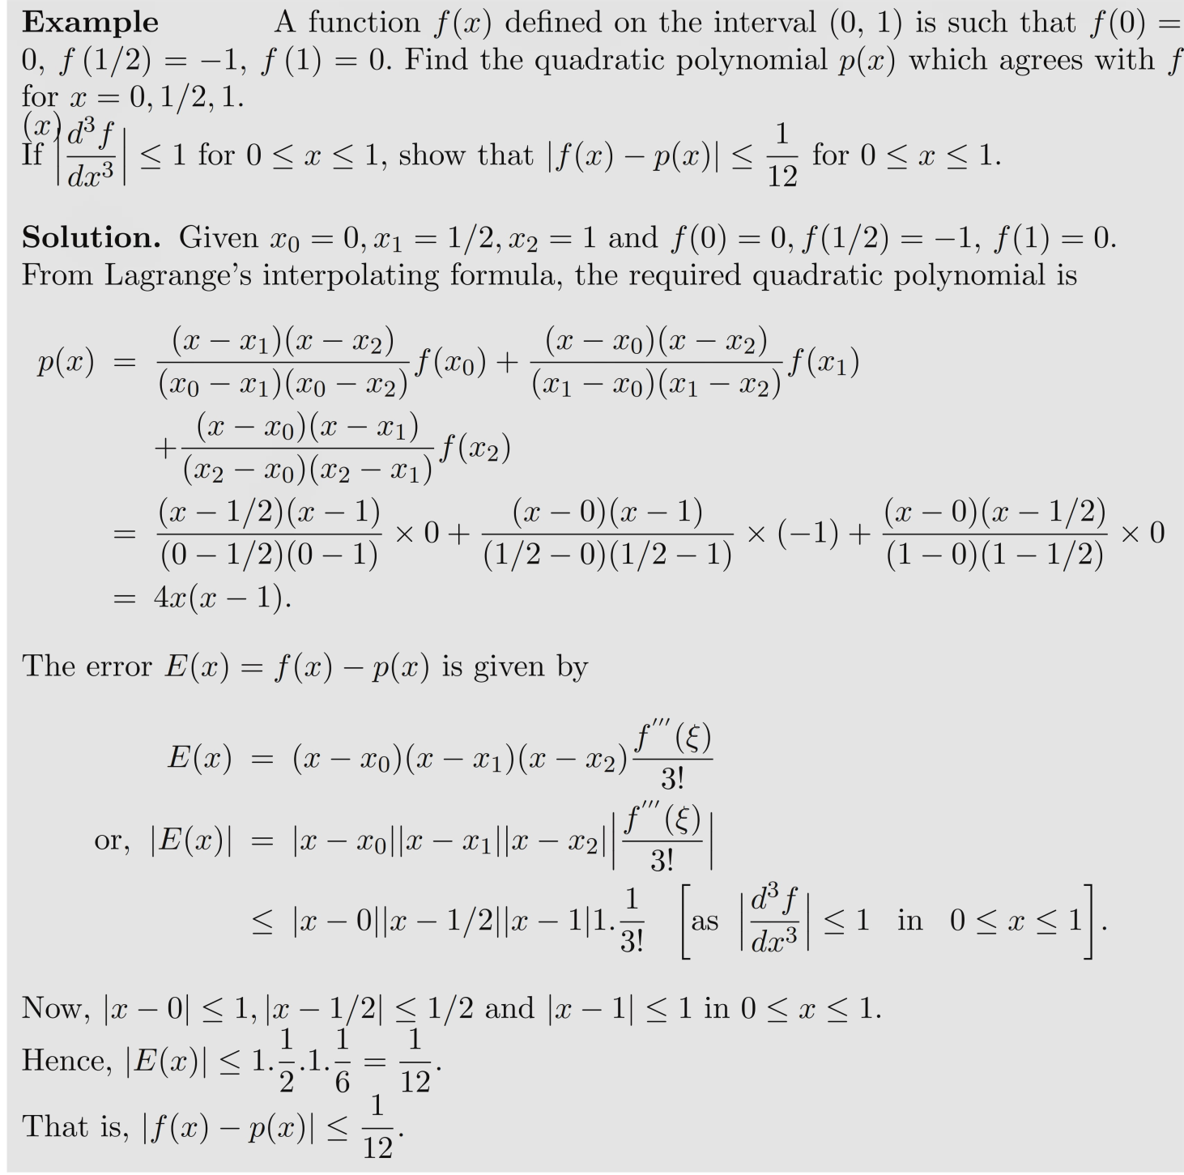

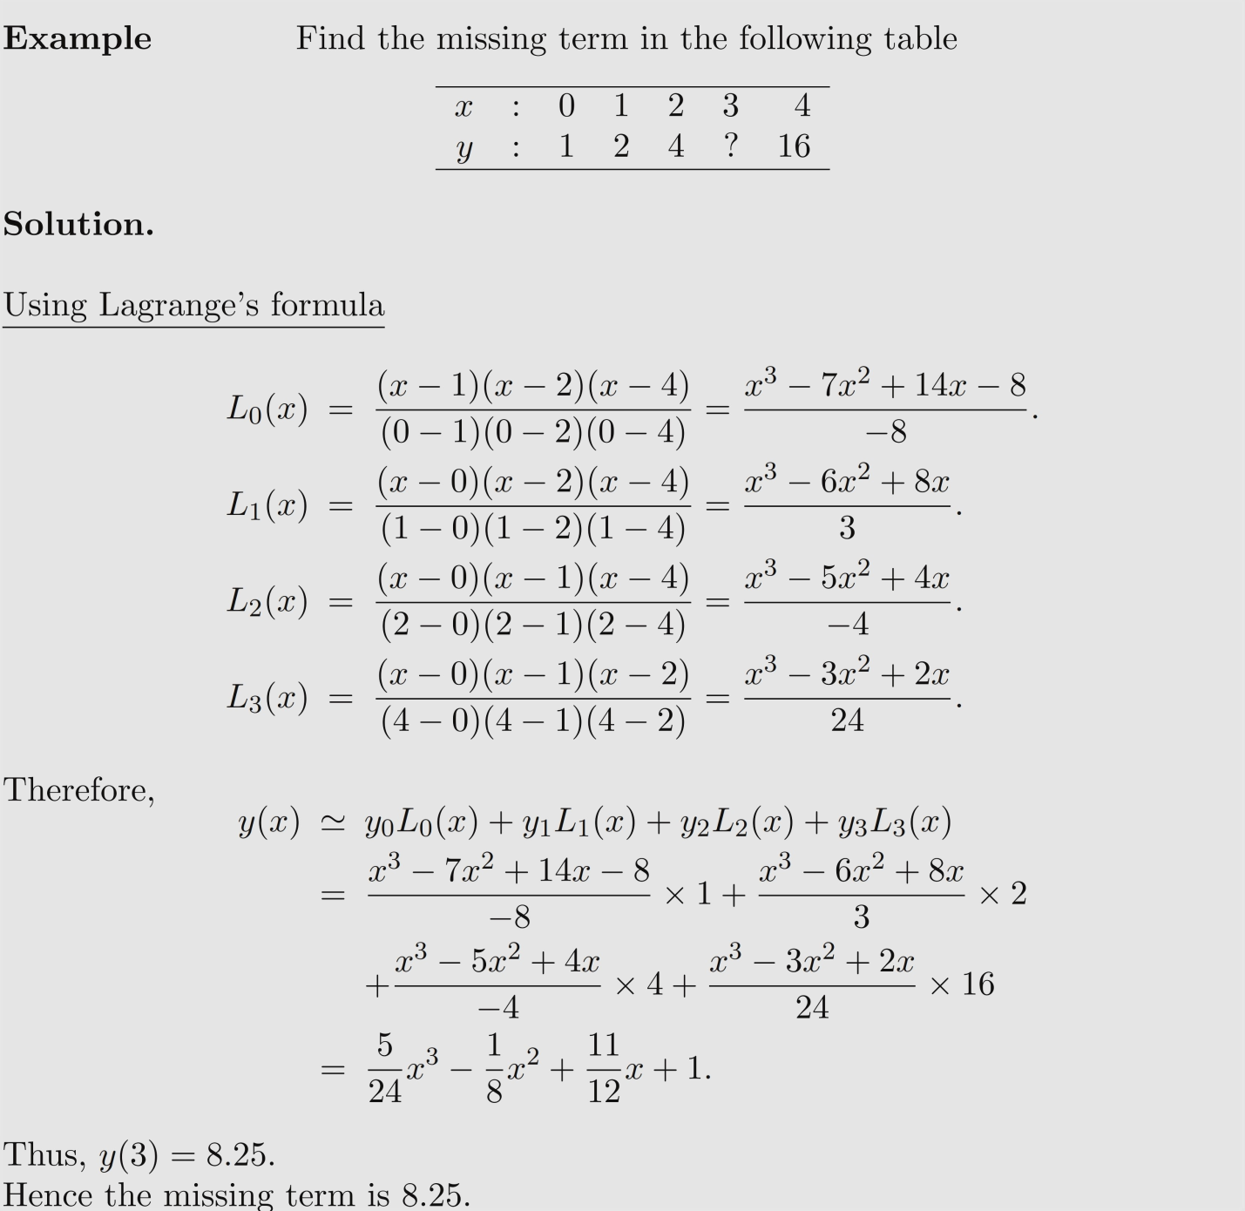

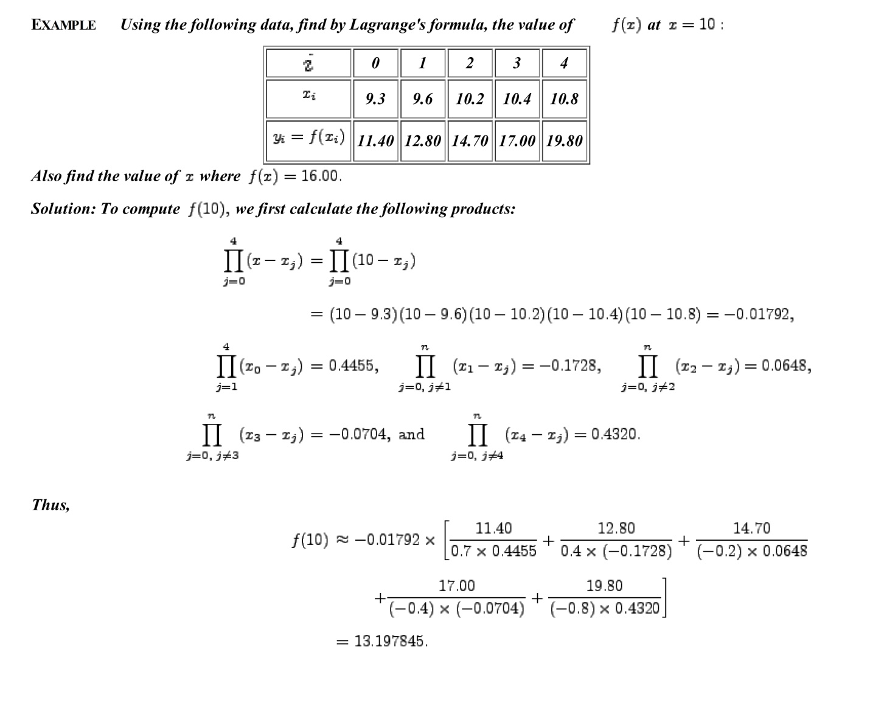

**4.6 Finite difference operator**

**Shift Operator :** Let be a non-zero constant is the step length. The shift operator for any arbitrary function defined in is represented by.

Now and in general

**Forward difference operator** : It is defined by where is the step length

is a linear operator and .

Putting we get

, The second order difference is given by

Similarly the 3rd order difference is represented by

and k-th order difference is given by

Exercise: i) Prove that first order difference of a constant is 0.

ii) The first order difference of a polynomial of degree is a polynomial of degree

**Backward difference operator :** The first order backward difference operator is defined by

**The central difference operator** The central difference operator is defined by

Thus we have the result

Example: i) Show that

(proved)

1. Show that

Proof: We know that

(proved)

**4.7 Summary**

In this Unit we have studied Newton’s forward, backward interpolations, Central Interpolation, Bessel’s and Stirling’s interpolation, Lagrange’s interpolation and the related problems. We have also studied the some operators like shift, forward difference, backward difference and cental difference and relations between them.

**4.8 Exercise**

1. Determine as a polynomial in for the following data:

|  |  |  |  |  |  |
| --- | --- | --- | --- | --- | --- |
| : | -4 | -1 | 0 | 2 | 4 |
|  | 1245 | 33 | 5 | 9 | 1335 |

Ans: – 5

1. Given the values:

|  |  |  |  |  |  |
| --- | --- | --- | --- | --- | --- |
| : | 5 | 7 | 11 | 13 | 17 |
|  | 150 | 392 | 1452 | 2366 | 5202 |

Evaluate using Lagrange’s interpolation formula. (Ans: 810)

1. The following table gives the sales of a concern for five years. Estimate the sales for the year i) 1986 ii) 1992:

|  |  |  |  |  |  |
| --- | --- | --- | --- | --- | --- |
| Year | 1985 | 1987 | 1989 | 1991 | 1993 |
| Sales | 40 | 43 | 48 | 52 | 57 |

Ans: i) 41.02 ii) 54.46

1. Find the seventh and the general terms of the series 3, 9, 20, 38, 65, ….

Ans: i) = 154 ii)

1. Use the Stirling’s formula to find from the following table

|  |  |  |  |  |  |  |
| --- | --- | --- | --- | --- | --- | --- |
|  | 20 | 25 | 30 | 35 | 40 | 45 |
|  | 14.035 | 13.674 | 13.257 | 12.734 | 12.089 | 11.309 |

Ans:

1. Prove that