**Product Store - ReadMe and How to Use file**

**Technology Used:**

**Backend:** .Net6, Web API, Entity Framework with Code First Approach, JWT Authentication.  
**Frontend:** Angular 15, Angular Material, Bootstrap  
**Database:** MsSQL Server  
  
  
**How to Run the Project:**

**Backend:  
prerequisite:** visual studio 2022 **1-** Open the assignment.sln file with Visual Studio 2022.  
**2-** Open the program manager console in visual studio and run this command: *update-databse.***3-** Once the update-database command executed successfully press the start button, you’ll see project is running on **http://localhost:5199/  
4-** You can see all endpoint of project here : [**http://localhost:5199/swagger/index.html**](http://localhost:5199/swagger/index.html) **FrontEnd:  
prerequisite:** angular-cli, node.js **1-** Before running frontend make sure that the backend is up and running.  
**2-** Open the project in VS Code and then open the terminal in VS Code while in the project directory  
**3-** Run the command **npm-install  
4-**  Once the above command executed successfully use commend: **ng-serve  
5-** You’ll see that angular project in now running on **localhost:4200**   
**6-** You’ll able to see this page afterwards:  
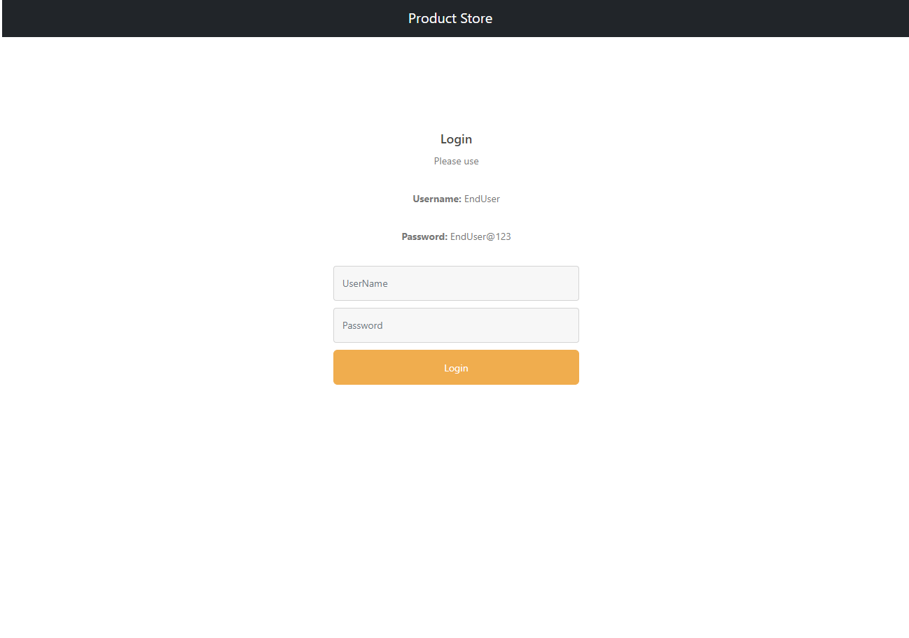

**7-** User **Username**: EndUser and **Password**: EndUser@123 to login.