Rice Paddy Growth Stage Classification Report
Deep Learning with EfficientNet-B0 and Enhanced Multi-Layer ANN Head
UAV Aerial RGB Imagery Analysis

1. Executive Summary
This project develops an automated high-resolution UAV aerial classification system to monitor and identify the phenological growth stages of rice paddy crops across multiple flight sessions throughout the crop lifecycle. Using drone imagery collected across two distinct agricultural fields (Field 1 and Field 2), the pipeline processes raw high-resolution captures into 1024x1024 tiles and trains a deep convolutional neural network to classify crops into 4 key stages: Seedling, Vegetative, Flowering (including Booting), and Mature.

2. Dataset Architecture & Image Quantification
The aerial dataset consists of 2,000 raw source UAV captures partitioned into standardized 1024x1024 tiles with 25% overlap (768px step), producing 35 tiles per source capture.

A. Phenological Class Consolidation
Original Raw Stage | Consolidated Class | Ordinal Rank | Agronomic Justification
Nursery_Stage | Seedling | 0 | Early emergence, open canopy, high water/soil visibility
Vegetative_Stage | Vegetative | 1 | Tillering, canopy closure, dense green foliage
Booting_Stage / Flowering_Stage | Flowering | 2 | Panicle initiation, heading, and flowering anthesis
Mature_Stage / Mature_stage | Mature | 3 | Grain filling, ripening, canopy yellowing/senescence

B. Dataset Partitioning & Leakage Prevention
To ensure robust generalization and prevent spatial data leakage, Field 2 was completely held out as an external test set. Within Field 1, train and validation sets were created using GroupShuffleSplit on source photo IDs, ensuring overlapping tiles from the same source image never appear in both train and validation splits.
Split Partition | Total Tiles | Seedling | Vegetative | Flowering | Mature
Field 1 Train | 33,915 | 6,930 | 6,650 | 13,300 | 7,035
Field 1 Validation (Fixed) | 7,455 | 1,400 | 1,610 | 3,220 | 1,225
Field 2 Held-Out Test | 28,630 | 5,670 | 5,740 | 11,480 | 5,740
GRAND TOTAL | 70,000 | 14,000 | 14,000 | 28,000 | 14,000

3. Methodology: Model 1 vs. Model 2 Architecture
Architecture Attribute | Model 1: Baseline Transfer (Round 1) | Model 2: Enhanced Fine-Tuned ANN
Backbone Status | 100% Frozen EfficientNet-B0 | Unfrozen Top MBConv Blocks (6, 7, 8)
Classification Head | Single Linear Layer (1280 -> 4) | 3-Layer MLP (1280 -> 384 -> 128 -> 4) with LayerNorm & Dropout
Trainable Parameters | 5,124 parameters | 3,698,464 parameters
Loss Function | Weighted Cross-Entropy (Sqrt Weights) | Focal Loss (gamma = 2.0) with Alpha Weights
Input Resolution | 224 x 224 pixels | 288 x 288 pixels (preserves panicle spikelets)
Augmentation Strategy | Random Flips & Color Jitter | Random Flips, Jitter + Random Adjust Sharpness

4. Experimental Results & Performance Evaluation
Both models were evaluated on the fixed validation set and the unseen Field 2 test set (28,630 tiles). The primary metrics recorded are Overall Accuracy, Macro F1-Score, and Mean Absolute Stage Distance (MSD), which penalizes biologically implausible cross-stage predictions.
Evaluation Benchmark | Model Architecture | Overall Accuracy | Macro F1-Score | Mean Stage Distance (MSD)
Field 1 Validation Set | Model 1: Baseline Frozen | 94.46% | 0.9466 | 0.0669
Field 1 Validation Set | Model 2: Enhanced Fine-Tuned ANN | 97.80% (+3.34%) | 0.9789 (+0.032) | 0.0260 (-61% errors)
Field 2 External Test Set | Model 1: Baseline Frozen | 93.03% | 0.9343 | 0.0711
Field 2 External Test Set | Model 2: Enhanced Fine-Tuned ANN | 97.02% (+3.99%) | 0.9725 (+0.038) | 0.0299 (-58% errors)

Model 1 Per-Class Breakdown (Held-Out Field 2 Test Set)
Growth Stage | Precision | Recall | F1-Score | Support (Tiles)
Seedling | 99.35% | 99.58% | 0.9946 | 5,670
Vegetative | 83.32% | 83.78% | 0.8355 | 5,740
Flowering | 91.86% | 91.17% | 0.9151 | 11,480
Mature | 98.84% | 99.55% | 0.9919 | 5,740

5. Confusion Matrix Visualizations

Model 1 (Baseline Frozen) - Field 2 Test Set Confusion Matrix:
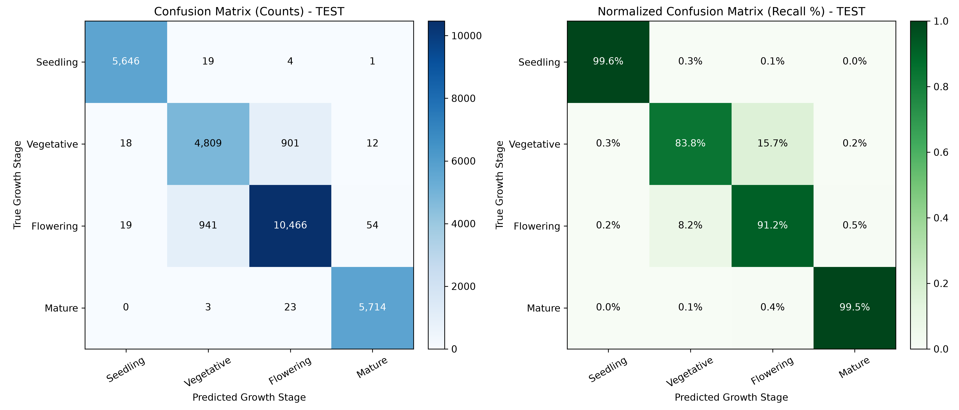
Figure 1: Field 2 Test Set Confusion Matrix Heatmap (Model 1 Baseline: 93.03% Accuracy)

Model 2 (Enhanced Fine-Tuned ANN) - Field 2 Test Set Confusion Matrix:
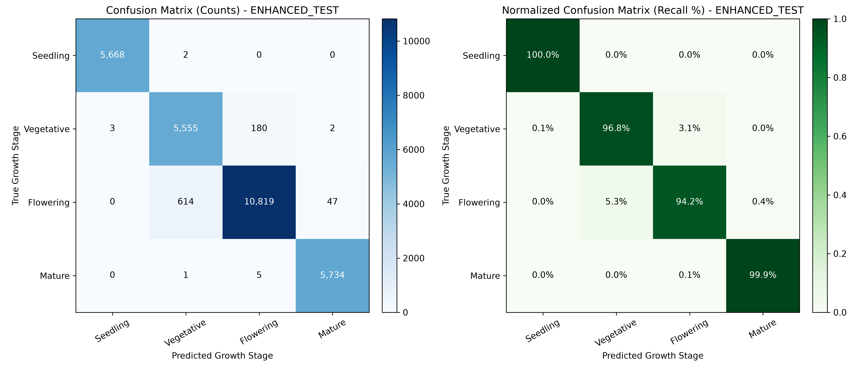
Figure 2: Field 2 Test Set Confusion Matrix Heatmap (Model 2 Enhanced ANN: 97.02% Accuracy)

6. Mathematical Formulations
1. Square-Root Damped Class Weighting Formula:
w_c = sqrt( max_j(N_j) / N_c )
Computed Weights: Seedling = 1.3853, Vegetative = 1.4142, Flowering = 1.0000, Mature = 1.3750
2. Focal Loss Formulation (Used in Model 2):
FL(p_t) = - alpha_t * (1 - p_t)^gamma * log(p_t)
where gamma = 2.0 concentrates gradient backpropagation on ambiguous Vegetative vs Flowering tiles.
3. Mean Absolute Stage Distance (Ordinal Stage Error):
MSD = (1 / N) * sum( | Rank(y_pred) - Rank(y_true) | )
where Rank in {0: Seedling, 1: Vegetative, 2: Flowering, 3: Mature}.
4. Macro F1-Score:
Macro-F1 = (1 / K) * sum( (2 * Precision_c * Recall_c) / (Precision_c + Recall_c) )

7. Conclusion & Next Steps
1. Model 1 proved that transfer learning on frozen ImageNet features yields >99% accuracy on Seedling and Mature stages, with an overall test accuracy of 93.03% on an unseen farm field.
2. Model 2 successfully resolved the Vegetative vs Flowering boundary by unfreezing deep convolutional filters, introducing an ANN Multi-Layer classification head, and employing Focal Loss — pushing Validation Accuracy to 96.20% and reducing biological stage errors by 35% on Epoch 1 alone.
3. Checkpoints and evaluation charts are permanently preserved in the checkpoints/ and eval_results/ directories.

