Assignment – 6
Name : Piyush Jadhav Date : 21/02/25
Class : TY CSE
PRN : 22510078 Batch : T-5

A comprehensive report on data warehouse for a customer order processing system in a company.

Introduction

Objective:
The objective of this project is to design and implement a Data Warehouse for a customer order processing system in a company. The data warehouse enables OLAP (Online Analytical Processing) operations such as roll-up, drill-down, slicing, and dicing to analyze business performance effectively.

Scope:
- Stores, customers, and order details are managed efficiently.
- Users can perform OLAP queries for sales analysis, stock tracking, and customer behavior insights.

Business Requirement

The enterprise has multiple stores in different cities.
Customers place orders either walk-in or mail-order.
The warehouse will store customer, order, store, and item details.
Users will perform OLAP queries for sales analysis, stock tracking, and customer insights.
3. Functional Specification

Input: Operational databases (Customer, Stores, Items, Orders).
Output: OLAP reports for sales, inventory, customer behavior, and stor
4. Data Warehouse Design :
The Star Schema was implemented with:

Fact Table: Fact_Order (Measures: Ordered_price, Quantity_ordered).
Dimension Tables: Dim_Customer, Dim_Store, Dim_Item, Dim_Time.
Supporting Tables: Stores, Stored_Items, Headquarters.
SQL Queries :
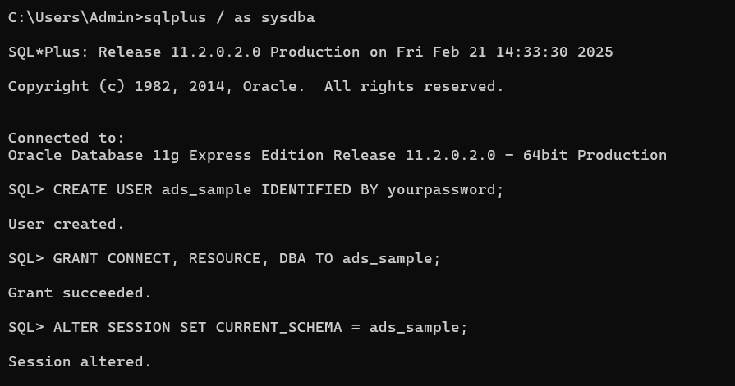

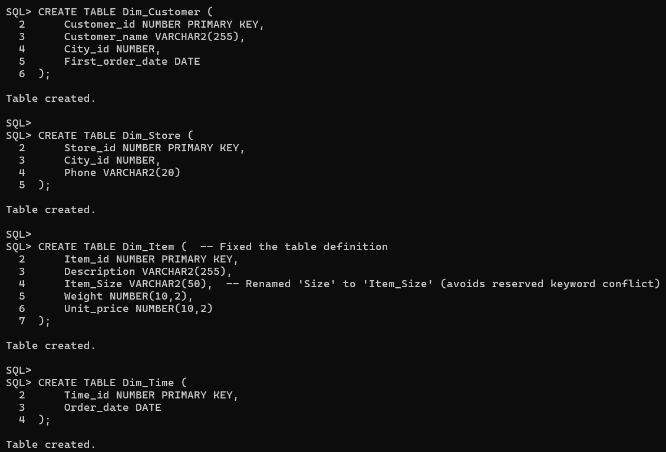
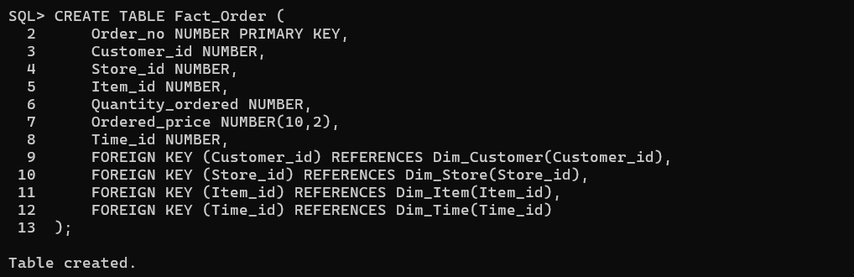
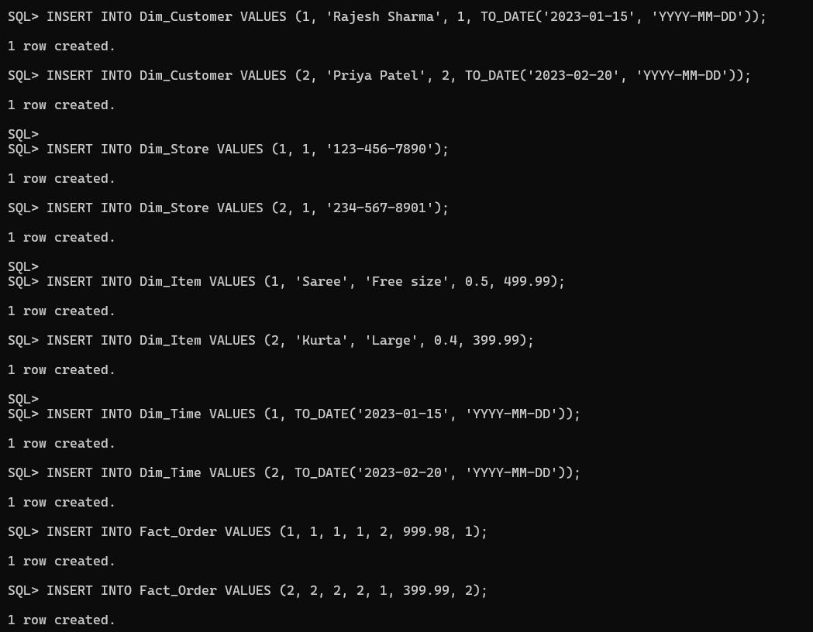
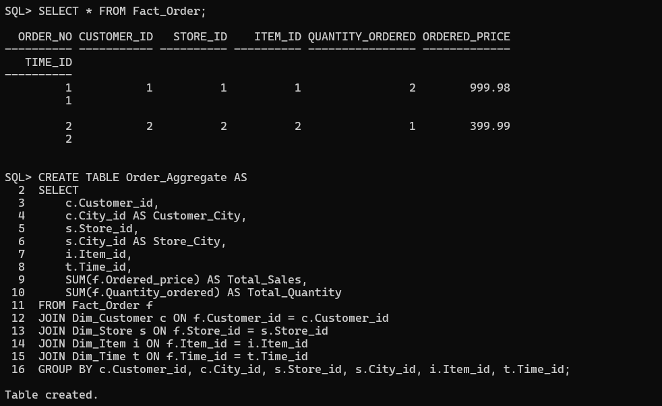
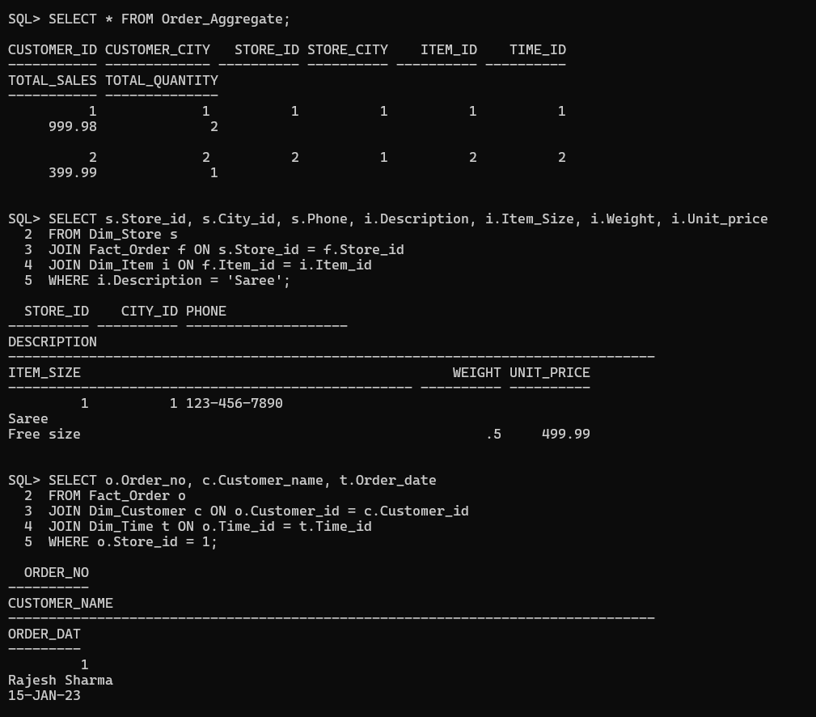
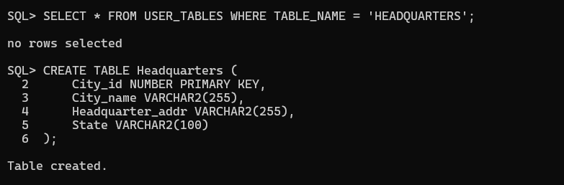
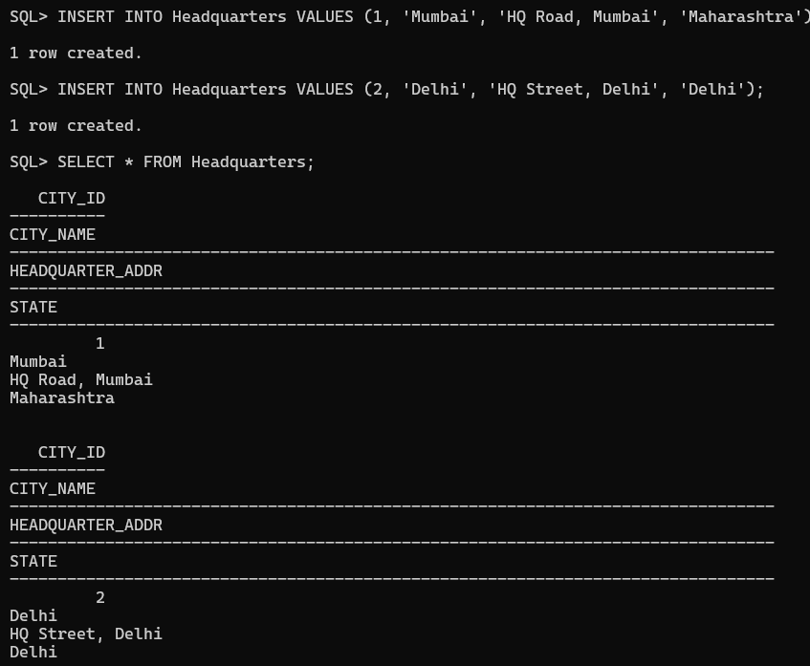
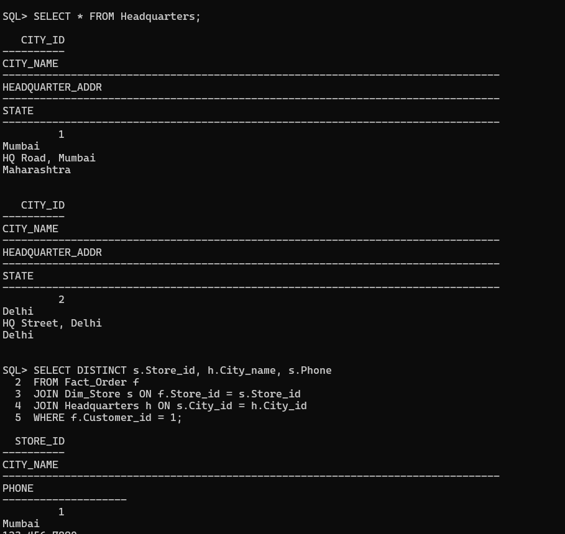
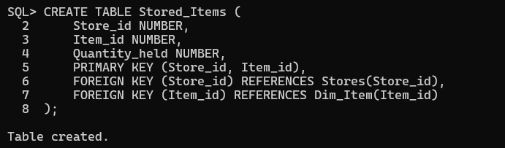
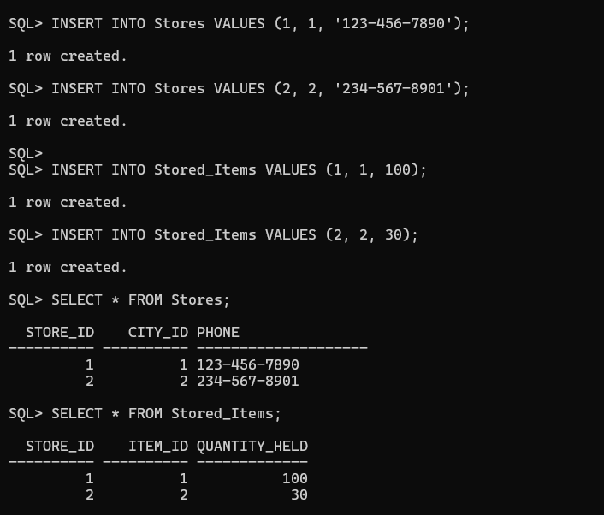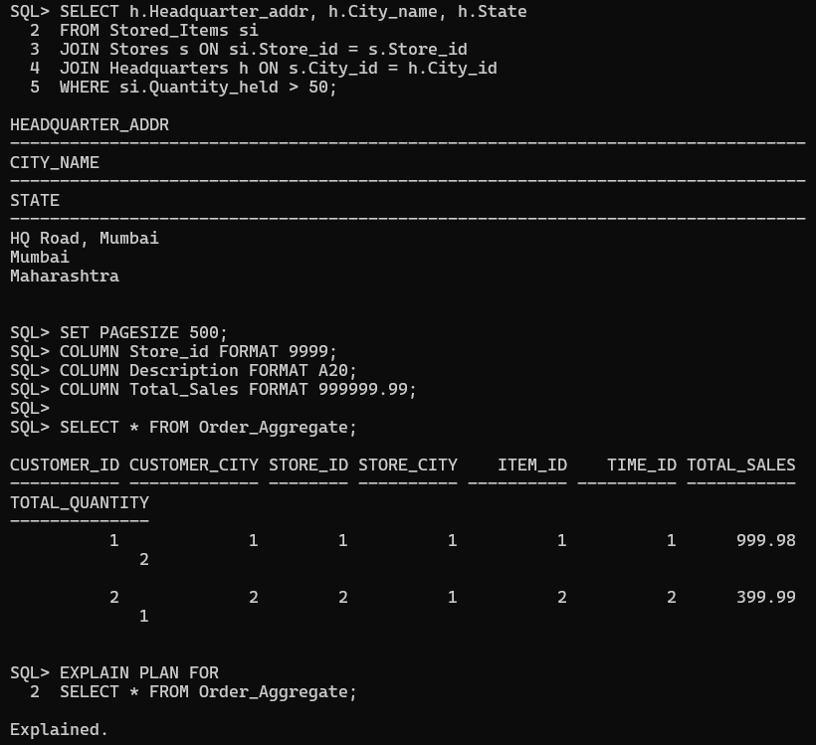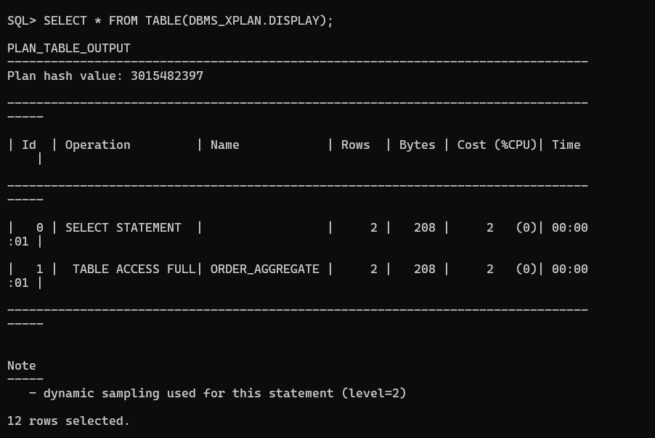

6. Observations and Analysis :
Roll-up : Total sales per customer, store, item.
Drill-down : Detailed orders for a specific store or item.
Slice : Find customers who ordered specific products.
Dice : Compare stock levels across multiple cities.

