Batch T2
Assignment No. 10
Student Name: Amit Wasnik
Student PRN: 22510015

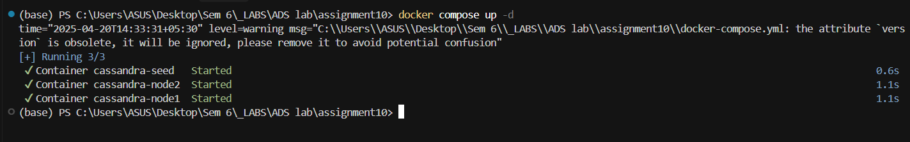


Seed Node
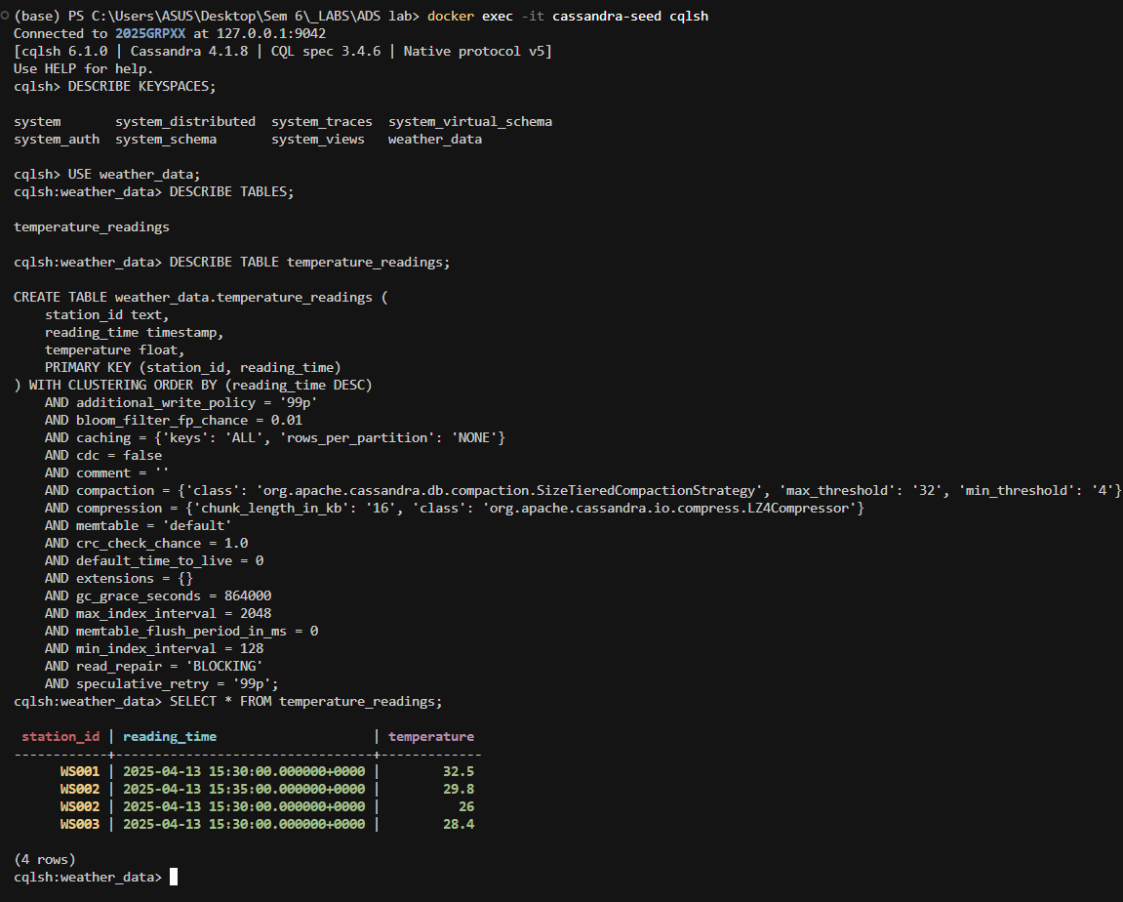

Node 1:
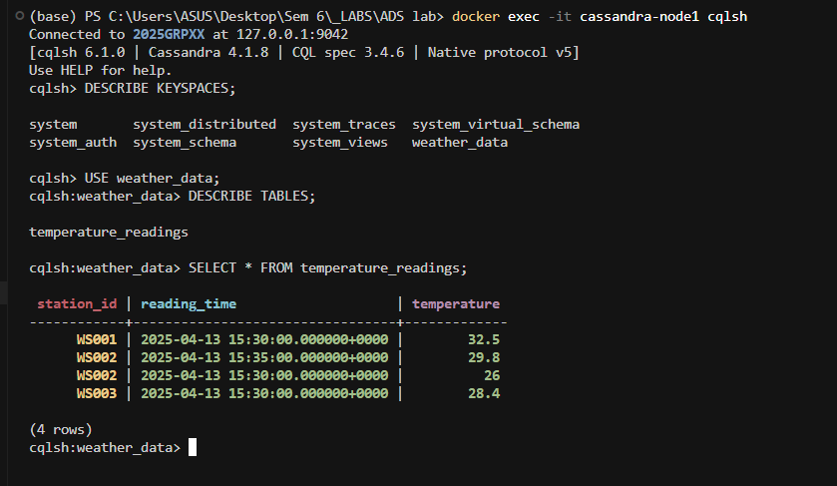

Node 2:
