Batch T5
Assignment No. 10
Student Name: Piyush Jadhav
Student PRN: 22510078

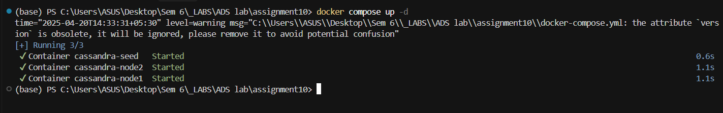


Seed Node
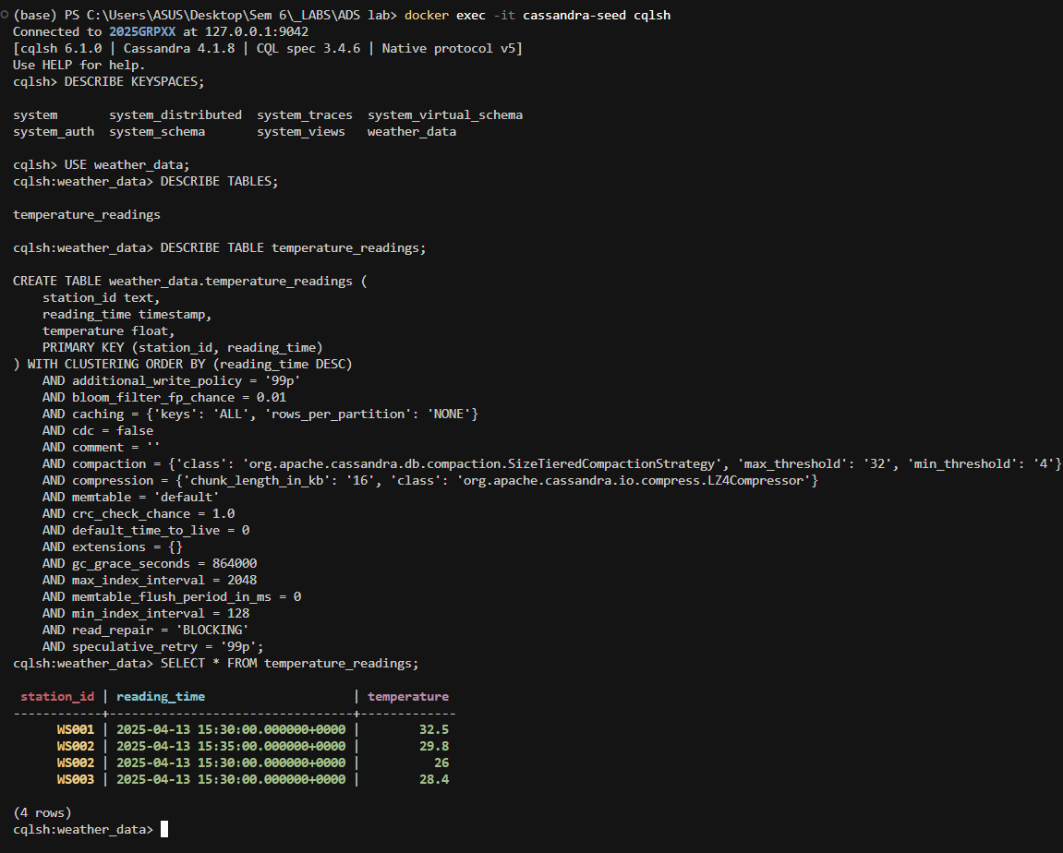

Node 1:
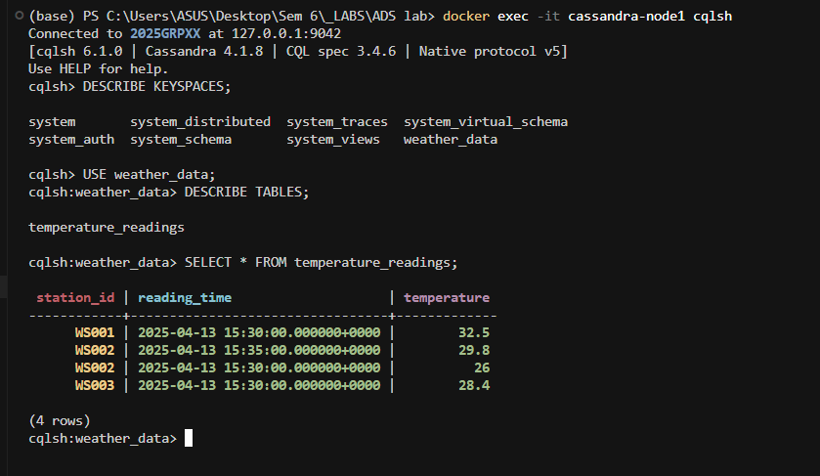

Node 2:
