SARVAM AI:

HOME-ASSIGNMENT DOCUMENTATION

**Acknowledgement**

I would like to express my sincere gratitude to Saurabh Karn, Founding Member of Sarvam AI, and Nitesh Methani, Machine Learning Engineer at Sarvam AI, for providing me with the opportunity to complete this home assignment as part of the internship application process. Their guidance and support have been invaluable in helping me develop this scalable LLM chatbot system.

This assignment has not only allowed me to demonstrate my skills and knowledge but also given me a chance to explore innovative AI technologies and contribute to a meaningful project. I appreciate the time and effort invested in creating this assignment and look forward to the opportunity to learn and grow further with Sarvam AI.

**Table of Content**

|  |  |  |
| --- | --- | --- |
| Sl.No. | Title | Page No. |
| 1. | Problem Statement | 4 |
| 2. | System Overview | 5 - 7 |
| 3. | System Architecture | 8 - 10 |
| 4. | Scalability | 11 |
| 5. | Cost Considerations | 12 |
| 6. | LLM Integration |  |
| 7. | Prompt Engineering and Fine Tuning |  |
| 8. | Deployment Instructions |  |
| 9. | Dockerization and Kubernetes |  |
| 10. | Gemini API Integration |  |
| 11. | Frontend Implementation |  |

**PROBLEM-STATEMENT**

Build a Scalable LLM Chatbot System Overview Design and implement a chat application powered by a Large Language Model (e.g., OpenAI, Anthropic, Llama, etc.) that can support 10,000+ users. Your solution should demonstrate your approach to building production-ready systems.

**System Overview**

Our chatbot system is designed to support over 10,000 users by leveraging a Large Language Model (LLM) for conversational interactions. The system integrates the Gemini API for client-side operations and utilizes React for the frontend. Docker and Kubernetes are employed for containerization and orchestration, ensuring scalability and reliability.

1. **Core Functionality:**

The core functionality of our scalable LLM chatbot system includes several key features designed to provide users with a seamless and engaging conversational experience.

1. ***Chat Interface:***

* **User-Interaction:** Users can input messages and engage in conversations with the LLM.
* **Real-Time Updates:** The chat log updates in real-time as new messages are sent or received.
* **Responsive Design:** Ensures a smooth user experience across different devices.

1. ***Conversation History:***

* **Contextual Understanding:** Maintains a record of previous interactions to provide contextually relevant responses.
* **Data Storage:** Conversation history is stored in a MongoDB database for efficient retrieval.

1. ***Scalability:***

* **Support for Large User Base:** Designed to handle over 10,000 users simultaneously.
* **Horizontal-Scaling:** Kubernetes allows for easy addition of more pods to handle increased traffic.
* **Vertical-Scaling:** Resources (CPU, RAM) can be increased for existing pods to improve performance.

1. **LLM Integration:**

* **Gemini-Api:** Utilizes the Gemini API for interacting with the LLM.
* **Prompt Engineering:** Custom prompts are crafted to enhance response quality.
* **Fine-Tuning:** Model parameters are adjusted for better performance.

1. **Containerization with Docker:**

* **Consistent Environment:** Docker ensures that both the frontend and backend applications run in consistent environments across different machines.
* **Efficient Deployment:** Docker images are lightweight and easy to deploy, reducing the time and resources needed for setup.
* **Isolation:** Docker containers provide isolation between applications, improving security and reducing conflicts.

1. **Orchestration with Kubernetes:**

* **Automated Deployment:** Kubernetes automates the deployment and scaling of Docker containers.
* **Self-Healing:** Kubernetes ensures that if a container fails, it will be automatically restarted.
* **Resource Management:** Kubernetes optimizes resource allocation to ensure efficient use of computing resources.

**EXAMPLE INTERACTION:**

**User:** explain theoretical physics to a toddler

**AI**: Imagine you have LEGOs! Theoretical physics is like building the biggest, coolest LEGO castle ever, but *without* actually having all the LEGOs.

We know some LEGOs exist (like the ones we see around us – that's like the stuff we can *see* and *touch* in the world). But theoretical physicists try to figure out what *other* LEGOs might be out there, even if we can't see them yet. They imagine tiny, tiny LEGOs that make up everything, or maybe even LEGOs that are *bigger* than the whole universe!

They use their imaginations and clever math to build their castle, and then they test their ideas to see if they fit with what we *do* know about the real LEGOs (the things we can see). Sometimes they're right, and sometimes they need to rebuild parts of their castle!

So, theoretical physics is like a giant LEGO castle made of *ideas* about how the universe works, and scientists keep building and changing it to make it even better. It's all about asking big questions like: "What is everything made of?" and "How did the universe begin?" It's super fun, even if it's a bit tricky!

**Summary:**

This core functionality provides a solid foundation for a robust and user-friendly chatbot system that can handle a large number of users while maintaining high performance and reliability. The use of Docker and Kubernetes ensures efficient deployment and scalability.

**System Architecture**

The system architecture is designed to support a large number of users while maintaining high performance and reliability. It consists of several key components:

1. **Frontend (React)**

* **User Interface**: Handles user interactions and displays chat conversations.
* **Real-time Updates**: Updates the chat log in real-time as new messages are sent or received.
* **Responsive Design**: Ensures a smooth user experience across different devices.

1. **Backend (Node.js)**

* **API Management**: Manages API requests, interacts with the LLM, and maintains conversation history.
* **LLM Integration**: Utilizes the Gemini API for interacting with the LLM.
* **Database Interaction**: Stores and retrieves conversation history from MongoDB.

1. **LLM Integration (Gemini API)**

* **Text Generation**: Uses the Gemini API to generate responses based on user input (both text and images).
* **Prompt Engineering**: Custom prompts are crafted to enhance response quality.
* **Fine-Tuning**: Model parameters are adjusted for better performance.

1. **Database (MongoDB)**

* **Conversation History**: Stores conversation history for context.
* **Data Retrieval**: Retrieves relevant data to inform responses.

1. **Containerization (Docker)**

* **Consistent Environments**: Docker ensures that both the frontend and backend applications run in consistent environments across different machines.
* **Efficient Deployment**: Docker images are lightweight and easy to deploy, reducing the time and resources needed for setup.

1. **Orchestration (Kubernetes)**

* **Scalability**: Kubernetes allows for easy addition of more pods to handle increased traffic.
* **Self-Healing**: Ensures that if a container fails, it will be automatically restarted.
* **Resource Management**: Optimizes resource allocation to ensure efficient use of computing resources.

1. **API Gateway**

* **Unified Entry Point**: Provides a single entry point for API requests.
* **Traffic Management**: Manages API traffic efficiently, ensuring smooth operation.

1. **Monitoring and Logging**

* **Performance Monitoring**: Tracks system performance to identify bottlenecks.
* **Error Logging**: Logs errors for debugging and improvement.

**System Architecture Diagram:**

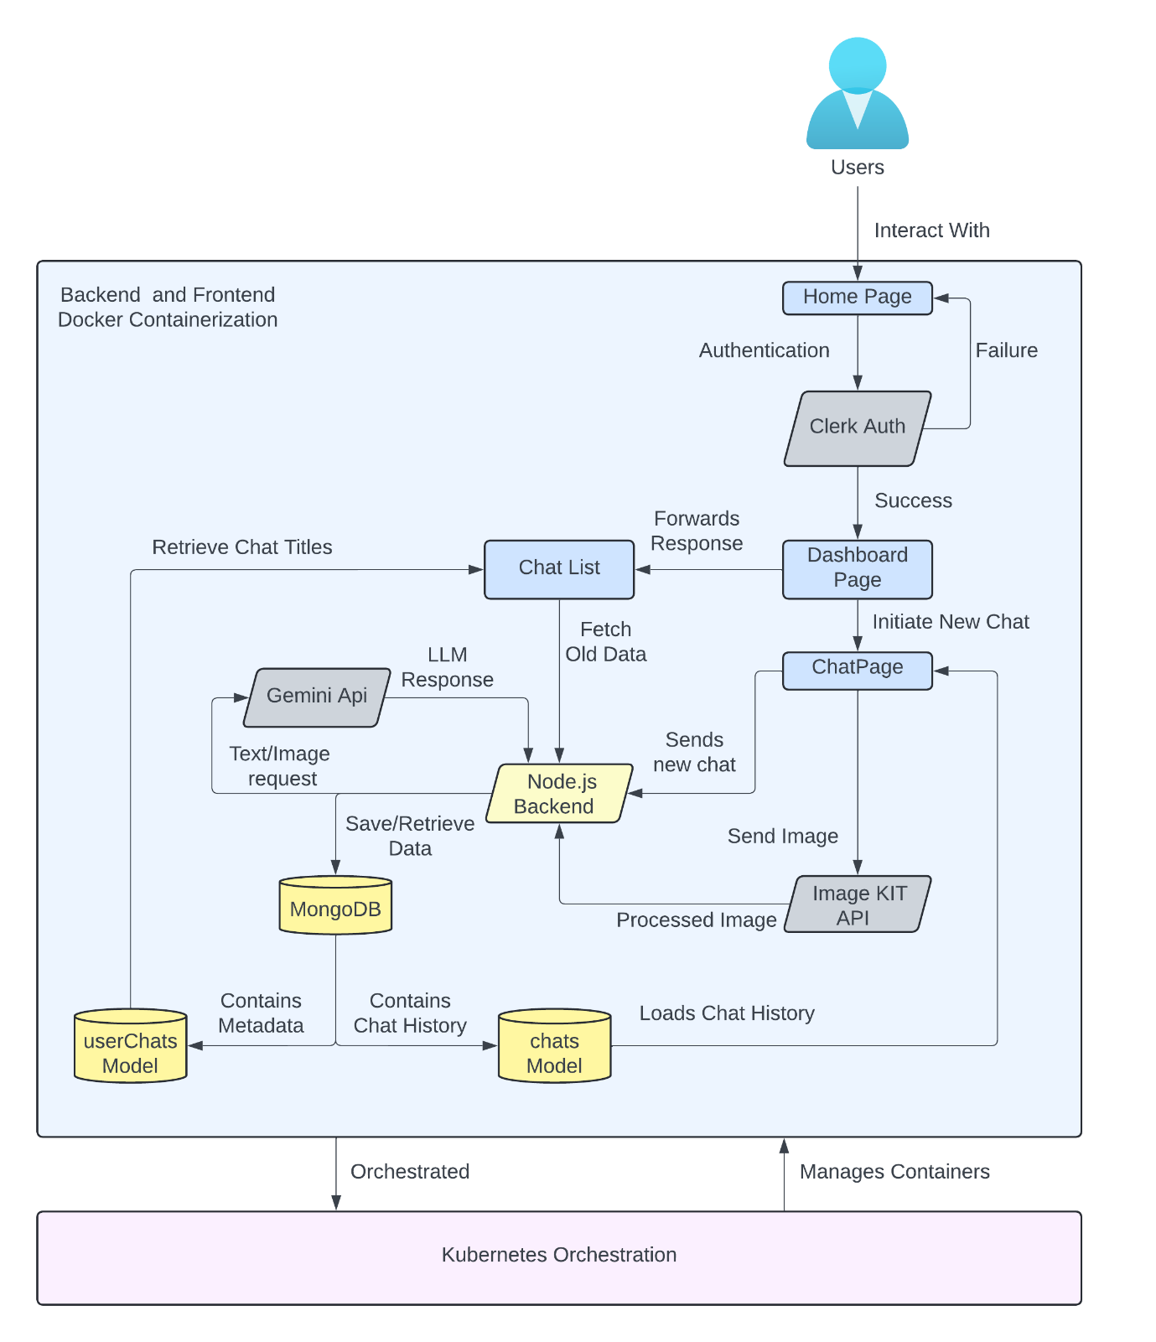

**Fig.1: System-Architecture for the Proposed LLM ChatBot System**

**Scalability**

Scalability is crucial for systems that need to handle a growing number of users or increased traffic. Our system is designed to scale both horizontally and vertically, ensuring that it can efficiently manage increased load without compromising performance. Key steps taken to scale the program includes Horizontal (HPA Autoscaler) Scaling, Vertical Scaling and test Service and Load Balancer Configuration

**Horizontal (HPA Autoscaler) Scaling**

* Configured Kubernetes HPA to automatically scale pods based on CPU and memory utilization.
* This allows the system to dynamically allocate more pods when traffic spikes.

Challenge: Finding the right CPU/memory thresholds to balance cost and performance.

**Vertical Scaling**

* Increased CPU and memory limits for existing pods to enhance performance.
* This ensures each pod can handle a higher number of requests before new ones are created.

Challenge: If a single pod reaches its resource limits, it could still become a bottleneck.

**Service & Load Balancer Configuration**

* Created a Kubernetes Service to expose the backend using a NodePort service.

Challenge: Since we were testing locally on Minikube, a proper LoadBalancer was unavailable. In a real cloud environment (AWS, GCP, Azure), we could use an external LoadBalancer to distribute traffic efficiently.

This approach makes the program scalable to a extent, but further enhancements and testing needs to be done for Cloud Environment. However, the use of Kubernetes also ensures reliability due to failure handling properties by pod replication and automatic restarts in case of failures