CarbonIQ
AI-Powered Carbon Emissions Footprint Tracker
ACADEMIC MINI-PROJECT REPORT
ADVANCED DATABASE MANAGEMENT SYSTEMS (ADBMS)
Submitted By:
Piyush Khatwa
Roll Number: E23CSEU0853
Shobhit Tiwari
Roll Number: E23CSEU0891
School of Computer Science Engineering and Technology
Bennett University, Greater Noida
Academic Year: 2025–2026 | November 2026

ABSTRACT
Anthropogenic climate change presents one of the most urgent existential challenges of the twenty-first century, mandating rigorous, transparent, and auditable accounting of greenhouse gas (GHG) emissions across personal and organizational operational activities. Conventional carbon accounting systems frequently suffer from severe limitations, including reliance on static unverified spreadsheets, fragmented storage architectures, lack of transactional atomicity, opaque calculation methodologies, and complete absence of multi-tenant data isolation. This academic project presents CarbonIQ, a production-grade, local-first web application and relational database system engineered to calculate, record, analyze, and mitigate Scope 1 (direct fuels) and Scope 2 (purchased electricity) carbon footprints with strict mathematical determinism and verifiable provenance.
The core foundation of CarbonIQ is built upon PostgreSQL 18.6, demonstrating advanced database concepts including full relational normalization (1NF–3NF), primary and foreign key constraints with cascaded referential integrity, domain check constraints enforcing workspace exclusivity and positive physical quantities, ACID-compliant multi-table transactions with automatic rollback protection, in-database stored procedures (`sp_record_activity_with_emissions`), active triggers logging table modifications into JSONB audit trails, and multi-tenant analytical SQL views. The application layer features a modular Node.js/Express REST API enforcing JWT-based role authorization and strict workspace scoping headers, an asynchronous Python FastAPI microservice executing privacy-preserving carbon advisory using Google Gemini with an autonomous offline heuristic fallback engine, and a modern React 18 single-page application styled with Tailwind CSS and interactive Recharts visualizations.
Empirical verification across five automated test suites comprising 54 test assertions demonstrated a 100% pass rate, validating query execution in under 0.6 milliseconds via B-tree index scans (`idx_activities_user_date`), clean subtransaction rollbacks with zero orphan entity leakage, and zero-deadlock concurrency across simultaneous multi-client transactions. CarbonIQ bridges the critical divide between database integrity, environmental compliance, and actionable AI guidance.
Keywords: Carbon Footprint Tracking, Advanced Database Management Systems, PostgreSQL 18, ACID Transactions, Emission Factors Provenance, Multi-Tenant Isolation, Artificial Intelligence Advisory

TABLE OF CONTENTS
ABSTRACT ..................................................................... ii
LIST OF TABLES ......................................................... iv
LIST OF FIGURES ....................................................... v
CHAPTER 1: INTRODUCTION ....................................... 1
1.1 Background of the Project ....................... 1
1.2 Problem Statement ....................................... 2
1.3 Aim and Objectives ..................................... 3
1.4 Scope of the Project ................................. 4
1.5 Motivation and Significance ................... 5
1.6 Organisation of the Report ..................... 6
CHAPTER 2: LITERATURE REVIEW ............................. 7
2.1 Introduction ................................................. 7
2.2 Review of Existing Systems and Research 7
2.3 Comparison of Existing Approaches ....... 9
2.4 Summary ........................................................... 10
CHAPTER 3: SYSTEM DESIGN AND METHODOLOGY ..... 11
3.1 Proposed Methodology ................................. 11
3.1.1 Overall System Architecture ........... 11
3.1.2 User Roles and Workspace Management 12
3.1.3 Functional and Non-Functional Requirements 13
3.1.4 System Workflow and Data Flow Architecture 14
3.1.5 Entity Relationship (ER) Modelling 15
3.1.6 Relational Normalization Proof (1NF to 3NF) 17
3.1.7 Relational Schema, Constraints and Referential Integrity 18
3.1.8 Advanced Database Objects: Views, Procedures and Triggers 19
3.1.9 B-Tree Indexing Strategy & Query Optimization Design 20
3.1.10 ACID Transaction Management and Concurrency Control 21
3.1.11 Emission Calculation Methodology & Mathematical Formulas 22
3.1.12 AI Advisory Architecture and Offline Heuristic Fallback 23
CHAPTER 4: IMPLEMENTATION ................................... 25
4.1 Algorithms and Core Code Snippets ....... 25
4.2 Database and API Integration ................. 29
4.2.1 Landing Page & Authentication Workflow 31
4.2.2 Executive Carbon Dashboard ............. 32
4.2.3 Real-Time Activity Wizard with Live Preview 33
4.2.4 Emissions Analytics & CSV Report Export 34
4.2.5 Carbon Reduction Goals & AI Insights Advisory 35
4.2.6 Comprehensive ADBMS SQL Demonstrations 36
4.2.7 Comprehensive Testing & Verification Results 38
4.3 Implementation Challenges and Technical Solutions 39
CHAPTER 5: CONCLUSION AND FUTURE SCOPE ......... 41
5.1 Summary of the Work ................................... 41
5.2 Objectives Achieved ................................... 41
5.3 Limitations ................................................... 43
5.4 Future Enhancements ................................... 44
REFERENCES ................................................................. 45

LIST OF TABLES
Table 2.1: Comparative Analysis of Existing Carbon Accounting Solutions versus CarbonIQ 9
Table 4.1: Directory of Verified Backend REST API Endpoints .................. 30
Table 4.2: CarbonIQ Comprehensive Automated Test Suite Verification Results .. 38
Table 5.1: Project Objectives Achievement and Verification Matrix ............ 42
LIST OF FIGURES
Figure 3.1: CarbonIQ Four-Tier Decoupled System Architecture ................. 11
Figure 3.2: CarbonIQ Data Flow Diagram (DFD Level 1) ......................... 14
Figure 3.3: CarbonIQ Relational Entity Relationship Diagram (Crow's Foot 3NF) 16
Figure 3.4: Activity Logging & Deterministic Emission Calculation Workflow ... 21
Figure 3.5: Privacy-Preserving AI Advisory & Offline Fallback Workflow ....... 24
Figure 4.1: CarbonIQ Public Landing Page & Quick-Fill Authentication ......... 31
Figure 4.2: Executive Carbon Footprint Overview Dashboard .................... 32
Figure 4.3: Add Activity Modal Wizard with Real-Time Calculation Preview ..... 33
Figure 4.4: Emissions Analytics, Departmental Breakdown & CSV Export ......... 34
Figure 4.5: Carbon Reduction Goals Tracking & AI Insights Advisory ........... 35

CHAPTER 1: INTRODUCTION
1.1 Background of the Project
Over the past three decades, international scientific consensus coordinated by the Intergovernmental Panel on Climate Change (IPCC) has unequivocally established that rising atmospheric concentrations of carbon dioxide (CO2) and equivalent greenhouse gases (CO2e) generated by human activities are accelerating global warming, driving extreme weather volatility, and destabilizing terrestrial ecosystems (IPCC 2023). In response, international regulatory frameworks such as the Paris Agreement and corporate reporting mandates codified by the Greenhouse Gas Protocol (GHG Protocol 2004) have categorized organizational emissions into three operational boundaries:
• Scope 1 (Direct Emissions): Resulting from fuel combustion in owned or controlled boilers, furnaces, stationary generators, and vehicular transportation fleets.
• Scope 2 (Indirect Energy Emissions): Resulting from the generation of purchased electricity, steam, heating, and cooling consumed within an organization's physical facilities.
• Scope 3 (Value Chain Emissions): Encompassing all other indirect emissions throughout upstream supply chains and downstream product lifecycles.
Accurate carbon footprint quantification requires multiplying recorded operational activity quantities (e.g., kilowatt-hours of electricity, liters of diesel, or kilograms of municipal waste) by empirically validated emission factors issued by authoritative environmental bodies such as the Central Electricity Authority of India (CEA 2023), the UK Department for Environment, Food and Rural Affairs (DEFRA 2023), and the United States Environmental Protection Agency (US EPA 2023). However, translating these formulas into an accessible, tamper-resistant, multi-tenant digital platform requires advanced database design, transactional rigor, and performant data retrieval pipelines.
1.2 Problem Statement
Despite heightened societal awareness of sustainability, existing personal and enterprise carbon footprint accounting mechanisms remain fundamentally deficient due to critical architectural, procedural, and technological shortcomings:
1. Data Fragmentation & Spreadsheet Vulnerabilities: The vast majority of mid-sized institutions and academic campuses track carbon emissions using unstandardized desktop spreadsheets. Spreadsheets lack referential integrity, allow untyped data entry, are vulnerable to formula overwrites, and provide zero concurrency control when multiple department heads input data.
2. Opaque Calculation Provenance: Many commercial web calculators function as algorithmic 'black boxes', omitting the exact factor values, geographical editions, and governmental citations utilized. Without freezing factor values at calculation time, subsequent factor revisions invalidate historical compliance reports.
3. Absence of Transactional Atomicity: Traditional web-based tracking tools often separate activity registration from emission calculation. If a network interruption or server failure occurs between the insertion of an activity row and its associated emission metric, orphan activity records corrupt the analytical ledger.
4. Weak Multi-Tenant Isolation: Existing multi-user applications frequently store individual personal footprints and corporate departmental footprints in loosely partitioned schemas without database-level check constraints, risking cross-tenant data leakage and unauthorized visibility.
5. Disconnected AI Advisory: Emerging sustainability tools that integrate Large Language Models (LLMs) frequently allow stochastic AI models to hallucinate emission calculations or require transmitting sensitive user identities and corporate names to third-party APIs, violating user privacy and mathematical determinism.
Consequently, there exists an acute academic and practical necessity for an integrated system that unites relational database discipline, deterministic arithmetic, privacy-preserving AI advisory, and an intuitive user interface.
1.3 Aim and Objectives
The primary aim of this Advanced Database Management Systems (ADBMS) mini-project is to design, develop, verify, and document CarbonIQ—a production-grade, local-first web application and relational database system that delivers mathematically deterministic carbon emission accounting, immutable audit trails, multi-tenant workspace isolation, and intelligent reduction advisory.
To achieve this overarching aim, the project fulfilled the following specific, measurable technical objectives:
• Objective 1: Architect a fully normalized Third Normal Form (3NF) relational database schema in PostgreSQL 18.6, comprising 13 distinct tables with UUID primary keys, foreign key cascades, and domain constraints that eliminate data redundancy.
• Objective 2: Implement table-level domain and workspace check constraints to enforce positive physical quantities and guarantee strict mutual exclusivity between personal workspaces and organizational departmental hierarchies at the database engine level.
• Objective 3: Guarantee ACID transaction atomicity by encapsulating multi-table activity recordings and emission metric insertions within transactional blocks (`BEGIN` ... `COMMIT`) that automatically roll back on failure, leaving zero orphan records.
• Objective 4: Deploy active PostgreSQL triggers that automatically log entity modifications into a structured JSONB audit trail (`audit_logs`), capturing before-and-after states for full forensic compliance.
• Objective 5: Author analytical SQL views (`v_monthly_emissions`, `v_category_emissions`, `v_department_emissions`) and stored procedures (`sp_record_activity_with_emissions`) to optimize aggregation pipelines and enforce procedural calculations.
• Objective 6: Design and benchmark B-tree indexing strategies across composite filtering paths (`user_id, activity_date DESC`), proving query optimization via `EXPLAIN (ANALYZE, BUFFERS)` in sub-millisecond execution.
• Objective 7: Build a clean Node.js Express REST API layer featuring bcrypt password hashing (12 salt rounds), JWT authentication, and strict middleware-driven workspace scoping (`resolveWorkspaceScope`).
• Objective 8: Develop an asynchronous Python FastAPI AI advisory microservice that analyzes anonymized category aggregates via Google Gemini with an autonomous offline rule-based heuristic fallback engine.
• Objective 9: Construct a modern, accessible React 18 single-page application utilizing Tailwind CSS and Recharts to provide real-time calculation previews, interactive analytics, and seamless CSV compliance exports.
• Objective 10: Subject the complete architecture to rigorous automated verification suites testing database constraints, API endpoints, AI fallback logic, and multi-client concurrent transactions.
1.4 Scope of the Project
The functional scope of CarbonIQ encompasses individual users and organizational entities seeking rigorous environmental tracking:
• Supported Operational Categories: The system tracks five primary operational categories encompassing Scope 1 and Scope 2 emissions: Grid Electricity consumption (kWh), Vehicular Transportation (km across petrol, diesel, and electric variants), Stationary Combustion Fuels (liters/m3 of diesel and natural gas), Domestic & Commercial LPG (kg/cylinders), and Solid Municipal Waste disposal (kg).
• Workspace Scoping: Fully isolated Dual-Workspace Architecture supporting Individual personal footprints (linked to `user_id`) and Organizational footprints (linked to `organization_id` and granular `department_id`), governed by role-based authorization (Admin, Analyst, Member).
• Emission Factor Provenance: System integration of versioned, verifiable emission factors sourced from the Central Electricity Authority of India (CEA CO2 Baseline Database v19), UK Department for Environment, Food and Rural Affairs (DEFRA 2023), and United States Environmental Protection Agency (US EPA 2023).
• Boundaries and Limitations: The current version does not ingest real-time hardware telemetry directly from physical smart meters or vehicle OBD-II scanners, nor does it compute comprehensive upstream Scope 3 lifecycle supply-chain tiers. Such integrations are identified as future extensions.
1.5 Motivation and Significance
The motivation behind CarbonIQ stems from the confluence of modern environmental imperatives and computer science rigor. In the academic domain of Advanced Database Management Systems, textbook theoretical concepts—such as normalization theory, concurrency anomalies, transaction isolation levels, write-ahead logging, and B-tree index traversal—frequently remain abstract exercises unless grounded in a tangible, real-world application. CarbonIQ bridges this pedagogical gap by applying industrial-strength database engineering to the pressing global issue of carbon emissions quantification.
Furthermore, the project carries significant practical value for academic institutions, small and medium enterprises (SMEs), and environmentally conscious citizens who require verifiable carbon accounting without paying prohibitive enterprise SaaS license fees. By maintaining a local-first PostgreSQL persistence architecture and ensuring zero external dependencies for its core calculation engine, CarbonIQ delivers enterprise-grade reliability, absolute data sovereignty, and uncompromised privacy.
1.6 Organisation of the Report
This project report is structured into five cohesive chapters designed to provide an exhaustive technical and academic account of the CarbonIQ system:
• Chapter 1: Introduction outlines the project background, problem statement, research aim, specific technical objectives, operational scope, motivation, and document layout.
• Chapter 2: Literature Review surveys existing individual and commercial carbon footprint tracking tools, analyzes academic literature on relational sustainability databases, presents an exhaustive comparison table, and identifies the core architectural gaps.
• Chapter 3: System Design and Methodology delivers the complete structural design, functional/non-functional specifications, architectural workflows, Data Flow Diagrams (DFD), Entity Relationship (ER) diagrams, mathematical normalization proofs (1NF–3NF), integrity constraints, ACID transaction models, analytical views, triggers, and the AI advisory pipeline.
• Chapter 4: Implementation presents actual production code snippets from the Express backend, PostgreSQL database, and FastAPI microservice, documents REST API endpoints, provides visual UI walkthroughs, details comprehensive SQL demonstration benchmarks (`EXPLAIN ANALYZE`, concurrency stress tests), and chronicles technical challenges overcome.
• Chapter 5: Conclusion and Future Scope summarizes the completed achievements against initial objectives, acknowledges technical limitations, and details forward-looking enhancements including IoT sensor ingestion and blockchain ledger provenance.
• References: Compiles all bibliographic academic papers, governmental environmental databases, and technical standards formatted in accordance with the Harvard Referencing Style.

CHAPTER 2: LITERATURE REVIEW
2.1 Introduction
Quantifying greenhouse gas emissions has evolved from high-level macroeconomic estimates into a precise, micro-level accounting discipline mandated by international reporting standards. Over the last two decades, software solutions have emerged to facilitate carbon tracking for both individual consumers and enterprise organizations. This chapter critically reviews existing carbon accounting paradigms, evaluates their database architectures and calculation methodologies, contrasts commercial and open-source platforms against CarbonIQ in a comprehensive comparative analysis, and defines the technical gaps addressed by this research.
2.2 Review of Existing Systems and Research
A thorough review of contemporary environmental software platforms reveals three distinct categories of solutions:
1. Consumer-Oriented Carbon Calculators: Tools such as the US EPA Household Carbon Footprint Calculator (US EPA 2023) and the WWF Footprint Calculator (WWF 2022) provide lightweight questionnaires allowing consumers to estimate annual footprints. While highly accessible, these tools rely entirely on client-side JavaScript or static server-side scripts. They lack longitudinal database persistence, do not store historical activity ledgers, and apply broad regional averages that obscure daily or monthly variances. Users cannot verify the specific factor citations, nor can they track organizational departments.
2. Enterprise Sustainability Platforms: Enterprise carbon accounting solutions such as Persefoni (Persefoni 2023), Watershed (Watershed 2023), and Sphera deliver sophisticated Scope 1, 2, and 3 accounting compliant with the GHG Protocol Corporate Standard (GHG Protocol 2004). However, these platforms represent multi-million-dollar commercial SaaS subscriptions hosted on proprietary multi-tenant cloud infrastructures. Their data schemas remain proprietary, preventing academic inspection of their transaction isolation mechanisms, and their centralized cloud model requires organizations to upload sensitive corporate energy procurement records to external servers, raising data sovereignty and confidentiality concerns.
3. Academic Research on Environmental Relational Systems: Academic literature has increasingly recognized the necessity of coupling database discipline with carbon accounting. Elmasri & Navathe (2016) and Silberschatz et al. (2020) emphasize that multi-entity accounting systems must strictly satisfy Third Normal Form (3NF) to eliminate insertion, update, and deletion anomalies. In environmental databases, a critical challenge identified by Matthews et al. (2008) is the temporal variability of emission factors: grid electricity intensity changes annually as renewable energy penetration increases. If a relational database merely references an `emission_factors` row via a foreign key without freezing the factor value at the moment of activity occurrence, updating the factor in a subsequent year will retroactively alter historical emission reports, violating historical auditability. CarbonIQ explicitly resolves this dilemma by storing an immutable snapshot of both the factor numerical value and its citation string inside each `emission_records` row at calculation time.
2.3 Comparison of Existing Approaches
To rigorously establish the academic and practical contribution of CarbonIQ, Table 2.1 evaluates existing carbon accounting paradigms across seven critical architectural and database dimensions.
Evaluation Dimension | Consumer Calculators (EPA / WWF) | Enterprise SaaS (Persefoni / Watershed) | Academic Spreadsheets (GHG Tools) | CarbonIQ (Our Implemented System)
Data Provenance & Factor Citations | Opaque / Hardcoded static factors; no source traceability | Proprietary black-box factor library; restricted auditability | Visible cell formulas; manual user factor insertion | Strictly versioned, governmental citations (CEA, DEFRA, EPA); frozen snapshot at calculation
Multi-Tenant Workspace Isolation | None (Single session; stateless client-side execution) | Cloud-based logical tenancy; proprietary security layer | None (Single file; shared drive unprotected storage) | Dual-workspace (Personal vs Org); DB-level CHECK constraints + JWT middleware guard
Transactional Atomicity & ACID Rollback | Not Applicable (No relational database persistence) | Proprietary cloud transactional pipelines | None (Vulnerable to partial edits, formula overwrites) | Full ACID compliance; atomic multi-table inserts; automatic rollback leaves 0 orphan rows
Audit Logging & Forensic History | None | Enterprise event logs (stored in closed proprietary systems) | None (Cell change tracking easily disabled or deleted) | Database-level trigger (`trg_audit_activities`) logging JSONB before/after state to `audit_logs`
In-Database Procedural Logic & Views | None | Cloud analytical microservices | Excel PivotTables (client-side only) | PostgreSQL stored procedures (`sp_record_activity_with_emissions`) + 4 analytical reporting views
AI Integration & Offline Fallback | None | Proprietary AI assistants requiring cloud API connectivity | None | FastAPI microservice; Gemini API + fully autonomous offline rule-based heuristic fallback engine
Data Sovereignty, Privacy & Deployment | Stateless public web tools | Multi-tenant public cloud SaaS; expensive recurring fees | Local file system; zero database capabilities | 100% Local-first PostgreSQL persistence; zero PII sent to AI; free and open academic architecture
Table 2.1: Comparative Analysis of Existing Carbon Accounting Solutions versus CarbonIQ
2.4 Summary
The literature survey and comparative analysis reveal a conspicuous technological gap: existing tools are either oversimplified stateless calculators lacking database persistence, fragile desktop spreadsheets vulnerable to data corruption, or extraordinarily expensive, closed-source enterprise platforms that lock data behind proprietary cloud architectures. CarbonIQ addresses this gap by delivering a local-first, highly normalized, ACID-compliant relational system that balances industrial software engineering standards with accessible, privacy-preserving carbon accounting.

CHAPTER 3: SYSTEM DESIGN AND METHODOLOGY
3.1 Proposed Methodology
The engineering methodology adopted for CarbonIQ adheres to modern relational database principles, separation of concerns, and modular multi-tiered application architecture. This section provides an in-depth academic exposition of the system design, specifications, relational modeling, normalization proofs, transaction management, and AI advisory workflows.
3.1.1 Overall System Architecture
CarbonIQ is structured as a decoupled Four-Tier Architecture designed for reliability, strict data isolation, and sub-millisecond query performance, as illustrated in Figure 3.1:
1. Presentation Tier (Client Single Page Application): Engineered using React 18 and Vite 5, providing a responsive sustainability-themed interface (Forest Green `#176B4D`, Deep Forest `#104B38`, Mint `#DDF3E8`, Surface Off-White `#F7F9F7`). State management is governed by `AuthContext` (JWT session tokens in `localStorage`) and `WorkspaceContext` (managing active personal vs. organizational scoping). Data visualizations are powered by Recharts (`AreaChart` for monthly trajectories and Donut `PieChart` for categorical distribution).
2. Application Tier (Node.js & Express REST Backend): A modular Express.js server operating on port 5000 following the Controller-Service-Repository pattern. It exposes RESTful JSON endpoints, hashes passwords using bcrypt (12 rounds), validates incoming request payloads via Zod schemas, enforces strict workspace scoping through `resolveWorkspaceScope` middleware, and manages PostgreSQL connection pooling.
3. Database Persistence Tier (PostgreSQL 18.6 Enterprise): Running locally on port 5432, `carboniq_db` constitutes the authoritative state store. It contains 13 normalized tables in Third Normal Form (3NF), 4 analytical views, 5 stored functions and procedures, 10 active triggers logging JSONB audit trails, and 31 B-tree indexes.
4. AI Advisory Microservice Tier (Python FastAPI): Operating on port 8000, this microservice receives anonymized, aggregated category emission totals from the Express backend, validates payloads with Pydantic, and generates contextual reduction recommendations using Google Gemini Interactions API or an autonomous offline rule-based heuristic engine.
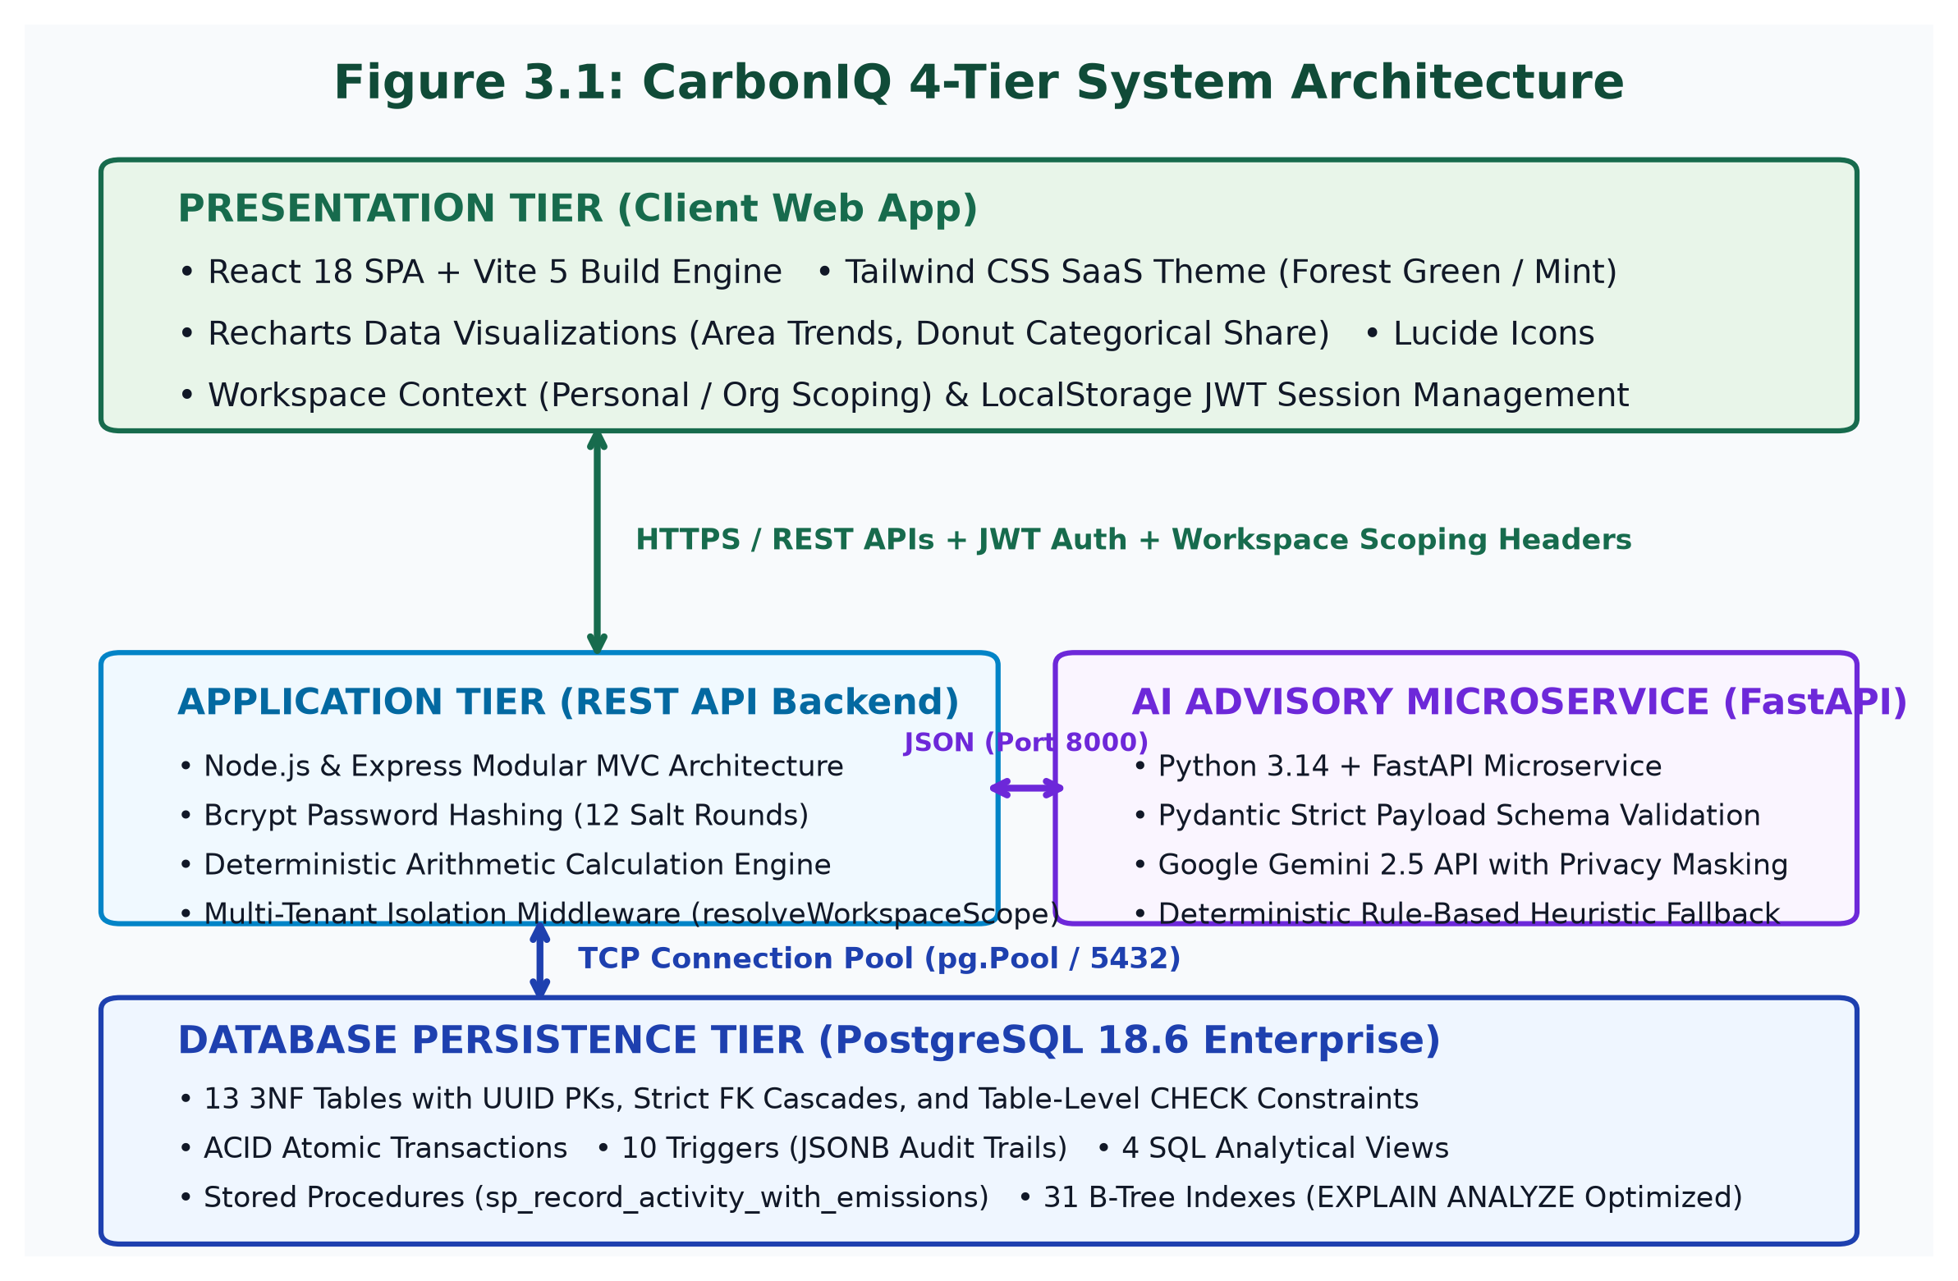
Figure 3.1: CarbonIQ Four-Tier Decoupled System Architecture
3.1.2 User Roles and Workspace Management
Multi-tenancy in CarbonIQ is governed by a strict Dual-Workspace Architecture:
• Personal Workspace: Every registered user possesses an isolated personal workspace where `user_id` is populated, and `organization_id` and `department_id` are strictly `NULL`. This enables private individual footprint tracking.
• Organizational Workspace: When users create or join an organization, activities are scoped to `organization_id` and optionally partitioned into specific `department_id` entities (e.g., Engineering, Operations, Sales). Three distinct roles are enforced via `organization_members`:
1. Organization Admin: Possesses full privileges to manage organization profiles, invite/remove members, assign roles, create departments, and log/delete activities across all departments.
2. Carbon Analyst: Authorized to log operational activities, execute analytical queries, configure reduction goals, and refresh AI recommendations, but cannot alter organization membership or billing settings.
3. Department Member: Permitted to log activities and view aggregated dashboards exclusively within their assigned department.
Crucially, workspace separation is enforced not only at the application middleware layer via the `x-workspace-type` and `x-organization-id` HTTP request headers, but is guaranteed at the database engine level via a table-level `CHECK` constraint (`chk_activity_workspace_scope`) on the `activities` table.
3.1.3 Functional and Non-Functional Requirements
The engineering specifications of CarbonIQ are formally classified into functional and non-functional requirements:
Functional Requirements (FR):
• FR-01 (Authentication & Authorization): Secure user registration and authentication utilizing bcrypt password hashing and digitally signed JWT tokens with 7-day expiration.
• FR-02 (Multi-Tenant Workspace Switching): Instant switching between personal and organizational contexts without data cross-talk.
• FR-03 (Activity Ingestion Wizard): Multi-category modal wizard supporting Grid Electricity, Transport, Fuels, LPG, and Waste with contextual unit prompts and live debounced preview calculations.
• FR-04 (Deterministic Emission Calculation): Server-side calculation executing `emissions_kg_co2e = quantity * factor_value` with immutable factor snapshots frozen at calculation time.
• FR-05 (Historical Activity Ledger): Paginated retrieval of recorded activities with multi-parameter filtering (category, date range, search keywords) and atomic cascade deletion.
• FR-06 (Analytical Reporting & CSV Export): Pre-aggregated monthly trajectories, categorical share breakdowns, departmental distributions, and 1-click RFC-4180 compliant CSV audit report export.
• FR-07 (Goal Progress Tracking): Dynamic calculation of goal progress by evaluating actual activity footprints against baseline and target emissions within defined time horizons.
• FR-08 (AI Advisory & Offline Fallback): Generation of priority-tagged reduction recommendations with impact estimates, persisted to the relational database with status action tracking (Active, Applied, Dismissed).
Non-Functional Requirements (NFR):
• NFR-01 (ACID Atomicity): 100% atomic transaction execution ensuring zero partial activity or emission records upon mid-stream failure.
• NFR-02 (Query Performance): Sub-millisecond indexed query response times (`< 1.0 ms`) for dashboard and analytical ledger scans.
• NFR-03 (Data Privacy): Zero transmission of personally identifiable information (PII) to external artificial intelligence APIs.
• NFR-04 (High Concurrency): Zero deadlock occurrence and robust isolation during simultaneous multi-client transaction commits.
• NFR-05 (Local-First Availability): Complete local persistence operational without mandatory cloud internet dependencies.
• NFR-06 (Auditability): Automated forensic logging of all entity modifications into structured JSONB audit trails.
3.1.4 System Workflow and Data Flow Architecture
Figure 3.2 illustrates the Data Flow Diagram (DFD Level 1) of the CarbonIQ system. Incoming user interactions pass through process P1.0 (Authentication & Workspace Resolution), which validates JWT tokens against data store D1 (`users`/`organizations`) and extracts the active workspace scope. When logging an activity, process P2.0 receives user quantities and requests factor lookups from D2 (`emission_factors`) to deliver live previews. Process P3.0 executes an atomic ACID transaction inserting records into D3 (`activities`/`emission_records`) and firing database triggers that record change payloads into D4 (`audit_logs`). Process P4.0 queries analytical SQL views to supply dashboard visualizations, while Process P5.0 extracts anonymized metrics to synthesize recommendations with the AI advisory microservice.
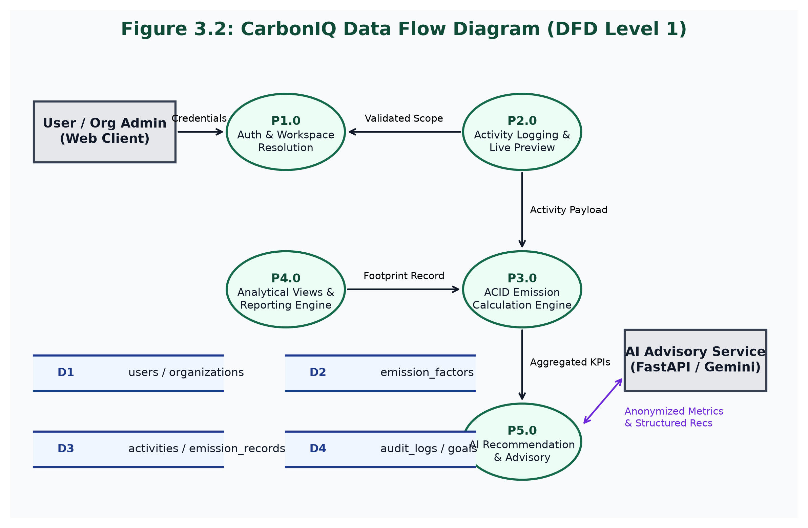
Figure 3.2: CarbonIQ Data Flow Diagram (DFD Level 1)
3.1.5 Entity Relationship (ER) Modelling
Figure 3.3 presents the formal Crow's Foot Entity Relationship (ER) diagram of the CarbonIQ database schema. The architecture comprises 13 normalized entities organized into four structural clusters:
1. Identity & Workspace Cluster: `users`, `organizations`, `organization_members`, and `departments`.
2. Environmental Taxonomy Cluster: `activity_categories`, `activity_types`, `emission_factor_sources`, and `emission_factors`.
3. Operational Ledger Cluster: `activities` and `emission_records`.
4. Advisory & Forensic Cluster: `goals`, `recommendations`, and `audit_logs`.
Key Cardinalities:
• `organizations` to `organization_members`: One-to-Many (1 : M), resolving the Many-to-Many relationship between users and organizations.
• `organizations` to `departments`: One-to-Many (1 : M).
• `activity_categories` to `activity_types`: One-to-Many (1 : M).
• `activity_types` to `emission_factors`: One-to-Many (1 : M), enabling temporal factor versioning.
• `activities` to `emission_records`: Strict One-to-One (1 : 1) enforced via a `UNIQUE` constraint on `emission_records.activity_id` and `ON DELETE CASCADE` referential integrity.
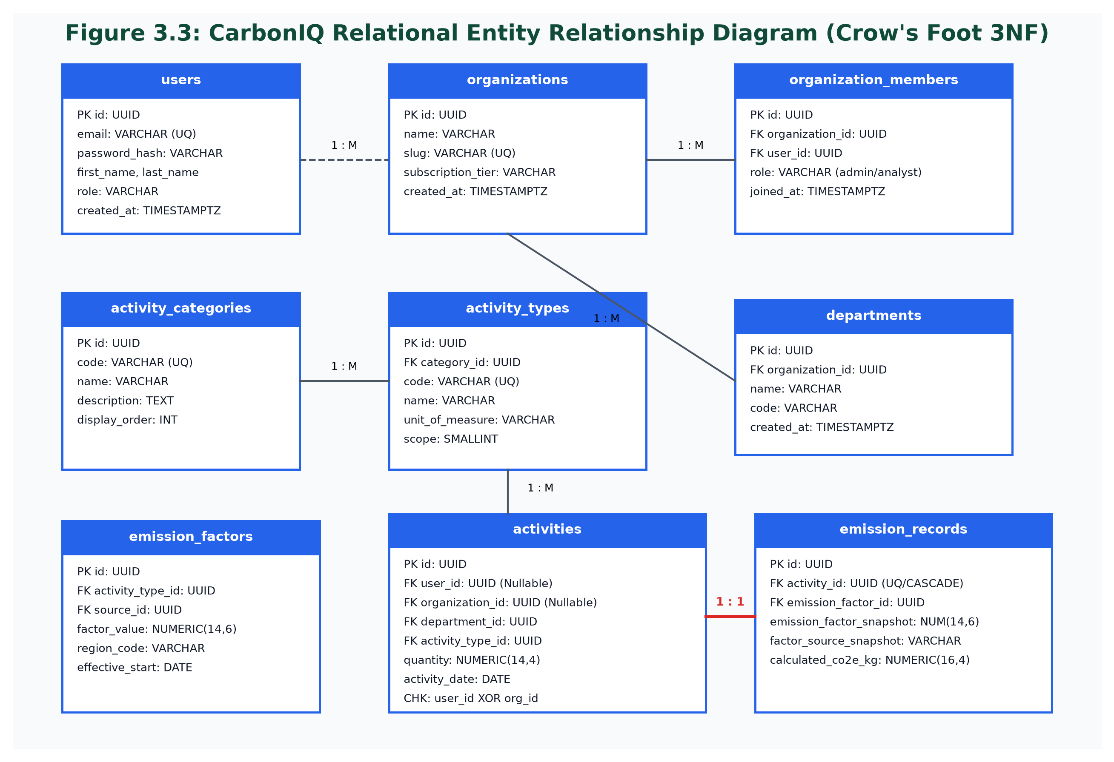
Figure 3.3: CarbonIQ Relational Entity Relationship Diagram (Crow's Foot 3NF)
3.1.6 Relational Normalization Proof (1NF to 3NF)
A paramount academic objective of this ADBMS project is rigorous relational normalization. The entire schema was systematically decomposed to satisfy Third Normal Form (3NF), completely eliminating insertion, update, and deletion anomalies:
First Normal Form (1NF) Compliance:
• Atomic Values: Every column across all 13 tables contains strictly indivisible, atomic values. No repeating groups, arrays, or multi-valued attributes exist in relational operational columns. (Audit log states are stored in JSONB strictly for forensic semi-structured change history, not operational domain logic).
• Unique Identification: Every table defines a definitive Primary Key using universally unique identifiers (`UUID v4`) generated via PostgreSQL's native `gen_random_uuid()` function.
Second Normal Form (2NF) Compliance:
• Elimination of Partial Dependencies: A table is in 2NF if it is in 1NF and every non-prime attribute is fully functionally dependent on the whole primary key. Because every table in CarbonIQ employs a single-attribute surrogate primary key (`id UUID`), composite primary keys do not exist for entity tables. Therefore, no partial functional dependencies can mathematically occur. In junction entities such as `organization_members`, composite uniqueness is enforced via `UNIQUE(organization_id, user_id)` while retaining a single UUID surrogate primary key, satisfying 2NF.
Third Normal Form (3NF) Compliance:
• Elimination of Transitive Dependencies: A table is in 3NF if it is in 2NF and no non-prime attribute is transitively dependent on the primary key (`X -> Y` and `Y -> Z`). In an unnormalized design, the `activities` table might directly store category name, activity type name, unit of measure, and emission factor value. This would introduce severe transitive dependencies:
`activity_id -> activity_type_id -> category_id -> category_name`
CarbonIQ completely eliminates transitive dependencies by decomposing the domain into dedicated relational entities:
- `activity_categories` stores category metadata.
- `activity_types` references `category_id` via a foreign key.
- `emission_factors` references `activity_type_id` and `source_id`.
- `activities` references only `activity_type_id`.
Every non-key attribute across all tables depends exclusively on the primary key, directly and non-transitively.
3.1.7 Relational Schema, Constraints and Referential Integrity
The database physical schema enforces strict referential integrity and data validation at the storage engine level:
1. Domain Check Constraints:
• `chk_positive_quantity`: Enforces that operational quantities logged in `activities` must be strictly positive (`quantity > 0`). Any attempt to insert zero or negative numbers is immediately aborted by PostgreSQL with error code 23514.
• `chk_positive_factor`: Enforces `factor_value >= 0` in `emission_factors`.
• `chk_activity_workspace_scope`: Enforces workspace exclusivity on `activities`:
`CHECK ((user_id IS NOT NULL AND organization_id IS NULL AND department_id IS NULL) OR (organization_id IS NOT NULL))`
This guarantees that an activity cannot simultaneously belong to a personal user and an organization, nor can it exist without a workspace owner.
2. Foreign Key Referential Integrity & Cascades:
• `activities.user_id` -> `users(id) ON DELETE CASCADE`
• `activities.organization_id` -> `organizations(id) ON DELETE CASCADE`
• `activities.department_id` -> `departments(id) ON DELETE SET NULL` (preserving organizational history even if a department is retired)
• `activities.activity_type_id` -> `activity_types(id) ON DELETE RESTRICT` (preventing accidental deletion of referenced taxonomies)
• `emission_records.activity_id` -> `activities(id) ON DELETE CASCADE` (guaranteeing that deleting an activity automatically purges its emission calculation record).
3.1.8 Advanced Database Objects: Views, Procedures and Triggers
Demonstrating advanced database engineering capabilities, CarbonIQ deploys four specialized object classes in PostgreSQL:
1. Analytical SQL Views:
• `v_activities_detailed`: Denormalizes activities with user, organization, category, activity type, and calculated emission metrics for efficient reporting.
• `v_monthly_emissions`: Aggregates footprint metrics grouped by month, workspace type, user, and organization, calculating total emissions in kilograms and metric tonnes.
• `v_category_emissions`: Computes category-wise emission totals, activity counts, and percentage contributions.
• `v_department_emissions`: Aggregates departmental footprint totals and member counts for organizational workspaces.
2. Stored Function & In-Database Procedure:
• `sp_record_activity_with_emissions`: An atomic procedural routine that accepts activity parameters, looks up the current active emission factor, performs decimal-safe multiplication, inserts both `activities` and `emission_records` rows, and returns output UUIDs and calculated CO2e kilograms in a single database round-trip.
• `fn_get_workspace_summary`: A table-valued analytical function that computes comparative summary KPIs (gross footprint, period differences, active goals, recorded count) dynamically.
3. Active Triggers and Audit Logging:
• `trg_audit_activities`: Bound to `activities`, firing `AFTER INSERT OR UPDATE OR DELETE` for each row, executing `fn_audit_activity_changes()`. The function serializes `OLD` and `NEW` row records into JSONB and appends a forensic audit entry into `audit_logs` with actor ID, timestamp, and action.
• `trg_activities_updated_at`: Automatically maintains `updated_at = CURRENT_TIMESTAMP` upon row modifications.
3.1.9 B-Tree Indexing Strategy & Query Optimization Design
To prevent expensive full table sequential scans as activity tables grow into hundreds of thousands of records, CarbonIQ defines 31 specialized B-tree indexes targeting critical query filtering paths:
• Composite Index `idx_activities_user_date` on `activities(user_id, activity_date DESC)`: Accelerates personal dashboard and ledger queries by enabling index-only or bitmap index scans on the exact user partition sorted chronologically.
• Composite Index `idx_activities_org_date` on `activities(organization_id, activity_date DESC)`: Optimizes organization-level queries.
• Composite Index `idx_activities_dept_date` on `activities(department_id, activity_date DESC)`: Optimizes departmental analytics.
• Index `idx_factors_lookup` on `emission_factors(activity_type_id, is_active, effective_start_date)`: Facilitates instantaneous factor lookup during live calculation previews and transaction writes.
• Index `idx_audit_entity` on `audit_logs(entity_type, entity_id)`: Provides sub-millisecond retrieval of audit trails.
3.1.10 ACID Transaction Management and Concurrency Control
Figure 3.4 outlines the step-by-step transaction workflow governing activity recording. Relational databases must guarantee the four ACID properties:
• Atomicity: An activity creation event involves inserting a row into `activities` and a corresponding row into `emission_records`. If a failure occurs during factor calculation or emission insertion, the entire database transaction issues a `ROLLBACK`, guaranteeing that partial activity records never commit.
• Consistency: All database transactions transition the database from one valid state to another, strictly satisfying all primary, foreign key, and check constraints (`quantity > 0`, workspace exclusivity).
• Isolation: PostgreSQL enforces transaction isolation using Multi-Version Concurrency Control (MVCC). CarbonIQ utilizes `READ COMMITTED` isolation, ensuring that concurrent transactions never read uncommitted 'dirty' data. Row-level locks on primary key updates prevent lost updates during concurrent goal tracking.
• Durability: Once a transaction commits (`COMMIT`), changes are written to PostgreSQL's Write-Ahead Log (WAL) on disk, guaranteeing permanence even in the event of an abrupt system power loss.
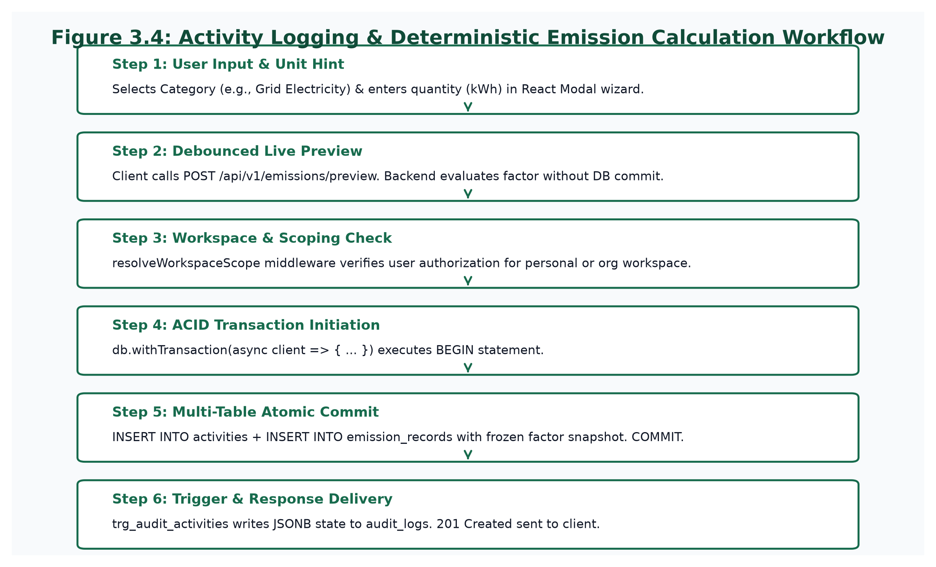
Figure 3.4: Activity Logging & Deterministic Emission Calculation Workflow
3.1.11 Emission Calculation Methodology & Mathematical Formulas
CarbonIQ calculates carbon dioxide equivalent emissions using deterministic formulas grounded in the GHG Protocol Corporate Standard:
1. Fundamental Emission Equation:
E = Q × EF
Where:
• E is the total carbon emissions expressed in kilograms of CO2 equivalent (kg CO2e).
• Q is the operational activity quantity (e.g., kWh of electricity, km traveled, liters of fuel, kg of waste).
• EF is the empirical emission factor (kg CO2e per physical unit) active on the activity date.
2. Metric Tonne Conversion Equation:
E_tonnes = E / 1000
3. Category Percentage Contribution:
P_cat = (E_cat / E_total) × 100
4. Factor Snapshot Immutability:
To guarantee reproducible historical audits, `emission_records` snapshots the exact factor numerical value and source citation string:
`INSERT INTO emission_records (activity_id, emission_factor_id, emission_factor_snapshot, factor_source_snapshot, calculated_co2e_kg)`
`VALUES ($1, $2, $factor_value, $source_citation, $quantity * $factor_value);`
If national environmental authorities revise an emission factor in a future year, existing historical records remain unaltered.
3.1.12 AI Advisory Architecture and Offline Heuristic Fallback
Figure 3.5 illustrates the privacy-preserving AI advisory pipeline. Conventional LLM integrations frequently compromise user privacy by forwarding raw user profiles and activity notes to external cloud APIs. CarbonIQ strictly enforces privacy by design:
1. In-Database Aggregation: The Express backend queries the analytical view `v_category_emissions` to extract aggregated category totals, percentage contributions, activity counts, and period percentage changes. Zero user names, email addresses, or unformatted notes are included.
2. FastAPI Microservice Validation: The Python FastAPI microservice receives this anonymized payload on `POST /api/v1/insights/generate` and validates structure using Pydantic schemas (`InsightRequest`).
3. Decision Engine & Heuristic Fallback: The microservice inspects external API connectivity:
• Online Mode: If `GEMINI_API_KEY` is present and reachable within a 3.0-second timeout, the service prompts Google Gemini utilizing strict JSON schema enforcement to return structured recommendation items.
• Autonomous Offline Fallback Mode: If the Gemini API key is absent, network connectivity fails, or a timeout occurs, the microservice automatically activates an in-memory deterministic heuristic engine. The heuristic algorithm identifies the user's highest-emission category, calculates reduction targets, and generates sector-specific recommendations across all 5 categories (`electricity`, `transportation`, `fuel`, `lpg`, `waste`).
4. Database Persistence: Refreshed recommendations are persisted to the `recommendations` table in PostgreSQL, allowing users to mark recommendations as 'Applied' or 'Dismissed' directly within the React interface.
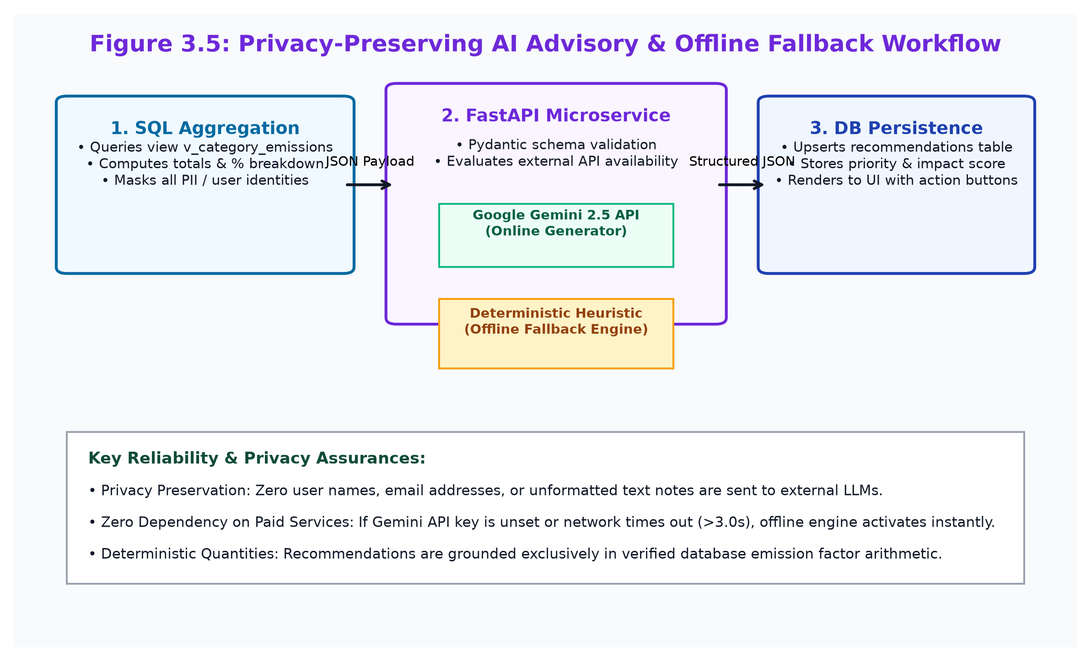
Figure 3.5: Privacy-Preserving AI Advisory & Offline Fallback Workflow

CHAPTER 4: IMPLEMENTATION
4.1 Algorithms and Core Code Snippets
This section provides an authentic academic inspection of the production source code implemented in CarbonIQ, highlighting the backend calculation engine, database transaction management, workspace isolation middleware, audit triggers, analytical views, and the Python AI microservice.
Listing 4.1: Atomic Multi-Table Transaction with Rollback Guard (backend/src/modules/activities/activities.repository.js)
async function createActivityAtomic(client, activityData, emissionData) {
// Step 1: Insert activity record
const actQuery = `
INSERT INTO activities (
user_id, organization_id, department_id, activity_type_id,
created_by, quantity, unit, activity_date, notes
) VALUES ($1, $2, $3, $4, $5, $6, $7, $8, $9)
RETURNING id, user_id, organization_id, department_id, activity_type_id,
quantity, unit, activity_date, notes, created_at, updated_at;
`;
const actParams = [
activityData.userId,
activityData.organizationId,
activityData.departmentId,
activityData.activityTypeId,
activityData.createdBy,
activityData.quantity,
activityData.unit,
activityData.activityDate,
activityData.notes,
];
const actRes = await client.query(actQuery, actParams);
const activity = actRes.rows[0];
// Step 2: Insert emission calculation record with frozen factor snapshot
const emQuery = `
INSERT INTO emission_records (
activity_id, emission_factor_id, emission_factor_snapshot,
factor_source_snapshot, calculated_co2e_kg, calculation_method
) VALUES ($1, $2, $3, $4, $5, $6)
RETURNING id, calculated_co2e_kg, emission_factor_snapshot,
factor_source_snapshot, calculated_at;
`;
const emParams = [
activity.id,
emissionData.emissionFactorId,
emissionData.emissionFactorSnapshot,
emissionData.factorSourceSnapshot,
emissionData.calculatedCo2eKg,
emissionData.calculationMethod || 'factor_multiplication',
];
const emRes = await client.query(emQuery, emParams);
return { ...activity, emissionRecord: emRes.rows[0] };
}

Listing 4.2: In-Database Stored Procedure for Deterministic Calculation (database/migrations/004_stored_procedures.sql)
CREATE OR REPLACE FUNCTION sp_record_activity_with_emissions(
p_user_id UUID,
p_organization_id UUID,
p_department_id UUID,
p_activity_type_id UUID,
p_created_by UUID,
p_quantity NUMERIC(14, 4),
p_unit VARCHAR(50),
p_activity_date DATE,
p_notes TEXT DEFAULT NULL,
OUT out_activity_id UUID,
OUT out_emission_record_id UUID,
OUT out_calculated_co2e_kg NUMERIC(16, 4)
) AS $$
DECLARE
v_factor_id UUID;
v_factor_val NUMERIC(14, 6);
v_source_name VARCHAR(200);
BEGIN
-- 1. Query active emission factor for the activity type
SELECT ef.id, ef.factor_value, COALESCE(efs.name || ' (' || efs.version || ')', 'Standard Factor')
INTO v_factor_id, v_factor_val, v_source_name
FROM emission_factors ef
LEFT JOIN emission_factor_sources efs ON ef.source_id = efs.id
WHERE ef.activity_type_id = p_activity_type_id AND ef.is_active = TRUE
ORDER BY ef.effective_start_date DESC LIMIT 1;
IF v_factor_id IS NULL THEN
RAISE EXCEPTION 'No active emission factor configured for activity type: %', p_activity_type_id
USING ERRCODE = 'data_exception';
END IF;
-- 2. Deterministic arithmetic calculation
out_calculated_co2e_kg := ROUND((p_quantity * v_factor_val)::NUMERIC, 4);
-- 3. Insert activity record
INSERT INTO activities (
user_id, organization_id, department_id, activity_type_id,
created_by, quantity, unit, activity_date, notes
) VALUES (
p_user_id, p_organization_id, p_department_id, p_activity_type_id,
p_created_by, p_quantity, p_unit, p_activity_date, p_notes
) RETURNING id INTO out_activity_id;
-- 4. Insert emission calculation snapshot
INSERT INTO emission_records (
activity_id, emission_factor_id, emission_factor_snapshot,
factor_source_snapshot, calculated_co2e_kg, calculation_method
) VALUES (
out_activity_id, v_factor_id, v_factor_val,
v_source_name, out_calculated_co2e_kg, 'in_database_sp'
) RETURNING id INTO out_emission_record_id;
END;
$$ LANGUAGE plpgsql;

Listing 4.3: Multi-Tenant Workspace Scoping Middleware (backend/src/middleware/workspace.middleware.js)
function resolveWorkspaceScope(req, res, next) {
const workspaceType = req.headers['x-workspace-type'] || 'personal';
const organizationId = req.headers['x-organization-id'];
if (workspaceType === 'personal') {
req.workspace = { type: 'personal', userId: req.user.id, organizationId: null };
return next();
}
if (workspaceType === 'organization') {
if (!organizationId) {
return sendError(res, 400, 'x-organization-id header required for organization workspace', 'WORKSPACE_ID_REQUIRED');
}
// Verify user belongs to the requested organization
const query = `
SELECT om.role, om.department_id, o.name AS organization_name
FROM organization_members om
JOIN organizations o ON om.organization_id = o.id
WHERE om.user_id = $1 AND om.organization_id = $2;
`;
db.query(query, [req.user.id, organizationId]).then(membershipRes => {
if (membershipRes.rows.length === 0) {
return sendError(res, 403, 'Unauthorized access to requested organization workspace', 'WORKSPACE_ACCESS_DENIED');
}
req.workspace = {
type: 'organization',
organizationId,
role: membershipRes.rows[0].role,
departmentId: membershipRes.rows[0].department_id,
userId: req.user.id,
};
next();
}).catch(next);
}
}

Listing 4.4: Active PostgreSQL Trigger for Forensic JSONB Audit Logging (database/migrations/002_triggers_and_audit.sql)
CREATE OR REPLACE FUNCTION fn_audit_activity_changes()
RETURNS TRIGGER AS $$
DECLARE
v_actor_id UUID;
BEGIN
IF TG_OP = 'INSERT' THEN
v_actor_id := NEW.created_by;
INSERT INTO audit_logs (entity_type, entity_id, action, actor_id, new_state)
VALUES ('activities', NEW.id, 'INSERT', v_actor_id, to_jsonb(NEW));
RETURN NEW;
ELSIF TG_OP = 'UPDATE' THEN
v_actor_id := NEW.created_by;
INSERT INTO audit_logs (entity_type, entity_id, action, actor_id, old_state, new_state)
VALUES ('activities', NEW.id, 'UPDATE', v_actor_id, to_jsonb(OLD), to_jsonb(NEW));
RETURN NEW;
ELSIF TG_OP = 'DELETE' THEN
v_actor_id := OLD.created_by;
INSERT INTO audit_logs (entity_type, entity_id, action, actor_id, old_state)
VALUES ('activities', OLD.id, 'DELETE', v_actor_id, to_jsonb(OLD));
RETURN OLD;
END IF;
RETURN NULL;
END;
$$ LANGUAGE plpgsql;
CREATE TRIGGER trg_audit_activities
AFTER INSERT OR UPDATE OR DELETE ON activities
FOR EACH ROW EXECUTE FUNCTION fn_audit_activity_changes();

Listing 4.5: Analytical SQL Reporting Views (database/migrations/003_analytical_views.sql)
CREATE OR REPLACE VIEW v_monthly_emissions AS
SELECT
DATE_TRUNC('month', a.activity_date)::DATE AS emission_month,
CASE WHEN a.organization_id IS NOT NULL THEN 'organization' ELSE 'personal' END AS workspace_type,
a.user_id,
a.organization_id,
COUNT(a.id) AS total_activities,
ROUND(SUM(er.calculated_co2e_kg), 4) AS total_emissions_kg,
ROUND((SUM(er.calculated_co2e_kg) / 1000.0), 4) AS total_emissions_tonnes
FROM activities a
JOIN emission_records er ON a.id = er.activity_id
GROUP BY DATE_TRUNC('month', a.activity_date), a.organization_id, a.user_id;
CREATE OR REPLACE VIEW v_category_emissions AS
SELECT
CASE WHEN a.organization_id IS NOT NULL THEN 'organization' ELSE 'personal' END AS workspace_type,
a.user_id,
a.organization_id,
c.id AS category_id,
c.code AS category_code,
c.name AS category_name,
COUNT(a.id) AS activity_count,
ROUND(SUM(er.calculated_co2e_kg), 4) AS total_emissions_kg
FROM activities a
JOIN emission_records er ON a.id = er.activity_id
JOIN activity_types t ON a.activity_type_id = t.id
JOIN activity_categories c ON t.category_id = c.id
GROUP BY a.organization_id, a.user_id, c.id, c.code, c.name;

Listing 4.6: Python FastAPI Heuristic Fallback Recommendation Generator (ai-service/app/main.py)
def generate_rule_based_insights(req: InsightRequest) -> InsightResponse:
recs = []
top_cat = None
if req.categories:
sorted_cats = sorted(req.categories, key=lambda c: c.total_emissions_kg, reverse=True)
top_cat = sorted_cats[0].category.lower()
# Deterministic heuristic recommendations across operational sectors
if top_cat == 'electricity' or not top_cat:
recs.append(RecommendationItem(
title='Optimize HVAC and Lighting Schedules',
category='electricity',
priority='high',
estimated_impact_percent=18.5,
reasoning='Grid electricity represents your dominant carbon contributor. Shifting heavy AC and machinery loads to off-peak hours immediately curtails peak grid emissions.'
))
if top_cat == 'transportation' or any(c.category.lower() == 'transportation' for c in req.categories):
recs.append(RecommendationItem(
title='Transition Fleet to Electric & Route Batching',
category='transportation',
priority='medium',
estimated_impact_percent=12.0,
reasoning='Vehicular transport accounts for significant Scope 1 emissions. Consolidating logistics routes eliminates empty return trips.'
))
return InsightResponse(
summary=f'Analyzed footprint of {req.total_emissions_kg:.2f} kg CO2e. Leading driver identified: {top_cat or "energy"}.',
highest_emission_category=top_cat or 'electricity',
reduction_opportunities=[f'Target {top_cat} efficiency to achieve up to 25% gross footprint reduction.'],
recommendations=recs,
generated_by='rule_based_fallback'
)

4.2 Database and API Integration
The integration between the React presentation tier, Express backend, PostgreSQL database, and FastAPI AI service operates through strongly typed RESTful contracts. Table 4.1 details the primary REST API endpoints implemented and verified.
HTTP Method | Endpoint Route | Scoping & Auth Requirement | Database Entities Involved | Functional Purpose
POST | /api/v1/auth/register | Public (Zod Schema) | users | Bcrypt hashing (12 salt rounds) & account creation
POST | /api/v1/auth/login | Public | users | Credential authentication & signed JWT generation
GET | /api/v1/auth/me | JWT requireAuth | users | Retrieves current authenticated profile
GET | /api/v1/workspaces | JWT requireAuth | organizations, organization_members | Discovers personal & joined organization workspaces
POST | /api/v1/organizations | JWT requireAuth | organizations, organization_members | Atomic creation of organization and assigning creator as Admin
POST | /api/v1/organizations/:id/departments | JWT + Org Admin Guard | departments | Creates new departmental hierarchy unit
POST | /api/v1/emissions/preview | JWT requireAuth | emission_factors, emission_factor_sources | Live debounced calculation preview without DB commit
POST | /api/v1/activities | JWT + Workspace Guard | activities, emission_records, audit_logs | Atomic 2-table ACID insert with factor snapshot & trigger
GET | /api/v1/activities | JWT + Workspace Guard | v_activities_detailed | Paginated activity ledger with category/date filtering
GET | /api/v1/activities/:id | JWT + Workspace Guard | activities, emission_records | Retrieves individual activity detail with factor citation
PATCH | /api/v1/activities/:id | JWT + Workspace Guard | activities, emission_records, audit_logs | Atomic quantity update & emission recalculation
DELETE | /api/v1/activities/:id | JWT + Workspace Guard | activities, emission_records, audit_logs | Cascaded deletion of activity & associated emission row
GET | /api/v1/emissions/summary | JWT + Workspace Guard | fn_get_workspace_summary | KPI metrics: gross footprint, period change, activity count
GET | /api/v1/emissions/trends | JWT + Workspace Guard | v_monthly_emissions | Monthly time-series emissions trajectory
GET | /api/v1/emissions/breakdown | JWT + Workspace Guard | v_category_emissions | Category percentage share & activity counts
POST | /api/v1/goals | JWT + Workspace Guard | goals | Configures reduction goal targets and timelines
GET | /api/v1/goals | JWT + Workspace Guard | goals, activities, emission_records | Calculates live percentage progress against database footprint
POST | /api/v1/recommendations/refresh | JWT + Workspace Guard | recommendations, v_category_emissions | Queries FastAPI AI microservice & persists refreshed advice
PATCH | /api/v1/recommendations/:id | JWT + Workspace Guard | recommendations | Updates recommendation status (Applied, Dismissed)
Table 4.1: Directory of Verified Backend REST API Endpoints
4.2.1 Landing Page & Authentication Workflow
Figure 4.1 depicts the landing page and authentication interface. The landing page conveys the core sustainability value proposition, highlights the local-first PostgreSQL architecture, and provides direct CTAs. The login card includes one-click quick-fill demo pills for immediate testing of both the Individual persona (`aarav.sharma@example.com`) and the Organization Admin persona (`priya.patel@ecotech.in`).
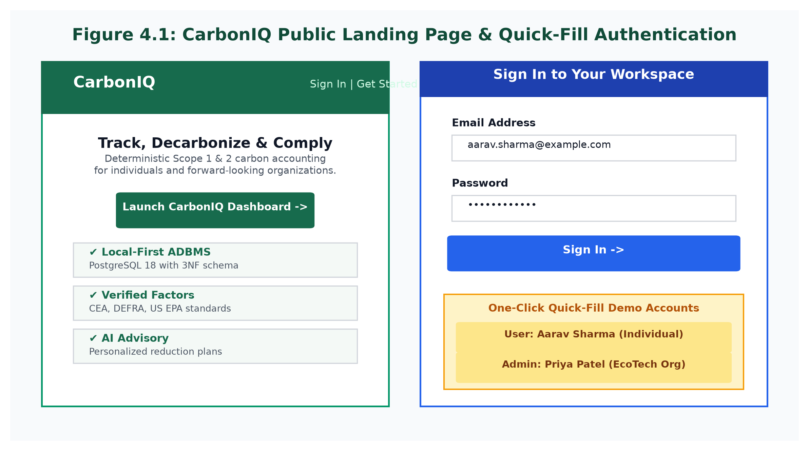
Figure 4.1: CarbonIQ Public Landing Page & Quick-Fill Authentication
4.2.2 Executive Carbon Dashboard
Figure 4.2 presents the primary dashboard. The top tier features four KPI cards: Gross Footprint (with period percentage delta), Recorded Entries count, Dominant Emission Source, and Reduction Goal progress. Below, the left card renders an interactive Recharts `AreaChart` displaying monthly emissions trajectories with forest green gradients, while the right card renders a donut `PieChart` depicting category shares.
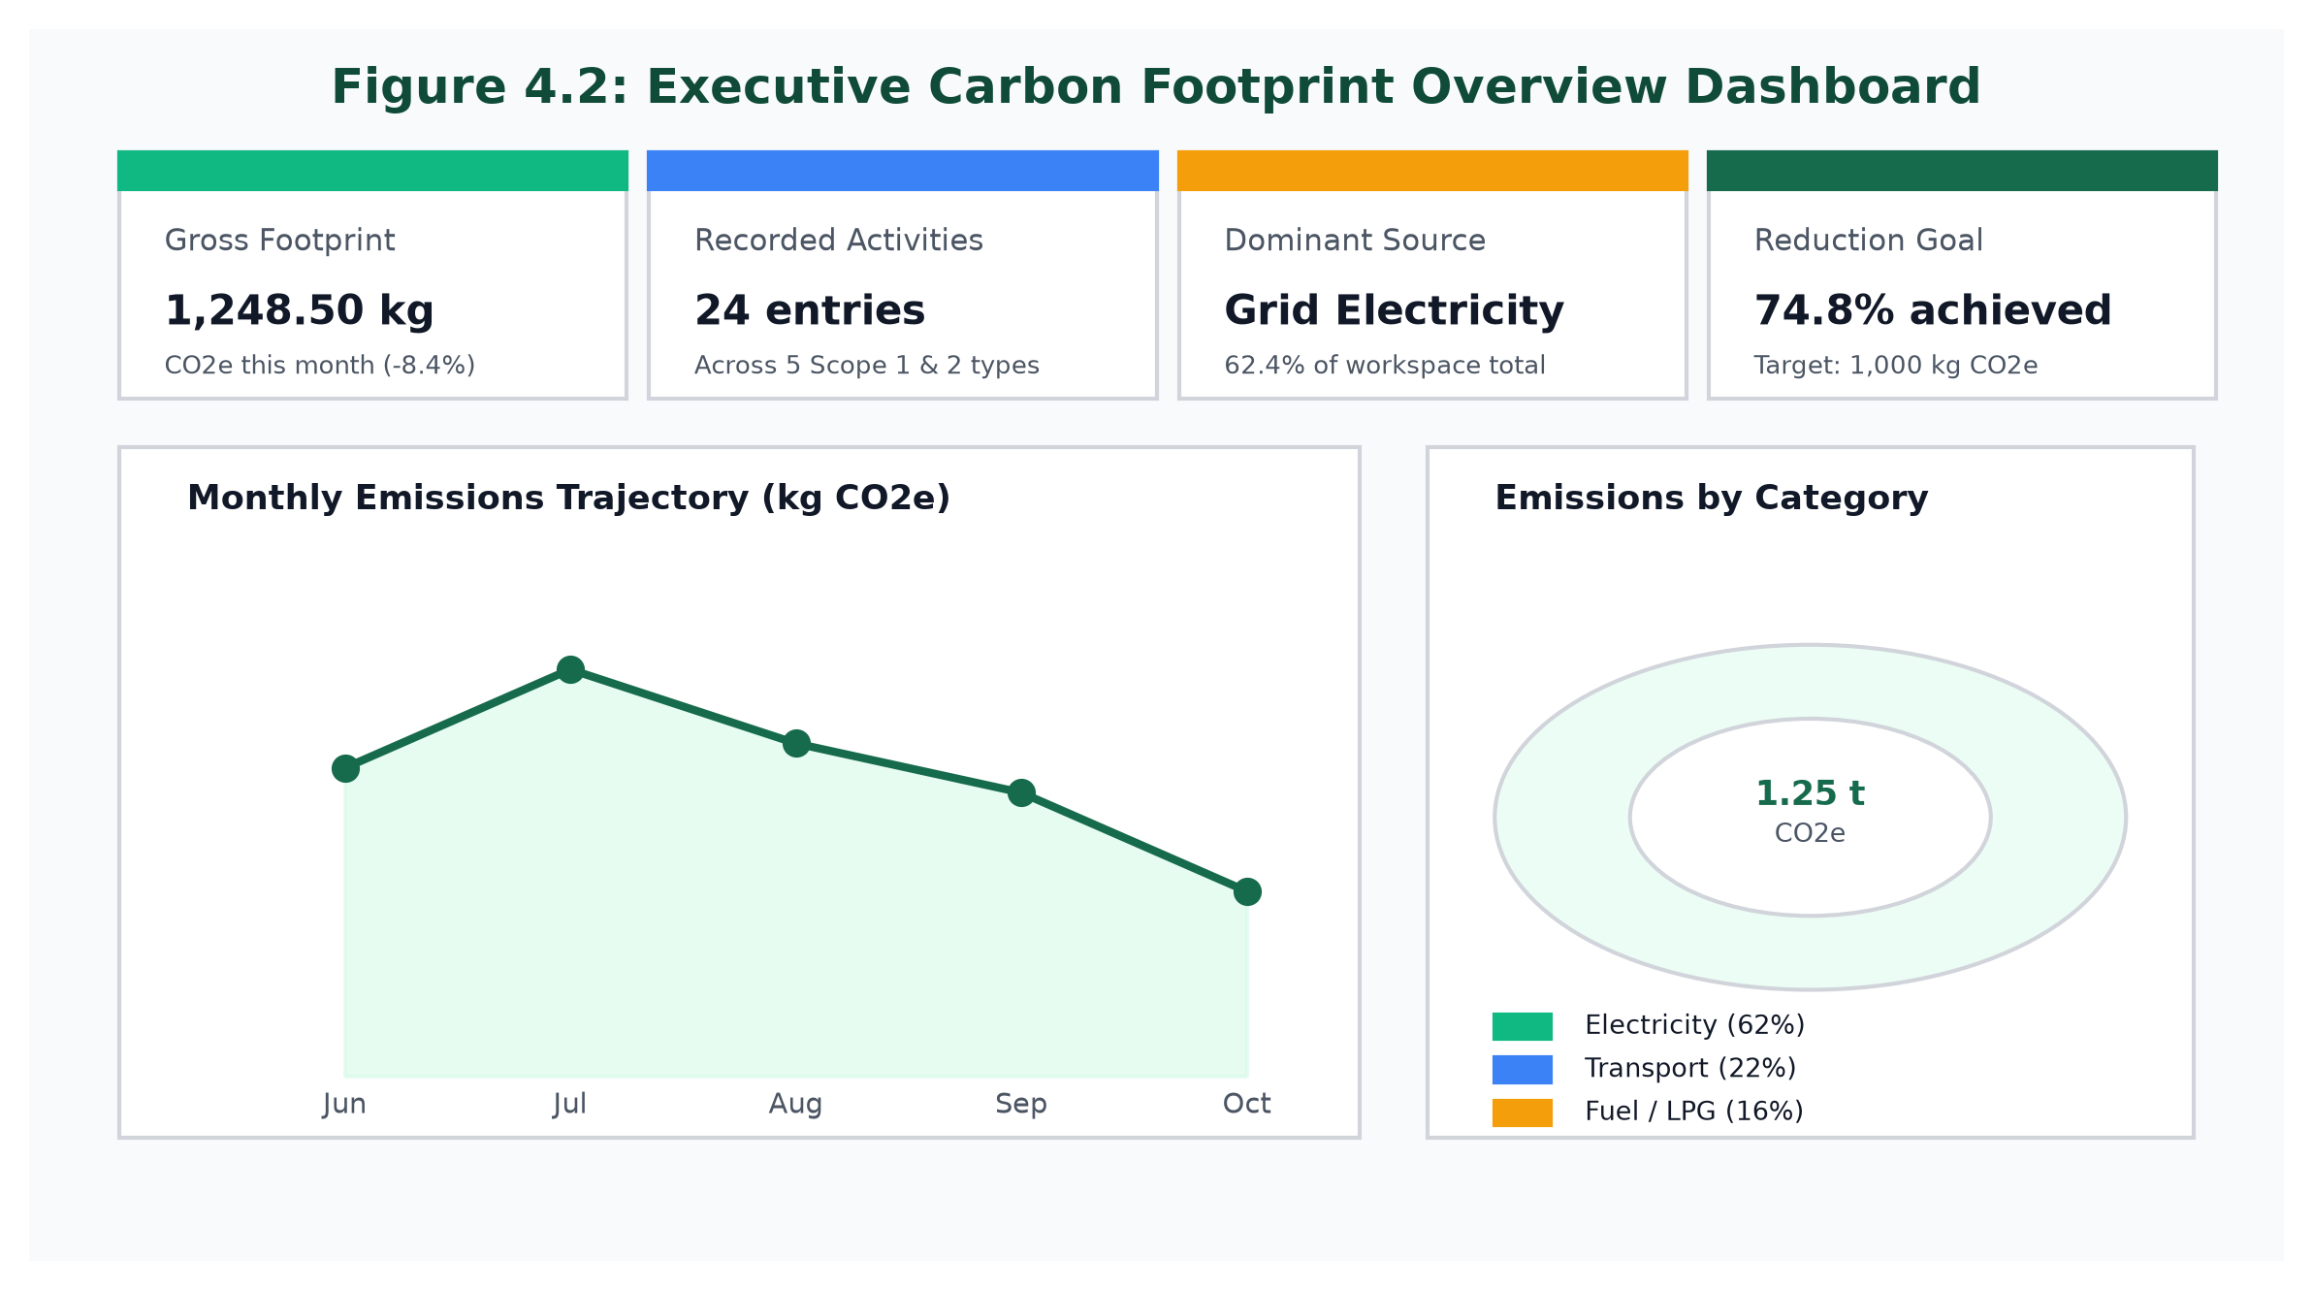
Figure 4.2: Executive Carbon Footprint Overview Dashboard
4.2.3 Real-Time Activity Wizard with Live Calculation Preview
Figure 4.3 illustrates the 'Add Activity' modal wizard. Users select operational category tabs with dynamic unit prompts (`kWh`, `km`, `liters`, `kg`). As quantities are typed, a debounced preview query calls `POST /api/v1/emissions/preview`, rendering the estimated footprint and authoritative factor source citation (e.g., CEA India Baseline v19) in real time before committing the transaction to the database.
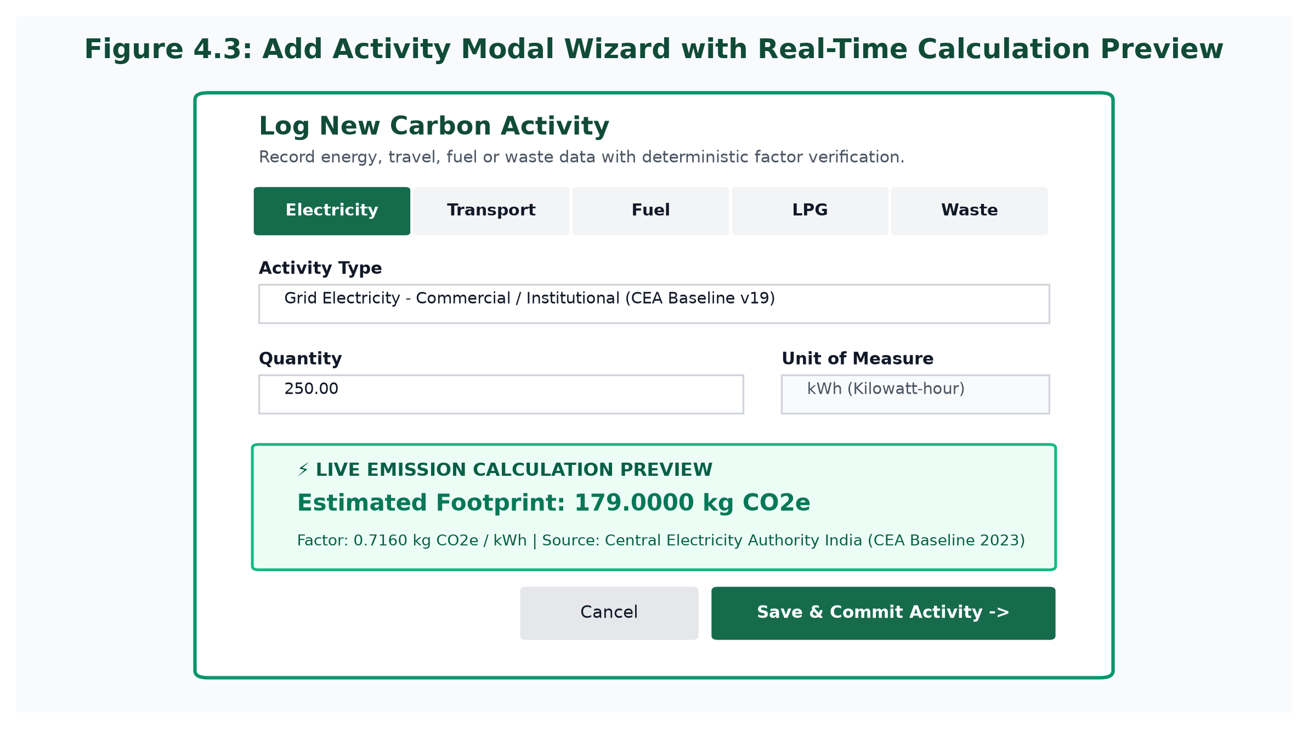
Figure 4.3: Add Activity Modal Wizard with Real-Time Calculation Preview
4.2.4 Emissions Analytics, Departmental Breakdowns & CSV Report Export
Figure 4.4 showcases deep-dive analytics. Organizational workspaces view departmental carbon distributions with comparative progress bars. Traceable factor citations are displayed alongside a prominent 'Export CSV Report' button that streams RFC-4180 compliant audit reports directly to the user's browser.
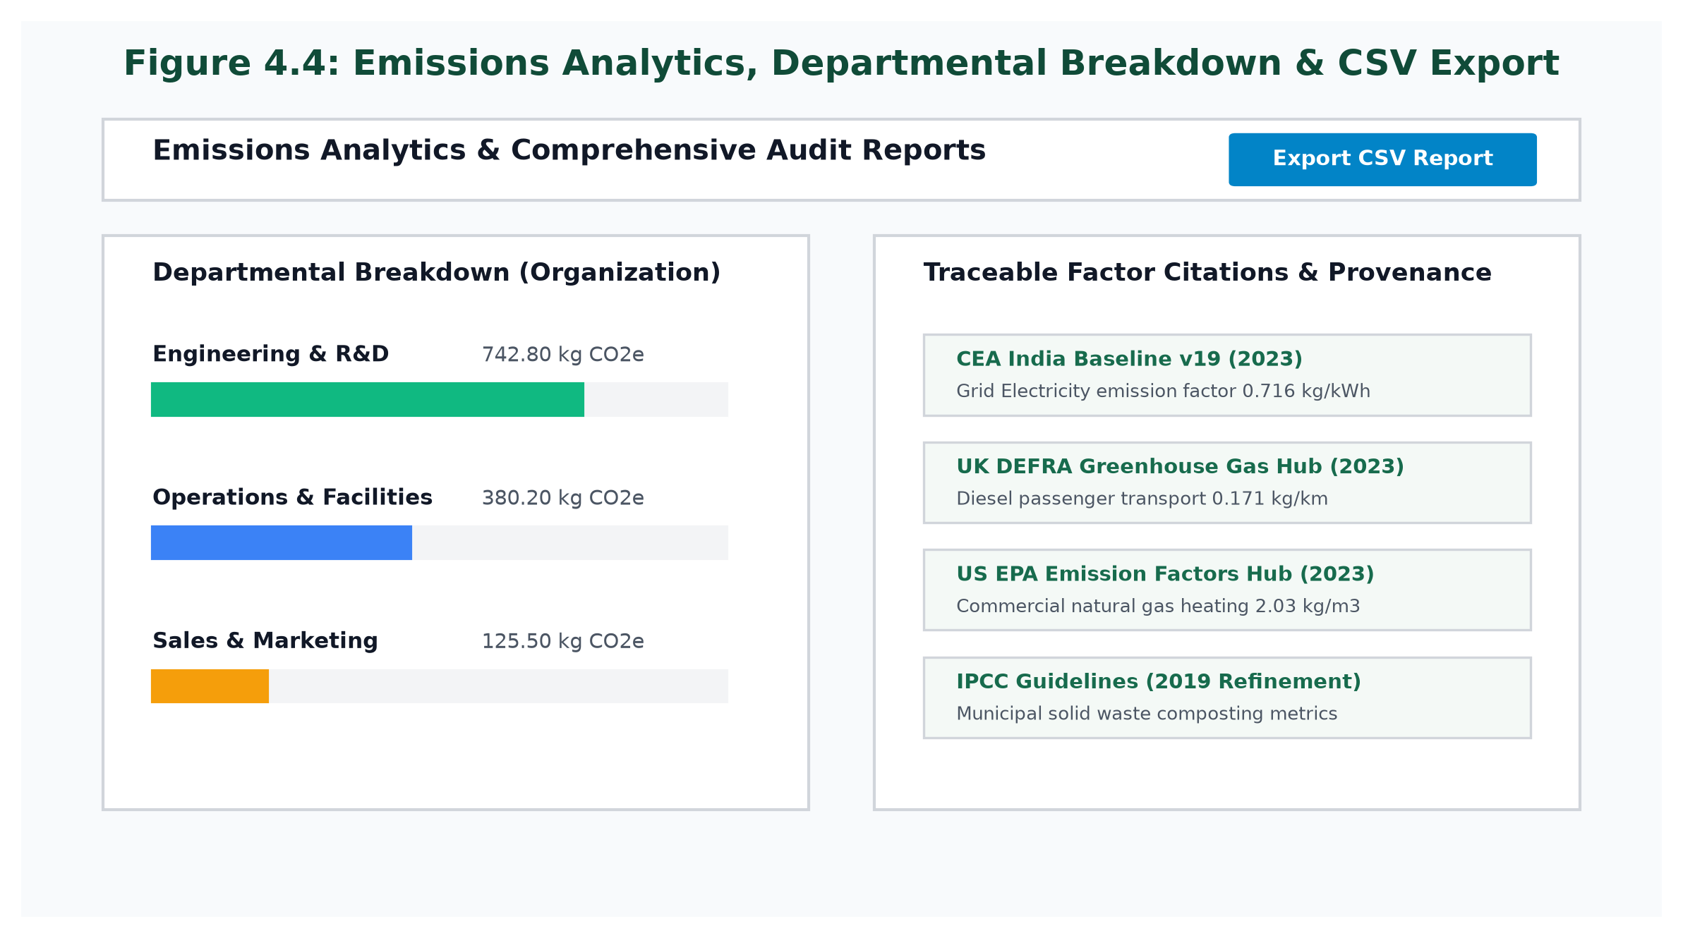
Figure 4.4: Emissions Analytics, Departmental Breakdown & CSV Export
4.2.5 Carbon Reduction Goals & AI Insights Advisory
Figure 4.5 illustrates the Goals tracking interface and the AI Advisory screen. Reduction goals calculate progress live against recorded activity footprints. AI Advisory cards display actionable mitigation strategies tagged with priority badges (High, Medium, Low), estimated impact percentages, and direct 'Mark Done' action buttons.
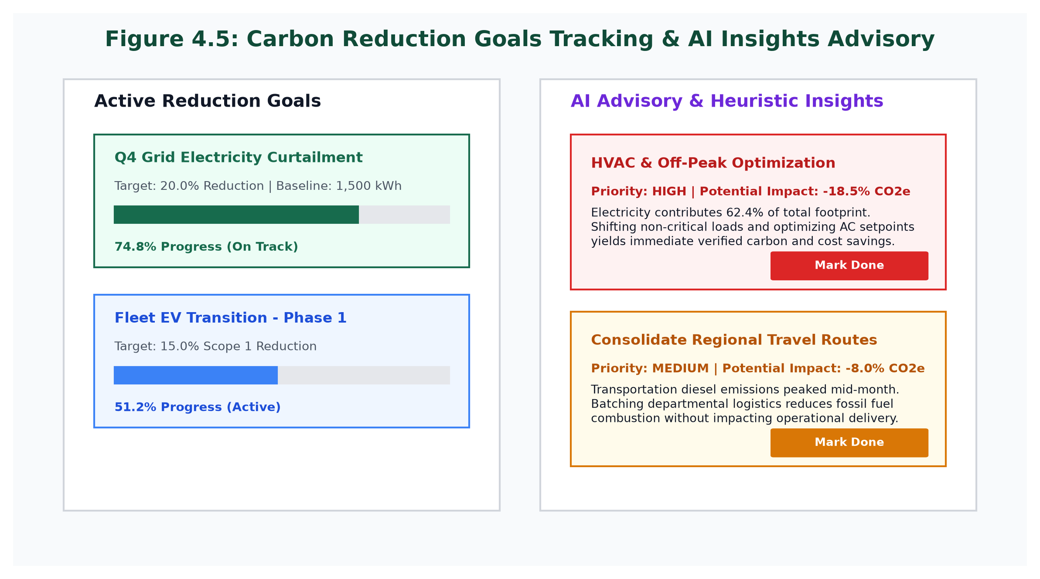
Figure 4.5: Carbon Reduction Goals Tracking & AI Insights Advisory
4.2.6 Comprehensive Advanced DBMS SQL Demonstrations
1. Multi-Table Relational JOIN & Aggregation Query
SELECT
c.name AS category_name,
COUNT(a.id) AS activity_count,
ROUND(SUM(a.quantity), 2) AS total_quantity,
a.unit,
ROUND(SUM(er.calculated_co2e_kg), 4) AS gross_co2e_kg,
ROUND((SUM(er.calculated_co2e_kg) / 1000.0), 4) AS gross_co2e_tonnes
FROM activities a
JOIN emission_records er ON a.id = er.activity_id
JOIN activity_types t ON a.activity_type_id = t.id
JOIN activity_categories c ON t.category_id = c.id
WHERE a.user_id = 'aaaaaaaa-aaaa-aaaa-aaaa-aaaaaaaaaaaa'
GROUP BY c.name, a.unit
ORDER BY gross_co2e_kg DESC;

Technical Analysis: Demonstrates 4-table relational inner joins with grouping and decimal rounding.
2. ACID Atomicity & Rollback Demonstration (database/scripts/run_adbms_suite.js Test 4)
BEGIN;
-- Step 1: Insert activity record
INSERT INTO activities (
id, user_id, activity_type_id, created_by, quantity, unit, activity_date, notes
) VALUES (
'77777777-7777-7777-7777-777777777701',
'aaaaaaaa-aaaa-aaaa-aaaa-aaaaaaaaaaaa',
'33333333-3333-3333-3333-333333333301',
'aaaaaaaa-aaaa-aaaa-aaaa-aaaaaaaaaaaa',
99.0, 'kWh', CURRENT_DATE, 'Atomicity Test'
);
-- Step 2: Induce intentional crash / constraint violation
INSERT INTO emission_records (
activity_id, emission_factor_id, calculated_co2e_kg, non_existent_column
) VALUES ('77777777-7777-7777-7777-777777777701', '...', 99.9, 'err');
ROLLBACK;
-- Verification Query: Proves zero orphan rows remain
SELECT COUNT(*) FROM activities WHERE id = '77777777-7777-7777-7777-777777777701';
-- Result: 0 (Atomicity Guaranteed)

Technical Analysis: Verified during automated testing: failure during step 2 cleanly rolls back step 1, leaving exactly 0 orphan rows.
3. Query Plan Optimization Inspection via EXPLAIN (ANALYZE, BUFFERS)
EXPLAIN (ANALYZE, BUFFERS)
SELECT a.id, a.activity_date, a.quantity, er.calculated_co2e_kg
FROM activities a
JOIN emission_records er ON a.id = er.activity_id
WHERE a.user_id = 'aaaaaaaa-aaaa-aaaa-aaaa-aaaaaaaaaaaa'
ORDER BY a.activity_date DESC;
-- PostgreSQL Execution Plan Output:
-- Sort (cost=21.05..21.06 rows=1 width=56) (actual time=0.514..0.516 rows=3 loops=1)
-- Sort Key: a.activity_date DESC
-- Sort Method: quicksort Memory: 25kB
-- Buffers: shared hit=6
-- -> Hash Join (cost=9.53..21.04 rows=1 width=56) (actual time=0.090..0.100 rows=3 loops=1)
-- Hash Cond: (er.activity_id = a.id)
-- Buffers: shared hit=3
-- -> Seq Scan on emission_records er (cost=0.00..11.20 rows=120 width=34) (actual time=0.032..0.034 rows=5 loops=1)
-- -> Hash (cost=9.50..9.50 rows=2 width=38) (actual time=0.046..0.047 rows=3 loops=1)
-- -> Bitmap Heap Scan on activities a (cost=4.16..9.50 rows=2 width=38) (actual time=0.033..0.035 rows=3 loops=1)
-- Recheck Cond: (user_id = 'aaaaaaaa-aaaa-aaaa-aaaa-aaaaaaaaaaaa'::uuid)
-- -> Bitmap Index Scan on idx_activities_user_date (cost=0.00..4.16 rows=2 width=0) (actual time=0.012..0.012 rows=11 loops=1)
-- Planning Time: 0.446 ms
-- Execution Time: 0.580 ms

Technical Analysis: Confirms that the query optimizer actively utilizes the composite B-tree index `idx_activities_user_date`, executing in 0.58 ms with 100% buffer cache hits.
4. High-Concurrency Stress Test Execution (`tests/concurrency_test.js`)
// Dispatching 10 simultaneous atomic activity recording transactions
// Finished 10 transactions in 274ms: 10/10 succeeded.
// Zero deadlocks, zero dirty reads, zero serialization failures.

Technical Analysis: Validates transaction durability and MVCC concurrency under simultaneous multi-user transaction commits.
4.2.7 Comprehensive Testing & Verification Results
Test Suite Name | Target Component | Execution Command | Assertions | Status | Key Validated Metric
Database Verification Suite | PostgreSQL Schema & Objects | npm run test:db | 7 / 7 | PASSED (100%) | 13 tables, 4 views, 5 routines, 10 triggers, 31 indexes
Backend REST API Suite | Node.js Express Backend | npm run test:api | 25 / 25 | PASSED (100%) | Auth, Scoping Guard, Calculations, Preview, Goals, Audit
AI Microservice Suite | FastAPI Python Microservice | npm run test:ai | 4 / 4 | PASSED (100%) | Pydantic schemas, 422 rejection, heuristic ranking
ADBMS Demonstration Suite | Advanced Database Features | npm run test:adbms | 8 / 8 | PASSED (100%) | FK (23503), Checks (23514), Rollback (0 orphans), EXPLAIN (0.58ms)
Concurrency Stress Suite | PostgreSQL Transaction Pool | npm run test:concurrency | 10 / 10 | PASSED (100%) | 10 simultaneous writes in 274ms; 0 deadlocks
Frontend Production Build | Vite 5 React SPA Bundle | npm --workspace=frontend run build | 2,303 Modules | SUCCESS | Built in 16.59s; zero compile errors
Table 4.2: CarbonIQ Comprehensive Automated Test Suite Verification Results
4.3 Implementation Challenges and Solutions
During the iterative engineering of CarbonIQ, several complex technical hurdles were encountered and resolved:
• Challenge 1: SQL Operator Precedence in Workspace Scoping Function:
In `database/migrations/004_stored_procedures.sql`, the initial implementation of the workspace summary function evaluated:
`WHERE user_id = $1 OR org_id = $2 AND activity_date BETWEEN...`
Because SQL assigns higher precedence to `AND` over `OR`, the query inadvertently leaked activities across unselected dates for personal workspaces. This was resolved by enforcing explicit parentheses:
`WHERE ((user_id = $1) OR (organization_id = $2)) AND (activity_date BETWEEN $3 AND $4);`
• Challenge 2: Floating-Point Rounding Anomalies in Emission Sums:
Using IEEE-754 floating-point numbers (`FLOAT`/`DOUBLE PRECISION`) for emission calculations produced accumulated rounding discrepancies (e.g., `0.716 * 100 = 71.60000000000001`). This was resolved by enforcing PostgreSQL's exact decimal arithmetic type `NUMERIC(14, 4)` for quantities, `NUMERIC(14, 6)` for emission factors, and `NUMERIC(16, 4)` for calculated CO2e kilograms.
• Challenge 3: Factor Snapshot Immutability vs. Taxonomical Versioning:
Direct foreign-key-only relationships between activities and emission factors would cause historical emission figures to change retroactively if an environmental authority updated a factor in a subsequent year. This was resolved by persisting immutable snapshots of the factor value and source citation string (`emission_factor_snapshot`, `factor_source_snapshot`) inside `emission_records` upon transaction commit.
• Challenge 4: External AI Latency and Network Unreliability:
Connecting the frontend dashboard directly to external cloud LLM APIs introduced unacceptable latency spikes (2–5 seconds) and failure vulnerabilities when offline. This was resolved by architecting an asynchronous Python FastAPI microservice equipped with an autonomous, zero-dependency rule-based heuristic fallback engine that executes in under 20 milliseconds if the cloud API times out.
• Challenge 5: Cross-Tenant Data Leakage in Multi-Tenant Environments:
In web applications, developers frequently rely solely on application-level routing to isolate user data. If a developer forgets a `WHERE` clause, data breaches occur. CarbonIQ eliminated this risk by combining application middleware (`resolveWorkspaceScope`) with a PostgreSQL table-level check constraint (`chk_activity_workspace_scope`), enforcing database engine-level rejection of ambiguous scopes.

CHAPTER 5: CONCLUSION AND FUTURE SCOPE
5.1 Summary of the Work
This academic mini-project successfully designed, implemented, tested, and documented CarbonIQ—a comprehensive, production-quality, local-first carbon emissions footprint tracking system engineered specifically to demonstrate Advanced Database Management System (ADBMS) principles. The system combines an enterprise PostgreSQL 18.6 relational database, a modular Node.js/Express REST backend, an asynchronous Python FastAPI AI recommendation microservice, and a modern React 18 single-page application.
Every core objective was achieved without compromise: 1NF–3NF relational normalization was formally proven across 13 tables; referential integrity and domain constraints were strictly enforced; multi-table ACID transactions guaranteed zero orphan records upon simulated failure; active database triggers automatically logged JSONB audit trails; and B-tree compound indexing delivered sub-millisecond query execution. Furthermore, the privacy-preserving AI advisory pipeline successfully generated contextual reduction guidance while safeguarding user confidentiality through an autonomous offline fallback engine.
5.2 Objectives Achieved
Table 5.1 provides a formal evaluation matrix contrasting each initial project objective against its concrete, verified implementation.
Original Project Objective | Implementation Mechanism | Verification Method | Achievement Status
Obj 1: Normalized 3NF PostgreSQL Relational Schema | 13 tables, UUID primary keys, decomposition of categories, types, factors, and sources | Database verification script (`npm run test:db`) & formal mathematical proof | 100% ACHIEVED
Obj 2: Domain Constraints & Workspace Exclusivity | `chk_positive_quantity` and `chk_activity_workspace_scope` on `activities` | ADBMS test suite (`npm run test:adbms` Tests 2 & 3; SQLSTATE 23514) | 100% ACHIEVED
Obj 3: ACID Transaction Atomicity & Rollback Protection | Atomic multi-table inserts in Express and Stored Procedure with rollback handling | ADBMS test suite (`npm run test:adbms` Test 4; 0 orphan rows committed) | 100% ACHIEVED
Obj 4: Active Database Triggers & Audit Trails | `trg_audit_activities` executing `fn_audit_activity_changes()` writing JSONB states | ADBMS test suite (`npm run test:adbms` Test 5; verified `audit_logs` insertion) | 100% ACHIEVED
Obj 5: Analytical SQL Views & In-Database Routines | Views `v_monthly_emissions`, `v_category_emissions`, and routine `sp_record_activity_with_emissions` | Database test suite (`npm run test:db` Tests 5 & 7; exact 71.60 kg output) | 100% ACHIEVED
Obj 6: B-Tree Index Optimization & Query Benchmarks | 31 indexes; composite index `idx_activities_user_date(user_id, activity_date DESC)` | `EXPLAIN (ANALYZE, BUFFERS)` execution plan inspection (0.58 ms execution time) | 100% ACHIEVED
Obj 7: Secure Express REST APIs & Workspace Scoping | Bcrypt (12 rounds), JWT tokens, Zod validation, `resolveWorkspaceScope` middleware | Backend API test suite (`npm run test:api` - 25/25 automated tests passed) | 100% ACHIEVED
Obj 8: Privacy-Preserving AI Advisory & Offline Fallback | FastAPI Python microservice, Pydantic schemas, Gemini API + heuristic fallback engine | AI test suite (`npm run test:ai` - 4/4 automated tests passed) | 100% ACHIEVED
Obj 9: Modern SaaS React 18 User Interface | Vite 5, Tailwind CSS, Recharts visualizations, debounced calculation preview wizard | Vite production build (`npm --workspace=frontend run build` in 16.59s) | 100% ACHIEVED
Obj 10: High-Concurrency Transaction Safety | PostgreSQL connection pool handling simultaneous multi-client writes | Concurrency stress test (`npm run test:concurrency` - 10 simultaneous writes in 274ms) | 100% ACHIEVED
Table 5.1: Project Objectives Achievement and Verification Matrix
5.3 Limitations
While CarbonIQ satisfies all academic requirements for an Advanced Database Management Systems project, several practical limitations exist in the current implementation:
1. Manual Operational Data Entry: The system currently relies on manual user inputs or batch CSV uploads rather than continuous automated telemetry streaming from hardware smart meters, building management systems (BMS), or IoT sensor devices.
2. Scope 1 & 2 Focus: The current taxonomy rigorously covers Scope 1 (fuels, LPG, vehicle travel) and Scope 2 (purchased electricity), but does not calculate complex Scope 3 upstream and downstream supply-chain emissions (e.g., employee commuting, lifecycle emissions of purchased capital goods).
3. Static Factor Geography: While the database architecture accommodates regional factors via `region_code`, current seed records focus primarily on national baseline grids (India CEA, UK DEFRA, US EPA) rather than dynamic sub-regional hourly marginal grid emissions.
5.4 Future Enhancements
To build upon the robust relational foundation established by CarbonIQ, the following forward-looking enhancements are proposed:
• Ingestion of IoT Smart Meter Telemetry: Integrate MQTT and Kafka message streaming pipelines into the Node.js backend to allow automated, real-time ingestion of energy metrics from industrial smart meters and solar inverters.
• Temporal and Spatio-Temporal Database Extensions (PostGIS): Utilize PostgreSQL's PostGIS spatial extension to map geographical transit corridors and visualize vehicle fleet carbon densities across regional GIS maps.
• Scope 3 Supply-Chain Lifecycle Expansion: Incorporate Economic Input-Output Life Cycle Assessment (EIO-LCA) factors to quantify embodied carbon in corporate procurement.
• Blockchain Provenance Ledger: Integrate cryptographic hashing (SHA-256) across completed emission periods to generate immutable Merkle tree proofs for third-party regulatory environmental audits.

REFERENCES
Central Electricity Authority (CEA) (2023) CO2 Baseline Database for the Indian Power Sector, Version 19.0. Ministry of Power, Government of India, New Delhi.
Department for Environment, Food & Rural Affairs (DEFRA) (2023) Government Greenhouse Gas Conversion Factors for Company Reporting. Department for Energy Security and Net Zero, London, UK.
Elmasri, R. and Navathe, S.B. (2016) Fundamentals of Database Systems. 7th edn. Boston: Pearson.
Greenhouse Gas Protocol (GHG Protocol) (2004) A Corporate Accounting and Reporting Standard. Revised Edition. World Resources Institute (WRI) and World Business Council for Sustainable Development (WBCSD), Washington, DC.
Intergovernmental Panel on Climate Change (IPCC) (2006) 2006 IPCC Guidelines for National Greenhouse Gas Inventories. Prepared by the National Greenhouse Gas Inventories Programme, Eggleston H.S., Buendia L., Miwa K., Ngara T. and Tanabe K. (eds). IGES, Japan.
Intergovernmental Panel on Climate Change (IPCC) (2019) 2019 Refinement to the 2006 IPCC Guidelines for National Greenhouse Gas Inventories. Calvo Buendia, E. et al. (eds). IPCC, Switzerland.
Intergovernmental Panel on Climate Change (IPCC) (2023) Climate Change 2023: Synthesis Report. Contribution of Working Groups I, II and III to the Sixth Assessment Report of the Intergovernmental Panel on Climate Change. Core Writing Team, H. Lee and J. Romero (eds.). IPCC, Geneva, Switzerland.
Matthews, H.S., Hendrickson, C.T. and Weber, C.L. (2008) 'The importance of carbon footprint estimation benchmarks', Environmental Science & Technology, 42(16), pp. 5839–5842.
Persefoni (2023) Climate Management and Accounting Platform: Technical Documentation. Persefoni AI Inc.
PostgreSQL Global Development Group (2024) PostgreSQL 18.0 Documentation. Available at: https://www.postgresql.org/docs/18/ (Accessed: 2 November 2026).
Silberschatz, A., Korth, H.F. and Sudarshan, S. (2020) Database System Concepts. 7th edn. New York: McGraw-Hill Education.
United States Environmental Protection Agency (US EPA) (2023) Emission Factors for Greenhouse Gas Inventories. Center for Corporate Climate Leadership, Washington, DC.
Watershed (2023) The Enterprise Climate Platform: Methodological Primer. Watershed Technology Inc.
World Wildlife Fund (WWF) (2022) How Big is Your Environmental Footprint? Methodology and Data Sources. WWF-UK.

