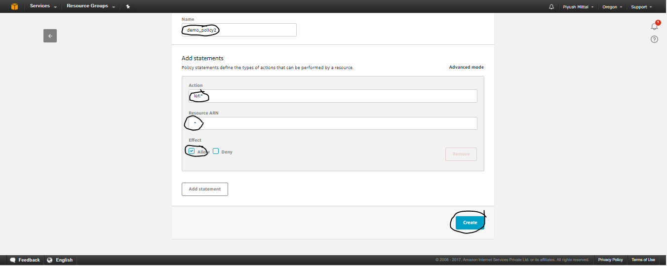

Create a policy provide name,Action,Resource ARN,Effect then Create.

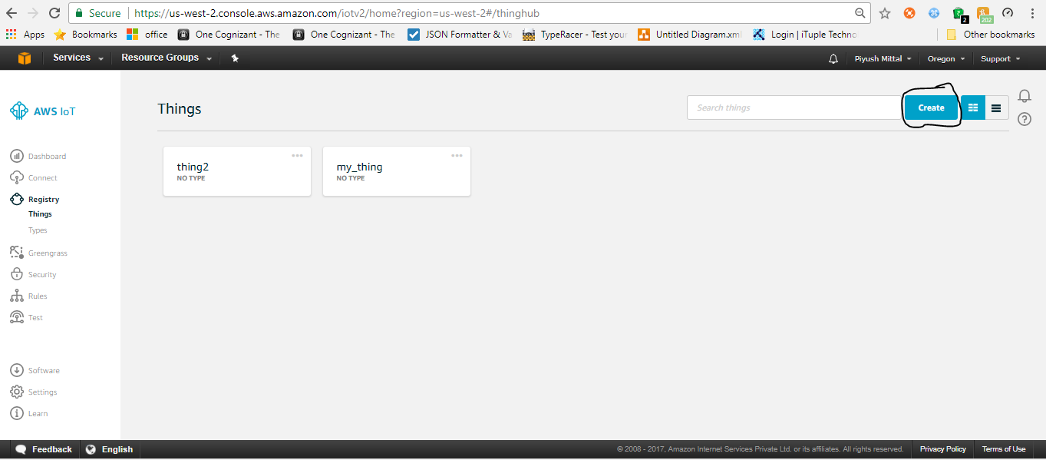

AWS Iot->Create

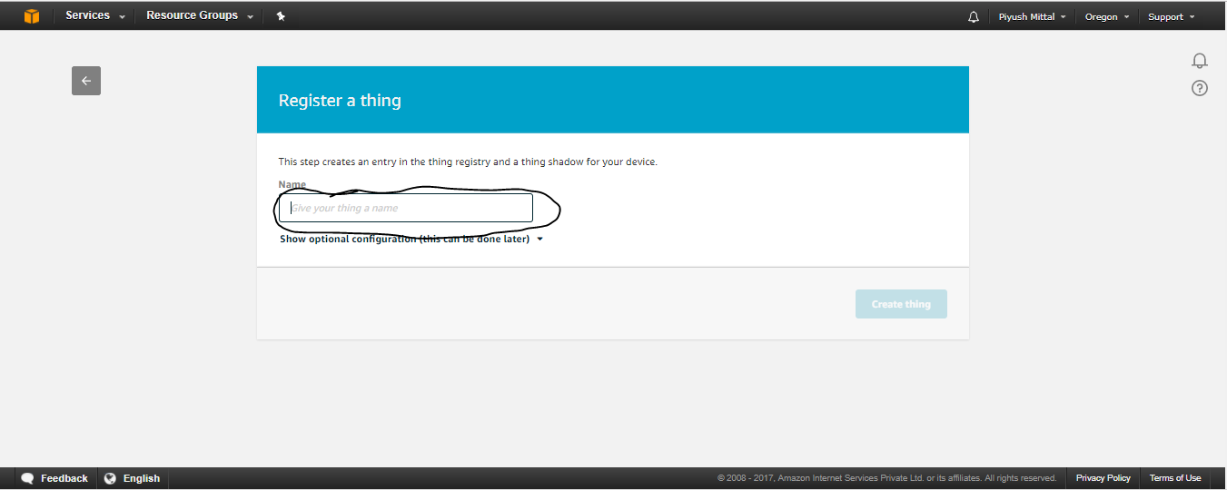

Give a Thing name.

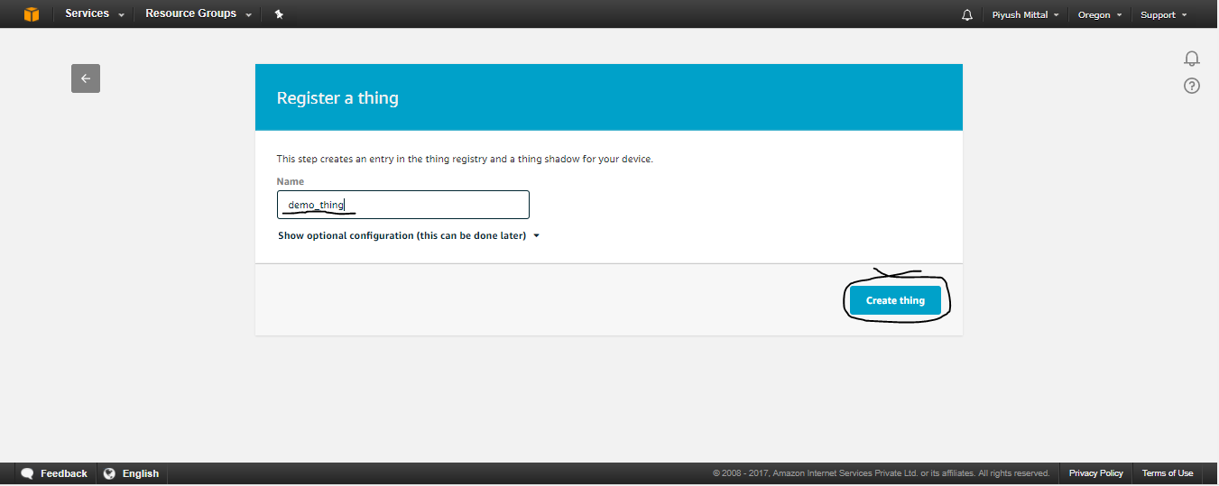

After giving thing name click on Create thing.

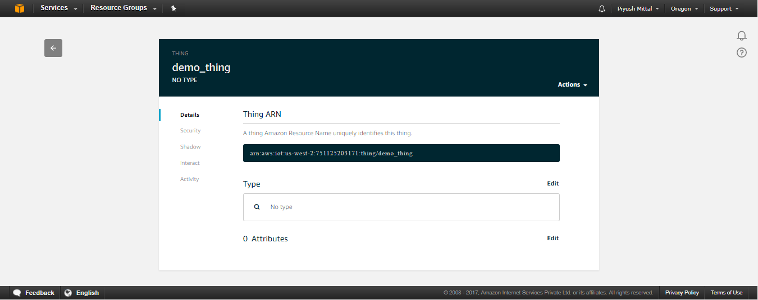

After creating a thing you will get redirect to above page.

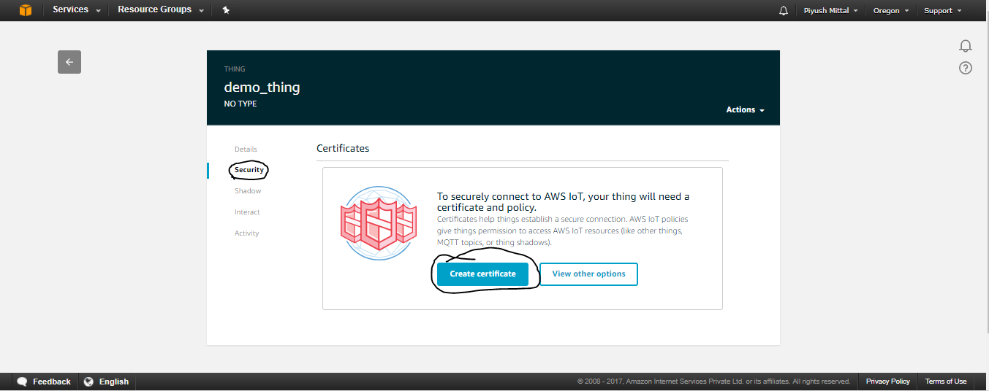

Click on security->create certificate

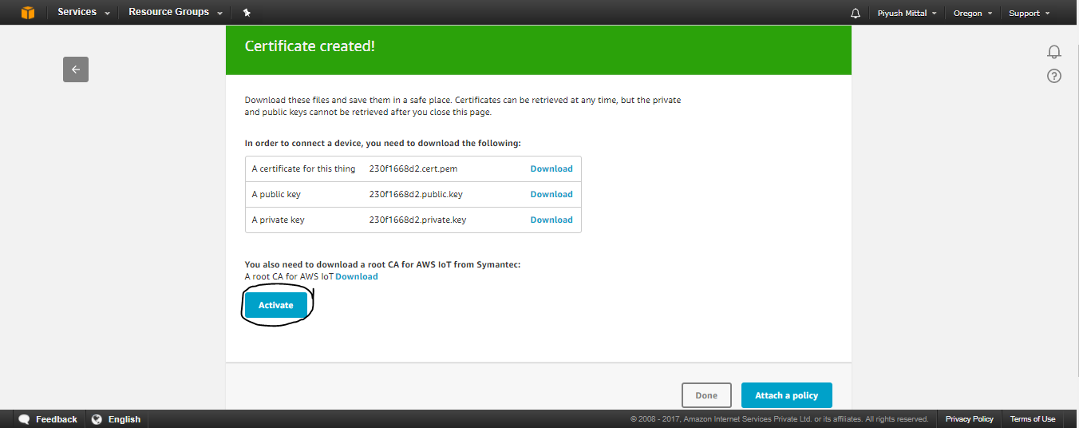

Click on Activate.

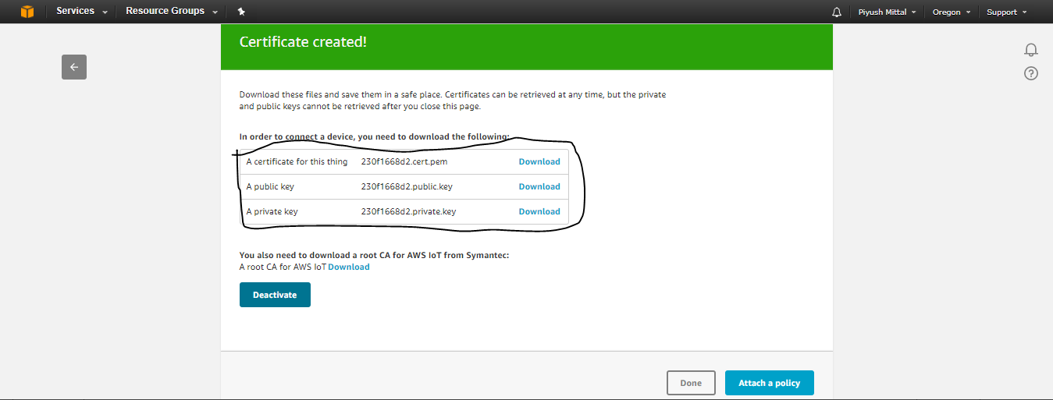

Download all the keys.

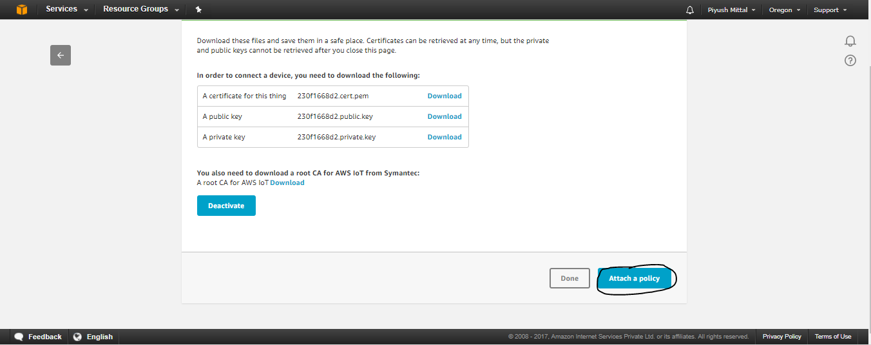

Click on Attach a Policy

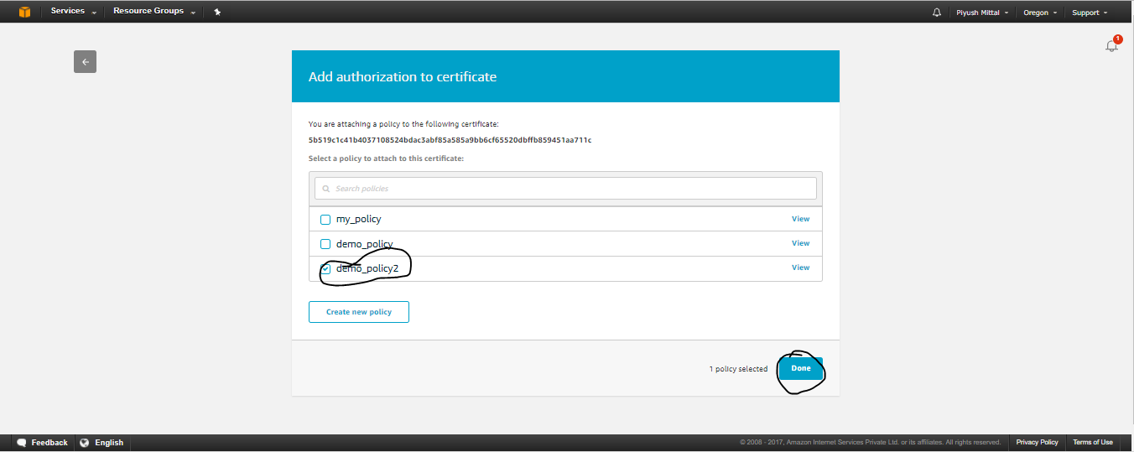

Attach previously created policy

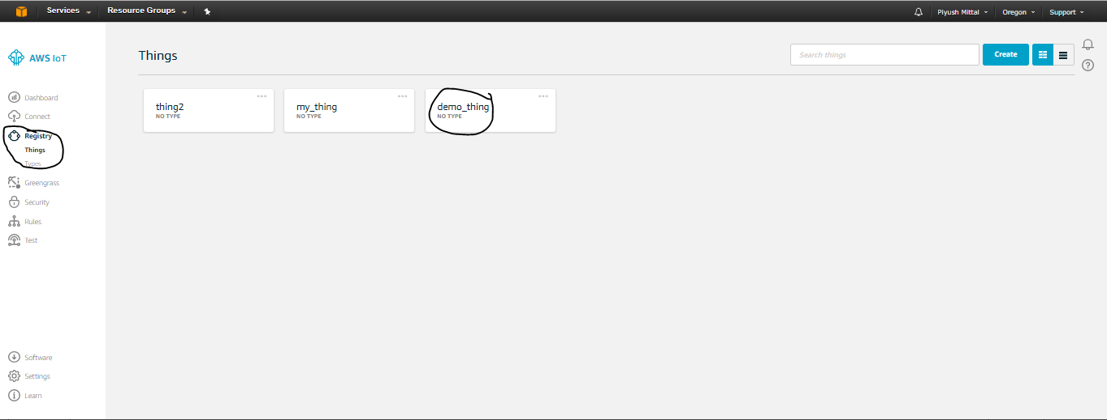

Now goto thing

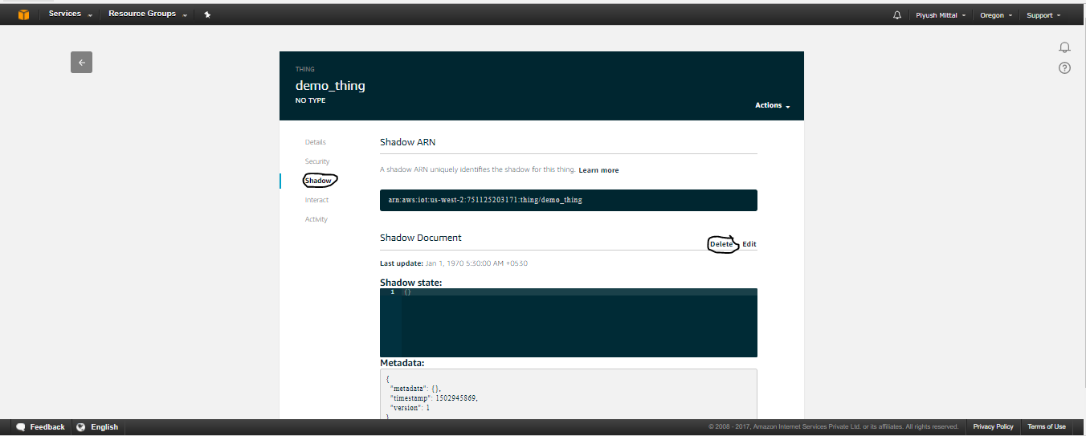

Shadow->delete

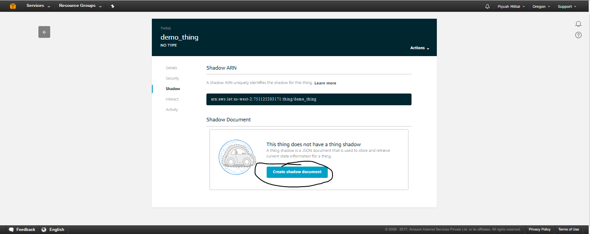

Create shadow document

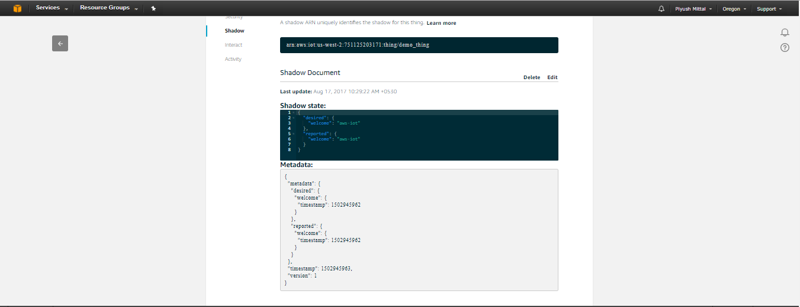

Connecting a thing with MQTT

Go to

<http://docs.aws.amazon.com/iot/latest/developerguide/managing-device-certs.html>

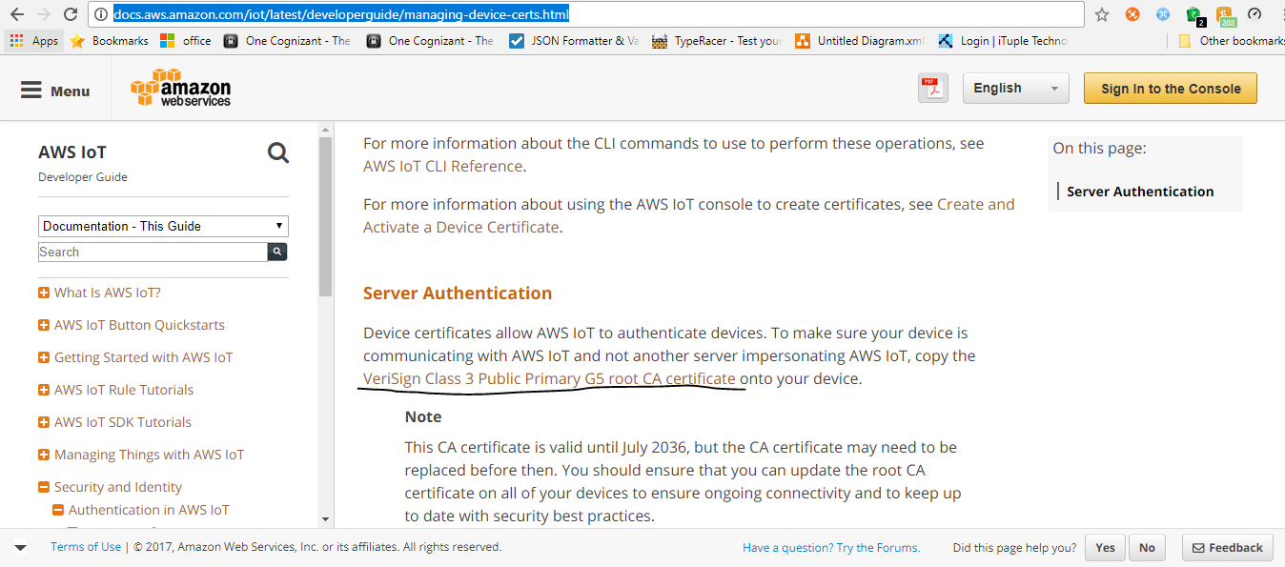

Click on underlined link

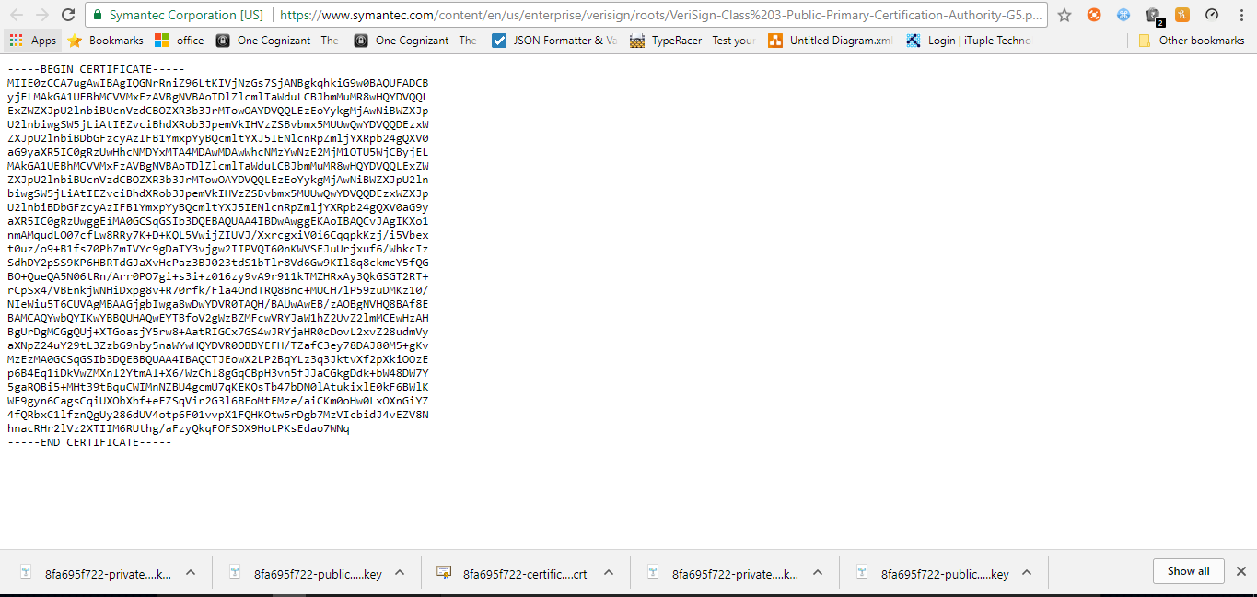

You will be redirected to the above screen.

Copy the stuff and paste to a file

Save that file with extension .pem

I have saved that file as

VeriSign-Class 3-Public-Primary-Certification-Authority-G5.pem

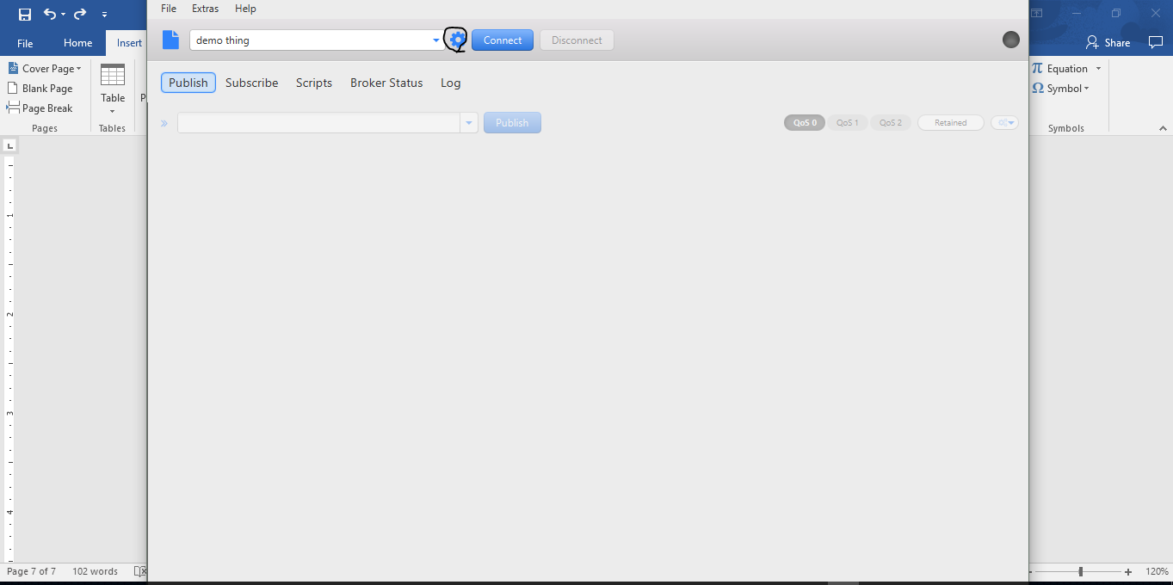

Click on highlighted symbol

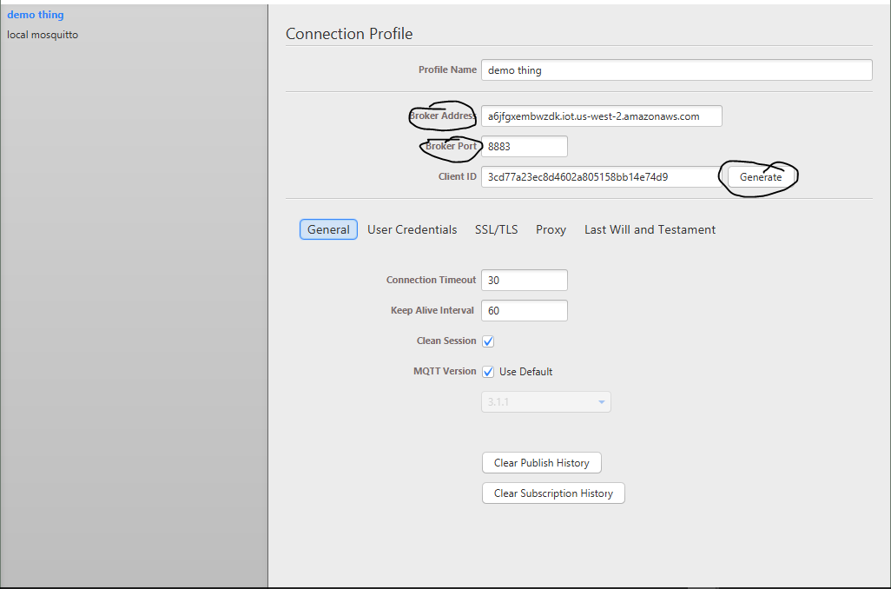

Give Broker Addredd and port then Generate client id

You will get Broker address from your IOT thing

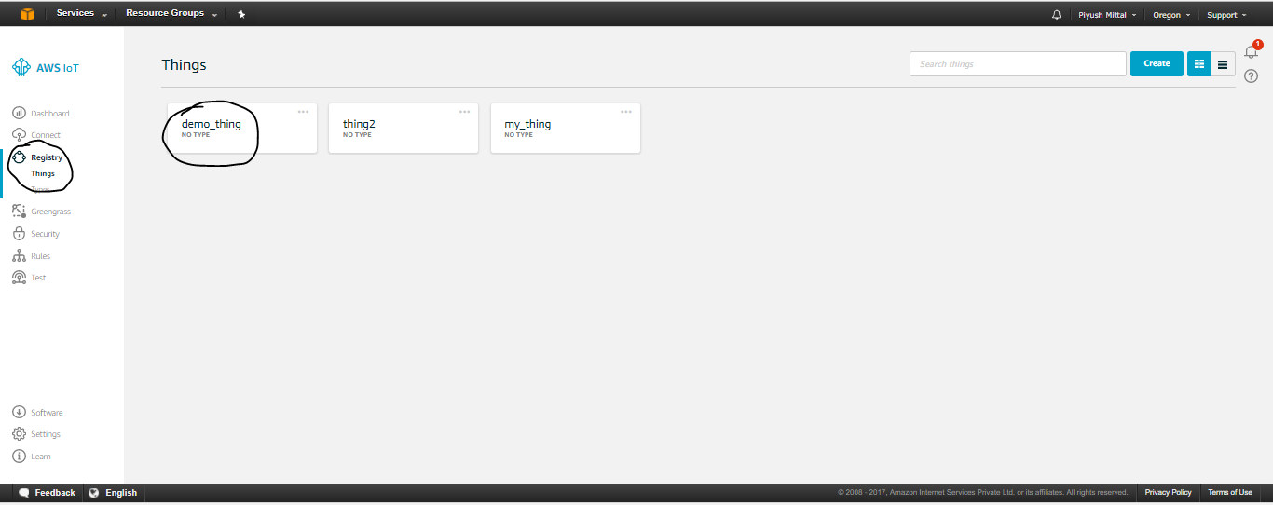

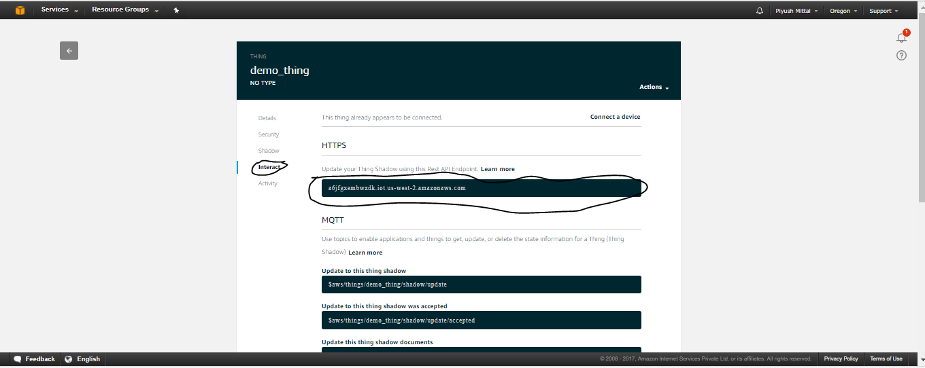

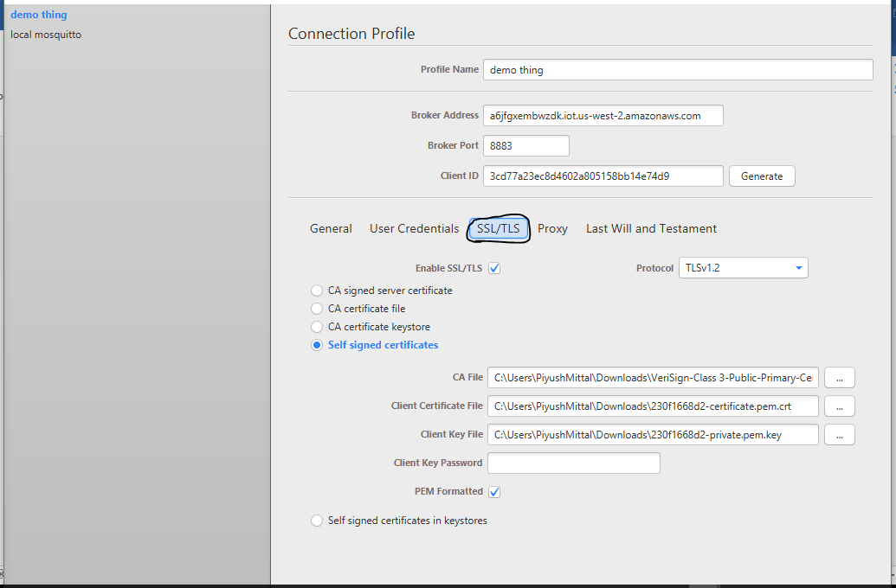

Click on SSL/TLS

Provide

CA file previously created

Client Certificate file previously downloaded

Client private key previously downloaded

Check PEM formatted

Now click on okay.

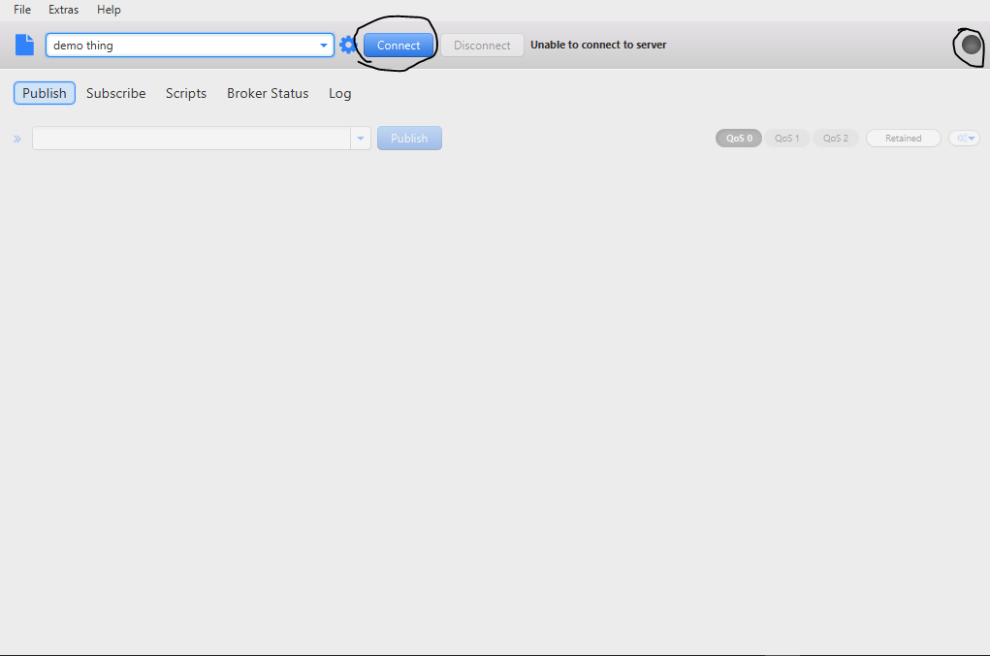

Click on connect

After connecting the light given at right most corner will become green