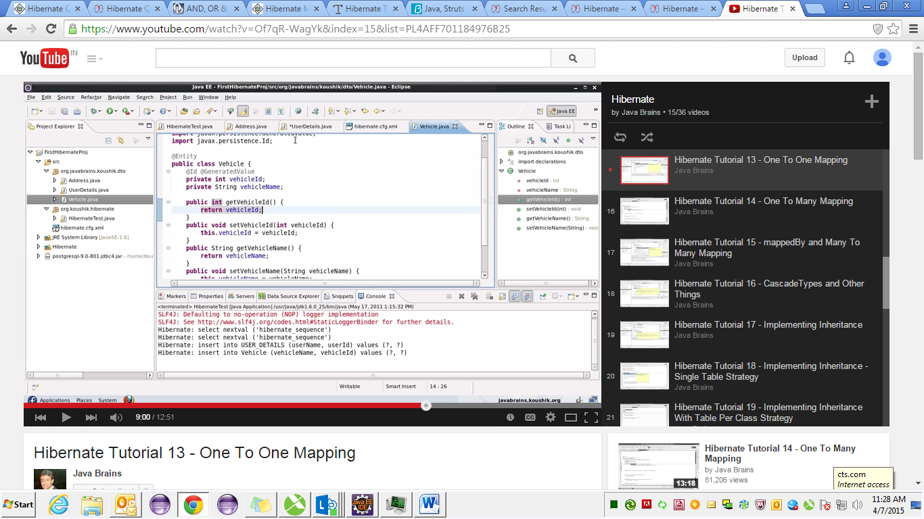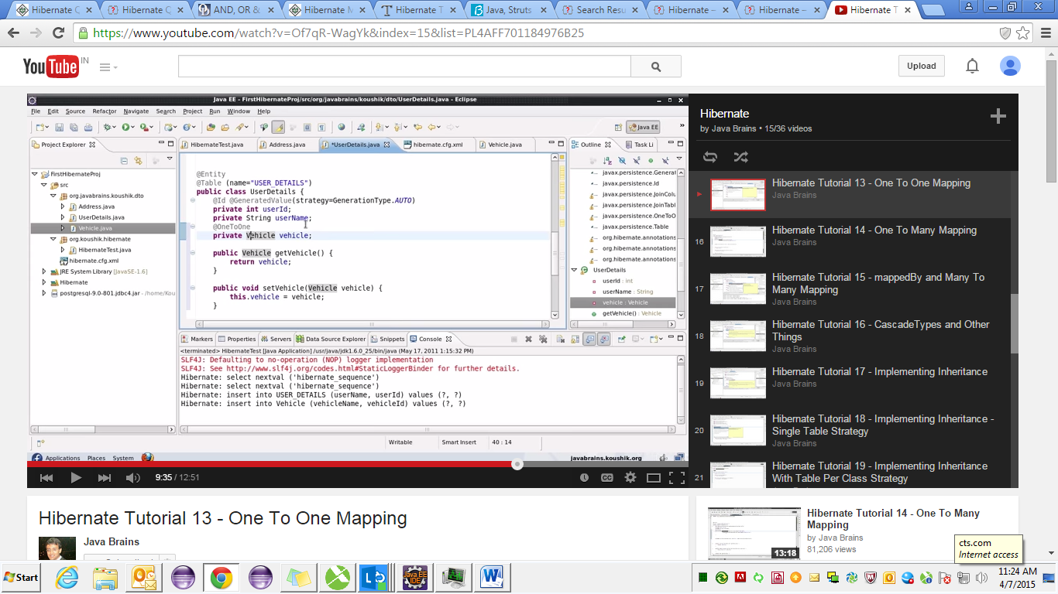

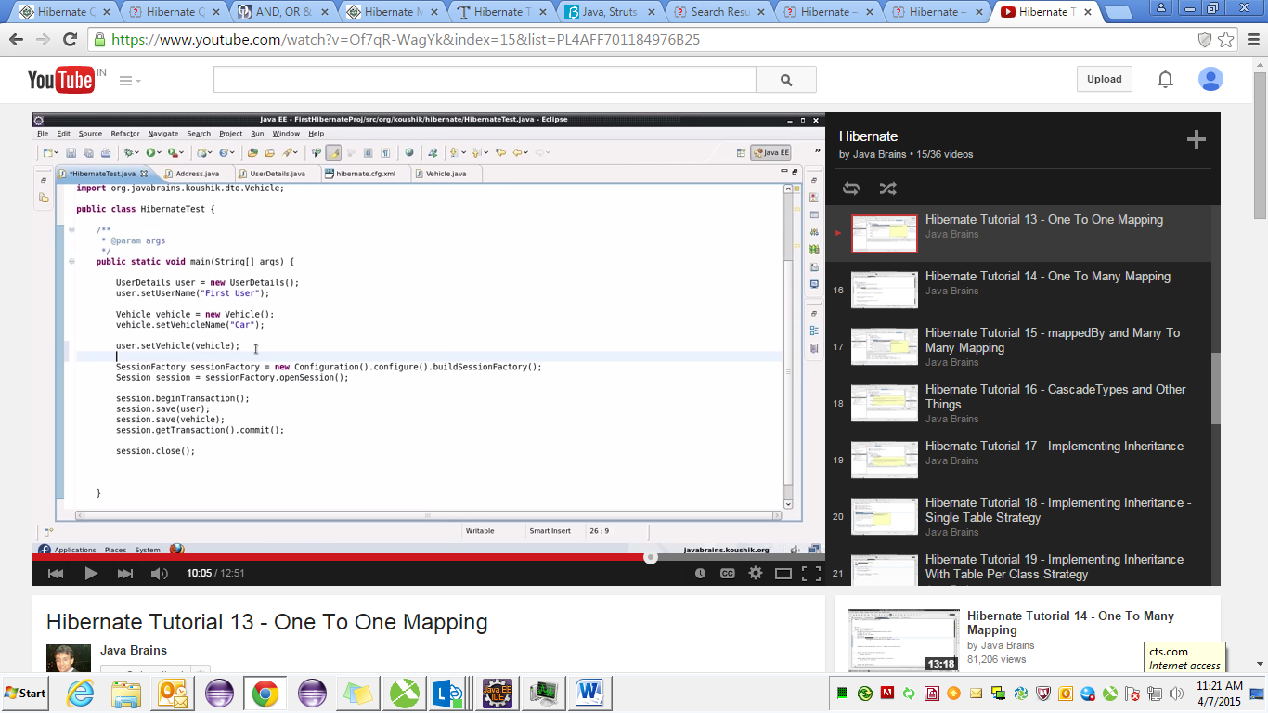

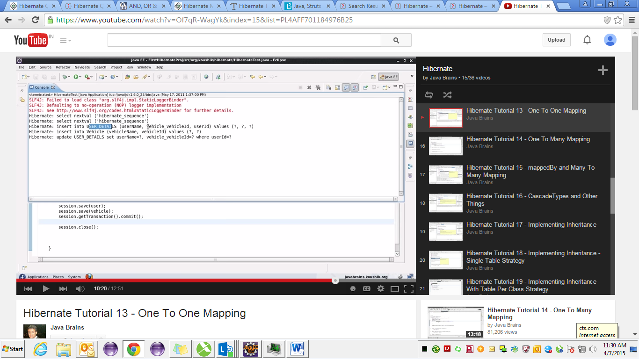

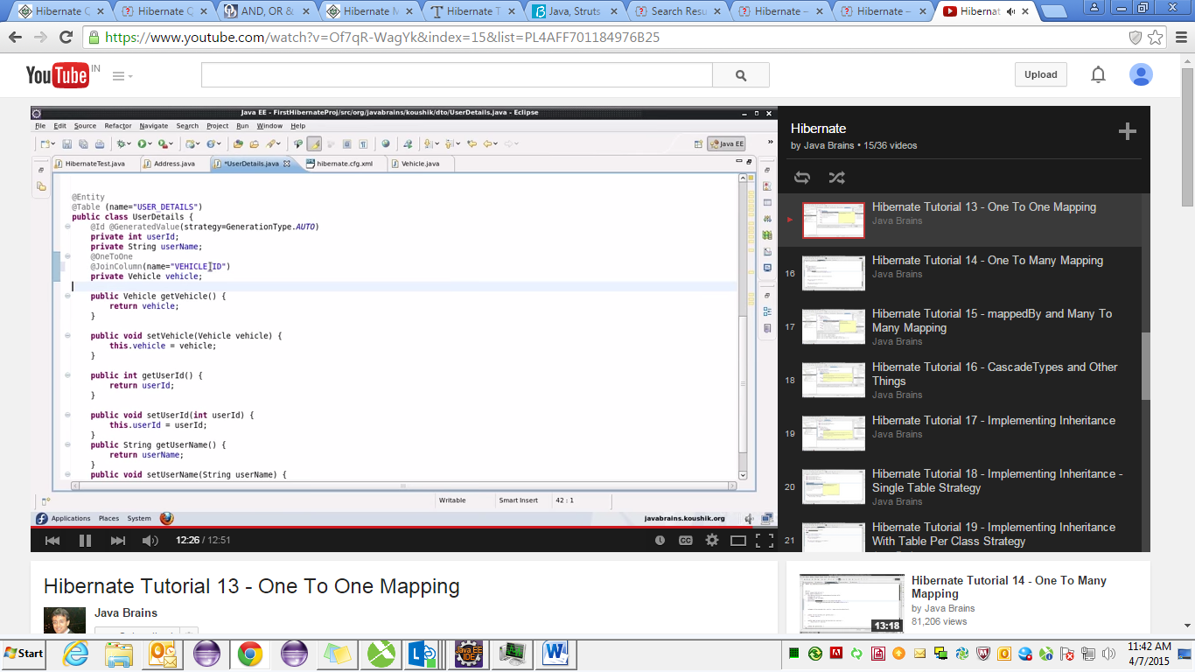

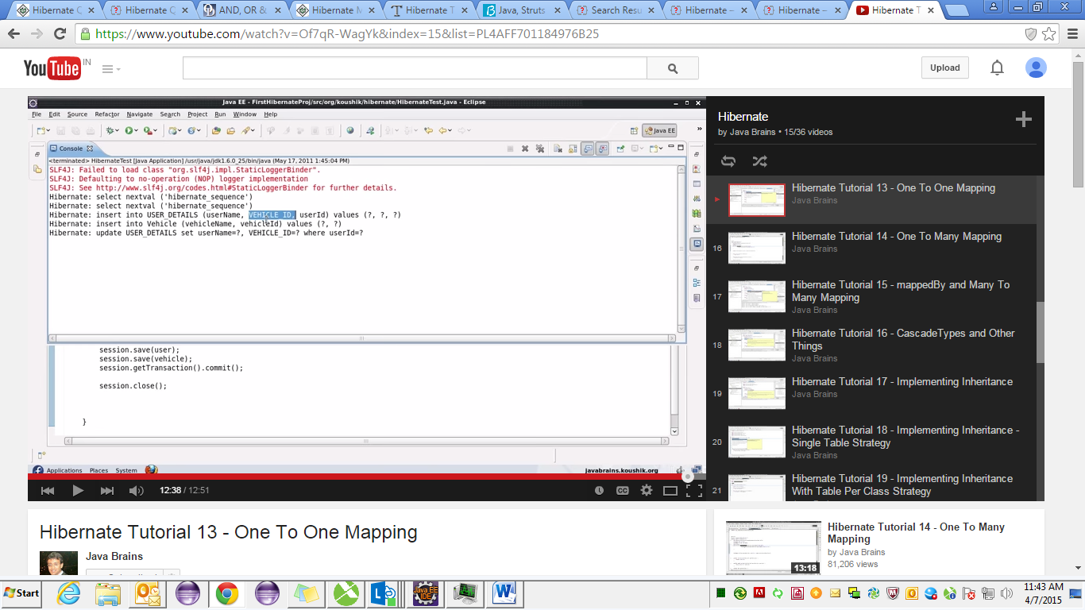

**package** test;

**import** javax.persistence.Entity;

**import** javax.persistence.GeneratedValue;

**import** javax.persistence.GenerationType;

**import** javax.persistence.Id;

**import** javax.persistence.JoinColumn;

**import** javax.persistence.OneToOne;

**import** javax.persistence.Table;

@Entity

@Table (name="USER_DETAILS")

**public** **class** UserDetails {

@Id @GeneratedValue(strategy=GenerationType.*AUTO*)

**private** **int** userId;

**private** String userName;

@OneToOne

/*@JoinColumn(name="VECHILE_ID")*/

**private** Vehicle vechile;

**public** **int** getUserId() {

**return** userId;

}

**public** **void** setUserId(**int** userId) {

**this**.userId = userId;

}

**public** String getUserName() {

**return** userName;

}

**public** **void** setUserName(String userName) {

**this**.userName = userName;

}

**public** Vehicle getVechile() {

**return** vechile;

}

**public** **void** setVechile(Vehicle vechile) {

**this**.vechile = vechile;

}

}

--------------------------------------------------------------------------------------------

**package** test;

**import** javax.persistence.Entity;

**import** javax.persistence.GeneratedValue;

**import** javax.persistence.Id;

**import** org.hibernate.annotations.GenericGenerator;

**import** org.hibernate.annotations.Parameter;

@Entity

**public** **class** Vehicle {

@Id @GeneratedValue

**private** **int** vechileId;

**private** String vechileName;

**public** **int** getVechileId() {

**return** vechileId;

}

**public** **void** setVechileId(**int** vechileId) {

**this**.vechileId = vechileId;

}

**public** String getVechileName() {

**return** vechileName;

}

**public** **void** setVechileName(String vechileName) {

**this**.vechileName = vechileName;

}

}

--------------------------------------------------------------------------------

**package** test;

**import** javax.persistence.Entity;

**import** javax.persistence.GeneratedValue;

**import** javax.persistence.Id;

**import** org.hibernate.Session;

**import** org.hibernate.SessionFactory;

**import** org.hibernate.cfg.Configuration;

**import** org.hibernate.Session;

**import** org.hibernate.SessionFactory;

**public** **class** tst {

**public** **static** **void** main(String[] args)

{

UserDetails user = **new** UserDetails();

user.setUserName("first user");

Vehicle vehicle=**new** Vehicle();

vehicle.setVechileName("car");

user.setVechile(vehicle);

SessionFactory sessionFactory=**new** Configuration().configure().~~buildSessionFactory~~();

Session session=sessionFactory.openSession();

//Session session=sessionFactory.openSession();

session.beginTransaction();

//session.save(user);

session.save(vehicle);

session.save(user);

session.getTransaction().commit();

session.close();

}

}

--------------------------------------------------------------------------

<?xml version=*'1.0'* encoding=*'utf-8'*?>

<!DOCTYPE hibernate-configuration PUBLIC

"-//Hibernate/Hibernate Configuration DTD 3.0//EN"

"http://www.hibernate.org/dtd/hibernate-configuration-3.0.dtd">

<hibernate-configuration>

<session-factory>

<property name=*"hibernate.dialect"*>

org.hibernate.dialect.MySQLDialect

</property>

<!--DONE-->

<property name=*"hibernate.connection.driver_class"*>

com.mysql.jdbc.Driver

</property>

<!--DONE-->

<property name=*"hibernate.connection.url"*>

jdbc:mysql://localhost:3306/abc

</property>

<!-- DONE -->

<property name=*"hibernate.connection.username"*>

root

</property>

<!-- DONE -->

<property name=*"hibernate.connection.password"*>

root

</property>

<!-- show all executed sql to stdout -->

<property name=*"show_sql"*>true</property>

<!-- create and droap the database schema automatically -->

<!-- <property name="hbm2ddl.auto">create</property> create schema every time u run the program -->

<property name=*"hbm2ddl.auto"*>update</property><!-- update the schema -->

<!-- name the annotation entity class (all the annotation name will be here ) -->

<!-- <mapping class="com.beans.UserBean"></mapping> -->

<mapping class=*"com.vo.t_user"*></mapping>

<mapping class=*"com.vo.t_login"*></mapping>

<mapping class=*"test.Vehicle"*></mapping>

<mapping class=*"test.UserDetails"*></mapping>

<!--<mapping class="Hibernate_Demo.dto.User"></mapping>

<mapping class="Hibernate_Demo.dto.Student"></mapping>

<mapping class="Hibernate_Demo.dto.BookCopy"></mapping>

<mapping class="Hibernate_Demo.dto.StudentBorrow"></mapping> -->

<!-- <mapping class="Hibernate_Demo.dto.UD19_FourWheeler_ImpInheritence_TablePerClass"></mapping>-->

<!-- <mapping class="Hibernate_Demo.dto.UD19_TwoWheeler_ImpInheritence_TablePerClass"></mapping> -->

<!-- List of XML mapping files -->

<!-- <mapping resource="Employee.hbm.xml"/> -->

</session-factory>

</hibernate-configuration>