//open site

driver.get("http://www.mi.com/in/index.html");

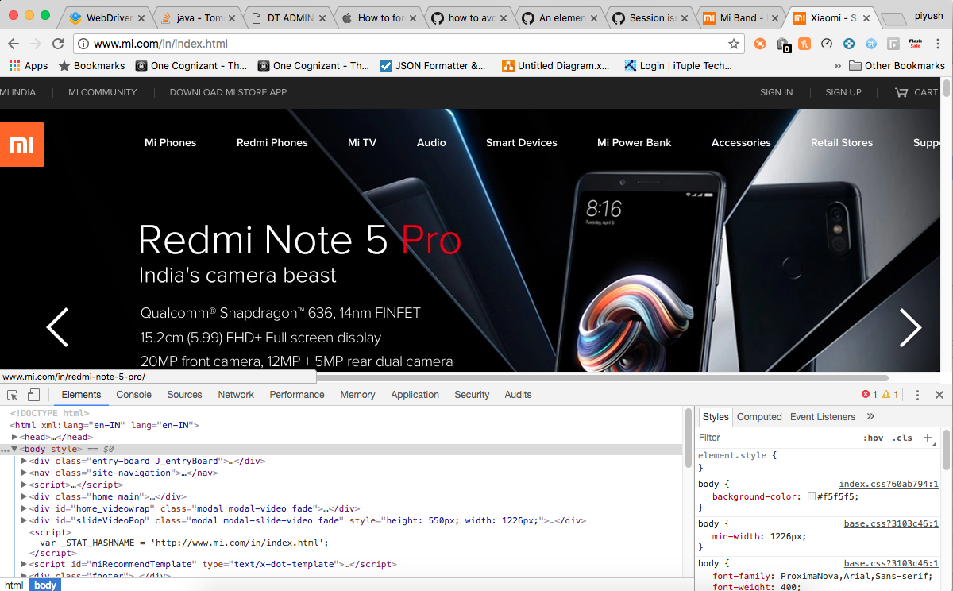

//click on Signin

driver.findElement(By.*xpath*("//*[@id=\"J_signEntries\"]/ul/li[1]")).click();

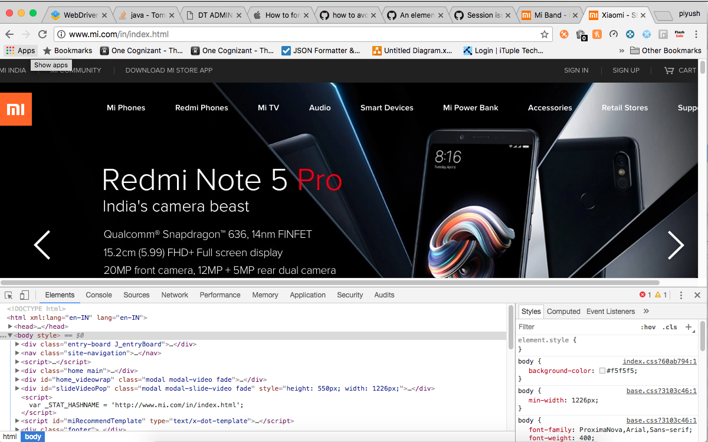

//username

Thread.*currentThread*().*sleep*(2000);

driver.findElement(By.*xpath*("//*[@id=\"username\"]")).sendKeys("9358909659");

