Create Spring boot Application

There are three ways to create SpringBoot application.

1. Using STS

2. Using Maven Project

3. Bootstrapping a Web Application with Spring Initializr

**3. Bootstrapping a Web Application with Spring Initializr**

3.1. Go to the following link:

Spring Initializr <http://start.spring.io/> is great tool to bootstrap your Spring Boot projects.

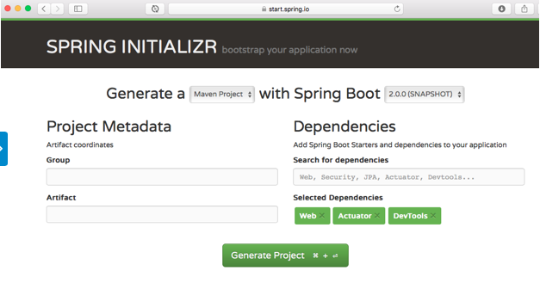

3.2. shown in the image above, we need to perform the following steps:

* Launch Spring Initializr and:
  + Choose com.in28minutes.springboot(give as per your choice) as the Group.
  + Choose student-services(give as per your choice) as the Artifact.
  + Choose from the following dependencies:
    - Web
    - Actuator
    - DevTools
* Click Generate Project.
* Import the project into Eclipse.

If you get below error:

java.lang.IllegalStateException: No Java compiler available

at org.apache.jasper.JspCompilationContext.createCompiler(JspCompilationContext.java:235) ~[tomcat-embed-jasper-8.5.6.jar:8.5.6]

at org.apache.jasper.JspCompilationContext.compile(JspCompilationContext.java:592) ~[tomcat-embed-jasper-8.5.6.jar:8.5.6]

at org.apache.jasper.servlet.JspServletWrapper.service(JspServletWrapper.java:368) ~[tomcat-embed-jasper-8.5.6.jar:8.5.6]

at org.apache.jasper.servlet.JspServlet.serviceJspFile(JspServlet.java:385) ~[tomcat-embed-jasper-8.5.6.jar:8.5.6]

at org.apache.jasper.servlet.JspServlet.service(JspServlet.java:329) ~[tomcat-embed-jasper-8.5.6.jar:8.5.6]

at javax.servlet.http.HttpServlet.service(HttpServlet.java:729) [tomcat-embed-core-8.5.6.jar:8.5.6]

at org.apache.catalina.core.ApplicationFilterChain.internalDoFilter(ApplicationFilterChain.java:230) [tomcat-embed-core-8.5.6.jar:8.5.6]

at org.apache.catalina.core.ApplicationFilterChain.doFilter(ApplicationFilterChain.java:165) [tomcat-embed-core-8.5.6.jar:8.5.6]

at org.apache.tomcat.websocket.server.WsFilter.doFilter(WsFilter.java:52) [tomcat-embed-websocket-8.5.6.jar:8.5.6]

at org.apache.catalina.core.ApplicationFilterChain.internalDoFilter(ApplicationFilterChain.java:192) [tomcat-embed-core-8.5.6.jar:8.5.6]

at org.apache.catalina.core.ApplicationFilterChain.doFilter(ApplicationFilterChain.java:165) [tomcat-embed-core-8.5.6.jar:8.5.6]

at org.springframework.web.filter.OncePerRequestFilter.doFilter(OncePerRequestFilter.java:101) [spring-web-4.3.4.RELEASE.jar:4.3.4.RELEASE]

at org.apache.catalina.core.ApplicationFilterChain.internalDoFilter(ApplicationFilterChain.java:192)

add below dependency:

<dependency>

<groupId>org.eclipse.jdt.core.compiler</groupId>

<artifactId>ecj</artifactId>

<version>4.6.1</version>

<scope>provided</scope>

</dependency>

Replace below “parent” entry from POM.xml (if you take code from <https://www.boraji.com/spring-boot-creating-web-application-using-spring-mvc>)

~~<parent>~~

~~<groupId>org.springframework.boot</groupId>~~

~~<artifactId>spring-boot-starter-parent</artifactId>~~

~~<version>1.5.4.RELEASE</version>~~

~~</parent>~~

<parent>

<groupId>org.springframework.boot</groupId>

<artifactId>spring-boot-starter-parent</artifactId>

<version>1.5.10.RELEASE</version>

<relativePath />

</parent>

Take Sample Application From:

<https://www.boraji.com/spring-boot-creating-web-application-using-spring-mvc>

Reference:

<https://dzone.com/articles/creating-a-web-application-with-spring-boot>