DS-505: PRACTICAL ASSIGNMENT SUBMISSION WORKBOOK
Big Data Handling and Management for Machine Learning Applications
B.Sc. (Data Science & Analytics) — Semester V | Academic Year: 2026-2027
Department of Computer Science & Data Science
Student Name: | ___________________________ | Roll Number: | _______________
Division / Batch: | ___________________________ | Submission Date: | ____ / ____ / 2026

PRACTICAL 01: Dataset Ingestion, Inspection & Descriptive Statistics with Pandas
[UNIT 1: Introduction to Big Data and Large Dataset Handling]
1. Problem Statement:
Write a Python program using Pandas to load a structured dataset (CSV/JSON), display its first 5 rows, last 5 rows, dimensions (shape), column names, and data types with info(). Generate comprehensive summary statistics of all numeric and categorical attributes using describe(include='all').
2. Python Implementation Code:
import pandas as pd

df = pd.read_csv("data.csv")
print("First 5 Rows:")
print(df.head())

print("Last 5 Rows:")
print(df.tail())

print("Shape:")
print(df.shape)

print("Column Names:")
print(df.columns)

print("Dataset Information:")
df.info()

print("Summary Statistics:")
print(df.describe(include='all'))
3. Execution Output Verification (Paste your terminal / Google Colab output below):
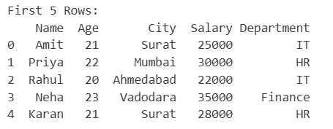
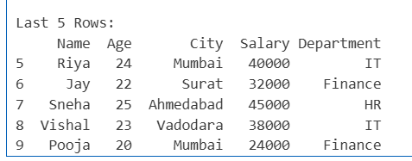
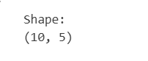
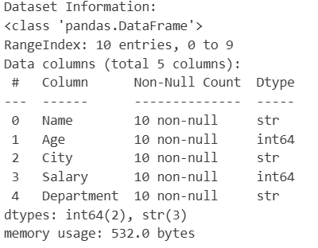
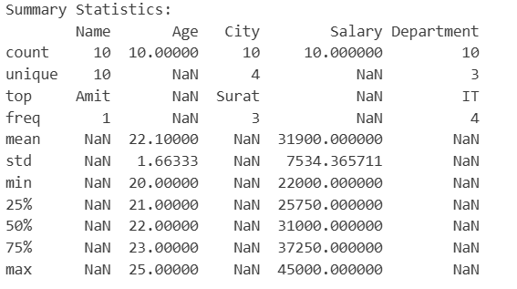

PRACTICAL 02: Data Hygiene: Missing Value Imputation, Deduplication & Renaming
[UNIT 1: Introduction to Big Data and Large Dataset Handling]
1. Problem Statement:
Write a Python program to perform data hygiene on a dataset with missing values and duplicate rows. Identify missing entries using isna().sum(), demonstrate both dropping rows (dropna()) and imputing missing numerical values with fillna(mean/median), remove duplicate records using drop_duplicates(), and rename columns using rename().
2. Python Implementation Code:
import pandas as pd
df = pd.DataFrame({
"Name": ["Piyush", "Om", "Smit", "prem", "jemish", "Rahul", "Riya", "Jay"],
"Age": [21, 22, None, 23, 21, None, 24, None],
"City": ["Surat", "Mumbai", "Ahmedabad", "Vadodara", "Surat", "Ahmedabad", "Mumbai", "Surat"],
"Salary": [25000, 30000, 22000, None, 25000, 22000, 40000, 32000]
})

print(df)
print("Missing Values:")
print(df.isna().sum())

print("\nAfter dropna():")
print(df.dropna())
df_mean = df.copy()
df_mean["Age"] = df_mean["Age"].fillna(df_mean["Age"].mean())
df_mean["Salary"] = df_mean["Salary"].fillna(df_mean["Salary"].mean())

print("After Filling Missing Values with Mean:")
print(df_mean)

df_median = df.copy()
df_median["Age"] = df_median["Age"].fillna(df_median["Age"].median())
df_median["Salary"] = df_median["Salary"].fillna(df_median["Salary"].median())

print("\nAfter Filling Missing Values with Median:")
print(df_median)
df_clean = df_mean.drop_duplicates()

print("After Removing Duplicates:")
print(df_clean)
df_clean = df_clean.rename(columns={
"Name": "Student_Name",
"Age": "Student_Age",
"City": "Student_City",
"Salary": "Monthly_Salary"
})

print("After Renaming Columns:")
print(df_clean)
print("Final Missing Values:")
print(df_clean.isna().sum())

3. Execution Output Verification (Paste your terminal / Google Colab output below):
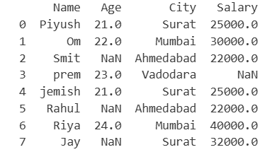
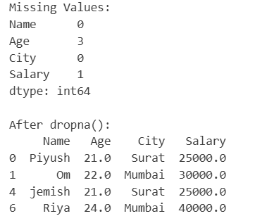
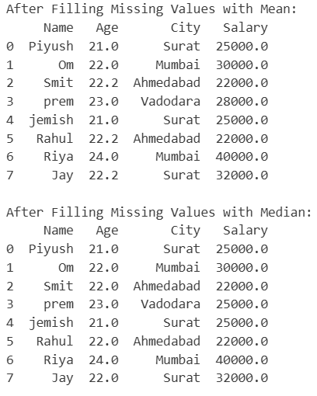
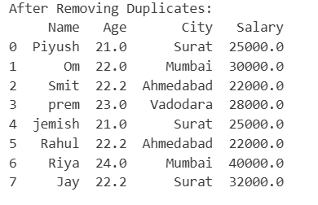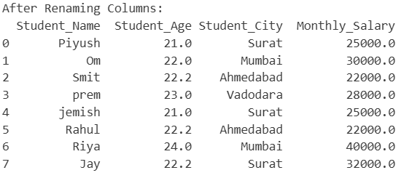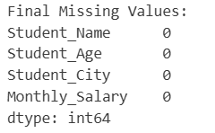

PRACTICAL 03: In-Memory Optimization via Dtype Downcasting & Deep Profiling
[UNIT 1: Introduction to Big Data and Large Dataset Handling]
1. Problem Statement:
Write a Python program to demonstrate in-memory optimization of large datasets. Profile baseline memory usage using memory_usage(deep=True), downcast integer columns (int64 -> int32/int16), downcast float columns (float64 -> float32), and convert repetitive string columns to category type. Report the total percentage reduction in RAM footprint.
2. Python Implementation Code:
import pandas as pd
import numpy as np
np.random.seed(24)
n_rows = 100_000

df = pd.DataFrame({
'User_ID': np.random.randint(1000, 9999, size=n_rows, dtype='int64'),
'Age': np.random.randint(18, 70, size=n_rows, dtype='int64'),
'Account_Balance': np.random.uniform(500.0, 50000.0, size=n_rows),
'Subscription_Type': np.random.choice(['Basic', 'Standard', 'Premium', 'VIP'], size=n_rows),
'Active_Status': np.random.choice(['Active', 'Inactive'], size=n_rows)
})

print(df.head())
print("Original Data Types:")
print(df.dtypes)
before = df.memory_usage(deep=True).sum() / 1024**2

print("Memory Usage Before Optimization:")
print(f"{before:.2f} MB")
df_c = df.copy()

df_c["User_ID"] = df_c["User_ID"].astype("int32")
df_c["Age"] = pd.to_numeric(df_c["Age"], downcast='integer')
df_c["Account_Balance"] = df_c["Account_Balance"].astype("float32")

df_c["Subscription_Type"] = df_c["Subscription_Type"].astype("category")
df_c["Active_Status"] = df_c["Active_Status"].astype("category")
print("After Optimization Data Types:")
print(df_c.dtypes)
after = df_c.memory_usage(deep=True).sum() / 1024**2
print("Memory Usage After Optimization:")
print(f"{after:.2f} MB")
reduction = before - after
percentage_reduction = (reduction / before) * 100
print("Memory Usage Reduction:")
print(f"{reduction:.2f} MB")
print(f"Percentage Reduction: {percentage_reduction:.2f}%")
3. Execution Output Verification (Paste your terminal / Google Colab output below):
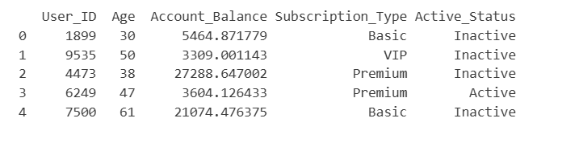
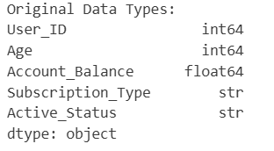
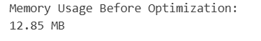
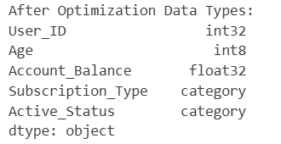
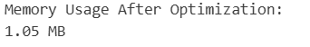
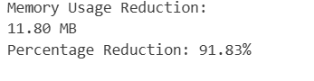

PRACTICAL 04: Out-of-Core Batch Ingestion & Aggregation via Chunking
[UNIT 1: Introduction to Big Data and Large Dataset Handling]
1. Problem Statement:
Write a Python program to ingest a large CSV file exceeding single-process RAM in batches using the chunksize parameter of pd.read_csv(). Calculate the cumulative record count, running sum of transaction amounts, and overall average transaction value across all chunks to prevent Out-Of-Memory (OOM) crashes.
2. Python Implementation Code:
import pandas as pd
import numpy as np
csv_filename = "employee.csv"
records = 100000

df_temp = pd.DataFrame({
'Employee_ID': range(1001, 1001 + records),
'Salary': np.random.uniform(15000.0, 80000.0, size=records).round(2),
'Department': np.random.choice(
['IT', 'HR', 'Finance', 'Marketing'], size=records
)
})

df_temp.to_csv(csv_filename, index=False)

print(f"Created '{csv_filename}' with {records:,} records.")
print(df_temp.head())
chunk_size = 10000
total_records = 0
running_sum = 0.0
chunk_number = 1

for chunk in pd.read_csv(csv_filename, chunksize=chunk_size):

chunk_count = len(chunk)
chunk_sum = chunk['Salary'].sum()

total_records += chunk_count
running_sum += chunk_sum

print(
f"Chunk {chunk_number}: Processed {chunk_count} rows | "
f"Chunk Sum: Rs. {chunk_sum:,.2f} | "
f"Running Total: Rs. {running_sum:,.2f}"
)

chunk_number += 1

overall_average = running_sum / total_records

print("FINAL AGGREGATION METRICS :")
print(f"Total Records Processed : {total_records:,}")
print(f"Total Cumulative Salary : Rs. {running_sum:,.2f}")
print(f"Overall Average Salary : Rs. {overall_average:,.2f}")

3. Execution Output Verification (Paste your terminal / Google Colab output below):
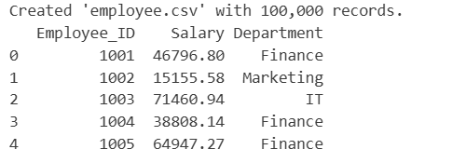
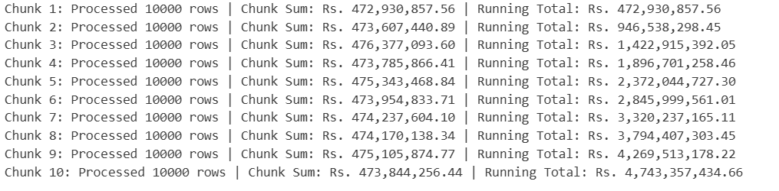
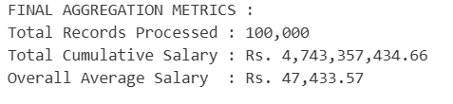

PRACTICAL 05: Apache Spark Session Initialization & DataFrame Schema Inspection
[UNIT 2: Big Data Processing using PySpark]
1. Problem Statement:
Write a Python program to install and initialize an Apache Spark session in PySpark using SparkSession.builder. Create a structured PySpark DataFrame from Python dictionaries, display its schema tree hierarchy using printSchema(), and print its rows using .show().
2. Python Implementation Code:
from pyspark.sql import SparkSession
from pyspark.sql.types import StructType, StructField, StringType, IntegerType, DoubleType
from pyspark.sql import SparkSession
from pyspark.sql.types import StructType, StructField, StringType, IntegerType

spark = SparkSession.builder \
.appName("StudentData") \
.master("local[1]") \
.getOrCreate()

data = [
(1, "Piyush", 21, "Surat"),
(2, "Om", 22, "Mumbai"),
(3, "Vansh", 20, "Ahmedabad"),
(4, "Jemish", 23, "Vadodara"),
(5, "Smit", 24, "Surat")
]

schema = StructType([
StructField("ID", IntegerType(), True),
StructField("Name", StringType(), True),
StructField("Age", IntegerType(), True),
StructField("City", StringType(), True)
])

df = spark.createDataFrame(data, schema)
df.show()

3. Execution Output Verification (Paste your terminal / Google Colab output below):
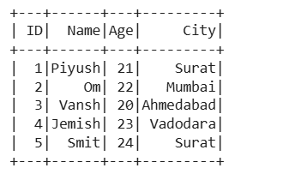
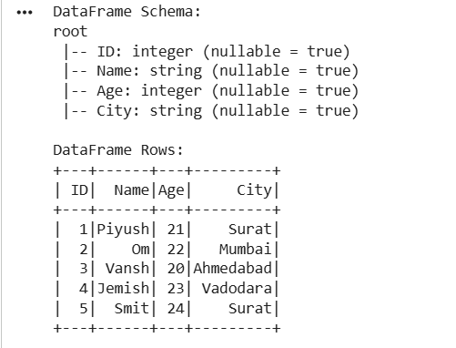

PRACTICAL 06: PySpark DataFrame Transformations: Selection, Filtering & Columns
[UNIT 2: Big Data Processing using PySpark]
1. Problem Statement:
Write a PySpark program to execute DataFrame transformations: select specific columns using .select(), filter rows using multi-condition boolean logic (e.g., Salary > 60000 and City == 'Surat') using .filter(), create a computed column using .withColumn(), and rename a column using .withColumnRenamed().
2. Python Implementation Code:
From pyspark.sql import SparkSession
from pyspark.sql.functions import col

spark = SparkSession.builder.appName("DS505_Transformations").master("local[*]").getOrCreate()

data = [
(1, "Piyush","IT", 55000, "Surat"),
(2, "Om", "HR", 75000, "Surat"),
(3, "Smit", "IT", 80000, "Mumbai"),
(4, "Prem", "Finance", 65000, "Surat"),
(5, "Jemish", "HR", 90000, "Ahmedabad")
]
columns = ["ID", "Name", "Dept", "Salary", "City"]
df = spark.createDataFrame(data, columns)

df.show()
print("Selecting 'Name' and 'Salary' columns:")
df.select("Name", "Salary").show()

print("Department-wise Salary Filter (Dept = 'HR' and Salary > 75000):")
df.filter((col("Dept") == "HR") & (col("Salary") > 75000)).show()

print("Add Computed Column (Bonus = 10% of Salary):")
df_with_bonus = df.withColumn("Bonus", col("Salary") * 0.10)
df_with_bonus.show()

print("Renaming Column 'Salary' to 'Base_Salary':")
df_renamed = df_with_bonus.withColumnRenamed("Salary", "Base_Salary")
df_renamed.show()

3. Execution Output Verification (Paste your terminal / Google Colab output below):
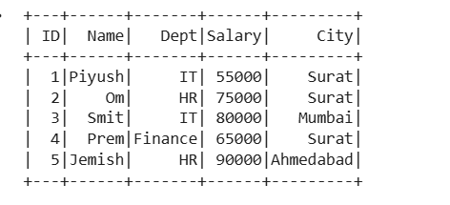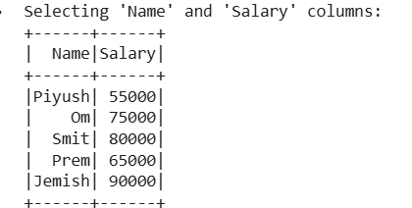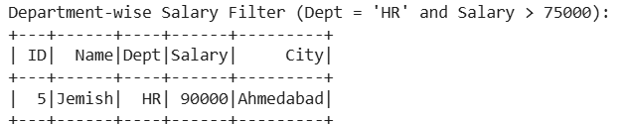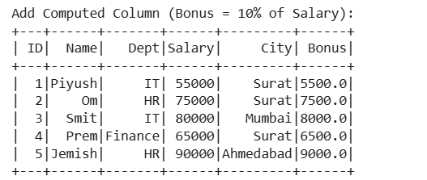
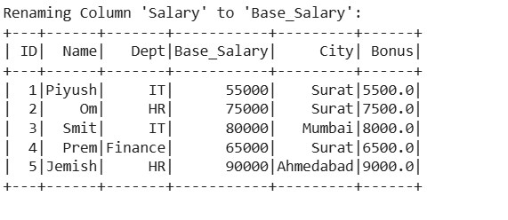

PRACTICAL 07: Grouped Aggregations & Action Execution in PySpark
[UNIT 2: Big Data Processing using PySpark]
1. Problem Statement:
Write a PySpark program to perform grouped aggregations and action executions. Group data by Department using .groupBy(), calculate aggregate metrics (count, average salary, maximum salary, total salary) using pyspark.sql.functions, sort records using .orderBy(), and execute actions (.count(), .show()).
2. Python Implementation Code:
from pyspark.sql import SparkSession
from pyspark.sql.functions import count, avg, max, sum

spark = SparkSession.builder.appName("GroupedAggregations").master("local[*]").getOrCreate()

data = [
(1, "Piyush", "IT", 50000),
(2, "Om", "HR", 40000),
(3, "Smit", "IT", 60000),
(4, "Prem", "HR", 45000),
(5, "Jemish", "Sales", 35000),
(6, "Vansh", "Sales", 55000)
]

columns = ["EmployeeID","Name" ,"Department", "Salary"]

df = spark.createDataFrame(data, columns)

df.show()
result = df.groupBy("Department").agg(
count("*").alias("Employee_Count"),
avg("Salary").alias("Average_Salary"),
max("Salary").alias("Maximum_Salary"),
sum("Salary").alias("Total_Salary")
)

result = result.orderBy("Total_Salary", ascending=False)

result.show()
print("Total Departments:", result.count())

spark.stop()
3. Execution Output Verification (Paste your terminal / Google Colab output below):
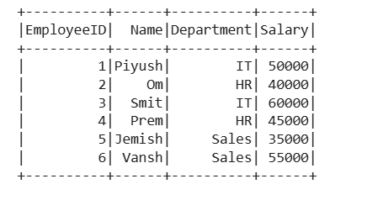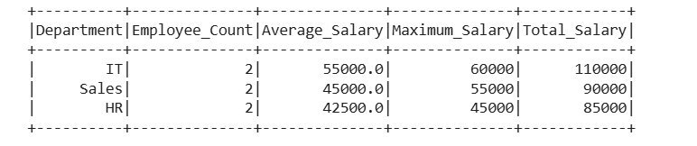

PRACTICAL 08: Columnar Storage with Apache Parquet Format in PySpark
[UNIT 2: Big Data Processing using PySpark]
1. Problem Statement:
Write a PySpark program to demonstrate high-performance columnar storage using Apache Parquet. Create a PySpark DataFrame, export it to Parquet format using .write.mode('overwrite').parquet(), reload the Parquet file using spark.read.parquet(), and verify schema preservation and row counts.
2. Python Implementation Code:
from pyspark.sql import SparkSession

spark = SparkSession.builder.appName("ParquetStorage").master("local[*]").getOrCreate()

data = [
(1, "Piyush", "IT", 50000),
(2, "Vansh", "HR", 40000),
(3, "Om", "Sales", 35000),
(4, "jemish", "IT", 60000)
]

columns = ["ID", "Name", "Department", "Salary"]

df = spark.createDataFrame(data, columns)

print("Original DataFrame:")
df.show()

print("Original Schema:")
df.printSchema()
path = "employee_data.parquet"

df.write.mode("overwrite").parquet(path)

df_parquet = spark.read.parquet(path)

print("Data Loaded from Parquet:")
df_parquet.show()

print("Loaded Schema:")
df_parquet.printSchema()
print("Original Row Count:", df.count())
print("Parquet Row Count:", df_parquet.count())

print("Schema Preserved:", df.schema == df_parquet.schema)

spark.stop()
3. Execution Output Verification (Paste your terminal / Google Colab output below):
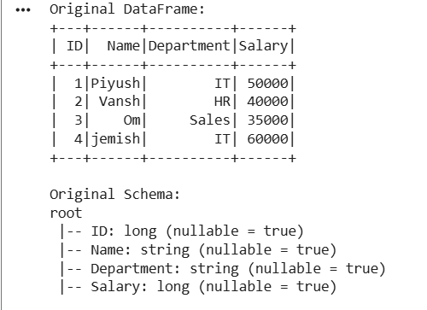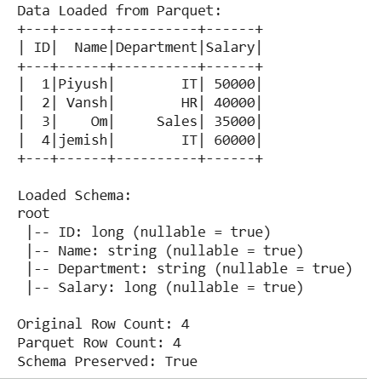

PRACTICAL 09: Missing Value Imputation with SimpleImputer & Categorical Encoding
[UNIT 3: Preparing Big Data for Machine Learning]
1. Problem Statement:
Write a Python program using Scikit-Learn to preprocess a machine learning dataset: handle missing numerical values using SimpleImputer with the mean strategy, transform categorical text labels into ordinal integers using LabelEncoder, and convert nominal variables to binary dummy indicators using One-Hot Encoding.
2. Python Implementation Code:
import pandas as pd
from sklearn.impute import SimpleImputer
from sklearn.preprocessing import LabelEncoder, OneHotEncoder

data = {
"Name": ["Piyush","Om","Smit","Prem","Vansh"],
"Age": [20, 25, None, 30, 35],
"Salary": [20000, None, 30000, 40000, 50000],
"Education": ["School", "College", "Graduate", "College", "Graduate"],
"Department": ["IT", "HR", "IT", "Sales", "HR"]
}

df = pd.DataFrame(data)

print(df)
imputer = SimpleImputer(strategy="mean")
df[["Age", "Salary"]] = imputer.fit_transform(df[["Age", "Salary"]])

le = LabelEncoder()
df["Education"] = le.fit_transform(df["Education"])

encoder = OneHotEncoder(sparse_output=False, handle_unknown="ignore")
encoded = encoder.fit_transform(df[["Department"]])

encoded_df = pd.DataFrame(
encoded,
columns=encoder.get_feature_names_out(["Department"]),
index=df.index
)

df = pd.concat([df.drop("Department", axis=1), encoded_df], axis=1)
print("Preprocessed Dataset:")
print(df)

3. Execution Output Verification (Paste your terminal / Google Colab output below):
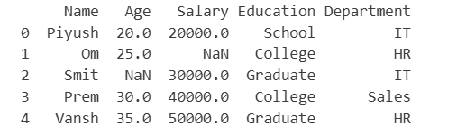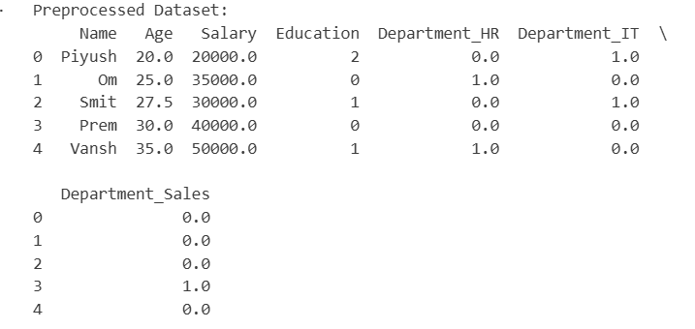

PRACTICAL 10: Feature Scaling (StandardScaler vs MinMaxScaler) & Train-Test Split
[UNIT 3: Preparing Big Data for Machine Learning]
1. Problem Statement:
Write a Python program to perform feature scaling and dataset partitioning. Apply StandardScaler (Z-score normalization) and MinMaxScaler to numerical features, compare their transformed distributions, and split the dataset into training (80%) and testing (20%) sets using train_test_split(..., test_size=0.2, random_state=42).
2. Python Implementation Code:
import pandas as pd
from sklearn.preprocessing import StandardScaler, MinMaxScaler
from sklearn.model_selection import train_test_split

data = {
"Age": [20, 25, 30, 35, 40, 45, 50, 55, 60, 65],
"Salary": [20000, 25000, 30000, 35000, 40000, 45000, 50000, 55000, 60000, 65000],
"Experience": [1, 2, 3, 4, 5, 6, 7, 8, 9, 10]
}

df = pd.DataFrame(data)

print(df)
standard_scaler = StandardScaler()
standard_data = standard_scaler.fit_transform(df)

standard_df = pd.DataFrame(standard_data, columns=df.columns)

print("StandardScaler :")
print(standard_df)

minmax_scaler = MinMaxScaler()
minmax_data = minmax_scaler.fit_transform(df)

minmax_df = pd.DataFrame(minmax_data, columns=df.columns)

print("MinMaxScaler:")
print(minmax_df)

print("StandardScaler Mean:")
print(standard_df.mean().round(2))

print("MinMaxScaler Minimum:")
print(minmax_df.min())

print("MinMaxScaler Maximum:")
print(minmax_df.max())
x = df
y = [0, 0, 0, 0, 0, 1, 1, 1, 1, 1]

x_train, x_test, y_train, y_test = train_test_split(
x, y, test_size=0.2, random_state=42
)

print("Training Data:")
print(x_train)

print("Testing Data:")
print(x_test)

print("Training Size:", len(x_train))
print("Testing Size:", len(x_test))

3. Execution Output Verification (Paste your terminal / Google Colab output below):
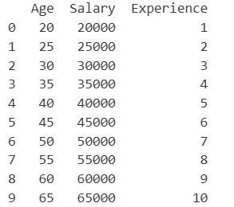
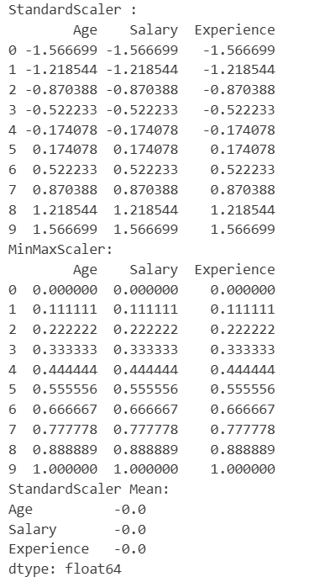
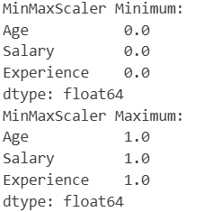
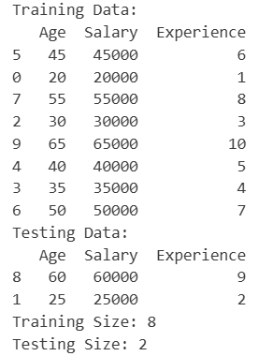

PRACTICAL 11: Continuous Predictive Modeling with Linear Regression
[UNIT 3: Preparing Big Data for Machine Learning]
1. Problem Statement:
Write a Python program to build, train, and evaluate a Linear Regression model using Scikit-Learn. Fit the model to predict salary based on years of experience, display model coefficients (slope and intercept), predict outcomes on the test dataset, and calculate Mean Squared Error (MSE) and R-squared (R2) score.
2. Python Implementation Code:
from sklearn.model_selection import train_test_split
from sklearn.linear_model import LinearRegression
from sklearn.metrics import mean_squared_error, r2_score

x = [[1], [2], [3], [4], [5], [6], [7], [8], [9], [10]]
y = [15000, 20000, 25000, 30000, 35000, 40000, 45000, 50000, 55000, 60000]

x_train, x_test, y_train, y_test = train_test_split(
x, y, test_size=0.2, random_state=42
)

model = LinearRegression()

model.fit(x_train, y_train)

print("Slope:", model.coef_[0])
print("Intercept:", model.intercept_)
y_pred = model.predict(x_test)

print("Actual Salary:", y_test)
print("Predicted Salary:", y_pred)

print("Mean Squared Error:", mean_squared_error(y_test, y_pred))
print("R2 Score:", r2_score(y_test, y_pred))
3. Execution Output Verification (Paste your terminal / Google Colab output below):
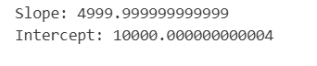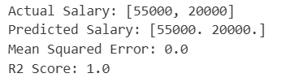

PRACTICAL 12: Classification with Decision Trees & K-Nearest Neighbors (KNN)
[UNIT 3: Preparing Big Data for Machine Learning]
1. Problem Statement:
Write a Python program to build and compare two classification models: DecisionTreeClassifier and KNeighborsClassifier (KNN) using Scikit-Learn. Train both models on a classification dataset, evaluate test predictions, and compare their performance using Confusion Matrix and Accuracy Score.
2. Python Implementation Code:
from sklearn.model_selection import train_test_split
from sklearn.tree import DecisionTreeClassifier
from sklearn.neighbors import KNeighborsClassifier
from sklearn.metrics import confusion_matrix, accuracy_score
from sklearn.datasets import load_iris

data = load_iris()

x = data.data
y = data.target

x_train, x_test, y_train, y_test = train_test_split(
x, y, test_size=0.2, random_state=42
)

model = DecisionTreeClassifier(random_state=42)
model.fit(x_train, y_train)
y_pred = model.predict(x_test)

print("Decision Tree Classifier")
print("Confusion Matrix:")
print(confusion_matrix(y_test, y_pred))
print("Accuracy Score:", accuracy_score(y_test, y_pred))
model1 = KNeighborsClassifier(n_neighbors=3)
model1.fit(x_train, y_train)
y_pred1 = model1.predict(x_test)

print("K-Nearest Neighbors Classifier")
print("Confusion Matrix:")
print(confusion_matrix(y_test, y_pred1))
print("Accuracy Score:", accuracy_score(y_test, y_pred1))
print("Model Comparison")
print("Decision Tree Accuracy:", accuracy_score(y_test, y_pred))
print("KNN Accuracy:", accuracy_score(y_test, y_pred1))
3. Execution Output Verification (Paste your terminal / Google Colab output below):
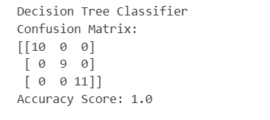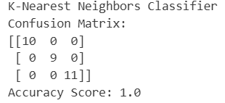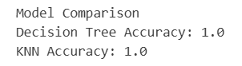

PRACTICAL 13: Text Data Cleaning & Custom Tokenization using Python
[UNIT 4: Introduction to Large Language Models and Big Data Applications]
1. Problem Statement:
Write a Python program to clean raw, noisy text data: convert characters to lowercase using lower(), remove special punctuation symbols using replace(), eliminate redundant whitespace using strip(), and tokenize sentences into individual word tokens using split().
2. Python Implementation Code:
text = " HELLO, World!! This is @ Python # Programming. "
text_replace = text.lower()
print("Lowercase Text:", text_replace)

for char in [",", "!", "@", "#", "."]:
text_replace = text_replace.replace(char, "")
print("Text after removing special characters:", text_replace)
text_s = text_replace.strip()

print("Text after removing leading and trailing spaces:", text_s)
text_j = " ".join(text_s.split())

print("Cleaned Text:", text_j)
tokens = text_j.split()

print("Cleaned Text:", text_j)
print("Word Tokens:", tokens)
3. Execution Output Verification (Paste your terminal / Google Colab output below):

PRACTICAL 14: Vocabulary Frequency Profiling & Stopword Filtering
[UNIT 4: Introduction to Large Language Models and Big Data Applications]
1. Problem Statement:
Write a Python program to profile vocabulary in a text corpus: clean sentences, filter out common English stopwords (e.g., 'the', 'is', 'in', 'and'), calculate word occurrence frequencies using collections.Counter, and display the top 5 most frequent keywords.
2. Python Implementation Code:
from collections import Counter

text = """
Python is a popular programming language.
Python is used in data science and machine learning.
Data science is useful and Python is easy to learn.
Machine learning is a part of data science.
"""

text = text.lower()
for char in [".", ",", "!", "?", ";", ":"]:
text = text.replace(char, "")
text = " ".join(text.split())
print("Cleaned Text:", text)
words = text.split()
print("Word Tokens:", words)
stopwords = ["the", "is", "in", "and", "a", "to", "of", "on", "for"]

filtered_words = [word for word in words if word not in stopwords]

word_freq = Counter(filtered_words)

print("Cleaned Words:", filtered_words)
print("Top 5 Most Frequent Keywords:")

for word, frequency in word_freq.most_common(5):
print(word, ":", frequency)
3. Execution Output Verification (Paste your terminal / Google Colab output below):
Cleaned Text: python is a popular programming language python is used in data science and machine learning data science is useful and python is easy to learn machine learning is a part of data science
Word Tokens: ['python', 'is', 'a', 'popular', 'programming', 'language', 'python', 'is', 'used', 'in', 'data', 'science', 'and', 'machine', 'learning', 'data', 'science', 'is', 'useful', 'and', 'python', 'is', 'easy', 'to', 'learn', 'machine', 'learning', 'is', 'a', 'part', 'of', 'data', 'science']
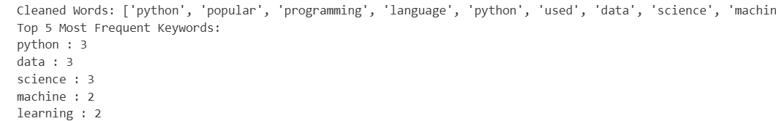

PRACTICAL 15: Pretrained Sentiment Analysis with Hugging Face Transformers
[UNIT 4: Introduction to Large Language Models and Big Data Applications]
1. Problem Statement:
Write a Python program to perform Sentiment Analysis using the Hugging Face Transformers library. Initialize a pretrained sentiment-analysis pipeline (pipeline('sentiment-analysis')), classify multiple user review statements into POSITIVE or NEGATIVE sentiment labels, and display the confidence prediction scores.
2. Python Implementation Code:
from transformers import pipeline

classifier = pipeline("sentiment-analysis")

reviews = [
"This product is excellent and amazing.",
"I am very disappointed with this product.",
"The quality is good and I love it.",
"The service was terrible and slow.",
"The product is okay."
]

results = classifier(reviews)

for review, result in zip(reviews, results):
print("Review:", review)
print("Sentiment:", result["label"])
print("Confidence Score:", round(result["score"], 4))
print()
3. Execution Output Verification (Paste your terminal / Google Colab output below):
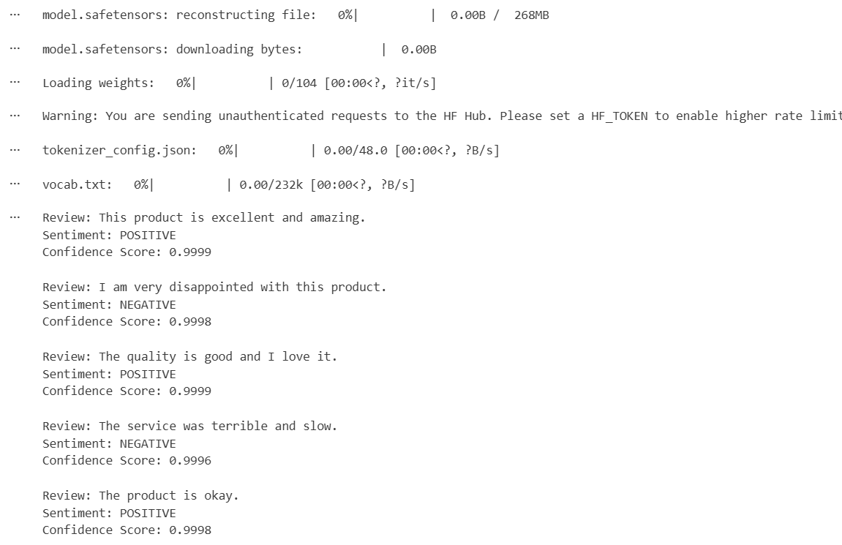

PRACTICAL 16: Automated Text Summarization using Pretrained LLM Pipeline
[UNIT 4: Introduction to Large Language Models and Big Data Applications]
1. Problem Statement:
Write a Python program to perform automated text summarization using a Hugging Face pretrained transformer model. Initialize the pipeline('summarization'), pass a multi-sentence news or technical article, specify max_length and min_length parameters, and generate a concise abstractive summary.
2. Python Implementation Code:
from transformers import pipeline

summarizer = pipeline(
"summarization",
model="sshleifer/distilbart-cnn-12-6",
framework="pt"
)

article = """
Artificial Intelligence is transforming many industries, including healthcare,
education, finance, and transportation. Machine learning enables computers to
learn from data and make predictions. Deep learning uses neural networks to
solve complex problems such as image recognition and natural language processing.
Companies use AI to automate repetitive tasks, improve decision-making, and
increase productivity. However, AI also raises concerns about data privacy,
security, and job displacement. Researchers are working to develop responsible
and reliable AI systems for the future.
"""

summary = summarizer(
article,
max_length=60,
min_length=20,
do_sample=False
)

print("Original Article:")
print(article)

print("\nGenerated Summary:")
print(summary[0]["summary_text"])
3. Execution Output Verification (Paste your terminal / Google Colab output below):
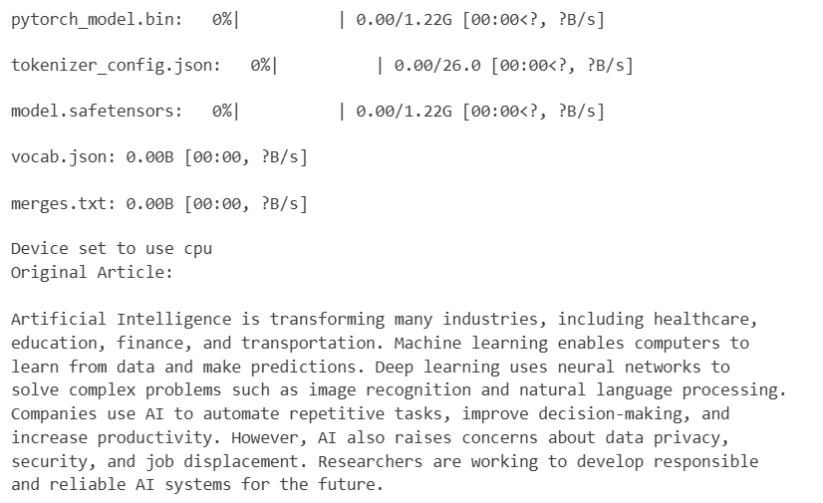 Generated Summary:
Machine learning enables computers to learn from data and make predictions . Deep learning uses neural networks to solve complex problems such as image recognition and natural language processing

