Streams Assignment Day 4

Solution :
Step 1: create db
Step 2: Create Raw Sales Staging Table

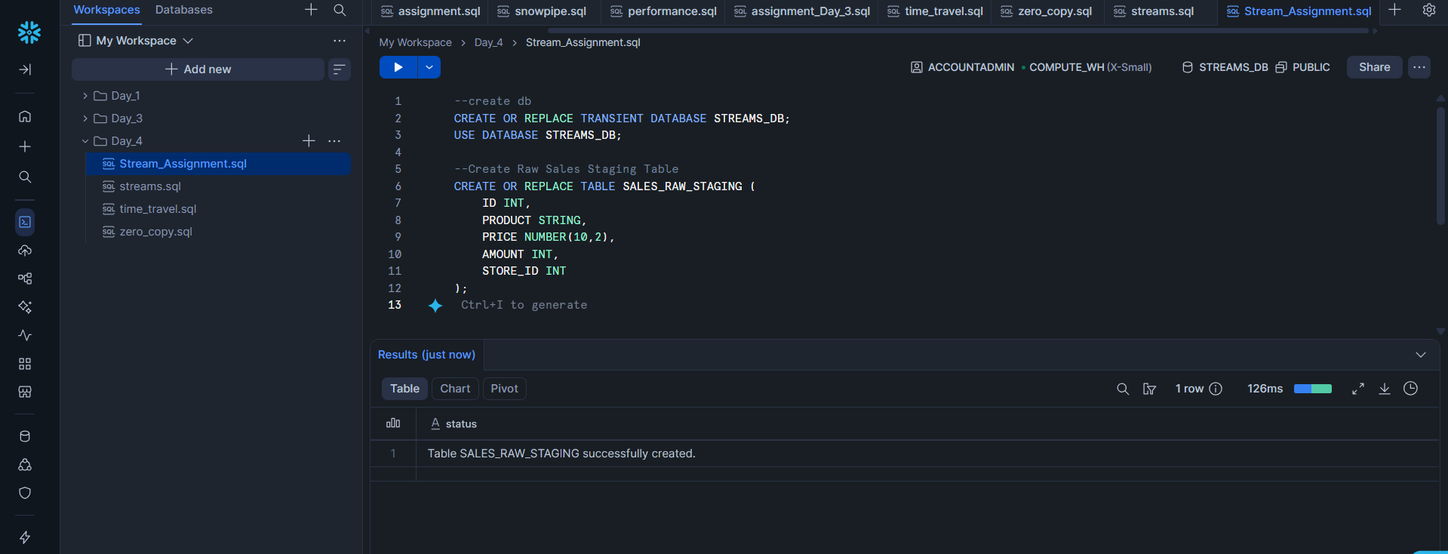
Step 3: Insert Initial Sales Data
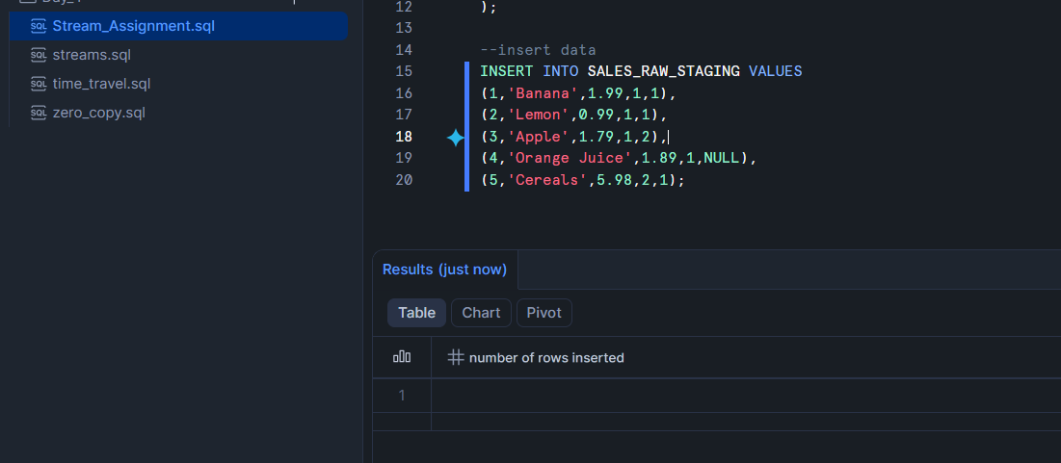
Step 4: Create Store Table
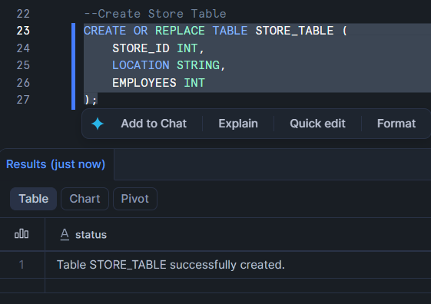
Step 5: Insert Store Data
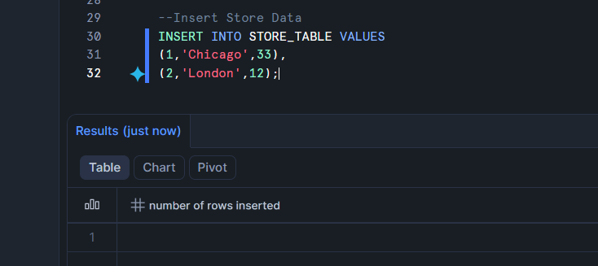
Step 6: Create Final Sales Table
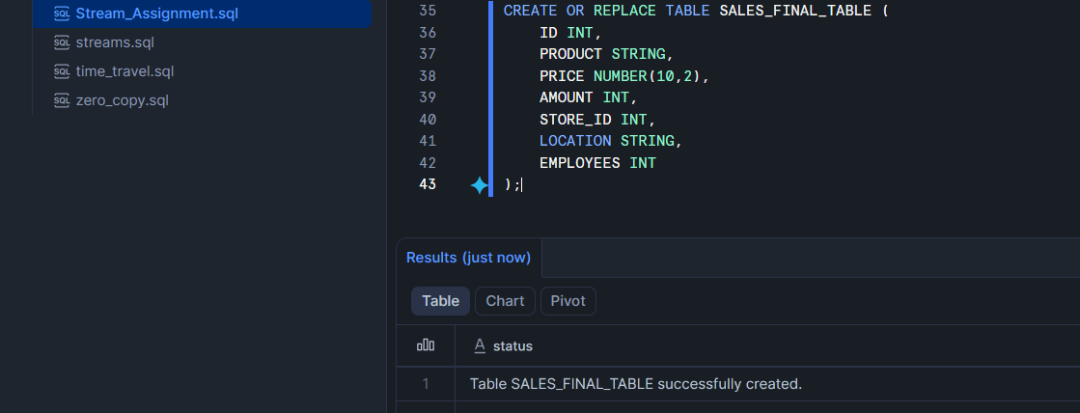
Step 7: Perform Initial Full Load
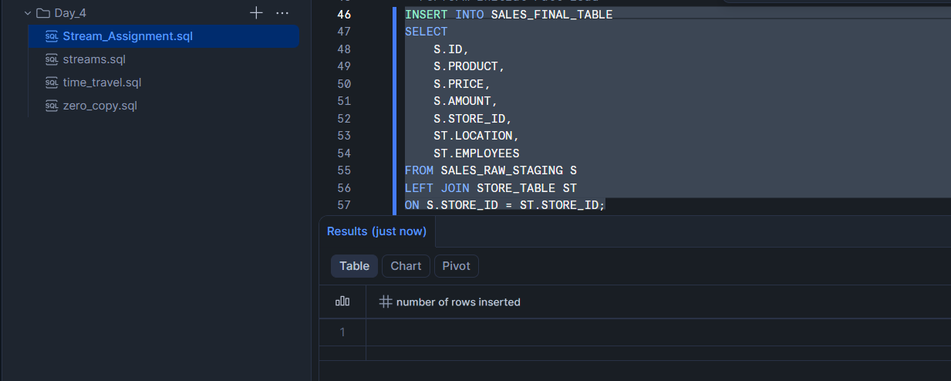

Step 8: Verify Initial Load
Sales raw table data
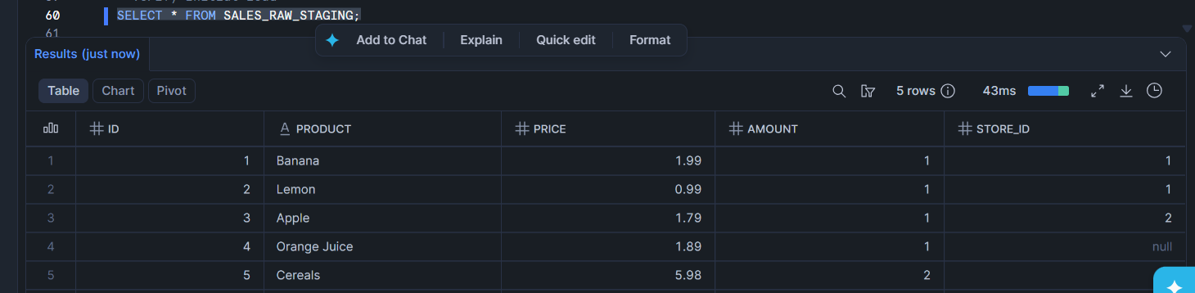
store table
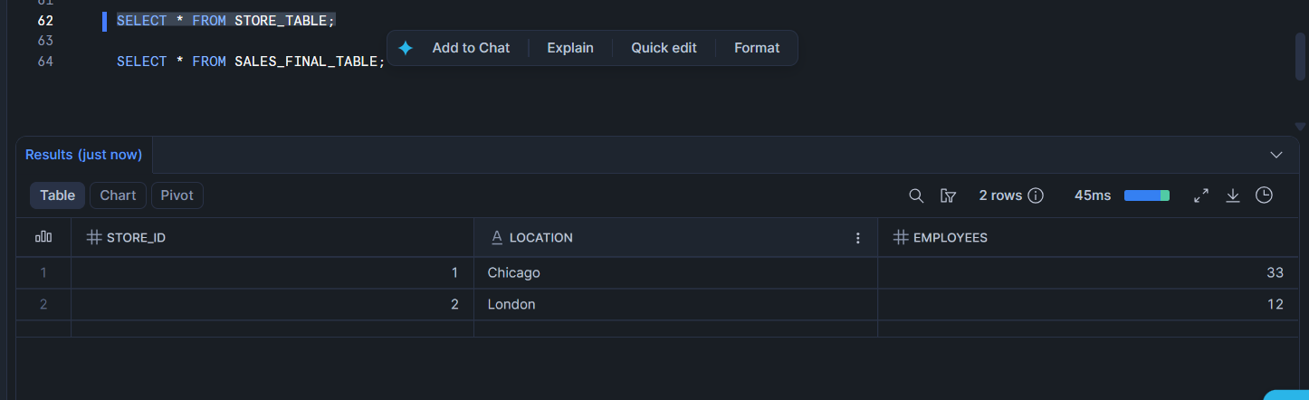
Sales final table: this contain 5 records
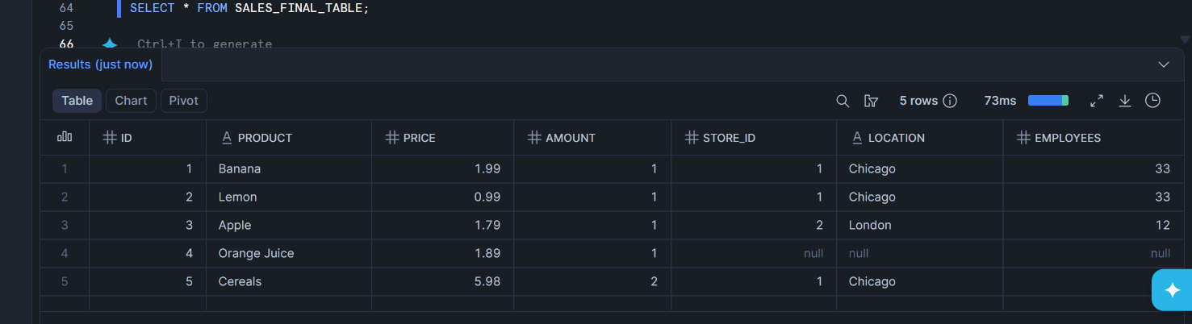
Step 9: Create Stream Object
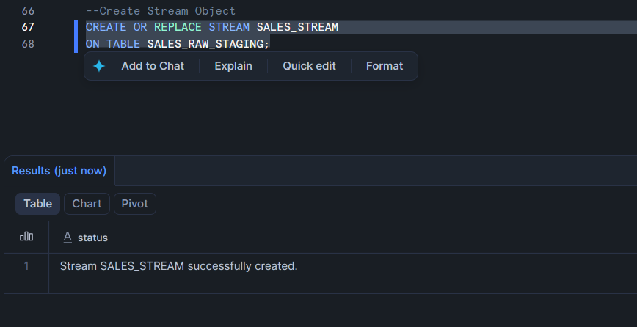
Step 10: View Stream Information
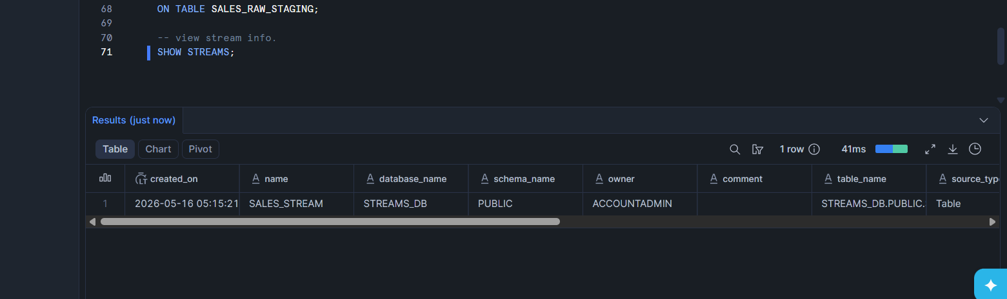
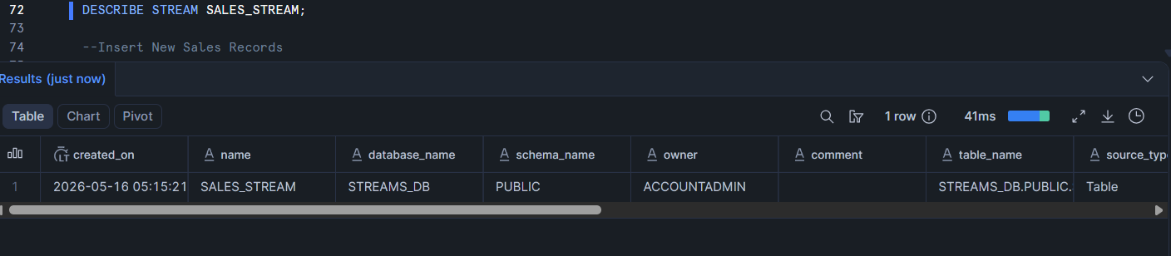
Q. Why is SALES_STREAM empty immediately after creation?
Ans-> Because the stream starts tracking changes only AFTER it is created.
It does not capture old existing records.

Step 11: Insert New Sales Records
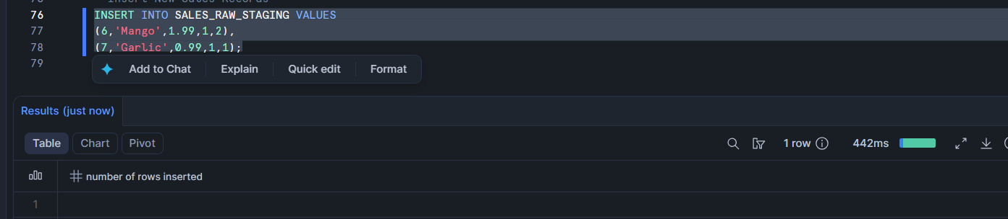
Step 12: Check Stream Data
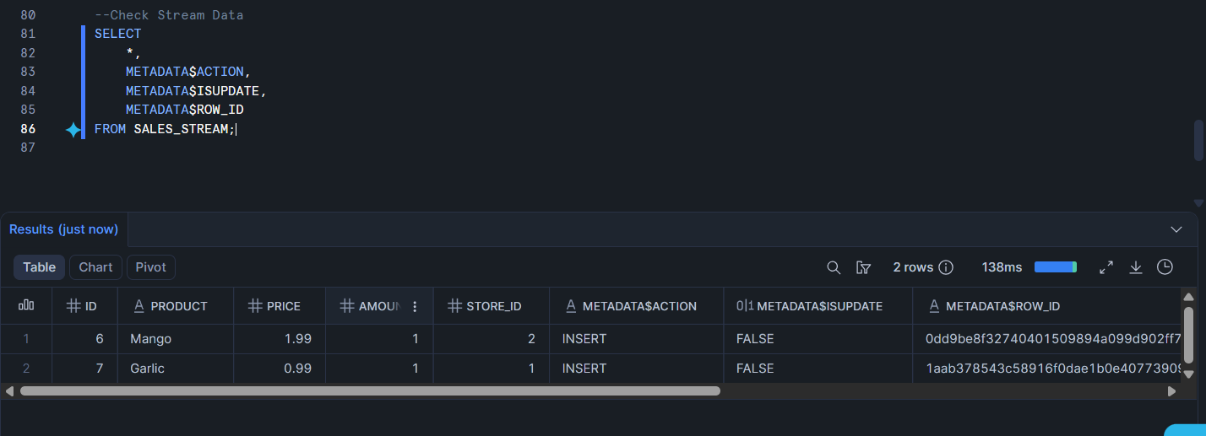
Q. What value do you see in METADATA$ACTION for newly inserted records?
Ans-> INSERT

Step 13: Verify Source and Target Tables
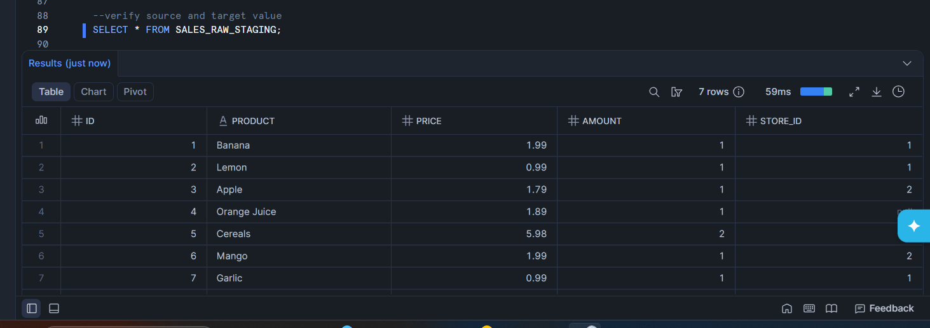

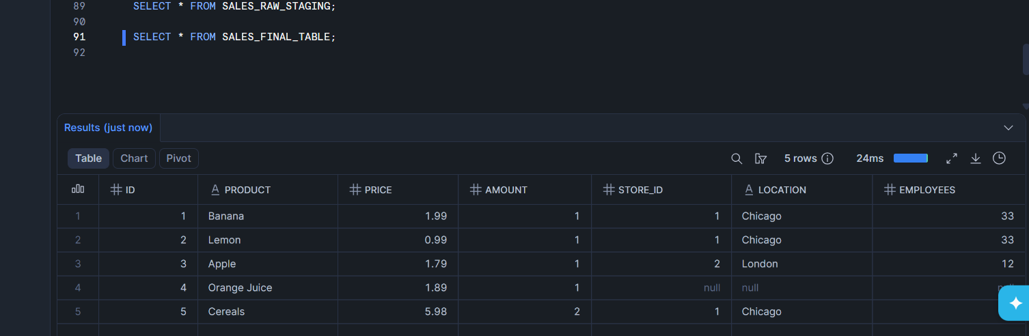
Q. Are the new records available in SALES_FINAL_TABLE before consuming the stream?
Ans-> No , Because stream data has not yet been consumed.

Step 14: Consume Stream Data
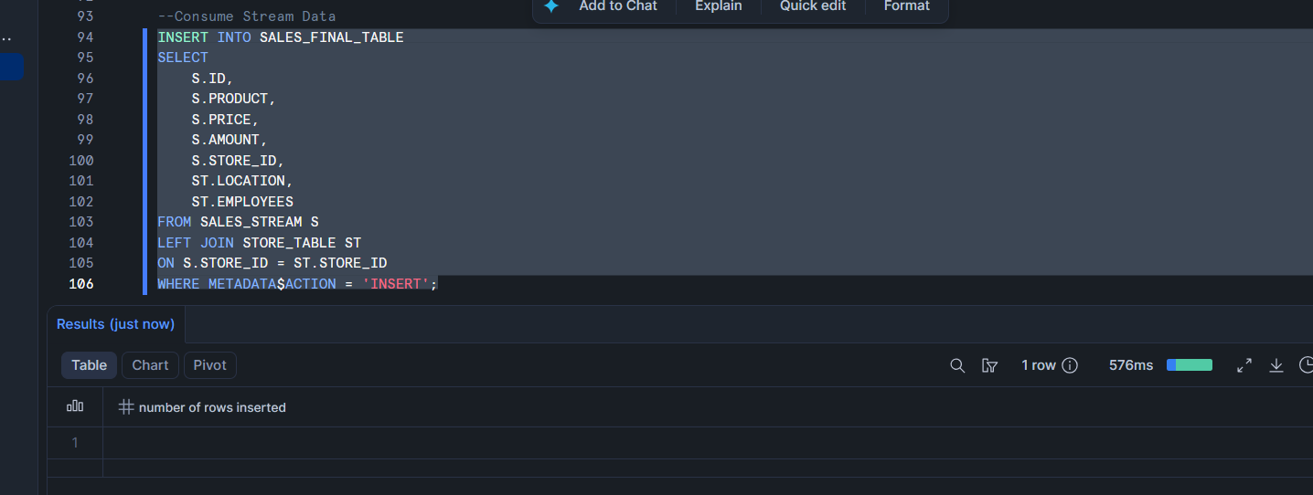
Step 15: Verify Stream After Consumption
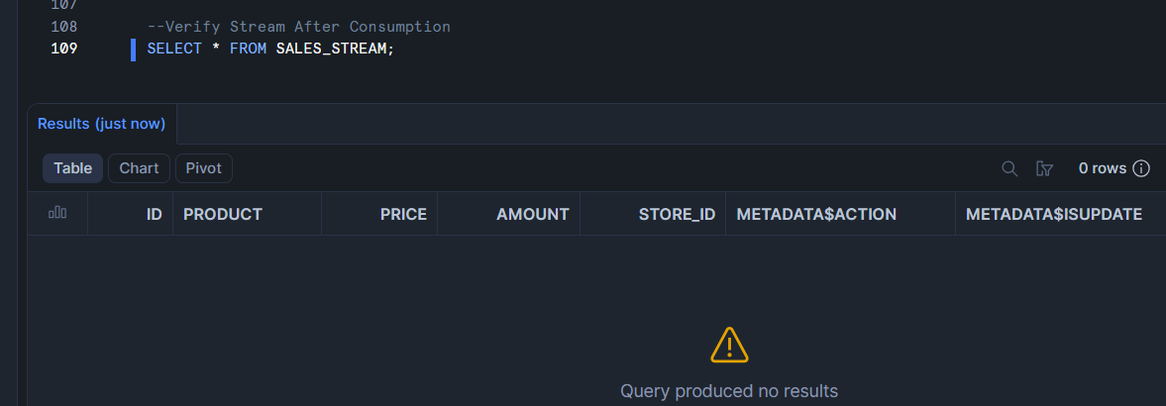
Q. Why did the stream become empty after inserting data into SALES_FINAL_TABLE?
A.-> Because Snowflake marks stream records as consumed after successful DML operations
The stream offset moves forward

Step 16: Insert More Sales Records
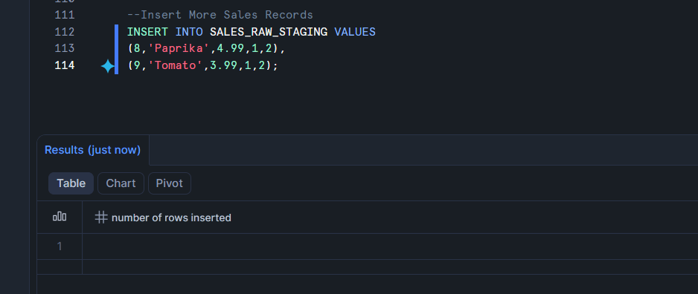
Step 17: Consume Second Stream Data
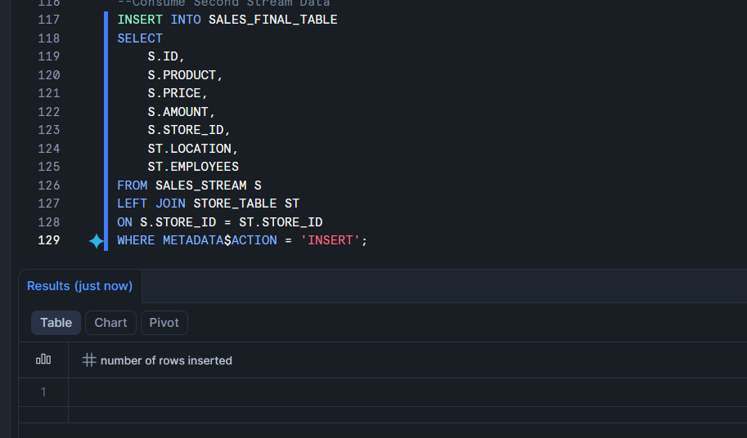

Step 18: Verify Final Insert Output
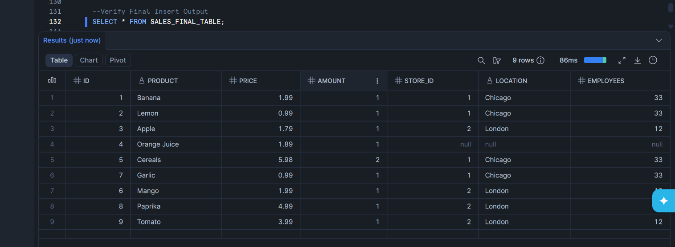
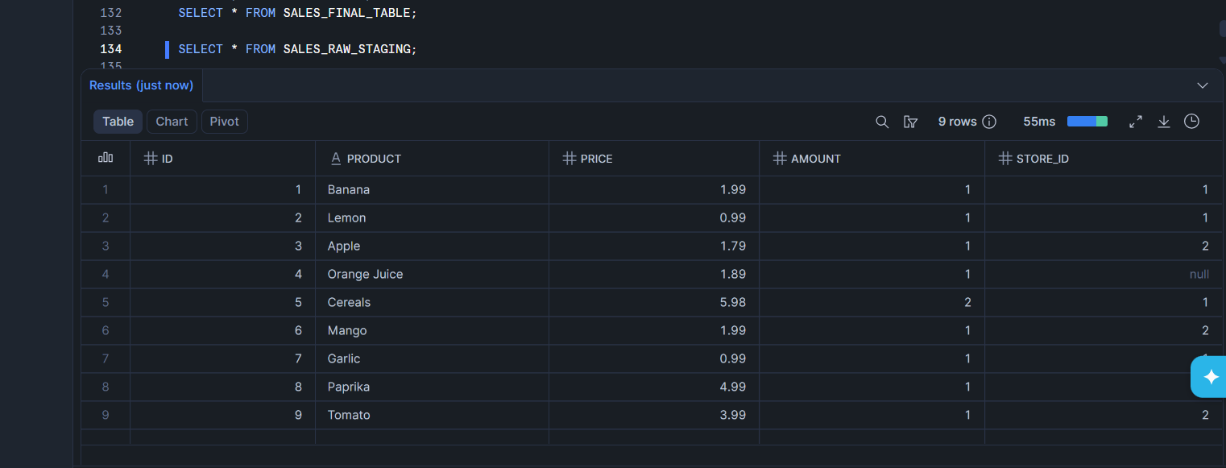
Q. How many records are now available in SALES_FINAL_TABLE?
A.-> 9 records
Step 19: Check Existing Data Before Update
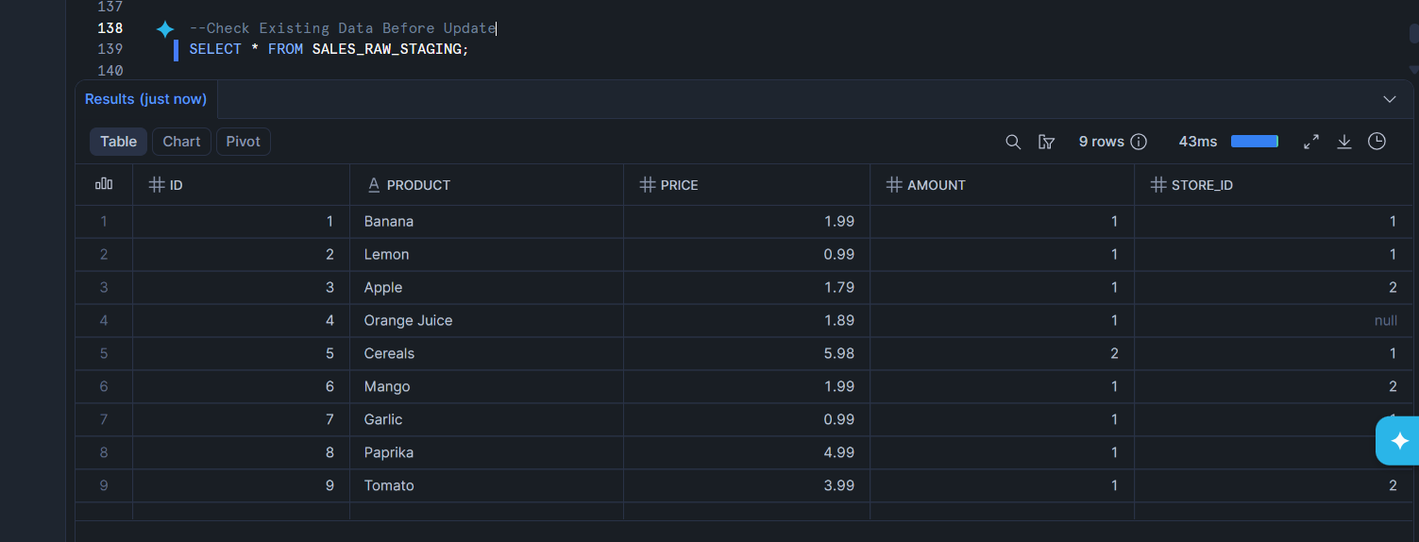
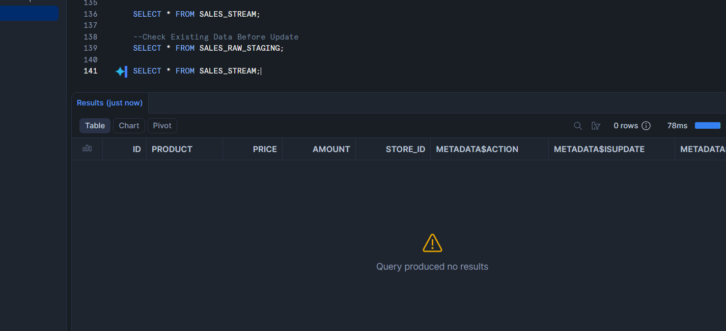
Step 20: Perform First Update
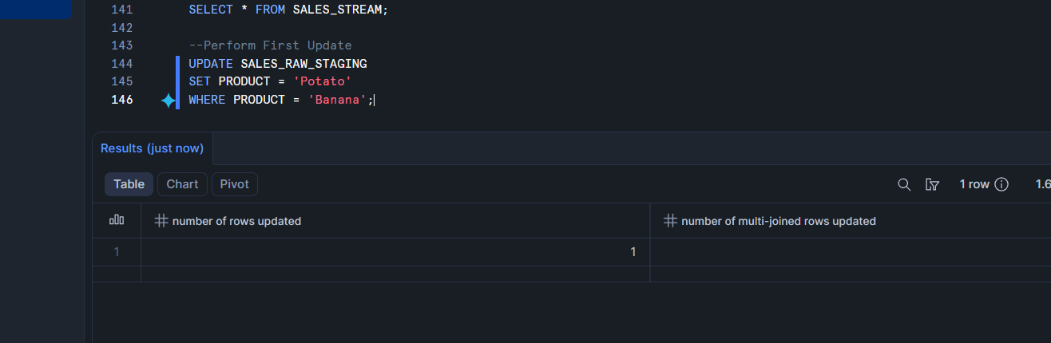
Step 21: Check Stream After Update
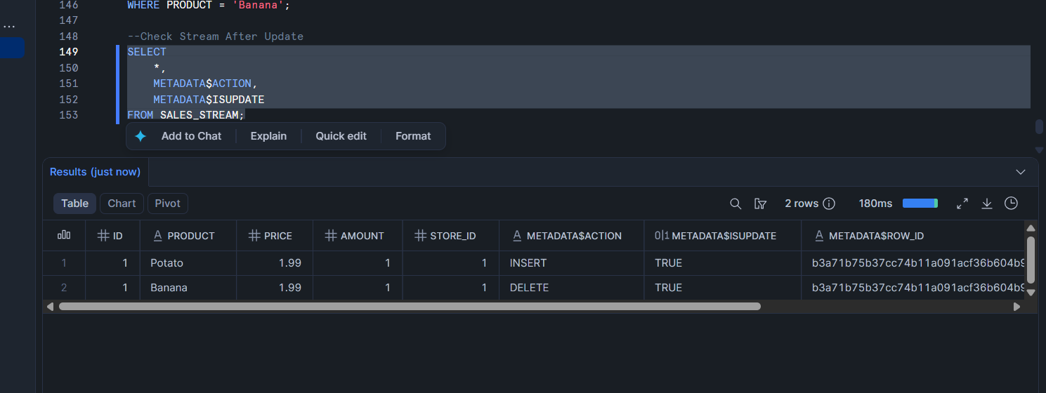
Q. How does Snowflake represent an UPDATE operation inside a stream?
A. -> Snowflake represents UPDATE as:
DELETE + INSERT
Step 22: Consume Update Using MERGE
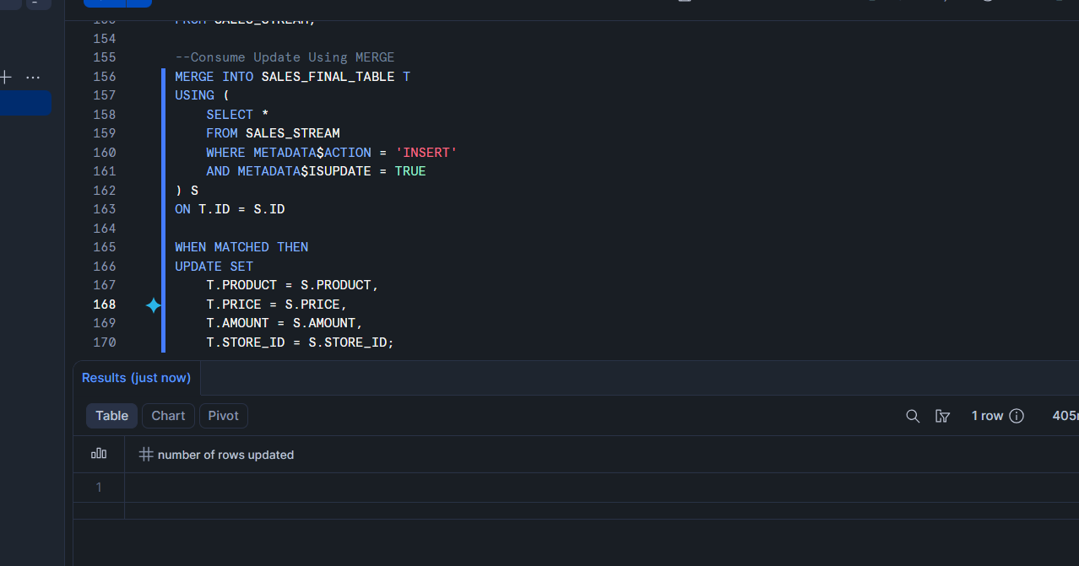
Step 23: Verify First Update
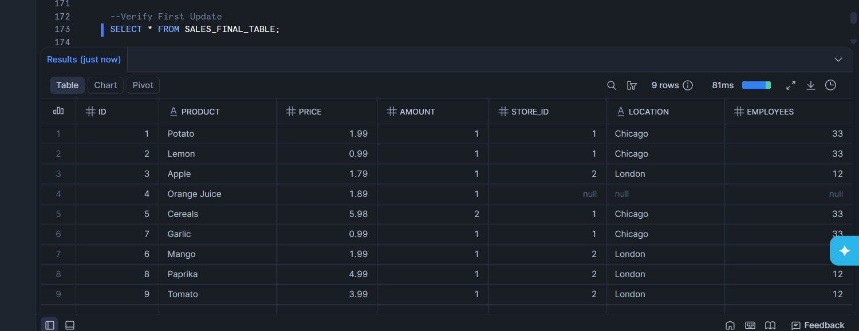
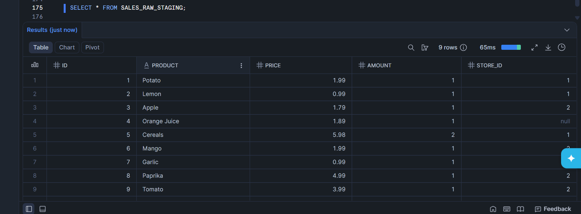

Q. Is Banana changed to Potato in SALES_FINAL_TABLE?
Ans-> Yes

Step 24: Perform Second Update
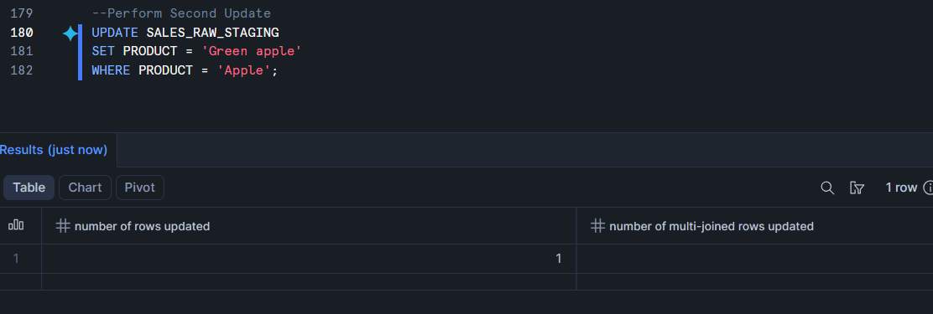
Step 25: Consume Second Update Using MERGE
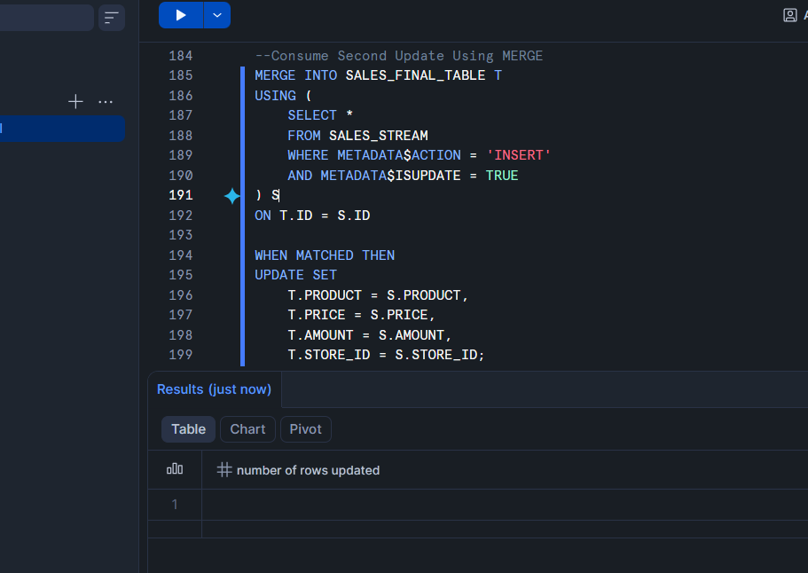
Step 26: Verify Final Output
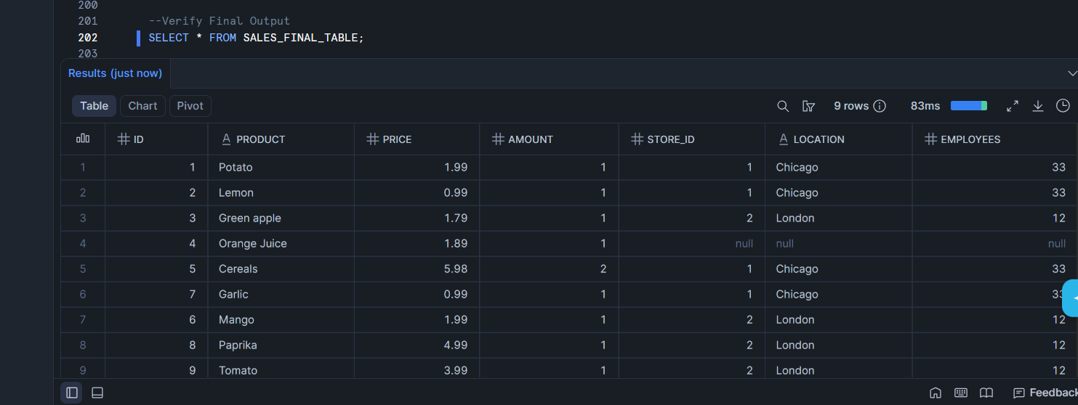
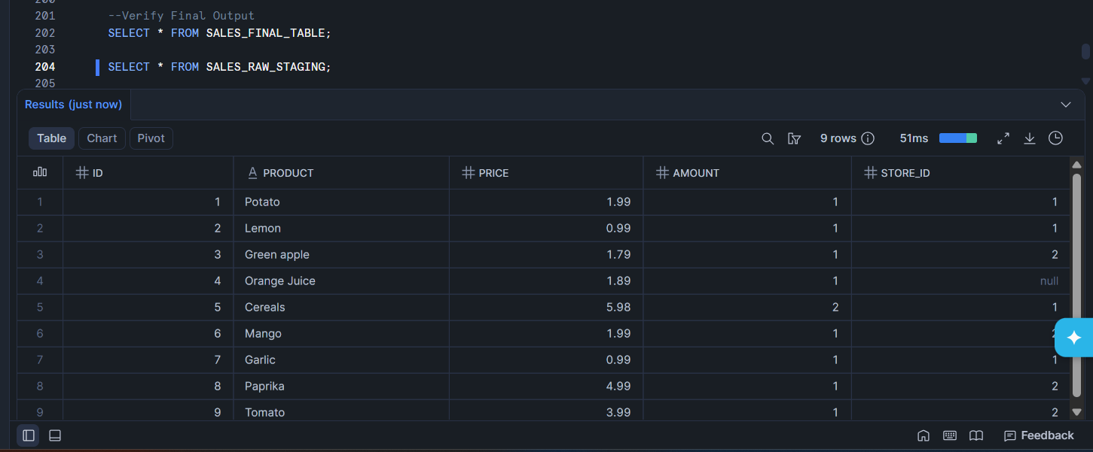
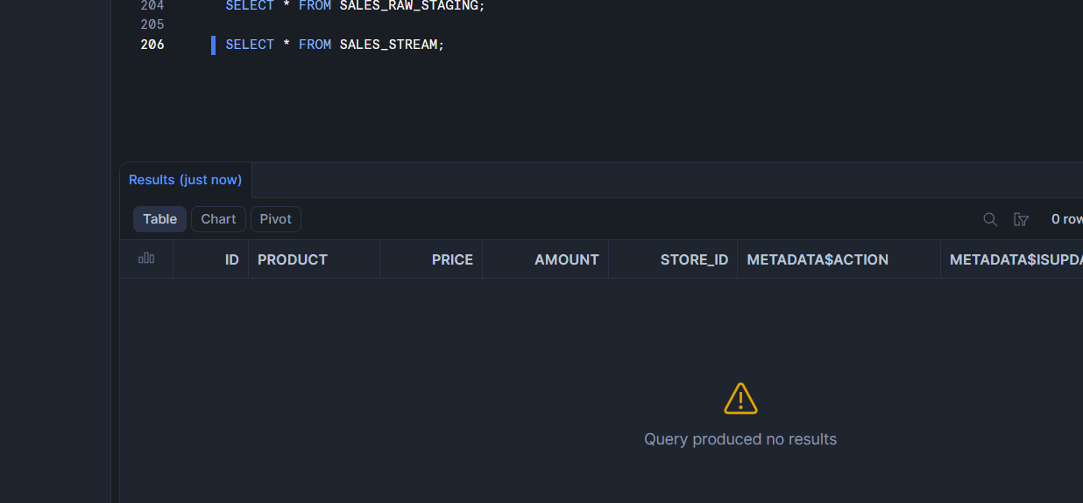
Q. Is Apple changed to Green apple in SALES_FINAL_TABLE?
Ans-> Yes, as u see in the image


