Retail Marketing Campaign Analytics
A retail company wants to analyze customer buying behavior and marketing campaign performance using Snowflake sample data.
The company has three teams:
1. Marketing Analysts
2. Finance Team
3. ETL Developers
Each team should use a separate warehouse. The company also wants to improve query performance using:
1. Warehouse scaling
2. Query result cache
3. Cluster key on customer sales date
Use Snowflake sample data from:
SNOWFLAKE_SAMPLE_DATA.TPCDS_SF10TCL.STORE_SALES
SNOWFLAKE_SAMPLE_DATA.TPCDS_SF10TCL.CUSTOMER
SNOWFLAKE_SAMPLE_DATA.TPCDS_SF10TCL.DATE_DIM
SNOWFLAKE_SAMPLE_DATA.TPCDS_SF10TCL.ITEM
________________________________________
Questions
Part 1: Warehouse Setup
Create three warehouses:
1. MARKETING_WH for marketing analysts
2. FINANCE_WH for finance team
3. ETL_WH for ETL developers
Use different warehouse sizes based on workload.
________________________________________
Part 2: Role Setup
Create three roles:
1. MARKETING_ANALYST
2. FINANCE_USER
3. ETL_DEVELOPER
Grant each role access only to its assigned warehouse.
________________________________________
Part 3: User Setup
Create users:
1. MKT_USER1
2. FIN_USER1
3. ETL_USER1
Set default role and default warehouse for each user.
________________________________________
Part 4: Create Performance Demo Database
Create a database called:
RETAIL_MARKETING_DB
Create a table called:
CAMPAIGN_SALES
using Snowflake sample tables.
________________________________________
Part 5: Grant Permissions
Grant proper database, schema, and table permissions to each role.
Marketing and Finance can only read data.
ETL Developer can create and modify tables.
________________________________________
Part 6: Performance Testing
Run a sales analysis query using XSMALL warehouse.
Then scale up the warehouse to SMALL.
Compare performance.
Then scale it down again.
________________________________________
Part 7: Cache Testing
Run the same query twice.
Observe why the second query is faster.
________________________________________
Part 8: Cluster Key Testing
Run a date-filter query before clustering.
Add cluster key on SALE_DATE.
Run the same query again.
Compare performance.

Step1: create ware house
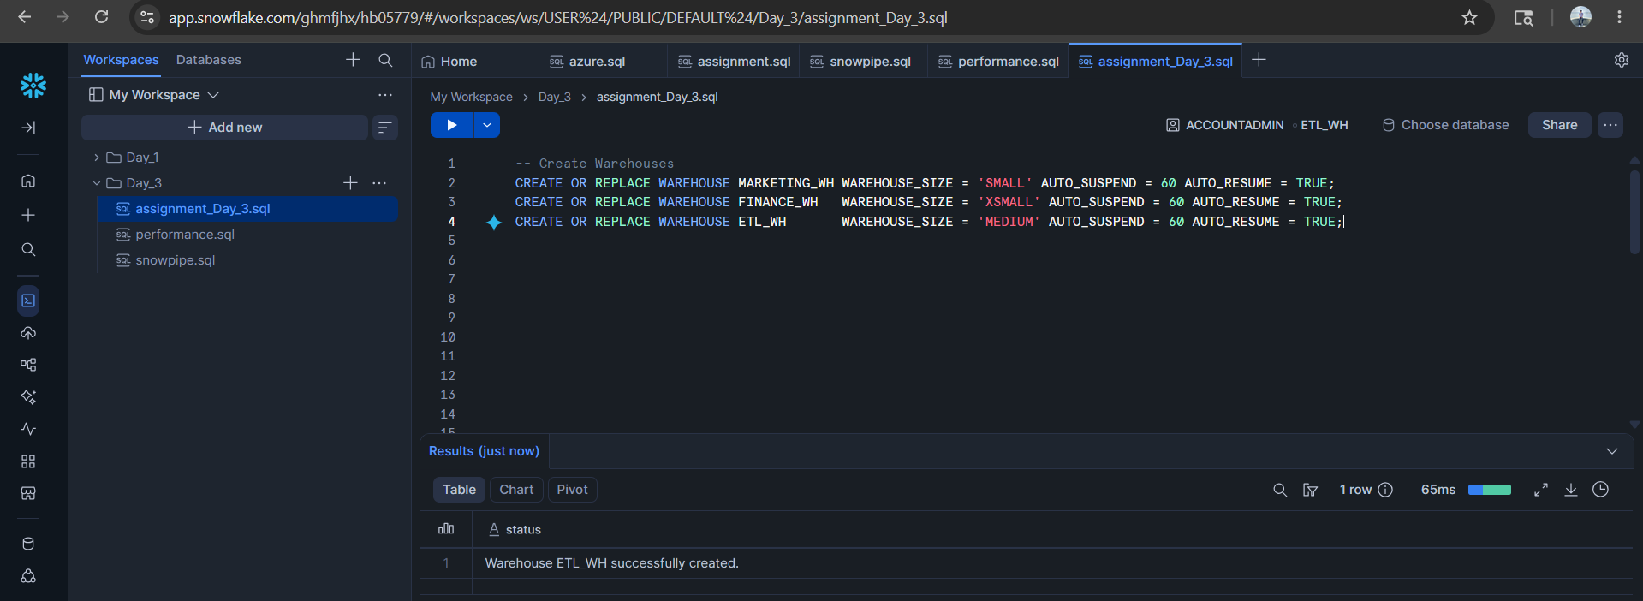
Step 2: Role assign
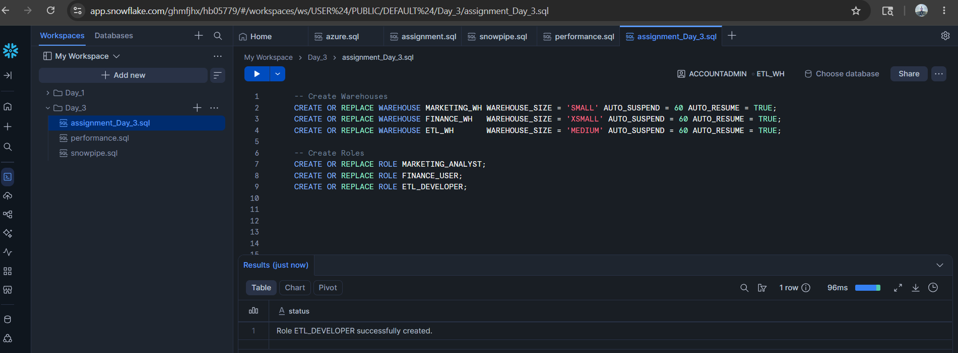
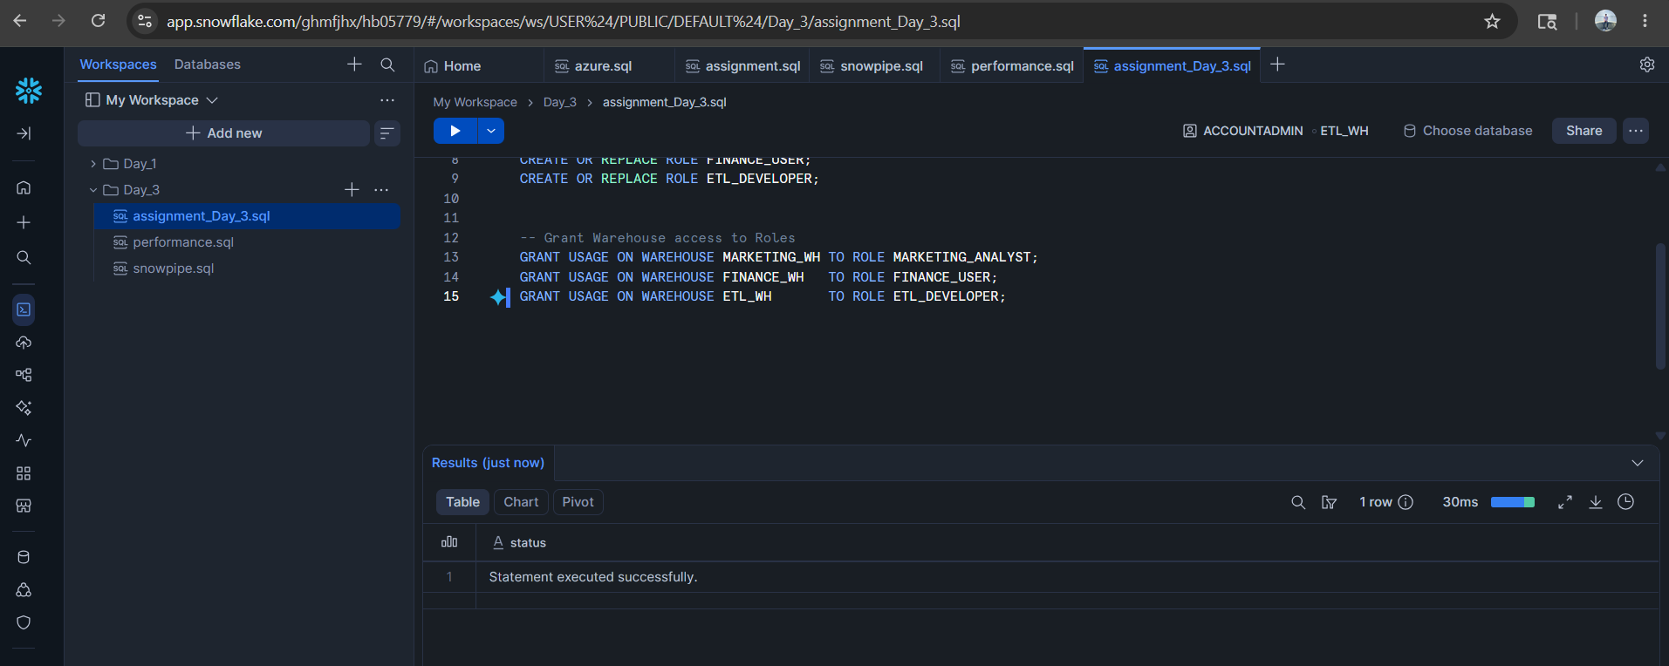
Step 3: create user and assign role to it
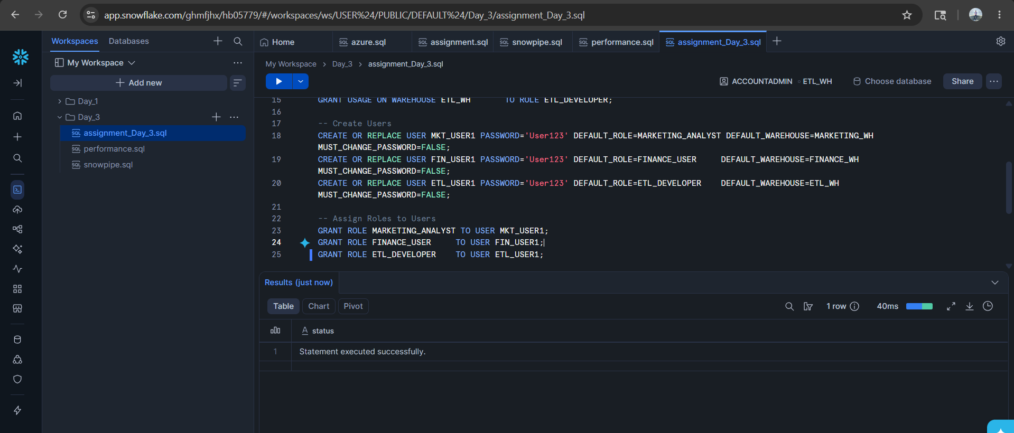

Step 4: create database
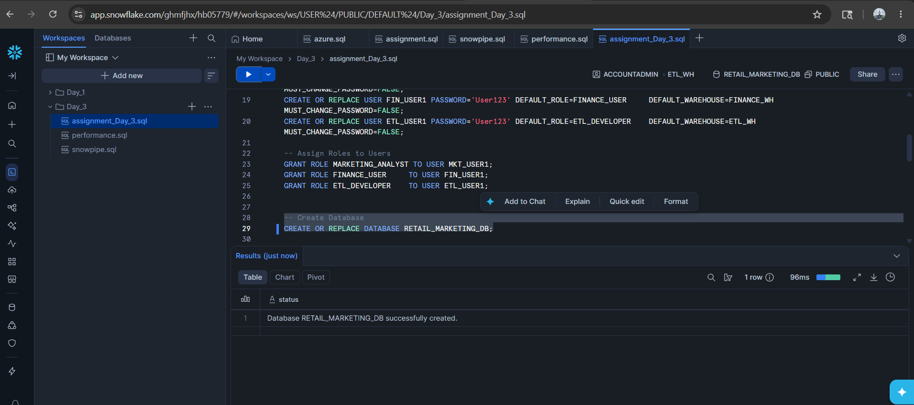
Step 5: Grant Permissions
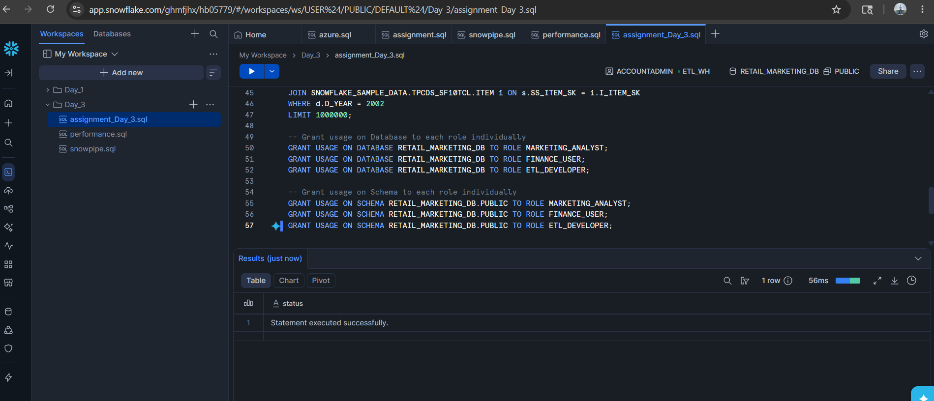

Step 6: Performance testing
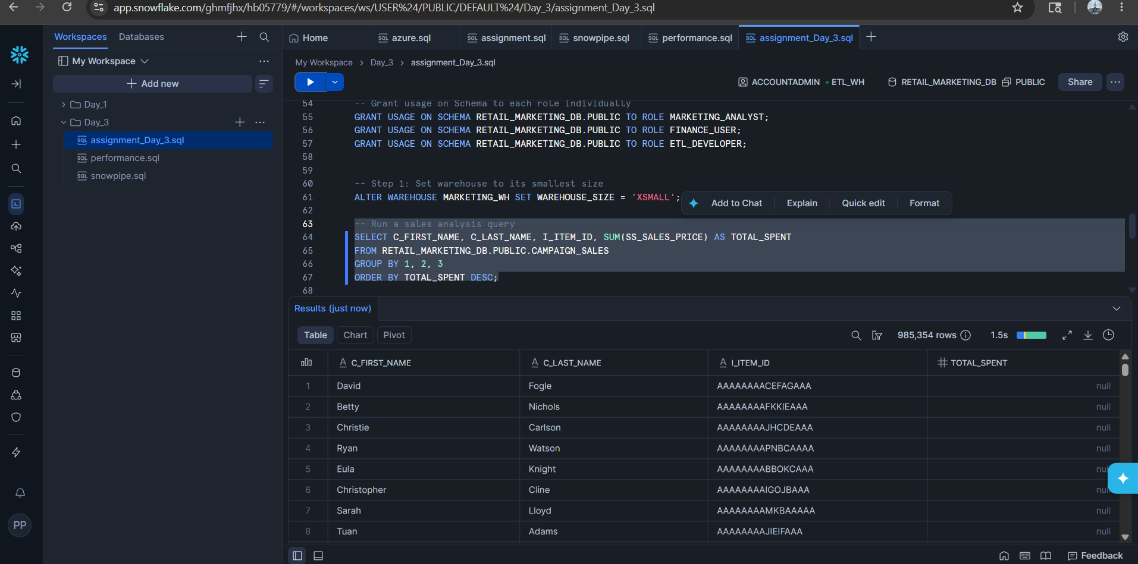
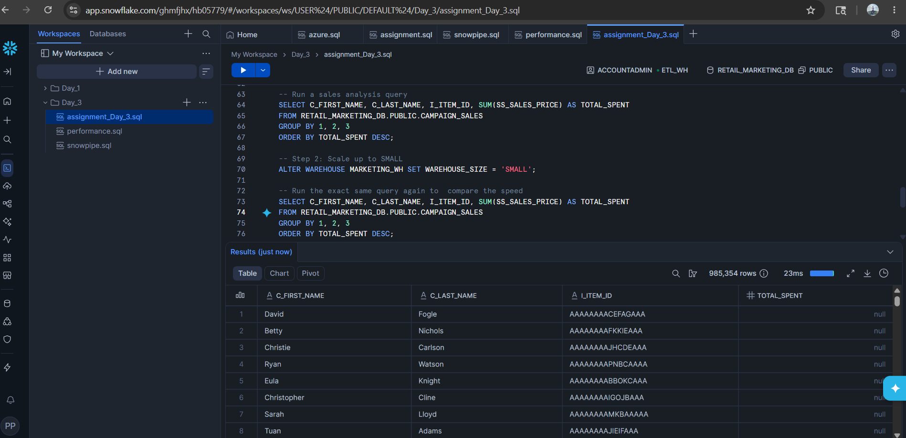
Step 7: Cache testing

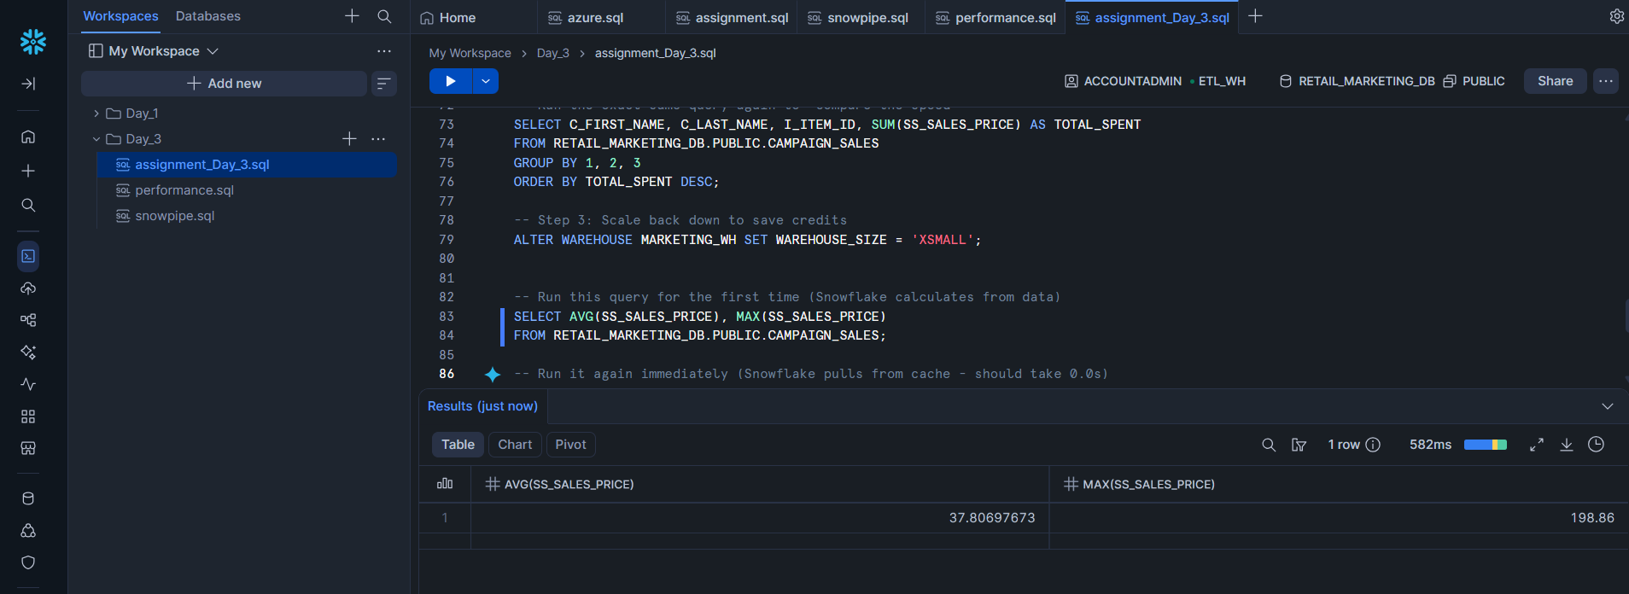
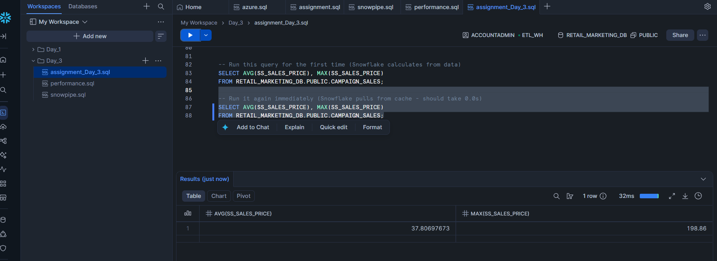

Step 8: Cluster key testing
