ONE PAGE BUSINESS CASE TEMPLATE

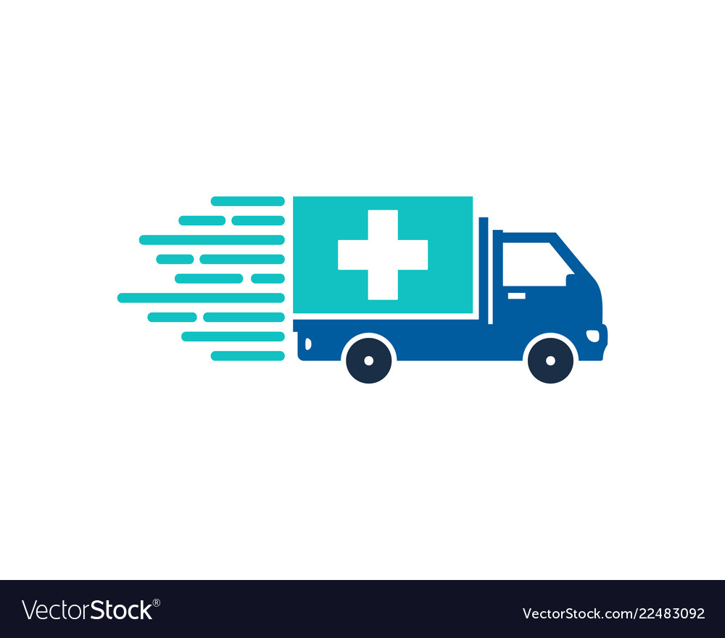
DATE | 13 January 2020
SUBMITTED BY | Piyush Pareek - RA1811003010358  Rohit Singh- RA1811003010354  Himanshu Bhardwaj- RA1811003010372
TITLE / ROLE | Medicine Delivery System
THE PROJECT
In bullet points, describe the problem this project aims to solve or the opportunity it aims to develop.
- This project aims to make medicine available in rural and remote areas.
- To provide medicine at affordable cost.
- To provide medicine that are rare to find at local medical stores.
- The best thing of home delivery medicine application is it saves time, as now patient don’t have to wait in a long queue, and sellers don’t have to deal with the high crowd.
- On online delivery medical application, customer can order the medicines according to their time schedule, where as they can order the medicines immediately or keep them on schedule.
THE HISTORY
In bullet points, describe the current situation.
- Very few or negligible medical stores are available in remote and rural areas.
- Middle class and lower-class people are not able to afford medicines.
- Currently online pharmacies are not able deliver in each and every area.
LIMITATIONS
List what could prevent the success of the project, such as the need for expensive equipment, bad weather, lack of special training, etc.
- Less availability of internet in some areas
- Lack of awareness among the rural people.
- Lack of availability of a certain type of medicine.
- Confusion in the selection of a particular medicine.
- Wait time for the customer may become longer than expected.
APPROACH
List what is needed to complete the project.
- HTML 5
- CSS
- JavaScript
- mySql
- PHP / Node Js
- Bootstrap
BENEFITS
In bullet points, list the benefits that this project will bring to the organization.
- The organization will get Online Exposure.
- Organization will be able to extend its business in different countries and later maybe worldwide.
- The organization will get to know about common diseases that are spread in rural areas.
- Get real-time updates/track about medicine order with the help of this application.
- The users can also manage the individual profiles by providing information.

DISCLAIMER

Any articles, templates, or information provided by Smartsheet on the website are for reference only. While we strive to keep the information up to date and correct, we make no representations or warranties of any kind, express or implied, about the completeness, accuracy, reliability, suitability, or availability with respect to the website or the information, articles, templates, or related graphics contained on the website. Any reliance you place on such information is therefore strictly at your own risk.

