AXIOS
Topic 1: What is Axios?
1. Definition
Axios is a JavaScript library used to make HTTP requests (GET, POST, PUT, DELETE, etc.) from a browser or from Node.js. It's "promise-based," meaning every request returns a Promise that you can handle with .then()/.catch() or async/await.
Think of it as a messenger you send to fetch or deliver data to a server, and it comes back to tell you "here's what I got" or "something went wrong."

2. Why is it needed?
JavaScript already has a built-in way to make HTTP requests called fetch(). So why does almost every real-world project use Axios instead?
Analogy: fetch is like a basic landline phone — it works, but you have to do everything manually (dial, hang up, check if the call connected). Axios is like a smartphone — it has built-in features: contact list (default configs), call recording (interceptors), auto-reject spam calls (error handling), and works the same way no matter which network you're on (browser or Node.js).
Concretely, problems Axios solves that fetch doesn't handle out of the box:
- Automatic JSON conversion: With fetch, you must call response.json() manually. Axios does this automatically.
- Automatic error throwing on bad status codes: fetch does NOT reject the promise for a 404 or 500 — you have to check response.ok yourself. Axios automatically throws an error for any non-2xx response.
- Request/response interceptors: Axios lets you "intercept" every request or response globally (e.g., add an auth token to every request automatically). fetch has no built-in way to do this.
- Works identically in browser and Node.js: fetch historically didn't exist in Node (it does now, but inconsistently across versions). Axios behaves the same everywhere.
- Easy timeouts and request cancellation.
- Automatic request/response data transformation.
Your Code
↓
Axios Request
↓
Merge Configs
(Global → Instance → Request)
↓
Request Interceptor
↓
Adapter (XHR / HTTP)
↓
Server/API
↓
Response Interceptor
↓
then / catch

So step-by-step:
- You call axios.get(url). Axios merges three layers of configuration: the global defaults, any instance-level config, and your per-request config (this is important for interviews — config merging order matters).
- The merged config is passed through any request interceptors you've registered, in the order they were added. Each one can read or modify the config (e.g., attach an auth token).
- The config is handed to the adapter — the actual low-level code that talks to the network. In a browser, this is XMLHttpRequest (or fetch, in newer Axios versions). In Node.js, it's the built-in http/https module.
- The adapter sends the real network request and waits for a response (or a timeout/network failure).
- The raw response comes back and is parsed (e.g., JSON.parse on the response body) and passed through any response interceptors, again in order.
- Finally, the resulting object is handed to your .then() or returned from your await — or, if anything failed along the way (network error, timeout, or a non-2xx status), it travels down the same pipeline but ends up rejecting the Promise, which your .catch() receives.
This pipeline structure is exactly why interceptors are powerful — they sit in the middle of this flow and can see/modify every single request and response without you repeating code everywhere.

4. Real Project Example
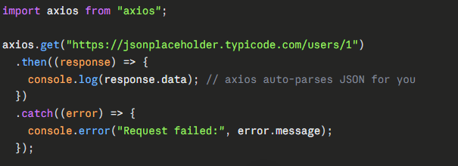
Compare this to the same thing with fetch:
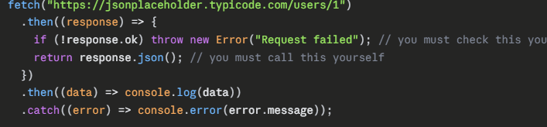Notice: with fetch, a 404 response does not automatically throw — you have to check response.ok manually. With Axios, a 404 automatically rejects the promise. This single difference trips up a lot of beginners.

5. Interview Questions
Q: What is Axios, and why would you choose it over the native fetch API?
A: Axios is a promise-based HTTP client. It's chosen over fetch because it auto-parses JSON, automatically rejects on non-2xx status codes, supports interceptors for global request/response handling, works consistently across browser and Node.js, and has built-in timeout and cancellation support.
Q: Does Axios use XMLHttpRequest or fetch internally?
A: In the browser, Axios traditionally uses XMLHttpRequest as its default adapter, though recent versions also support a fetch-based adapter. In Node.js, it uses the built-in http/https modules. This adapter layer is swappable — that's how libraries can even mock Axios in tests.
Q: Why doesn't fetch reject the promise on a 404 or 500 error?
A: Because fetch only rejects on network-level failures (like DNS failure or no internet). It considers any response that successfully reaches the client — even a 404 — as a "successful" fetch. Axios changes this behavior by checking the status code itself and explicitly throwing if it's outside the 2xx range.

6. Common Mistakes
A very common beginner mistake is forgetting that Axios wraps your data inside a response object — so you need response.data, not just response, to get the actual payload. Another frequent error is assuming try/catch isn't needed because "it's just a GET request" — but network errors, timeouts, and 4xx/5xx responses all throw, so error handling is mandatory in production code. A third common mistake is treating the second argument of axios.post(url, data, config) incorrectly — beginners sometimes put data inside the config object instead of as the second standalone argument.
7. Best Practices
In real projects, you almost never call the global axios object directly for every request. Instead, you create an Axios instance with a baseURL and default headers (we'll cover this in the next lesson, right before interceptors) so you don't repeat the full URL and headers everywhere. You also centralize error handling logic (often via interceptors) instead of writing .catch() blocks all over your codebase. Always set a reasonable timeout so a hung request doesn't freeze your app.

8. Hands-on Exercise
Try this in a Node.js project:
- Run npm install axios.
- Write a script that does axios.get('https://jsonplaceholder.typicode.com/users/1') and logs response.data.
- Then deliberately request an invalid endpoint, like https://jsonplaceholder.typicode.com/invalid-route, wrap it in try/catch, and log error.response.status, error.response.data, and error.message. Observe the structure of the error object — this is critical for real debugging.

IMP
- What is config?
In Axios, config means settings/options that control how a request behaves.
Examples of config:
- Which URL to call ,HTTP method (GET, POST) , Headers ,Timeout ,Base URL ,Auth token
Example config object:
{
url: "/users",
method: "get",
timeout: 5000,
headers: {
Authorization: "Bearer token123"
}
}
Axios has 3 levels of config.
1. Global Defaults (These apply to every axios request.)
const axios = require("axios");
axios.defaults.baseURL = "https://api.example.com";
axios.defaults.timeout = 5000;
axios.defaults.headers.common["Authorization"] = "Bearer ABC";
2. Instance-Level Config
Sometimes one app talks to multiple APIs.
Instead of global config, create separate axios instances.
Example:
const axios = require("axios");
const api = axios.create({
baseURL: "https://api.example.com",
timeout: 3000
});
3. Per-Request Config (Per-request config = special instructions for one request)
This applies to only one request.
Example:
axios.get("/users", {
timeout: 10000,
headers: {
token: "123"
}
});
Only this request gets:
- timeout = 10 sec
- custom headers
Other requests unaffected
.
- What is Adapter?
In Axios, an adapter is the layer that actually sends the HTTP request.
Axios itself provides a nice API: axios.get("/users")
But Axios does not directly talk to the network.
Instead, it hands the request to an adapter.
What adapter does
Adapter takes Axios config:
{
url: "/users",
method: "get",
headers: {...}
}
and converts it into an actual request using platform-specific APIs.
Then it returns the response back to Axios.
Flow:
Your Code
↓
Axios
↓
Adapter
↓
Browser / Node network API

Topic 2: Axios Instances and Default Config
1. Definition
An Axios instance is a separate, customized copy of Axios created using axios.create(config). It comes pre-loaded with its own default settings — like a base URL, default headers, or timeout — so you don't have to repeat them on every single request.
js
const api = axios.create({
baseURL: "https://api.myapp.com",
timeout: 5000,
headers: { "Content-Type": "application/json" },
});
Now api.get("/users") actually calls https://api.myapp.com/users.

2. Why is it needed?
Analogy: Imagine you're writing letters to the same company every week. Would you rewrite the full company address, your return address, and "Dear Sir/Madam" every single time? No — you'd use a pre-printed letterhead with all that fixed information already on it, so you only write the actual message. An Axios instance is your letterhead.
Without instances, in a real project, you'd write this everywhere:
js
axios.get("https://api.myapp.com/users", { headers: { Authorization: "Bearer xyz" } });
axios.get("https://api.myapp.com/orders", { headers: { Authorization: "Bearer xyz" } });
axios.get("https://api.myapp.com/products", { headers: { Authorization: "Bearer xyz" } });
That's repetitive, error-prone (what if you change the base URL or forget a header somewhere?), and hard to maintain. Worse — if you're calling two different APIs (say, your own backend and a third-party payment API), they probably need different base URLs, different auth tokens, and different timeouts. The global axios object can only hold one set of defaults at a time. Instances solve this by letting each API have its own isolated configuration.
This is also exactly why interceptors (next topic) are usually attached to an instance rather than the global axios object — you want your auth-token-injecting interceptor to apply only to your backend, not to some random third-party API you're also calling.

3. How does it work internally?
When you call axios.create(config), here's what happens:
- Axios takes its own built-in default config object (things like default timeout=0, default headers, default adapter, etc.).
- It creates a new instance object by merging your passed-in config on top of those built-in defaults. Your values override the defaults wherever they overlap.
- This new instance gets its own private interceptor manager — meaning interceptors you add to this instance do NOT affect the global axios object or any other instance.
- The instance is returned as a callable function (yes, in Axios you can literally call api(config) directly, plus it has .get, .post, etc. methods attached) — internally this is done by creating a bound function and copying prototype methods onto it.
- When you later call api.get('/users'), Axios merges configs in this priority order (lowest to highest):
library defaults → instance defaults (from create()) → request-specific config (the one you pass per call).
This 3-layer merge is a classic interview point: per-request config always wins over instance config, which always wins over global defaults.

3. How does it work internally?
When you call axios.create(config), here's what happens:
- Axios takes its own built-in default config object (things like default timeout=0, default headers, default adapter, etc.).
- It creates a new instance object by merging your passed-in config on top of those built-in defaults. Your values override the defaults wherever they overlap.
- This new instance gets its own private interceptor manager — meaning interceptors you add to this instance do NOT affect the global axios object or any other instance.
- The instance is returned as a callable function (yes, in Axios you can literally call api(config) directly, plus it has .get, .post, etc. methods attached) — internally this is done by creating a bound function and copying prototype methods onto it.
- When you later call api.get('/users'), Axios merges configs in this priority order (lowest to highest):
library defaults → instance defaults (from create()) → request-specific config (the one you pass per call).
This 3-layer merge is a classic interview point: per-request config always wins over instance config, which always wins over global defaults.

4. Real Project Example
A common real-world pattern — a dedicated api.js file:
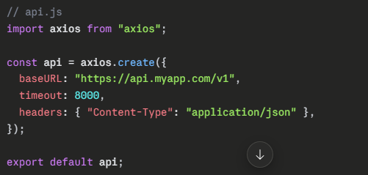
// userService.js
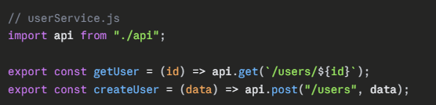
Now every part of your app imports api instead of the raw axios, and if the base URL ever changes, you update it in one place.
A multi-API real-world example:
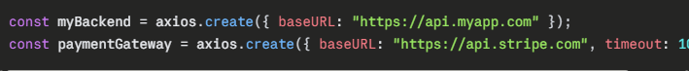Each has its own settings and (later) its own interceptors — totally isolated.

5. Interview Questions
Q: What's the difference between calling axios.get() directly versus through an instance created by axios.create()?
A: Calling axios.get() directly uses Axios's global default config. An instance created via axios.create() has its own merged config (baseURL, headers, timeout, etc.) and its own separate interceptor chain, isolated from the global object and from other instances.
Q: If you set timeout: 5000 in axios.create() but pass timeout: 2000 in a specific request, which one wins?
A: The per-request config wins. Axios merges config in increasing priority: library defaults → instance config → request config. The most specific (last) one always overrides.
Q: Why would a real project use multiple Axios instances?
A: Because different APIs often need different base URLs, auth schemes, timeouts, and error-handling logic (via interceptors). A single global config can't cleanly serve multiple distinct backends at once.

6. Common Mistakes
A common mistake is creating a new instance inside a component or function that runs repeatedly (e.g., inside a React component body without useMemo, or inside a loop) — this creates a brand-new instance, including a brand-new interceptor chain, every single time, wasting memory and potentially attaching duplicate interceptors. Instances should be created once, at module load time, and exported/reused. Another mistake is forgetting that headers set in axios.create() are defaults, not permanent — they can still be overridden (intentionally or accidentally) by a per-request config that sets the same header differently.

7. Best Practices
In real projects, create one instance per distinct API/backend you talk to, and put each in its own file (api.js, paymentApi.js). Set sensible defaults: a baseURL, a reasonable timeout (never leave it at 0/infinite in production), and Content-Type headers. Export the instance as a default export so the rest of the app imports and reuses the same object — this also means any interceptors you attach apply consistently everywhere that instance is used.

8. Hands-on Exercise
- Create an Axios instance with baseURL: 'https://jsonplaceholder.typicode.com' and timeout: 5000.
- Use it to fetch /posts/1 and log the result.
- Now make a one-off request to the same instance but override the timeout to 1 millisecond (an unrealistically short timeout) just for that single call, and confirm in your catch block that it throws a timeout error — proving that request-level config overrides instance-level config.
Try it and share what error message/object you get for step 3 — it's a good way to see Axios's error structure in action.

Topic 3: Interceptors
1. Definition
An interceptor is a function you register with Axios that automatically runs before every request is sent or after every response is received (or when an error occurs) — without you having to manually call it each time.
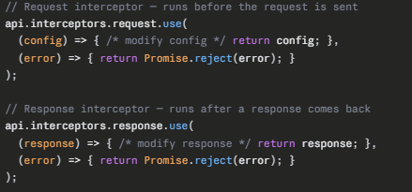
There are two types:
2. Why is it needed?
Analogy: Think of airport security checkpoints. Every single passenger (request), no matter which gate (endpoint) they're flying to, has to pass through the same checkpoint. The security officer doesn't go to each gate individually and check passengers one by one — instead, everyone is funneled through one common checkpoint before continuing their journey. That checkpoint is the interceptor.
In real apps, there are things that need to happen for every request or every response, and writing that logic manually each time would be repetitive and error-prone:
- Attaching an auth token (Authorization: Bearer ...) to every outgoing request.
- Logging every request/response for debugging.
- Automatically refreshing an expired token and retrying the failed request.
- Globally handling specific error codes (e.g., redirect to login on 401, show a toast on 500).
- Transforming response data into a consistent shape before it reaches your components.
Without interceptors, you'd have to manually repeat this logic in every single API call across your entire app — and if you ever need to change it (e.g., switch how tokens are stored), you'd have to hunt down every occurrence. Interceptors centralize this into one place.

3. How does it work internally?
Recall from Topic 1's diagram: every request flows through request interceptors → adapter → response interceptors. Here's the internal mechanism more precisely:
- Axios instances maintain an internal interceptor manager, which is really just an array of handler pairs. Calling .interceptors.request.use(onFulfilled, onRejected) simply pushes a new handler pair into that array and returns an ID (so you can later remove it with .eject(id)).
- When you call api.get(url), internally Axios doesn't just call the adapter directly — it builds a chain of promises. It takes the array of request interceptors and unshifts the actual adapter call onto the end, then takes the array of response interceptors and pushes them after that.
- So conceptually, your single .get() call gets turned into something like:
Promise.resolve(config).then(reqInterceptor1).then(reqInterceptor2)...then(sendToAdapter).then(resInterceptor1).then(resInterceptor2)...
- Each interceptor function receives the result of the previous one (config object for request interceptors, response object for response interceptors) and must return it (or a modified version) so the chain continues correctly. If you forget to return config in a request interceptor, the next step receives undefined, and your request breaks silently — a very common bug.
- If any interceptor throws, or calls Promise.reject(), the chain jumps straight to the nearest onRejected handler down the line (just like a normal promise chain) — this is how a request interceptor's error handler or your final .catch() gets triggered.
- Multiple interceptors run in the order they were registered for requests, but note: as of certain Axios versions, request interceptors execute in reverse registration order in some edge cases — for now just know request interceptors run in registration order by default, and you can verify with logging.

4. Real Project Example
The most common real-world use — auto-attaching an auth token: 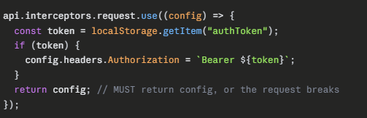
A common response interceptor — global 401 handling (token expired → redirect to login):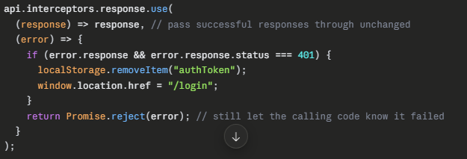
A common response interceptor — global 401 handling (token expired → redirect to login):
5. Interview Questions
Q: What's the difference between a request interceptor and a response interceptor?
A: A request interceptor runs before the request is sent and receives the config object — used to modify outgoing requests (e.g., add headers). A response interceptor runs after a response (or error) is received and receives the response/error object — used to handle or transform incoming data globally.
Q: Why must you always return config (or return response) inside an interceptor?
A: Because interceptors form a promise chain internally. Each interceptor's return value becomes the input to the next one. If you don't return it, the next step in the chain receives undefined, silently breaking the request or response.
Q: How would you implement automatic token refresh using interceptors?
A: In the response interceptor's error handler, check if the error status is 401. If so, call your refresh-token endpoint to get a new token, update storage, update the original request's headers with the new token, and retry the original request using axios(originalRequest) — returning that promise instead of rejecting.
Q: Can you remove an interceptor once it's added?
A: Yes. interceptors.request.use() returns a numeric ID. Calling interceptors.request.eject(id) removes that specific interceptor.

6. Common Mistakes
The single most common beginner mistake is forgetting to return the config or response inside an interceptor — this causes requests to silently fail or send undefined headers, and it's notoriously hard to debug because there's no clear error message. Another mistake is attaching interceptors to the global axios object instead of a specific instance — this means your auth-token logic accidentally applies to every API you call, including third-party ones that don't need (or want) your token. A third mistake is forgetting to call Promise.reject(error) in the error handler of an interceptor — if you swallow the error without rejecting, your calling code's .catch() never fires, even though something actually went wrong.

7. Best Practices
Attach interceptors to a specific Axios instance, not the global object, so their scope is limited to the API they're meant for. Keep interceptor logic small and focused — one interceptor for auth, a separate one for logging, rather than one giant interceptor doing everything (easier to test and remove individually). Always re-reject errors you don't fully handle, so calling code can still respond appropriately. For token refresh logic, guard against infinite retry loops (e.g., mark the retried request so it isn't retried a second time if the refresh itself fails).
Topic 4: Error Handling in Axios
When an Axios request fails:
try {
const res = await axios.get("/users");
} catch (error) {
console.log(error);
}
The error object is not just a string.
Axios gives a rich error object.
Typical error object:
{
message: "Request failed with status code 404",
name: "AxiosError",
code: "ERR_BAD_REQUEST",
config: {...},
request: {...},
response: {...}
}
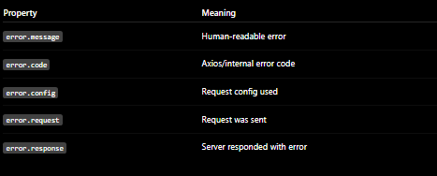
The 3 Main Error Types
You must distinguish these:
1. HTTP Errors (Request reached server. Server responded. But status code is error.)
try {
await axios.get("https://jsonplaceholder.typicode.com/invalid");
} catch (error) {
console.log(error.response);
}
output =
{
status: 404,
statusText: "Not Found",
data: {...},
headers: {...}
}
2. Network Errors (Request never reached server properly.)
- No internet
- DNS failure
- CORS issue (browser)
- Server down
- Wrong domain
Example:
await axios.get("https://abc-does-not-exist.com");
output
{
message: "Network Error"
}
error.request exists
error.response does NOT exist

3. Timeout Errors (Axios waited too long.)
axios.get("/users", {
timeout: 1000
});
{
code: "ECONNABORTED",
message: "timeout of 1000ms exceeded"
}
Production-Grade Error Handling
catch (error) {
if (error.response) {
console.log("HTTP Error");
} else if (error.request) {
console.log("Network Error");
} else {
console.log("Axios Setup Error");
}
}

