Redux ToolKit
1. Definition
Redux Toolkit (RTK) is the official, recommended way to write Redux logic. It's not a different library from Redux — it's a set of tools built on top of Redux that wraps the verbose patterns you just learned (action types, action creators, reducers, store setup) into a few simple functions: mainly configureStore() and createSlice().

2. Why is it needed?
Analogy: Think back to plain Redux as building furniture with raw lumber, a hand saw, and nails — you have full control, but you're manually doing every cut, every joint, every measurement, and it's easy to make a mistake (like accidentally mutating state). Redux Toolkit is like buying that same furniture as a well-designed flat-pack kit: pre-cut pieces, clear instructions, fewer chances to mess up — but you still end up with the same final furniture, built on the same underlying principles (single store, actions, pure reducers).
The Redux team created RTK because, in real-world use, plain Redux had three well-known, persistent complaints:
- "Too much boilerplate" — as you just experienced, even a counter needed action types, action creators, and a switch-statement reducer.
- "Too easy to mutate state by accident" — beginners (and even experienced devs) would write state.value++ without realizing it broke Redux's core rule, causing silent bugs.
- "Too many decisions to make" — should I use combineReducers? Which middleware do I need for async calls? Should I install Redux DevTools manually? Plain Redux gives you a toolbox with no defaults; RTK gives you sensible defaults out of the box.
RTK solves all three directly, which is why the official Redux docs now say: "if you're writing Redux logic by hand today, you should be using Redux Toolkit." This is also why your earlier question made sense — many beginners genuinely think "RTK" is a separate, newer thing from "Redux," when really RTK is how you're supposed to write Redux now.

3. How does it work internally?
This is the most interesting part for interviews — RTK's "magic" isn't really magic, it's built on a clever library called Immer.
The mutation problem, solved by Immer:
When you write this inside a createSlice reducer:
js
increment: (state) => { state.value += 1; }
...it looks like you're directly mutating state. But you're not actually mutating the real state object. Here's what happens step by step:
- RTK's createSlice wraps every reducer function you write with Immer's produce() function internally.
- When your reducer runs, Immer doesn't give it the real state object — it gives it a special "draft" object, which is a JavaScript Proxy wrapping the real state.
- A Proxy intercepts every property read and write. So when your code does state.value += 1, the Proxy records "this path (value) was changed to this new value" instead of actually changing the original object.
- After your reducer function finishes running, Immer looks at everything that was recorded as "changed" on the draft, and uses that to construct a brand new state object — copying over all the unchanged parts by reference (for efficiency) and replacing only the parts that actually changed.
- This new object is what Redux actually stores. The original state object was never touched. Immutability is preserved — Redux's core rule is upheld — even though your code reads like ordinary mutation.
configureStore internals: Instead of you manually wiring up createStore, combining reducers, and adding middleware/DevTools support, configureStore() does this automatically: it combines all your slice reducers into one root reducer, automatically adds redux-thunk middleware (needed for async logic — more on this when we cover RTK Query), automatically connects Redux DevTools, and adds some development-only middleware that warns you if you accidentally do something unsafe (like storing a non-serializable value, e.g., a class instance, in state).
createSlice internals: It auto-generates action types and action creators for you based on the reducer names you provide. So increment: (state) => {...} inside a slice named "counter" automatically becomes an action with type "counter/increment", and counterSlice.actions.increment() is auto-generated to return { type: "counter/increment" } — exactly the boilerplate you wrote by hand in Topic 1, just generated for you.

4. Real Project Example
A realistic slice for a shopping cart feature:
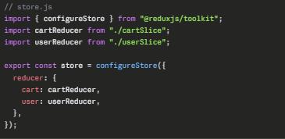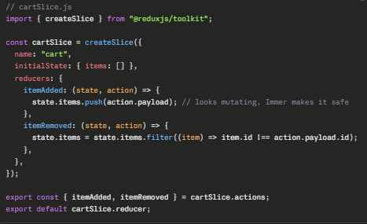
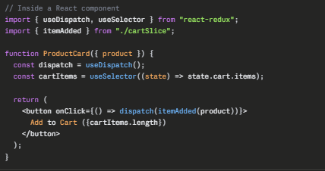
5. Interview Questions
Q: How does Redux Toolkit let you write "mutating" code in reducers while still keeping state immutable?
A: RTK uses a library called Immer internally. Inside createSlice, your reducer receives a Proxy-wrapped "draft" of the state, not the real object. Changes you make to the draft are tracked, and Immer then produces a brand new immutable state object based on those tracked changes — so the actual Redux state is never mutated, even though your code looks like it's mutating.
Q: What does configureStore do differently from the older createStore?
A: configureStore automatically combines multiple slice reducers, adds redux-thunk middleware for async logic, connects Redux DevTools, and adds development checks (like warning on non-serializable state or accidental mutations outside of createSlice) — all of which had to be manually configured with plain Redux's createStore.
Q: Does createSlice actually mutate the original state object?
A: No — never. It only appears to, because of Immer's Proxy-based draft mechanism. The underlying state object passed into the reducer is left completely untouched; a new object is always produced and returned.
Q: If you need to write a reducer case that's NOT triggered by an action defined in this slice (e.g., responding to another slice's action, or a default case), how do you do that in RTK?
A: Using the extraReducers field in createSlice, which lets you respond to action types defined outside the slice (commonly used for handling async thunk actions, which we'll cover with RTK Query).

6. Common Mistakes
A common mistake is returning a new value AND mutating the draft in the same reducer — e.g., doing state.value += 1; return state;. Immer specifically disallows mixing "draft mutation" style with "return a new value" style in the same function; you should pick one approach (almost always, just mutate the draft and don't return anything). Another mistake is assuming you can mutate state outside of a createSlice reducer (e.g., directly editing store.getState().cart.items.push(...) somewhere in your app) — Immer's magic only applies inside the reducer functions defined in createSlice; anywhere else, you're touching the real object and breaking Redux's rules. A third common mistake, especially for those who learned plain Redux first, is manually writing action type strings or switch statements inside RTK code out of habit — defeating the entire purpose of createSlice, which auto-generates these for you.

7. Best Practices
Organize your app by feature slices — one file per slice (cartSlice.js, userSlice.js, authSlice.js), each exporting its reducer and its auto-generated action creators. Keep reducers focused on synchronous, simple state updates; handle async logic with thunks or RTK Query (next topics) rather than cramming async code into a slice's reducers field. Always use the useSelector hook to read only the specific piece of state a component needs (e.g., useSelector(state => state.cart.items)) rather than the entire state tree, to avoid unnecessary re-renders. Let configureStore handle setup — avoid manually re-adding middleware or DevTools config unless you have a very specific, advanced need.

A. Middleware
1. Definition
Middleware in Redux is a function that sits between the moment you call dispatch(action) and the moment that action actually reaches the reducer. It can inspect the action, modify it, log it, delay it, stop it entirely, or trigger other side effects — before deciding whether to let it continue.
2. Why is it needed?
You already understand this concept perfectly — you just didn't know it yet. Redux middleware is the exact same idea as an Axios interceptor. Recall: an Axios request interceptor sits between "you call .get()" and "the request actually goes to the network," and can inspect/modify the config. Redux middleware sits between "you call dispatch()" and "the action actually reaches the reducer," and can inspect/modify the action. Same pattern, different pipeline.
Why is this needed at all? Because of a rule from Topic 1 you must remember: reducers must be pure, synchronous functions — no API calls, no setTimeout, no randomness. But real apps obviously need to make API calls, log things, and react to actions with side effects. So Redux needs some place in the pipeline where impure, async, side-effect-y code is allowed to live — and that place is middleware, which runs before the action reaches the strictly-pure reducer.
3. How does it work internally?
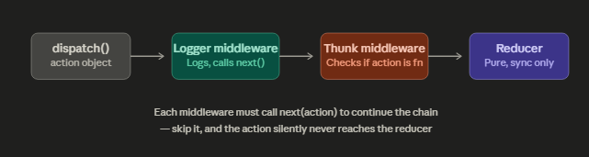
Here's the actual mechanism, step by step:
- Every Redux middleware has a very specific three-layer curried function signature:
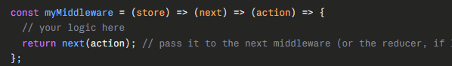
- store gives you access to dispatch and getState. next is a function representing "the next thing in the chain" — either the next middleware, or (if this is the last middleware) the actual reducer. action is the dispatched action.
- When you call store.dispatch(action), Redux doesn't call your reducer directly. It calls the first middleware in your configured chain, passing the action.
- That middleware does whatever it wants (log it, inspect it, modify it) and then calls next(action) to pass control to the second middleware — and so on, exactly like the Axios interceptor chain you already learned.
- Critical rule, identical to the Axios interceptor mistake: if a middleware forgets to call next(action), the chain stops dead — the reducer never receives the action, and the state silently never updates. Same bug, same root cause, different library.
- configureStore (from RTK) automatically includes redux-thunk as a default middleware — which is exactly how thunks (next section) become possible without you manually configuring anything.
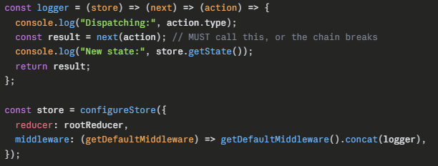
B. Thunks
1. Definition
A thunk is a function returned by an action creator, instead of a plain action object. Normally, dispatch() expects a plain object like { type: 'x' }. A thunk lets you instead dispatch a function — one that receives dispatch and getState as arguments, and can run async code (like an Axios call) before dispatching real actions.
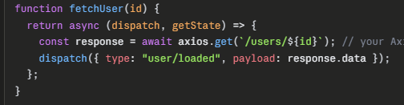
2. Why is it needed?
Remember: reducers must be pure and synchronous, and even middleware in general just sits in a pipeline — but plain Redux's dispatch() only accepts plain objects by default. So how do you do something like "call an API, wait for the result, then dispatch an action with that result"? You can't do that inside a reducer (impure/async), and you can't do it with a plain dispatch(action) call (no waiting involved). Thunks solve exactly this gap — they're "deferred logic with access to dispatch," letting you sequence async work and then dispatch the real, plain-object actions once you have the data.
3. How does it work internally?
Thunk support comes from a tiny piece of middleware (redux-thunk), and now that you understand middleware, its internals are genuinely simple:
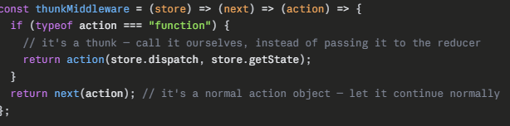That's the entire trick: thunk middleware checks typeof action === "function". If you dispatch a plain object, it just passes through to the next middleware/reducer as usual. If you dispatch a function, the middleware intercepts it, never lets it reach the reducer, and instead calls it directly — giving it dispatch and getState so it can do async work and dispatch real actions whenever it's ready.
RTK's createAsyncThunk builds on top of this manual pattern to remove its boilerplate (much like createSlice did for reducers):
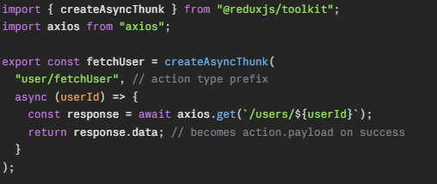Internally, createAsyncThunk auto-generates three action types based on the lifecycle of the promise inside it:
- user/fetchUser/pending — dispatched immediately when the thunk starts.
- user/fetchUser/fulfilled — dispatched when your async function resolves successfully, with the return value as action.payload.
- user/fetchUser/rejected — dispatched if your async function throws (e.g., the Axios call fails with one of the error types you learned in Topic 4!).
This is the direct bridge to the next concept — your slice needs a way to listen for these three auto-generated action types, since they weren't defined inside that slice's own reducers.

C. extraReducers
extraReducers is used to handle actions that are created outside the current slice. It is commonly used with createAsyncThunk to manage API request states such as pending, fulfilled, and rejected. It allows a slice to respond to actions generated by other slices or external sources.
extraReducers is a field inside createSlice used to handle action types that were not defined by this slice's own reducers object — most commonly, the pending/fulfilled/rejected actions generated by createAsyncThunk, or actions dispatched by a completely different slice.

2. Why is it needed?
Think back to createSlice: the reducers field auto-generates action types based on the names you give it (e.g., increment becomes "counter/increment"). But createAsyncThunk's three lifecycle actions (pending/fulfilled/rejected) are generated by a completely separate function, with their own type strings. Your slice has no automatic way to know these types exist or how to react to them — so extraReducers is the dedicated escape hatch for "listen to action types that came from outside this slice's own reducers block."
3. How does it work internally?
extraReducers uses a "builder callback" pattern:
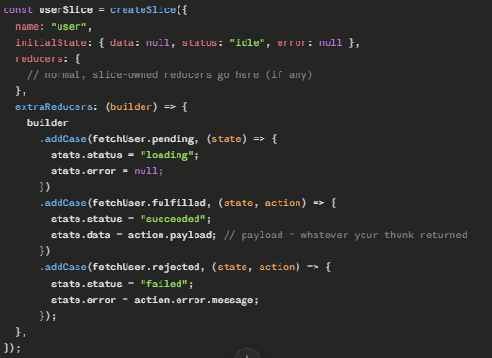Internally, builder.addCase(actionTypeOrCreator, reducerFn) simply registers: "when an action with this exact type string is dispatched, run this reducer function." Since fetchUser.pending, .fulfilled, and .rejected are themselves action creators with a .type property attached (RTK does this automatically), you can pass them directly instead of typing the raw string — and you still get the same safety/correctness as the reducers field, including Immer's draft-mutation magic from Topic 2.
This is also exactly how you'd track loading states for any Axios call cleanly — status: 'idle' | 'loading' | 'succeeded' | 'failed' is the industry-standard pattern for representing async request state in Redux.

