ASSIGNMENT 15
Q1 ASSUME THERE IS SA TABLE NAME MULTICAST , WITH ALL OF THE SAME COLUMN DEFINITIONS AS SALESPEOPLE WRITE A COMMAND THAT INSERT AL THE SALES PEOLE EITH MORE THAN ONE CUSTOMERS IN THE TABLE;

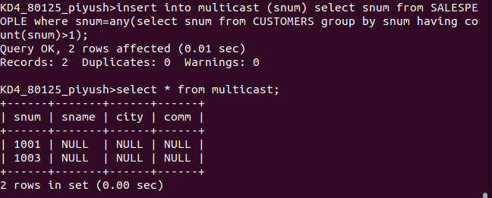
Q2 WRITE A COMMAND THAT DELETES ALL CUSTOMERAS WITH NO CURENT ORDERS;
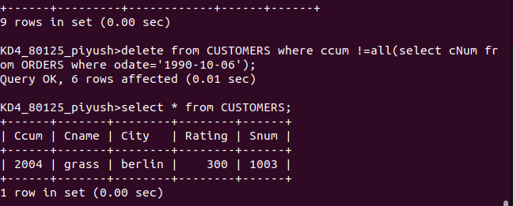
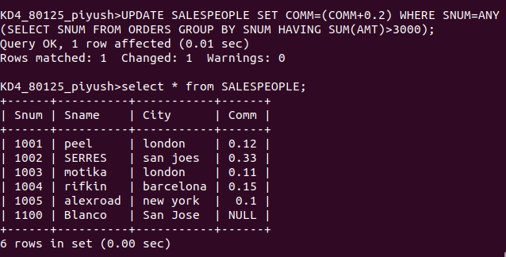
Q3 WRITE A COMMAND THAT INCREASE BY TWENTY PERCENT THE COMMISSIONS OF ALL SALESPEOPLE WITH TOTAL ORDER ABOVE 3000

