MYSQL ASSIGNMENT: 5
QUESTION 1:
WRITE A QUERY THAT WILL GIVE YOU ALL ORDERS FOR MORE THAN RS1000
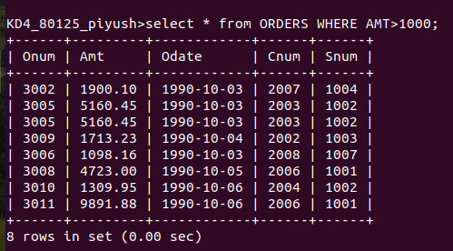
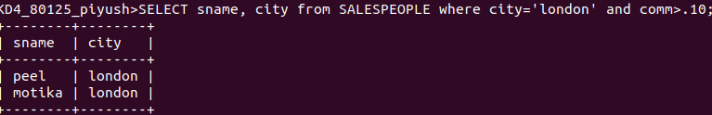
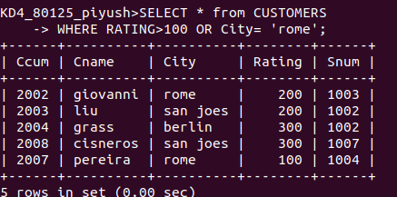
QUESTION 2:
WRITE A QUERY THAT WILL GIVE YOU THE NAMES AND CITIES OF ALL SALESPEOPLE IN LONDON WITH A COMMISION ABOVE 0.10?
QUESTION 3:
WRITE A QUERY ON CUSTOMER TABLE WHOSE OUTPUT WILL EXCLUDE ALL THE CUSTOMERS WITH A RATING <=100,UN LESS THEY ARE LOCATED IN ROME:
QUESTION 4;
What will be the output of following query?
Select * from orders where (amt<1000 or NOT(ODATE =’1990-10-03’ AND CNUM>2003));
ANSWER: HERE THE ONUM 3001 & 3003 IS EXCLUDED AND THE ENTIRE TABLE IS PRINTED ON Screen.
QUESTION 5;
What will be the output of the following query?
Select * from orders where not ((odate =’1990-10-03’ or snum>1006) and amt >=1500);
ANSWER:

QUESTION 6:
WHAT IS SIMPLER WAY TO WRITE ?
SELECTSNUM,SNAME,CITY,COMM FROM SALESPEOPLE WHERE (COMM>.12 OR COMM<.14)
ANSWER:
SELECT * FROM SALESPERSON
WHERE COMM=13;

