ASSIGNMENT 10
Q1 WRITE A QUERY THAT PRODUCE ALL PAIRS OF SALESPEOPLE WHO /..........
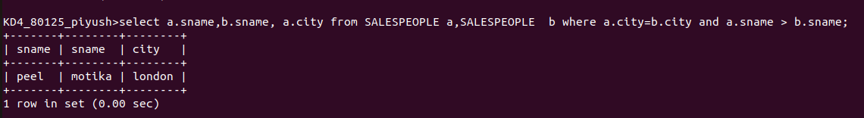

Q2NWRITE A QUERY THAT PRODUCES THE NAMES AND CITIES OF ALL CUSTOMERS WITH THE SAME RATING AS HOFFMAN
