Assignment 9:
Q 1 WRITE A QUERY THAT LISTS EACH ORDER NUMBER FOLLOWED BY THE NAME OF CUSTOMERS WHO MADE THE ORDER
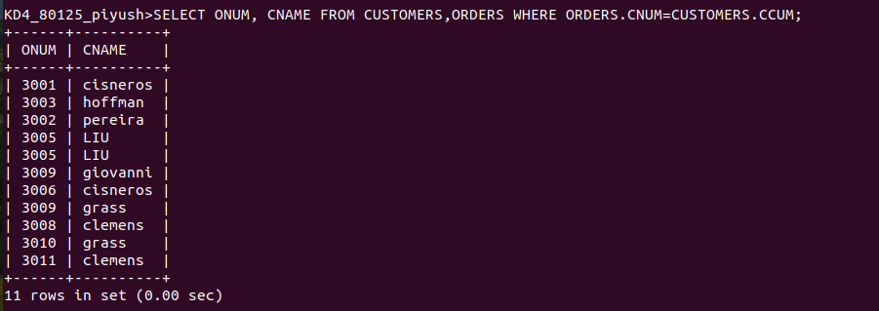

Q2 WRITW A QUERY THAT GIVES THE NAME OF BOTH THE SALESPERSON AND THE CUSTOMERS FOR EACH ORDER ALONG WITH THE ORDER NUM
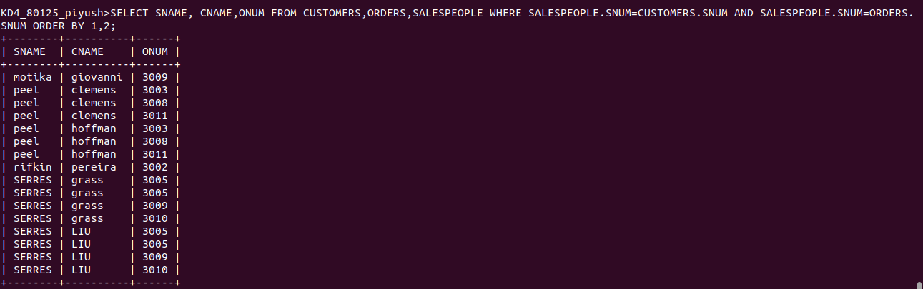
Q3 WRITE A QUERY THAT PRODUCES ALL CUSTOMERS SERVICED BY SALESPERSON WITH A COMMISION ABOVE 12% OUTPUT THE CUSTOMER’S NAME, THE SALESPERSON’S NAME, AND THE SALESPERSON’S RATE OF COMMISION
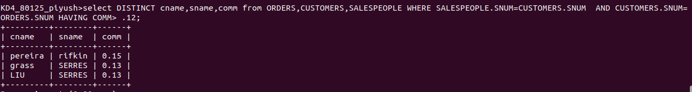

Q4 WRITE A QUERY THAT CALCULATE THE AMT OF SALESPERSON’S COMM ON EACH ORDER BY A CUSTOMER WITH A RATING ABOVE 100

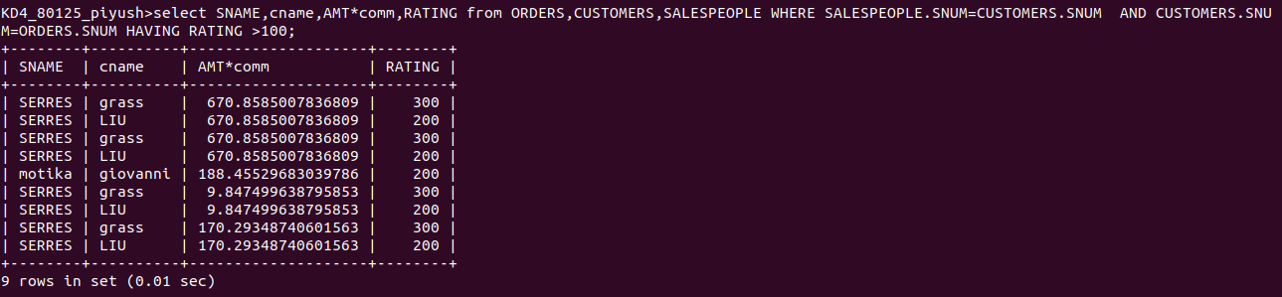

Q4

