MY-SQL ASSIGNMENTS (1-5) DT:10/09/2023

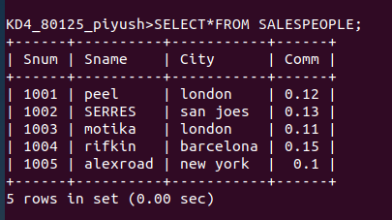
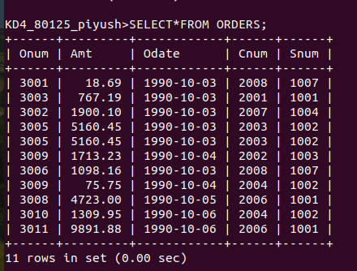
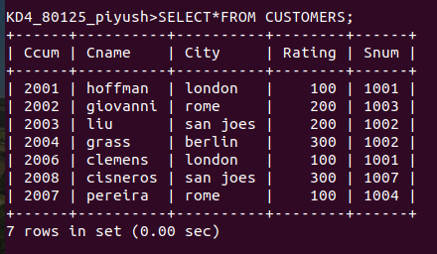
ASSIGN NO 1.
Question: create the following tables with the given structures and insert sample data as specified:
MY-SQL ASSIGNMENT NO. 2 DATE :10/09/2023

QUESTION:1
WHICH FIELD OF THE CUSTOMER TABLE IS PRIMARY KEY?
ANSWER:
--> PRIMARY KEY IS THAT FIELD OF A TABLE WHICH IS UNIQUE FOR EACH AND EVERY ROW OF THE TABLE.
--> PRIMARY KEY OF AN TABLE CAN BE ACT AS FOREIN KEY TO ANOTHER TABLE.
--> EXAMPLE: ROLL ROLL, ADHAR NUMBER, BANK ACCOUNT ETC

AS PER THE QUESTION, The CNUM FIELD , is the primary key of the customer table.

QUESTION:2
WHAT IS THE 4TH COLUMN OF CUSTOMERS TABLE?
ANSWER:
RATING is the 4th column of customer table.

QUESTION:3
WHAT IS ANOTHER WORD FOR ROW ? FOR COLUMN?
ANSWER:

The another name for row is ‘RECORD’ and ‘TUPLE’.
AND
the other word for column is ‘FIELD’.
QUESTION:4
WHY ISN’T IT IS POSSIBLE TO SEE THE FIRST FIVE ROWS OF THE TABLE?
ANSWER:
In mysql, for the faster insertion the data is saved randomly anywhere in the disk and its memory address is saved. When we try to see the first 5 rows or any order of rows ,it is not possible. Since the data is saved randomly and we dont have any concrete records from where we can reckon the first and last entered tuple.

MY-SQL ASSIGNMENT NO. 3

QUESTION:1
DOES ANSI RECOGNIZE THE DATA TYPE DATE?
ANSWER:
yes , the ANSI recognize the date data type in the format “yyyy-mm-dd”.

QUESTION:2
WHICH SUBDIVISION OF SQL IS USED TO INSERT VALUES IN TABLE?
ANSWER:
The DML division i.e data manupulation command is the division to insert values in table.

ASSIGNMENT NO : 4

QUESTION 1
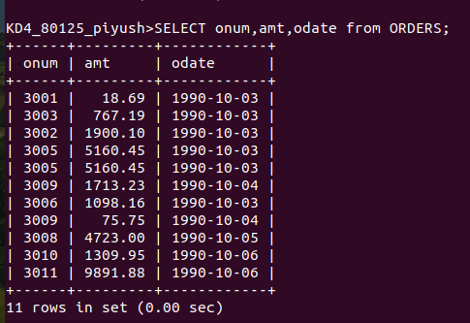
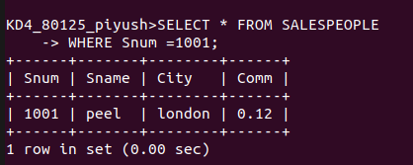
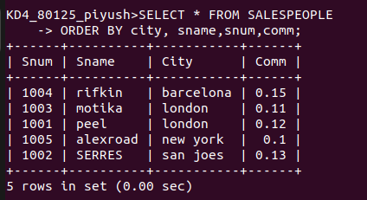
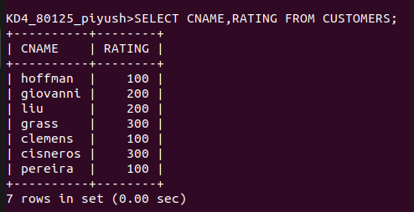
WRITE A SELECT COMMAND THAT PRODUCE THE ORDER NUMBER, AMT, AND DATE FOR ALL ROWS OF ORDER TABLW
QUESTION :3
WRITE A QUERY THAT DISPLAYS THE SALESPEOPLE TABLE WITH THE COLUMN IN THE FOLLOWING ORDERS CITY, SNAME, SNUM, COMM.
QUESTION 2
WRITE A QUERY THAT PRODUCES ALL THE ROWS FROM THE CUSTOMERS TABLE FOR WHICH THE SALESPERSON’S NUMBER IS 1001:

QUESTION:4
WRITE A SELECT COMMAND THAT PRODUCES THE RATING FOLLOWED BY NAME OF EACH CUSTOMER IN SAN JOSE:

