Assignment 11
Q1 write a query that uses a subquery to obtain all orders for all the ..................

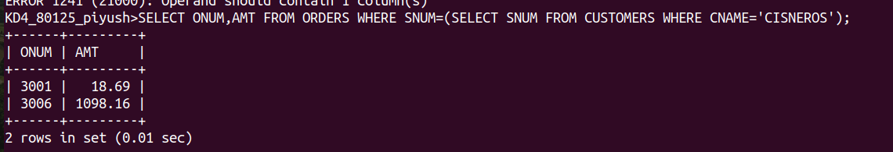
Q2 WRITE A QUERY THAT PRODUCES THE NAME ......................

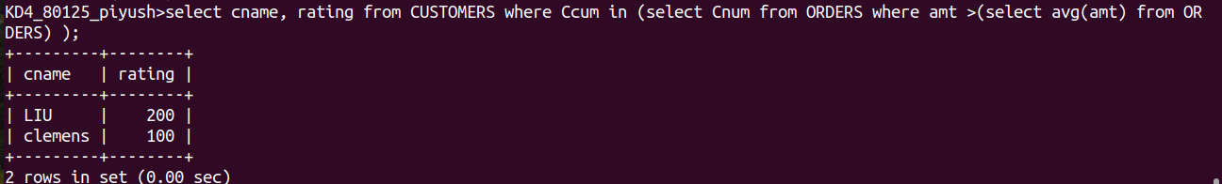
Q3 WRITE A QUERY THA SELECTS.........................

