ASIIGNMNENT 12
Q1 WRITE A QUERY THAT SELECT ALL CUSTOMERS............
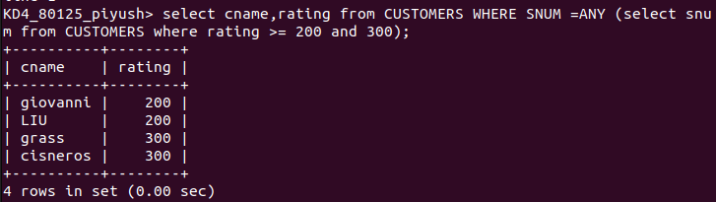

Q2
WRITE A query using any all that will find all salesperson who have no customers located in there city
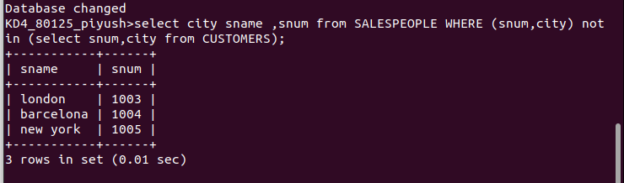
Q3. Write a query that selects all orders for amounts greater than any for the customers in London.

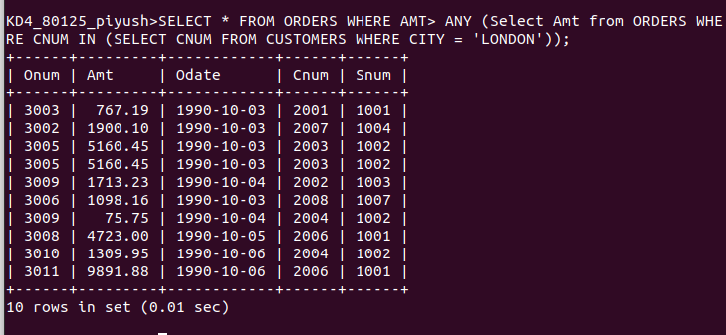
Q4. Write the above query using MIN or MAX.
SELECT * FROM ORDERS
WHERE AMT >(SELECT MIN(AMT) FROM ORDERS WHERE CNUM IN (SELECT CNUM FROM CUSTOMERS WHERE CITY = 'London'));
