ASSIGNMENT : 6

Q.1> WRITE TWO DIFFERENT QUERIES THAT WOULD PRODUCE ALL ORDERS TAKEN ON OCTOBER 3RD OR 4YH ,1990:
QUERY 1:
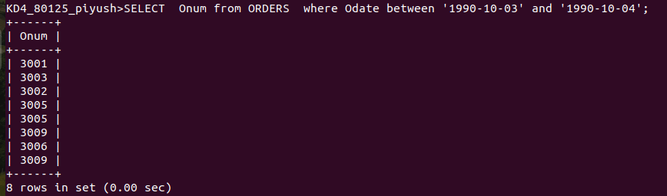
QUERY 2:

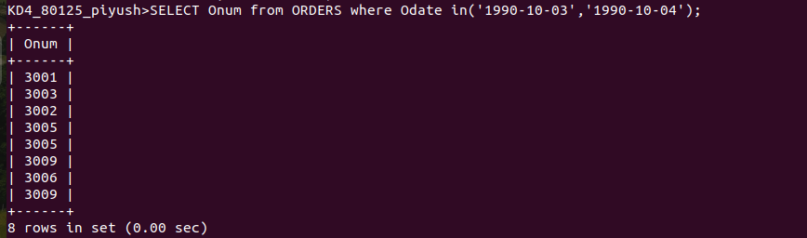
QUESTION 2:
WRITE A QUERY THAT SELECTS ALL OF THE CUSTOMERS SERVED BY PEEL OR MOTIKA;
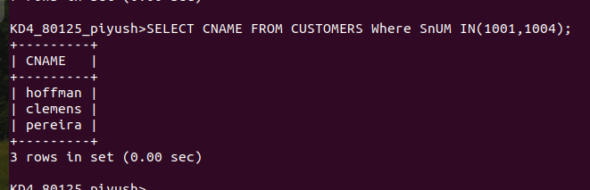
QUESTION 3;
WRITE A QUEARY THAT WILL PRODUCE ALL THE CUSTOMERS WHOSE NAME BEGINS WITH A LETTER FROM ‘A’ TO ‘G’
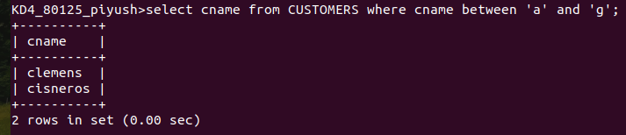
QUESTION 4;
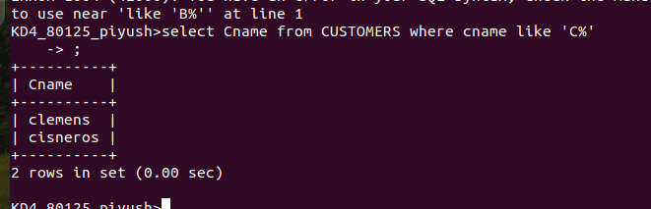
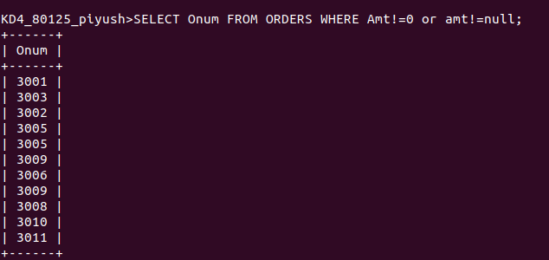
WRITE A QUERY THAT SELECT ALL CUSTOMERS BEGINS WITH C:
QUESTION 5;
WRITE A QUERY THAT SELECT ALL ORDERS EXCEPT THOSE WITH ZERO AND NULL IN AMT FIELD:

