ASSIGNMENT 8
Q1 ASSUME EACH SALESPERSON HAS 12%............
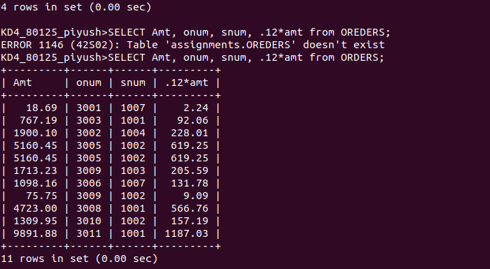
Q2 WRITE A QUERY ON CUSTOMER TABLE.......

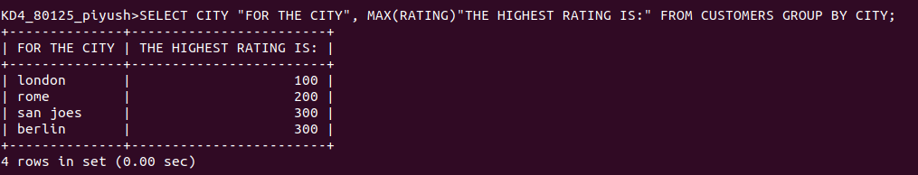
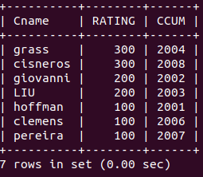
Q3 WRITE A QUERY THAT LIST.......

Q4 WRITE A QUERY THAT TOTAL......
