ASSIGNMENT 7:
Q1 WRITE A QUERY THAT COUNTS ALL ORDERS FOR OCT 3
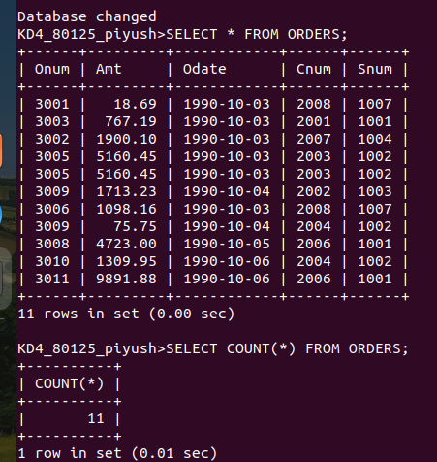

Q2 WRITE A QUERY THAT COUNTS NUMBER OF DIFFERENT NON-NULL CITY VALUES IN THE CUSTOMER TABLE

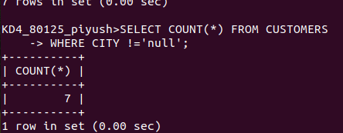

Q3 WRITE A QUERY THAT SELECTS EACH CUSTOMERS SMALLEST ORDER



Q 4 WRITE A QUERY THAT SELECT THE FIRST CUSTOMER IN ALPHABETICAL ORDERS , WHOSE NAME BEGINS WITH G
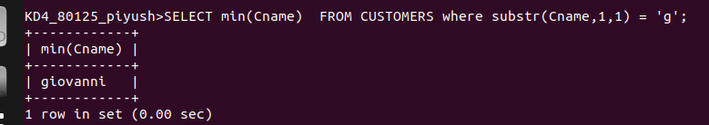
Q5 WRITE A QUERY THAT SELECT HIGHEST RATING OF EACH CITY:
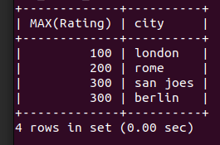

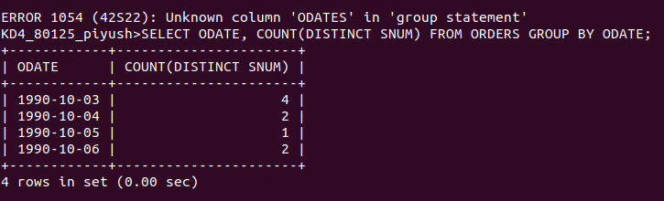
*
Q6 WRITE A QUERY THAT COUNTS THE............

