A Project Report on

## The Emotion Based Music Player

Submitted in partial fulfillment of the requirements

in

### Computer Engineering

By

Piyush Sawarkar (17102021)

Ankit Srivastava (17102044)

Ninad More (17102067)  
Jainam Shah (18202005)

Under the Guidance of

Prof Amol Kalugade



#### Department of Computer Engineering

#### A.P. Shah Institute of Technology G.B.Road,Kasarvadavli, Thane(W), Mumbai-400615

UNIVERSITY OF MUMBAI

#### Academic Year 2020-2021

**Approval Sheet**

This Project Report entitled ***“Emotion Based Music Player”*** Submitted by ***“Piyush Sawarkar”(17102021),“Ankit Srivastava”(17102044),“Ninad More”(17102067),“Jainam Shah”(18202005)***is approved for the partial fulfillment of the requirement in ***Computer Engineering*** from ***University of Mumbai*** .

Prof. Amol Kalugade

Guide

Prof. S.H.Malave

Head, Computer Engineering Department

Place:A.P.Shah Institute of Technology, Thane Date:

### CERTIFICATE

This is to certify that the project entitled ***“Emotion Based Music Player”*** submitted by ***“Piyush Sawarkar”(17102021),“Ankit Srivastava”(17102044),“Ninad More”(17102067),“Jainam Shah”(18202005)*** for the partial fulfillment of the requirement for award of a degree ***Bachelor of Engineering*** in ***Computer Engineering .***,to the University of Mumbai,is a bonafide work carried out during the academic year 2020-2021.

Prof. Amol Kalugade

Guide

Prof. S.H.Malave Dr. Uttam D.Kolekar Head,Computer Engineering Department Principal

External Examiner

Place:A.P.Shah Institute of Technology, Thane Date:

### Declaration

We declare that this written submission represents our ideas in our own words and where others’ ideas or words have been included, We have adequately cited and referenced the orig- inal sources. We also declare that We have adhered to all principles of academic honesty and integrity and have not misrepresented or fabricated or falsified any idea/data/fact/source in our submission. We understand that any violation of the above will be cause for disciplinary action by the Institute and can also evoke penal action from the sources which have thus not been properly cited or from whom proper permission has not been taken when needed.

———————————————

Piyush Sawarkar (17102021)

———————————————

Ankit Srivastava (17102044)

———————————————

Ninad More (17102067)

———————————————

Jainam Shah (18202005)

Date:

# Contents

**1.project conception and initiation**

1.1 Abstract

1.2 Objectives

1.3 Literature review

1.4 Problem Definition

1.5 Scope

1.6 Technology stack

1.7 Benefits for environment and society

**2.Project Design**

2.1 proposed system

2.2 Design(flow of modules)

2.3 class diagram

2.4 module-1

module-2.....

.....module-n

**3.Planning for next semester**

planning

**1.1 Abstract**

This project is basically built up on the idea of using emotions of a person.

Here we present only one among many applications of usage of emotions

*“The Emotion Based Music Player”.*

It plays music based on the emotions of a “single” person observing the screen.

**1.2 Objectives**

To make “An Emotion Recognition System” + “Music Player”.

**1.3 Literature Review**

264 million people of all ages suffer from depression.

People want some one to help understand their emotion without being told.

The latest study shows *90 percent* of the population listens to music on average,

they do so 32.1 hours a week.

So we used Machine Learning approach to solve this problem to some extent.

(Again, there are many other ways to approaches and extended versions how this could be more better.)

**1.4 Problem Definition**

Some of the big tech giants use history to predict and influence our Minds to promote

Things beneficial to them, and make us feel like they are very important to use and we must consume resources by them.

So basically the objective is to build a system more or like the same.

But with a Slight TWIST:

“NO MORE INFLUENCE of ***THEM***on Our MINDS, in taking decision about WHAT WE SHOULD CONSUME AND WHAT WE SHOULD NOT...”

Some Explanation of the Problem:

Basically the idea is to use the current Emotions of the consumer and promote things they like as per there mood and emotion and not as per any propaganda.

By the above said arguments its not hard to see that the revenue model this system would fetch would be too low infront of “them”, but it’s a myth, COMPLETELY!

Rather its observed as a part of research or even its not hard to feel that if some person

Is shown what they need at the right time and at the right moment they appreciate it

Much better, due to the fact that Humans Posses “INSTANT GRATIFICATION”.

**1.5 Scope**

The System could be a game-changer if its capitalized int the right way for some suitable definition of Capitalisation.

To elaborate the definition, it doesn’t have to mean that would need a huge starting cost but its basically promoting the idea of Being CROSS-PLATFORM seamlessly.

A WEBAPP, A MOBILE APP, // This is just a primitive scope of this idea which any one can simply think of , and is very boring.

….AND MORE CAPITALISATION BRANCHES MAY INCLUDE,

MUSIC BREAK BOOTHS (just like Food-Joints seen on highways)

This Could be a place where people can sit alone just by generating a token and having a nice cup of tea in their hand along with their preffered choice of music played just by observing the emotions and their exhaustion level, again their lies great potential for a business investor to promote things which help multiply their business For example,

Selling refreshments, promoting advertisements, offering subscription plans to loyal consumers.

Loyal, because its observed on statistical basis that people tend to be more loyal to the things which give them “INSTANT GRATIFICATION”.

Code EDITOR JUST LIKE EVERY BEGINNER PROGRAMMER

WOULD LOVE to USE..

A GREAT Partnership Potential is possesd in this Approach FOR PROGRAMMERS.

Usually its observed that new programmers have a nice fancy of listening to music while coding OR even its observed that Some People do feel nice to get a bit of relaxation using power of music so as to get better and nicer Programming Solutions to Complex Problems 🡪 WHICH IS CALLED AS HEALTHY PROCRASTINATION.

SO while such people Procrastinate about a better solution to a complex problem in their heads, a SMART BUSINESS IDEA would be to provide an extensions to their CODE EDITORS, which would make them not let them wasting time in searching some playlist here and there on 1000’s of websites, Rather providing directly on their coding platforms.

Surely this would fetch a nice breed of people induldged in such activities.

AGAIN THE SOLE IDEA OF MAKING THIS PROJECT WAS TO USE THE POWER OF EMOTIONS in some way.

SO MUSIC WAS CHOSEN. BUT THE IDEA COULD BE VERY WELL EXTENDED TO USE ON SOME SHOPPING SITES TO PROMOTE BRANDS PEOPLE ARE LOOKING FOR…

Like, Rather than only using the previous knowledge of the consumer why not complement it along with the use of their Current mood and recommend things they want and as per mood reject some promotion ideas and say yes to some other promoting ideas.

THERE ARE COUNTLESS EXAMPLES MORE, that’s why SUITABLE CAPITALISATION definition was told at beginning.

**1.6 Technology stack**

Fisherface ML algorithm

**1.7 Benefits for environment and society**

Its seen more and more depressed people are involving into social media platforms, for getting rid of their anxieties and stress,

BUT the FACT is that they are actually getting under a TRAP of the fancy “ONILNE BUSSINESS MODEL”.

SO this SYSTEM focusses on the very point that PEOPLE SHOULD BE THE ULTIMATE DECISION MAKER and NOT Some FANCY “*They*” ☺

2.1 proposed system

Collecting data

Loading and saving trained model

Haarcascade model

Result Calculation

Fisherface ML algorithm

Linear discriminant analysis (LDA)

Principal Component Analysis (PCA)

Face detection

Train and predict methods

Playing music

2.2,2.3,2.4:

**THE WHOLE PROGRAM FLOW:**

**Collecting data**

Facial expression detection in Fisherface works with the help of

trained models. Reason behind this is to allow user to take

dataset according to their use. Suppose if we take a huge amount of

dataset of around 25-30k it will give nice accuracy no doubt but if

the situation is like that the user of the devices are a few people.

Now in such condition if we take some precise dataset with around

400-450 images as input releted to the user then it will also give

good accuracy with the benefit of less amount of dataset and less

storage on memory to operate. As well as small memory of data give

output fast which result in quick response time. Here we first tried

with Cohn-Kanade dataset then we made some classification in the as

our need make it to train our model.

**Loading and saving trained model**

For training, We have used Fisherface method of cv2 library.

To save the model for later use we have implemented .save method.

Now at the detection time first we have load model in memory using

.read method.

**Haarcascade model**

Haarcascade model is precise face detection trained model which is provided by Open-cv. It return the co-ordinates in terms of (x, y) at (left, bottom) of face frame and it’s width and height from those co-ordinates.

As here in the .detectMultiScale() method it is capable of detect multiple faces and it return an array of all the faces(co-ordinates) as an element.

The arguments has set according to the threshold what we need for our checking purpose. We have set it such like it doesn’t affect our model accuracy.

**Result Calculation**

In our model we have not stick on one image for testing, While the code will run it will take around 10 images in a short time(1-2 sec) and for all those images it will compute result and according to the average value of that it will give result. Apart from that we have make two

codes one work on single face at a time while another work with multiple faces in the image.

**Machine Learning**

**Fisherface ML algorithm**

Fisherface algorithm is an algorithm which work on the basis of LDA and PCA concepts. Linear discriminant analysis (LDA) is a supervised Learning method of machine learning. Now supervised Learning is that where we use such data whose answer is also given to the model to learn it. It work on the concept of dimensionality reduction. Which reduce the execution time among classification.

Principal Component Analysis (PCA) is a one kind of conversion from correlated variables to uncorrelated in the form of mathematical values.

It is mostly used for the observing data and from that by some probabilistic calculation generate models. The flow of Fisherface is like it takes classified images then it will reduce the dimension of the data and by calculating it’s statistical value according the given categories it stores numeric values in .xml file. While prediction it also calculate the same for given image and compare the value with the computed dataset values and give according result with confidence value.

**Resizing images**

Whatever the image we have chosen for dataset it mostly related to the size which can give an precise output. The size is chosen such like the model can able to easily distinguish face from image by haarcascade model. And the size what we get from real time scan is not always same as data (very less difference) so, We resize it to the exact model data size. In our case we have chosen 350*350.

Here In this method, we have implemented the cropping of image by given parameters of haarcascade by clahe_image[] and use of cv2’s method .resize() to the given size. Finally, We have stored those images in dictionary and after some count(=10) take it to check result.

**Gray scaling images**

It was the need for the method and because of it’s contrast and shaded face, it result in benefit for algorithm to get output.

**Face detection**

As the given in the code grab_face() methods uses to get the images and do all operation and finally return cropped ,grayed face value in dictionary.

**Train and predict methods**

This code is use to get prediction and confidence value for given amount of image. Then get the max function with obtained output and final result is shown to the user.

Playing music

**Detected emotions**

We have implemented the linking of python with javascript through eel library. Which provide us the privilege to access python methods from js as well as vice versa. Here the striating flow will be in python code as the library is implemented in python then it transfer the control to html, JS. And according to the result we show emoticons.

**Sad     happy  angry neutral**

According to which we can classify emotion directory for playing song we have chosen this 4 emotions.

Methods for playing songs

**In JavaScript file we have implemented too much methods for the switching of song.**

1. **Queue**
2. **Based on Emotion**
3. **Random**

In the first one as queue works it has been implemented. In second one we call python code to get emotion from user’s facial expression and according to that chosen next song which is also randomly and played it. In third one we directly used random function and all the methods are dynamic it can handle as change in number of songs accordingly.

**HTML, CSS and JS concepts for online music player.**

As we know the css give a great look to communicate and through JS we can interact with user and not look like complicated program run at console and it also give user privilege to choose any song to play.

Next Semester Planning:

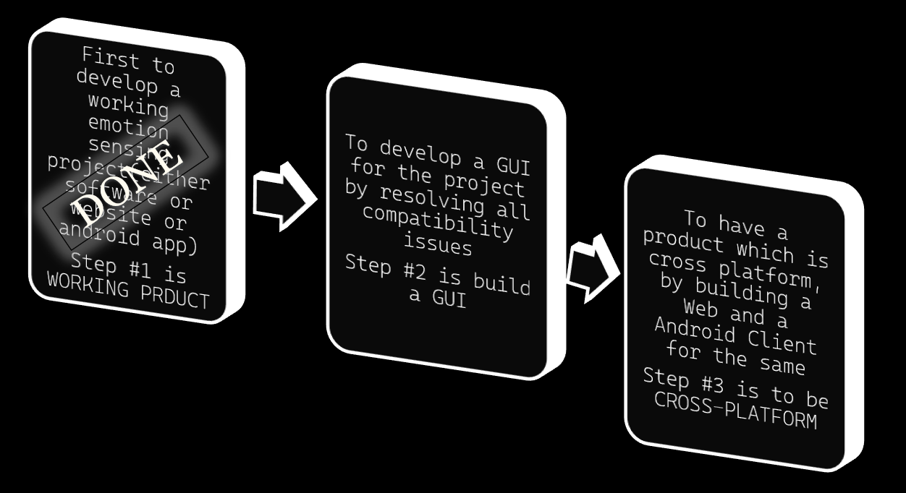

Refferences:

https://github.com/PiyushSawarkar/College-Mini-Project/blob/master/PAPER.pdf