Campus Ride Share Matching System
  - Software Architecture and Design Specification
Software Engineering Mini Project | PES University | Team 12
Version 1.2 | 12 October 2026 | Status: Prepared for review
This specification describes the web application architecture, data model, interfaces and booking rules used to fulfil the SRS. It guides development and integration testing.

Project team
Name | SRN
Pratham S Reddy | PES1UG24AM200
Piyush Shiv | PES1UG24AM191
Pravith Mohandas | PES1UG24AM202
Ramneek Gautam | PES1UG24AM220

Revision history
Version | Date | Change
1.0 | 12 Oct 2026 | Initial team draft
1.1 | 12 Oct 2026 | Aligned requirements design and tests with the application baseline
1.2 | 12 Oct 2026 | Clarified verification status and precise design references

Contents
1. Introduction
2. Document overview
3. Architecture
4. Design
5. Appendices

1 Introduction

1.1 Purpose scope and audience
This SAD defines the architecture and detailed design of Campusride for developers, test engineers and course evaluators. It covers accounts, ride search and offers, bookings, capacity, messaging, history and ratings. It implements the SRS v1.2 scope and supplies contracts for STP v1.2. Payments, live tracking, geographic route optimization and native apps are excluded.

1.2 Definitions
ADR means architecture decision record. REST denotes HTTP resource operations. STRIDE is a threat categorization model. A ride is a driver offer; a booking is a passenger request. A participant is the driver or an eligible passenger. Session identity is held server-side and referenced by the campus.sid cookie.

2 Document overview
Read Section 3 for responsibilities, constraints and security, then Section 4 for data, lifecycle, sequences and APIs. The RTM links the same FR, NFR and SEC identifiers across the three documents. Appendix references identify implementation files and tooling.

3 Architecture

3.1 Goals and constraints
Prioritize correct capacity updates, server-side authorization, a manageable student-project codebase and testable workflows. Use the existing React/Vite, Express/Node.js and PostgreSQL stack. Performance target: p95 ≤2 seconds for search and dashboard at 50 concurrent users on a documented test environment. Deployment remains a team-selected environment; no production availability certification is claimed.

3.2 Stakeholders and concerns
Stakeholder | Concern
Students | Useful matches, clear booking status and participant communication
Developers | Simple contracts, repeatable setup and predictable state changes
Test engineers | Isolated fixtures, concurrency tests and traceable results
Faculty and maintainers | Scope compliance, diagrams, evidence and safe configuration

3.3 Component UML diagram
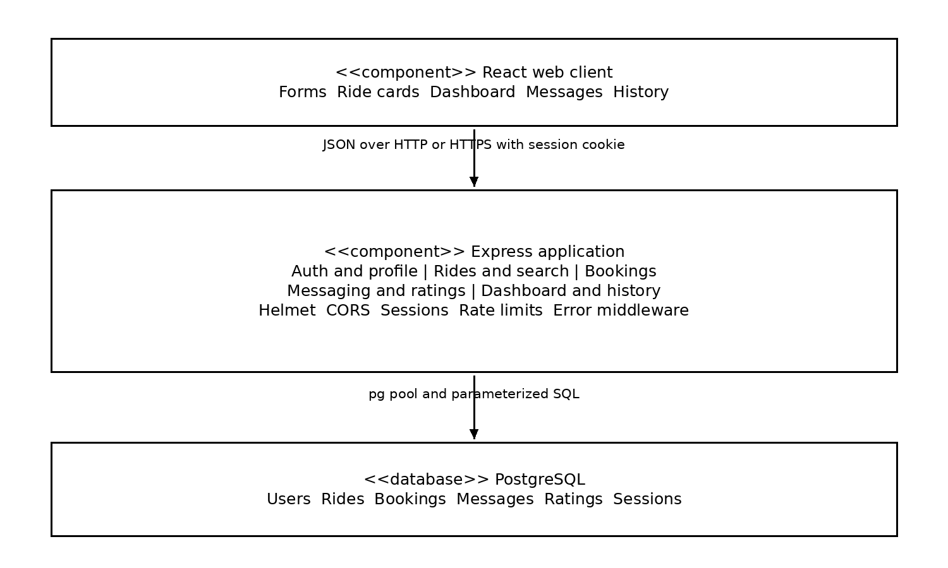
Figure 1 Layered application components and data flow.

3.4 Component descriptions
The React client manages forms and presentation. Auth/profile routes validate users, hash passwords and manage sessions. Ride/search routes publish and filter offers. Booking routes enforce lifecycle and seat allocation. Message/rating routes enforce participation. Dashboard/history routes query records scoped to the current user. PostgreSQL stores domain records and the session store.
These are logical components inside one Express application, currently implemented in src/backend/src/app.js. They are not separately deployed microservices. Helmet, CORS, rate limiting, JSON parsing and error middleware apply across route groups.

3.5 Pattern decisions and technology stack
Decision | Choice and rationale
ADR-01 Architecture | Layered modular monolith. One API process and one database simplify coursework development and transactions. Logical modules can later be split into files.
ADR-02 Persistence | PostgreSQL supports relational constraints, partial uniqueness and row locking for capacity.
ADR-03 Authentication | Server-side sessions stored in PostgreSQL; HttpOnly cookies keep session identifiers out of frontend JavaScript.
ADR-04 Matching | Case-insensitive text against pickup OR destination, optional date and seats; order by departure. No fuzzy proximity scoring.
ADR-05 Seat policy | Reserve on acceptance, not on request. Revalidate locked ride capacity at acceptance time.
ADR-06 Messaging | Ride-level shared conversation and 10-second client polling. WebSockets and direct-message storage are outside this baseline.

3.6 Technology and stores
Frontend: React 19, Vite 6, JavaScript and CSS. Backend: Express 5, pg, bcryptjs, express-session, connect-pg-simple, Helmet, cors and express-rate-limit. Database: PostgreSQL 16 in Compose and CI. Tests: Vitest, Testing Library and Node’s built-in node:test. CI: GitHub Actions on pull requests to main and pushes to main, using Node.js 22.

3.7 Risks and mitigation
Risk | Mitigation
Concurrent allocation | Lock ride and booking rows; test last-seat competition and transaction rollback.
Cancellation race | Make ride cancellation and active-booking updates atomic and adopt a consistent lock order before release.
Search date drift | Use explicit timestamp offsets and one configured database timezone; verify boundary-day tests.
Shared chat mistaken for direct chat | Label conversations as ride-wide and test with multiple accepted passengers.
Integration suite skipped | Set DATABASE_URL_TEST to an isolated database and inspect skipped counts.

3.8 Traceability and security architecture
Logical component | SRS requirements
Auth and profile | FR-01 FR-02 FR-03; SEC-01 SEC-02 SEC-05
Rides and search | FR-04 FR-05 FR-06 FR-17; NFR-01
Bookings | FR-07 FR-08 FR-09 FR-16 FR-18; NFR-04 SEC-03 SEC-04
Dashboard and history | FR-10 FR-12; NFR-06
Messaging and ratings | FR-11 FR-13; SEC-03 NFR-06
Middleware and operations | FR-14 FR-15; NFR-05 SEC-01 through SEC-05

3.9 Security architecture
STRIDE threat | Control and remaining work
Spoofing | bcrypt cost 12; PostgreSQL sessions; login regenerates session ID. Production secret must be mandatory.
Tampering | Server validation, ownership checks, parameterized SQL and constraints. Add consistent ID/query validation.
Repudiation | created_at and updated_at provide timestamps. Add structured action logs if audit trails are required.
Information disclosure | cleanUser excludes hashes; participant checks protect messages. Limit public projections to intended fields and remove operational guidance from production errors.
Denial of service | Auth limit 20 requests per 15 minutes and 20 kB body limit. Deployment monitoring and wider limits are future hardening.
Elevation of privilege | Driver ownership and booking participation checked using the session user, not client-submitted identity.
Trust boundaries separate the browser, API and database. Production uses HTTPS and secure cookie/proxy configuration. SameSite=Lax and configured-origin CORS reduce cross-origin exposure; an explicit CSRF/origin validation control should be reviewed before public deployment. Session secrets and database credentials belong in environment configuration.

4 Design

4.1 Data model and lifecycle
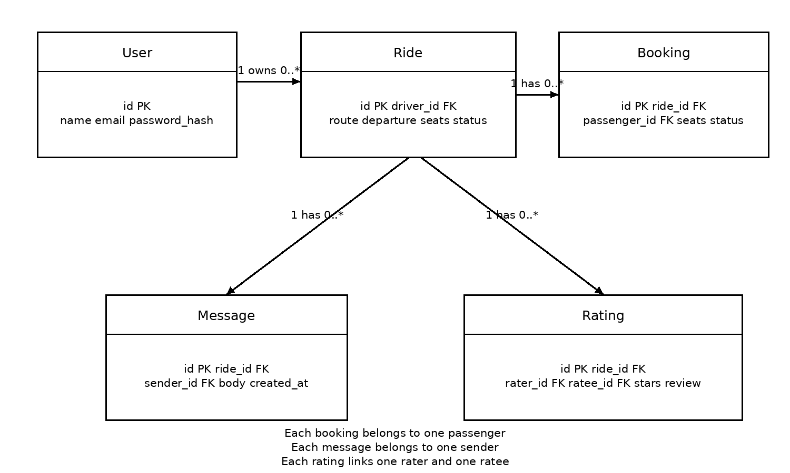
Figure 2 Domain class relationships corresponding to PostgreSQL tables.
Users have unique email. Rides contain total and available seats with database range checks. Bookings reference a ride and passenger; a partial unique index permits only one PENDING or ACCEPTED request per pair. Messages reference ride and sender. Ratings have unique ride/rater/ratee tuples and a 1–5 range. The session table is managed by connect-pg-simple.
Capacity rule: A PENDING request and its cancellation do not alter available seats. ACCEPTED reserves capacity; cancelling that booking restores capacity once, capped at total seats. COMPLETED retains the consumed capacity and does not automatically complete the parent ride. Ride cancellation closes the offer and cancels active bookings; the atomicity and capacity reconciliation work in Section 4.6 must be verified by TC-17.
Transition | Actor and capacity effect
PENDING to ACCEPTED | Owner only; OPEN future ride; lock ride; subtract seats.
PENDING to REJECTED | Owner only; no seat change.
PENDING or ACCEPTED to CANCELLED | Driver or passenger; restore seats only for prior ACCEPTED.
ACCEPTED to COMPLETED | Owner after departure; no seat restoration.
OPEN ride to CANCELLED | Owner; active bookings cancelled. Parent COMPLETED is not currently set by booking completion.

4.2 UML sequence diagrams
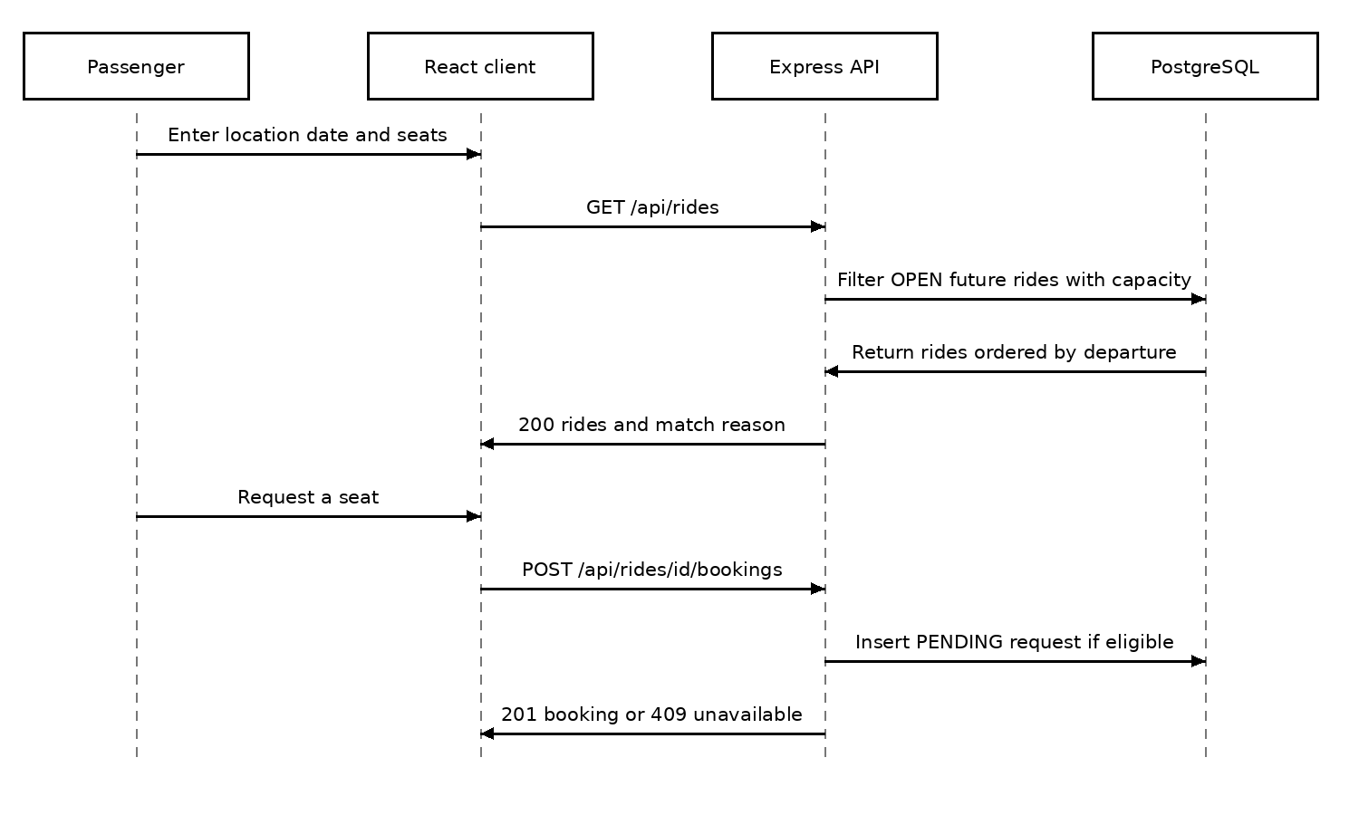
Figure 3 Search and create a pending booking. Authentication middleware precedes the booking insert.
The booking insert checks current capacity but reserves none. A partial unique index protects against concurrent duplicate active requests. A request may later fail acceptance if another request consumes the remaining seats.

4.2.1 Driver acceptance sequence
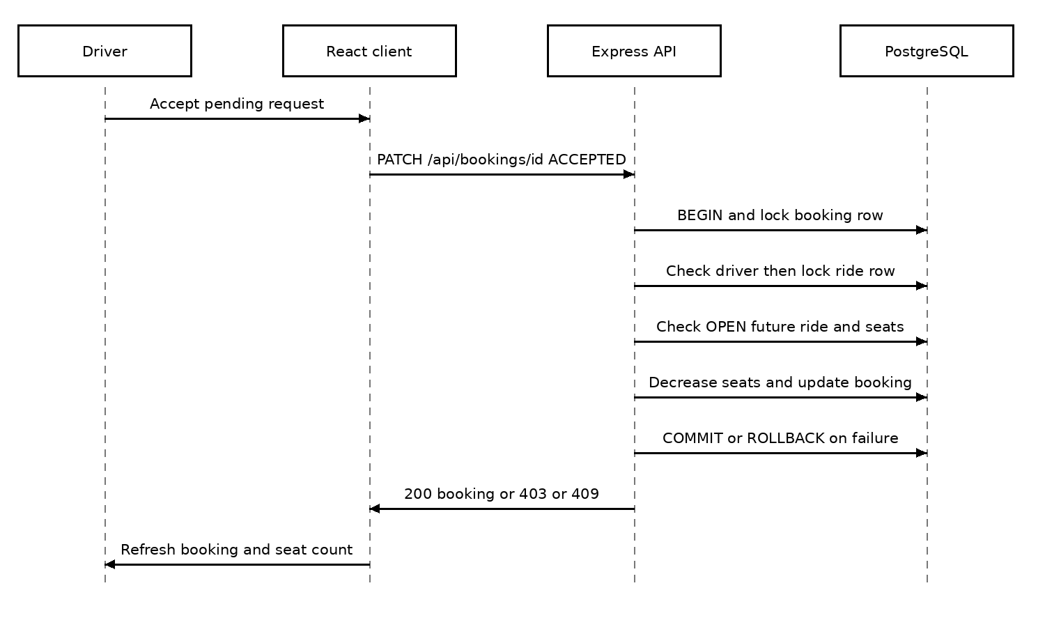
Figure 4 Driver acceptance with transactional seat reservation.
On acceptance, BEGIN precedes a booking-row lock, ownership validation and a ride-row lock. The API rechecks ride state, departure and available seats. It updates capacity and status together, then COMMITs; errors cause ROLLBACK and release the client.

4.3 API design
Base path: /api. Protected operations require the campus.sid cookie. JSON errors use {error: {code, message}}. Database records generally use snake_case, while request fields such as departureAt, totalSeats, rideId and rateeId use camelCase.
Component and operation | Request | Response and errors
Auth POST /auth/register | {name,email,password}; confirmation is client-only | 201 {user}; 400 validation; 409 EMAIL_TAKEN; 429 rate limit
Auth POST /auth/login | {email,password} | 200 {user}; 401 INVALID_CREDENTIALS; 429 rate limit
Auth POST /auth/logout | No body; session required | 204; 401 without session
Profile GET or PATCH /me | PATCH {name} | 200 {user}; 400 invalid name; 401
Rides GET /rides | q date seats query parameters | 200 {rides}; public; sorted by departure; up to 100
Rides POST /rides | {pickup,destination,departureAt,totalSeats,notes?} | 201 {ride}; 400 validation; 401
Bookings POST /rides/{id}/bookings | {seats} integer 1–8 | 201 {booking}; 400 invalid input; 401; 409 unavailable/duplicate/self
Bookings PATCH /bookings/{id} | {status: ACCEPTED|REJECTED|CANCELLED|COMPLETED} | 200 {booking}; 400 invalid status; 401; 403 policy; 404 missing; 409 capacity/state
Rides PATCH /rides/{id}/cancel | No body; owner required | 200 {ride}; 401; 404 if open owned ride not found

4.3.1 Request example
POST /rides with {"pickup":"PES University","destination":"Indiranagar Metro","departureAt":"2026-10-20T17:00:00+05:30","totalSeats":2,"notes":"Meet at main gate"}. A successful response contains the created ride with total_seats=2 and available_seats=2. POST /rides/{id}/bookings with {"seats":1} creates a PENDING request.

4.3.2 Coordination and read APIs
Operation | Contract
GET /rides/mine | Signed-in owner’s rides with pending_requests, newest departure first.
GET /rides/{id}/bookings | Owner only; {bookings}; 403 non-owner, 404 missing ride.
GET /dashboard | {offered,bookings,requests}; own future offers limit 5, booking and request lists limit 10 each.
GET /history | {rides}; own driver/passenger records with role, booking_status and counterpart; up to 100.
GET /conversations | {conversations}; accepted/completed bookings; rows may repeat a ride for multiple passengers.
GET /rides/{id}/messages | {messages}; owner or accepted/completed passenger; oldest first; first 300.
POST /rides/{id}/messages | {body}; 201 {message}; 400 invalid text; 401; 403 ineligible.
POST /ratings | {rideId,rateeId,stars,review?}; 201 {rating}; 400 invalid; 403 ineligible; 409 duplicate.
GET /health and /openapi.json | Public API liveness and route metadata. Health does not query database readiness.

4.4 Error handling logging and monitoring
Known validation and permission failures return 4xx responses. Conflicts return 409; recognized database configuration/connectivity failures return 503; unexpected errors return 500. Server logs record unexpected failures. Production logs must exclude credentials and private message bodies. Track error rate, API latency, database availability, failed login attempts and CI failures; no monitoring service is currently configured.

4.5 UX design
Use responsive cards, explicit state labels, labelled forms, keyboard navigation and visible validation. Offer forms accept 1–8 seats. Search filters available rides; the request action submits one seat. Driver controls appear in Overview and My rides. Completion appears after departure. Message polling occurs every 10 seconds. A refresh updates affected views after actions.

4.6 Open issues and next steps
Before release, add the passenger cancellation control in the UI; make ride cancellation atomic with booking changes and reconcile available seats; normalize invalid IDs and date/seat filters to 400 errors; configure the timezone; reject default production secrets; and label chat as shared by ride. Deduplicate conversation entries and address the 300-message limit. Verify HTTPS, proxy/session behavior and CSRF controls in the chosen deployment. These are implementation gaps, not completed features.

5 Appendices

5.1 Glossary
Term | Definition
API | Application Programming Interface; enables communication between the frontend and backend.
ADR | Architecture Decision Record; documents an important architectural choice and its rationale.
CI | Continuous Integration; automated checks run when code changes are submitted.
ER Diagram | Entity-Relationship Diagram; represents entities, attributes and relationships in the database.
FK | Foreign Key; references a key in another database table to maintain relationships.
HTTP/REST | Protocol and architectural style used for communication between the frontend and backend.
JWT | JSON Web Token; a token format commonly used to represent claims between parties.
PK | Primary Key; uniquely identifies a record in a database table.
RTM | Requirements Traceability Matrix; maps requirements to design elements and test cases.
SAD | Software Architecture and Design Specification.
SRS | Software Requirements Specification.
STP | Software Test Plan.
STRIDE | A threat-modelling framework covering spoofing, tampering, repudiation, information disclosure, denial of service and elevation of privilege.
UML | Unified Modeling Language; a notation for representing software structure and behaviour.

5.2 References
The following project artefacts and technical resources support this specification:
Team 12, Campus Ride Share Matching System — Software Requirements Specification (SRS), Version 1.2, 12 October 2026.
Team 12, Campus Ride Share Matching System — Software Test Plan (STP), Version 1.2, 12 October 2026.
Team 12, Campus Ride Share Matching System project repository and README, available at https://github.com/PiyushShiv26/SE-mini-project.
Project implementation: src/backend/src/app.js, src/db/schema.sql and src/frontend/src/App.jsx.
Automated tests and continuous integration configuration: tests/backend, tests/frontend and .github/workflows/ci.yml.
The repository files are implementation references. They should be checked against the relevant commit when validating the final implementation.

5.3 Tools
Tool | Purpose
React and Vite | Frontend application and development/build tooling.
Node.js and Express | Backend runtime and HTTP API implementation.
PostgreSQL | Relational database for application records.
Docker Compose | Local database and development environment setup, where configured.
Git and GitHub | Source control, collaboration and repository hosting.
GitHub Actions | Automated continuous integration checks.
Microsoft Word | Preparation and formatting of project documentation.
Python document tooling | Document generation and formatting support.
Diagram-drawing tools | Creation of architecture, data-model and sequence diagrams.
Team review: ____________________ Date: __________
Faculty approval: ________________ Date: __________

