Campus Ride Share Matching System
  - Software Requirements Specification
Software Engineering Mini Project | PES University | Team 12
Version 1.2 | 12 October 2026 | Status: Prepared for review
This specification defines the student ride-sharing requirements and acceptance criteria. It establishes a common baseline for implementation, architecture review and testing.

Project team
Name | SRN
Pratham S Reddy | PES1UG24AM200
Piyush Shiv | PES1UG24AM191
Pravith Mohandas | PES1UG24AM202
Ramneek Gautam | PES1UG24AM220

Revision history
Version | Date | Change
1.0 | 12 Oct 2026 | Initial team draft
1.1 | 12 Oct 2026 | Aligned requirements design and tests with the application baseline
1.2 | 12 Oct 2026 | Clarified verification status and precise design references

Contents
1. Introduction
2. Overall description
3. External interface requirements
4. System features and functional requirements
5. Non functional and security requirements
6. Quality attributes and acceptance tests
7. System models and use cases
8. Requirements traceability matrix

Approval
Team review: __________________ Date: __________
Faculty or course evaluator: __________________ Date: __________

1 Introduction

1.1 Purpose
The Campus Ride-Share Matching System connects students offering rides with students requesting seats. The SRS defines observable behavior and measurable acceptance criteria for the browser application and backend API. Student drivers and passengers, developers, testers and course evaluators are its audience.

1.2 Scope
The release includes accounts, profiles, ride offers, location/date/capacity search, booking decisions, cancellations, participant messaging, ride history and ratings. One account may act as both driver and passenger. Payments, live GPS, map navigation, automatic route optimization, emergency dispatch and native mobile apps are excluded.

1.3 Definitions and references
Term | Meaning
SRS SAD STP | Requirements specification, architecture and design specification, software test plan
RTM | Requirements traceability matrix
Ride and booking | A driver’s offer and a passenger’s seat request; these have separate states
API and session | JSON service interface and cookie-linked server authentication state
References: Team 12 project brief; SAD v1.2; STP v1.2; repository README.md, src/backend/src/app.js, src/db/schema.sql and tests/.

2 Overall description
Campusride is a layered web application: React 19 with Vite presents the interface, Express 5 on Node.js handles the API, and PostgreSQL stores accounts and ride data. The server is authoritative for permissions and capacity. Local development uses a browser, Node.js and PostgreSQL 16; Docker Compose provides a database service. GitHub Actions runs the project checks with Node.js 22.

2.1 Roles constraints and assumptions
Visitors may register, sign in and call the public ride search. Registered students may offer rides or request seats. Maintainers configure the environment and examine CI and service logs; there is no separate application administrator interface. Accounts are intended for the campus community, but this release accepts valid email syntax and does not verify university membership. Users need a supported browser and network connection.
Use synthetic data for testing and environment configuration for credentials. Store departure timestamps with timezone information. Matching uses text, date and seats; it does not infer nearby geographic routes or rank by an AI score.

3 External interface requirements
Interface | Contract
User interface | Landing and account forms; Overview; Find a ride; Offer a ride; My rides; Messages; Ride history; Profile. Show validation, loading, empty and booking status states.
Hardware | Standard desktop or mobile browser and network; no special sensors or vehicle hardware.
Software | React calls /api JSON endpoints with credentials included. Express uses pg and connect-pg-simple for durable data and sessions.
Communication | Local HTTP; HTTPS for production. Credentialed CORS allows the configured frontend origin. The body limit is 20 kB.

3.1 Business rules
Pending requests do not reserve seats. Acceptance reserves seats while locking the ride row. Rejection changes no capacity. Cancelling an accepted booking restores seats up to the original total. Multiple pending requests may compete for the last seat; acceptance determines allocation.
Booking states are PENDING, ACCEPTED, REJECTED, CANCELLED and COMPLETED. Completion applies to individual bookings after departure and does not automatically change the parent ride to COMPLETED. Ride cancellation changes the parent and its active bookings. Messages are shared by ride, so all eligible passengers can read the same conversation; they are not private one-to-one chats.
The API supports multi-seat requests, while the present UI request button submits one seat. The search seat selector filters results and does not set the booking quantity. History includes all relevant offers and booking outcomes, including upcoming records.

4 System features and functional requirements
All requirements are release requirements. FR-03, FR-11, FR-12, FR-13 and FR-15 are Medium priority; the remaining FRs are High priority. The source is the Team 12 project brief and student workflow. Each acceptance criterion is verified through the matching STP test case.

4.1 Accounts and rides

FR-01 Registration
The system shall create an account using a name of 2–80 characters, a valid unique email of at most 254 characters and a password of 8–72 characters.
Acceptance: 201 with user and session; invalid input 400; duplicate email 409. Test: TC-01.

FR-02 Authentication
The system shall sign in with valid credentials and invalidate the session on sign out.
Acceptance: Valid login 200; incorrect credentials 401; logout 204; old session denied. Test: TC-02.

FR-03 Profile
The system shall allow the signed-in user to view their profile and update their name.
Acceptance: Name persists; email and identity are not editable through this endpoint. Test: TC-03.

FR-04 Offer ride
The system shall publish pickup and destination of 1–120 characters, future departure, 1–8 total seats and optional notes up to 500 characters.
Acceptance: 201 ride with available seats equal to total seats; invalid mandatory data 400. Test: TC-04.

FR-05 Search rides
The system shall match a case-insensitive substring against pickup OR destination and optionally filter by date and minimum seats.
Acceptance: Only OPEN future rides with enough seats appear, ordered by departure; maximum 100. Test: TC-05.

FR-06 Ride details
The system shall display route, departure, seats, notes and driver summary in ride cards.
Acceptance: Returned details match persisted ride; no password hash is disclosed. Test: TC-06.

4.2 Bookings dashboard and messages

FR-07 Request seats
The system shall create a PENDING request for 1–8 seats when the ride is OPEN, future and has enough capacity.
Acceptance: 201 request without reducing seats; self-booking and active duplicate denied with 409. Test: TC-07.

FR-08 Driver decision
The system shall allow only the ride owner to accept or reject a PENDING request.
Acceptance: Acceptance checks live capacity and reduces seats; rejection leaves seats unchanged. Test: TC-08.

FR-09 Cancel booking
The system shall allow the driver or passenger to cancel a PENDING or ACCEPTED booking.
Acceptance: Pending cancellation changes no capacity; accepted cancellation restores seats once up to total seats; repeated terminal cancellation is rejected. Test: TC-09.

FR-10 Dashboard
The system shall display the signed-in student’s offered rides, passenger bookings and driver requests.
Acceptance: Records belong to that user; lists respect the endpoint limits. Test: TC-10.

FR-11 Messaging
The system shall allow the driver and ACCEPTED or COMPLETED passengers to exchange ride-level text messages of 1–2000 characters.
Acceptance: Authorized read/send succeeds; pending passengers and outsiders denied. Test: TC-11.

FR-12 History
The system shall display the student’s offered rides and bookings with role and counterpart details.
Acceptance: Only relevant records appear, newest departure first, up to 100 rows. Test: TC-12.

4.3 Ratings integrity and operations

FR-13 Ratings
The system shall allow driver and passenger to rate each other after booking completion and departure, with 1–5 stars.
Acceptance: One rating per ride/rater/ratee; self-rating invalid, ineligible 403, duplicate 409. Test: TC-13.

FR-14 Validation and errors
The system shall reject invalid inputs and unauthorized actions using structured JSON errors.
Acceptance: Response uses error.code and error.message without password or stack trace. Test: TC-14.

FR-15 Service metadata
The system shall expose API liveness and OpenAPI route metadata without sensitive configuration.
Acceptance: Health returns status ok and service name; metadata reports OpenAPI 3.0.3. Test: TC-15.

FR-16 Seat integrity
The system shall keep available seats between zero and total seats during simultaneous booking decisions.
Acceptance: Two acceptances competing for the final seat yield one success and one 409. Test: TC-16.

FR-17 Cancel ride
The system shall allow the owner to cancel an OPEN ride and cancel its active bookings.
Acceptance: Ride becomes CANCELLED; active bookings become CANCELLED; new requests denied. Test: TC-17.

FR-18 Complete booking
The system shall allow the owner to complete an ACCEPTED booking once departure has passed.
Acceptance: Only the owner may complete an accepted booking after departure; completion retains the consumed capacity and enables ratings without marking the parent ride COMPLETED. Test: TC-18.

5 Non functional and security requirements
ID and category | Requirement and measure | Test
NFR-01 Performance | Target p95 ≤2 seconds for ride search and dashboard at 50 concurrent users on a documented local test environment, excluding password hashing. | TC-19
NFR-02 Usability | Core forms and navigation shall be usable by keyboard with visible focus and labelled inputs, without blocking overflow at 375 and 1440 pixel widths. | TC-20
NFR-03 Compatibility | Registration, search and booking flows shall complete in current Chrome and Firefox; Safari is included when available. | TC-21
NFR-04 Reliability | Committed records shall survive an API restart and failed booking acceptance shall roll back both capacity and booking changes. | TC-22
NFR-05 Maintainability | Each proposed merge shall pass frontend lint, tests and build and backend tests with isolated PostgreSQL integration enabled. | TC-23
NFR-06 Privacy | Public ride results shall exclude passwords, email addresses and session secrets; private records shall require appropriate ownership or participation. | TC-24

5.1 Security objectives
SO-01 Protect accounts, credentials and authenticated sessions from unauthorized access. SO-02 Protect private ride coordination and preserve booking and capacity integrity under malicious or concurrent requests.

SEC-01 Secure transport and session
Production shall use HTTPS and cookies with Secure, HttpOnly and SameSite=Lax; logout shall destroy the server session. Verification: TC-25.

SEC-02 Credentials
Passwords shall be stored as bcrypt hashes with cost 12 and excluded from user responses. Authentication routes shall limit requests to 20 per 15 minutes per client IP. Verification: TC-26.

SEC-03 Authorization
The API shall enforce ride ownership for driver actions and participant eligibility for messages and ratings, independently of the UI. Verification: TC-27.

SEC-04 Data integrity
SQL shall use parameterized values, database constraints and transactional capacity updates. Verification: TC-28.

SEC-05 Configuration
Runtime secrets shall come from environment configuration and shall not be committed; production shall reject missing or development session secrets. Verification: TC-29.

6 Quality attributes and acceptance tests
Acceptance requires a complete student workflow: register driver and passenger, publish and find a future ride, request and accept a seat, exchange a message, complete the booking after departure, view history and rate the counterpart. Unauthorized actions must fail without changing data. Performance and production security controls are targets to verify, rather than inferred pass results.
Quality attribute | Acceptance evidence
Correctness | TC-01 through TC-18 and TC-16 concurrency evidence
Availability and integrity | TC-22 restart and rollback results; health is liveness only, not database readiness
Usability and compatibility | TC-20 and TC-21 viewport, keyboard and browser records
Security and privacy | TC-24 through TC-29 negative tests and configuration review
Maintainability | TC-23 CI logs with database integration enabled

7 System models and use cases
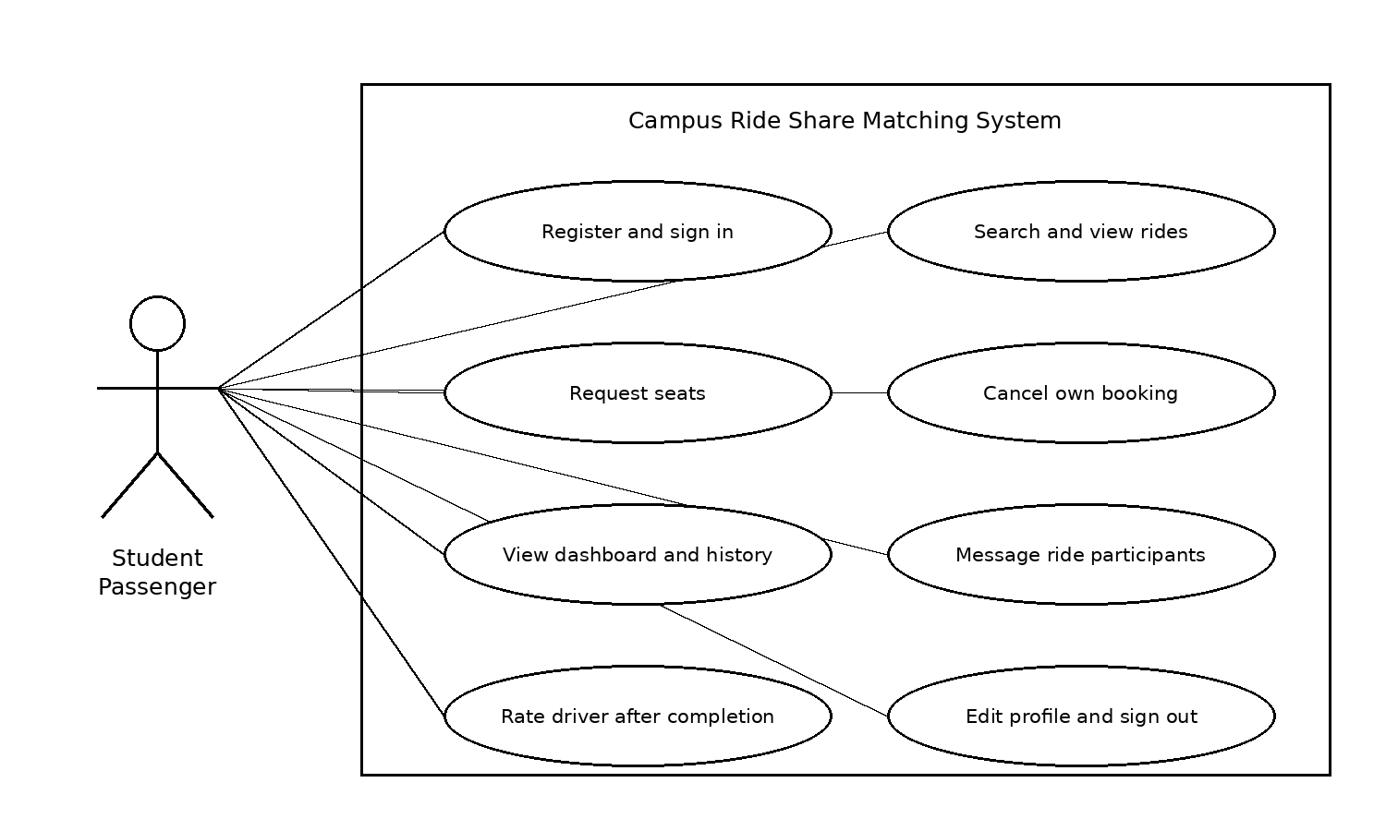
Figure 1 Passenger use cases. Driver and passenger are roles of the same student account.

7.1 Driver use cases
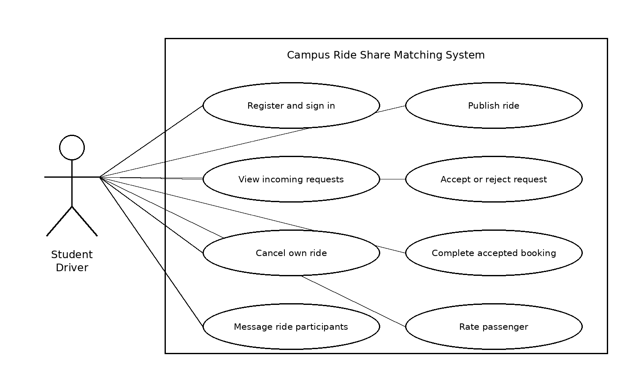
Figure 2 Driver use cases. Authentication is required for all state-changing actions.

7.2 Primary use case specification
Use case | Precondition and normal outcome
Request seats | Signed-in passenger and eligible future ride. Search, view ride, request seats. A PENDING booking is created; available seats are unchanged.
Accept request | Signed-in ride owner and PENDING booking. Lock and validate the ride, reserve capacity and mark ACCEPTED in one transaction.
Failure alternatives | Insufficient capacity or unavailable ride returns 409. Non-owner decisions return 403. Failed acceptance leaves both records unchanged.

8 Requirements traceability matrix
Verification status Not run means that a design reference and planned test exist, but execution evidence has not been recorded. It does not mean Passed. References point to the numbered SAD v1.2 sections and STP v1.2 test procedures.
Requirement | SAD section and design | Test | Test status
FR-01 | 3.4 Auth; 4.3 POST /auth/register | TC-01 | Not run
FR-02 | 3.9 Sessions; 4.3 login and logout | TC-02 | Not run
FR-03 | 3.4 Profile; 4.3 GET and PATCH /me | TC-03 | Not run
FR-04 | 3.4 Rides; 4.3 POST /rides | TC-04 | Not run
FR-05 | 3.5 ADR-04; 4.3 GET /rides | TC-05 | Not run
FR-06 | 4.3 GET /rides; 4.5 Ride cards | TC-06 | Not run
FR-07 | 4.1 PENDING; 4.2 Request sequence | TC-07 | Not run
FR-08 | 4.1 Decisions; 4.2.1 Accept sequence | TC-08 | Not run
FR-09 | 4.1 CANCELLED; 4.3 PATCH /bookings/{id} | TC-09 | Not run
FR-10 | 4.3.2 GET /dashboard | TC-10 | Not run
FR-11 | 3.5 ADR-06; 4.3.2 Message APIs | TC-11 | Not run
FR-12 | 4.3.2 GET /history | TC-12 | Not run
FR-13 | 4.1 Ratings model; 4.3.2 POST /ratings | TC-13 | Not run
FR-14 | 4.4 Error handling; 3.9 Validation | TC-14 | Not run
FR-15 | 4.3.2 Health and OpenAPI; 4.4 Liveness | TC-15 | Not run
FR-16 | 3.5 ADR-05; 4.1 Constraints; 4.2.1 Locks | TC-16 | Not run
FR-17 | 4.1 Ride cancellation; 4.3 Cancel API | TC-17 | Not run
FR-18 | 4.1 COMPLETED; 4.3 PATCH /bookings/{id} | TC-18 | Not run
NFR-01 | 3.1 Latency target; 3.5 ADR-04 Search | TC-19 | Not run
NFR-02 | 4.5 UX design | TC-20 | Not run
NFR-03 | 3.6 React web client; 4.5 UX design | TC-21 | Not run
NFR-04 | 4.1 Persistence; 4.2.1 Rollback | TC-22 | Not run
NFR-05 | 3.6 Tests and CI | TC-23 | Not run
NFR-06 | 3.9 Disclosure controls; 4.3.2 Access | TC-24 | Not run
SEC-01 | 3.9 HTTPS and session controls | TC-25 | Not run
SEC-02 | 3.9 Hashing and rate limits | TC-26 | Not run
SEC-03 | 3.9 Ownership and participation | TC-27 | Not run
SEC-04 | 4.1 Constraints; 4.2.1 Transaction | TC-28 | Not run
SEC-05 | 3.9 Environment secrets; 4.6 Hardening | TC-29 | Not run

