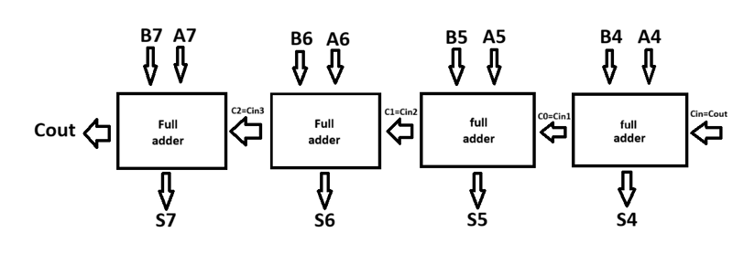
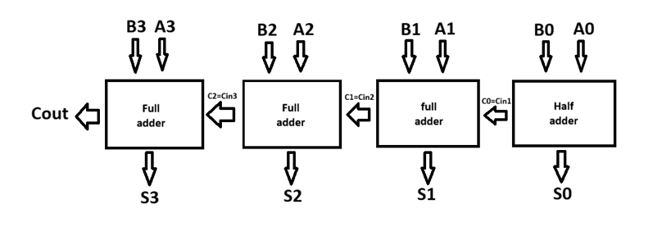

So the ideas was to get the best case of approximation method in 8 bit carry ripple carry adder , approximation in lower nibbles of 8 bit no. A[0:3] , and in that too approximation in carry propagations cases .
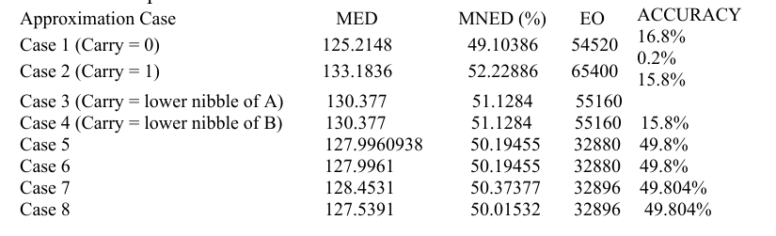
From the previous research, we concluded that case 5 came across the best case scenario among that 8 cases , a little bit brief about of case 5 is that Cin1= A0, Cin2=B1, Cin3=A2, Cin4=B3.
You asked me do a image processing of 512*512 grayscale image using this approximation methodology.
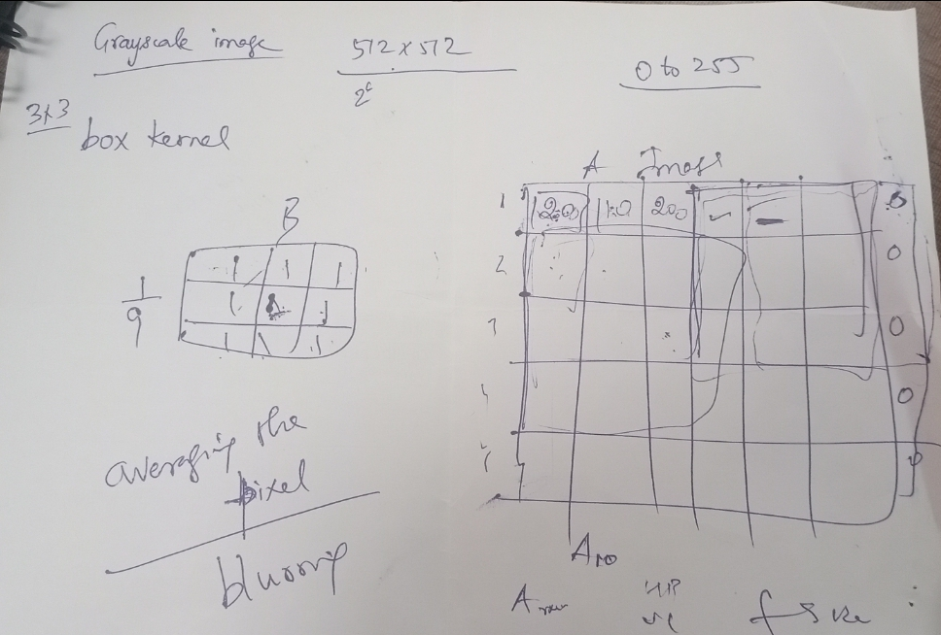

I Used a grayscale image of 512*512 and kernel of 3*3 , multiplying with image matrix with stride=1 .
Case -1 , I did without padding and case-2 with padding.
When kernel will multiply with 512*512 , giving 9 partial products , each pixel of image having information in 8 bits , so while 9 partial products , I used the approximation method and divide it by 9 to get avg value and output putted in the output matrix .
CASE-1 WITHOUT PADDING
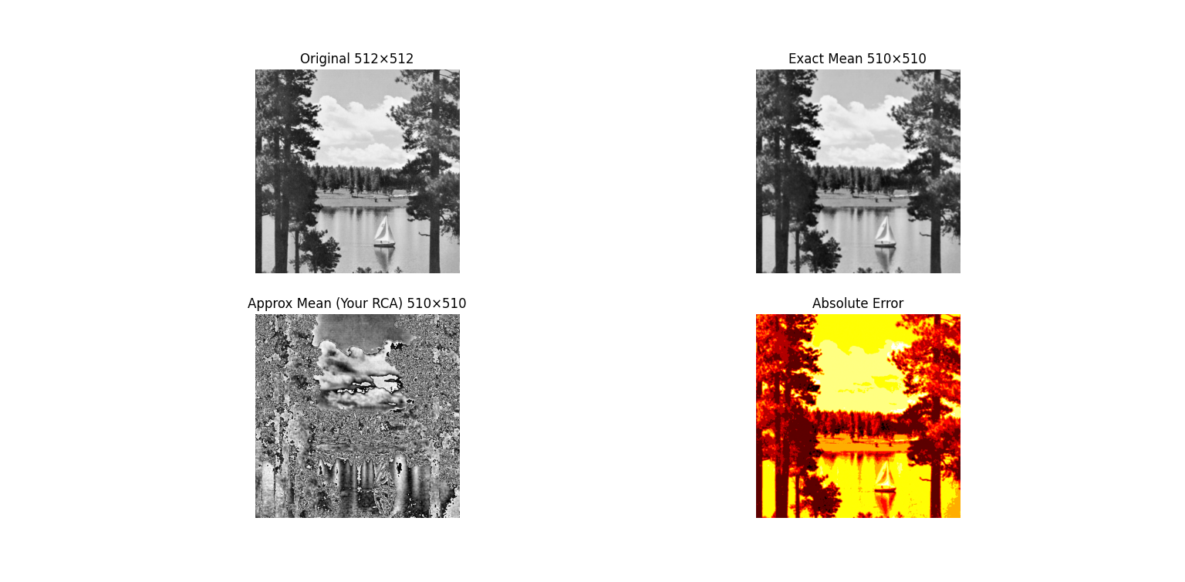

CASE-2 WITH PADDING
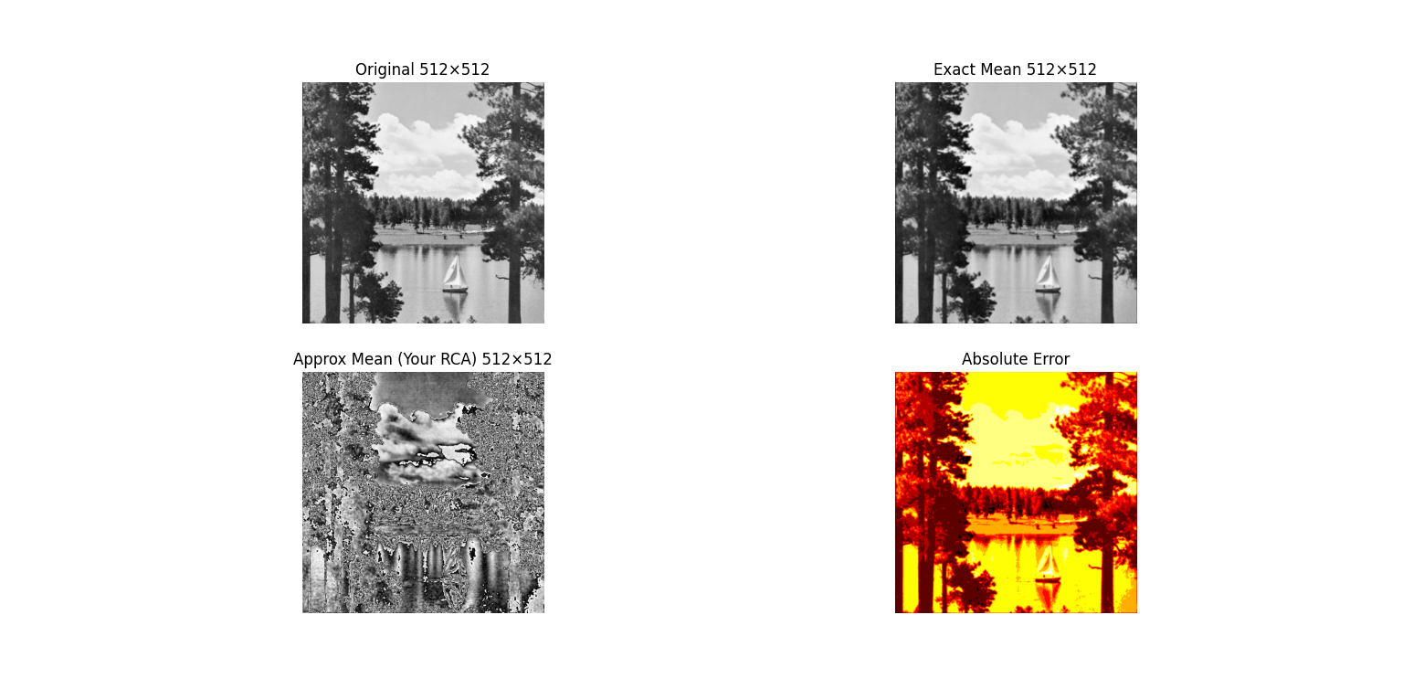

Original is my input image , exact mean is the processed image without any approximation , approx mean is the approximated image and absolute error is original – approx. image.
What I remembered u said that approximated image should be a blurred image but I am getting a very distorted image . So please give a comment on this , where I making a mistake.
Reference , when I asked gpt about this , its saying due to a lot of approximation in the lower nibble of pixel. I should approximate only 1 or 2 bit .

PIYUSH SINGH
524EC0014

