**ATMA RAM SANATAN DHARMA COLLEGE**

**UNIVERSITY OF DELHI**



**DATABASE MANAGEMENT SYSTEMS**

**PRACTICAL FILE**

**SUBMITTED BY:**

**PIYUSH SOLANKI**

**COLLEGE ROLL NO: 21/18092**

**BSC (HONS) COMPUTER SCIENCE**

**SUBMITTED TO:**

**Ms. MANISHA BAGRI**

**DEPARTMENT OF COMPUTER SCIENCE**

**INDEX**

|  |  |
| --- | --- |
| SNO. | DESCRIPTION |
| 1. | Query to display Employee name , Job , Hire Date , Employee number ; for each employee with Employee number appearing first. |
| 2. | Query to display unique Jobs from the Employee table. |
| 3. | Query to display the Employee Name concatenated by a Job separated by a comma. |
| 4. | Query to display all the data from the Employee Table. Separate each column by a comma and name the said column as THE_OUTPUT. |
| 5. | Query to display the Employee Name and Salary of all the employees earning more than $2850. |
| 6. | Query to display Employee Name and Department Number for the Employee No=79. |
| 7. | Query to display Employee Name and Salary for all employees whose salary is not in the range $1500 and $2850. |
| 8. | Query to display Employee Name and Department No. of all the employees in Dept 10 and Dept 30 in the alphabetical order by name. |
| 9. | Query to display Name and Hire Date of every Employee who was hired in 1981. |
| 10. | Query to display Name and Job of all employees who have not been assigned a supervisor. |
| 11. | Query to display the Name ,Salary, Commission for all the employees who earn commission. |
| 12. | Sort the data in descending order of Salary and Commission. |
| 13. | Query to display Name of all the employees where the third letter of their name is ‘A’. |
| 14. | Query to display Name of all employees either have two ‘R’s or have two ‘A’s in their name and are either in Dept No =30 or their Manager’s Employee No=’7788’. |
| 15. | Query to display Name ,Salary ,Commission for all employees whose Commission amount is greater than their Salary increased by 5%. |
| 16. | Query to display the Current Date along with the day name. |
| 17. | Query to display Name, Hire Date and Salary Review Date which is the 1st Monday after six months of employment. |
| 18. | Query to display Name and Calculate the number of months between today and the date on which employee was hired of Department ‘Purchase’. |
| 19. | Query to display the following for each Employee <E-Name> earns <Salary> monthly but wants <3 * Current Salary> . Label the Column as Dream Salary. |
| 20. | Query to display Name with 1st letter Capitalized and all other letter lower case and length of their name of all the employees whose name starts with ‘J’ ,’A’ and ‘M’. |
| 21. | Query to display Name ,Hire Date and Day of the week on which the employee started. |

**DATABASE SCHEMA**

Relation : EMPLOYEE

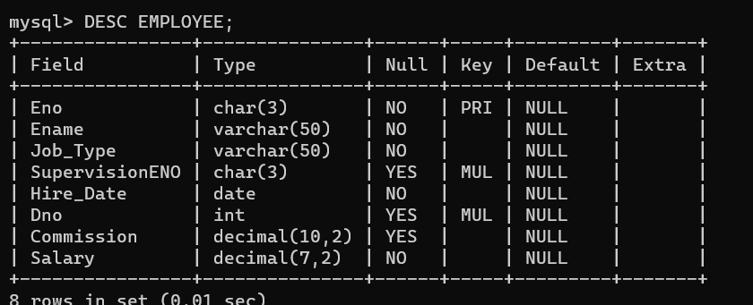

Relation : DEPARTMENT

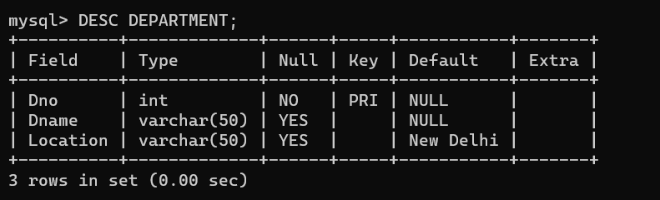

**DDL**

CREATE TABLE EMPLOYEE(

Eno CHAR(3) NOT NULL PRIMARY KEY,

Ename VARCHAR(50) NOT NULL ,

Job_Type VARCHAR(50) NOT NULL,

SupervisionENO CHAR(3) ,

Hire_Date DATE NOT NULL,

Dno INT , Commission DECIMAL(10,2) ,

Salary DECIMAL(7,2) NOT NULL);

CREATE TABLE DEPARTMENT(

Dno INT NOT NULL,

Dname VARCHAR(50) ,

Location VARCHAR(50) DEFAULT ‘New Delhi’ ,

PRIMARY KEY(Dno) );

ALTER TABLE EMPLOYEE

ADD CONSTRAINT SupervisionConstraint

FOREIGN KEY (SupervisionENO) REFERENCES EMPLOYEE(Eno);

ALTER TABLE DEPARTMENT

ADD CONSTRAINT DepartmentConstraint

FOREIGN KEY (Dno) REFERENCES DEPARTMENT(Dno);

**DML**

INSERT INTO DEPARTMENT VALUES(10,'Headquarters' ,'Mumbai'),(45,'Legal','Mumbai'),(30,'IT','Bengaluru'),(20,'Outreach','Dallas'),(95,'Purchase','Dallas');

INSERT INTO DEPARTMENT (Dno ,Dname) VALUES(90,'Sales'),(40,'Administration'),(50,'Research');

INSERT INTO EMPLOYEE

VALUES('811','Shay Restieaux','Lawyer','232','1999-04-16',45,574.69,500.22),

('823','Marcille Occleshaw','Lawyer','232','2003-12-27',45,574.68,507.10),

('832','Desiri Allott','Payment Coordinator','89','2007-11-03',95,239.84,683.09),

('87','Blake Lewis','Sales Intern','86','2008-05-02',90,125.45,921.37),

('997','Mag Giacomo','Tech Intern','23','2009-05-12',30,NULL,200.80);

INSERT INTO EMPLOYEE

VALUES ('763','Rodrick Haighton','Computer System Engineer','23','2005-05-08',30,NULL,627.74),

('981','Nina Fisby','System Analyst','23','2017-07-26',30,324.39,920.84),

('809','Cornie Munby','Software Consultant','23','1986-06-07',30,NULL,688.37),

('915','Layton Murrie','Graphic Designer','23','2006-06-24',30,NULL,640.31),

('498','Skell Woolerton','Software Tester','23','2004-04-04',30,NULL,506.44),

('842','Rivy Buzek','Help Desk Technician',NULL,'1982-05-25',30,NULL,295.31);

INSERT INTO EMPLOYEE

VALUES('778','John Smith','Managing Director',NULL,'1980-06-12',10,NULL,5800.23),

('153','Andy Beaford','VP Accounting','778','2000-09-08',40,NULL,502.30),

('23','Piyush Solanki','SDE Manager','778','2001-09-19',30,NULL,2465.92),

('25','Jatin Solanki','Accounts Manager','778','2003-03-01',40,NULL,2865.92),

('86','Tania Chauhan','Sales Manager','778','1983-08-14',90,235.90,2921.37),

('89','Alicia Jones','Purchase Manager','778','1982-10-26',95,NULL,980.35),

('232','Isa Haques','Legal Manager','778','1996-07-23',45,NULL,651.05);

**QUERY 1**

**Description**

**Query to display Employee Name, Job, Hire Date, Employee Number for each employee with the**

**Employee Number appearing first.Query with result:**

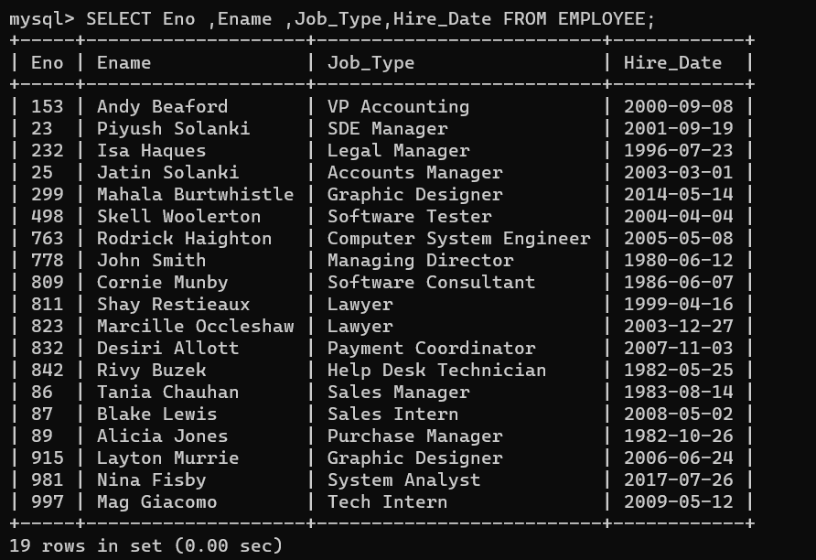

**QUERY 2**

**Description**

**Query to display unique jobs from the Employee Table.Query with result:**

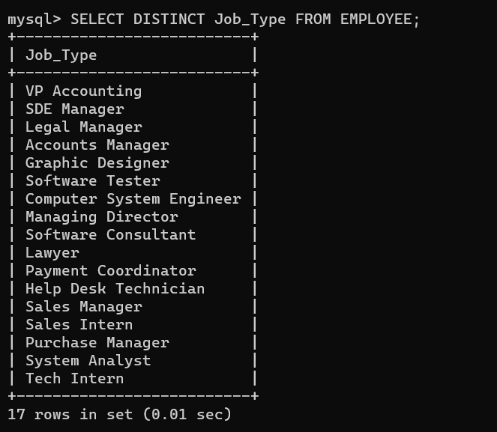

**QUERY 3**

**Description**

**Query to display the Employee Name concatenated by a Job separated by a comma.**

**Query along with result:**

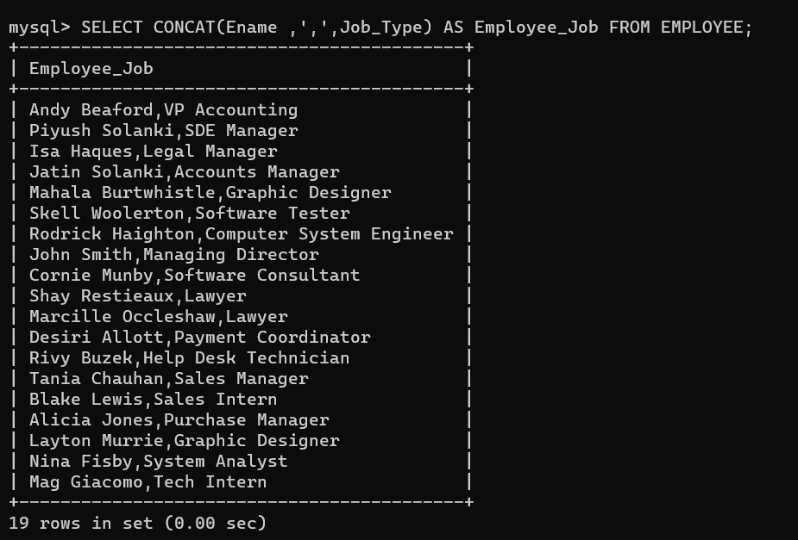

**QUERY 4**

**Description**

**Query to display all the data from the Employee Table. Separate each Column by a comma and name**

**the said column as THE_OUTPUT.Query along with result:**

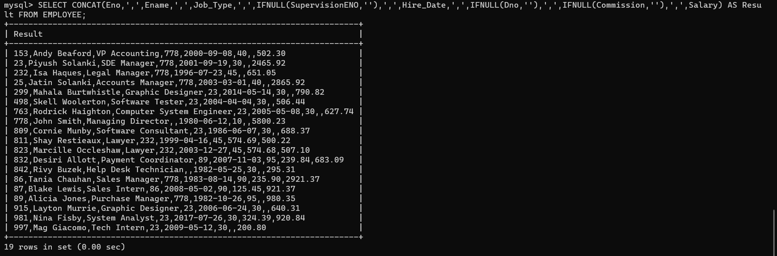

**QUERY 5**

**Description**

**Query to display the Employee Name and Salary of all the employees earning more than $2850.**

**Query along with result:**

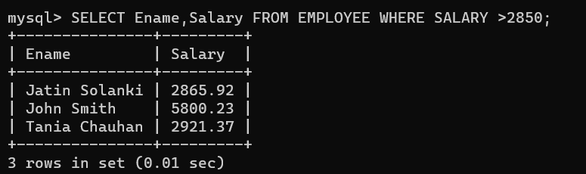

**QUERY 6**

**Description**

**Query to display Employee Name and Department Number for the Employee No = 89**

**Query along with result:**

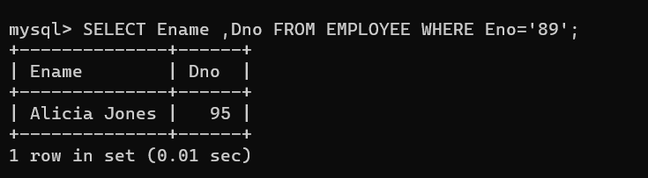

**QUERY 7**

**Description**

**Query to display Employee Name and Salary for all employees whose salary is not in the range of**

**$1500 and $2850.**

**Query along with result:**

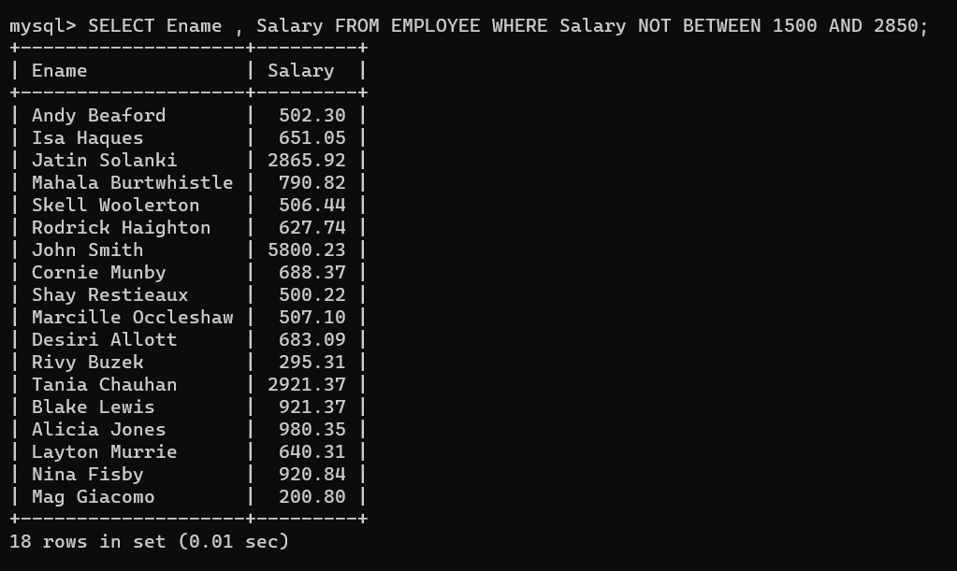

**QUERY 8**

**Description**

**Query to display Employee Name and Department No. of all the employees in Dept 10 and Dept 30**

**in the alphabetical order by name.**

**Query along with result:**

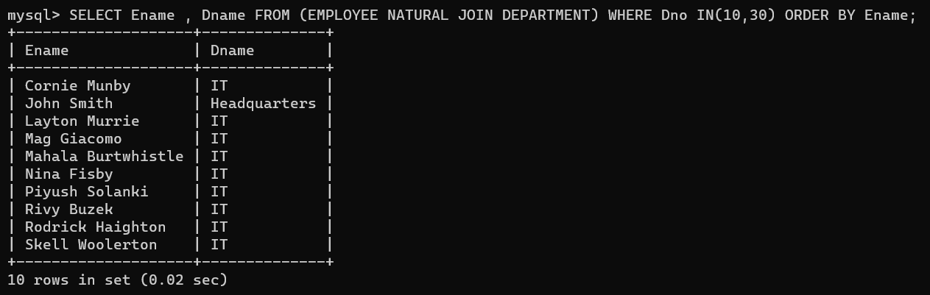

**QUERY 9**

**Description**

**Query to display Name and Hire Date of every Employee who was hired in 1980.**

**Query along with result:**

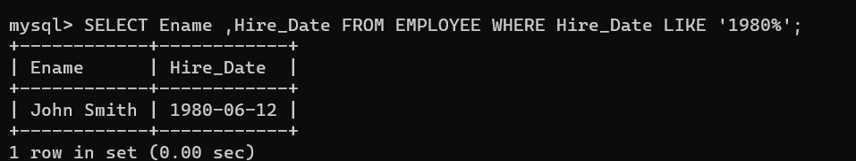

**QUERY 10**

**Description**

**Query to display Name and Job of all employees who have not been assigned a supervisor.Query along with result:**

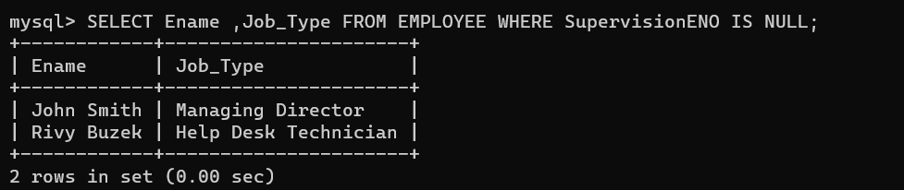

**QUERY 11**

**Description**

**Query to display the Name, Salary and Commission for all the employees who earn commission.**

**Query along with result:**

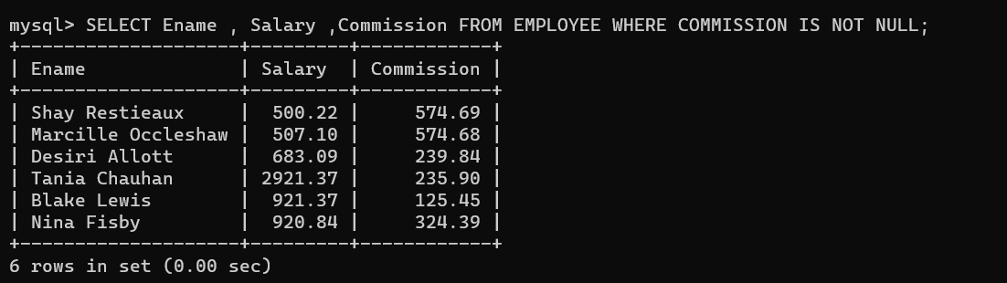

**QUERY 12**

**Description**

**Sort the data in descending order of Salary and Commission**

**Query along with result:**

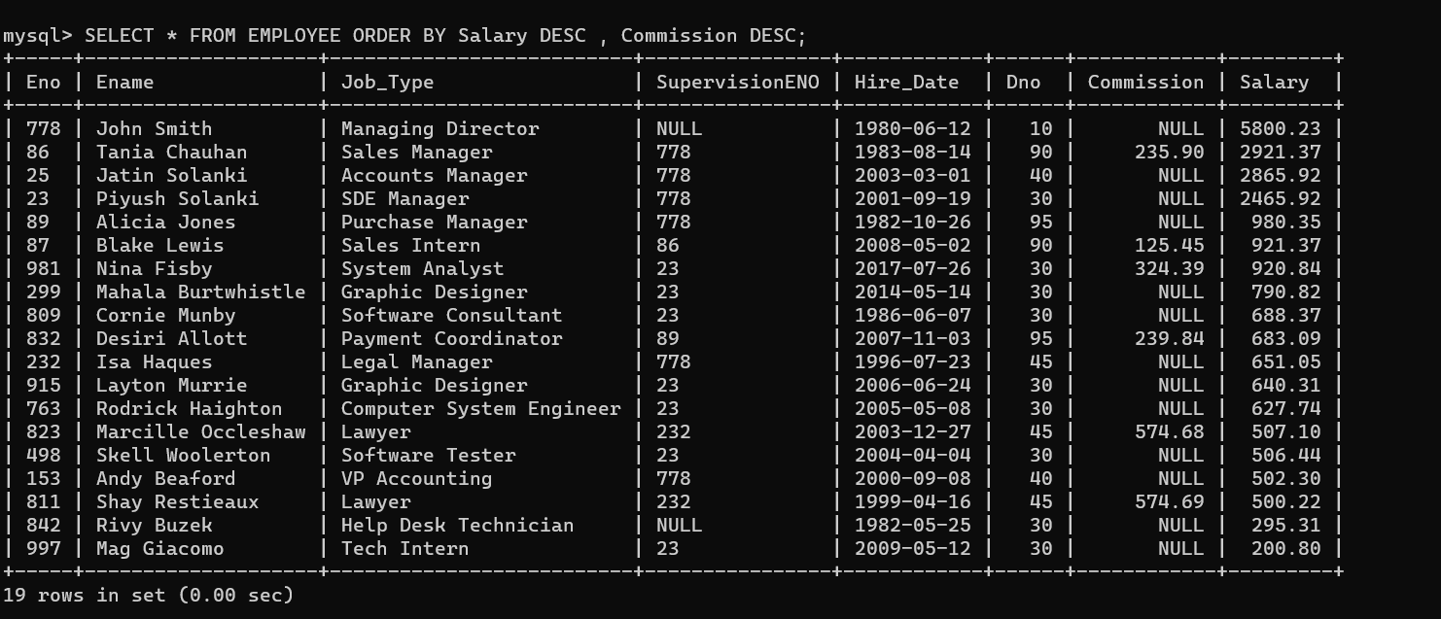

**QUERY 13**

**Description**

**Query to display Name of all the employees where the third letter of their name is ‘A’.**

**Query along with result:**

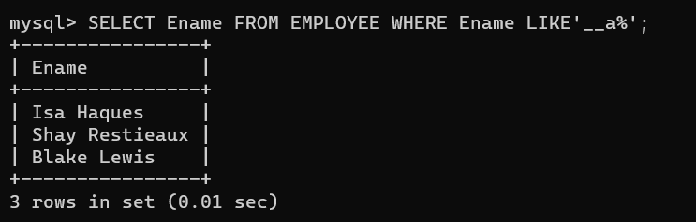

**QUERY 14**

**Description**

**Query to display Name of all employees either have two ‘R’s or have two ‘A’s in their name and are**

**either in Dept No = 30 or their Manger’s Employee No = ‘778’.**

**Query along with result:**

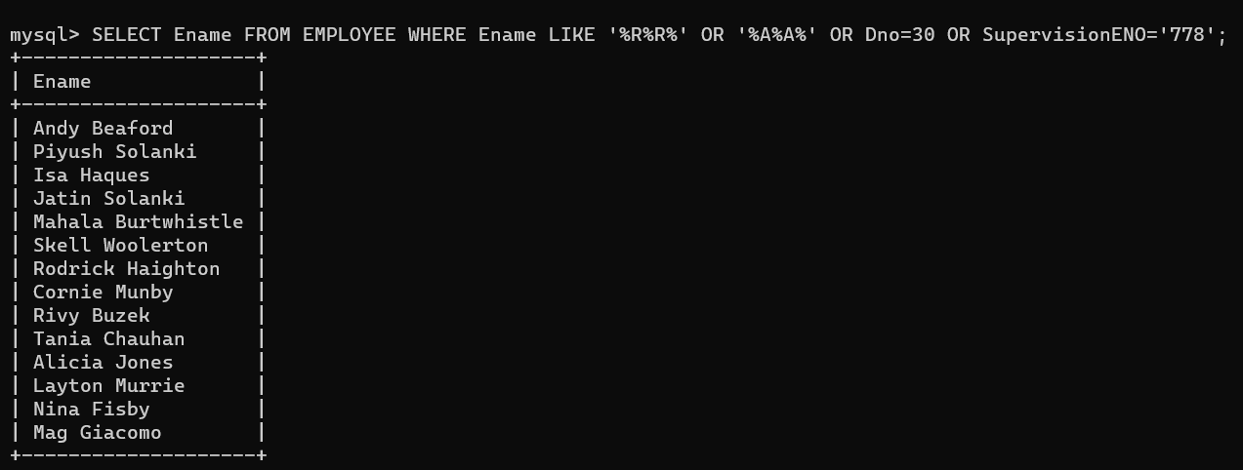

**QUERY 15**

**DESCRIPTION**

**Query to display Name ,Salary ,Commission for all employees whose Commission amount is greater than their Salary increased by 5%.**

**Query along with result:**



**QUERY 16**

**Description**

**Query to display the Current Date along with the day name.**

**Query along with result:  
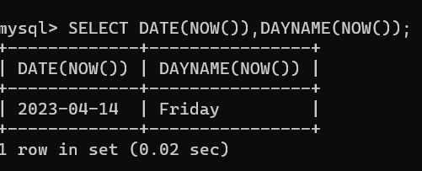**

**QUERY 17**

**Description**

**Query to display Name, Hire Date and Salary Review Date which is the 1st Monday after six months**

**of employment**

**Query along with result:**

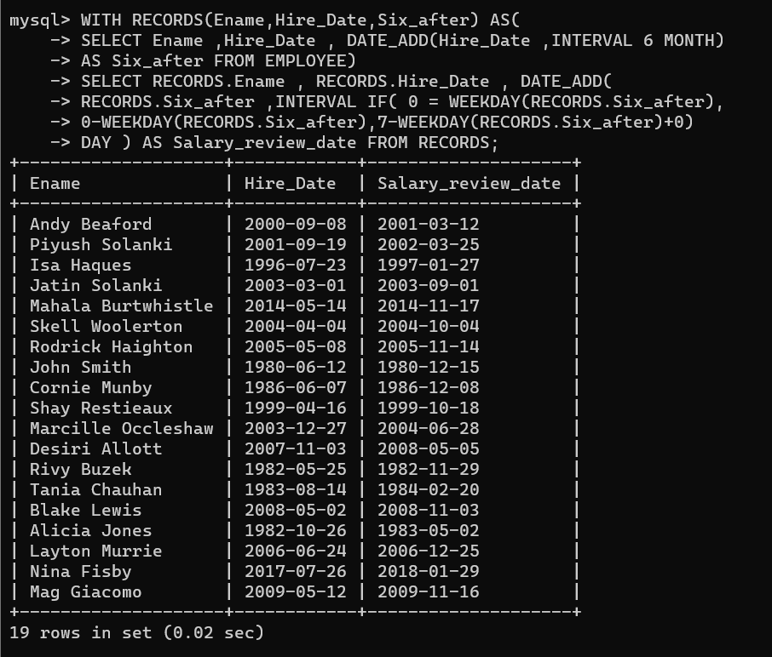

**QUERY 18**

**Description**

**Query to display Name and calculate the number of months between today and the date on which**

**employee was hired of department ‘Purchase’.**

**Query along with result:**

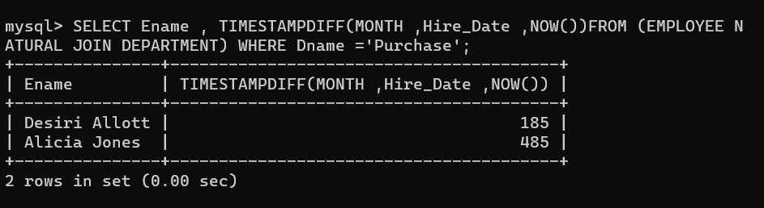

**QUERY 19**

**Description**

**Query to display the following for each employee <EName> earns < Salary> monthly but wants < 3 \***

**Current Salary >. Label the Column as Dream Salary.Query along with result:**

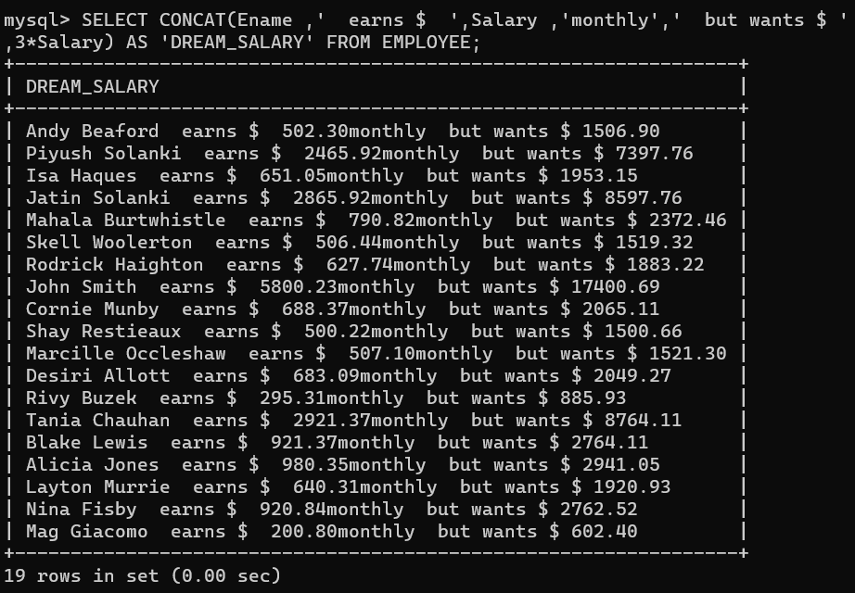

**QUERY 20**

**Description**

**Query to display Name with the 1st letter capitalized and all other letter lower case and length of**

**their name of all the employees whose name starts with ‘J’, ’A’ and ‘M’.**

**Query along with result:**

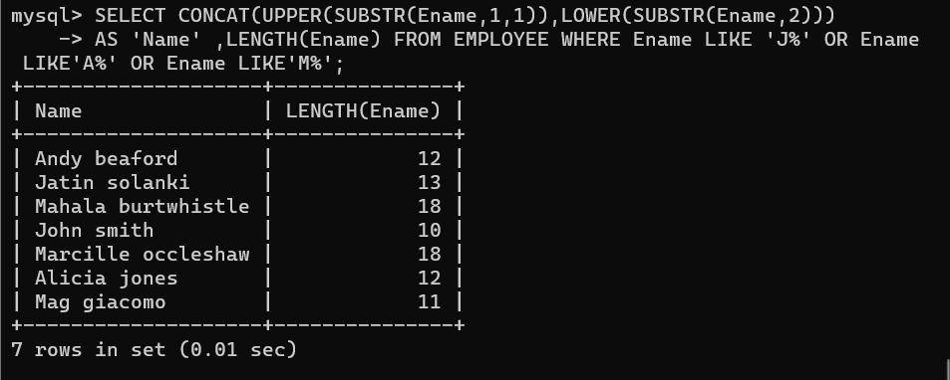

**QUERY 21**

**Description**

**Query to display Name, Hire Date and Day of the week on which the employee started.**

**Query along with result:**

